**SAHR EMMANUEL Jinnan District, Tianjin**

**+8618322551874**

[**sahremman@outlook.com**](mailto:sahremman@outlook.com)

# EDUCATION

## Tianjin University 08/2017~07/2021

* BSc. Chemical Engineering

Working towards a Chemical Engineering Degree

## Sime Darby Central High School 08/2008~07/2011

* WAEC Certificate
* High School Diploma

## Projects and Course-works

* Gas-Solid circulating fluidized bed heat exchange Technology – Current Thesis project.
* I researched in the area of environmental engineering on waste water treatment at Tianjin Co-Innovation Center of Chemical Science and Engineering – in my third year

# EXPERIENCE

## Nicom Distillery-Monrovia 05/2014- 08/2015

* Bottling Operator and later Effluent treatment Department

## Lonestar Cell Corporation 08/2011~07/2012

* Head of field Sales Agent- Bomi County.

# SKILLS

### -Basic Aspen Plus Skills

* **-OriginPro**
* **-Microsoft Office Skills (word, excel, PowerPoint).**
* **-Analytical Thinking**
* **-Laboratory Skills**
* **-Advance Communication**
* **-Attention to detail**
* **Interests and Hobbies :** Chemical Engineering and Environmental related industries,Reading and Writing,Soccer, traveling, community service,dancing, swimming
* **Language:** English

# EVALUATION

* Good people management and communication skills. Team player.
* Able to work under high pressure and time limitation.
* With good managerial skills and organizational capabilities.

# Reference

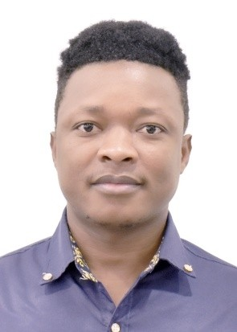

Mr. Feng Jiang, Asst. Professor Department of Chemical Engineering

Tianjin University, Tianjin, 300350, PR China Tel: 0086 138 2027 8355, [jiangfeng@tju.edu.cn](mailto:jiangfeng@tju.edu.cn)

Mr. Joseph Franklin, Engineer

Lonestar Cell Communication, Monrovia, 1000, 10-Liberia

Tel: +231888113529, [jjfklin@gmail.com](mailto:jjfklin@gmail.com)