
REPUBLIC OF LIBERIA
ENVIRONMENTAL PROTECTION AGENCY
Bright Building, 302-A Sekou Toure Avenue, Mamba Point
P. O. Box 4024, 1000 Monrovia, 10 Liberia

Environmental Research and Radiation
Safety Department (ERRS)
Third Quarter Report, 2026
(July 1 – September 30, 2026)

Reporting Department | Environmental Research and Radiation Safety Laboratory
Reporting Period | July 1 – September 30, 2026
Date Submitted | September 2026
Head of Department | Rafael S. Ngumbu
Contact Number | 0775764953
Email | rngumbu@epa.gov.lr / rafaelngumbu@yahoo.com
Reporting Units | Chemical Management Unit (CMU); Environmental Monitoring and Research Unit (EMRU); Radiation Safety Unit (RSU); Waste and Remediation Unit (WRU)

Monrovia, Liberia

Table of Contents

Right-click and select “Update Field” to build this list.

List of Tables

Table 1. Key Performance Indicators (KPIs) — progress tracking Q1–Q3 2026 (cumulative)
Table 2. EMRU summary of activities by quarter, 2026
Table 3. EMRU overall performance grade, Quarter III 2026
Table 4. RSU summary of major activities, Quarter III 2026
Table 5. WRU summary of activities, Quarter III 2026
Table 6. Chemical Management Unit — report particulars
Table 7. Activities summary, Chemical Management Unit, Quarter III 2026
Table 8. Applications received and responded to, CMU, Quarter III 2026
Table 9. Chemical registration licenses issued, CMU, Quarter III 2026
Table 10. Effluent discharge licenses issued, CMU, Quarter III 2026
Table 11. Chemical release and clearances issued, CMU, Quarter III 2026
Table 12. Fumigation license issued, CMU, Quarter III 2026
Table 13. Chemical disposal licenses issued, CMU, Quarter III 2026
Table 14. Chemical escort operations conducted, CMU, Quarter III 2026
Table 15. Chemical inventory conducted, CMU, Quarter III 2026
Table 16. Chemical importation licenses issued, CMU, Quarter III 2026
Table 17. Chemical seizure incidents, CMU, Quarter III 2026
Table 18. Chemical transportation licenses issued, CMU, Quarter III 2026
Table 19. Other deliverables, CMU, Quarter III 2026
Table 20. Activities deferred or planned for the next quarter, CMU
Table 21. Environmental Monitoring and Research Unit — report particulars
Table 22. Foreign meetings, trainings or workshops attended by staff of EMR
Table 23. Domestic meetings, trainings or workshops attended by staff of EMR
Table 24. Environmental investigations and monitoring conducted during Quarter III, 2026
Table 25. Training conducted by staff of the ERRS Department
Table 26. Laboratory accreditation issued, EMR Unit, Quarter III 2026
Table 27. Complaints received by the EMR Unit, Quarter III 2026
Table 28. Sachet water applications received and responded to, July – September 2026
Table 29. Sachet water response letters picked up, July – September 2026
Table 30. Sachet water applicants that paid, July – September 2026
Table 31. Sachet water certificates printed out, July – September 2026
Table 32. Sachet water certificates issued, July – September 2026
Table 33. Sachet water laboratory results received, July – September 2026
Table 34. Sachet water site verifications, July – September 2026
Table 35. Summary of sachet water activities, EMR Unit, Quarter III 2026
Table 36. Laboratory analyses conducted, EMR Unit, July – September 2026
Table 37. Laboratory accreditation record, EMR Unit, Quarter III 2026
Table 38. Water quality — timeliness and completeness of reporting by companies, July 2026
Table 39. Legend — reporting timeliness and completeness classification
Table 40. Soil quality — timeliness and completeness of reporting by companies, July 2026
Table 41. Summary of water, soil and air quality analysis reported by each proponent to EPA-Liberia for July, 2026
Table 42. Water quality — timeliness and completeness of reporting by companies/proponents, August 2026
Table 43. Radiation Safety Unit — report particulars
Table 44. Radiation Safety Unit staff
Table 45. Radiation bills issued, RSU, Quarter III 2026
Table 46. Radiation licenses issued, RSU, Quarter III 2026
Table 47. National basic occupational radiation safety and protection training, RSU, Quarter III 2026
Table 48. Environmental, industrial and medical radiation facilities inspected in Quarter III, 2026
Table 49. Medical and industrial facilities inventoried during Quarter III, 2026
Table 50. Staff trained during Quarter III 2026, RSU
Table 51. Summary of major activities, RSU, Quarter III 2026
Table 52. Waste and Remediation Unit — report particulars
Table 53. Waste management applications received, July 2026
Table 54. Waste management applications received, August 2026
Table 55. Waste management applications received, September 2026
Table 56. Waste management applications responded to, Quarter III 2026
Table 57. Waste certificates issued, Quarter III 2026
Table 58. Noise levels recorded at the Peuto Dela Torres Compound, 14 September 2026

List of Figures

Figure 1. Cumulative KPI achievement at the end of Quarter III 2026 against 2026 annual targets
Figure 2. Breakdown of CMU regulatory instruments issued, Quarter III 2026
Figure 3. EMRU quarter-on-quarter activity trend, 2026
Figure 4. EMRU operational activity summary, Quarter III 2026
Figure 5. WRU waste management applications received by month, Quarter III 2026
Figure 6. WRU waste application pipeline, Quarter III 2026
Figure 7. Classification of waste undertakings applied for, WRU, Quarter III 2026
Figure 8. Field investigations, escorts and assessments by unit, Quarter III 2026
Figure 9. Regulatory instruments issued by the Chemical Management Unit, Quarter III 2026
Figure 10. Application response performance, Chemical Management Unit, Quarter III 2026
Figure 11. Chemical escort operations by consignment and date, CMU, Quarter III 2026
Figure 12. Environmental investigations and monitoring activities by month, EMR Unit, Quarter III 2026
Figure 13. Complaints received by nature of complaint, EMR Unit, Quarter III 2026
Figure 14. Sachet water certification workflow, EMR Unit, Quarter III 2026
Figure 15. Sachet water certification pipeline, EMR Unit, Quarter III 2026
Figure 16. Samples analysed per laboratory exercise, EMR Unit, Quarter III 2026
Figure 17. Timeliness of proponent reporting to the EMR Unit, Quarter III 2026
Figure 18. Radiation licenses issued by institution and type, RSU, Quarter III 2026
Figure 19. Quarter III output against annual targets, RSU, 2026
Figure 20. Regulatory output of the Radiation Safety Unit, Quarter III 2026
Figure 21. Recorded noise levels against the permissible night-time limit, Peuto Dela Torres Compound, 14 September 2026
Figure 22. EPA technical team conducting night-time noise level measurements, Tubman Boulevard, Montserrado County, 15 September 2026

1. Executive Summary

The third quarter of 2026 was a period of sustained regulatory and field activity for the Environmental Research and Radiation Safety (ERRS) Department. This report consolidates the quarterly submissions of the Chemical Management Unit (CMU), the Environmental Monitoring and Research Unit (EMRU) and the Radiation Safety Unit (RSU) and the Waste and Remediation Unit (WRU) for the period 1 July to 30 September 2026.
The Chemical Management Unit maintained a full response rate on all applications received, recording thirty-eight (38) applications and thirty-eight (38) responses. The Unit issued thirty-five (35) regulatory instruments: nineteen (19) chemical release/clearances, five (5) chemical importation licences, five (5) effluent discharge licences, three (3) chemical registration licences, two (2) annual transportation licences and one (1) fumigation licence. Chemical release/clearances again represented the largest single category, accounting for fifty-four percent (54%) of all instruments issued. The Unit also conducted six (6) chemical escort operations covering eighty-eight (88) trucks of explosives, ferric chloride and ammonium nitrate.
The Environmental Monitoring and Research Unit sustained strong field performance, conducting ninety-one (91) environmental investigation and monitoring activities and analysing ninety-one (91) environmental quality media for soil, water and air. The Unit received thirty-five (35) sachet water applications and responded to all thirty-five (35), issued twenty-six (26) response letters, received fourteen (14) payments and nineteen (19) laboratory results, printed eleven (11) certificates and issued eleven (11) certificates to proponents. It further issued one (1) laboratory accreditation, reviewed twenty-six (26) environmental monitoring reports and received six (6) complaints, including three (3) noise pollution complaints that prompted night-time field measurement exercises.
The Radiation Safety Unit advanced its regulatory infrastructure, issuing four (4) radiation bills, seven (7) radiation importation licences and three (3) possess-and-use licences. The Unit organised and held the Validation Programme for the Draft Radiation Safety Law, drafted an Inspection Manual, operating guidelines and five (05) inspection checklists, calibrated Radiation Safety Laboratory equipment and resolved outstanding issues with the RAIS system with IAEA support. Three (3) staff attended IAEA fellowships and regional training in Ethiopia and Tanzania.
Across the Department, performance continued to be constrained by cross-cutting systemic challenges: inadequate logistical resources, in particular vehicles and fuel; insufficient personal protective equipment for chemical handlers; shortages of computers and IT infrastructure; staffing gaps; and the need for specialised technical training in dosimetry, regulatory reporting systems and laboratory analysis. Low proponent engagement and incomplete parameter reporting continued to weaken the evidence base available for timely decision-making.
The Waste and Remediation Unit received seventeen (17) waste management applications during the quarter — three (3) in July, seven (7) in August and seven (7) in September — responded to fifteen (15) applications and issued four (4) waste certificates. The Unit continued its assessment of waste service providers’ facilities, contributed to multiple Environmental and Social Impact Assessment (ESIA) site verification exercises, and represented the Agency at national and international engagements, including the seventh meeting of the Expert Working Group on the review of Annex II in Geneva, the Jeju International Environment Forum in Korea and International World Ozone Day in Buchanan.

2. Summary of the Department’s Mandates

The ERRS Department plays a central role in safeguarding Liberia’s environmental and public health through research, monitoring, licensing, and regulatory oversight.
The ERRS Department, originally established under the EPA’s Department of Compliance and Enforcement, is mandated to conduct routine environmental monitoring and research across various environmental media, including water, soil, air, radiation, and noise. The primary goal is to generate empirical data that informs national policies aimed at preventing environmental degradation, mitigating pollution, and minimizing the impacts of development activities on ecosystems and human health.
Structurally, the Department comprises four core units:
- Chemical Management Unit (CMU)
- Environmental Monitoring and Research Unit (EMRU)
- Radiation Safety Unit (RSU)
- Waste and Remediation Unit (WRU)

These units collaboratively execute the department’s broad mandate, which includes:
- Issuing licenses and permits for the importation, use, discharge, and disposal of chemicals and radiation sources;
- Accrediting analytical laboratories, waste handlers, industries, and health facilities for the safe use and management of hazardous substances;
- Maintaining national registries for chemicals and radiation sources in accordance with Part IV, Section 44 and Part IX, Section 96 of the Environmental Protection and Management Law of Liberia;
- Reviewing environmental monitoring reports submitted by regulated entities;
- Designing and implementing research programs to address emerging and existing environmental issues;
- Promoting public awareness and stakeholder engagement in environmental monitoring and decision-making.

The ERRS Department is led by a director and operates under a proposed structure that formalizes its specialized units, each playing a vital role in supporting Liberia’s environmental governance and regulatory compliance framework.
This report documents the Department’s performance and initiatives undertaken during the third quarter of 2026 (July to September 2026), building on the activities of the first and second quarters to offer a broader context for understanding the progress and strategic direction of the ERRS Department.

3. Outstanding Achievements During the Quarter

3.1 Chemical Management Unit (CMU)
During the third quarter of 2026 (July–September), the Chemical Management Unit demonstrated exemplary operational efficiency, achieving a full response rate on all applications received. The Unit received thirty-eight (38) applications and issued thirty-eight (38) responses, and issued a total of thirty-five (35) regulatory instruments across six categories: sixteen (16) formal licences (chemical registration, importation, effluent discharge, fumigation and transportation) and nineteen (19) chemical release/clearances. Chemical release/clearances represented the largest single category, accounting for fifty-four percent (54%) of all regulatory instruments issued.
Specifically, the Unit issued three (3) Chemical Registration Licences, five (5) Chemical Importation Licences, five (5) Effluent Discharge Licences, one (1) Fumigation Licence and two (2) Annual Transportation Licences, alongside nineteen (19) Chemical Release/Clearances. The Unit conducted six (6) chemical escort operations covering eighty-eight (88) trucks of explosives, ferric chloride and ammonium nitrate between 5 and 24 September 2026.
No nationwide chemical inventory, verification/inspection investigation, training, seizure or chemical disposal licence was recorded during the quarter. A laboratory chemical inventory of school laboratories has been scheduled to commence in the next reporting period.

3.2 Environmental Monitoring and Research Unit (EMRU)
During the third quarter of 2026, the EMRU sustained robust monitoring and research activity. The Unit received thirty-five (35) applications for sachet water and responded to all thirty-five (35). It issued twenty-six (26) response letters to proponents, received fourteen (14) payments from EPA receipts, printed eleven (11) certificates and issued eleven (11) certificates to compliant proponents. The laboratory received and processed nineteen (19) results from applicants, and the Unit issued one (1) laboratory accreditation, to MNG Gold Liberia in Bong County.
The Unit reviewed twenty-six (26) environmental monitoring reports submitted by proponents and conducted ninety-one (91) environmental investigation and monitoring activities across multiple counties. These included the GIZ-coordinated Joint Anti-Mineral Smuggling awareness exercises in Grand Cape Mount County, a large multi-agency assessment programme of mineral and sachet water facilities, contamination investigations at the Monrovia Industrial Park, pollution investigations at ArcelorMittal in Nimba County, and noise pollution investigations in Congo Town and Sinkor. Six (6) complaints were received during the quarter. Six (6) laboratory analysis exercises were conducted on twenty-six (26) water samples.

3.3 Radiation Safety Unit (RSU)
During the third quarter of 2026, the Radiation Safety Unit expanded its regulatory and compliance activities. The Unit issued four (4) radiation bills, seven (7) radiation importation licences to Bea Mountain Mining Corporation and three (3) possess-and-use licences to AMI Expeditionary Health Care and ArcelorMittal. Non-compliance notices were prepared and sent to facilities operating radiation-emitting equipment, and follow-up communications were issued to facilities that had not completed the licensing process.
The Unit organised and held the Validation Programme for the Draft Radiation Safety Law and drafted several regulatory documents, including an Inspection Manual, guidelines for operating imaging equipment and five (05) inspection checklists. Radiation Safety Laboratory equipment (survey meters and the IdentiFinder) was calibrated, and outstanding issues with the RAIS system were resolved with support from the IAEA.
Three (3) staff attended foreign training: the IAEA Fellowship on Notification and Authorization in Ethiopia (1–31 July 2026), the IAEA Fellowship on Inspection and Enforcement in Tanzania (1–31 August 2026) and the Regional Training on Radiation Protection in the Context of Non-Medical Human Imaging, Inspection Devices and Consumer Products in Dar es Salaam (20–24 July 2026). Staff also participated in the Africa CDC/One Health Workshop on the Liberia National Laboratory Policy and Strategic Plan (2026–2030) and in several ESIA technical review sittings and site verification visits.

3.4 Waste and Remediation Unit (WRU)
During the third quarter of 2026, the Waste and Remediation Unit continued the assessment of waste service providers’ facilities and processed seventeen (17) waste management applications, of which fifteen (15) were responded to and four (4) proceeded to the issuance of waste certificates. The Unit contributed to multiple Environmental and Social Impact Assessment (ESIA) site verification exercises arising from technical review sittings, maintained regular telephone follow-ups with proponents on response letters, and prepared responses and certificates of accreditation for waste companies.
The Unit also represented the Agency at a substantial number of national and international engagements during the quarter, including the seventh meeting of the Expert Working Group on the review of Annex II held in Geneva, Switzerland; the 2026 Green Solution Support Programme and the Jeju International Environment Forum in Korea; a scoping mission on waste management and the circular economy conducted with the UNOSD and the Korea Environment Corporation, including a one-day workshop on waste; International World Ozone Day activities in Buchanan; a three-day validation and technical session on stakeholder mobilisation, sectoral engagement and greenhouse gas data collection; a five-day training workshop organised by the Liberia Water and Sewer Corporation (LWSC); the RAP Verification; and the seventh edition of Know Your Environment (KYE) organised by Planning and Policy.

4. Progress Tracking, Quarter III 2026

4.1 Key Performance Indicators (KPIs) — Quarter III 2026
The KPI results for the third quarter of 2026 reflect continued progress across the reporting units’ core mandates, while highlighting areas requiring further support and strategic intervention. Quarter I and Quarter II figures are carried forward from the ERRS Second Quarter Report 2026 so that achievement is tracked cumulatively across the first nine months of the year.

Table 1. Key Performance Indicators (KPIs) — progress tracking Q1–Q3 2026 (cumulative)
Unit | No. | Key deliverable | Q1 2026 | Q2 2026 | Q3 2026 | Q4 2026 | Cumulative (9M) | Annual target | % achieved
Radiation Safety Unit | 1 | Develop and Legislate Nuclear Act of Liberia 2026 | In Progress | Responded to the second set of IAEA comments on the Radiation Safety Act | Organised and held the Validation Programme for the Draft Radiation Safety Law; drafted Inspection Manual, operating guidelines and five (05) inspection checklists |  | In Progress | 1 Act | —
 | 2 | Conduct Basic Radiation Trainings for 50 Radiographers and 50 Radiation workers for health Facilities and Industrial and Mining facilities | 0 | 0 | 0 |  | 0 | 100 Workers | 0%
 | 6 | Conduct Nationwide inventory of Radiation Sources at about fifty (50) health, mining and industrial facilities across Liberia. | 0 | 7 medical facilities + 4 mining-radiation monitoring inventories (11 total) | 0 |  | 11 | 50 Facilities | 22%
Chemical Management Unit | 4 | Conduct Nationwide Chemical inventory at about 60 industrial facilities across Liberia. | None conducted | 1 nationwide inventory (LIDA, Freeport, Monrovia) | None conducted |  | 1 | 60 Facilities | 1.7%
 | 7 | Issue chemical registration and importation licenses to 60 proponents | 41 Chemical Registration + 6 Chemical Importation licenses issued | 10 Chemical Registration + 4 Chemical Importation licenses issued | 3 Chemical Registration + 5 Chemical Importation licences issued |  | 69 (47 Q1 + 14 Q2 + 8 Q3) | 60 Proponents | 115% — Target Met
 | 9 | Issue annual effluent discharge licenses to about 30 proponents across Liberia | 4 Effluent Discharge licenses issued | 4 Effluent Discharge licenses issued | 5 Effluent Discharge licences issued |  | 13 (4 Q1 + 4 Q2 + 5 Q3) | 30 Proponents | 43.3%
 | 14 | Issue chemical disposal licenses to five (5) proponents | None issued | None issued | None issued |  | None | 5 Proponents | 0%
 | 15 | Issue fumigation licenses to 10 proponents | 4 Fumigation licenses issued | 3 Fumigation licenses issued | 1 Fumigation licence issued |  | 8 (4 Q1 + 3 Q2 + 1 Q3) | 10 Proponents | 80%
 | 16 | Issue licenses to four (4) chemical transporting firms | 3 Transportation licenses issued | 1 Transportation license issued | 2 Transportation licences issued |  | 6 (3 Q1 + 1 Q2 + 2 Q3) | 4 Firms | 150% — Target Met
 | 17 | Restore or remediate five (5) polluted sites. | None reported | 1 site remediated: Sethi Ferro Fabrik, Iron Factory (14-day exercise) | None reported by CMU; EMRU reported 1 restoration (chemical spillage site, Bomi Highway) and 1 remediation (gold mine, Upper Montserrado / Lower Margibi) |  | 3 | 5 Sites | 60%
 | 20 | Conduct training of fumigation applicators | None reported | 1 BCRP training conducted (Bong County, April) | None reported |  | 1 training conducted | All existing applicators | —
Environmental Monitoring and Research Unit | 3 | Equip EPA central laboratory with advanced analytical equipment, reagents & field compliance monitoring tool kits including mobile laboratory | Ongoing | Ongoing | Ongoing |  | Ongoing | 1 Lab & 1 Mobile Lab | —
 | 5 | Hire two (2) Lab technicians, two (2) quality control officers, and two (2) laboratory supervisors for quality laboratory delivery services | Ongoing | Ongoing | Ongoing |  | Ongoing | 6 Staff | —
 | 8 | Issue annual laboratory accreditation to about 12 analytical laboratories | None issued | 6 laboratory accreditations issued (BMMC x4, GLM, ArcelorMittal) | 1 laboratory accreditation issued (MNG Gold Liberia, Bong County) |  | 7 | 12 Laboratories | 58.3%
 | 10 | Analyze environmental quality media (water, soil, sediments, air, noise, vibration, vegetation) and conduct environmental monitoring | 53 lab results processed; 44 site verifications conducted | 36 lab results processed; 66 environmental investigations conducted | 19 lab results received; 91 environmental investigations conducted; 6 laboratory analysis exercises |  | 108 lab results; 201 investigations | All required facilities | —
 | 11 | Review, Update, and Validate the 2022 Environmental Inspection Manual of Liberia | Ongoing | Ongoing | Ongoing |  | Ongoing | 1 Manual | —
 | 12 | Review Environmental monitoring reports submitted by 100 proponents. | 34 environmental monitoring reports reviewed | 27 environmental monitoring reports reviewed | 26 environmental monitoring reports reviewed |  | 87 (34 Q1 + 27 Q2 + 26 Q3) | 100 Proponents | 87%
 | 21 | Issue Annual Certification to Sachet Water Factories in Liberia | 75 certificates printed; 43 certificates picked up | 36 certificates printed; 32 certificates picked up | 11 certificates printed; 11 certificates issued |  | 122 printed; 86 issued | All Producers | —
Waste and Remediation Unit | 22 | Conduct National Mapping and Registration of 100 Waste Generators and 50 Service Providers | Ongoing assessments of waste service providers | 26 waste service providers assessed and classified (10 in April, 10 in May, 6 in June) | 17 applications received (3 July, 7 August, 7 September); ongoing assessment of waste service providers’ facilities |  | 26 assessed (Q1–Q2) + 17 applications received (Q3) = 43 providers engaged | 150 (100 Generators, 50 Providers) | 28.7%
 | 23 | Conduct Environmental Monitoring at 50 Waste Facilities | Ongoing facility assessments | Ongoing facility assessments; multiple ESIA site verifications | Ongoing assessment of waste service providers’ facilities; contributed to multiple ESIA site verification exercises arising from technical review sittings; attended the RAP Verification |  | Ongoing | 50 Facilities | —
 | 24 | Conduct five (5) Public Awareness Campaigns on Waste Segregation and Disposal | Composting training and awareness campaigns conducted | Attended World Environment Day celebration; attended 3rd KYE session | 4 engagements: International World Ozone Day (Buchanan); 7th edition of Know Your Environment (KYE); 3-day validation and technical session on stakeholder mobilisation, sectoral engagement and GHG data collection; UNOSD / Korea Environment Corporation scoping mission and one-day workshop on waste and the circular economy |  | Ongoing — multiple awareness and stakeholder engagements | 5 Campaigns | —
 | 25 | Issue waste management licenses to 50 waste services providers | Accreditations prepared for qualifying companies | 15 applications responded to; 11 waste certificates issued | 15 applications responded to; 4 waste certificates issued |  | 15 (11 Q2 + 4 Q3) | 50 Providers | 30%
Cross-Cutting / All Units (General ERRS) | 13 | Conduct environmental investigation and research in at least two thematic areas and publish findings in scientific journals | 51 environmental investigations conducted | 66 environmental investigations conducted (EMRU) | 91 environmental investigations conducted (EMRU) |  | 208 (51 Q1 + 66 Q2 + 91 Q3) | 2 Thematic Areas | —
 | 18 | Conduct two training sessions for Chemical Handlers and First Respondents | None reported | None reported | None reported |  | None reported | 2 Training Sessions | 0%
 | 19 | Develop an automated database system of the ERRS Laboratory | Cloud database set up for document verification | Ongoing | RSU updated its facilities and communication databases; RAIS issues resolved with IAEA support |  | Cloud database established; ongoing maintenance | 1 System | —
Note: Q1 and Q2 entries are reproduced from the ERRS Second Quarter Report 2026; Quarter III entries are drawn from the four unit submissions consolidated in this report. Q4 2026 is reserved. For Output 22 the cumulative figure combines providers assessed in Quarters I–II with applications received in Quarter III.

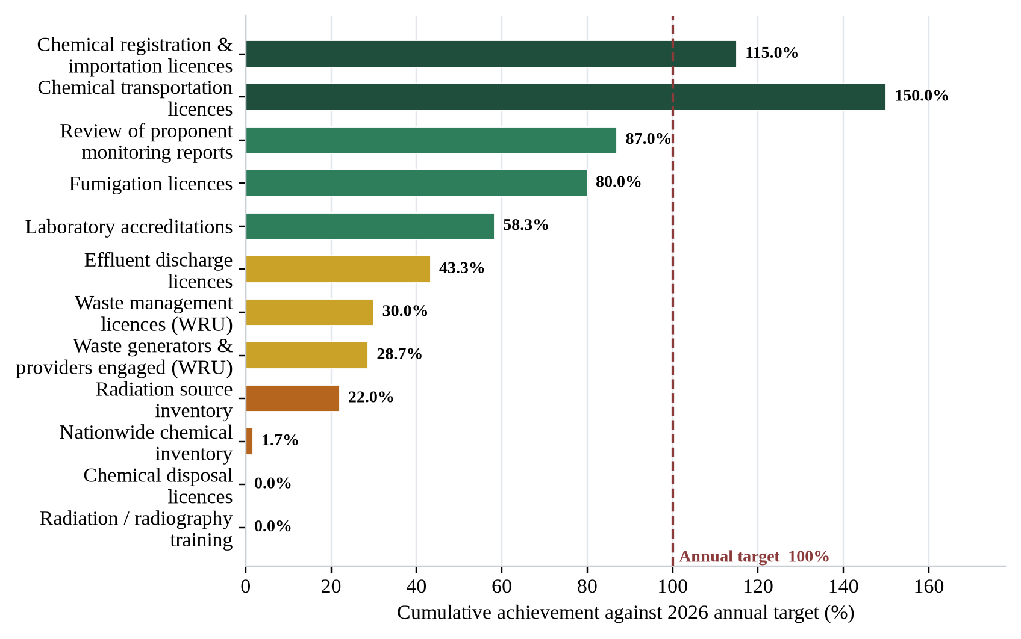
Figure 1. Cumulative KPI achievement at the end of Quarter III 2026 against 2026 annual targets
The figure above visualises cumulative progress over the first nine months of the year against the annual targets established for 2026. Two chemical licensing targets have already been met and exceeded, while radiation source inventory, nationwide chemical inventory, chemical disposal licensing and radiography training remain materially behind target. Waste management licensing has advanced to fifteen (15) certificates against an annual target of fifty (50) providers.

4.2 KPI Achievements and Remaining Tasks, Quarter III 2026

4.2.1 Chemical Management Unit
The Chemical Management Unit maintained strong licensing performance, issuing thirty-five (35) regulatory instruments against a full (100%) response rate on the thirty-eight (38) applications received. Outputs included sixteen (16) formal licences (3 chemical registration, 5 chemical importation, 5 effluent discharge, 1 fumigation and 2 transportation licences) and nineteen (19) chemical release/clearances, alongside six (6) chemical escort operations. Remaining tasks for the year include the nationwide chemical inventory, for which one (1) of sixty (60) target facilities has been completed, and chemical disposal licensing, which remains at zero against a target of five (5) proponents.
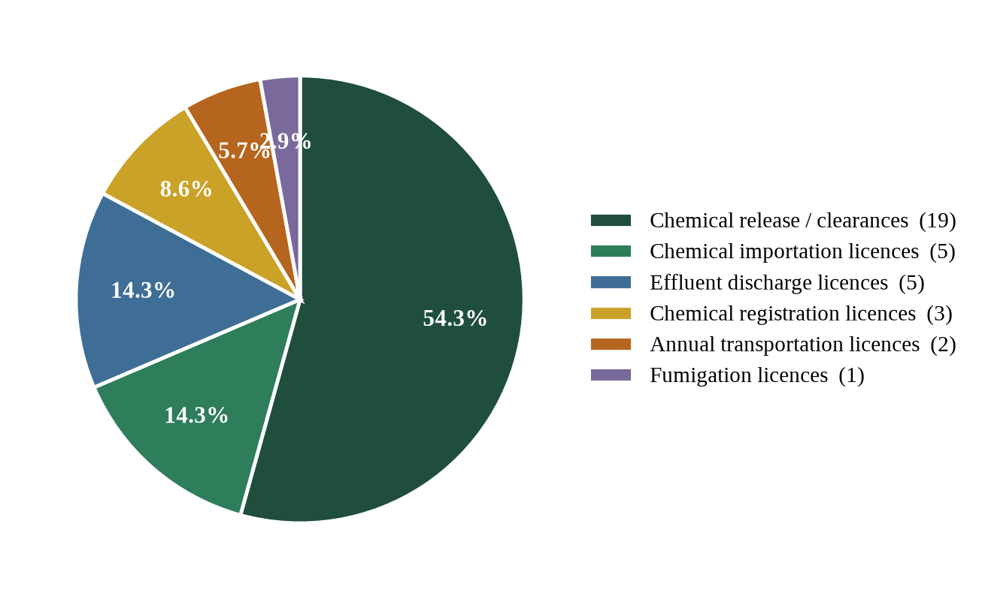
Figure 2. Breakdown of CMU regulatory instruments issued, Quarter III 2026
The chart above breaks down the thirty-five (35) regulatory instruments issued by the Chemical Management Unit during the third quarter. Chemical release/clearances dominate the Unit’s output at 54.3%, consistent with the pattern observed in Quarter II, and reflect the high volume of trade-related regulatory support provided by the Unit.

4.2.2 Environmental Monitoring and Research Unit
The Environmental Monitoring and Research Unit delivered strong field results: thirty-five (35) application letters received and responded to, nineteen (19) laboratory results processed, eleven (11) certificates printed and eleven (11) issued, one (1) laboratory accreditation issued, twenty-six (26) monitoring reports reviewed and ninety-one (91) environmental investigations conducted — the highest quarterly investigation count recorded so far in 2026. The quarter-over-quarter summary and overall performance grade are presented below.
Table 2. EMRU summary of activities by quarter, 2026
Category | Quarter I | Quarter II | Quarter III
Number of Foreign Events Attended | 1 | 0 | 4
Number of Local Events | 0 | 0 | 3
Number of Environmental Investigations | 51 | 66 | 91
Number of Local Trainings Conducted | 0 | 0 | 0
Number of Sachet Water applications received | 84 | 31 | 35
Number of Sachet Water responses | 84 | 31 | 35
Number of Response letters issued | 51 | 32 | 26
Number of applicants who paid | 49 | 37 | 14
Number of environmental quality analyses | 53 | 36 | 91
Laboratory Accreditation | 0 | 6 | 1
Number of Monitoring activities conducted | 63 | 66 | 91
Number of Sachet Water certificates issued | 43 | 32 | 11
Number of Sachet water certificates printed | 75 | 36 | 11
Number of Site Verifications | 44 | Not separately reported | 0
Number of Laboratory Results | 53 | 36 | 19
Note: Quarter I and Quarter II figures are reproduced from the ERRS Second Quarter Report 2026.
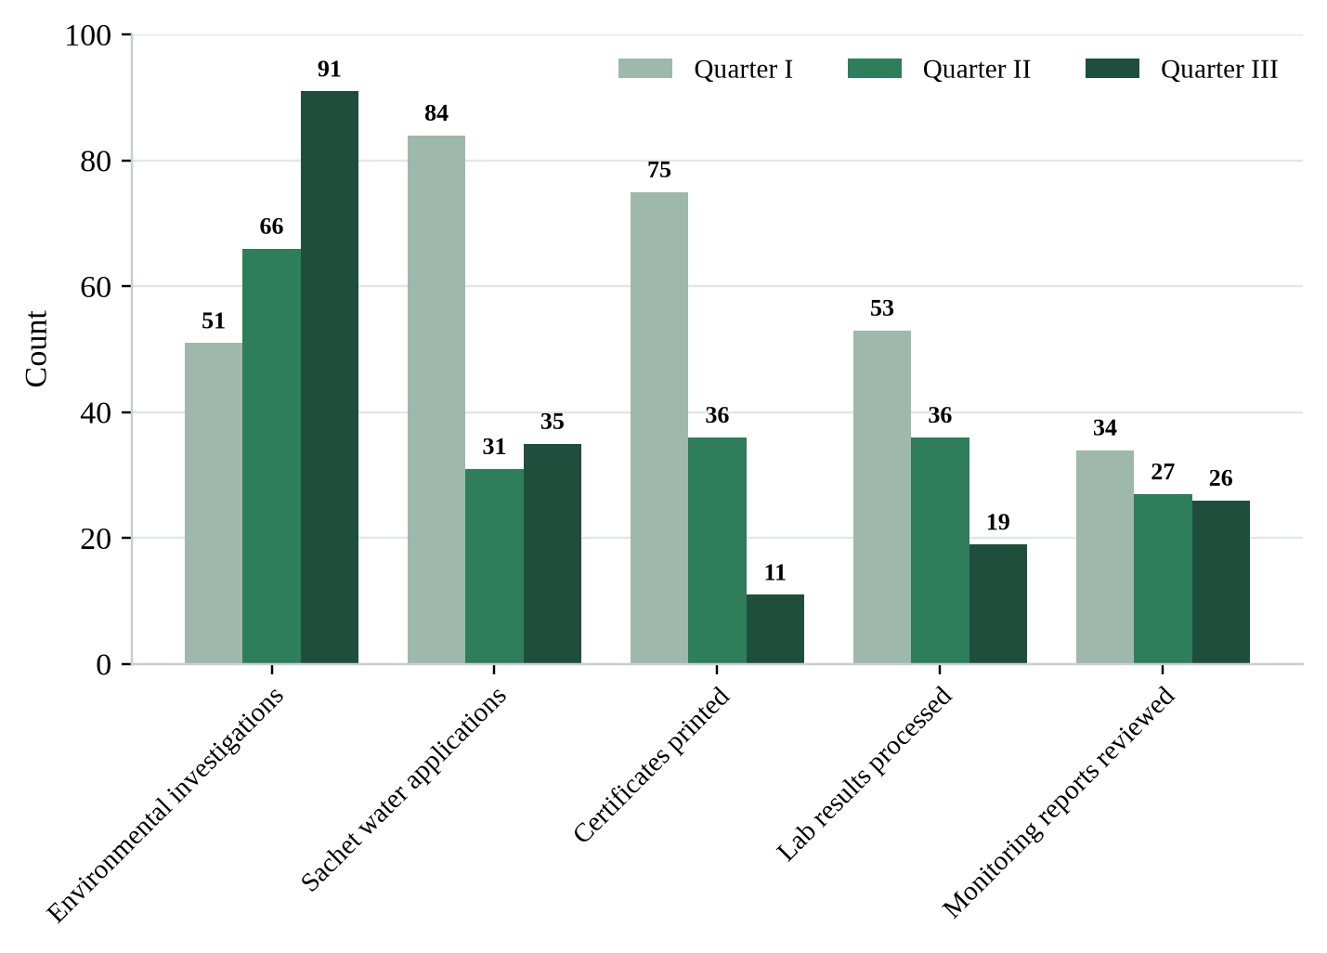
Figure 3. EMRU quarter-on-quarter activity trend, 2026
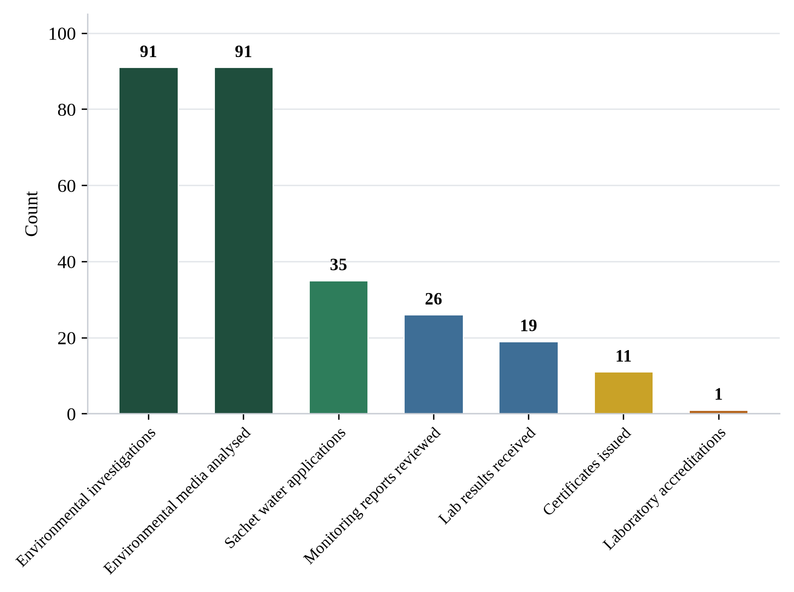
Figure 4. EMRU operational activity summary, Quarter III 2026
Table 3. EMRU overall performance grade, Quarter III 2026
No. | Output description | Planned activities | Indicators | Targets | Progress | Status
1 | Issue annual laboratory accreditation | Assess and accredit analytical laboratories | Number of accreditations issued | 12 laboratories | 1 issued in Q3 (7 cumulative) | On track
2 | Analyse environmental quality media | Sample and analyse water, soil and air | Number of media analysed | All required facilities | 91 analysed in Q3 | Achieved
3 | Conduct environmental monitoring and investigations | Field investigations, site verifications, complaint response | Number of investigations | All required facilities | 91 conducted in Q3 | Achieved
4 | Review environmental monitoring reports | Review proponent submissions against national standards | Number of reports reviewed | 100 proponents | 26 reviewed in Q3 (87 cumulative) | On track
5 | Issue annual certification to sachet water factories | Process applications, laboratory testing and certification | Certificates printed and issued | All producers | 11 printed and 11 issued in Q3 | Behind target
6 | Conduct site verifications of sachet water proponents | Field verification of applicant premises | Number of site verifications | All applicants | 0 conducted in Q3 | Not started

4.2.3 Radiation Safety Unit
The Radiation Safety Unit concentrated on regulatory infrastructure during the quarter, issuing four (4) bills, seven (7) importation licences and three (3) possess-and-use licences, and holding the Validation Programme for the Draft Radiation Safety Law. No medical or industrial facility inventory, inspection or occupational radiation safety training was conducted during the quarter, leaving the national inventory at eleven (11) of the fifty (50) target facilities and the training indicator at zero. The summary of the Unit’s major activities for the quarter is presented below.
Table 4. RSU summary of major activities, Quarter III 2026
Category | 2026  (Quarter III) | Annual target  (2026) | Total completed | Percentage completed (%)
Number of Medical facilities inventoried | 0 | 50 | 7 | —
Number of industrial facilities inventoried | 0 | — | 0 | —
Number of Mining Radiation Monitoring and Inventories | 0 | — | 4 | —
Number of operators/radiographers trained | 0 | 50 | 0 | 0%
Number of trained persons under personnel monitoring | 0 | 50 | 0 | 0%
Number of Publications | 0 | 2 | 0 | 0%
Number of Internal Training(s) Conducted | 0 | N/A | 0 | –
Number of Bills issued | 4 | N/A | 5 | –
Number of Radiation Importation License(s) issued | 7 | N/A | 7 | –
Number of Radiation Possess & Use License(s) issued | 3 | N/A | 3 | –
Note: Reproduced from the RSU Quarter III 2026 submission. Cells shown as — were left blank in the source unit report.

4.2.4 Waste and Remediation Unit
The Waste and Remediation Unit processed seventeen (17) waste management applications during the quarter, responded to fifteen (15) and issued four (4) waste certificates. Application volume rose sharply after July, with seven (7) applications received in each of August and September against three (3) in July. Eleven (11) of the seventeen applications concerned non-hazardous municipal waste and five (5) concerned hazardous streams — scrap, used tyres, used batteries, used cables, plastics, medical waste and sewage — while one (1) was a request for an acquaintance meeting.
Table 5. WRU summary of activities, Quarter III 2026
Category | July | August | September | Quarter III total
Waste management applications received | 3 | 7 | 7 | 17
Applications responded to | — | — | — | 15
Waste certificates issued | — | — | — | 4
Non-hazardous (municipal) undertakings applied for | 3 | 3 | 5 | 11
Hazardous waste undertakings applied for | 0 | 3 | 2 | 5
Other requests (acquaintance meeting) | 0 | 1 | 0 | 1
Note: Applications responded to and certificates issued were reported for the quarter as a whole and are not disaggregated by month in the source unit report.
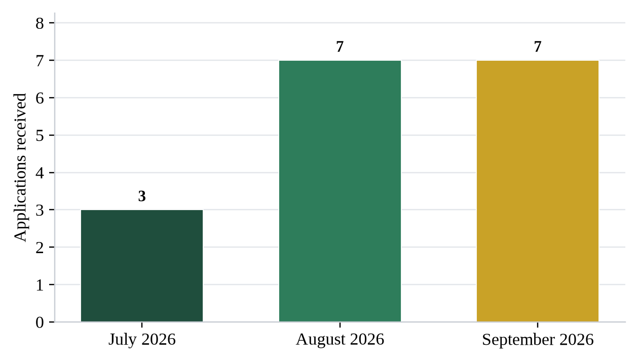
Figure 5. WRU waste management applications received by month, Quarter III 2026
Application volume more than doubled from July to August and held at that level in September, indicating growing engagement by waste service providers with the accreditation process.
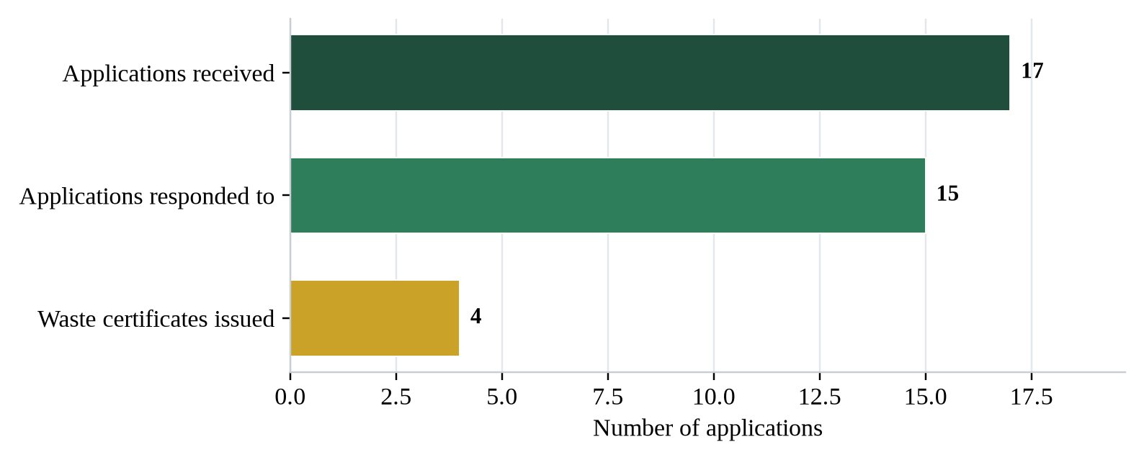
Figure 6. WRU waste application pipeline, Quarter III 2026
The pipeline shows attrition between application and certification: fifteen (15) of the seventeen (17) applications received a formal response, but only four (4) reached certification within the quarter. The Unit records that several requests for permits were responded to but the proponents concerned are yet to come into compliance.
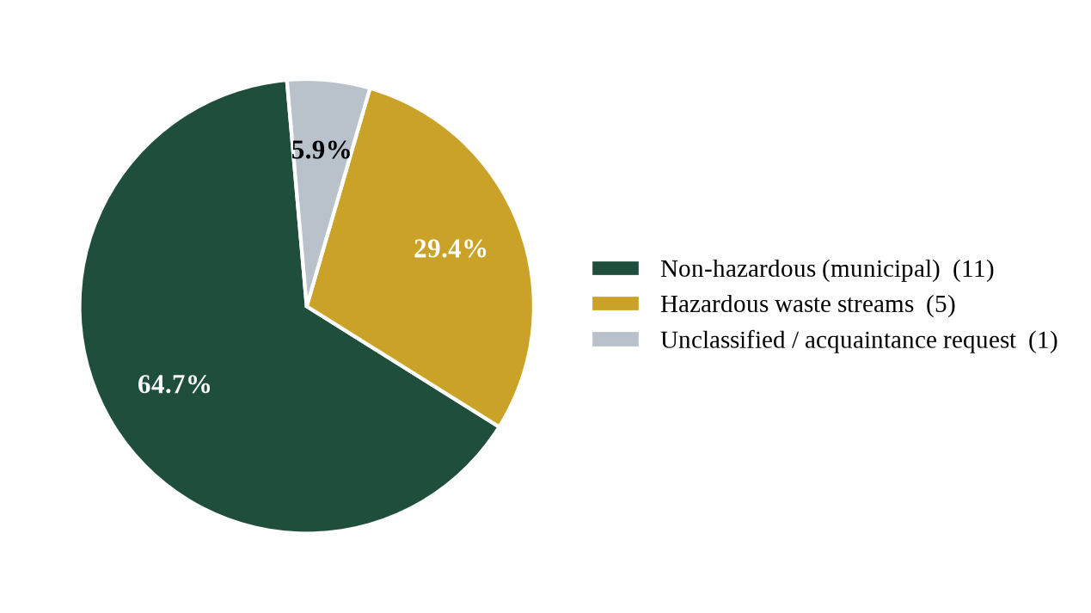
Figure 7. Classification of waste undertakings applied for, WRU, Quarter III 2026
Non-hazardous municipal waste accounts for just under two-thirds of the applications received, with hazardous streams — scrap metal, used tyres, used batteries, used cables, plastics, medical waste and sewage — making up a further 29.4%. Against the annual targets, the Unit has now issued fifteen (15) waste management certificates of the fifty (50) planned for 2026 (30%), and forty-three (43) generators and providers have been assessed or have applied of the one hundred and fifty (150) targeted (28.7%). Environmental monitoring of waste facilities and the public awareness campaign programme remain ongoing.

4.2.5 Field Activity Across the Department
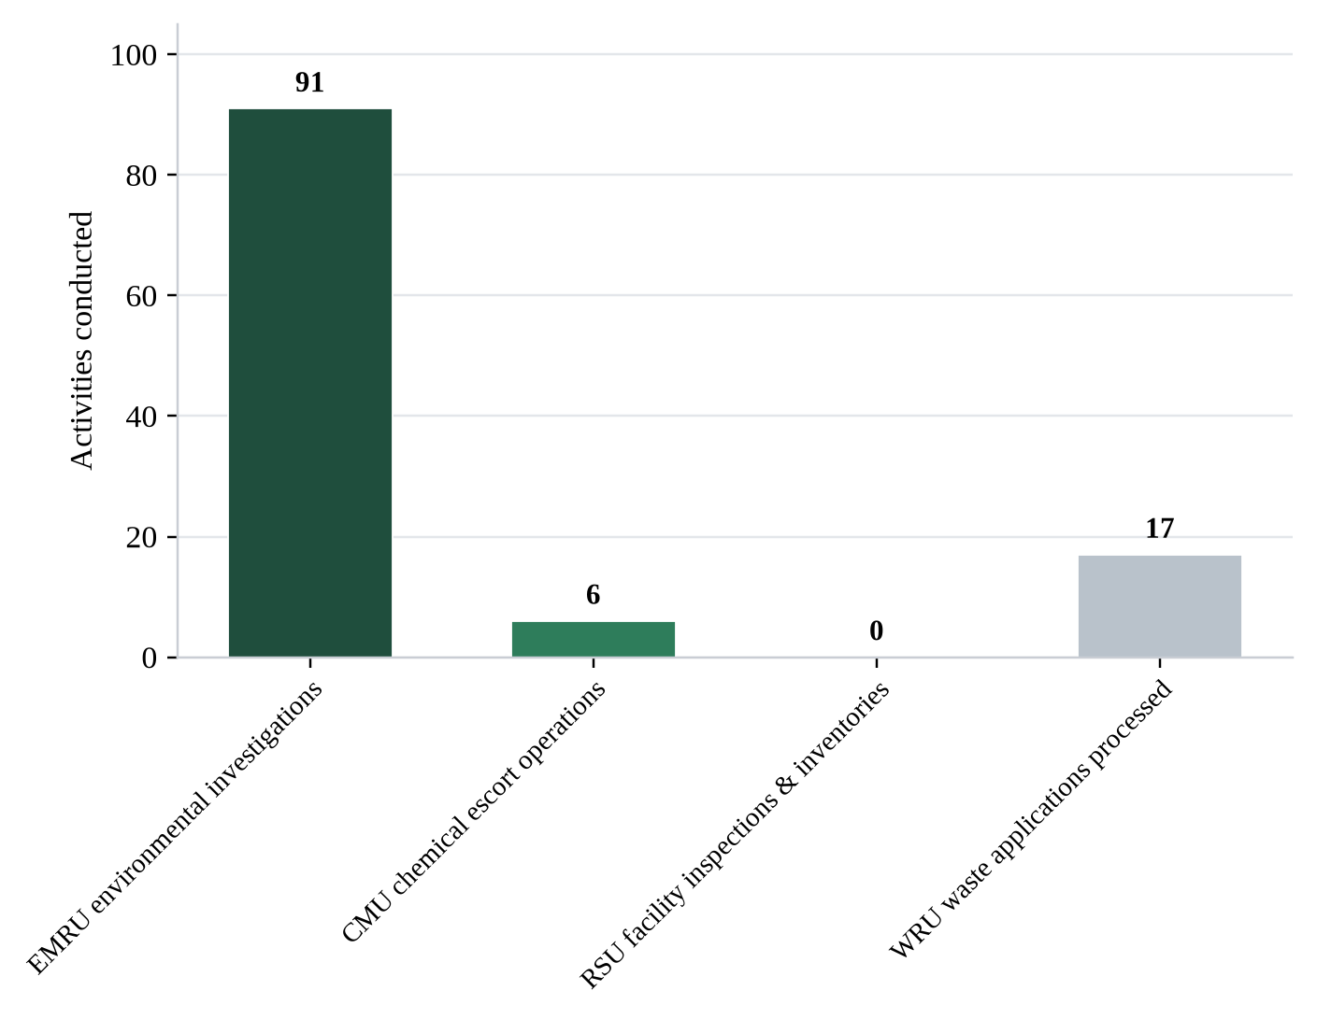
Figure 8. Field investigations, escorts and assessments by unit, Quarter III 2026
The figure compares the primary field-based activities of each unit for the quarter. The Environmental Monitoring and Research Unit accounted for the overwhelming majority of field activity with ninety-one (91) investigations, followed by the Waste and Remediation Unit with seventeen (17) waste management applications processed. The Radiation Safety Unit recorded no facility inspection or inventory during the quarter.

5. Detailed Summary of Undertakings

The sections that follow reproduce each unit’s Quarter III 2026 submission in full, in the order Chemical Management Unit, Environmental Monitoring and Research Unit, Radiation Safety Unit and Waste and Remediation Unit. Content, wording and figures are carried over from the source unit reports without abridgement.

5.1 Chemical Management Unit (CMU)

5.1.1 Report Particulars
Table 6. Chemical Management Unit — report particulars
Description | Detail
To | Mr. Rafael S. Ngumbu, Manager, ERRS Department
From | Mr. Emmanuel Suah, Head of Chemical Management Unit
Contact | +231 775520872 · esuah@epa.gov.lr
Reporting quarter | Quarter Three, 2026
Reporting period | July 1 – September 30, 2026
Reporting date | September 28, 2024
Note: Reporting date reproduced exactly as recorded in the source unit report.

5.1.2 Background
The Chemical Management Unit is one of the Units in the Environmental Research and Radiation Safety Department at the Environmental Protection Agency. In collaboration with relevant sections, units, and departments of the EPA and other national and international stakeholders, the Unit was established to implement relevant provisions of the Agency’s Act and the Environmental Protection and Management Laws. Understanding the chemical sector as one of the largest industrial sectors in the world and a fast emerging in Liberia, and considering the adverse consequences of unsound chemical management, the Unit was also established to undertake actions to prevent and mitigate the impacts on the environment, human health and economy of chemical accidents.
The Unit supports the Agency in achieving several specific targets of the Sustainable Development Goals. It is a collaborative hub for implementing Multilateral Environmental Agreements (MEAs) on chemicals and hazardous waste. It works closely with focal points of the Stockholm Convention on Persistent Organic Pollutants (POPs), Vienna Convention for the Protection of the Ozone Layer, the Montreal Protocol on Substances that Deplete the Ozone Layer, Minamata Convention on Mercury, Rotterdam Convention on the Prior Informed Consent Procedure on Hazardous Chemicals and Pesticides in International Trade, and the Basel Convention on the Control of Trans-boundary Movement of Hazardous Wastes and their Disposal for effective delivery.
The Unit issues chemical registration and importation licenses, chemical importation clearances, effluent discharge licenses, chemical disposal licenses, fumigation licenses. Additionally, the Unit serves as the Custodian of the Pollutant and Chemical Registry and is responsible for verifying and inspecting relevant proponents’ applications and activities.
This report covers activities beginning in July to September 2026. The Chemical Management Unit (CMU) demonstrated exemplary operational efficiency during July–September, achieving a response rate on all applications received. The unit issued a total of 15 licenses and 19 clearances, such as chemical registration, chemical importation, Chemical Transportation, fumigation, and effluent discharge licenses. The unit conducted critical chemical escort operations.

5.1.3 Activities Summary for the Quarter
Table 7. Activities summary, Chemical Management Unit, Quarter III 2026
Indicator | Number
Number of Foreign Events Attended | 0
Number of Local Events Attended | 0
Number of Verification / Inspection Investigations | 0
Number of Training Conducted | 0
Number of Non-bill or Letters Communicated | 0
Number of Other Activities Conducted | 0
Number of Meetings Attended | —
Number of Applications Received | 38
Number of Responses | 38
Number of Chemical Escorts | 0
Chemical Clearances / Letters | 19
Nationwide Chemical Inventory | 0
Chemical Registration Licenses | 3
Chemical Importation Licenses | 5
Effluent Discharge Licenses | 5
Number of Chemical Seizures | 0
Annual Transportation License | 2
Chemical Disposal Licenses | 0
Number of Fumigation License | —
Note: An em dash (—) indicates a cell left blank in the source unit report. The entry for chemical escorts is reproduced as submitted; six escort operations are itemised in Table 9 below.
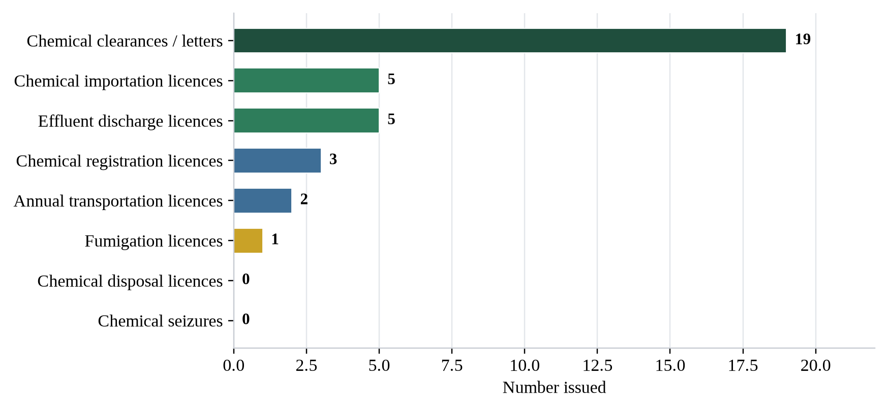
Figure 9. Regulatory instruments issued by the Chemical Management Unit, Quarter III 2026
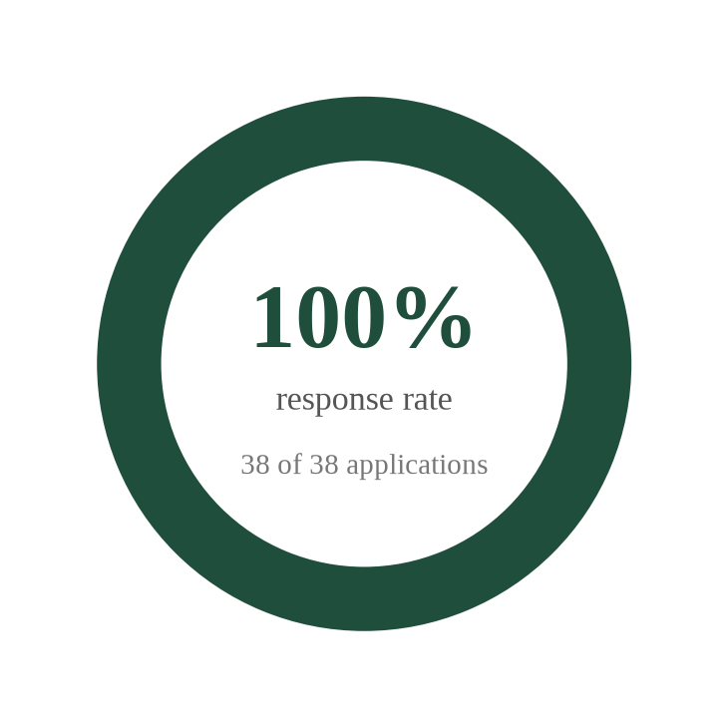
Figure 10. Application response performance, Chemical Management Unit, Quarter III 2026

5.1.4 Major Deliverables
5.1.4.1 Applications Received and Responded To
Table 8. Applications received and responded to, CMU, Quarter III 2026
No. | Applicant | Location
1 | Bea Mountain Mining Inc. | Monrovia, Liberia
2 | New Green World Fumigation Service Inc. | Dry Rice Market, Bardnersville
3 | Firestone Liberia, LLC | Harbel ,Margibi County
4 | AND Incorporated | Japan Freeway
5 | Everette Transport Corporation | 16th Street Sinkor, Monrovia, Liberia
6 | LIPFOCO | Monrovia, Liberia
7 | Jeety Rubber, LLC | Salala, Margibi County
8 | Cavalla Rubber Corporation | Maryland County
9 | Maryland Oil Palm Plantation | Maryland County
10 | Arcelor-Mital Liberia | Monrovia, Liberia
11 | Bea Mountain Mining Corporation | Dry Rice Market, Bardnersville
12 | H&K | HarbelBuchanan, Grand Bassa County
13 | Jamila Mining Corporation | Japan Freeway
14 | New Pest Fumigation Services | Rehab16th Street Sinkor, Monrovia, Liberia
15 | Zoom Lion Fumigation Monrovia, Liberia | —
16 | Monrovia Breweries | Salala, Margibi County
17 | Liberia Soap & Detergents | Maryland County
18 | Liberia Agriculture Company | Buchanan, Grand Bassa County
19 | LIPFOCO Mattress Factory | Bong Mines Bridge,
20 | Golden Veroleum Liberia | Maryland County
21 | Arcelor-Mital Liberia | —
22 | Bea Mountain Mining Corporation | —
23 | CGL International | —
24 | Africa Global Logistic | —
25 | New Pest Fumigation Services | Rehab, Paynesville
26 | Fouani Brothers Corporation | Monrovia, Liberia
27 | Liberia Agriculture Company | Buchanan, Grand Bassa County
28 | Mano Manufacturing Company | —
29 | The GEMPRO Group of Companies | —
30 | CGGC Mining Services | Congo Town
31 | K & P Agriculture | —
32 | Cavalla Rubber Corporation | Maryland County
33 | Firestone Rubber, LLC | Harbel, Margibi
34 | Golden SIFCA | Maryland County
35 | HYSAA Liberia, Inc. | Monrovia, Liberia
36 | Monrovia Breweries Inc. | Monrovia, Liberia
37 | Maryland Oil Palm Plantation | Maryland County
38 | Sunny Brother Inc. | Clara Town, Monrovia
Note: Locations shown as — were not stated in the source unit report.
5.1.4.2 Chemical Registration Licenses Issued
Table 9. Chemical registration licenses issued, CMU, Quarter III 2026
No. | Institution | Address
1 | Cavalla Rubber Corporation | Maryland County
2 | Maryland Oil Palm Plantation | Maryland County
3 | Jeety Rubber, LLC | Margibi County

5.1.4.3 Effluent Discharge Licenses Issued
Table 10. Effluent discharge licenses issued, CMU, Quarter III 2026
No. | Institution | Address
1 | Maryland Oil Palm Plantation | —
2 | Cavalla Rubber Corporation | —
3 | Arcelor Mittal Liberia | —
4 | Jeety Rubber, LLC | —
5 | Bea Mountain Mining Inc. (Matambo Pit) | —

5.1.4.4 Chemical Release / Clearances Issued
Table 11. Chemical release and clearances issued, CMU, Quarter III 2026
No. | Institution | Address
1 | Bea Mountain Mining Corp. (8X) | Grand Cape Mount
2 | Bea Mountain Mining Inc. (5X) | —
3 | LIPFOCO (5X) | —
4 | Supreme Liberia Inc. | —
Note: The multiplier in parentheses denotes the number of clearances issued to the proponent, giving the quarter total of nineteen (19) clearances.
5.1.4.5 Fumigation License Issued
Table 12. Fumigation license issued, CMU, Quarter III 2026
No. | Institution | Address
1 | New Green World | Russel Avenue, 15–16 Streets

5.1.4.6 Chemical Disposal License Issued
Table 13. Chemical disposal licenses issued, CMU, Quarter III 2026
No. | Institution | Address
– | None | –

5.1.4.7 Chemical Escorts Conducted
Table 14. Chemical escort operations conducted, CMU, Quarter III 2026
No. | Chemical escorted | Date | Number of trucks
1 | Explosive | September 5, 2026 | 6 trucks
2 | Ferric chloride | September 9, 2026 | 3 trucks (6 Six)
3 | Explosive | September 18, 2026 | 24 trucks
4 | Ammonium nitrate | September 22, 2026 | 16 trucks
5 | Ammonium nitrate | September 23, 2026 | 16 trucks
6 | Ammonium nitrate | September 24, 2026 | 23 trucks
 | Total |  | 88 trucks
Note: Consignment details reproduced as recorded in the source unit report.
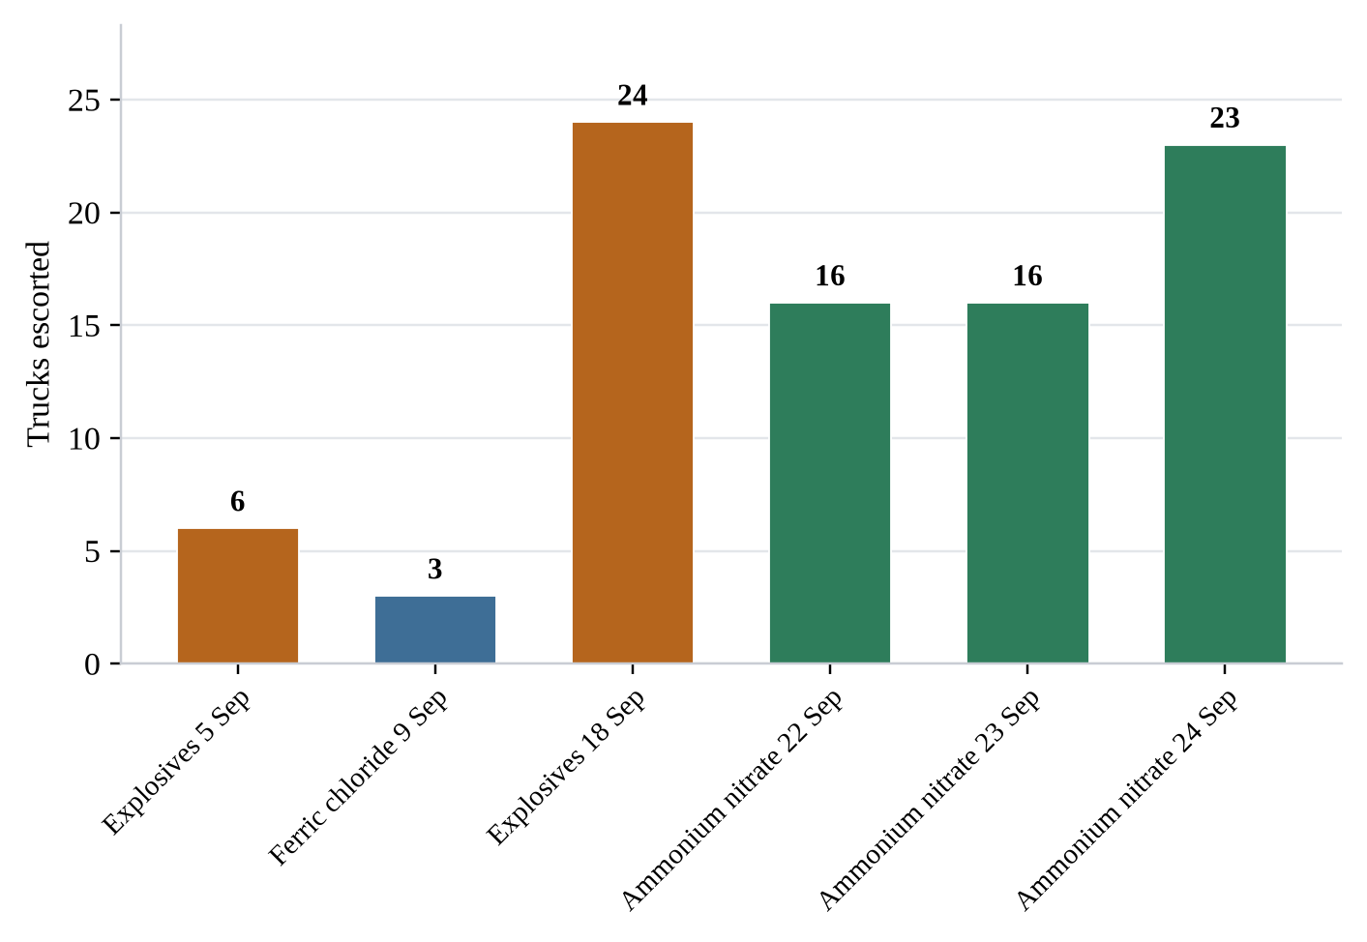
Figure 11. Chemical escort operations by consignment and date, CMU, Quarter III 2026
5.1.4.8 Chemical Inventory Conducted
Table 15. Chemical inventory conducted, CMU, Quarter III 2026
No. | Institution | Address
– | None | –

5.1.4.9 Chemical Importation Licenses Issued
Table 16. Chemical importation licenses issued, CMU, Quarter III 2026
No. | Institution | Address
1 | CGGC Mining Services | —
2 | Cavalla Rubber Corporation | —
3 | Golden SIFCA | —
4 | Maryland Oil Palm Plantation | —
5 | Firestone Liberia, LLC | —

5.1.4.10 Chemical Seizure Incidents
Table 17. Chemical seizure incidents, CMU, Quarter III 2026
No. | Institution | Address
– | None | –

5.1.4.11 Chemical Transportation Licenses Issued
Table 18. Chemical transportation licenses issued, CMU, Quarter III 2026
No. | Institution | Address
1 | AND Incorporated | —
2 | Everette Transport Corporation | —

5.1.5 Other Deliverables
Table 19. Other deliverables, CMU, Quarter III 2026
Category | Status
Other Letters / Non-bill Communicated | None
Meetings Attended | None
Verifications / Inspections / Investigations | None
Other Activities | —

5.1.6 Activities Deferred or Planned for the Next Quarter
Table 20. Activities deferred or planned for the next quarter, CMU
No. | Activity
1 | Laboratory chemical inventory: an inventory of laboratories chemical in school laboratories will commence next month to support the effective management, safe handling, storage, and disposal of chemicals, while minimizing potential risks to human health, environmental quality, and laboratory safety.

5.2 Environmental Monitoring and Research Unit (EMRU)

5.2.1 Report Particulars
Table 21. Environmental Monitoring and Research Unit — report particulars
Description | Detail
Reporting unit | Environmental Monitoring and Research
Date | September 1, 2026
Reporting period | July – September 2026
Report compiled by | Stephen M. Gibson
Head of Unit | Joseph F. Charles
Contact number | 0777932238
Email | josefacha2020@gmail.com / jcharles@epa.gov.lr

5.2.2 Summary of the Unit’s Mandates
The Environmental Monitoring and Research Unit (EMR) operates under the Environmental Research and Radiation Safety Department (ERRS). It is mandated to conduct environmental research and routine monitoring of key environmental media—including water, soil, air, radiation, and noise—across Liberia. The Unit’s primary objective is to generate reliable, evidence-based analytical data to inform policy development and decision-making processes aimed at preventing future environmental disasters, reducing pollution risks, and minimizing the environmental and bioreceptor impacts associated with development projects and other human activities.
In addition to monitoring and research, the EMR Unit designs and implements research and development programs that support environmental compliance monitoring while addressing existing and emerging environmental challenges. The Unit also provides public information and environmental education to promote awareness and encourage the active participation of an informed citizenry in environmental quality planning and monitoring initiatives. The Unit is headed by Assistant Director Joseph Charles, who provides strategic leadership and technical oversight for all EMR activities.
During this quarter, the Environmental Monitoring and Research Unit conducted a comprehensive internal review to assess progress in implementing its 2026 work plan, in alignment with the operational framework and strategic objectives of the Environmental Research and Radiation Safety Department (ERRS).

5.2.3 Key Activities Carried Out During the Review Period
- Analyzed environmental quality media (soil, water, & air)
- Monitored facilities.
- Received applications for sachet water
- Responded to applications
- Printed out certificates

5.2.4 Outcomes Achieved
As a result of these activities, the Environmental Monitoring and Research Unit achieved the following outcomes:
- Received Thirty-five (35) applications for sachet water.
- Responded to thirty five (35) applicants
- Received fourteen (14) payments from EPA receipts
- Printed eleven (11) certificates for sachet water.
- Issued eleven (11) certificates to Proponents
- Issued twenty Six (26) response letters to proponents.
- Received Ninteen (19) lab results from applicants.
- Issued Six (1) Laboratory accreditation to proponent.
- Analyzed Ninty (91) environmental quality media for (soil, water, and air).
- Reviewed Twenty-six (26) environmental monitoring reports submitted by the proponent.
- Conducted Ninty one (91) environmental media investigations.
- Conducted six (6) labotaory analysis

5.2.5 Detailed Summary of Undertakings During the Third Quarter 2026
5.2.5.1 Foreign Meetings, Trainings or Workshops Attended by Staff
Table 22. Foreign meetings, trainings or workshops attended by staff of EMR
Indicator | Number
Total number of foreign events attended | 4
Total number of staff who attended foreign events | 4

5.2.5.2 Domestic Meetings, Trainings or Workshops Attended by Staff
Table 23. Domestic meetings, trainings or workshops attended by staff of EMR
Indicator | Number
Total number of local events attended | 3
Total number of staff who attended local events | 3

5.2.5.3 Environmental Investigations and Monitoring Conducted
The Unit conducted ninety-one (91) environmental investigation and monitoring activities during the quarter. The full schedule of undertakings is set out below.
Table 24. Environmental investigations and monitoring conducted during Quarter III, 2026
No. | Investigation description and summary
1. | July 14, 2026: Participated in a GIZ-coordinated Joint Anti-Mineral Smuggling Team that conducted refresher training and public awareness on anti-mineral smuggling, highlighting the roles of participating institutions (LIS, LNP, FIA, Ministry of Mines & Energy, and EPA) and the economic impacts of mineral smuggling in Tienii, Grand Cape Mount County.
2. | July 15, 2026: Participated in a similar awareness and refresher training in Mano Kojuah Town, Grand Cape Mount County, an area affected by illicit gold mining where mercury is used for gold extraction. The session emphasized the environmental and economic impacts of mineral smuggling.
3. | July 16, 2026: Participated in the GIZ-coordinated Joint Anti-Mineral Smuggling Awareness Team in Gogoima Town, Grand Cape Mount County, where awareness was raised on anti-mineral smuggling, the roles of partner institutions (LIS, LNP, FIA, Ministry of Mines & Energy, and EPA), and the adverse effects of mineral smuggling on government revenue.
4. | A joint team (EPA, NWASH, FDA, MPHIL, MOH etc) 2026, joint assessment at the City Life Mineral water facility. Located in Louisana, upper Caldwell
5. | A joint team (EPA, NWASH, FDA, MPHIL, MOH etc) 2026, joint assessment at the Wilhen Enterprise Inc. Mineral water facility. Located inBentol city, Montserrado
6. | A joint team (EPA, NWASH, FDA, MPHIL, MOH etc) 2026, joint assessment at the Magnolia Holdings Inc.Mineral water facility. Located in Caresburg, Montserrado
7. | A joint team (EPA, NWASH, FDA, MPHIL, MOH etc) 2026, joint assessment at the Sanbob Smart mineral water. facility. Located in Fendell community, Montserrado
8. | A joint team (EPA, NWASH, FDA, MPHIL, MOH etc) 2026, joint assessment at the LOFA Mineral Water facility. Located in Omega coummunity, Montserrado
9. | A joint team (EPA, NWASH, FDA, MPHIL, MOH etc) 2026, joint assessment at the WINDY Water company, located in Omega coummunity, Paynesville Montserrado
10. | A joint team (EPA, NWASH, FDA, MPHIL, MOH etc) 2026, joint assessment at the RIB Mineral water , located in Fendell coummunity, Montserrado
11. | A joint team (EPA, NWASH, FDA, MPHIL, MOH etc) 2026, joint assessment at the WAS Fresh Mineral water company , located in Zayzay coummunity, Montserrado
12. | A joint team (EPA, NWASH, FDA, MPHIL, MOH etc) 2026, joint assessment at the SPECIAL Mineral Water , located in FDA coummunity, Montserrado
13. | A joint team (EPA, NWASH, FDA, MPHIL, MOH etc) 2026, joint assessment at the BUSTERS Enterprise Inc Mineral Water , located in MonteBarclay coummunity, Montserrado
14. | A joint team (EPA, NWASH, FDA, MPHIL, MOH etc) 2026, joint assessment at the SURE LIFE Mineral water , located in MonteBarclay coummunity, Montserrado
15. | A joint team (EPA, NWASH, FDA, MPHIL, MOH etc) 2026, joint assessment at the K ONE Mineral water , located in Red-hill, Omega coummunity, Montserrado
16. | A joint team (EPA, NWASH, FDA, MPHIL, MOH etc) 2026, joint assessment at the SILVER SPRING Mineral water , located in Red-hill, Omega coummunity, Montserrado
17. | A joint team (EPA, NWASH, FDA, MPHIL, MOH etc) 2026, joint assessment at the ECHO SPRING Mineral water , located in Red-hill, Omega coummunity, Montserrado
18. | A joint team (EPA, NWASH, FDA, MPHIL, MOH etc) 2026, joint assessment at the WOLOGIZI SPRING Mineral water , located in Red-hill, Omega coummunity, Montserrado.
19. | A joint team (EPA, NWASH, FDA, MPHIL, MOH etc) 2026, joint assessment at the HELLEN Natural Mineral water , located inNimba United, Mt. Barclay , Montserrado.
20. | A joint team (EPA, NWASH, FDA, MPHIL, MOH etc) 2026, joint assessment at the ABC Mineral water , located inNimba United, Mt. Barclay , Montserrado.
21. | A joint team (EPA, NWASH, FDA, MPHIL, MOH etc) 2026, joint assessment at the FLOURISH FRESH DRINKING WATER , located in Nimba United, Peter Town, Mt. Barclay , Montserrado.
22. | A joint team (EPA, NWASH, FDA, MPHIL, MOH etc) 2026, joint assessment at the Yavasia mineral water , located in Kemah Town, Mt. Barclay Mt. Barclay , Montserrado.
23. | A joint team (EPA, NWASH, FDA, MPHIL, MOH etc) 2026, joint assessment at the Prospect Mineral Water , located in Graceland, Johnsonville Township , Montserrado.
24. | A joint team (EPA, NWASH, FDA, MPHIL, MOH etc) 2026, joint assessment at the HOPE MINERAL WATER , located in Graceland, Johnsonville Township , Montserrado.
25. | A joint team (EPA, NWASH, FDA, MPHIL, MOH etc) 2026, joint assessment at the Mother & Son mineral water , located in Flower Garden junction ,Duport Road, Montserrado.
26. | A joint team (EPA, NWASH, FDA, MPHIL, MOH etc) 2026, joint assessment at the EL ROI MINERAL WATER, located in Up Town, Johnsonville Montserrado.
27. | A joint team (EPA, NWASH, FDA, MPHIL, MOH etc) 2026, joint assessment at the MUAZAM WATER, located in Wheins Town, Telecom community, Montserrado.
28. | A joint team (EPA, NWASH, FDA, MPHIL, MOH etc) 2026, joint assessment at the CLA B. Mineral water Inc, located in Pearl Garden, Marshall Road, Montserrado.
29. | A joint team (EPA, NWASH, FDA, MPHIL, MOH etc) 2026, joint assessment at the EDNA Mineral water, located in Pearl Garden, Marshall Road, Montserrado.
30. | June 15, 2026, a joint team (EPA, NWASH, FDA, MPHIL, MOH etc) 2026, joint assessment at the Kayea Water Factory, located in Montserrado.
31. | June 15, 2026, a joint team (EPA, NWASH, FDA, MPHIL, MOH etc) 2026, joint assessment at the Georgia Foundation Water Company, located in Montserrado.
32. | June 18, 2026, a joint team (EPA, NWASH, FDA, MPHIL, MOH etc) 2026, joint assessment at the Zee Natural Mineral Water Factory, located in Montserrado.
33. | June 18, 2026, a joint team (EPA, NWASH, FDA, MPHIL, MOH etc) 2026, joint assessment at the Mama's Pure Spring Inc. Water Factory, located in Montserrado.
34. | June 18, 2026, a joint team (EPA, NWASH, FDA, MPHIL, MOH etc) 2026, joint assessment at theFresh Potable Aqua Water Factory, located in Montserrado.
35. | June 19, 2026, a joint team (EPA, NWASH, FDA, MPHIL, MOH etc) 2026, joint assessment at theDove Mineral Water Company, located in Montserrado.
36. | June 19, 2026, a joint team (EPA, NWASH, FDA, MPHIL, MOH etc) 2026, joint assessment at the Lan Mineral Water Factory located in Montserrado.
37. | June 19, 2026, a joint team (EPA, NWASH, FDA, MPHIL, MOH etc) 2026, joint assessment at the Sweet for Liberians Mineral Water Factory located in Montserrado.
38. | June 19, 2026, a joint team (EPA, NWASH, FDA, MPHIL, MOH etc) 2026, joint assessment at the Jungle Mineral Water Factory located in Montserrado.
39. | June 19, 2026, a joint team (EPA, NWASH, FDA, MPHIL, MOH etc) 2026, joint assessment at the Best Choice Mineral Water Factory located in Montserrado.
40. | June 19, 2026, a joint team (EPA, NWASH, FDA, MPHIL, MOH etc) 2026, joint assessment at the Ducor Mineral Water Factorylocated in Montserrado.
41. | June 22, 2026, a joint team (EPA, NWASH, FDA, MPHIL, MOH etc) 2026, joint assessment at the Fresh Aqua Mineral Water Factorylocated in Montserrado.
42. | June 22, 2026, a joint team (EPA, NWASH, FDA, MPHIL, MOH etc) 2026, joint assessment at the Evelyn Mineral Water Factory located in Montserrado.
43. | June 22, 2026, a joint team (EPA, NWASH, FDA, MPHIL, MOH etc) 2026, joint assessment at the Rock Valley Mineral Water Factory located in Montserrado.
44. | June 23, 2026, a joint team (EPA, NWASH, FDA, MPHIL, MOH etc) 2026, joint assessment at theAssured Aqua Mineral Water Factory located in Montserrado.
45. | June 24, 2026, a joint team (EPA, NWASH, FDA, MPHIL, MOH etc) 2026, joint assessment at the Cavalla Mineral Water Factory located in Montserrado.
46. | June 29, 2026, a joint team (EPA, NWASH, FDA, MPHIL, MOH etc) 2026, joint assessment at the Prosperity Purified Natural Mineral Water located in Montserrado.
47. | June 29, 2026, a joint team (EPA, NWASH, FDA, MPHIL, MOH etc) 2026, joint assessment at the Mercy Pure Drinking Inc. located in Montserrado
48. | June 29, 2026, a joint team (EPA, NWASH, FDA, MPHIL, MOH etc) 2026, joint assessment at the Della Mineral Water located in Montserrado
49. | June 29, 2026, a joint team (EPA, NWASH, FDA, MPHIL, MOH etc) 2026, joint assessment at theBalakai Mineral Water located in Montserrado
50. | June 29, 2026, a joint team (EPA, NWASH, FDA, MPHIL, MOH etc) 2026, joint assessment at the Quality Mineral Water located in Montserrado
51. | June 30, 2026, a joint team (EPA, NWASH, FDA, MPHIL, MOH etc) 2026, joint assessment at the Evannah Natural Mineral Water located in Montserrado
52. | June 30, 2026, a joint team (EPA, NWASH, FDA, MPHIL, MOH etc) 2026, joint assessment at the Pehmee Natural Mineral Water located in Montserrado
53. | June 30, 2026, a joint team (EPA, NWASH, FDA, MPHIL, MOH etc) 2026, joint assessment at the Love Springs Mineral Water located in Montserrado
54. | June 30, 2026, a joint team (EPA, NWASH, FDA, MPHIL, MOH etc) 2026, joint assessment at the Redemption Mineral Water located in Montserrado
55. | July 2, 2026, a joint team (EPA, NWASH, FDA, MPHIL, MOH etc) 2026, joint assessment at the Sunlight Mineral Water located in Montserrado
56. | July 2, 2026, a joint team (EPA, NWASH, FDA, MPHIL, MOH etc) 2026, joint assessment at the Keagon Mineral Water located in Montserrado
57. | July 2, 2026, a joint team (EPA, NWASH, FDA, MPHIL, MOH etc) 2026, joint assessment at the Yankee Fresh located in Montserrado
58. | July 3, 2026, a joint team (EPA, NWASH, FDA, MPHIL, MOH etc) 2026, joint assessment at the Ellen Springs Mineral Water located in Montserrado
58. | July 3, 2026, a joint team (EPA, NWASH, FDA, MPHIL, MOH etc) 2026, joint assessment at the Jaza Springs Mineral Water located in Montserrado
60. | July 3, 2026, a joint team (EPA, NWASH, FDA, MPHIL, MOH etc) 2026, joint assessment at the EMJ Aqua Business Center located in Montserrado
61. | July 3, 2026, a joint team (EPA, NWASH, FDA, MPHIL, MOH etc) 2026, joint assessment at the Bri Aqua located in Montserrado
62. | July 3, 2026, a joint team (EPA, NWASH, FDA, MPHIL, MOH etc) 2026, joint assessment at theJoy Academy Mineral Water located in Montserrado
63. | July 6, 2026, a joint team (EPA, NWASH, FDA, MPHIL, MOH etc) 2026, joint assessment at the Liz Pure Mineral Waterlocated in Montserrado
64. | July 6, 2026, a joint team (EPA, NWASH, FDA, MPHIL, MOH etc) 2026, joint assessment at the Garden Springs Safe Drinking Water located in Montserrado
65. | July 6, 2026, a joint team (EPA, NWASH, FDA, MPHIL, MOH etc) 2026, joint assessment at the Yako Mineral Water located in Montserrado
66. | July 7, 2026, a joint team (EPA, NWASH, FDA, MPHIL, MOH etc) 2026, joint assessment at the Drink Smile Mineral Water located in Montserrado
67. | July 7, 2026, a joint team (EPA, NWASH, FDA, MPHIL, MOH etc) 2026, joint assessment at the Cure Safe Mineral Water located in Montserrado
68. | July 7, 2026, a joint team (EPA, NWASH, FDA, MPHIL, MOH etc) 2026, joint assessment at the Kul-J Mineral WaterWater located in Montserrado
69. | July 7, 2026, a joint team (EPA, NWASH, FDA, MPHIL, MOH etc) 2026, joint assessment at the Sure Success Mineral Waterr located in Montserrado
70. | July 7, 2026, a joint team (EPA, NWASH, FDA, MPHIL, MOH etc) 2026, joint assessment at the Oceanus Dotty Pure Spring Mineral Water located in Montserrado
71. | July 7, 2026, a joint team (EPA, NWASH, FDA, MPHIL, MOH etc) 2026, joint assessment at the Addy Mineral Water located in Montserrado
72. | A joint team (EPA, NWASH, FDA, MPHIL, MOH etc) 2026, joint assessment at the Astech Pure Drinking, located in Logan Town, Montserrado
73. | A joint team (EPA, NWASH, FDA, MPHIL, MOH etc) 2026, joint assessment at the Diamond Natural Mineral, located in Caldwell Coffee Farm, Montserrado
74. | A joint team (EPA, NWASH, FDA, MPHIL, MOH etc) 2026, joint assessment at the Sweet Life, located in Caldwell Coffee Farm, Montserrado
75. | A joint team (EPA, NWASH, FDA, MPHIL, MOH etc) 2026, joint assessment at the General Raa Safe Mineral Water, located in Caldwell Coffee Farm, Montserrado
76. | A joint team (EPA, NWASH, FDA, MPHIL, MOH etc) 2026, joint assessment at the Redemption Mineral Water, located in Caldwell Coffee Farm, Montserrad
77. | A joint team (EPA, NWASH, FDA, MPHIL, MOH etc) 2026, joint assessment at the Faith Spring Mineral Water located in Caldwell Coffee Farm, Montserrad (July ends here)
78. | On July 10, 2026 formed part of a team that collected samples from a Mine site in Bensonville, Montserrado relating surface water pollution (was not captured in July report)
79. | On July 14,2026 formed part of a team that implemented a restoration activity at a chemical spillage site on the Bomi Highway (was not captured in July report)
80. | On August 10,2026, formed part of a team that conducted an environmental contamination investigation at both NP Liberia Limited and Fouani Brother corporation located in the Industrial Park based on a complaint of salt spillage and paticulates causing corrosion on cooking gas stoarge tank
81. | On August 13,2026, formed part of a team that conducted an environmental pollution investigation in Bolo town, yekepa, Nimba county, following a complaint about Arcelor Mittal pollution of their waters.
82. | On August 28,2026, formed part of a team that conducted site verification at Golden Loaf Artisanal Bakery, located at Airfield Shark Junction.
83. | August 20, 2026, formed part of a team that conducted site verification/assessment concerning waste water pollution at the White House community in Congo town.
84. | Formed part of a team on August 4th, 2026 that conducted a remediation activity at a gold mine (name of the company) in Upper Montserrado and Lower Margibi
85. | Formed part of a team on August 12, 2026 that conducted inspection and monitoiring activities at the ArcelorMittal facility in Grand Bassa.
86. | Formed part of a team on August 28 that investigated an alleged noise pollution in Gbangay Town Community, Montserrado (August Ends Here)
87. | On September 2,2026, formed part of a team that conducted site verification at Pan Oxygen, located in Free port, Monrovia Liberia.
88. | On September 2, 2026, formed part of a team that conducted a site verification at Monrovia Club Breweries, located in Duala, Bushord Island.
89. | On the 14, September 2026, a team conducted noise pollution investigation in Puertotorre community in Congo town, Paynesville. The complaint was filed in by Mr.Amara Kamara and some prominent individuals
90. | On the 20th September,2026 a team of technicians conducted a Noise pollution investigation on 3rd street Sinkor at the facility of T.Nah garden and innovation center. The complaint was filed by the Management of Monroe chicken restaurant.
91. | On September 2, 2026, formed part of team that conducted an environmental assessment and site verification at MDMC, located at Mount Barclay.
 | Total activities: 91
Note: Entries are reproduced as recorded in the source unit report, including the month markers inserted by the Unit.
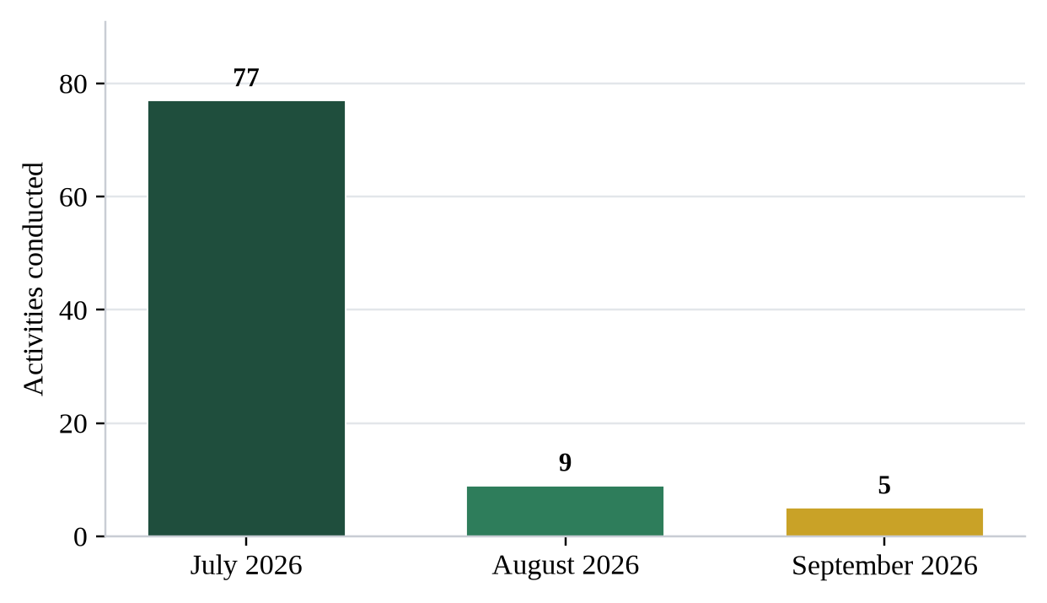
Figure 12. Environmental investigations and monitoring activities by month, EMR Unit, Quarter III 2026
5.2.5.4 Training Conducted by Staff of the ERRS Department
Table 25. Training conducted by staff of the ERRS Department
S/N | Staff / Division facilitating | Training description and summary / host institution
1. | — | —
2. | — | —
 | Total number of trainings conducted | 0

5.2.5.5 Laboratory Accreditation Issued
Table 26. Laboratory accreditation issued, EMR Unit, Quarter III 2026
S/N | Company | Location
1 | MNG Gold Liberia | Bong County
 | Total number of lab accreditation issued | 1

5.2.5.6 Complaints Received
Table 27. Complaints received by the EMR Unit, Quarter III 2026
S/N | Proponent | Location | Nature of complaint
1. | NP Liberia Limited and Fouani Brother corporation | Gardnersville, Japaness Freeway / Montserrado | Environmental contamination investigation at both NP Liberia Limited and Fouani Brother corporation located in the Industrial Park based on a complaint of salt spillage and paticulates causing corrosion on cooking gas stoarge tank
2. | Arcelor Mittal | Bolo town, yekepa, Nimba county | Environmental pollution investigation in, following a complaint about Arcelor Mittal pollution of their waters.
3. | — | White House community in Congo town, Montserrado | Environemntal investigation concerning waste water pollution
4. | — | Gbangay Town Community, Montserrado | Environmental investigation concerning alleged noise pollution
5. | Filed in by Mr. Amara Kamara and some prominent individuals | Puertotorre community in Congo town, Paynesville, Montserrado | Environmental Investigation concerning noise pollution
6. | Filed by the Management of Monroe chicken restaurant. | 3rd street, Sinkor Montserrado | Environmmental investigation concerning Noise pollution
 | Total number of complaints received |  | Six (6)

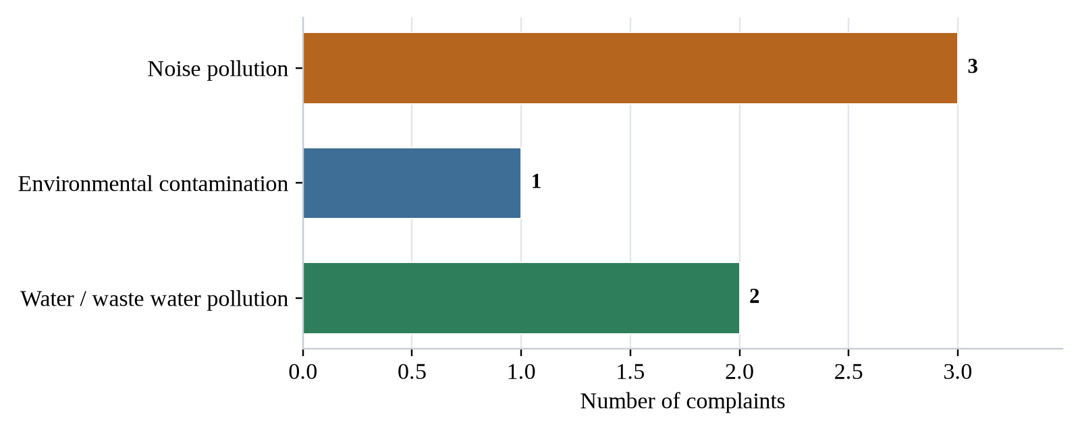
Figure 13. Complaints received by nature of complaint, EMR Unit, Quarter III 2026

5.2.6 Sachet Water Third Quarter Report, July – September 2026
5.2.6.1 Total Applications Received and Responded To
Table 28. Sachet water applications received and responded to, July – September 2026
No. | Facility name | Owner name | Location | Contacts
1 | Darbeh's Water of Luxury | Emmanuel R. Euss | Bushrod Island, Caldwell Township, Benson Street | 0770456274/0888600557
2 | Gee Aqua Mineral Water | Mowoe King | Fish Town City, River Gee County | 0886407542/0777407542
3 | Grekan Safe Drinking Water | Daniel Weah Grekan, Jr. | Gee City, Buah District, Grand Kru County | 775975422
4 | National Toiletry Inc (Renewal) | Fomba V. Trawally | Bernard Farm, Paynesville City | 077973383/0886973383
5 | Rhema Spring Natural Mineral Water (Renewal 2026) | Payma Christopher Quoiquoi | Bloch C, 3rd Street, Christopolis Community | 0880963510/0777536910
6 | Spark Water Liberia, INC. | Amos Torh. Gardt, ll | Rehab Community, Paynesville City | 0777555100/0886758176
7 | Varngarco Mineral Water Factory | Elizabeth Garpue | Gardnerville, Tusa Field Community | 0886997372/0888075203
8 | Bangally Fresh Mineral Water | Bangally Konneh | Greenville City, Sinoe County | 776577305
9 | Big So Purified Water | Mrs. Keibeh Kollie | Caldwell, Montserrado County | 777282969
10 | Cash Purified Drinking Water | Ben T. Payr | Boley-Ville Community Zwedru City, Grand Gedeh | 0775740552 / 0886937740
11 | City Distribution (Inc) | Brendan Davis | Caldwell , New Georgia | 0777990955/0886032006
12 | Creative Mineral Water | Aloysius M. Farley | New Greenville, Murrayville Township, Sinoe C ounty | 770615357
13 | Diamond Lite Mineral Water Compound | Thompson Zogar Manager | Harmon Hills, Tubmanburg Bomi County | 776729888
14 | General Raa Save Mineral Water | Mohammed Rashied Jah | Caldwell True Van, Montserrado County | 772227601
15 | Ma J Mineral Water | Warren H. Cooper Jr. | Grenvill City, Sinoe County | 776577305
16 | National Delivery Services (NDS) Mineral Water | Varlee S. Komala | Bethel Hill Community, Barbesville | 0770492577/0880997500
17 | 2 Real Mineral Water | Qlando Caranda | Greenville City, Sinoe County | 776577305
18 | Sinoe Pure & Safe Mineral Water | Dapae Tweh | Greenville City, Sinoe County | 776577305
19 | Sky Fresh Mineral Water | Mary N. Moses | Jah Tondo Town, Brewerville | 0777325956/0880687547
20 | Solukon International | Rev. Solomon Konbloyon | Foday's Town, Lower Margobo Couty, Liberia | 0777292065/0775592301
21 | National Delivery Services (NDS) Mineral Water | Varlee S. Komala | Bethel Hill Community, Barbesville | 0770492577/0880997500
22 | Eddie & Son Inc | Denise Nyankun | SuperMarket Old Field Gardnersvlle | 0770210848/0886383504
23 | Enzah Spring Water Factory | Moisalah A. Turay | Barnesville,Dukuly Compound, Dabwe Tow, Dry Rice Market | 0881414601/0760288017
24 | Johnnet Trading | Michael K. Sando | Camp Johnson Road | 0886605912/0770350054/0777687936
25 | Natural Spring Mineral Water | Alfred Droe Peter Zodehgar | Kabbah, Barnersville Township, Montserrado County | 776880499
26 | New Liberia Mineral Water | Momo C. Conneh | Caldwell Bridge | 0881181111/0775651775
27 | Saviour Purification Water Inc. | Musu S. Kamara | Benson & Buchanan Street Intersection Monrovia, Liberia | 0775981225/0886828822
28 | Vital Fresh Purified Water | Theodorsia Johnson | Old Road, Gaye Town | 886132488
29 | 2 Real Mineral Water | Qlando Caranda | Greenville City, Sinoe County | 776577305
30 | Eddie & Son Inc | Denise Nyankun | SuperMarket Old Field Gardnersvlle | 0770210848/0886383504
31 | Enzah Spring Water Factory | Moisalah A. Turay | Barnesville,Dukuly Compound, Dabwe Tow, Dry Rice Market | 0881414601/0760288017
32 | Johnnet Trading Incorporated | Michael K. Sando | Camp Johnson Road | 0886605912/0770350054/07 77687936
32 | Natural Spring Mineral Water | Alfred Droe Peter Zodehgar | Kabbah, Barnersville Township, Montserrado County | 776880499
33 | New Liberia Mineral Water | Momo C. Conneh | Caldwell Bridge | 0881181111/0775651775
34 | Saviour Purification Water Inc. | Musu S. Kamara | Benson & Buchanan Street Intersection Monrovia, Liberia | 0775981225/0886828822
35 | Vital Fresh Purified Water | Theodorsia Johnson | Old Road, Gaye Town | 886132488
 | Total applications received and responded to |  |  | Thirty-Five (35)
Note: The serial number 32 appears twice in the source unit report; both entries are reproduced unchanged.
5.2.6.2 Total Response Letters Picked Up
Table 29. Sachet water response letters picked up, July – September 2026
No. | Company name | Location | Comments | Recommendations
1 | Darbeh's Water of Luxury | Bushrod Island, Caldwell Township, Benson Street | Respond letter prepared and picked up | Payment is made, ensure lab analysis is submitted
2 | National Toiletry Inc (Renewal) | Bernard Farm, Paynesville City | Respond letter prepared and picked up | Payment is made, lab analysis is submitted and certificate is printed and picked up and proceed for site verification
3 | Rhema Spring Natural Mineral Water (Renewal 2026) | Bloch C, 3rd Street, Christopolis Community | Respond letter prepared and picked up | To ensure payment is made and lab analysis is submitted
4 | Saviour Purification Water Inc. | Benson & Buchanan Street Intersection Monrovia, Liberia | Respond letter prepared and picked up | To ensure payment is made and lab analysis is submitted
5 | Spark Water Liberia, INC. | Rehab Community, Paynesville City | Respond letter prepared and picked up | Payment is made, lab analysis is done, to ensure certificate is printed out and issued
6 | Varngarco Mineral Water Factory | Gardnerville, Tusa Field Community | Respond letter prepared and picked up | To ensure payment is made and lab analysis is submitted
7 | Bangally Fresh Mineral Water | Greenville City, Sinoe County | Respond letter prepared and picked up | To ensure payment is made and lab analysis submitted
8 | Big So Purified Water | Caldwell, Montserrado County | Respond letter prepared and picked up | To ensure payment is made and lab analysis submitted
9 | Bracco Life Mineral Water Compnay | Brewerville Township, Mounton Comer | Respond letter prepared and picked up | To ensure payment is made and lab analysis submitted
10 | Creative Mineral Water | New Greenville, Murrayville Township, Sinoe C ounty | Respond letter prepared and picked up | To ensure payment is made and lab analysis submitted
11 | General Raa Save Mineral Water | Caldwell True Van, Montserrado County | Respond letter prepared and picked up | To ensure payment is made and lab analysis submitted
12 | Ma J Mineral Water | Grenvill City, Sinoe County | Respond letter prepared and picked up | To ensure payment is made and lab analysis submitted
13 | National Delivery Services (NDS) Mineral Water | Bethel Hill Community, Barbesville | Respond letter prepared and picked up | Payment is made, lab analysis is submitted, certificate is printed and issued, to ensure site verification is conducted
14 | 2 Real Mineral Water | Greenville City, Sinoe County | Respond letter prepared and picked up | To ensure payment is made and lab analysis submitted
15 | Sinoe Pure & Safe Mineral Water | Greenville City, Sinoe County | Respond letter prepared and picked up | To ensure payment is made and lab analysis submitted
16 | Sky Fresh Mineral Water | Jah Tondo Town, Brewerville | Respond letter prepared and picked up | Payment is made, lab analysis is submitted, certificate is printed and issued, to ensure site verification is conducted
17 | Abu Development Initiative (Renewal, 2026) | Logan Town, Briad Stree, Bushord Island | Respond letter prepared and picked up | To ensure payment is made, lab analysis is submitted
18 | City Distribution (Inc) | Caldwell , New Georgia | Respond letter prepared and picked up | Payment is not made, lab analysis is not submitted
19 | Demas Enterprise Inc. | River View Road, Virginia, Montserrado County | Respond letter prepared and picked up | Payment is made, lab analysis is submitted and certificate is printed out but not picked up
20 | Diamond Lite Mineral Water Compound | Harmon Hills, Tubmanburg Bomi County | Respond letter prepared and picked up | To ensure payment is made and lab analysis is submitted
21 | Enzah Spring Water Factory | Barnesville,Dukuly Compound, Dabwe Tow, Dry Rice Market | Respond letter prepared and picked up | To ensure payment is made and lab analysis is submitted
22 | Johnnet Trading Incorporated | Camp Johnson Road | Respond letter prepared and picked up | To ensure payment is made and lab analysis is submitted
23 | Mansa Mineral Water Company | Tyler Island, SKD Boulevard | Respond letter prepared and picked | To ensure payment is made and lab analysis is submitted
24 | Mudasu Safe Drinking Water | Caldwell | Respond letter prepared and picked up | To ensure payment is made and lab analysis is submitted
25 | New Liberia Mineral Water | Caldwell Bridge | Respond letter prepared and picked up | To ensure payment is made and lab analysis is submitted
26 | Vital Fresh Purified Water | Old Road, Gaye Town | Respond letter prepared and picked up | To ensure payment is made and lab analysis is submitted
 | Total response letters picked up |  |  | Twenty-Six (26)

5.2.6.3 Total Applicants That Paid
Table 30. Sachet water applicants that paid, July – September 2026
No. | Company name | Proponent name | Location | Contacts
1 | City Distribution (Inc). | Brendan Davis | Caldwell , New Georgia | 0777990955/0886032006
2 | Darbeh's Water of Luxury | Emmanuel R. Euss | Bushrod Island, Caldwell Township, Benson Street | 0770456274/0888600557
3 | Juslee Aqua | Mannix Kollie | Parker Paint, Wood Camp Paynesville, Liberia | 886644944
4 | National Toiletry Inc. (Renewal 2026) | Fomba V. Trawally | Bernard Farm, Paynesville City | 077973383/0886973384
5 | Original Country Man Pure Mineral Water | Anothony S. Kollie | Caldwell, Montserrado County, Liberia | 776830019
6 | Spark Water Liberia, INC. | Amos Torh. Gardt, ll | Rehab Community, Paynesville City | 0777555100/0886758176
7 | Solukon International | Rev. Solomon Konbloyon | Foday's Town, Lower Margobo Couty, Liberia | 0777292065/0775592301
8 | Vital Fresh Purified Water (Renewal 2026) | Theodorsia Johnson | Old Road, Gaye Town | 886132488
9 | National Delivery Services (NDS) Mineral Water | Varlee S. Komala | Bethel Hill Community, Barbesville | 0770492577/0880997500
10 | Sky Fresh Mineral Water | Mary N. Moses | Jah Tondo Town, Brewerville | 0777325956/0880687547
11 | B & H Mineral Water | Samuel D. Gee | Zwedru City, Grand Gedeh County | 0776421641/0880046723
12 | Demas Enterprise Inc. | Quincy McWilliams | River View Road, Virginia, Montserrado County | 0770240444/0888240444
13 | Eddie & Son Inc | Denise Nyankun | SuperMarket Old Field Gardnersvlle | 0770210848/0886383504
14 | Wologizi Purified Mineral Water | Mayango Saygbay | Zayzay Community, Paynesville | 0776579405/0770501281
 | Total applicants that paid |  |  | Fourteen (14)

5.2.6.4 Total Certificates Printed Out
Table 31. Sachet water certificates printed out, July – September 2026
No. | Company name | Proponent name | Location | Contacts
1 | National Toiletry Inc. (Renewal 2026) | Fomba V. Trawally | Bernard Farm, Paynesville City | 077973383/0886973384
2 | Solukon International | Rev. Solomon Konbloyon | Foday's Town, Lower Margobo Couty, Liberia | 0777292065/0775592301
3 | Vital Fresh Purified Water (Renewal 2026) | Theodorsia Johnson | Old Road, Gaye Town | 0886132488
4 | Aishmar Group Of Companies | Amanda J. Davies | Foday Town, RIA Highway, Margibi County | 0778918419/0887936809
5 | Mekki's Water INC. | Alphonso Tatic Mansary | Barclay Avenue, 14th Street Sinkor | 776404042
6 | National Delivery Services (NDS) Mineral Water | Varlee S. Komala | Bethel Hill Community, Barbesville | 0770492577/0880997500
7 | Sky Fresh Mineral Water | Mary N. Moses | Jah Tondo Town, Brewerville | 0777325956/0880687547
8 | Sweet Life Drinking Water | Aaron T. Fooko | Coffee Farm, Caldwell | 0886229820/0777254069
9 | B & H Mineral Water | Samuel D. Gee | Zwedru City, Grand Gedeh County | 0776421641/0880046723
10 | Demas Enterprise Inc. | Quincy McWilliams | River View Road, Virginia, Montserrado County | 0770240444/0888240444
11 | Wologizi Purified Mineral Water | Mayango Saygbay | Zayzay Community, Paynesville | 0776579405/0770501281
 | Total certificates printed out |  |  | Eleven (11)

5.2.6.5 Total Certificates Issued
Table 32. Sachet water certificates issued, July – September 2026
No. | Company name | Owner name | Location | Contact
1 | Demas Enterprise Inc. | Quincy McWilliams | River View Road, Virginia, Montserrado County | 0770240444/0888240444
2 | National Toiletry Inc. (Renewal 2026) | Fomba V. Trawally | Bernard Farm, Paynesville City | 077973383/0886973384
3 | Aquagee Pure Water | David Wolobah | Samuel K. Doe Road, Bernard Farm, Paynesville, Liberia | 0778918419/0887936809
4 | Blue Source Water Company | Marbu F. Neal | G4 Avenue 11 St, Brewerville, Virgina | 0776421641/0880046723
5 | Foya Natural Mineral Water | Bill P. Borbor | Police Academy, Paynesville | 0776145018/0880243118
6 | Mekki's Water INC. | Alphonso Tatic Mansary | Barclay Avenue, 14th Street Sinkor | 0778918419/0887936809
7 | National Delivery Services (NDS) Mineral Water | Varlee S. Komala | Bethel Hill Community, Barbesville | 0776421641/0880046723
8 | Sweet For Liberia Mineral Water | Korvah G. Flomo | Duport Road, Opposit Christ Embassy, | 0776145018/0880243118
9 | Aishmar Group Of Companies | Amanda J. Davies | Foday Town, RIA Highway, Margibi County | 0778918419/0887936809
10 | B & H Mineral Water | Samuel D. Gee | Zwedru City, Grand Gedeh County | 0776421641/0880046723
11 | Pure H20 Purified Water | Mr. Johnny S. Chowoe | Wein Town, Margibi County, Liberia | 0776145018/0880243118
 | Total certificates issued |  |  | Eleven (11)

5.2.6.6 Total Lab Results Received
Table 33. Sachet water laboratory results received, July – September 2026
No. | Company name | Owner’s name | Location
1 | Juslee Aqua | Mannix Kollie | Parker Paint, Wood Camp Paynesville, Liberia
2 | National Toiletry Inc. (Renewal 2026) | Fomba V. Trawally | Bernard Farm, Paynesville City
3 | Spark Water Liberia, INC. | Amos Torh. Gardt, ll | Rehab Community, Paynesville City
4 | Solukon International | Rev. Solomon Konbloyon | Foday's Town, Lower Margobo Couty,
5 | Vital Fresh Purified Water (Renewal 2026) | Theodorsia Johnson | Old Road, Gaye Town
6 | Aquagee Pure Water | Mannix Kollie | Samuel K. Doe Road, Bernard Farm, Paynesville
7 | Blue Source Water Company | Fomba V. Trawally | G4 Avenue 11 St, Brewerville, Virgina
8 | Foya Natural Mineral Water | Amos Torh. Gardt, ll | Police Academy, Paynesville
9 | Mekki's Water INC. | Rev. Solomon Konbloyon | Barclay Avenue, 14th Street Sinkor
10 | National Delivery Services (NDS) Mineral Water | Theodorsia Johnson | Bethel Hill Community, Barbesville
11 | Sweet For Liberia Mineral Water | Mannix Kollie | Duport Road, Opposit Christ Embassy, Paynesville
12 | Aquagee Pure Water | David Wolobah | Samuel K. Doe Road, Bernard Farm, Paynesville, Liberia
13 | Blue Source Water Company | Marbu F. Neal | G4 Avenue 11 St, Brewerville, Virgina
14 | Foya Natural Mineral Water | Bill P. Borbor | Police Academy, Paynesville
15 | Mekki's Water INC. | Alphonso Tatic Mansary | Barclay Avenue, 14th Street Sinkor
16 | National Delivery Services (NDS) Mineral Water | Varlee S. Komala | Bethel Hill Community, Barbesville
17 | Sweet For Liberia Mineral Water | Korvah G. Flomo | Duport Road, Opposit Christ Embassy,
18 | B & H Mineral Water | Samuel D. Gee | Zwedru City, Grand Gedeh County
19 | Demas Enterprise Inc. | Quincy McWilliams | River View Road, Virginia, Montserrado County
 | Total lab results received |  | Ninteen (19)

5.2.6.7 Total Site Verifications
Table 34. Sachet water site verifications, July – September 2026
No. | Proponent name | Location
— | — | —
 | Total sites verification | One (0)
Note: Total reproduced exactly as stated in the source unit report.
5.2.6.8 Summary of Sachet Water Activities
Table 35. Summary of sachet water activities, EMR Unit, Quarter III 2026
Activity | Frequency
Total Application Letters Received | 35
Total Application Responded To | 35
Total Response Letters Issued | 26
Total Applicants that Paid | 14
Total Sites Verification | 0
Total Labs Conducted | 19
Total Certificate Printed Out | 11
Total Certificate Issued | 11
Total Amount | $3,150

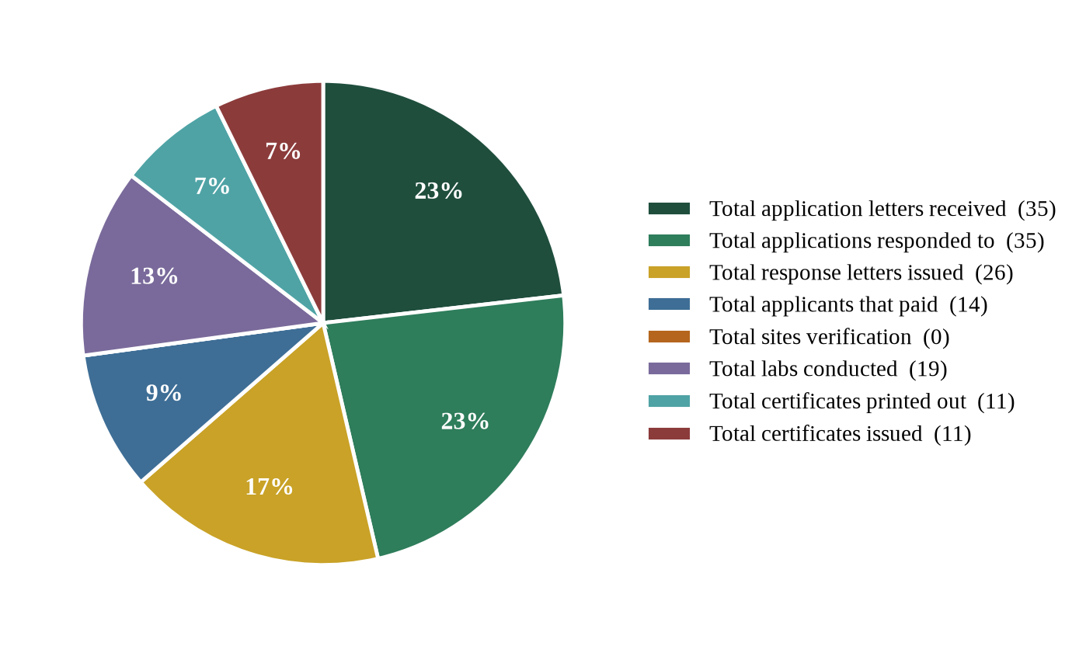
Figure 14. Sachet water certification workflow, EMR Unit, Quarter III 2026
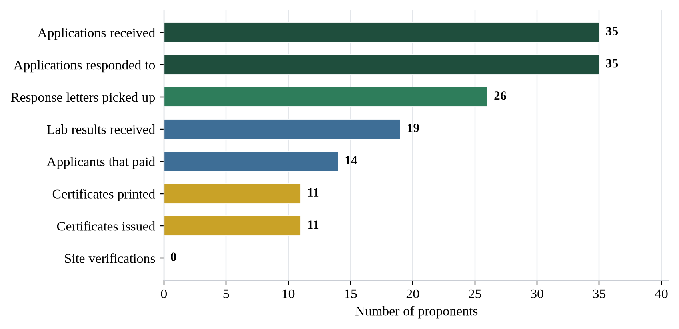
Figure 15. Sachet water certification pipeline, EMR Unit, Quarter III 2026

5.2.7 Laboratory Analysis Conducted During July – September 2026
Activities description: laboratory analysis conducted and parameters analyzed for:
Table 36. Laboratory analyses conducted, EMR Unit, July – September 2026
No. | Date | Samples and location | Parameters analyzed
1 | July 27, 2026 | Two (2) surface water samples from Kinjor, Grand Cape Mount County | PH, ORP, EC, TDS, Salinity, and Turbidity, sulfate, cyanide, Iron, Nitrate, Copper.
2 | August 11, 2026 | Two (2) surface water samples and one (1) ground water sample from the Monrovia Industrial Pack, LPRC Community, Gardnesville | PH, ORP, EC, TDS, Salinity, and Temperature, Turbidity, sulfate, Chlorine and Bromine.
3 | August 17, 2026 | Eight (8) surface water samples and one (1) ground water from Bolo town, Arcelor Mittal Liberia, Nimba County | PH, EC, ORP, Salinity, TDS, Turbidity, Zinc, Nitrite, Chromium, Iron, Copper, Ammonia and Nitrate.
4 | August 25, 2026 | Two (2) surface water samples and seven (7) ground water samples from Bea Mountain, Kinjor, Grand Cape Mount County | PH, EC, ORP, Salinity, TDS, and Temperature.
5 | August 28, 2026 | Two (2) ground water samples from Golden Loaf Artisanal Bakery, Airfield Shark Junction | PH, EC, Salinity, Turbidity, TDS, and Temperature.
6 | September 02, 2026 | One (1) surface water sample from Monrovia Club Breweries sludge pit, Montserrado County | PH, ORP, EC, TDS, Salinity, and Temperature.

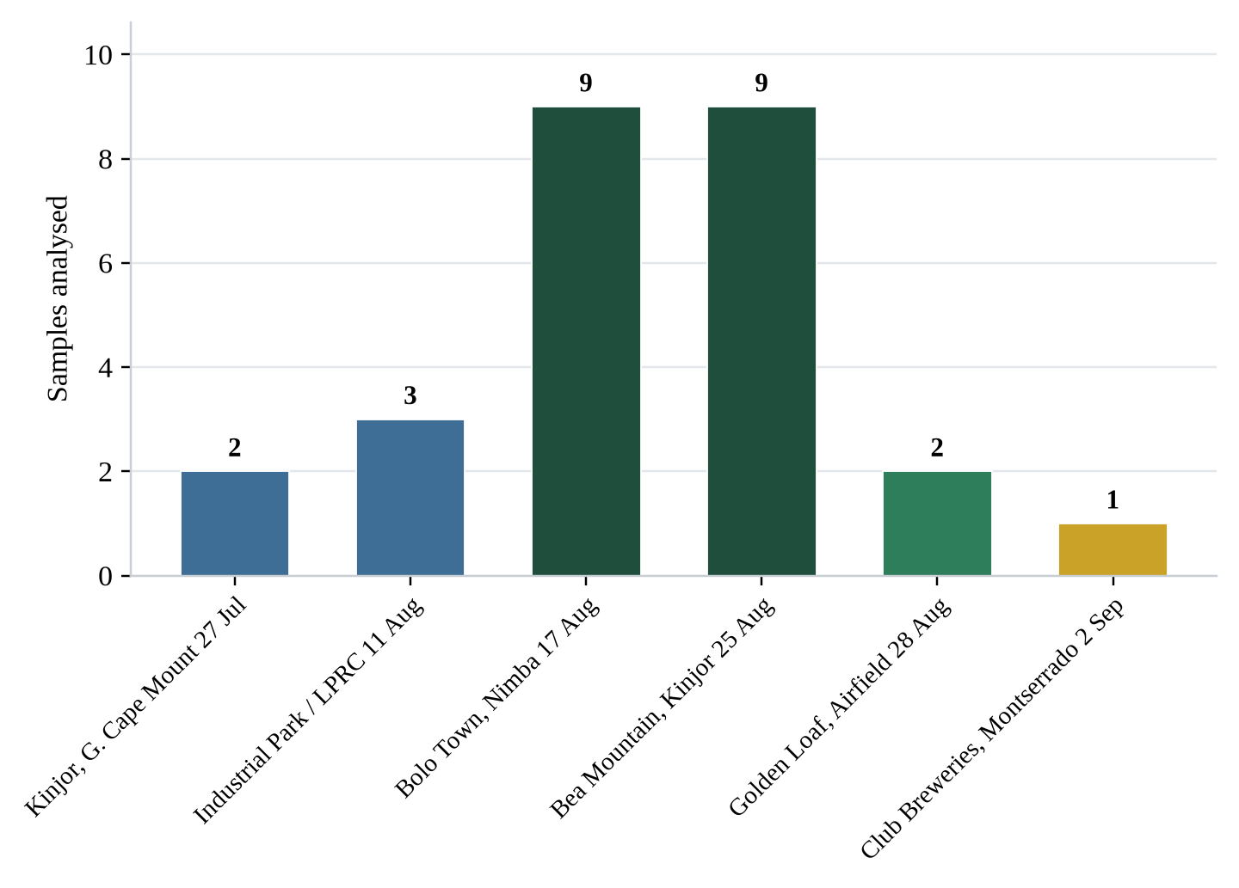
Figure 16. Samples analysed per laboratory exercise, EMR Unit, Quarter III 2026

5.2.8 Laboratory Accreditation — Third Quarter Report (July – September)
Table 37. Laboratory accreditation record, EMR Unit, Quarter III 2026
Field | Record
No. | 1
Proponent name | MNG Gold Mine
Address | Congo town, Tubman boulevard
Contact person | Cem Aktay
Contact number | 0776330358 / 0886526019
No. of sites | 1
Application date | 12/08/2026
Response date | 17/08/2026
Amount paid (USD) | 2,525.00
Receipt no. | 4789
Payment date | 07/09/2026
Certification date | 07/09/2026
Expiration date | 06/09/2026
Note: All values reproduced exactly as recorded in the source unit report.
5.2.8.1 Administrative Notes
- Application Date: Date the written application/expression of interest is officially received.
- Response Date: Date of EPA/ERRS formal response to the proponent.
- Amount Paid, Receipt No. and Payment Date: Verify against the official payment/financial record.
- Certification Date: Date the accreditation certificate is issued.
- Expiration Date: Date the accreditation certificate expires in accordance with the approved validity period.

5.2.9 Third Quarter Surveillance Reports
5.2.9.1 Summary of the Third Quarter, 2026
- Total number of reports received = 26
- Diseases or events reported = Water Quality; Soil Quality; Air Quality
- Total number of reporting site/proponents = 40
- Number of reporting site/proponents that did not report = n/a

5.2.9.2 Summary of July, 2026
- Total number of reports received = 7
- Diseases or events reported = Water Quality; Soil Quality; Air Quality
- Total number of reporting site/proponents = 9
- Number of reporting site/proponents that did not report = n/a

Table 38. Water quality — timeliness and completeness of reporting by companies, July 2026
No. | Reporting proponents | Current monthly  (Timeliness) | Current monthly  (Completeness) | % Cumulative  timeliness | % Cumulative  completeness
1 | Sethi Ferro Fabrik | L | 100% | 50% | 75%
2 | Cavalla Resources Liberia INC-Geo Fantro | T | 100% | 100% | 100%
3 | Cavalla Resources Liberia Inc-Kitoma | T | 100% | 100% | 100%
4 | Rainbow Paint Factory | T | 100% | 100% | 100%
5 | BUMU International Liberia INC | L | 100% | 50% | 75%
6 | Atlantic Shipping Liberia Company Limited Incorporated | L | 100% | 50% | 75%
7 | International Aluminium Factory | T | 100% | 100% | 100%
8 | International Aluminium Factory | T | 100% | 100% | 100%
9 | Golden SIFCA Incorporated | L | 100% | 50% | 75%

Table 39. Legend — reporting timeliness and completeness classification
Classification | Code | Cumulative performance band | Range
On time | T | ≥ 80% on time / complete | High
Late | L | ≥ 50 – 79.9% on time / complete | Moderate
No report received | NR | < 50% on time / complete | Low

Table 40. Soil quality — timeliness and completeness of reporting by companies, July 2026
No. | Reporting proponents | Current monthly  (Timeliness) | Current monthly  (Completeness) | % Cumulative  timeliness | % Cumulative  completeness
1 | Sethi Ferro Fabrik | NR | 0% | 0% | 0%
2 | Cavalla Resources Liberia INC-Geo Fantro | T | 100% | 100% | 100%
3 | Cavalla Resources Liberia Inc-Kitoma | T | 100% | 100% | 100%
4 | Rainbow Paint Factory | T | 100% | 100% | 100%
5 | BUMU International Liberia INC | NR | 0% | 0% | 0%
6 | Atlantic Shipping Liberia Company Limited Incorporated | L | 100% | 50% | 75%
7 | International Aluminium Factory | T | 100% | 100% | 100%
8 | International Aluminium Factory | NR | 0% | 0% | 0%
9 | Golden SIFCA Incorporated | L | 100% | 50% | 75%

Table 41. Summary of water, soil and air quality analysis reported by each proponent to EPA-Liberia for July, 2026
 | Water Quality |  |  |  | Air Quality |  |  |  |  | Soil Quality
Company | pH | SS | NH₄ | NO₃ | CO | CO₂ | NO₂ | VOC | PM2.5 | pH | NO₂ | NO₃ | NH₄ | CEC
Permissible range / limit | 6.5–8.0 | ≤ 10.0  (mg/l) | ≤ 1.0  (mg/l) | ≤ 40.0  (mg/l) | 50  (ppm) | 350–1000  (ppm) | 5  (ppm) | 0.6–1.0  (ppm) | 10 | n/a | n/a | n/a | n/a | n/a
Sethi Ferro Fabrik | 7.07 | 8.57 | n/a | 0.48 | 165 | 421 | 1.65 | n/a | 12.1 | NR | NR | NR | NR | NR
Cavalla Resources Liberia INC-Geo Fantro | 6.5 | n/a | 0.01 | 0.735 | NR | NR | NR | NR | NR | 4.75 | n/a | n/a | n/a | 4.5
Cavalla Resources Liberia Inc-Kitoma | <0.05 | n/a | 0.15 | 0.543 | NR | NR | NR | NR | NR | 4.43 | n/a | n/a | n/a | 7.1
Rainbow Paint Factory | 7.18 | 0.43 | n/a | 0.003 | 16 | 178.5 | 1.7 | n/a | 5.25 | 5.88 | n/a | n/a | n/a | n/a
BUMU International Liberia INC | 7.3 | n/a | n/a | 2.6 | n/a | 46.2 | 0.35 | 0.056 | 17 | NR | — | NR | NR | NR
Atlantic Shipping Liberia Company Limited Incorporated | 7.35 | 9.27 | n/a | 0.5 | 5 | 5.25 | 0.03 | 0.001 | 4.67 | 6.56 | 0.45 | n/a | n/a | 48.3
International Aluminium Factory | 7.25 | n/a | n/a | 0.4 | 482.25 | 5.15 | n/a | 0.08 | 6.55 | 5.52 | n/a | n/a | n/a | 110.2
International Aluminium Factory | 7.25 | n/a | n/a | 0.4 | 11 | 540.4 | 0.006 | <0.001 | 5.29 | NR | NR | NR | NR | NR
Golden SIFCA Incorporated | 6.84 | 9.21 | n/a | 0.45 | 20.3 | 430 | 0.68 | n/a | 6.65 | 6.38 | <0.001 | n/a | n/a | <0.001
Note: NR = acceptable/normal range; SS = Suspended Solids; NH₄ = Ammonia; NO₂ = Nitrate; NO₃ = Nitrite; CO = Carbon monoxide; CO₂ = Carbon dioxide; VOC = Volatile. Values are reproduced as reported by each proponent.

5.2.9.3 Summary of August 2026
- Total number of reports received = 11
- Diseases or events reported = Water Quality; Soil Quality; Air Quality
- Total number of reporting site/proponents = 17
- Number of reporting site/proponents that did not report = n/a

Table 42. Water quality — timeliness and completeness of reporting by companies/proponents, August 2026
No. | Reporting proponents | Current monthly  (Timeliness) | Current monthly  (Completeness) | % Cumulative  timeliness | % Cumulative  completeness
1 | Bea Mountain Mining Corp, Ndablama | L | 100% | 50% | 75%
2 | Star Ready Mix Concrete Corporation | L | 100% | 50% | 75%
3 | Bea Mountain Mining Corp, Matambo Project area | L | 100% | 50% | 75%
4 | Bea Mountain Mining Corp, Weajue | L | 100% | 50% | 75%
5 | Bea Mountain Mining Corp. New Liberty Gold mine | L | 100% | 50% | 75%
6 | MNG Gold Mine | T | 100% | 100% | 100%
7 | Liberia Agriculture Company | L | 100% | 50% | 75%
8 | Krish Veneer Industries Inc. | T | 100% | 100% | 100%
9 | RM group INC | T | 100% | 100% | 100%
10 | Cheema and Chahal (C & C) INC | L | 100% | 50% | 100%
11 | Mano Palm Oil Industries | T | 100% | 100% | 100%
12 | B & B Rubber Factory | L | 100% | 50% | 75%
13 | Modern Oil Factory | L | 100% | 50% | 75%
14 | Pan Oxygen Factory | T | 100% | 100% | 100%

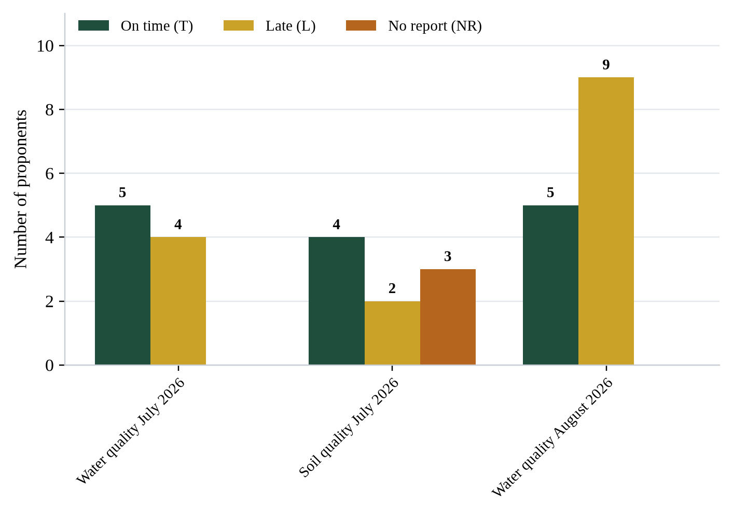
Figure 17. Timeliness of proponent reporting to the EMR Unit, Quarter III 2026

5.2.10 Outstanding Surveillance Returns
PENDING — EMRU SURVEILLANCE RETURNS FOR QUARTER III 2026
• September 2026 monthly surveillance summary and reporting-quality tables (water, soil and air) were not included in the source submission.
• Air quality timeliness and completeness tables for July and August 2026, equivalent to Tables 39, 46 and 53 of the Second Quarter Report 2026, were not provided.
• Soil quality timeliness and completeness table for August 2026 was not provided.
• Site-specific water quality results tables, equivalent to Tables 28–34 of the Second Quarter Report 2026, were not provided; the source report lists the laboratory exercises and the parameters analysed but not the measured values.
• Summary of water, soil and air quality analysis reported by each proponent for August and September 2026.

5.3 Radiation Safety Unit (RSU)

5.3.1 Report Particulars
Table 43. Radiation Safety Unit — report particulars
Description | Detail
Report title | Radiation Safety Unit Report (Quarter III)
Date | September 28, 2026
Reporting period | Quarter III (July – September 2026)
Reporting quarter | Quarter III, 2026
Director of the Department | Mr. Rafael S. Ngumbu, Sr.
Contact number | 0775764953
Email | rngumbu@epa.gov.lr / rafaelngumbu@yahoo.com

5.3.2 Unit Staff
Table 44. Radiation Safety Unit staff
Name | Position
Varney Evanson Armah | Assistant Director, RSU
Mildred Chuka Piah | Radiation Safety Laboratory Supervisor
Amula B. Dorley | Radiation Safety Laboratory Technician, Medical and Industrial (pending)
Abubakar Jawo | Radiation Safety Laboratory Technician, Medical and Industrial (pending)
Korpo F. Kollie | Support Staff

5.3.3 Summary of the Unit’s Responsibilities
The Radiation Safety Unit is charged with the responsibility of coordinating and driving every activity related to Importation, Exportation, Possess, Use, Transfer, Disposal, and Monitoring of radiation sources within the country. The Unit, through the Department of Environmental Research and Radiation Safety, documents and reports Regulatory Information of Interest to External Parties (e.g., the International Atomic Energy Agency, AFRA) as part of the country’s international obligations.
The responsibilities of the Unit are as follows:
- To coordinate the drafting, finalization, and validation of the Radiation/Nuclear Law of Liberia.
- Conduct Inspection of radiation sources.
- To conduct a Nationwide Radiation source inventory at medical and industrial facilities.
- To document the Radiation sources inventory data for the status and location of sources throughout the country.
- To conduct basic occupational radiation safety and protection training for operators of radiation-generating devices/sources in medical and industrial activities involving the use of ionizing radiation.
- To prepare and to issue licenses for institutions possessing radiation-generating devices/sources.
- To update Liberia’s RASIMS database for reporting to the country’s Technical Officer at IAEA.
- To integrate data and document information of sub-projects coordinated by various counterparts within the Agency.

5.3.4 Outstanding Achievements During Quarter III of 2026 Under Review
- Attended the IAEA Fellowship on Notification and Authorization in Ethiopia, July 1–31, 2026
- Prepared Licenses for applicants
- Prepared and sent non-compliance notices to facilities operating radiation-emitting equipment
- Attended the IAEA Fellowship on Inspection and Enforcement in Tanzania, August 1–31, 2026
- Participated in the Regional Training on Radiation Protection in the Context of Non-Medical Human Imaging, Inspection Devices and Consumer Products in Dar Es Salaam, Tanzania, from July 20–24, 2026
- Drafted several regulatory documents (Inspection Manual, Guidelines for operating imaging equipment, and five (05) Inspection Checklists)
- Calibrated equipment of the Radiation Safety Lab (survey meters, IdentiFinder)
- Organized and held the Validation Program for the Draft Radiation Safety Law
- Resolved issues with the RAIS system with support from the IAEA
- Participated in the Africa CDC/One Health Workshop on the Development of Liberia National Laboratory Policy & Strategic Plan (2026–2030) (one person)
- Participated in the Advanced QuickBooks Training for Finance Staff (one person)
- Held meetings with applicants and licensees to discuss non-compliance issues
- Participated in several site verification visits organized by the ESIA
- Reviewed and responded to applications for radiation licenses
- Identified Health and Industrial facilities for inspection and inventory
- Sent follow-up communications to facilities that have not completed the licensing process
- Prepared and followed up on the requests of the Unit
- Updated a database for facilities with radiation sources
- Updated the Communication Database of the Unit
- Participated in several ESIA Technical Review Sittings.
- Prepared the Unit’s quarterly report

5.3.5 RSU Activities During Quarter III of 2026
5.3.5.1 Radiation Bills Issued
Table 45. Radiation bills issued, RSU, Quarter III 2026
No. | Institution | Location
1 | BMMC | New Liberty Gold Mine, Grand Cape Mount County, Liberia.
2 | Jahmale Medical Solutions | AB Tolbert Road, ELWA Junction, Paynesville City
3 | SDA Cooper Hospital | 12th Street, Sinkor
4 | Capital Link | Buchanan, Grand Bassa County

5.3.5.2 Radiation Licenses Issued
Table 46. Radiation licenses issued, RSU, Quarter III 2026
Institution | Type of licenses | Number of licenses
Bea Mountain Mining Corporation (BMMC) | Importation Licenses | 7
AMI Expeditionary Health Care | Possess and Use Licenses | 1
ArcelorMittal | Possess and Use | 2
Total |  | 10

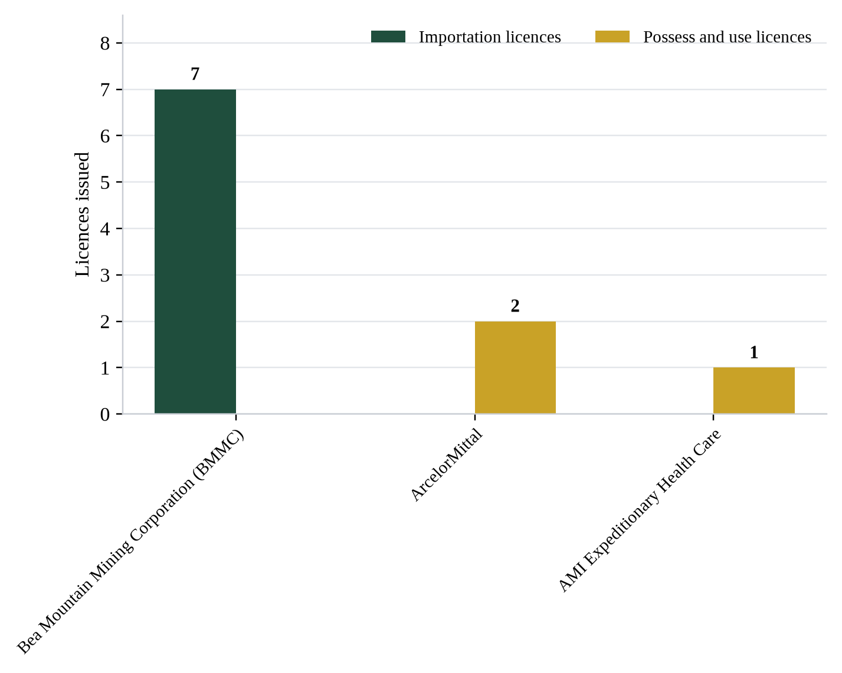
Figure 18. Radiation licenses issued by institution and type, RSU, Quarter III 2026
5.3.5.3 National Basic Occupational Radiation Safety and Protection Training
Table 47. National basic occupational radiation safety and protection training, RSU, Quarter III 2026
Institution | Number of persons trained | Location | Date
None | – | — | –

5.3.5.4 Environmental, Industrial and Medical Radiation Facilities Inspected
Table 48. Environmental, industrial and medical radiation facilities inspected in Quarter III, 2026
Facility name and location | Facility type | Date
— | — | —
Note: No entries were recorded against this table in the source unit report.
5.3.5.5 Medical and Industrial Facilities Inventoried
Table 49. Medical and industrial facilities inventoried during Quarter III, 2026
Facility’s name and location | Facility type | Date
— | — | —
Note: No entries were recorded against this table in the source unit report.
5.3.5.6 Staff Trained During Quarter III 2026
Table 50. Staff trained during Quarter III 2026, RSU
S/N | Name of staff | Location | Category
1. | Varney E. Armah | Ethiopia | In-person
2. | Mildred Chuka Piah | Tanzania | In-person
3. | Abubakar Jawo | Tanzania | In-person

5.3.5.7 Summary of Major Activities
Table 51. Summary of major activities, RSU, Quarter III 2026
Category | 2026  (Quarter III) | Annual target  (2026) | Total completed | Percentage completed (%)
Number of Medical facilities inventoried | 0 | 50 | 7 | —
Number of industrial facilities inventoried | 0 | — | 0 | —
Number of Mining Radiation Monitoring and Inventories | 0 | — | 4 | —
Number of operators/radiographers trained | 0 | 50 | 0 | 0%
Number of trained persons under personnel monitoring | 0 | 50 | 0 | 0%
Number of Publications | 0 | 2 | 0 | 0%
Number of Internal Training(s) Conducted | 0 | N/A | 0 | –
Number of Bills issued | 4 | N/A | 5 | –
Number of Radiation Importation License(s) issued | 7 | N/A | 7 | –
Number of Radiation Possess & Use License(s) issued | 3 | N/A | 3 | –
Note: Cells shown as — were left blank in the source unit report.
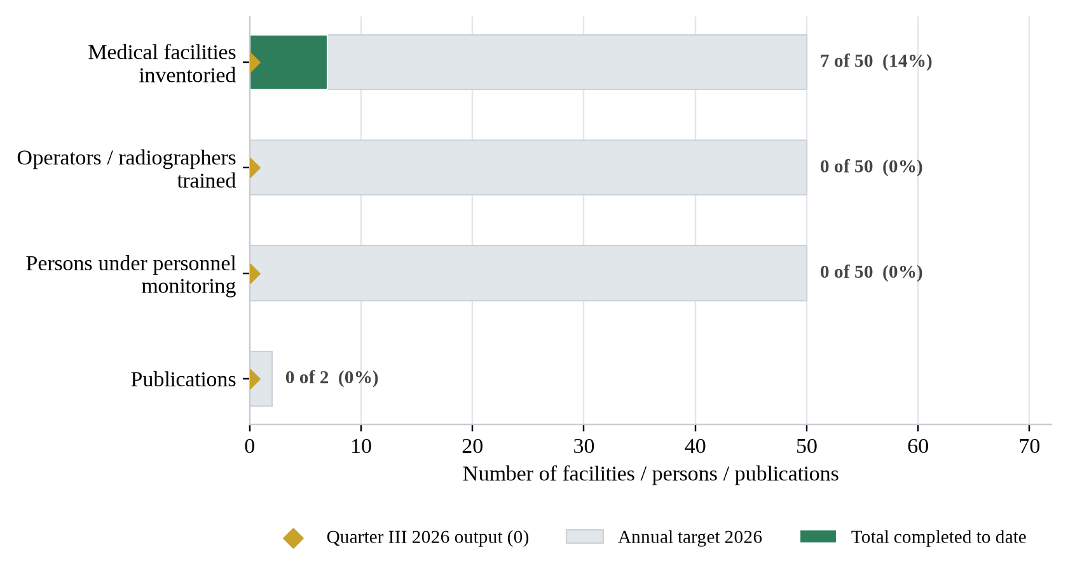
Figure 19. Quarter III output against annual targets, RSU, 2026
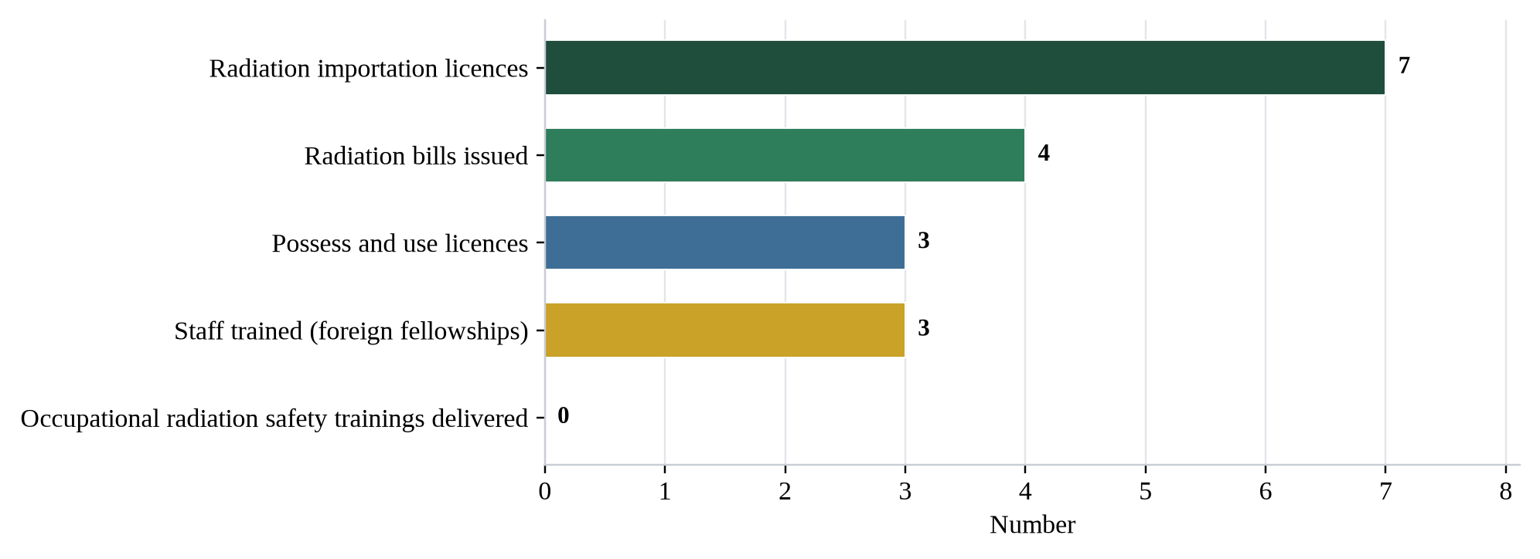
Figure 20. Regulatory output of the Radiation Safety Unit, Quarter III 2026

5.4 Waste and Remediation Unit (WRU)

5.4.1 Report Particulars
Table 52. Waste and Remediation Unit — report particulars
Description | Detail
Reporting unit | Waste and Remediation Unit (WRU)
Date | September 29, 2026
Reporting period | July – September 2026
Head of Unit | Margaret M. Beyslow
Contact number | 0886957001 / 0770958385
Email | mbeyslow@epa.gov.lr

5.4.2 Summary of the Unit’s Mandates
The Waste and Remediation Unit (WRU) is a Unit of the Department of Environmental Research and Radiation Safety, charged with the responsibility of developing environmental regulation, guidelines, Safety and standards which help turn the goal of environmental protection into quantified and enforceable laws. The unit conducts scientific analyses to validate adherence or conform to regulation, guidelines and standards as defined by the regulative instruments. WRU also oversees environmental regulations related to waste, pollution and pollution sources to assess and control the impact of pollutants on the environment.
The WR Unit is headed by an Assistant Director.

5.4.3 Department Strategic Goals
The WR Unit work to support the Department of Environmental Research and Radiation Safety in achieving the cardinal two strategy goals amongst others developed from the eight (8) strategy goals of the EPA.
- Goal 1. Developing and enforcing Environmental Laws, Regulations and Guidelines
- Goal 2. Ensuring effective Environmental Monitoring, audit and evaluation.

5.4.4 Outstanding Achievements During the Quarter Under Review
- Ongoing assessment of waste service providers’ facilities.
- Contributed to multiple Environmental and Social Impact Assessment (ESIA) site verification exercises arising from technical review sittings, ensuring compliance with environmental standards and regulatory requirements.
- Participated in a three (3) days validation and technical session, Stakeholders Mobilization, Sectoral engagement and GHG Data Collection.
- Participated in the seventh meeting of the Expert Working Group on the review of annexes II, held in Geneva, Switzerland.
- Participated in the International World Ozone’s Day’s activities held in Buchana.
- Conducted a scoping mission on waste management and the Circular Economy in collaboration with the UNOSD and the Korean Environment Corporation, including a one day workshop on waste.
- Attended Five (5) days training workshop organized by the Liberia Water and Sewer Corporation (LWSC).
- Attended the RAP Verification.
- Participated in the 2026 Green Solution Support Program and Jeju international Environment forum in Korea.
- Participated in the seventh edition of KNOW YOUR ENVIRONMENT (KYE) organized by Planning And Policy.
- Regular follow-ups through phone calls to proponents for response letters.
- Participated in ESIA meetings and consultation activities.
- Prepared responses and certificate of accreditation for Waste companies.

5.4.5 Applications Received During the Quarter
Table 53. Waste management applications received, July 2026
No. | Company name | Undertaking
1. | Dumpa Hero Inc. | Non-Hazardous (municipal)
2. | Sylvester Toe sanitation Service | Non-Hazardous (Municipal)
3. | Divine Sanitation Services Inc. | Non-Hazardous (Municipal)

Table 54. Waste management applications received, August 2026
No. | Company name | Undertaking
1. | ARK Group of Companies | Non-Hazardous (municipal)
2. | Vision Care Cleaners Business Incorporation | Non-Hazardous (Municipal)
3. | Number Group of Companies | Hazardous (Scraps and Plastic)
4. | Eco-Green Environmental & Waste Solution | Hazardous (Medical)
5. | Z.L Integrated Waste Management Solution | Non-Hazardous (Municipal)
6. | S.S.W Incorporated | Hazardous (Scrap, Used Tires, Used Batteries, Used Cables)
7. | Eco-Clean Liberia Inc | Request for Acquaintance Meeting

Table 55. Waste management applications received, September 2026
No. | Company name | Undertaking
1. | JEMB Inc. | Non-Hazardous (municipal)
2. | AM Public Sanitation Service | Non-Hazardous (municipal)
3. | GIVO Africa | Hazardous (Plastic)
4. | Libra Sanitation Incorporated | Hazardous (Sewage)
5. | Environmental Service Enterprise | Non-Hazardous (Municipal)
6. | OCEANS | Non-Hazardous (Municipal)
7. | T. K Group of Companies | Non-Hazardous (Municipal)

5.4.6 Applications Responded To
Table 56. Waste management applications responded to, Quarter III 2026
No. | Company name | Location / undertaking
1. | JEMB Inc. | Non-Hazardous (municipal)
2. | AM Public Sanitation Service | Non-Hazardous (Municipal)
3. | ARK Group of Companies | Non-Hazardous (Municipal)
4. | GIVO Africa | Hazardous (Plastic)
5. | Libra Sanitation Incorporated | Hazardous (Sewage)
6. | Environmental Service Enterprise | Non-Hazardous (Municipal)
7. | Dumpa Hero Inc. | Non-Hazardous (Municipal)
8. | Sylvester Toe Sanitation Service | Non-Hazardous (Municipal) N
9. | Vision Care Cleaners Business Incorporation | Non-Hazardous (Municipal)
10. | WORK-LIBERIA Group of Companies | Hazardous (Scrap, Used Tires, Used batteries)
11. | North Star Industrial Inc. | Hazardous (Scraps)
12. | Number Group of Companies | Non-Hazardous (Scrap and Plastic)
13. | Divine Sanitation Services Inc. | Non-Hazardous (Municipal)
14. | OCEANS | Non-Hazardous (Municipal)
15. | T. K Group of Companies | Non-Hazardous (Municipal)
 | Total applications responded to | 15
Note: Reproduced as recorded in the source unit report, including the stray character against serial 8 and the classification of Number Group of Companies, which is listed as hazardous on receipt of the application and as non-hazardous in the response table.

5.4.7 Waste Certificates Issued
Table 57. Waste certificates issued, Quarter III 2026
No. | Company | Location / classification
1. | North Star Industrial Inc. | Hazardous (Scraps) Battery Factory, Somalia Drive
2. | Numbers Group Of Companies | New Town Community Upper Johnson
3. | Universal Impex Inc. | Hazardous (Scrap)
4. | GIGAS Waste Management | Hazardous (Used tires, used filters, Used Batteries) Morris Farm Paynesville
 | Total certificates issued | 4

Kindly note that there are several requests for permit that have been responded to but the proponents are yet to come to compliance.

6. Challenges

6.1 Chemical Management Unit (CMU)
- Lack of Personal Protective Equipment (PPE): chemical handlers should be provided with the necessary personal protective equipment to guarantee their safety and compliance with occupational health and safety regulations.
- Inadequate workspace furniture: the current workspace available to the Unit and the ERRS Department at large is adequate but lacks better furniture. Due to this, the team has not been able to properly organize its documents and equipment to perform their activities in the Unit.
- Free Port implementation setbacks: the Unit is experiencing setbacks in the effective implementation of its duties at the Free Port of Monrovia, due to the proposed training that is yet to be conducted by the National Port Authority (NPA).

6.2 Environmental Monitoring and Research Unit (EMRU)
Key challenges faced by the unit during the quarter include, but are not limited to:
- Monitoring activities are delayed due to poor road conditions, limited logistics, and reliance on a personal low-clearance vehicle, which restricts access to sites, slows field operations, and poses safety and equipment risks.
- Proponent engagement remains low, with late and partially compliant report submissions, weakening report tracking, and reducing the value of data for timely decision-making.
- Key environmental parameters (NO₃, Co, NH₄, PM2.5, and consistent pH) are frequently missing, alongside variable compliance with national standards and EPA benchmarks—highlighting gaps in technical capacity, supervision, and enforcement.
- Assigning police personnel during site verifications is recommended to strengthen compliance and support smooth field operations.

We request that the administration address some of these constraints.

6.2.1 Lessons Learned
The delegation of tasks has strengthened accountability and responsibility within the team, thereby improving overall performance. This focused approach has enhanced staff morale and reinforced the mission of the ERRS Department. Consequently, unit personnel have developed a comprehensive work plan outlining strategic interventions to advance the EPA’s growth and development.
Nevertheless, the unit’s challenges underscore the pressing need for adequate resources and institutional support for environmental management and analytical functions. Delays in inspections, shortages of critical laboratory reagents and equipment, and insufficient logistical support have constrained the unit’s operational effectiveness. These limitations compromise the timeliness and accuracy of environmental assessments and impede the unit’s capacity to address emerging environmental issues.

6.3 Radiation Safety Unit (RSU)
- Insufficient number of vehicles for the ERRS department to conduct inventory and inspections at facilities possessing radiation-generating devices/sources in the counties.
- Delay in the publication of the draft Regulation to support and affirm full regulatory activities.
- Inadequacy of training for RSU staff in the operation of the RADKOR Dosimetry System for personnel dose assessment and reporting.
- Insufficient training in the use of RASIMS to report on the country’s TSAs. Full establishment of regulatory control to designate responsibilities for reporting internally (nationally).
- Insufficiency in the number of competent staff within the Unit.

6.4 Waste and Remediation Unit (WRU)
- Limited logistics: lack of computers, vehicles and fuel for fieldwork.
- The Unit does not have a functional printer.
- Insufficient staffing to meet workload demands.
- Lack of scratch cards to communicate with proponents and amongst staffs.
- Delay in processing documentation from receipt to certification.

Lessons Learned
- The unit is squarely positioned as a powerhouse in the department of ERRS.
- Better reporting and communication of activities significantly enhance the agency’s ability to meet its mandate. The WR unit plays a pivotal role in supporting environmental protection and compliance.

7. Recommendations

7.1 Chemical Management Unit (CMU)
The Unit recommends the following:
- The provision of PPE for chemical handlers to mitigate risks associated with chemical exposure and enhance the overall safety standards within the unit's operations.
- Improve interdepartmental and unit coordination and collaborations.

7.2 Environmental Monitoring and Research Unit (EMRU)
To address these challenges and enhance the unit's efficacy, the following recommendations are proposed:
- Strengthen reporting compliance through clear deadlines, legal enforcement, and structured follow-up for late submissions.
- Mandate complete parameter reporting, with emphasis on NO₃ and consistent pH monitoring across all proponents.
- Provide technical guidance and capacity building to improve data quality and regulatory adherence.
- Enhance routine monitoring through spot checks, periodic audits, and expanded digital reporting systems for timely, complete, and real-time surveillance.
- Escalate corrective actions by enforcing action plans and prioritizing repeat non-compliant sites in line with EPA frameworks.
- Utilize the EPA vehicle to improve field mobility, productivity, and timely completion of activities.
- Provide additional computers and software to accelerate data processing and reporting, strengthening overall monitoring, analysis, and response capacity.

The provision of additional computers and software will improve the timely delivery of results. With adequate resources, strategic planning, and targeted investment, the unit can overcome current challenges, strengthen environmental monitoring, analysis, and response, and more effectively fulfill its mandate to protect environmental quality.

7.3 Radiation Safety Unit (RSU)
Recommendations and opportunities for the next period:
- Acquire the support of Management to publish the draft regulation;
- Sign and publish the drafted Radiation Fees Schedule (Schedule 5)
- Increase national inventory coverage to about 85% for medical and industrial practices involving the use of radiation in Liberia.
- Follow up with the IAEA on the request for the operation of the OSLD machine for dose assessment.
- Provide basic occupational radiation safety training to all medical facilities in Liberia and its proximity whose activities and practices involve the use of ionizing radiation.
- Attract more foreign training courses to enhance the skill set and competence of RSU staff.
- Recruit new radiation protection staff or transfer trained radiation protection staff to the unit.

7.4 Waste and Remediation Unit (WRU)
The Unit strongly recommends that the below mentioned challenges and logistical constraints outlined be addressed to enable technicians respond adequately to emerging environmental incidents of waste related issues and to enable the Unit conduct more inspections/assessment on Waste activities and companies.
- Address the logistical constraints of the Unit — computers, vehicles, fuel for fieldwork, a functional printer and scratch cards for communication with proponents.
- Strengthen staffing so that the Unit can meet its workload demands and shorten the time taken to process documentation from receipt to certification.
- Provide requisite training opportunities and upgradation for staff of the unit to enhance their work in scientific research, compliance monitoring and data logging.

8. Conclusion

The third quarter of 2026 marked a period of sustained regulatory action and operational delivery for the Environmental Research and Radiation Safety (ERRS) Department. Across its core mandates of environmental monitoring, chemical management and radiation safety, the reporting units demonstrated continued commitment to safeguarding Liberia’s environmental integrity and public health.
The Chemical Management Unit maintained full operational responsiveness, issuing thirty-five (35) regulatory instruments against a one hundred percent (100%) response rate on thirty-eight (38) applications, and conducting six (6) chemical escort operations covering eighty-eight (88) trucks of hazardous consignments. Two of its annual licensing targets — chemical registration and importation, and chemical transportation — have now been met and exceeded for 2026.
The Environmental Monitoring and Research Unit recorded its strongest field quarter of the year, conducting ninety-one (91) environmental investigations and analysing ninety-one (91) environmental quality media, while managing the sachet water certification pipeline from thirty-five (35) applications through to eleven (11) certificates issued. Persistent challenges with delayed proponent reporting and incomplete parameter coverage nonetheless continued to limit the evidential value of the surveillance data.
The Radiation Safety Unit advanced its regulatory framework by holding the Validation Programme for the Draft Radiation Safety Law, drafting an inspection manual, operating guidelines and five (05) inspection checklists, calibrating laboratory equipment and resolving outstanding RAIS issues with IAEA support, while issuing four (4) bills and ten (10) licences. Facility inventory and occupational radiation safety training, however, recorded no output during the quarter and remain materially behind their annual targets.
Across the Department, performance continued to be constrained by cross-cutting systemic challenges — inadequate logistical resources (vehicles, fuel and computers), insufficient personal protective equipment, and the need for specialised technical training in dosimetry, laboratory analysis and regulatory reporting systems. Strategic investment in these areas remains imperative to enhance the ERRS Department’s operational resilience, ensure stricter regulatory compliance, and fully realise its mandate of protecting Liberia’s environment in the quarter ahead.
The Waste and Remediation Unit sustained the growth of its accreditation pipeline, receiving seventeen (17) waste management applications, responding to fifteen (15) and issuing four (4) waste certificates, while continuing the assessment of waste service providers’ facilities and contributing to ESIA site verification exercises. The Unit also carried the Department’s representation at a demanding schedule of national and international engagements. Its throughput nonetheless remains constrained by the absence of vehicles, computers and a functional printer, by insufficient staffing, and by delays in moving documentation from receipt to certification — the principal reason why only four (4) of the fifteen (15) applications answered during the quarter reached certification.

9. Annex and Pictorials

9.0.1 Report on Noise Pollution Investigation Conducted in the Peuto Dela Torres Compound, Oldest Congo Town, Montserrado County, Republic of Liberia
Background
On 14 September 2026, the Environmental Protection Agency (EPA) received a formal complaint from residents of Peuto Dela Torres Compound concerning excessive noise, public disturbances, amplified music, street activities, and other activities reportedly affecting the residential environment.
The complainants requested the EPA to investigate the reported activities, identify the sources of noise, conduct appropriate noise-level assessments, verify applicable permits, and take appropriate measures where violations are established.
Based on the urgency of the complaint, an EPA technical team conducted field verification at approximately 7:30 p.m. The area was observed to be a mixed residential, commercial, and entertainment environment. Noise was observed to originate from multiple sources, including amplified music from entertainment centers and businesses, pedestrians, megaphones, and vehicular movement. A noise meter was used to obtain field readings at eleven (11) locations.
Meanwhile, two of the complainants declined to allow the investigation team access to their premises, stating that it was already late. Consequently, noise level readings could not be recorded at those locations.
Noise Qualities Data Recorded
Table 58. Noise levels recorded at the Peuto Dela Torres Compound, 14 September 2026
No. | Measurement location / source | Field observation | Reading  (dBA) | Coordinates | Time | Permissible  limit (night)
1. | Rear of Cllr. Francis Korkpor's fence | Pedestrians and music; no vehicle movement observed | 62.5 | 6.270661, -10.7400045 | 7:28 | 55 dBA
2. | Front gate of Cllr. Francis Korkpor's residence | General environmental activities | 62.7 | 6.2707293, -10.7399801 | 7:32 | 55 dBA
3. | In front of General Merchandise Store, between three entertainment centers | Three entertainment centers playing music | 79.8 | 6.27035797, -10.74017802 | 7:38 | 55 dBA
4. | In front of entertainment center associated with Miss Doris Zagbar | Music from smaller speaker; larger speaker reportedly used on weekends | 94.8 | 6.26995953, -10.74042023 | 7:44 | 55 dBA
5. | Miss Awinner Domah's Business Center, main road | Business/general road activities | 94.8 | 6.2699881, -10.7404402 | 7:48 | 55 dBA
6. | Miss Millter's Business Center, One Step Corner | Music being played | 86.8 | 6.2695226, -10.7406856 | 7:50 | 55 dBA
7. | Derrick G. Teah's Entertainment Center | Music being played | 87.1 | 6.26914987, -10.74090233 | 7:57 | 55 dBA
8. | Main road toward Mr. Amara Kamara and other residences | Music from surrounding shops | 77.1 | 6.2688929, -10.7410699 | — | 55 dBA
9. | In front of Mr. Amara Kamara's residence | Normal community activities; complainant contacted | 62.8 | 6.2688815, -10.7411116 | 8:04 | 55 dBA
10. | In front of Madam Felecia France's gate | Measurement taken outside compound; gateman contacted | 64.2 | 6.2688752, -10.74112235 | 8:10 | 55 dBA
11. | Along fence of Cllr. Philip A.Z. Banks' residence | Occupants reportedly out of the country | 62.9 | 6.2699058, -10.7404459 | 8:28 | 55 dBA

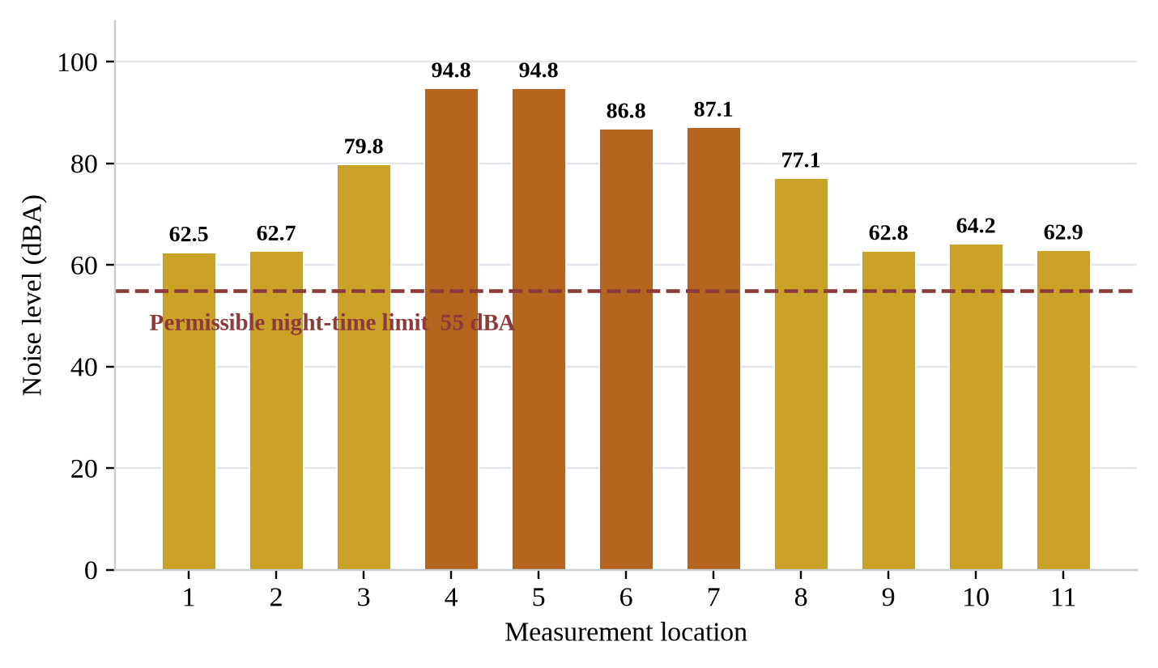
Figure 21. Recorded noise levels against the permissible night-time limit, Peuto Dela Torres Compound, 14 September 2026
Conclusion
The field investigation confirmed the presence of multiple identifiable noise sources within the Peuto Dela Torres Compound, particularly amplified music associated with commercial and entertainment activities.
The recorded readings, ranging from 62.5 to 94.8 dBA, indicate elevated noise conditions at several monitoring points and provide sufficient basis for continued regulatory assessment and follow-up compliance monitoring.
A final determination of regulatory non-compliance is based on validated measurements recorded in accordance with the applicable EPA measurement procedures.
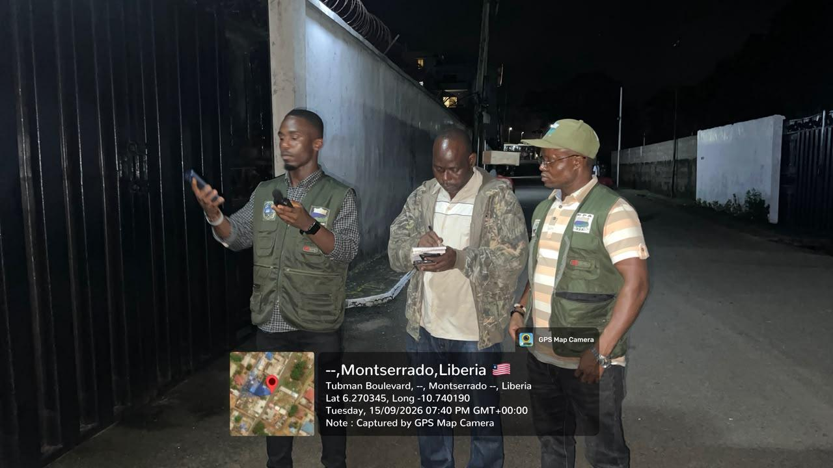
Figure 22. EPA technical team conducting night-time noise level measurements, Tubman Boulevard, Montserrado County, 15 September 2026

