Chemical Storage Inspection — Corrective Action Record

Inspection details
Inspection ID | INS-010
Inspection date | 20 October 2026
Inspection time | 13:49
Site / operator | ArcelorMittal Liberia (AML), Yekepa
County | Nimba County, Liberia
Coordinates | 7.475344, -8.638833
Inspection area | Chemical storage
Compliance status | NOT COMPLIANT
Related reference | CMU-072

Finding: obsolete nitric acid and inadequate incident management
AML acknowledged that it has two containers of obsolete nitric acid in its possession. The company reported that it has been attempting to neutralize the material but could not establish the quantity or volume requiring removal or disposal. No disposal plan was available at the time of inspection. AML stated that it had never disposed of nitric acid into the tailings storage facility (TSF).
The company reported that an incident involving the chemical occurred approximately three weeks before the inspection and that the EPA had not been notified.
As an interim measure, the containers had been separated from other chemicals and moved to a temporary storage area away from workers. Trenches had been dug around the containers, and calcium carbonate was being applied in the trenches in case of leakage. These are interim precautions; they do not constitute an approved disposal plan or demonstrate that the containers and surrounding area are safe.

Compliance determination and basis
NOT COMPLIANT. The company has not established the quantity of obsolete nitric acid, produced a documented and approved disposal plan, or notified the EPA of the reported incident. The ongoing attempt to neutralize an unknown quantity, together with uncertainty about the material’s condition and the incident circumstances, presents a potential chemical exposure and environmental release risk. The reported separation and trenching are interim controls only.

Required corrective actions
- Stop unapproved handling and neutralization. Secure the containers and prevent access by unauthorized personnel. Do not open, transfer, mix, or attempt further neutralization until the material and container condition have been assessed by competent hazardous-material personnel.
- Notify the EPA immediately. Submit a written incident notification describing the incident date, circumstances, any suspected release or exposure, response to date, and current storage location. Explain the reported three-week notification delay.
- Identify and quantify the material. Provide an inventory of both containers, including labels, product/SDS information, container condition, and a defensible estimate of the remaining quantity. If safe measurement is not possible, arrange assessment by a qualified contractor.
- Submit a safe management and disposal plan for EPA review. Identify the competent service provider and permitted receiving facility, packaging and transport arrangements, worker protection, spill/emergency measures, and final treatment/disposal route. Provide disposal manifests or certificates when completed.
- Assess the incident area. Have a qualified person assess the containers, trenches, soil, and any drainage pathway for evidence of leakage or contamination. Document findings and submit any required sampling and remediation proposal to the EPA.
- Maintain interim controls. Until the EPA accepts the corrective plan, keep the area restricted, clearly marked, and protected from weather and incompatible materials. Inspect it routinely and keep a dated log. Report any active leak, exposure, or change in container condition to the EPA immediately.
- Demonstrate closure. Submit dated photographs, incident notification, inventory/quantity assessment, approved contractor and facility details, transport/disposal records, and evidence that the area has been assessed and any impacts addressed.

EPA follow-up
Set a written deadline for the incident notification and corrective-action plan, record the responsible AML contact, and schedule a follow-up verification inspection. Do not mark this finding closed until documentary evidence has been reviewed and corrective actions verified.

Photo evidence
Photographs supplied through the links in the main-branch file “Nitric Acid/pic”. Captions describe visible scene elements only; the images alone do not establish chemical identity or confirm the reported nitric-acid incident.

Photo evidence appendix
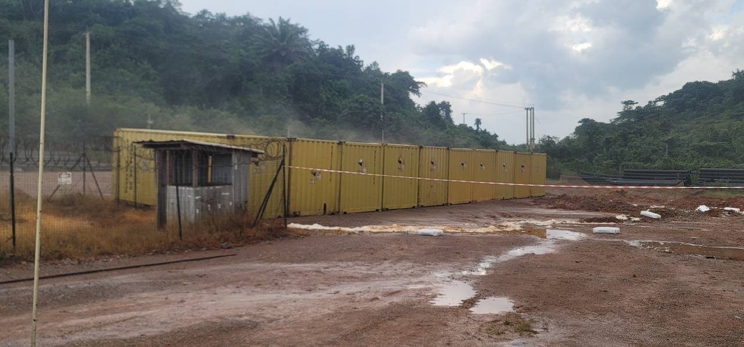
Photo 1. Exterior view of the storage area and adjacent ground.
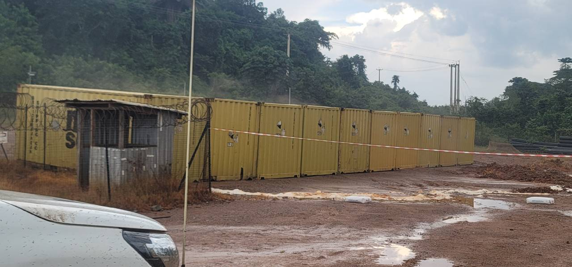
Photo 2. Closer view of the chemical-storage containers.

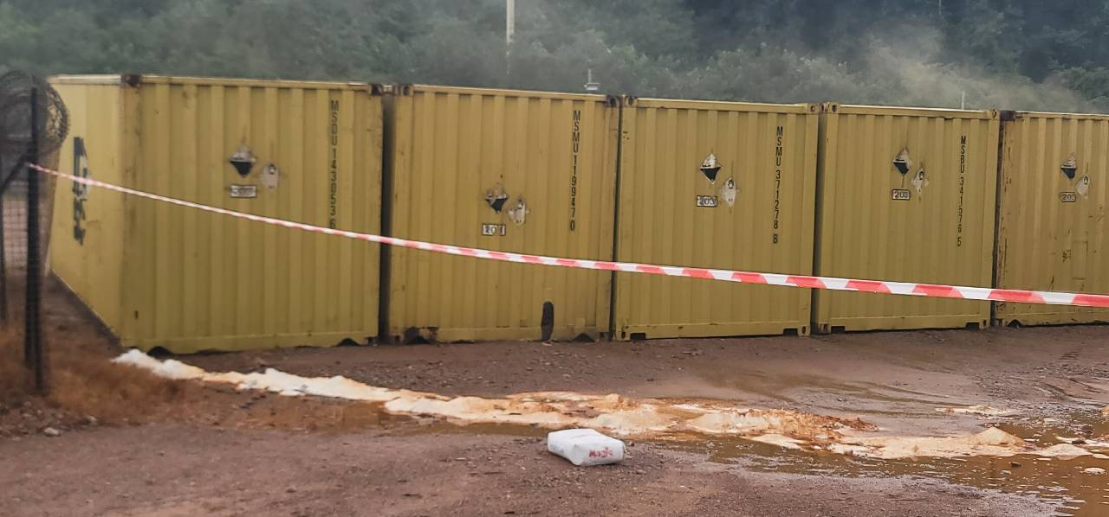
Photo 3. Inspection personnel at the storage area.
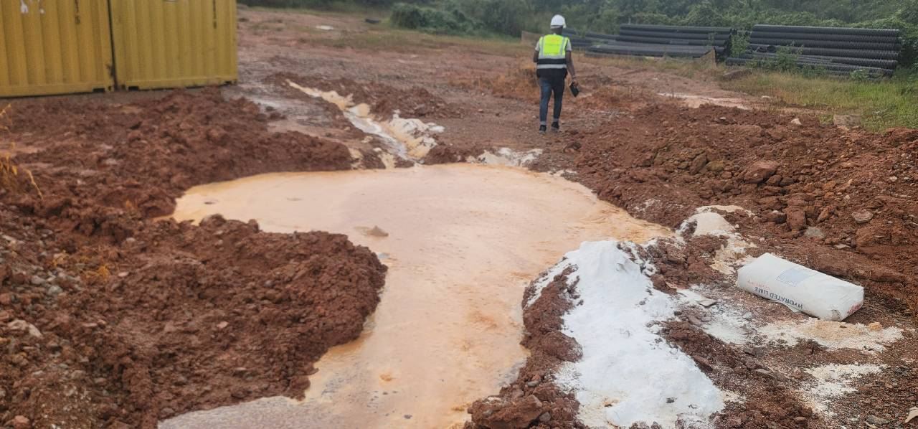
Photo 4. Exterior view of the storage area from another angle.

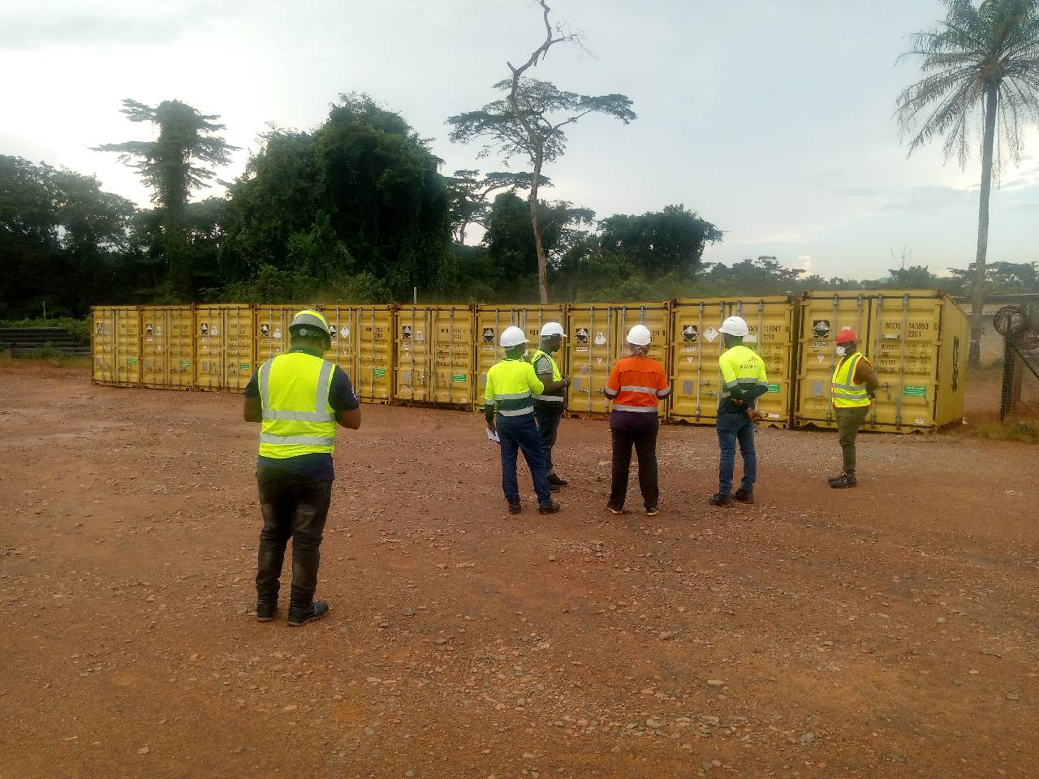
Photo 5. Inspection personnel beside the storage containers.
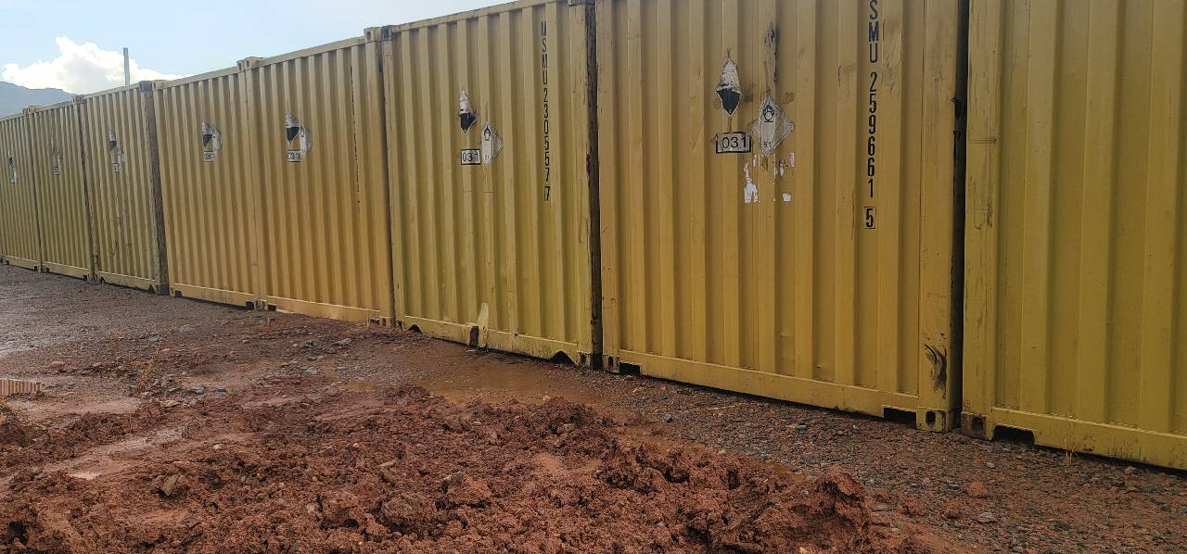
Photo 6. Barrier tape visible in front of the storage containers.

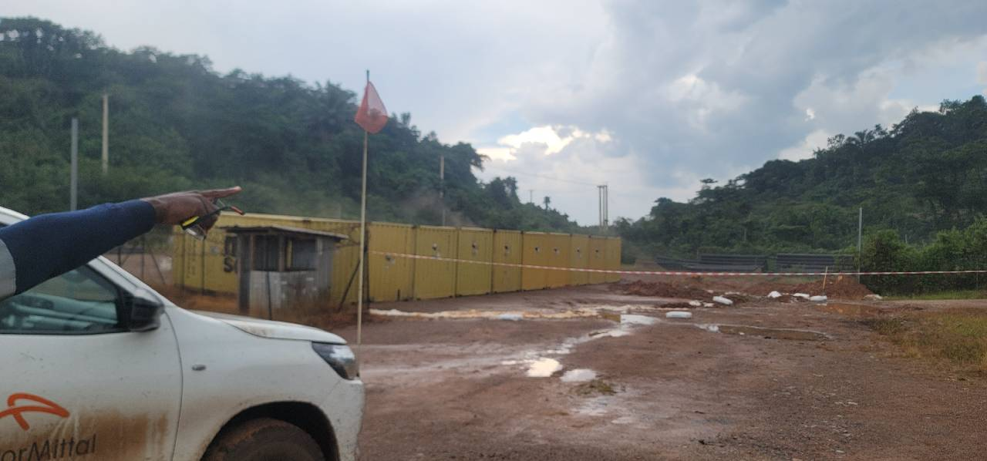
Photo 7. Ground and surface-water conditions near the storage area.
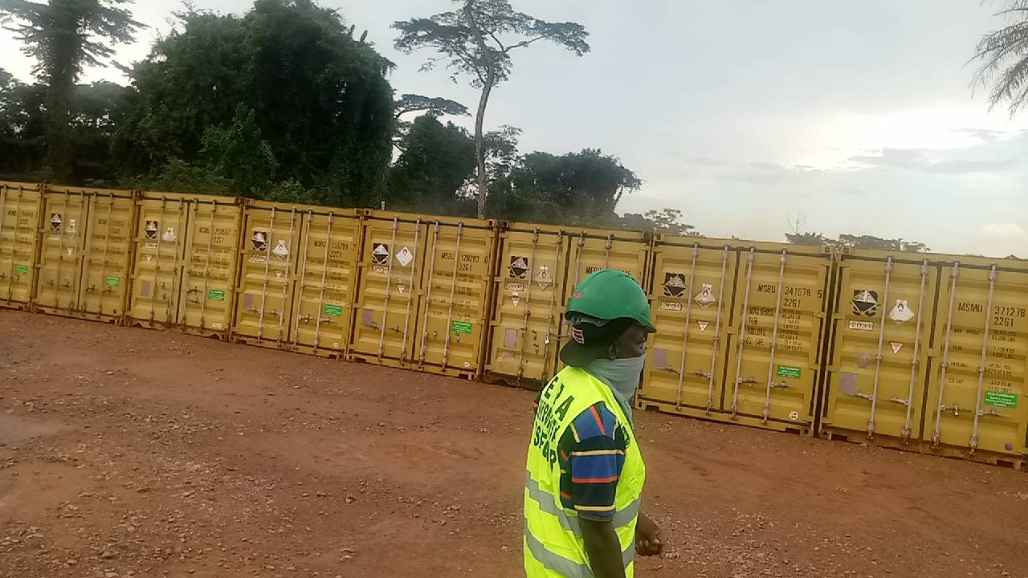
Photo 8. Wider view of the storage area and surrounding site.

Evidence source links
Evidence 1: https://drive.google.com/file/d/1BAjHV0U6XYD39cuiNbSEGQU-06-y3FH3/view?usp=drivesdk
Evidence 2: https://drive.google.com/file/d/11TZn0nlFYZFSR9JbzISrMgt2Zb-ous_h/view?usp=drivesdk
Evidence 3: https://drive.google.com/file/d/1WZ6HBI2dHSxFcMF6P7GmTt8-8YC3Iv9W/view?usp=drivesdk
Evidence 4: https://drive.google.com/file/d/1Xc0v9K6s9ZtVy1RMqJg1MF147A2huyIx/view?usp=drivesdk
Evidence 5: https://drive.google.com/file/d/1DodCN8gf07Rl-X2AaXt8JQgSoZhlPdfi/view?usp=drivesdk
Evidence 6: https://drive.google.com/file/d/1O__QmeV6bRUUzTqmzI4nNMSMnX4lKkyF/view?usp=drivesdk
Evidence 7: https://drive.google.com/file/d/1uaN2-YW70aF-EX9x11OLbCYSImjjqMoz/view?usp=drivesdk
Evidence 8: https://drive.google.com/file/d/1s-8RuselKN7PCpX4Nx0u6FO_liJ4FJZ4/view?usp=drivesdk
Prepared from the information supplied. Confirm inspection ID, coordinates, incident date, observed versus reported details, applicable permit conditions, and corrective-action deadlines against original field notes before issuing as a final regulatory notice.

