* On the user management, the groups that a user is part of should only show groups that the user is active in, not pending.



* A group leader should not be able to create a ‘Church Event’

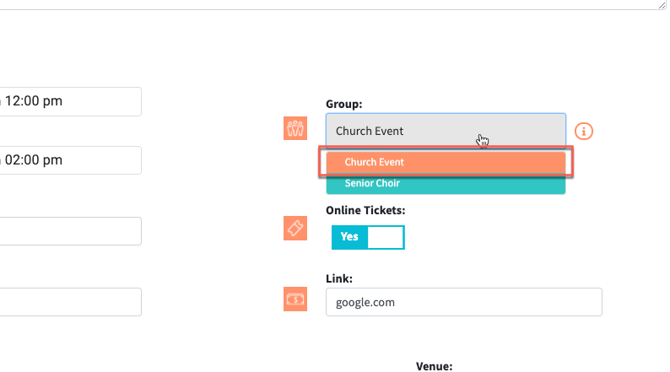

* This an added request, but is it possible to remove the blank ‘star’ image from the Leader column on the Group User page? The blank star would only show on the Edit Group page.

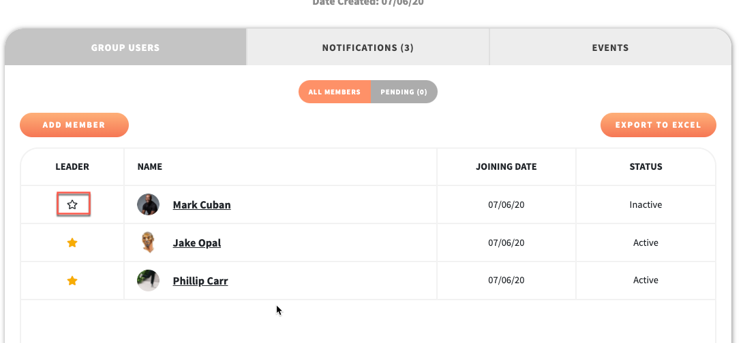

* All of the gift options should not show on the giving history page filter. The only options that should show need to be the options a user actually paid to. In the example below, there should only be one option in the filter.

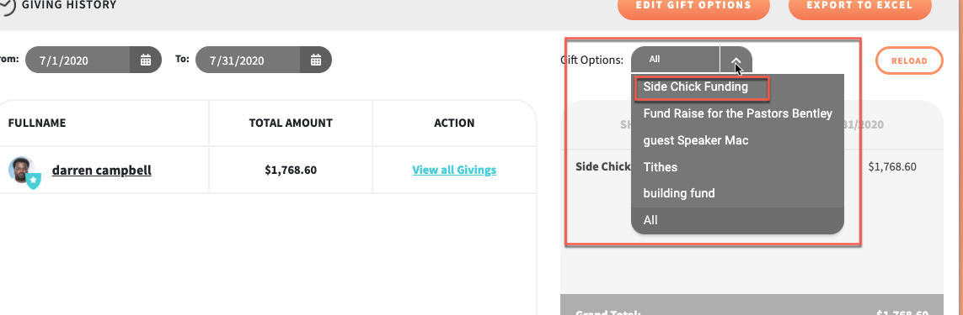

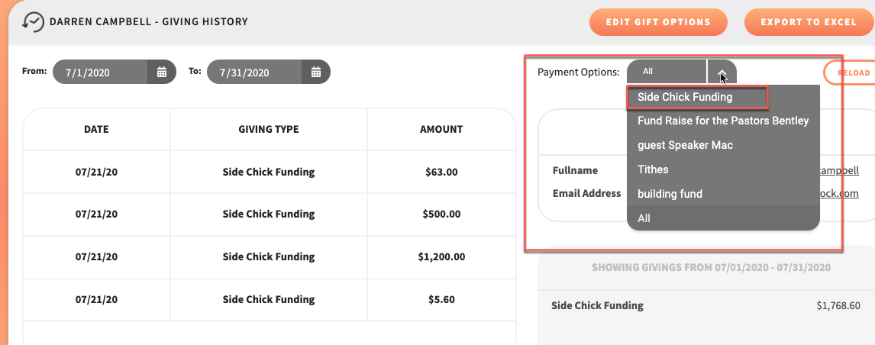

* On the User Profile, the giving history module is showing any history

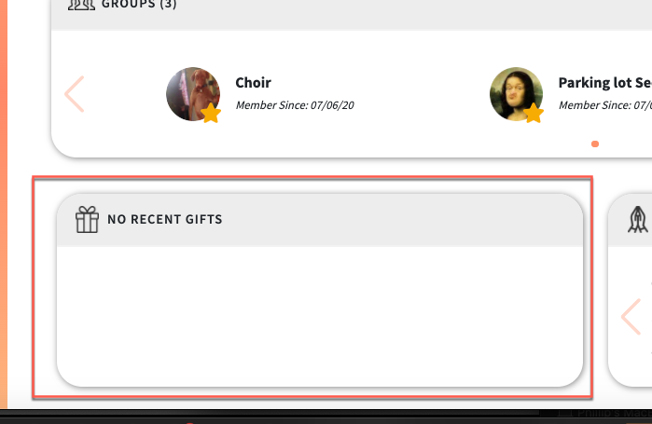

* On the User Profile, the prayer request module is not centering a prayer request when there is only one request

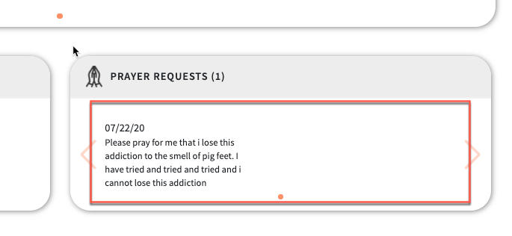

* When a church enters their payment information to get a FaithMo account, there are a couple issues:
  + The first is that the expiration month field doesn’t allow a leading ‘0’ followed by another digit and when you try to backspace out of the field, it takes you to a blank page

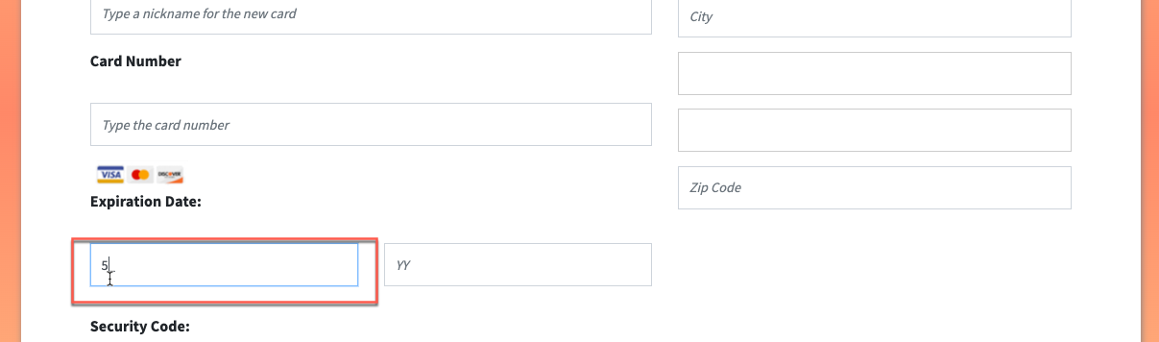

* + There is no ‘State’ or ‘Country’ field identifier on the address side

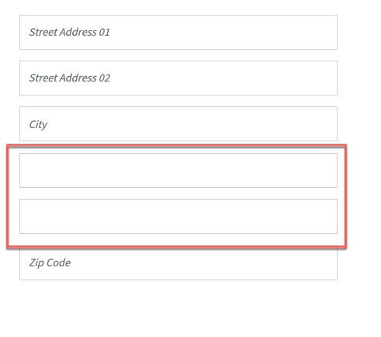

* + Change the ‘Security Code’ text to ‘CVV Code’ and add a link for the ‘What is this?’ to navigate to <https://www.cvvnumber.com/cvv.html>

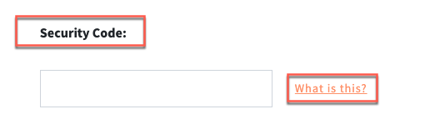

* + Can the edit form fields only expand if the ‘Use New Card’ radio button is selected?

