Open tool and click on the ‘Add Files’ button on left panel.

Select all images from 1.1 hotplate tofu folder.

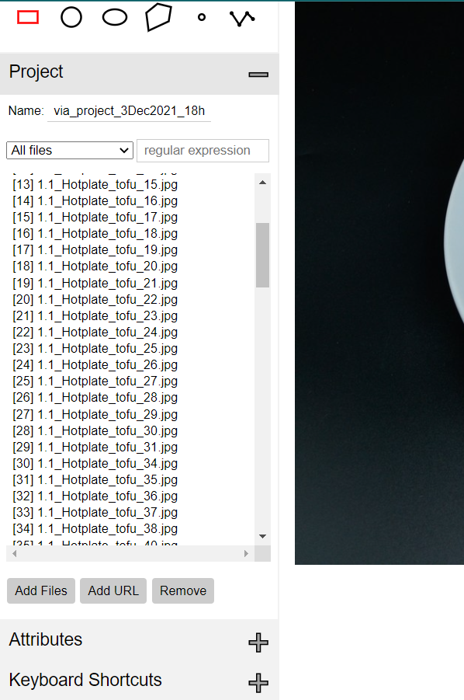

From tool menu, click ‘Annotation’ -> select ‘Import Annotation (from json)’ and choose the json file inside the 1.1 hotplate tofu folder.

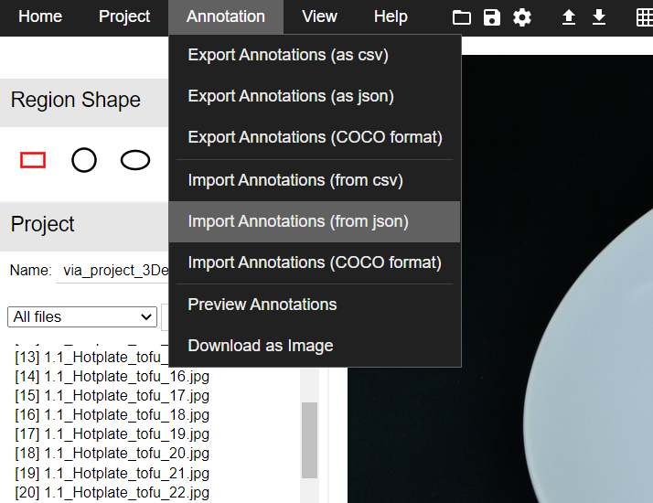

You can now see the annotation on images.

You can save by ‘Export Annotations (as json)’ and use it later when you want to resume.