

과 목 명 : iOS프로그래밍실무

학 과 : 컴퓨터소프트웨어

학 번 : 201822048

     반 : A

이 름 : 황재하

제 출 일 : 2023.05.03

담당교수 : 한성현 교수님

실습.1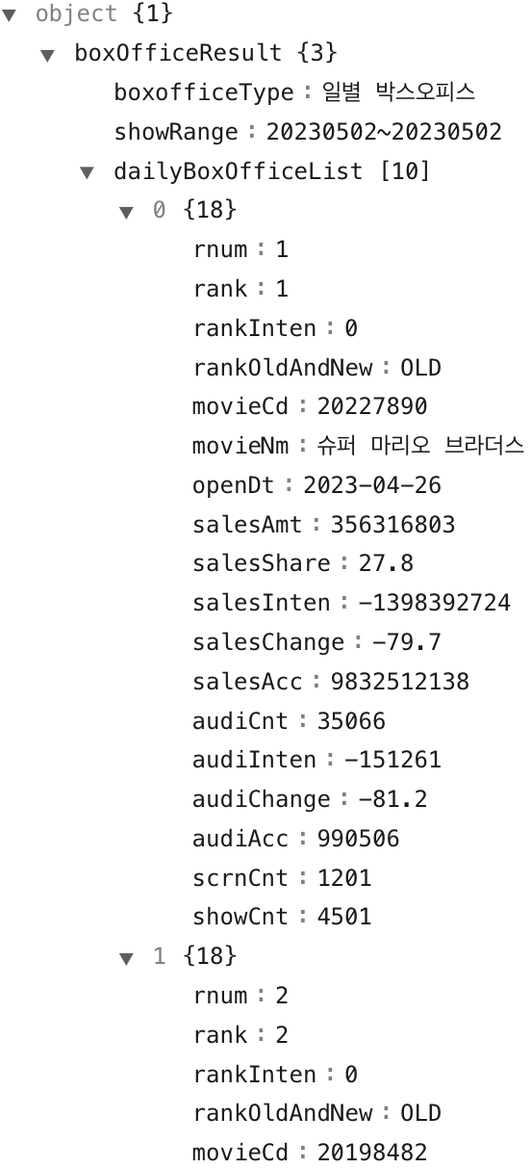

실습.2

movieNm : 슈퍼 마리오 브라더스, 드림, 존 윅 4, …

실습.3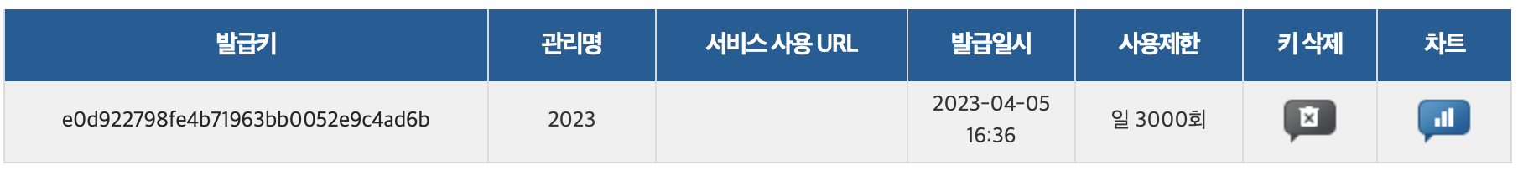

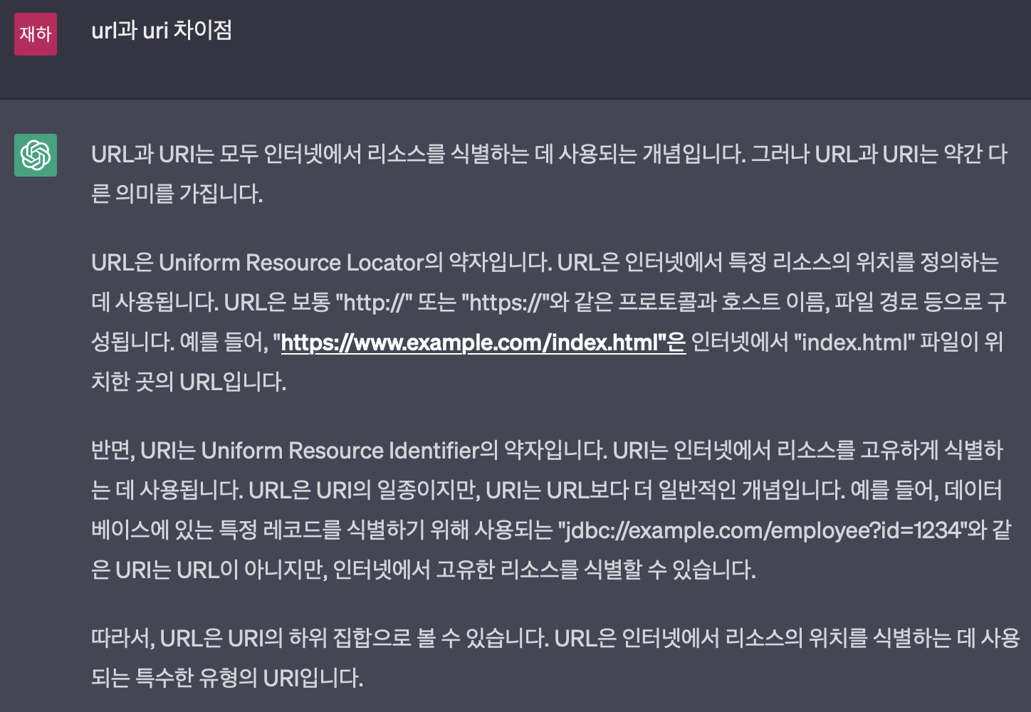실습.4

실습.5

import Foundation

// MARK: - Welcome

struct Welcome: Codable {

let boxOfficeResult: BoxOfficeResult

}

// MARK: - BoxOfficeResult

struct BoxOfficeResult: Codable {

let boxofficeType, showRange: String

let dailyBoxOfficeList: [DailyBoxOfficeList]

}

// MARK: - DailyBoxOfficeList

struct DailyBoxOfficeList: Codable {

let rnum, rank, rankInten: String

let rankOldAndNew: RankOldAndNew

let movieCD, movieNm, openDt, salesAmt: String

let salesShare, salesInten, salesChange, salesAcc: String

let audiCnt, audiInten, audiChange, audiAcc: String

let scrnCnt, showCnt: String

enum CodingKeys: String, CodingKey {

case rnum, rank, rankInten, rankOldAndNew

case movieCD = "movieCd"

case movieNm, openDt, salesAmt, salesShare, salesInten, salesChange, salesAcc, audiCnt, audiInten, audiChange, audiAcc, scrnCnt, showCnt

}

}

enum RankOldAndNew: String, Codable {

case old = "OLD"

}

실습.6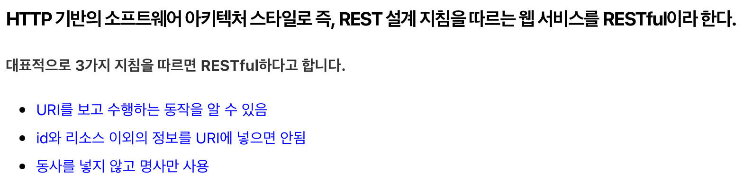

실습.7

실습.8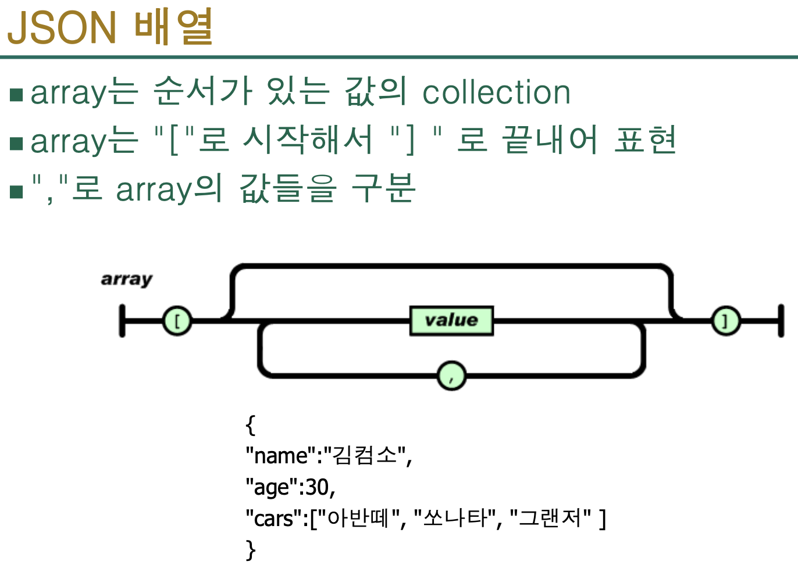

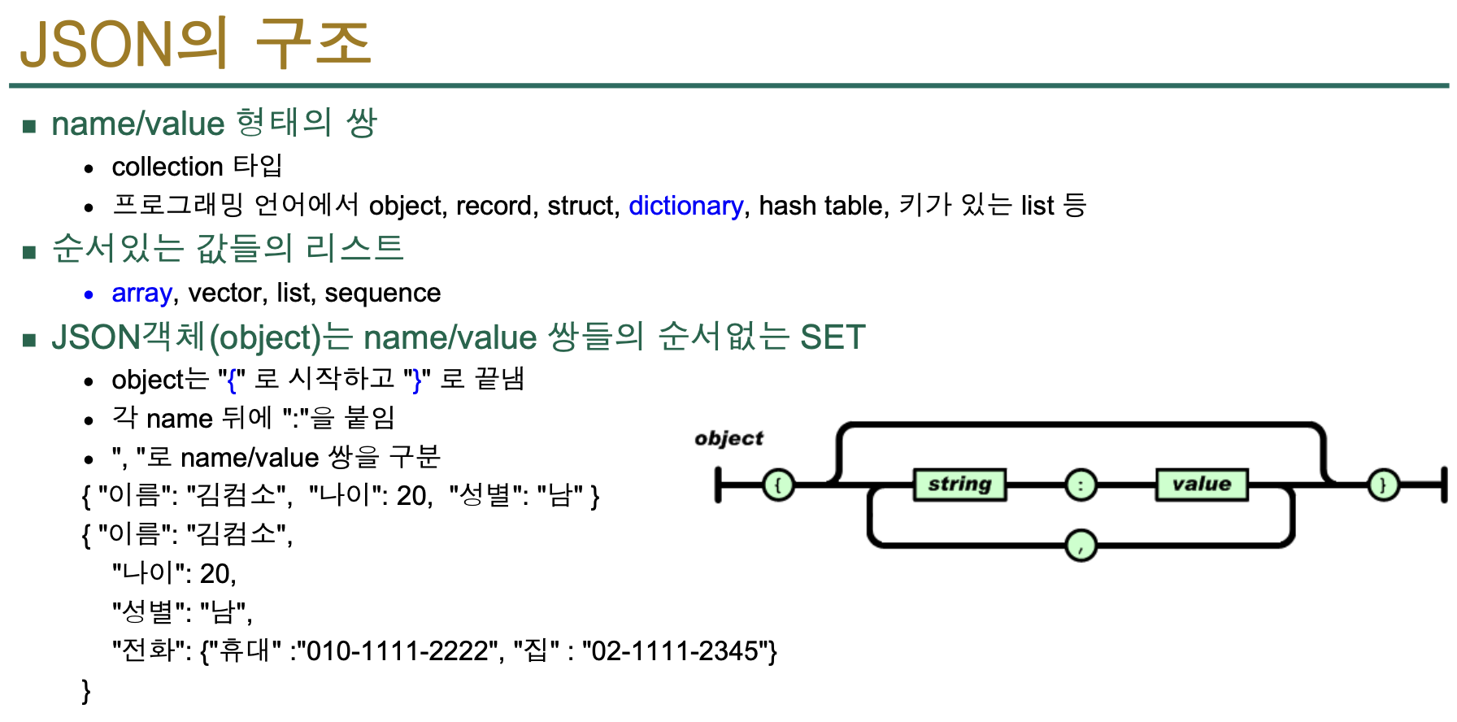

실습.9

실습.9

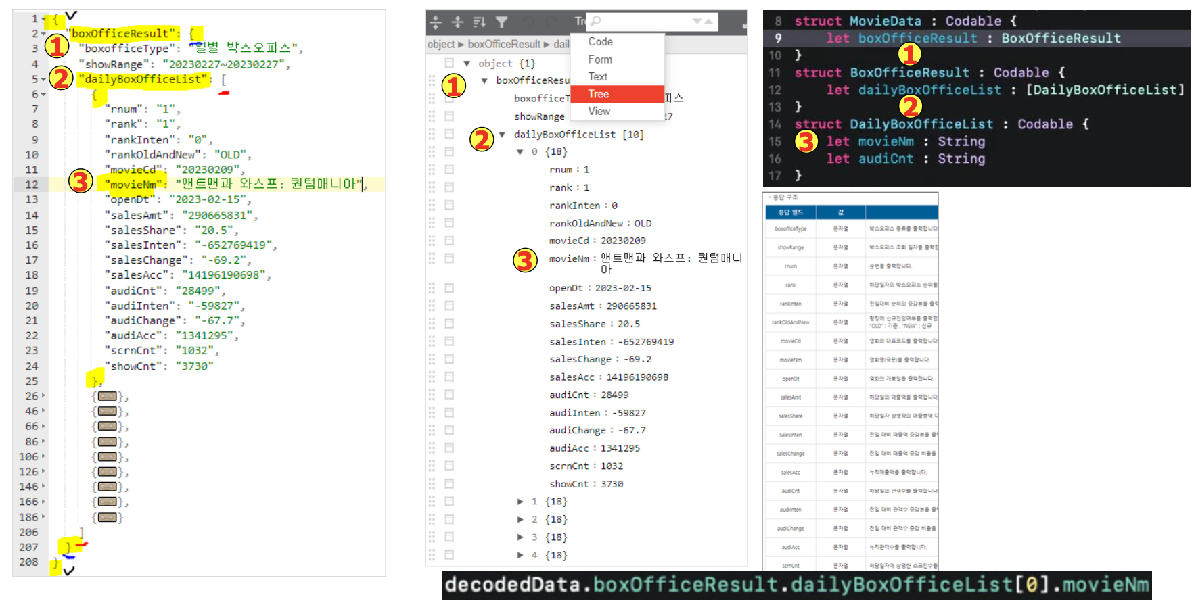

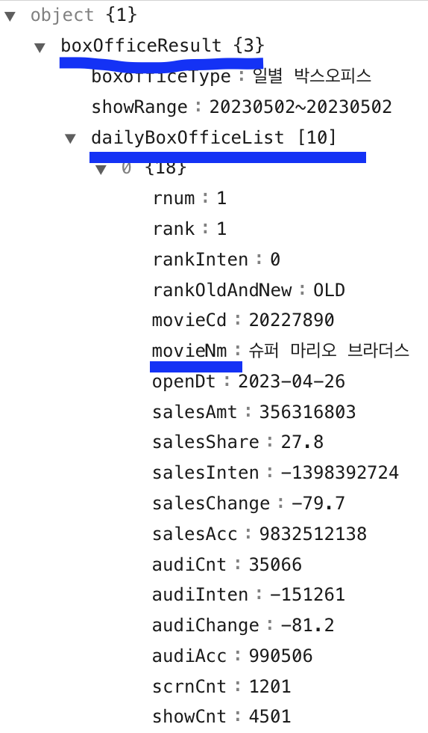

실습.10

한국도로공사 고속도로 공공데이터 open api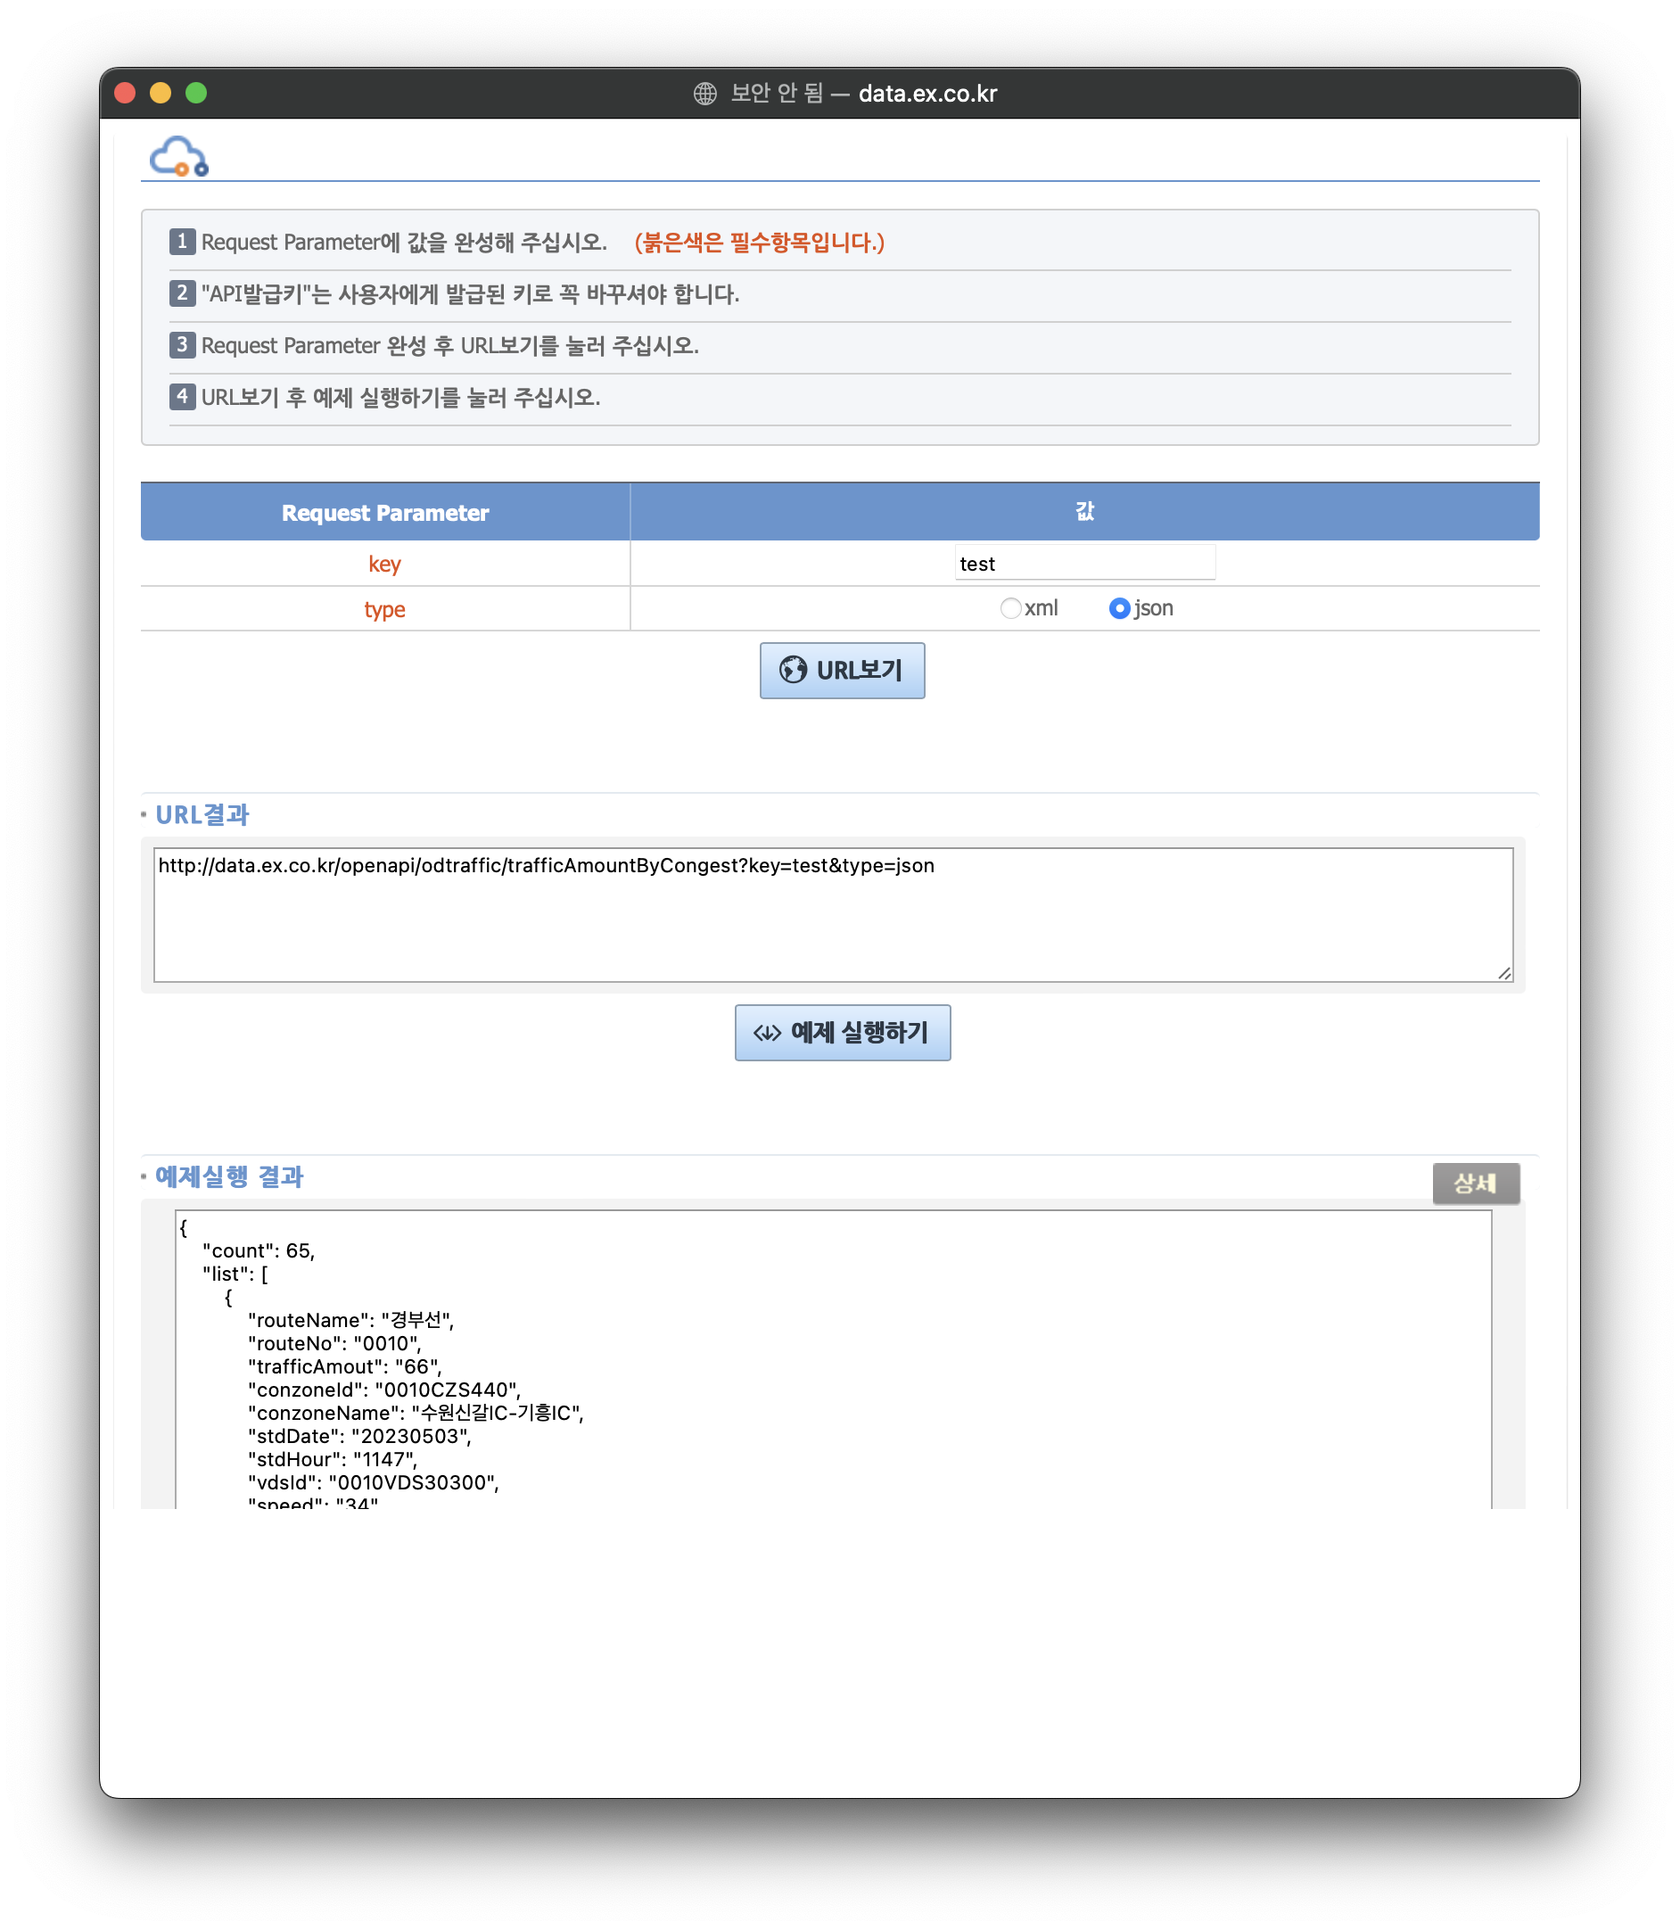

실습.11

//

// ViewController.swift

// MovieHwangjh

//

// Created by 황재하 on 5/3/23.

//

import UIKit

class ViewController: UIViewController, UITableViewDelegate, UITableViewDataSource {

@IBOutlet weak var table: UITableView!

let name = ["슈퍼 마리오 브라더스", "드림", "존윅4", "스즈메의 문단속", "옥수역 귀신", "리바운드", "더 퍼스트 슬램덩크", "랜필드", "킬링 로맨스", "무명"]

override func viewDidLoad() {

super.viewDidLoad()

table.dataSource = self

table.delegate = self

// Do any additional setup after loading the view.

}

func tableView(_ tableView: UITableView, numberOfRowsInSection section: Int) -> Int {

return name.count

}

func tableView(_ tableView: UITableView, cellForRowAt indexPath: IndexPath) -> UITableViewCell {

let cell = tableView.dequeueReusableCell(withIdentifier: "myCell", for: indexPath) as! MyTableViewCell

cell.movieName.text = name[indexPath.row]

return cell

}

}

//

// MyTableViewCell.swift

// MovieHwangjh

//

// Created by 황재하 on 5/3/23.

//

import UIKit

class MyTableViewCell: UITableViewCell {

@IBOutlet weak var movieName: UILabel!

override func awakeFromNib() {

super.awakeFromNib()

// Initialization code

}

override func setSelected(_ selected: Bool, animated: Bool) {

super.setSelected(selected, animated: animated)

// Configure the view for the selected state

}

}

