CS744 EMR system test cases

Han Chen

Created date: 2/9/2015 Han

V2. 2/16/2015 JingBo

V3. 2/24/2015 Yufan

V4. 2/28/2015 JingBo

V5. 3/2/2015 Han

V6. 3/9/2015 Han

**Assumptions**

In the requirement, it says “The primary care physician of the patient creates and adds information to the EMR”, which means the only users of this system is physicians. However, there must be an administrator account to add physicians’ accounts to system before it delivered. Therefore physicians can use it directly without registering by themselves. According the requirement, we decide to test login module first. Later on other test cases for other component of system will be provided.

**Transition diagram**

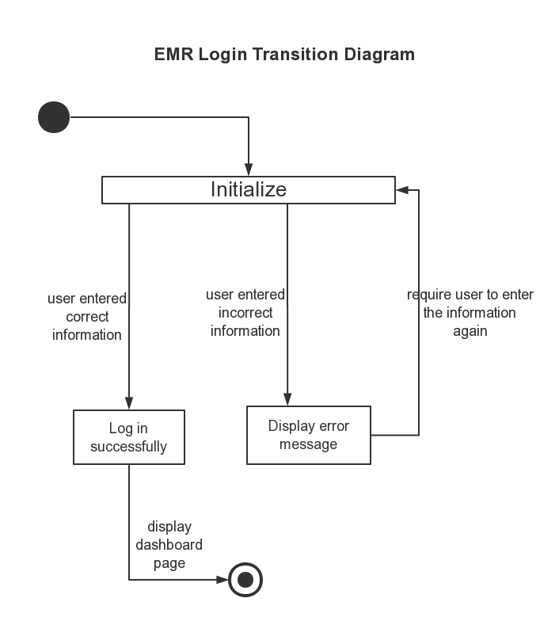

**Test Cases**

We fixed the Login page with adding the warning message to notice user if his/her username or password is invalid. Moreover, we updated the toolbar test cases.

|  |  |  |  |  |  |  |  |
| --- | --- | --- | --- | --- | --- | --- | --- |
| **Cases** | | **Scenario** | **Expected output** | **Actual output** | **Developer** | **Tester** | **Test Date** |
| Login test cases | 1 | Open website, click “login” button without entering anything | There should be message displayed to notice user the information is invalid, and there is nothing else happen | warning message displayed | Yufan | Han | 2/9/2015 |
| 2 | Enter information (username, password) | in password text box the password should be displayed as dots | password is displayed as dots | Yufan | Han | 2/9/2015 |
| 3 | Enter invalid information, click “login” button | There should be message displayed to notice user the information is invalid | warning message displayed | Yufan | Han | 2/9/2015 |
| 4 | Enter valid information, click “login” button | System should display dashboard page | Dashboard displays | Yufan | Han | 2/9/2015 |
| Dashboard test  cases | 1 | Click “Patient” button | System should display patient page | showing patients table | Yufan | Jingbo | 2/16/2015 |
| 2 | Click “Dashboard” button | System should display home page | showing home page | Yufan | Jingbo | 2/16/2015 |
| 3 | Click “EMR” button | System should display EMR page | showing EMR page | Yufan | Jingbo | 2/16/2015 |
| 4 | Click “Transcription” button | System should display transcription page | showing transcription page | Yufan | Jingbo | 2/16/2015 |
| Patient test case | 1 | Click “EMR” button on patient list | System should display EMR page | showing EMR page | Han | Jingbo | 2/16/2015 |
| 2 | non-existing patient name to search Primary care patient | It should show result “No matching records found” | result”No matching records found” showed | Han | Jingbo | 2/16/2015 |
| 3 | existing patient name to search Primary care patient | It should show the search result | the patient is showed in the primary care patient list | Han | Jingbo | 2/16/2015 |
| 4 | non-existing patient name to search Temporary care patient | It should show result “No matching records found” | result”No matching records found” showed | Han | Jingbo | 2/16/2015 |
| 5 | existing patient name to search Temporary care patient | It should show the search result | the patient is showed in the temporary care patient list | Han | Jingbo | 2/16/2015 |
| Transcription test case | 1 | Click “view” button on transcription list | System should display transcription page | showing transcription page | Yufan | Han | 2/24/2015 |
| 2 | Click “Create” button on transcription page | System should display creating transcription page | showing creating transcription page | Yufan | Han | 2/24/2015 |
| 3 | Click “Empty” button on Give access to physician | System should display physician list | showing physician list | Yufan | Han | 2/24/2015 |
| 4 | Click “Date” button on Give access to physician | System should display calendar | showing calendar | Yufan | Han | 2/24/2015 |
| Create  transcription  test case | 1 | Click Diagnostic Test “Empty” button | System should display Diagnostic Test selection | showing Diagnostic Test selection | JingBo | Yufan | 2/24/2015 |
| 2 | Click Surgery “Empty” button | System should display Surgery selection | showing Surgery selection | JingBo | Yufan | 2/24/2015 |
| 3 | Input on Prescription information text field | System should allow input information | allowing input information | JingBo | Yufan | 2/24/2015 |
| 4 | Click “Create” button | New transcription should be created | transcription created | JingBo | Yufan | 2/24/2015 |
| 5 | Click “Cancel” button | System should back to last page | back to last page | JingBo | Yufan | 2/24/2015 |
| Toolbar test cases | 1 | Click “Message” button in toolbar on dashboard | There will be a drop down menu appears | drop down menu appears | Yufan | Han | 2/28/2015 |
| 2 | Click drop down menu item of “Message” menu | It should show details of messages | details show correctly | Yufan | Han | 2/28/2015 |
| 3 | Click “Task” button in toolbar on dashboard | There will be a drop down menu appears | drop down menu appears | Yufan | Han | 2/28/2015 |
| 4 | Click drop down menu item of “Task” menu | It should show details of tasks | details show correctly | Yufan | Han | 2/28/2015 |
| 5 | Click “Alert” button in toolbar on dashboard | There will be a drop down menu appears | drop down menu appears | Yufan | Han | 2/28/2015 |
| 6 | Click drop down menu item of “Alert” menu | It should show details of alerts | details show correctly | Yufan | Han | 2/28/2015 |
| 7 | Click “UserProfile” button in toolbar on dashboard | There will be a drop down menu appears | drop down menu appears | Yufan | Han | 2/28/2015 |
| 8 | Click drop down menu item of “UserProfile” menu | It should show details of user profile | details show correctly | Yufan | Han | 2/28/2015 |
| Patient page GUI test cases | 1 | Click green EMR button on patient page | It should go to the patient’s EMR page and display the existing EMR | page shows correctly | Jingbo | Han | 3/2/2015 |
| 2 | Click red EMR button on patient page | It should go to a page with empty EMR waiting to be created | page shows correctly | Jingbo | Han | 3/2/2015 |
| 3 | Input fuzzy keyword in search box | It should display search result | result shows correctly | Jingbo | Han | 3/2/2015 |
| 4 | Input keyword in search box | It should display search result on real-time | result shows on real-time | Jingbo | Han | 3/2/2015 |
| 5 | Click drop down box to change the number of patient displayed | It should change the number | displayed number changes | Yufan | Han | 3/2/2015 |
| 6 | Click the column to change the order of sequence of patient names | The order should be changed | order changes correctly | Yufan | Han | 3/2/2015 |
| 7 | Click the column to change the order of sequence of patient genders | The order should be changed | order changes correctly | Yufan | Han | 3/2/2015 |
| 8 | Click the column to change the order of sequence of patient birthdays | The order should be changed | order changes correctly | Yufan | Han | 3/2/2015 |
| 9 | Click the column to change the order of sequence of patient relation types | The order should be changed | order changes correctly | Yufan | Han | 3/2/2015 |
| 10 | Click the column to change the order of sequence of patient access levels | The order should be changed | order changes correctly | Yufan | Han | 3/2/2015 |
| 11 | Click the column to change the order of sequence of actions | The order should be changed | order changes correctly | Yufan | Han | 3/2/2015 |
| EMR page GUI test cases | 1 | Click “Patient Information” tab | It should show patient information panel | panel shows correctly | Han | Jingbo | 3/9/2015 |
| 2 | Click “Transcription” tab | It should show Transcription panel | panel shows correctly | Han | Jingbo | 3/9/2015 |
| 3 | Click “Associated physicians” tab | It should show associated physicians panel | panel shows correctly | Han | Jingbo | 3/9/2015 |
| 4 | Click “patient infor” panel heading | The panel should be collapsed | panel collapses correctly | Han | Jingbo | 3/9/2015 |
| 5 | Click “physician condition” panel heading | The panel should be collapsed | panel collapses correctly | Han | Jingbo | 3/9/2015 |
| 6 | Click “medical disorder” panel heading | The panel should be collapsed | panel collapses correctly | Han | Jingbo | 3/9/2015 |
| 7 | Click “view” button of specific transcription record in “Transcription” tab | The detailed information of particular transcription should be shown in the transcription page | page shows correctly | Yufan | Jingbo | 3/9/2015 |
| 8 | Click drop down box to change the number of physicians displayed in “Associated Physician” tab | It should change the number of physicians displayed | number changes | Yufan | Jingbo | 3/9/2015 |
| 9 | Click the column to change the order of sequence of physician names | The order should be changed | order changes correctly | Yufan | Jingbo | 3/9/2015 |
| 10 | Click the column to change the order of sequence of access right | The order should be changed | order changes correctly | Yufan | Jingbo | 3/9/2015 |
| 11 | Click the column to change the order of sequence of expired date | The order should be changed | order changes correctly | Yufan | Jingbo | 3/9/2015 |
| 12 | Click the column to change the order of sequence of actions | The order should be changed | order changes correctly | Yufan | Jingbo | 3/9/2015 |
| 13 | Input the physician name into physician searching box to search physician | There should be a drop down box to show the fuzzy searching result | Drop down box shows correctly | Yufan | Jingbo | 3/9/2015 |
| 14 | Input the physician name into physician searching box and hit enter | The searching result should be displayed in searching box | Result shows correctly | Yufan | Jingbo | 3/9/2015 |
| 15 | Input the keywords in the searching box of “temporary care physician list” panel | The record should be displayed based on the keywords on real-time | Displays are correct | Yufan | Jingbo | 3/9/2015 |
| 16 | Click the date of “expired date” | The date control should be displayed with the date shown | Display is correct | Yufan | Jingbo | 3/9/2015 |
| 17 | Select different date on the date control | This operation should change the expired date | Expired date changes | Yufan | Jingbo | 3/9/2015 |
| 18 | Click “add” button in adding physician panel | It should add physician to the upper list and to the database | Working correctly | Yufan | Jingbo | 3/9/2015 |
| 19 | Click the “delete” button of each relationship | There should be an alert appearing to get deleting confirmation from current user | Alert appears | Yufan | Jingbo | 3/9/2015 |
| 20 | Click “Ok” button to confirm deleting the relationship | The relationship should be deleted | Deleting successfully | Yufan | Jingbo | 3/9/2015 |
| 21 | Click “Cancel” button to cancel the operation | The relationship should not be deleted | Deleting doesn’t happen | Yufan | Jingbo | 3/9/2015 |
|  |  |  |  |  |  |  |  |
|  |  |  |  |  |  |  |  |
|  |  |  |  |  |  |  |  |
|  |  |  |  |  |  |  |  |
|  |  |  |  |  |  |  |  |