Project report

Final Project-
DHCP Server & Client

Course Title: Internet Applications
Name:

Date: June 15th, 2016

Overview
The goal of the project is mainly about:
- Deeply understand the details of DHCP (Dynamic Host Configuration Protocol).
- Complete a DHCP server program and run it in one Ubuntu virtual machine.
- Complete a DHCP client program and run it in another Ubuntu virtual machine.

Requirements Analysis
- The environment of this coursework is based on Ubuntu operation system and using C language with gcc compiler and gdb debugger. We are using VirtualBox under macOS to run both client and server virtual machine.
- To configure the client and server, first extra Ethernet card is added to ensure that both client and server are in the same intranet and uses the build-in tool to connect to the virtual through Ethernet card 0. And because that when the destination address of the broadcast packet is 255.255.255.255, the source IP address must be 0.0.0.0. We use iptabls rules to achieve that.
The code is showing below
sudo iptables -t nat -A POSTROUTING -d 255.255.255.255 -o eth1 -j SNAT --to-source 0.0.0.0
sudo iptables-save > /etc/network/iptables.rules
Then write the command below into the /etc/rc.local, so that the command can execute automatically when the system start
iptables-restore < /etc/network/iptables.rules
exit 0
- The server contains two configuration file
The first is “dhcp.config” which contains the subnet mask, DNS server IP address, Router address and the lease time. The rest part of the configuration file is the IP address pool that contains the IP addresses can be allocated to clients.
The second file is “dhcp.lease” which contains the information of allocated IP address and the clients’ information including hardware address (MAC address) and time stamp.
- The coursework contains 5 parts. The first one is the address acquisition. The client send DHCP Discover and Request broadcast and the server response the client by sending DHCP Offer and ACK back using either unicast and broadcast. After the server sending out the ACK it will remove the IP address from the IP pool and record the time stamp, MAC address and IP address to the dhcp.lease file to record the lease of the IP address. When the client receives the ACK packet it will get all the information including IP, Mask, Router, DNS, DHCP server, LEASE time and then set the information to the Ethernet card in this case eth1.
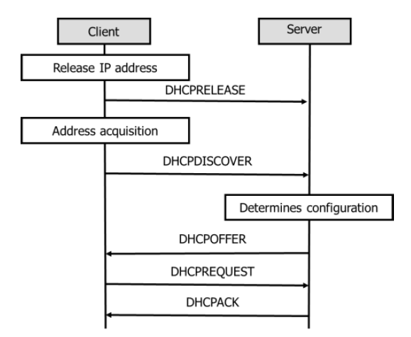
The second one is renewing the IP address including unicast the request after T1 expires, boradcast the reuqest after T2 expires, start address acquisition after the lease time expires. The server will fierst check whetehr the IP address is legal by reading the dhcp.leae file and then buy calculating the lease time, it will decide whether the requested IP address can renew or not. If the client can renew the IP address, the server will send ACK and renew the lease recording, if not the server will send NAK. After receibing the NAK, the client will start address acquisition wich is sending DHCP Discover packet broadcastly.
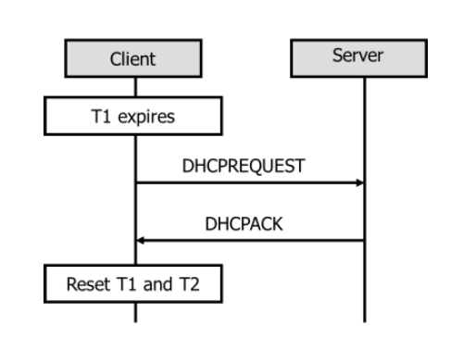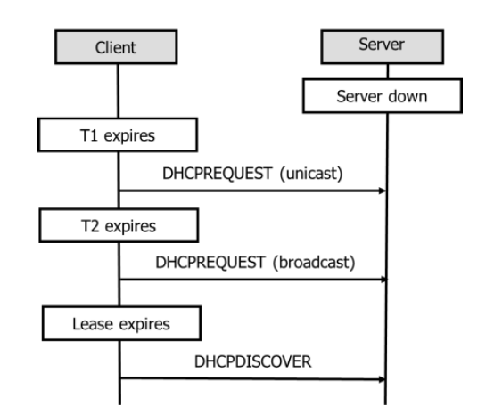
If the client request an abnormal IP address, the server will response with NAK and client will start address acquisition to get a legal IP address.
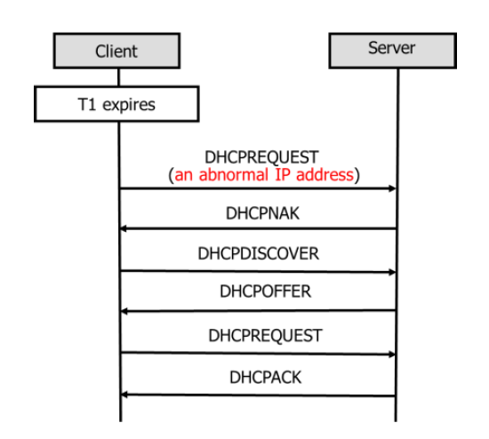
The third one is getting extra infromation from the DHCP server, the client send DHCP Inform to the server and the server will response to the client ACK.
The forth one is that the client release the IP addres by sending DHCP Release to the server
After receied the DHCP Release packet, the server will add the released IP address back to the IP pool and delete the corresponding lease log in the dhcp.lease file. For the client, if the client finished sending the release packet, it will automatically use an abnormal IP address instead of the normal IP address.

Preliminary Design
We design the DHCP client in 4 main parts, including sending DHCP Discover, Request, Release, Inform and receiving the corresponding reply form the DHCP server.
For the design of DHCP server, it includes 3 main parts, including receiving the request from DHCP client and sending the corresponding reply (DHCP Offer, ACK/NAK) to the client.
Client:
The program will first generate the non-option part of the package which can be reused by other kind of DHCP packet. And the socket will bind to Ethernet card 1 so that the DHCP packet will be delivered over eth1 which connect both the client and server.
- Address acquuisition
The discover packet contains client IP address and the boot flags which indicate whether the server send the Offer and ACK by unicast and broadcast. The program will set the client IP address to 0.0.0.0 which indicate that the request client has no IP address. And in the Discover packet, the transaction ID will be generated and filled by the client. Each packet will have a different ID to indicate the request and reply process.
For the options in Discover packet:
Option 53: DHCP Message Type, the value is 0x35 in hex which indicate the Discover packet
Option 60: Class Identifier, the value is our BUPT number which is 0x2014213083/0x2014213086
Option 55: Parameter request list, the value is a list of parameters that the server need to reply to the client when sending DHCP offer packet.
Option 255: End, the value is 0xff, which indicate the end of the option parts.
Since the packet sent from the client need at least 312 bytes long, so if the send buffer is longer than 312 bytes, if will automatically add padding at the end of option 255 to reach the minimum length 312 bytes.
After constructing the packet, the client will send the Discover packet to the server by broadcast or unicast according to user’s choice. And then start to listen then localhost port 68 to receive the response of the server. After the server receives the packet, it will first check option 53 to see which packet it is, if the packet is HDCP discover, the server will first look into the IP lease pool to see whether there any IP addresses available. If there are IP addresses can be send to the client, the server will construct the DHCP Offer packet by reading the configuration file. The subnet mask, DNS Server IP address, Router IP address and Lease time as well as the IP pool are stored in the file, by reading the file can these parameters be got. Then the server will change the op to 0x02 to indicate it is server’s reply and set your IP address to one of the IP sin the IP pool. Finally send back to the client by broadcast or unicast according to the flags in the Discover packet. After receiving the packet, the client will send Request to request the IP address. The server will reply the request by sending ACK which almost the same as the offer except the option 53. After receiving the server’s ACK reply to the request, the client will extract the IP address, subnet mask, DNS, Router and Lease time information. Then the client will use the information to set the Ethernet card, so that the whole address acquisition process is finished.
- Renew the IP address
The client can send unicast and broadcast DHCP Request to renew the IP address automatically or manually. The user can manually choose the renew at T1 expires or T2 expires or let the program to decide when to renew the IP. For automatically renew the IP, the server will generate an independent thread to check the time while the main thread is scanning the user’s input. When the time reach the T1 time which is half of the Lease time, the client will automatically send unicast DHCP Request and listen to server’s response, if the server is down, the client will wait for T2 expires which is seventh of eight of the lease time. When the time reach T2, the client will send broadcast DHCP Request, if the server does not response the client, the client will continue to wait until lease time expires. After the lease time expires, the client will restart to address acquisition to get a new IP address. If the server replies any of the request packet during renewing the IP address, the client will reset the timer and load the lease time, T1, T2 into the thread. If the client uses an abnormal IP to request the server, or the client IP address is out of lease time, the server will first check whether the IP address is valid and decide to reply to the client with DHCP ACK or NAK. If the client IP address is valid, the server will first renew the lease record in the dhcp.lease file and send reply the client with the ACK packet.
- Release the IP address
The client can send DHCP Release packet when the user use command –release, the client will first construct the packet by modifying the client IP address and adding option 53, option 54 and option 255 to the option parts. Since the DHCP release packet need not reply, so that after send out the packet, the client will set the IP address of itself as an abnormal IP address (instead of 0.0.0.0 since using the code cannot set the IP address to 0.0.0.0) to indicate that the IP address has been released.
After received the HDCP Release packet, the server will first decide whether the IP address has been send before, that is checking the leased IP address form the log file, dhcp.lease, if the IP address is in the lease file, then the server will remove the corresponding lease and then add the IP address back to the IP lease pool in the configuration file. If the leased IP is not recorded in the lease file, the server will do nothing.
- DHCP Inform
The client can send DHCP Inform when user manually choose the command “--inform”, the client will add client IP address to the packet and then add option 53, 54 55, 60, 255 to the option parts to indicate the request items, so that the server can reply to the client with corresponding information. When the server receives the DHCP Inform packet, it will add the corresponding information into the option parts and then send back to the client. After receiving the packet, the client just prints out the information and do nothing to the interfaces and the lease time.

Detailed Design
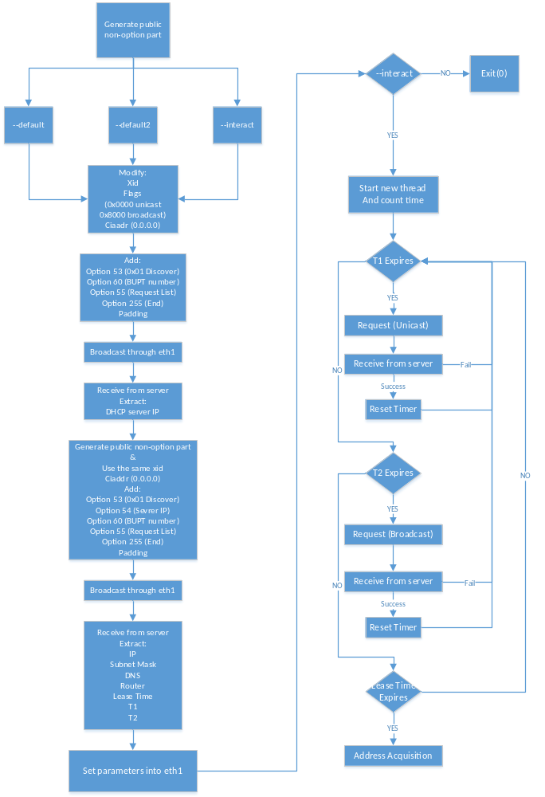
Flow chart for Address Acquisition
As can been seen from the flow chart for address acquisition function. The client will first decide which command does user input and according to the user’s input the program will decide the process. If the user input “--default”, the program will start the address acquisition process using broadcast as well as the server will reply the client by broadcast. If the user input “—default2”, the program will start the address acquisition process by broadcast to the server and the server will reply to the client with unicast packet. In this case, there is no HDCP relay in the intranet between the client and the server, so that the unicast cannot be delivered, to simulate this process, extra host is needed to serve as the client. So that the unicast offer and ACK can be delivered and captured by Wireshark. To construct the DHCP Discover packet, first the fields of the packet need to be generate and filled with the corresponding value. So that it can be reused by other three kinds of DHCP packet. Then adding the options for the packet. Including Option 53, 55, 60 and etc. According to user’s choice, the client will send to the server and the serve will respond to the client according to the flags in the packet.
If the user’s input is “—interact”, after getting the IP address, unlike command “--default” and “—default2”, it will start another thread to check the time instead of directly end the process. The second thread is trying to count time by comparing the time stamp. If the time stamp changes, it means that one second has passed. So that the counting time function can be achieved. If the time reaches T1, the client will send DHCP Request by unicast to request the server to renew its IP address, if the sever does not reply to the client, the client will wait until the time reaches T2, if the time reach T2, the client will broadcast send DHCP Request. If the server still not response to the client, it will wait until the time reach Lease time and then start address acquisition to get a new IP address.
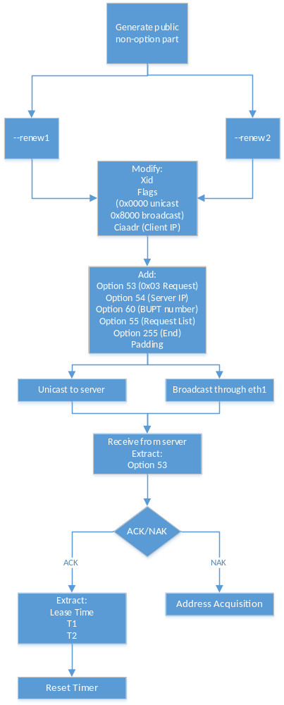
Flow chart for Renew IP
For new the IP address, beside using the multithread to check the time, the user can also renew the IP address manually by using the command “—renew1” and “—renew2”. If the user’s input is “—renew1”, it will start unicast the request as the timer reaches T1 do. If the user’s input is “—renew2”, the client will send the broadcast request to the server to new the IP address. If the server response an ACK, the client can continue to use the IP address, if the server reply with an NAK, the client will release the IP address and start a new address acquisition process.
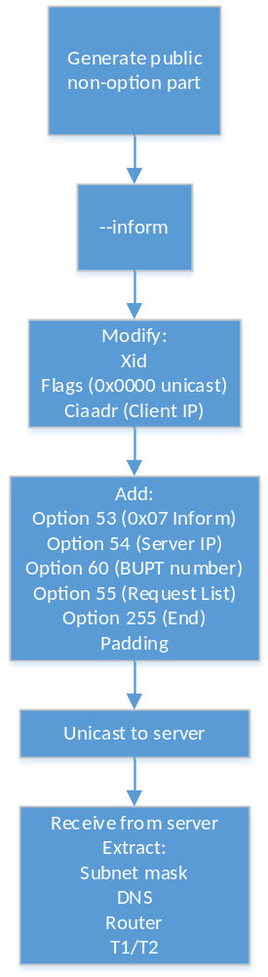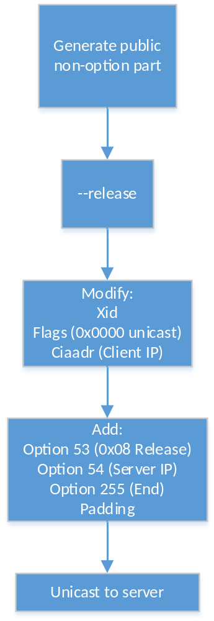
Flow chart for Inform Flow chart for Release
If the user input “--inform” the server will get the information from the configuration file and send the information back to the client, the client will extract the corresponding parameters and then display these parameters on the screen to show whether the “—inform” command successful.
If the user input “--release” the server will first check whether the released IP address is in the IP pool, if it is in the IP pool, the server will first delete the corresponding recordings in the dhcp.lease file and then add the IP in the end of the IP pool to reuse it.
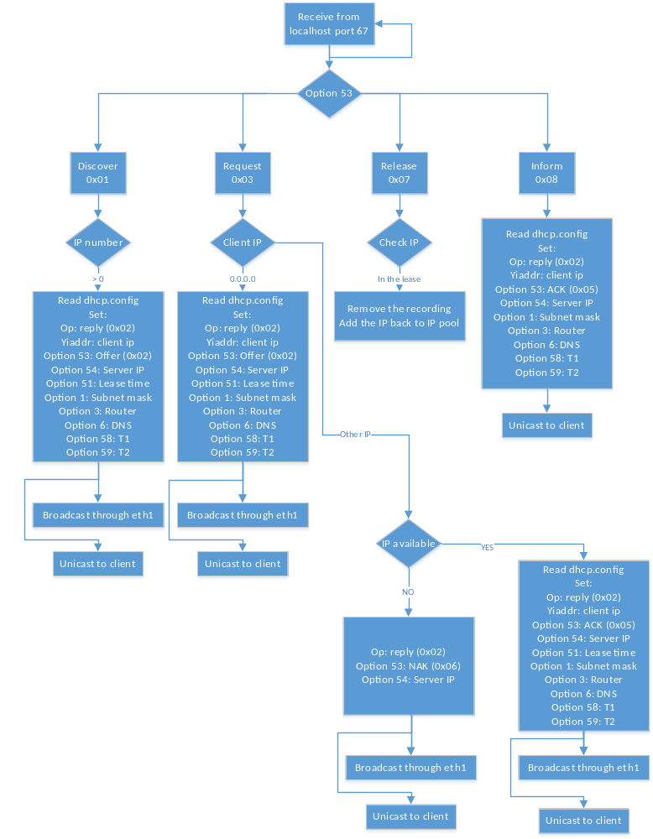
Flow chart for the server
As can be seen from the flow chart, the server is always listening for the packet arrive and by judge option 53 to decide which packet arrives. And then construct the corresponding packet to response to the client. If the packet is DHCP Release, the server will not response, just do some file operation instead of response.
The server will also unicast or broadcast to the client according to the flags defined in the client. If the client wants the server to unicast response, the server will send the packet unicast. If not, the server will broad the packet.

Results
--default:
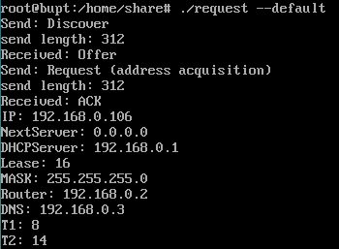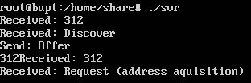
Client Server
As can be seen from the screenshot of the virtual machine, the “—default” command can manually get a new IP address and the client side can print the information of the sent packet and the received content including the IP address, Next server, DHCP Server IP, Lease time, T1, T2, Subnet mask, Router and DNS.
In the server side, the server will print the request type of the client and print the reply type to the client. Both of them can be seen by the user to have a hole view of the process.
--inform
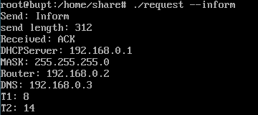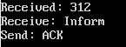
Client Server
As can be seen from the screen shot of the client and server, the “—inform” command used by the user just request some parameters from the server including DHCP Server IP address, Subnet Mask, Router, DNS, T1 and T2. Unlike the ACK for request, the ACK for inform does not reset the timer. It just asks some parameters from the server. And as can be seen from the server side, there is nothing to handle just get some parameters form the configuration file and send to the client.
--renew1
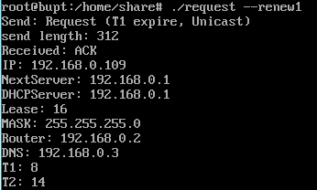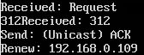
Client Server
As can be seen from the screen shot, the user input “—renew1” to manually renew the IP address. The IP address is still available, so that the server replies the client with ACK, and the client will extract all the information from the ACK packet and on the sever side, the server will print out the request IP, so that the user can have a good view of the process.
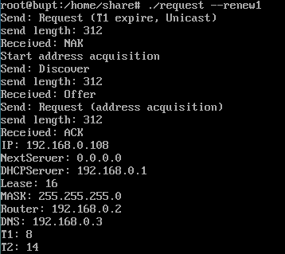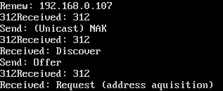
Client Server
The screen shot above shows the NAK process of the request. If the client uses an abnormal IP to request to the server or just time out. After checking the lease file from the server, the server will reply with an NAK and after receiving the NAK, the client will start address acquisition to get a new IP address instead of the abnormal IP or the timeout IP address. During the process, all the received packet and the sent packet will be print out for the user to check the process.
--release
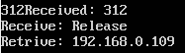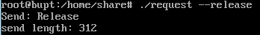
Client Server
The screen for the “--release” command shows that, after receiving the release packet form the client, the server will print the release IP address to show the released IP. After received the IP address, the server will response to the client, just start to remove the lease file and edit the IP poll.
--interact and the Wireshark result
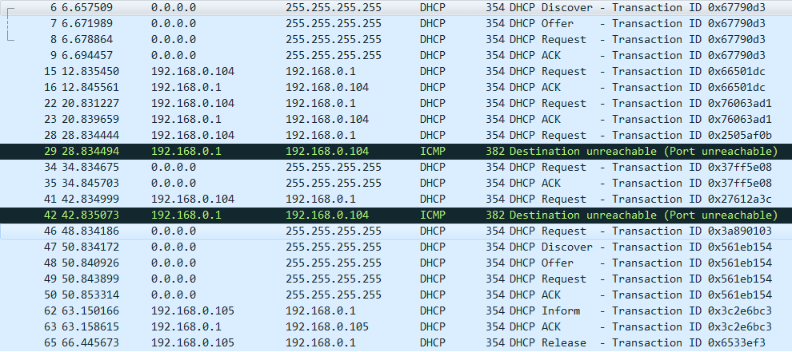
As can be seen form the Wireshark capture result. First the client will start interact with the server since it has no IP address, and the Lease time 16 seconds, so that T1 is 8 sec. The client unicast request the server per 8 seconds when reach T1, of the server is down, the client will wait for T2 and send the broadcast request, if the server is still down at T2, the client will still wait for Lease time and start address acquisition. If the server replies the client with an ACK, the client will reset the timer and continue to count the time.
The configuration file and lease records
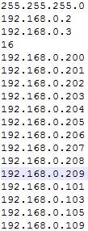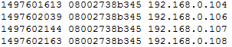
dhcp.config dhcp.lease

As can be seen from the configuration file and the lease record file, the 192.168.0.105 and 109 has been released, so that they are at the end of the IP pool and for the IP lease, they are missing.
Also, for the IP 192.168.0.108, it has been renewed by the client so that its time stamp has been renewed.

