Project report

Final Project-
DNS Server & Client

Course Title: Internet Applications
Name:

Date: June 15th, 2016

Overview
The goal of the project is mainly about:
- Deeply understand the details of DNS (Domain Name System) Protocol.
- Complete several server program (including local server, root server, TLD server and other servers) based on Ubuntu system.
- Complete a DNS client program based on Ubuntu system and run it by command line.

Requirements Analysis
- The environment of this coursework is based on Ubuntu operation system and using C language with gcc compiler and gdb debugger.
- To configure the virtual machine, we copy the virtual machine into 5, one is for client and local server, one is for root server, and one is for TLD server, one for 2nd level server and one for PTR server. After copied the virtual machine, we will modify the IP address of the virtual machines so that they can communicate with each other. And when we developing it, we use different port in order to developing the program in one virtual machine which is easier.
- The program should support Chinese domain name and both iterative and recursive query. There are three domain name serves, including root, TLD, 2nd level server.
- The client will use TCP to communicate with the local server and the server will use UDP to communicate with each other
- The server should use file to store the cache.

Preliminary Design
We design the DNS client in three main parts, including processing user’s command, sending corresponding query and process the received response.
For the design of DNS server, it includes 3 main parts, including receiving the query from DNS client or other server, analyzing the query and check cache or do iteration and recursion query and receiving the response and analyzing it, refresh or add the result into the cache. Finally send the response back to the DNS client.

DNS Client:
The specific process is as follow:
1. Process the input of the user
The program will first process use’s input. By typing in the parameters of the domain name and the type and input whether use iteration or recursion to query the server.
The client uses the following command:
./client 主页.百度.商业 -A 主页.北邮.中国 -CNAME 主页.百度.中国 -MX -R
The client first will extract the domain name and the corresponding query type and finally get the query mode (iteration or recursion). The user can query A, CNAME, MX and PTR type recourse records to the DNS server and the query type can be iteration and recursion. Only the Recursion mode that the user can query multiple domains. And both of these mode can query different type of the RRs.
After the user input all the domain name that he or she want to query, the client will begin to construct the TCP packet according to the input parameters. If the user use -I instead of -R, the RD field in the Flag part will be 0 instead of 1 to indicate that the query will use iteration instead of recursion.
2. Construct the packet according to the user’s input and send to the local server
The transaction id will be a random number generate by the client to indicate the DNS query packet. And then the flag area will be added to the send buffer. In the flag area, the recursion desired part will be modified to indicate whether the server will use the recursion query or the iteration query. And after constructing the flag part, then according to the numbers of the user’s wanted query domain name, the questions count will be added to indicate the number of the queries. And then follows the Answer RRs, Authority RRs and Additional RRs. All these three parts are 0, because that those parts will be filled by the DNS server if there are any RRs. That’s the end of the header part.
Then according to the number of the user’s input domain name, the client start to generate the Queries part. In this part, all the query will be separate with each other. Since the domain name is in Chinese, and the encoding of Chinese used in Ubuntu is UFT-8, so each Chinese character’s length is equals to three char. By splitting the domain by dot and then calculate the sub domain’s length, the sub domain's length will be get which will be in the start of the domain to indicate the start and the length of the sub domain instead of the dot in the human reading language. If the query type is PTR, then first convert the IP address into the reverse version, for example, if the user want to query the domain name of the 1.2.3.4, first the program will revert the IP address into 4.3.2.1 and then add the .in-addr.arpa domain at the end of the reversed IP address. The in-addr.apra domain is the root domain of the PTR query, which is made to distinguish the normal DNS resolve and the reverse DNS resolve which the PTR (PoinTeR) query is. After finish the name part of the single query, the query type will be added following to the name, and the query will follows with the class type, in our case, the class type is always 0x0001, which stand for Internet.
After adding all the queries to the send buffer, the client will send the packet to the local DNS server by TCP protocol using port 53, which is the standard port of DNS.
3. Process the received data from the local server
After send out the query packet, the client start to listen to the connection and waiting for receiving the response of the server. After received the packet from the server, the client will first analyze the flag part, so that it can know whether there are answers or the input domain is correct or not. If the Rcode is 0x03 which means no domain, and if the Rcode is 0x00 which means correct and there are answers. If the authority bit is set to 1, that mean the answer is resolved by the authority server not from other server that have the corresponding cache.
Then is to check the answer number, authority and addition numbers. These three parameters indicate the how many records are there in the answer area. Then according to the answer, authority and answer number to extract the corresponding records.
The client will first skip the query part by get the length of the query section. If the name is a kind of pointer or mixed of pointer. The server will look for the domain name in the correspond area of the received packet.
The following screenshot is the code for processing the pointer domain name.
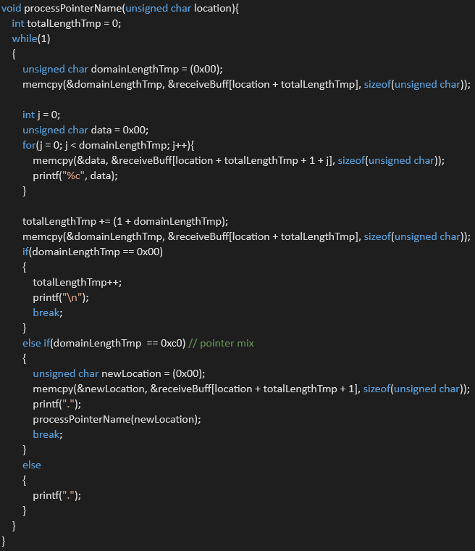
If not, the client will first get the length of the sub-domain and then according the length of the sub-domain to separate each domain using dot, and if the domain’s length is zero which means the end of the domain. Then the client will follow the protocol to get the following section value according the specific length. For A record, the IP address’s length is 4, and the IP address is in numeric format, so there is no separate byte like the domain name section. For the CNAME records, the data part will be resolved with the same method that used to resolve the domain name, since the CNAME value is still a name. For the MX records, the data is the domain name of the mail exchange server and there are corresponding A records for the MX server, so after get an MX records, there always have one or several A records in the addition part. For the PTR records, the resolve method is almost like the same as the CNAME records. By the same time that the client resolve the answers, it will print out the result to the screen.
DNS local server:
The DNS local server is the core of the whole DNS program, is will separate different queries to single one and request the query to the corresponding server.
The specific process is as follow.
1. Process the query from the DNS client
The client will first send the query to the local server, the local server will first get the parameter including RD bit and query number from the header of the DNS packet to make a further process. Then the server will according to the query number to extract the query records one by one and then according to whether the client want iterative or recursive query. The local will first get the name field in the query records. Each domain name will start with the length of it, also it is the method to separate each domain. The last domain is the TLD (top level domain) which will be used for recursive query. Because according to the requirement, for the recursive query, the local server will send the packet directly to the TLD server, so the top level domain of the query domain name is important.
2. Check whether there is a cache
After get each domain name, the local server will first check whether there is a cache at local server. By combine the query type (A/CNAME/MX) and the domain name, the local server will get the corresponding file and by reading the file, in the file, there are data and its corresponding TTL, if it is the records of MX server, there is addition preference in the cache file.
After getting the data from the cache, the local server will continue to check for the next query until there are no queries. If there are no cache for the specific query, then the local server will query to the corresponding server, if it’s iterative query, the local server will query the root server for the TLD name server. If its recursive query, the local server will check the local NS records and send it to the TLD server directly.
In addition, the cache will not store the PTR record, since PTR record is to verify the correctness of the A record, so that, neither server should cache the PTR records and all PTR records must be authorized.
3. Query the upper level server according to the query type
if it’s iterative query, the server will first send the query to the root server and the root server will resolve the top level domain of the queried domain name and then return the responsible next level name serve with and NS record in the answer section as well as a corresponding A record that indicate the IP address of the name server. After the local server received the name server of the next domain, it will query the next level domain name server until there are answers or no such domain name returned by the SOA. The following code show how our program achieve this process.
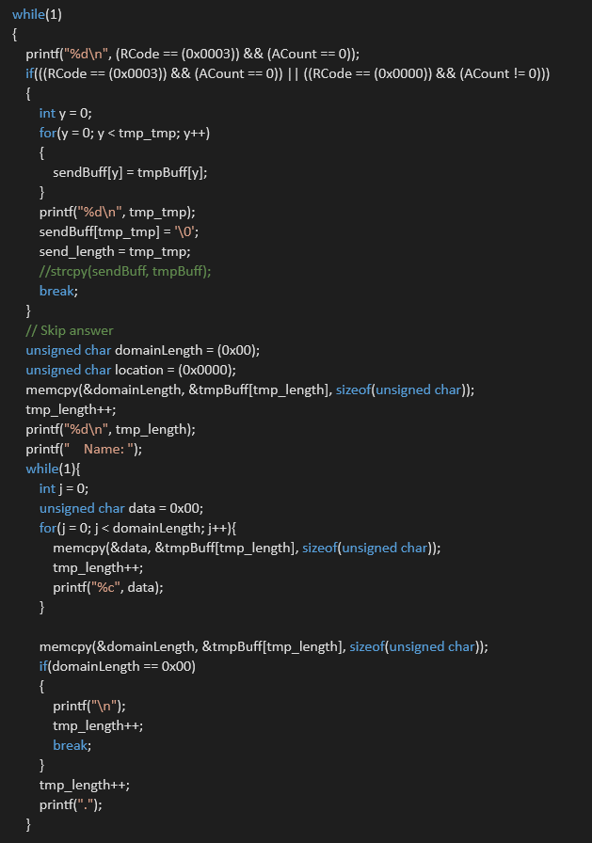
The programming will use iterative method to achieve that. After received that there are answers or no such name, the local server will return the result to the client.
3. Cache the response and response to the client
After received the answer from the name server which can be the cache from other name server or the records in the SOA, the local server will automatically cache the answer. After received the response that by recursive query, the local server will first analyze it by extracting the name, the query type, the data and the TTL or preference from the answer section. The analyzed data will store into the document in the RR folder of the local server which will be used when the client query the same domain name.
4. Check the TTL of the cache
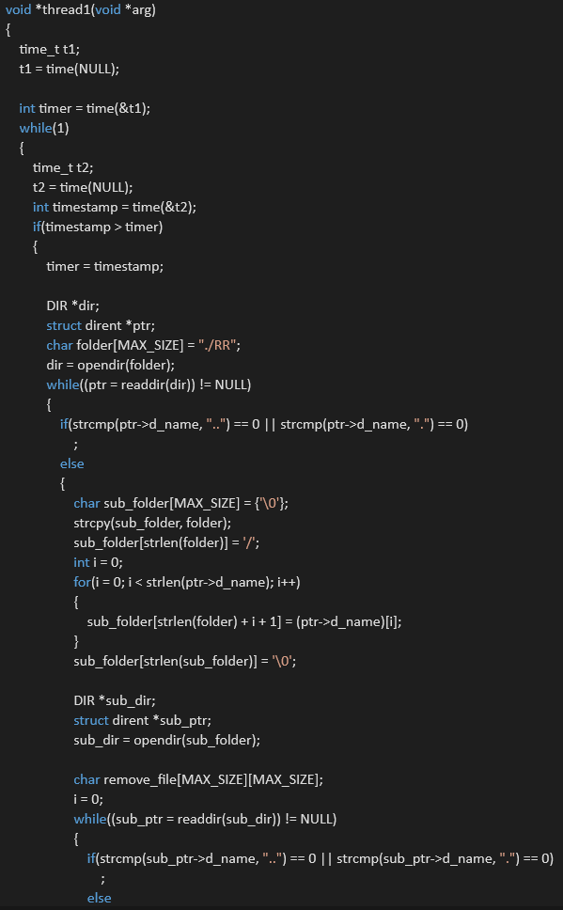
The upper shown screenshot is the multithread code to check the TTL.
The data from the upper level server does not available for a long time, it will be unavailable when the TTL timeout, so the local server will use the multi thread to check the cache file to see whether the cached record is available or not. The new thread will first get the time stamp, and check the time stamp. If the time stamp changes, which means that the time has passed one second. Then the local server start to check the cache file in the RR folder. The local server will first read all the folders in the RR folder which can be type A, CNAME, MX. After get all folders, the server will start to read all the files under the folder which is record for specific domain name. If the TTL of the domain is not less than zero, then it will be decreased by 1, if the TTL is less than zero or equals zero. The record should be removed or if there are only one record, the record file will be removed. The local server will modify the cache file by reading the content and then put the data into another file and then remove the old file and rename the new file into the old file.
In addition, the server will stop check the TTL when processing the file, since if read and writing at the same time, where will be an error when reading the file, or the content the local server read will be not available. So this is to avoid the misreading the wrong data.
DNS root server:
The root server only works when the query type is iteration according to the requirement, the only when the query type is iteration, the local server will send the query to the root server if and only if there is no cache in the local server.
1. Resolve the query form the local server:
If the client use the iterative query to query the records, the local server will send the packet to the root server and the local server will extract the TLD of the query domain, since the local server will first split the queries if there are multiple query in the received packet, so there is only one query in the packet that send to the root server, so the server will just get only one query in the query field, which will be more easier to handle and process.
2. Check the TLD in the local records and return the result:
The TLD information is stored in the local NS folder in the root server. After get the TLD of the requested domain name, the root server will start check the TLD server that responsible for the TLD domain, if there are the record in the folder, the root server will read the file and also read the corresponding A record in the A folder to get the IP address of the TLD server. If there are no TLD record in the root server, the server will read the SOA file and put the SOA information into the authority field, and also the Rcode will be set to 0x03 to indicate “no such name”. If they are TLD server in the record, the root server will return the TLD server in the NS record in the authority filed and an A record in the addition field.
DNS TLD server:
Recursive query:
1. Check the 3rd level domain and query the corresponding server
The program is almost the same as the root server, which is check the local NS record, if no record is found , the sevrer will return SOA information which indicate that there are no such 2nd level domain. If there are the 2nd level domain, the TLD server will query the corresponding IP address.
2. Cache the answer if it is recursive query
If there are results, the TLD server will like the local server to analyze the received packet and then cache the result if there are any if and only if it’s recursive query
3. Response to the local server
After analyzed the received packet, the TLD server will send the packet back to the local server.
Iterative query:
1. Resolve the query form the local server
This program is the same as the local server. It will not be discussed here.
2. Check the 2nd level domain in the local records and return the result to local server:
The program is almost the same as the root server, the only difference is that the TLD server will resolve the 2nd level domain instead of the TLD domain and the record in the NS file is not different from the TLD server.
DNS 2nd level server:
The 2nd level server’s program is almost the same as the TLD server, if there are no lower level name serves, the 2nd level name server must have the record for the domain and without calculate the TTL, since the name server is the SOA of the domain name, the domain name and it’s record is always correct and available.
PTR server:
The server is the same as the DNS server’s, the only difference is that the record type is PTR and the domain is different. The root for PTR is in-addr.arpa and the TLD and other domain is number. In the real world, there are no as many as the protocol indicate, so the next level of the PTR root name server may only one in the specific region. Except this, the code and the logic of the PTR server is the same as the normal DNS server

Detailed Design
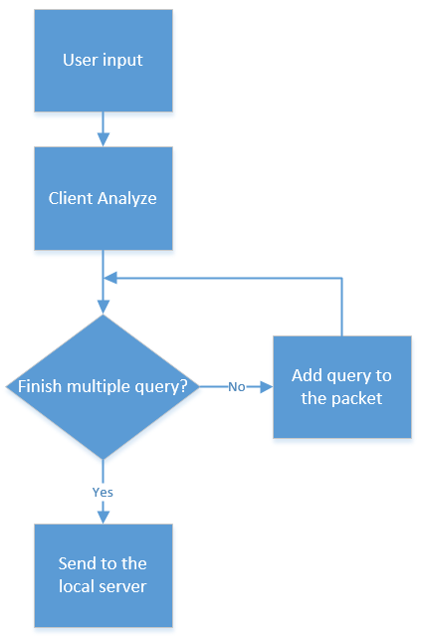
As can be seen form the flow chart, the client will first process the user’s input data, and then the client will analyze the user input and construct the query packet. The client will not send out the packet until finished processing the user input. After adding all the queries into the packet, the client will send out the packet to the local server.
After received the response from the local server. The client will first get all the query number, answer number, authority number and addition number. According to the number of these four field, the client can analyze the corresponding type of the answer instead of the wrong answer since the only way to separate the four field is according to the number of the answer and resolve the record one by one according to the protocol and the domain length.
Then according to the protocol, the client can resolve the type of A, CNAME, MX, SOA and PTR type of the record. The SOA type is appeared if and only if the query domain does not exist. And the MX type of query will have the MX record and A record to store the name of the name server and the IP of the name server. For type A record, the client will print the domain name and the IP address of the query. For the CNAME record, the client will print the queried domain name and the corresponding CNAME of the domain name. For PTR record, the client will print the PTR domain name which can be different with the IP address and the corresponding domain name of the PTR domain. For the MX query, the client will print the domain name and then the mail exchanging server name and its IP address.
The flow chart is as follow.
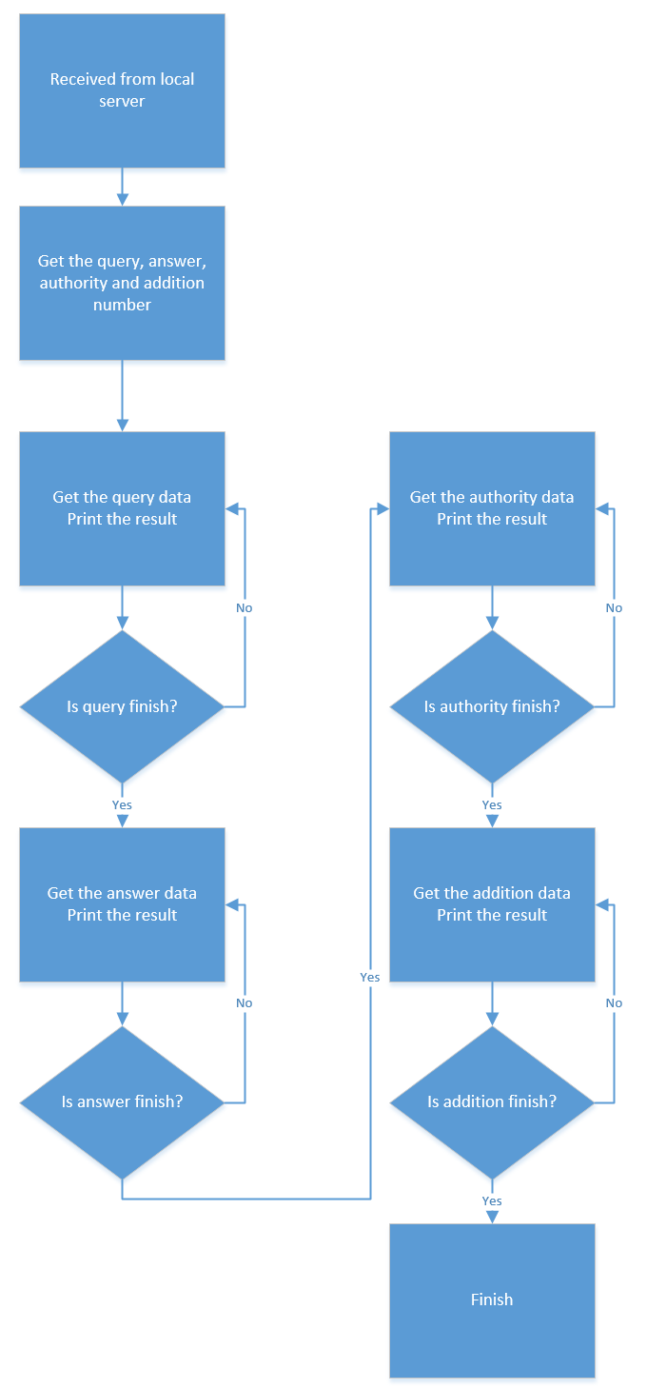
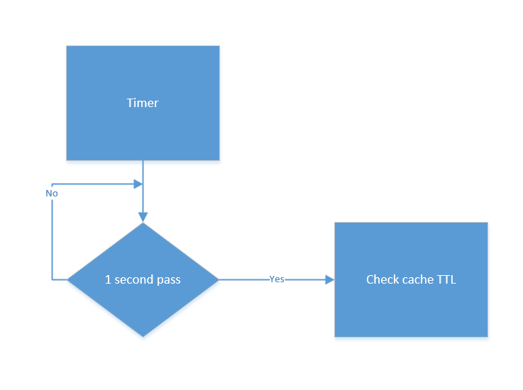
The local server and other server except the root server and the lowest level serve need not check the TTL of the cache because they does not have cache. And also the NS record does not have cache since the NS record is stored in the upper level name server and the NS record will not expire forever.
The server will user multithread to check the cache to see whether the cache is expired or not. If the server received a query, the server will stop the thread, and then check the corresponding cache. After check the cache, the server will start the thread to check the file to check the TTL. If the TTL is less than zero, the record will be removed, and if there are only one record in the file, the file will also be removed form the cache.
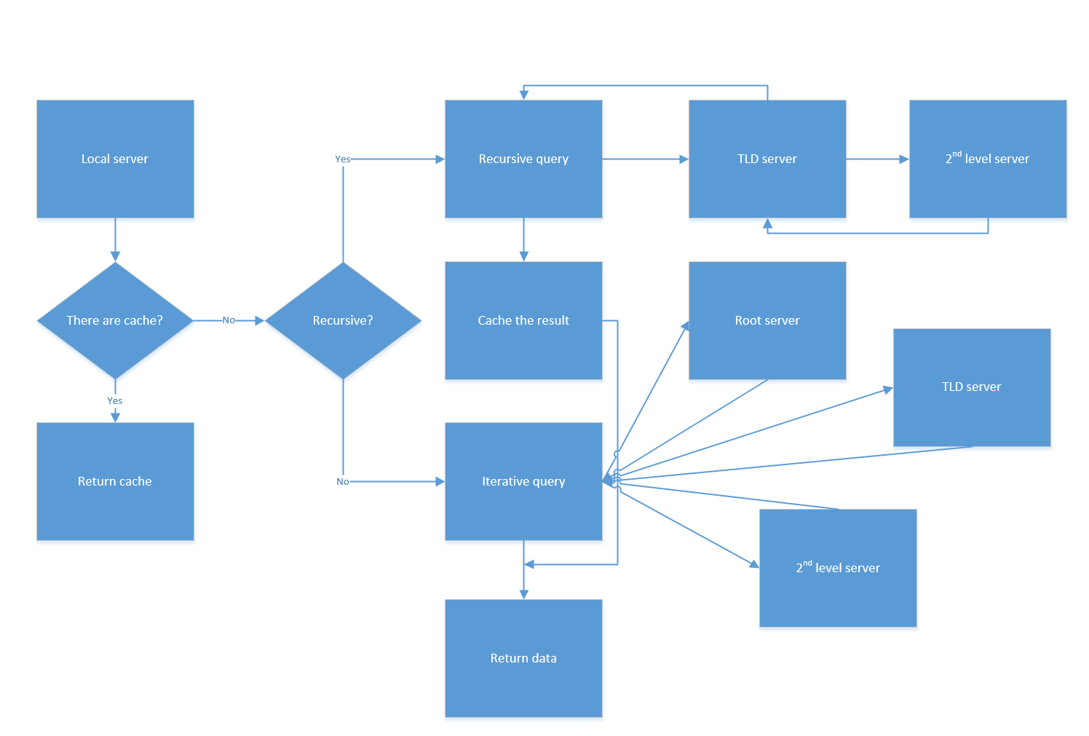
The above flow chart is the flow chart for the local server and the other servers. After getting the packet from the client, the local server will first check whether there are cache in the server if there is a cache, then the server will return the cache to the client. If there are no cache in the server, the server will check the type of the query is iteration or recursion. If it is iteration, the server will send the packet to the root server, if not the local server will analyze the TLD of the query domain, and send the query to the TLD server. For recursive query, if the TLD server does not have the cache, it will query the lower level server to get the resolve, and so on until there are records or no such domain name. For iterative query, the local server will send the packet to the root server, the root server is to resolve the next level of the domain name server. Then the local server will query the next level name server and so on, until the domain name is resolved or be identified to be no such name.

Result：
To test the result of the program, we first begin to construct the virtual machines to run several server program, the server’s including local server which is within the same virtual machines of the DNS client, and one VM for root server, one for TLD 商业, one for TLD 中国, one for the name server of baidu and one for the name server for youku and BUPT. After running the all the servers and configure the server with an addition network interface card, so that all the server can communicate with each other, and then configure the original interface to different IP address so that we can use ssh to connect to the virtual machine. The following picture is the running status of our virtual machines.
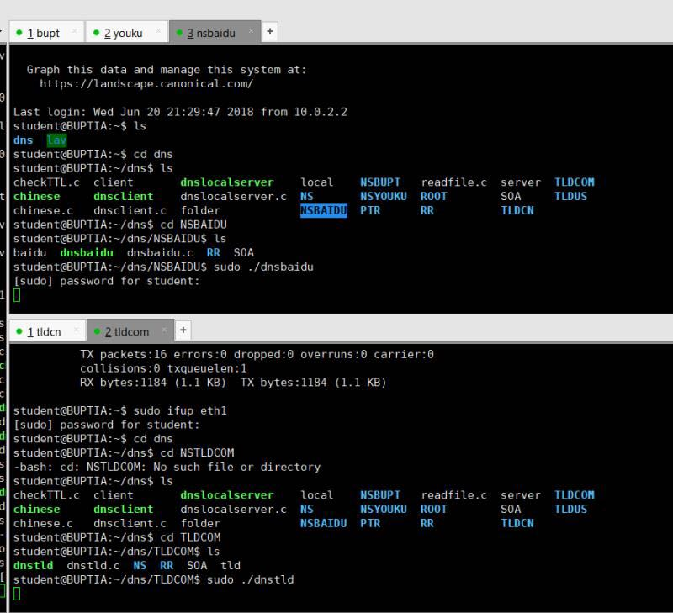
In the picture, we first run the server program in each VM, each VM have their role. And the following picture is the file structure of the sevrer.
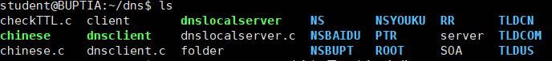
As we can see from the files. The NS folder is the place where the local server stores the NS record for the recursive query. When the client use the recursive query, the local server will find the corresponding NS record for the TLD domain. And for the RR folder, this folder is for the local server to store its cache, the local server will user multithread to check the folder and its subfolder and all files in it. The servers’ file structure is almost the same which contains a NS folder and a RR folder for the cache. Except the lowest level name server, its RR folder is to store the records not the cache. And there is a SOA file which store the information of the domain. If the domain name is not exist, the server will read the SOA file and send back the corresponding packet.
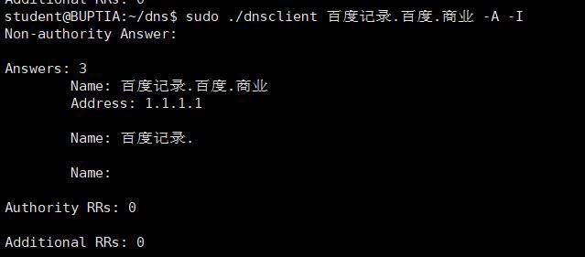
As can be seen from the picture that is the result of the query. The client is using iterative query and the result of the query 百度记录.百度.商业is 1.1.1.1，there are one answer and the authority and addition records is zero.
The following picture show the Iterative query of the domain name, since the client and the local server are at the same virtual machine, the IP address of the are both 127.0.0.1. The client will first send the packet to the local server using TCP which cannot be resolved by the Wireshark, it just will show the TCP data. And the local server check its cache, if there are no cache in the local server, the local server will query the root server which is 192.168.1.3, and then the root sever will analyze the packet and send the next server of the domain to the local server which IP address is 192.168.1.2 and then the local server will send the query to the next server which return by the root server. After received the query from the local server the COM server will analyze the 2nd level domain and check the local records to see whether there is an domain called 百度. And then the COM server will send the name server’s IP address which response for the domain of 百度. The local server will then query the name server of 百度. The name server which is the NS record is stored in the authority section and the corresponding IP address which is the A record is in the addition section. Then the name server for 百度 will return the result to the local server and the local server will send it back to the client. The result can be whether there are result or no such domain.
As can be seen from the following Wireshark capture, the there are two TCP packet which is the query and response between the DNS client and the local sevrer. And there are six UDP DNS packet which are the query between the local server and three name servers.
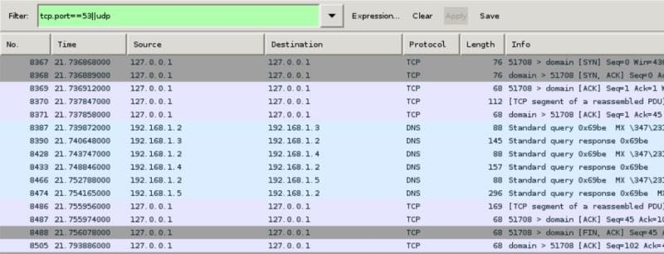
In the following picture, we are using the recursive query to query the domain name. In this process, the result can be shown as follows, there are two answers which mean that there are two mail exchange sever of 百度 and the corresponding IP address are stored in the addition section.
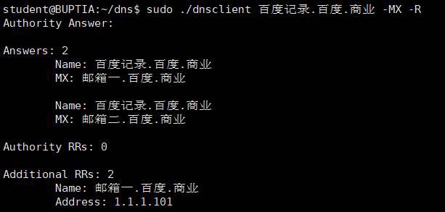
The client will first send the packet to the local server using TCP and the local server will analyze the top level domain of the queried domain name and then send the query to the corresponding TLD server, if there are no such top level domain, the local server will return no such domain with a SOA, if there are such top level domain, the local server will send the query to the TLD server, and the TLD server will analyze the lower level domain name, if there are such domain, it will send the query to the corresponding domain name server, if not the server will return no such domain name. Then after received the response from the server the local server will cache the result and return the response to the client using TCP.
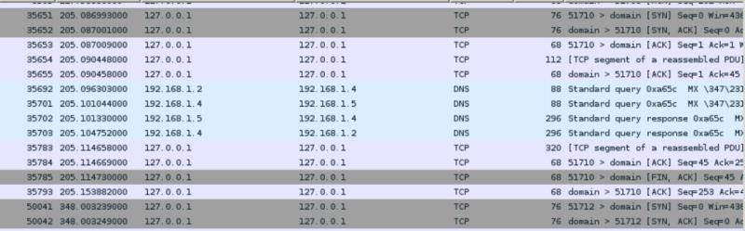
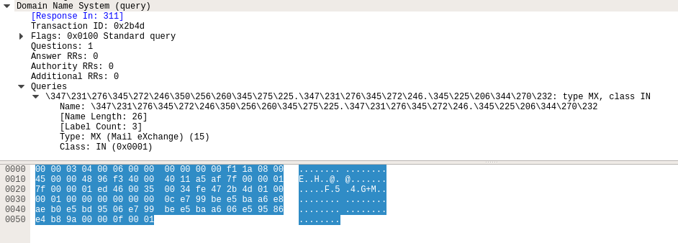
This is the screenshot of the Wireshark, it can be seen from the picture, the query can be resolved by the Wireshark, but when the protocol changes to TCP, it can’t be resolved since TCP, but the packet is still correct.
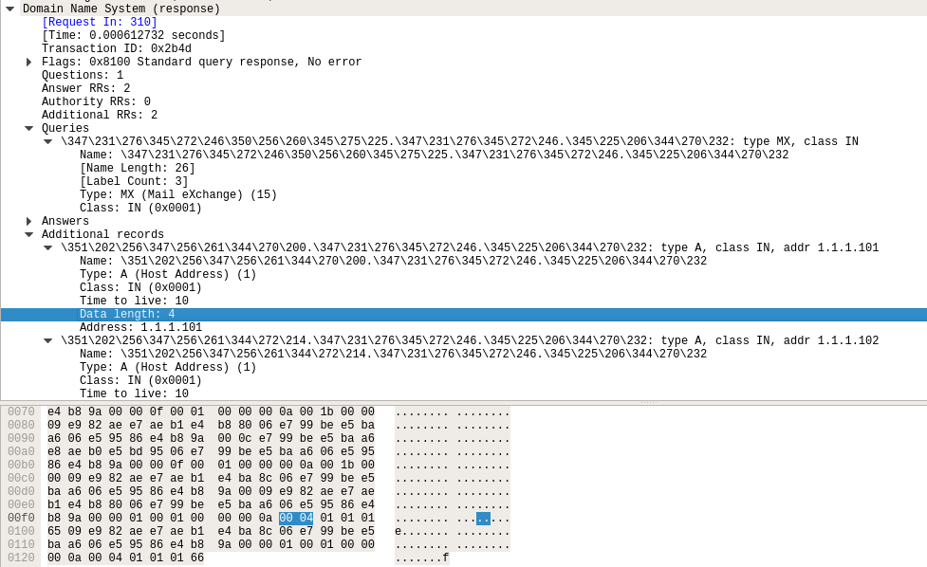
And also this is the screenshot of the response packet, the server returns two answers and all three answer is MX record, there are two addition record which is the type A record to indicate the IP address of the MX server.

Conclusion：
According to the Wireshark, our program is successful and the program achieved the task. During the coursework, we learned a lot, including programing, teamwork and searching the corresponding document. Especially the searching and learning. We have to read the RFC document and other blogs to get a further understanding of the DNS protocol. Finally, we finished our program.
Works:
A:
1. analyze the DNS protocol and looking for the RFC document to get understand the DNS protocol
2. use wireshark and nslookup command to capture total five kind of packet including query and type A, type CNAME, type MX and type PTR records.
3. construct the DNS client and the local server.

B:
1. analyze the DNS protocol and looking for the RFC document to get understand the DNS protocol as well as looking for other documentations
2. construct the DNS root, TLD, 2nd and other servers.

