Project report

Final Project-FTP Proxy

Course Title: Internet Applications
Name: WANG Yufei (2013213208)
WANG Ningdong (2013213216)
Date: June 15th, 2016

Overview
The ultimate goal of the project is to deeply understand the related knowledge of FTP for completing a FTP proxy program based on Linux command line terminal. Basically, the FTP proxy is able to set up separate control connections with both FTP client and FTP server and if required, the FTP proxy need to set up data connection separately with these two devices, involving both passive mode and active mode.

Requirements Analysis
- The environment of the project is based on Linux operation system using C language with gcc compiler and gdb debug tool.
- In order to set up FTP server easier, we make the use of existing software like FileZilla server. And the existing FTP client in the Linux OS.
- In order to set up separate control connections with FTP client and FTP server respectively, there are two specific difficulties we should figure out. On the one hand, since the FTP proxy serves as an intermediary for file transfer between the FTP client and FTP server, its ability to receive commands including PWD, CWD, LIST/MLSD, MDIR, DELE and RNFR/RNTO, which all from FTP client using control connection need to be configured and modified well if necessary and then forward the instructions to FTP server using the same control connection. On the other hand, the FTP proxy should provide the receiving ability to resolve and modify replies from FTP server, and then deliver the replies to FTP client.
- In order to set up data connections separately, two points involving data transmission should be realized successfully. One is that the FTP proxy could receive the file from FTP client and then upload it to FTP server when there is an uploading request from FTP client. Besides, another one is the ability of FTP proxy to receive the file from FTP server and then download it to FTP client. Also, FTP proxy deliver the file to cache for store at the same time. In addition, when the requested file already exists in the cache, the FTP proxy not necessarily download the specific file from FTP server but from its cache directly.

Preliminary Design
We design the FTP proxy in eight main parts, including 6 sockets, 1 extra method, 1 cache method.
- Proxy_cmd_socket:
The socket is implemented for listen to the connection of the client, in order to activate all flowing operation. In our FTP proxy, the proxy_cmd_socket is established at the beginning of the start of the proxy, it listens port 21 message (of course can be changed easily by changing the #define value, but the port of the server and the proxy should be modified at the same time), after the socket is bind and listen, it is added to a file descriptor set. When the socket is selected, it means that there is a connection launched from a client, and the proxy should accept the connection and establishes the control connection to the server which is connect to 192.168.56.1 ‘s port 21. Then all the control connections are established both for standard mode and passive mode (the control connection are the same). And then add both accept_cmd-socket and connect_cmd_socket to the FD_SET.
- Accept_cmd_socket:
The accept_cmd_socket accepts the control connection from the client, when the accept_cmd_socket is selected, it means that the client send the commands to the server, and the proxy get the commands’ content and analyses the command if the content is PORT it means that it is the standard mode and the server should connect to the specific port that provided by the server, and the proxy will change both the IP address (client IP address -> proxy IP address), port number (client port -> proxy’s available port number) and then send to the server, so that the server will connect to the proxy when establishing the data connection; if the content is PASV which means that the client is require the server to enter the passive mode, and the proxy will record the status; if the content is RETR, the proxy will get the required file name and type to judge whether the file is in the cache or whether it is PDF or JPG format, to prepare for cache transmission or store the file in the cache directory; if the content is STOR it means that the client will upload file to the server, the status will be recorded. For other status the socket will transfer the content directly to the connct_cmd_socket.
- Connect_cmd_socket:
This socket is to receive the command and the reply from the server, and send the command to the accept_cmd_socket which means that send the command and the reply from the server to the client. In this process, the proxy will check the content of the received packet, if there is “226 Entering passive mode…” which means that it is the reply of the server that it has already prepared for the passive transmission and the client should connect to the port that provided by the server. The proxy modifies the IP address and the port number (server IP address-> proxy IP address, server port -> proxy available port). So that the client can connect to the proxy and the proxy can connect to the server when establishing the data connection.
- Proxy_data_socket:
Standard mode:
The proxy_dat_socket is established when the accept_cmd_socket receives PORT command and the proxy_data_socket is listen to the port provide by the proxy to let the FTP server to connect. When the proxy_data_socket is selected, it means that the server has begins to start the data connection to the client, and then it accepts the connection and start the connection to the client according to the PORT command provided client IP address and the port number, when finishes all the connection the accept_data_socket is established and the connect_data_socket is established, the add both of them in to the FD_SET. At standard mode, the proxy_data_socket will execute no operation except the accept and the connection establishing from the server to the client.
Passive mode:
The proxy_data_socket is established when the connect_cmd_socket receives “226 Entering…” command and the proxy_data_socket is listen to the port provide by the proxy to let the FTP server to connect. When the proxy_data_socket is selected it means that the client has begans to connect to the server, in this case, is the proxy. The FTP proxy accept the connection and start a new connection from itself to the server, uses the IP address and port address from the packet of server that is reply of the PASV. Then the hole data connection will be established. During the establish of the connection, if the file is cached in the cache file, the connect_data_socket will be closed in order to transferring the data only between the proxy and the client. Meanwhile, the server will not close the connection due to the proxy has close the data connection which means that the proxy has abort the transmission.
- Accept_data_socket:
Passive mode:
If the file is not cached in the proxy, when downloading, if the file format is JPG or PDF, the proxy will store the file into the cache direction in order to reduce the bandwidth of the server. If the file is not JPG or PDF format, the proxy just forward the data from the accept_data_socket to the connect_data_socket, if the file is cached in the proxy the proxy will start the transmission back to the client, the detail will be discussed in “Cache method” section. If the file is upload from the client to the server, the proxy just forward the data from the connect_data_socket to the accept_data_socket. If the data is not the file content (not the file transmission), the proxy will also forward the data from the connect_data_socket to the accept_dat_socket or accept_dat_socket to the connect_data_socket.
Standard mode:
At Standard mode, the accept_data_socket is only being selected when there are data from the client to the server, so FTP proxy just forward the data from the client to the proxy and from the proxy to the server
- Connect_data_socket:
Passive mode:
At passive mode, the accept_data_socket is only being selected when there are data from the client to the server, so FTP proxy just forward the data from the client to the proxy and from the proxy to the server
Standard mode:
If the file is not cached in the proxy, when downloading, if the file format is JPG or PDF, the proxy will store the file into the cache direction in order to reduce the bandwidth of the server. If the file is not JPG or PDF format, the proxy just forward the data from the connect_data_socket to the accept_data_socket, if the file is cached in the proxy the proxy will start the transmission back to the client, the detail will be discussed in “Cache method” section. If the file is upload from the client to the server, the proxy just forward the data from the accept_data_socket to the connect_data_socket. If the data is not the file content (not the file transmission), the proxy will also forward the data from the connect_data_socket to the accept_dat_socket or accept_dat_socket to the connect_data_socket.

- Get_free_port:
First, form a socket and a struct of internet, set the port number of the struct as 0, which means that the port number should be allocated by the OS automatically (of course, a free port number), and then if the bind is success, we use the getsockname to get the sock and its corresponding struct’s information including the port number, and then close the socket and return the free port number. Then a random free port number can be get. And for the fixed port number, it can implement by using setsockopt to free the port after close the socket, but we use it for the fixed FTP control connection port and data connection port.
- Cache method:
Standard mode:
First, when the accept_cmd_socket receives the RETR command, it checks the filename and type to determined that whether the file should be cache or has already cached, if not cached, the proxy forward the RETR command to start the file transmission, while the transmission, the proxy automatically cache the file if the file is confirmed to be cached in the proxy; if the file is cached in the cache directory, the proxy will not forward the RETR command, and the start transmit the “150 Opening…” command to the client and start connection to the client, if the connection is established, start to transmit the file, after finishing transmission to the client, the proxy will send another command to the client which is the “226 Successful…”, and the close the data connection, close the corresponding socket and clear the corresponding socket in the FD_SET, the cache operation will finished.
Passive mode:
First, the same is standard mode, check whether the file need to be cached in the cache direction and cache the file if need, when return the file, the proxy close the data connection to the server and start transmission to the client, which is the same as the standard mode.

The proxy_cmd_socket, accept_cmd_socket, connect_cmd_socket consist the control connection part, they all forward the command data and command and the most importantly the checking part of passive/standard mode, download/upload, cache/not cache, and etc.

The proxy_data_socket, accept_data_socket, connect_data_socket consist the data connection part
Meanwhile get_free_port and cache method are implemented within the specific socket.

Detailed Design
Design principle:
According to the FTP’s operation, and RFC 0959. And the capture result of TCP, FTP packet from Linux to the FileZilla server. (The ftp client is the CLI version in Linux, not FileZilla client)

According to the capture of the packets in standard mode, the control connection is established from the client to the server, and it lasts until the client close the connection (QUIT command). On the other hand, the data connection is different from standard mode to passive mode
In the standard mode, to download a file from the server (for example, get b.txt), the client first sends PORT command to inform the server that which port should the server connected to, and the server will not connect to the client, until it receives the RETR command, then the server start connect to the client, and while the data connection is establishing, the serve first send “150 Opening data…” from the control connection to inform the client that it is the server connecting the port and the following is the data, after the data connection is established, the server begins to transfer the data, and then start close the data connection, while at the same time the server send “226 successfully…”, to inform the client that the data has been transferred successfully and the client should close the connection.
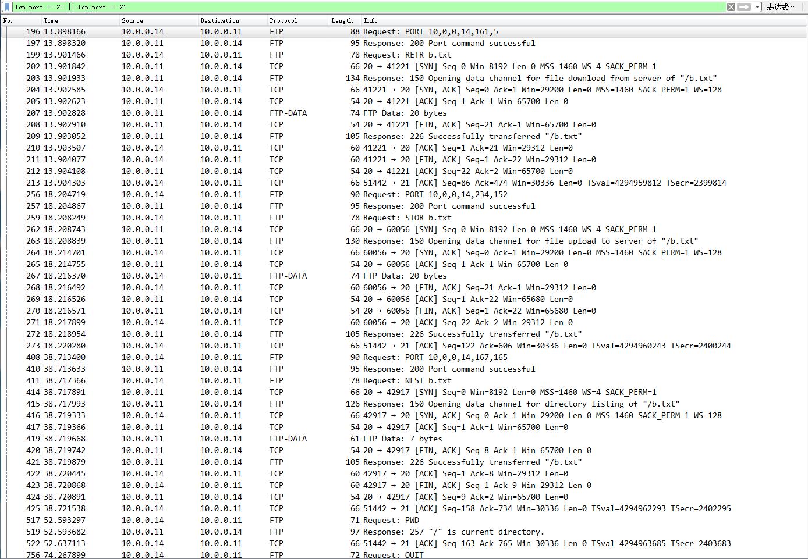
In passive mode, the data connection sequence is different from the standard mode, for example, the client wants to download file from the server in passive mode, the client first send server “PASV”, to inform the server to enter passive mode, and after receive the command, the server send back the passive mode parameters including server’s IP address and its port number, then after receiving the reply, the client start to connect to the server before the “RETR” command is send, then the RETR command is send and the data transferring begins, the rests are the same.
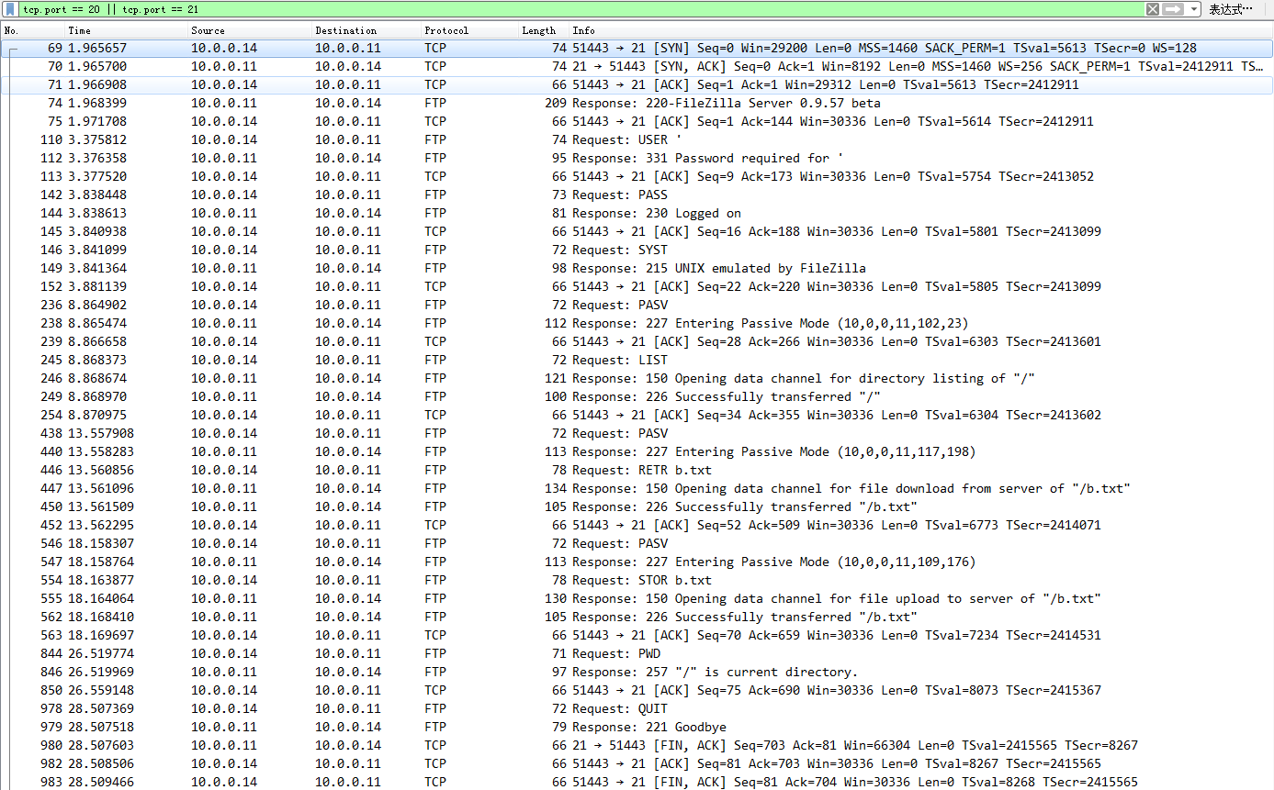
Flow chart
Proxy_cmd_socket:
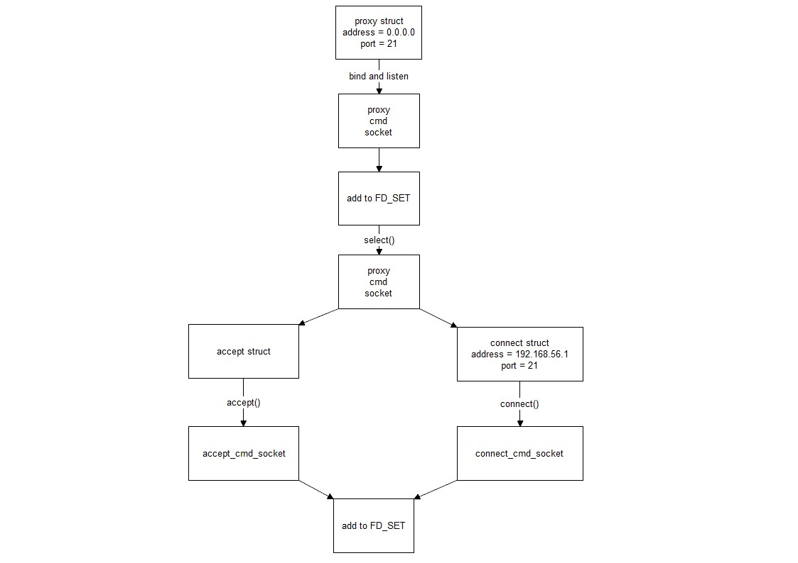
Accept_cmd_socket
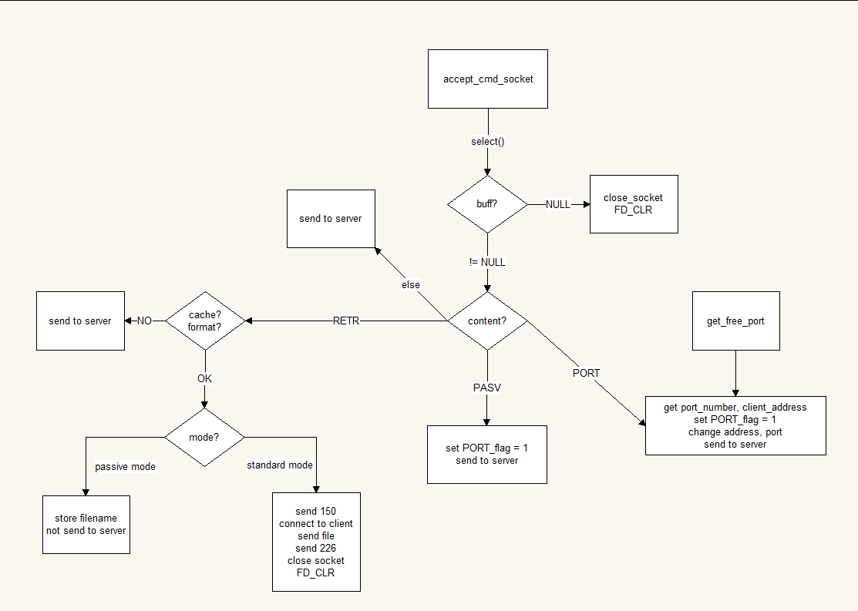
Connect_cmd_socket
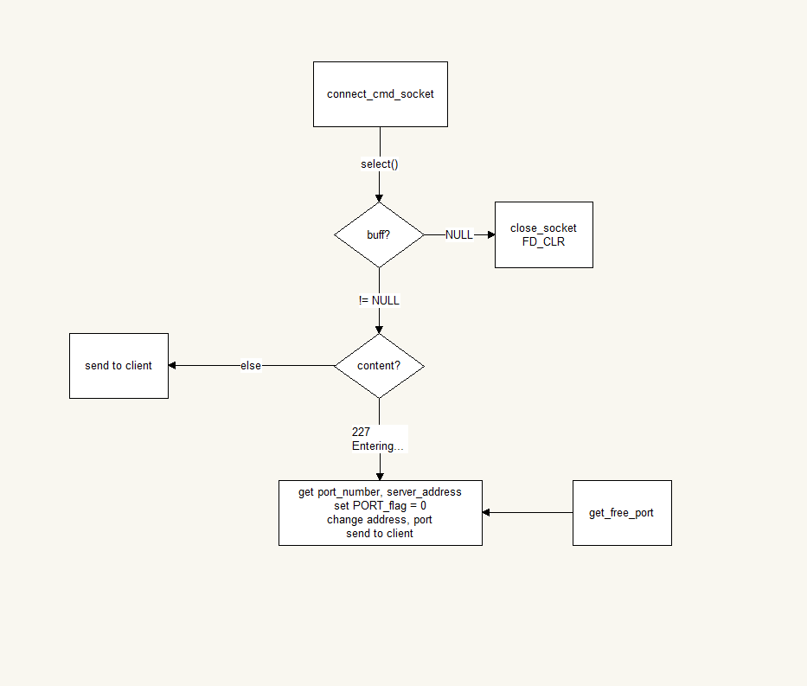
Proxy_data_socket
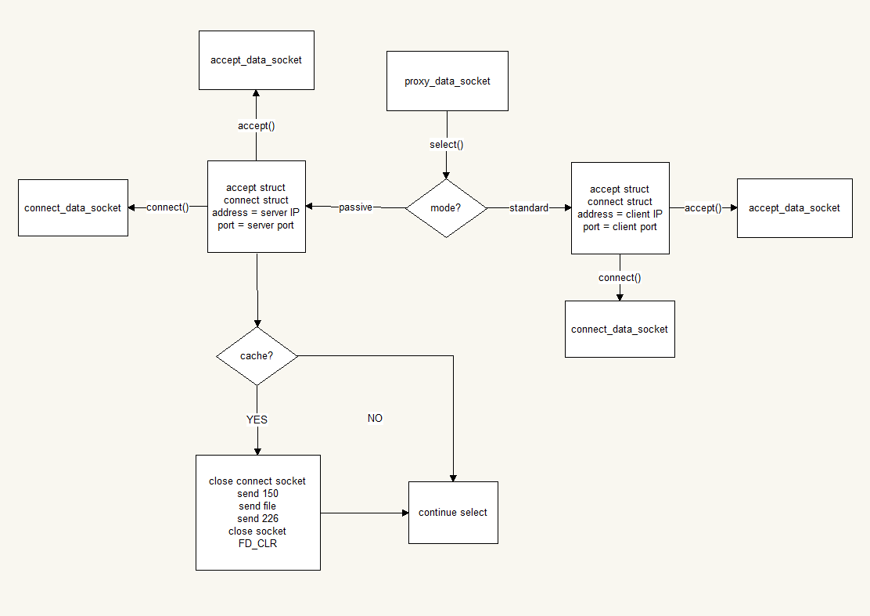
Accept_data_socket
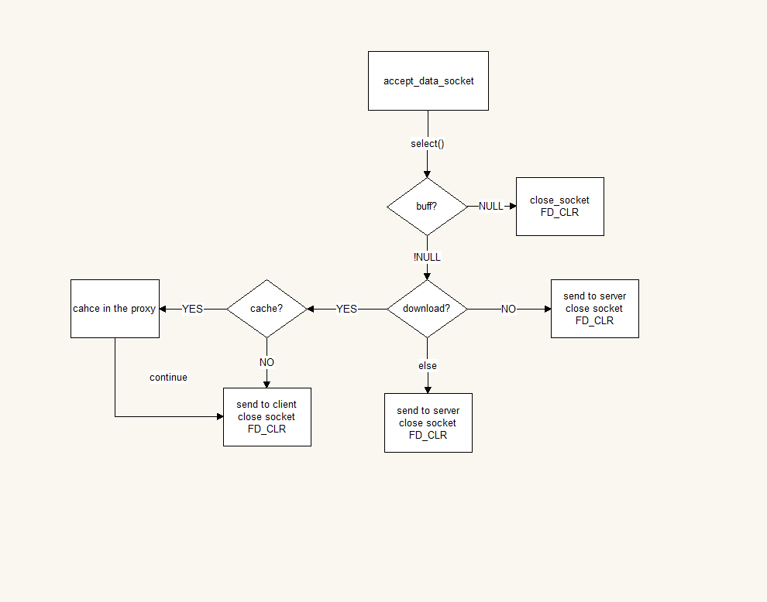
Connect_data_socket
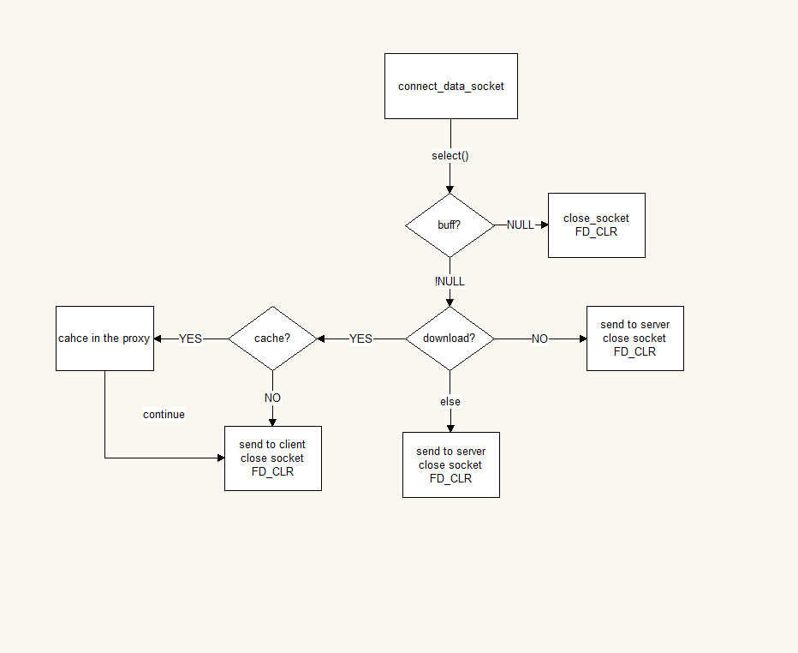

Results
At first, we will use the command line in the Windows7 to test the standard mode (since the passive mode seems don’t work), and then use the CuteFTP client to test both the standard mode and the passive mode (when using mget in the client software, the software always start several new connections to the server which lead to the mget command failure when using the client software not the command line bothe in windows and Linux (in VM))
- In standard mode (the default mode), LIST command and the PWD command
The result is successful, the LIST command returns the file list and the direction list of the FTP share folder, and the PWD command returns the local directory of the FTP share folder. The FTP client can login the FTP server through the FTP proxy, and the command can be transferred successfully.
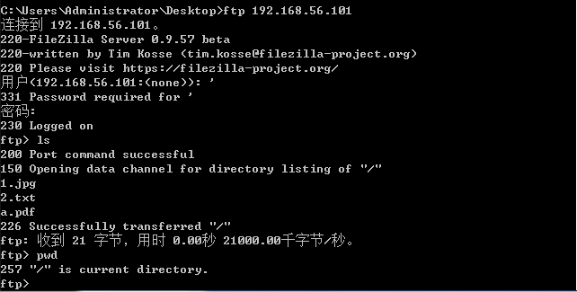
The FileZilla server’s log showing that the command and data have been transferred successfully.
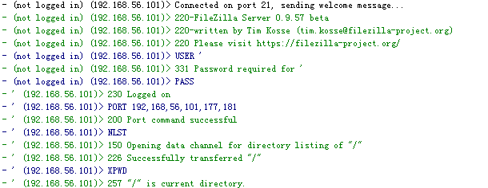
- mget command, the mget command first will send the port command to the server, and then send the NLST command to list all the file that typed in behind the mget command (e.g. mget a.* NLST will return all types of file whose name is “a”), and then after receiving all the NLST command, the client will send the RETR command that downloading all the file that match the mget condition. According to the testing result, the mget command runs successfully, and the client download all the file and the file will be cached in the cache file directory.
During the testing, we found that if we use mget command downloading files, the command will recognize the “jpg” format as capital “JPG” format which will make the cache method failure, so we changed our cache method to cache both the lower-case and the upper-case of the format name.
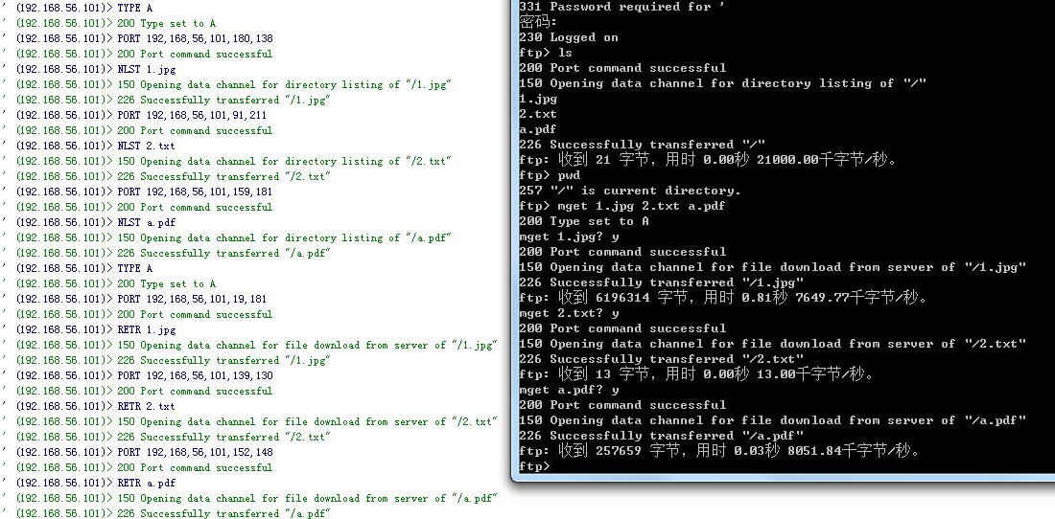
- mkdir and delete command, first we list all the file and directories in the FTP share folder, and check them in the explorer, then we make a new directory and delete a file in the share folder, then list the file and directory, and check them in the Windows. The result is that the command is running successfully.
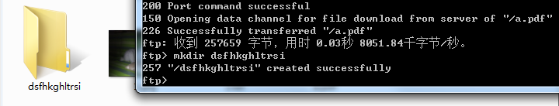
The FileZilla’s log also shows that the command is executed successfully.
The delete command delete the corresponding file in the FTP share folder.
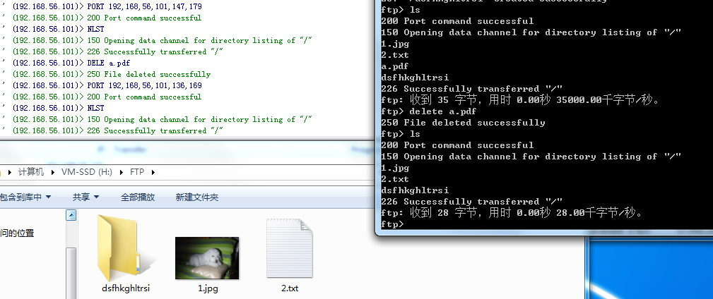
- Put command (STOR), the client first sends PORT command to show the server the connection port number, then sends that STOR command to show the upload, the testing result is successful according to the file status in the Linux, Windows and FileZilla server’s log.
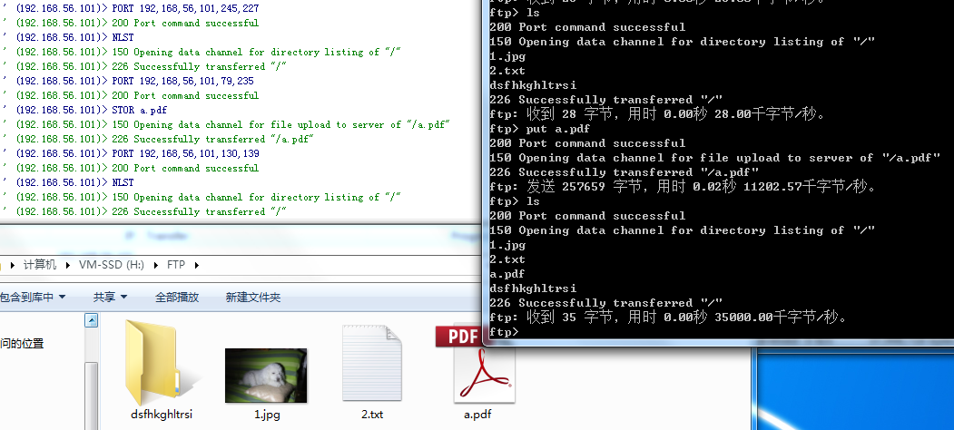
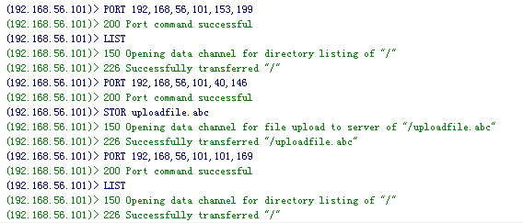
- Passive mode
After testing all the functions in the standard mode we then test the above command in the passive mode, all the command can be executed successfully and the cache method is working finely.
mget, pwd command in Linux terminal
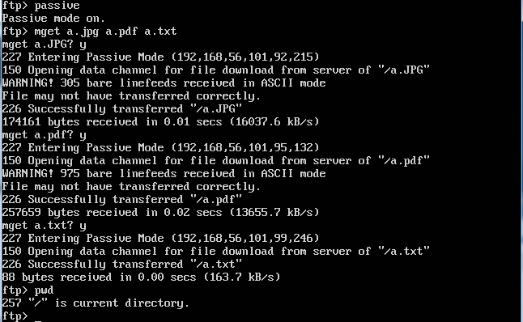
In CuteFTP client
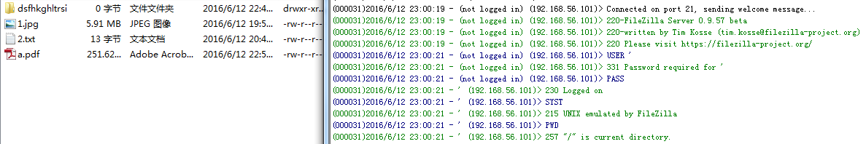
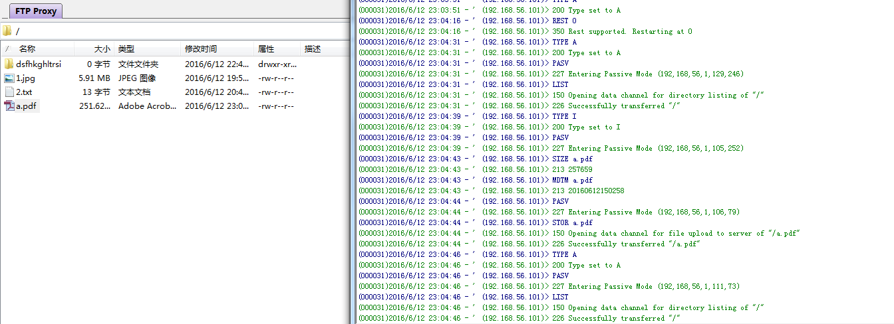
ls, mkdir, delete, put command
