**Thyroid Disease Classification Using ML**

Project report submitted to

**“Madurai Kamaraj University”**

in partial fulfillment of the requirements

for the award of the Degree of

**Bachelor of Science**

**in**

**Computer Science**

***Submitted***

**By**

**TEAM ID : NM2023TMID31087**

**TEAM LEADER : B. YUVARAJAN**

***Under the Guidance of***

**Dr. B. UMADEVI M.Sc.,M.Phil.,Ph.D.,**

**(Assistant Professor, GAC, Melur)**



**GOVERNMENT ARTS COLLEGE**

**P.G & DEPARTMENT OF COMPUTER SCIENCE**

**MELUR – 625 106**

# INDEX

|  |  |  |
| --- | --- | --- |
| **S. NO.** | **CONTENTS** | **Page No** |
| **1.** | **INTRODUCTION** | **1** |
| **1.1**  **1.2** | OVERVIEW  PURPOSE |  |
| **2.** | **LITERATURE SURVEY** | **2** |
| **2.1**  **2.2** | EXISTING PROBLEM  PROPOSED SYSTEM |  |
| **3.** | **THEORITICAL ANALYSIS** | **3** |
| **3.1**  **3.2** | BLOCK DIAGRAM  HARDWARE/SOFTWARE DESIGNING |  |
| **4.** | **EXPERIMENTALINVESTIGATIONS** | **6** |
| **5.** | **FLOWCHART** | **7** |
| **6.** | **RESULT** | **8** |
| **7.** | **ADVANTAGES & DISADVANTAGES** | **10** |
| **8.** | **APPLICATIONS** | **10** |
| **9.** | **CONCLUSION** | **11** |
| **10.** | **FUTURESCOPE** | **11** |
|  | BIBILOGRAPHY | **12** |
|  | APPENDIX | **12** |

# 1. INTRODUCTION

# 1.1 OVERVIEW

Thyroid diseases, such as hypothyroidism and hyperthyroidism, are common endocrine disorders that affect the function of the thyroid gland. These diseases can have a significant impact on a patient's health and quality of life. Early and accurate diagnosis of thyroid diseases is important for effective treatment.

In recent years, machine learning techniques have been applied to the classification of thyroid diseases. The goal of these studies is to develop models that can accurately diagnose thyroid diseases based on clinical and laboratory data.

# 1.2 PURPOSE

There are several machine learning algorithms that have been used for thyroid disease classification, including decision trees, random forests, k-nearest neighbors (KNN), support vector machines (SVM), artificial neural networks (ANN), and deep learning algorithms such as convolutional neural networks (CNNs) and recurrent neural networks (RNNs).

The input data for these models can include clinical features, such as age, gender, and symptoms, as well as laboratory test results, such as thyroid-stimulating hormone (TSH) levels and levels of thyroxine (T4) and triiodothyronine (T3).

The performance of these models is usually evaluated using metrics such as accuracy, precision, recall, and F1 score. In general, deep learning algorithms have shown better performance than other machine learning algorithms in thyroid disease classification tasks.

# 

# 2. LITERATURE SURVEY

# 2.1 EXISTING PROBLEM

The current existing system includes:

***Clinical examination:*** This involves a physical examination of the neck to check for any visible signs of thyroid enlargement or nodules.

***Blood tests:*** Blood tests are used to measure the levels of hormones produced by the thyroid gland and to check for antibodies that may indicate autoimmune diseases such as Hashimoto's thyroiditis.

***Ultrasound:*** An ultrasound scan can provide images of the thyroid gland and help to identify any nodules or other abnormalities.

***Fine needle aspiration biopsy (FNAB):*** This is a procedure in which a small sample of tissue is taken From a thyroid nodule using a fine needle, which is then examined under a microscope to check for cancer.

# 2.2 PROPOSED SYSTEM

The proposed system is by using Artificial Intelligence (AI) and Machine Learning (ML) In recent years, there have been several studies exploring the use of AI and ML algorithms for predicting thyroid diseases. These systems are trained on large datasets of patient data and use various features such as demographic information, blood test results, and ultrasound images to make prediction.

# 3. THEORITICAL ANALYSIS

# 3.1 BLOCK DIAGRAM

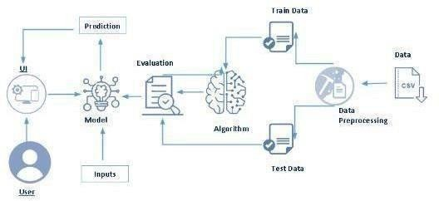

# 3.2 HARDWARE AND SOFTWARE DESIGNING

**Python**

Python is an interpreted, object-oriented, high-level programming language with dynamic semantics. It was created by Guido van Rossum, and first released on February 20, 1991. Its high-level built-in data structures, combined with dynamic typing and dynamic binding, make it very attractive for Rapid Application Development, as well as for use as a scripting or glue language to connect existing components together. Python's simple, easy to learn syntax emphasizes readability and therefore reduces the cost of program maintenance.

Python supports modules and packages, which encourages program modularity and code reuse. The Python interpreter and the extensive standard library are available in source or binary form without charge for all major platforms, and can be freely distributed.

# Anaconda Navigator

Anaconda Navigator is a free and open-source distribution of the Python and R programming languages for data science and machine learning related applications. It can be installed on Windows, Linux, and macOS. Conda is an open-source, cross platform, package management system. Anaconda comes with so very nice tools like JupyterLab, Jupyter Notebook, QtConsole, Spyder, Glueviz, Orange, Rstudio, Visual Studio Code. For this project, we will be using Jupyter notebook and Spyder.

# Jupyter Notebook

The Jupyter Notebook is an open-source web application that you can use to create and share documents that contain live code, equations, visualizations, and text. Jupyter Notebook is maintained by the people at Project Jupyter. Jupyter Notebooks are a spin-off project from the IPython project, which used to have an IPython Notebook project itself. The name, Jupyter, comes from the core supported programming languages that it supports: Julia, Python, and R. Jupyter ships with the IPython kernel, which allows you to write your programs in Python, but there are currently over 100 other kernels that you can also use.

# Spyder

Spyder, the Scientific Python Development Environment, is a free integrated development environment (IDE) that is included with Anaconda. It includes editing, interactive testing, debugging, and introspection features. Initially created and developed by Pierre Raybaut in 2009, since 2012 Spyder has been maintained and continuously improved by a team of scientific Python developers and the community. Spyder is extensible with first-party and third party plugins includes support for interactive tools for data inspection and embeds Python specific code. Spyder is also pre-installed in Anaconda Navigator, which is included in Anaconda.

# Flask

Web frame work used for building. It is a web application framework written in python which will be running in local browser with a user interface. In this application, whenever the user interacts with UI and selects emoji, it will suggest the best and top movies of that genre to the use.

# Hardware Requirements:

* Operating system: window 7 and above with 64bit o Processor Type -Intel Core i3-3220
* RAM: 4Gb and above
* Hard disk: min 100GB

# 4. EXPERIMENTALINVESTIGATION

Here we are going to build a machine learning model that predicts whether the given message is as pam or not, based on these parameters a supervised machine learning model is built to predict the best Material to be used for building 3Dmodels.A web application is build so that the user can type in the mentioned part a meters and the material which suits the best is show case don UI.

**5. FLOWCHART**

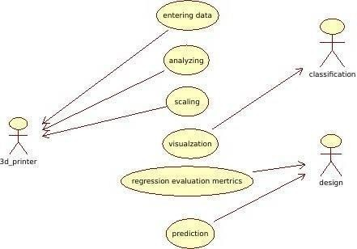

**USECASEDIAGRAM**

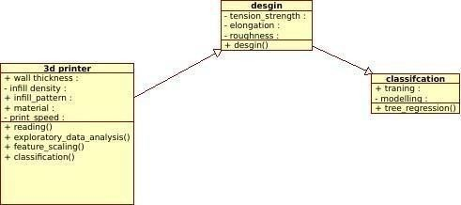

# 6. RESULT

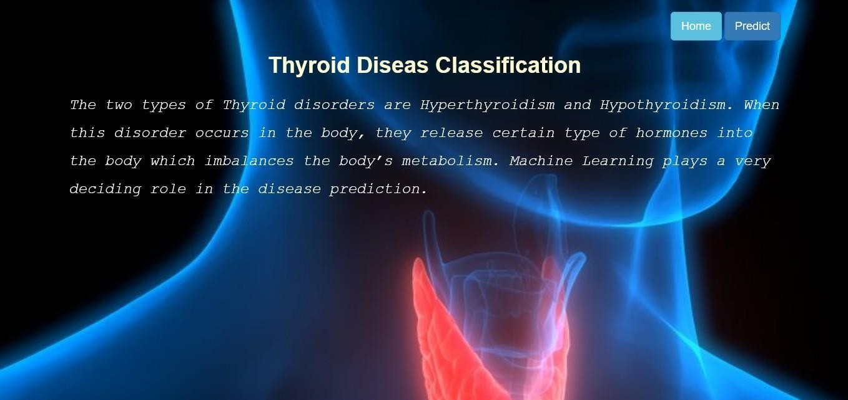

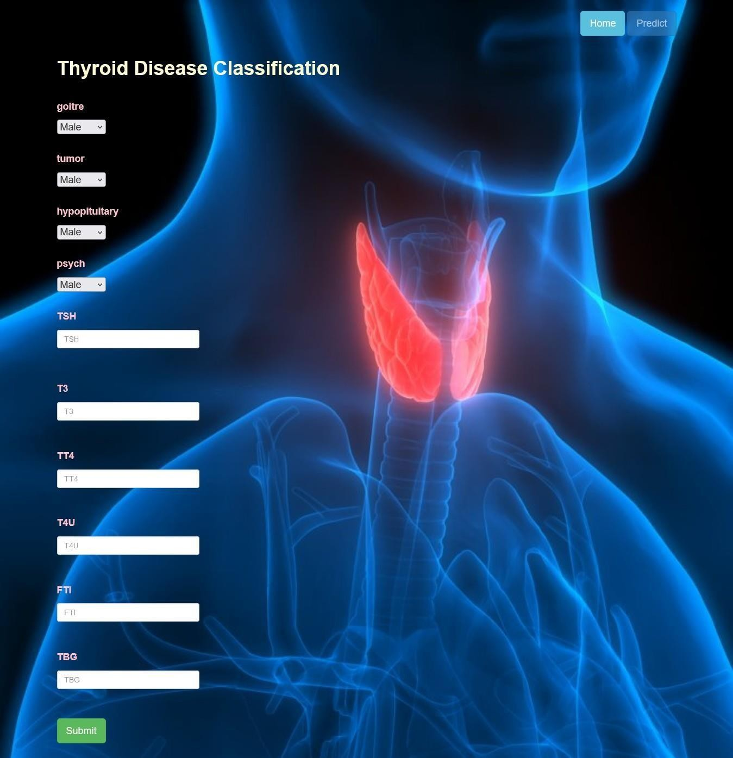

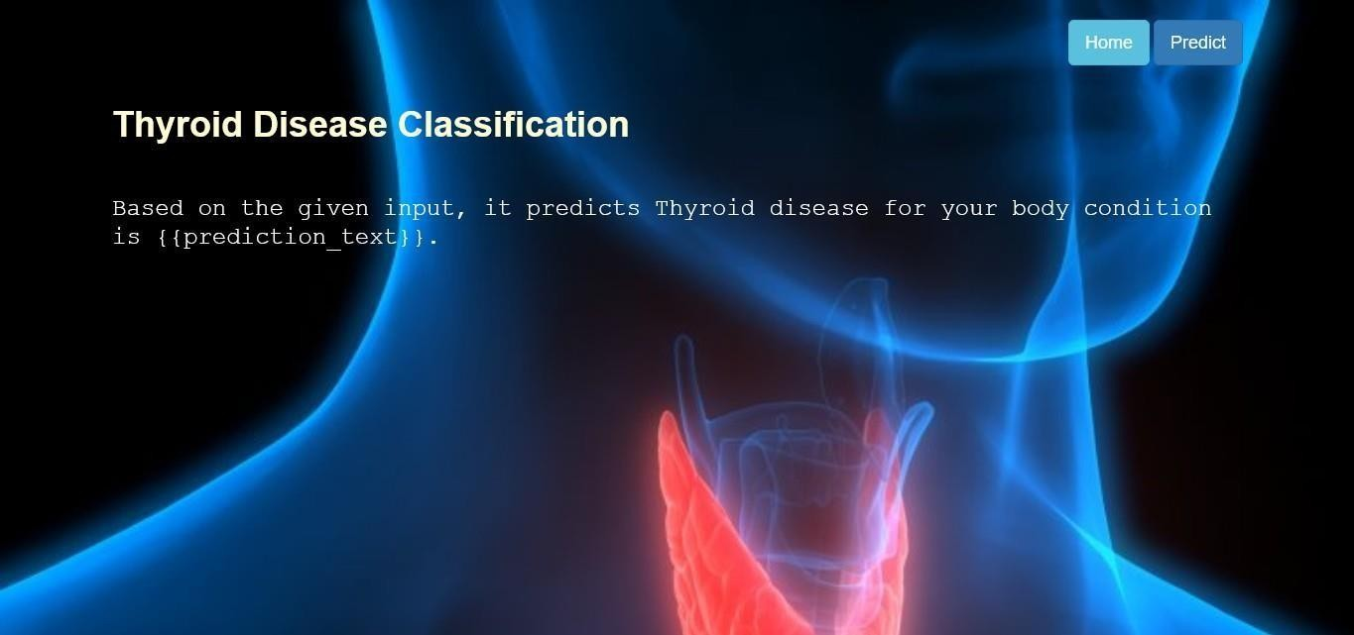

**7. ADVANTAGES & DISADVANTAGES**

**ADVANTAGES**

* Easy to use
* Cost efficient
* Time efficient

**DISADVANTAGE**

* Initial costs of printer
* Postprocessing
* Printing time
* Special skill required for 3Dmodels
* Manufacturing Job Losses

# 8. APPLICATIONS

3D printing has gone through a number of changes over the years. In the early days, 3D printing was time-consuming and costly, and not very practical for applications outside of industry. However, with the advent of today’s moreflexibleandcost-effective3D printing methods, there are areas where3D printing has become a practical tool.

# It is applicable in different sectors such as

* Engineering And Design
* Consumer products
* Manufacturing
* Education
* Aerospace
* Medical
* Movies/Theatres
* Architectures

# 9. CONCLUSION

3D printing technology could revolutionize and re-shape the world. Advance in 3D technology can significantly change and improve the way we manufacture products goods worldwide.

If the last industrial revolution brought us mass production and the advent of economics of scale – the digital 3D printing revolution could bring mass manufacturing back a full of circle – to an era of mass personalization, and return to individual craftsmanship.

# 10. FUTURESCOPE

Future applications for 3D printing might include creating open-source scientific equipment to create open-source labs Science- based applications like reconstructing fossils in paleontology. Replicating ancient and priceless sartifacts in archaeology Reconstructing bones and body parts in forensic pathology. The technology currently being researched for building construction.

# 

# BIBILOGRAPHY

* <http://mashable.com/2014/03/06/3d-printed-blood-vessels/>
* <http://www.3dprinter.net/>

# APPENDIX

