2A Prints Accounting User Manual
2026-10-20 - King Zizou
This manual takes you from your first download to your year-end reports, one screen at a time, with pictures.

1. Welcome
2A Prints Accounting is a desktop accounting program built for Ghanaian small and medium businesses and non-profits. It keeps your sales, purchases, expenses, stock, bank, payroll and tax records in one place and produces the reports the Ghana Revenue Authority (GRA) and your auditors ask for.
How to read this manual. It follows the order in which you will actually use the program: subscribe, install, set up the company, add people and records, record daily transactions, close the month, and read reports. Sections 11 (HR and Payroll) and 12 (NGO mode) are optional and apply only if you use those features.
What you need. A Windows, Mac or Linux computer, an internet connection (the program saves to your online company database and shows "Synced" at the top of the screen), and an email address for your account.
Words used in this manual
Term | Meaning
Company | One set of books. Everything you record belongs to one company.
User | A person who signs in to your company. Each user has a role that decides what they can see and do.
Role | A named set of rights, for example Administrator or Cashier.
Posting | Saving a transaction so it writes its debit and credit entries to the ledger.
Licence key | The code that activates a paid subscription for your company.
Payroll add-on | The optional paid module for staff, payslips, PAYE and SSNIT.

1.1 What is new in version 2.1.2
Version 2.1.2 adds a delete right, committed amounts on grants, payment approval and a tidier menu. Each item points to the section that explains it.
- Full rights. A fourth access level, Full, adds delete to Edit. Only the Administrator role has it by default (section 4.2).
- A right for every module. Grants, Funds, Compliance, Quick Sale (POS), Recurring Invoices, Overdue, Budget vs Actual, Supplier Deposits, Currencies and Audit Log each have their own right (4.2).
- Committed on funds and grants. Bills charged to a grant but not yet paid show as Committed, not Spent (12.2 to 12.4).
- Overspend warning. You are warned when a restricted fund has spent or promised more than it received (12.4).
- Payment approval. Large supplier payments made by someone without Full rights wait for approval (3.2 and 7.3).
- Petty cash can be edited (7.6).
- Safety backup before deletes. In the desktop app, a copy is saved to your Backup folder before a delete (4.2).
- Menu changes. Products, Stock Take and Stock Transfers sit together in a Products group that also shows in Non Profit mode. Customer Deposits are under Sales and Supplier Deposits under Purchases (6.10 and 7.7). In Admin, Company Information, you can hide more menus for Non Profit mode (12.1).
- Tax tick box. Sales, purchases and expenses have a Charge VAT and levies tick box, so an item that carries no VAT can be recorded without it.
- Payment forms. Receive Payment, Make Payment and Pay Expense show invoices with a balance first; a filter shows fully paid or all invoices. Pay Expense lists only Expenses Suppliers.
- Fixed lists. Supplier type is Expenses Supplier or Inventory Supplier. Product type is Inventory or Non Inventory.
- Leave days by level. An employee's level sets the leave days; the program asks you to enter them if a level has none (11.2).
- Licences. If the accounting licence ends but the payroll licence is still valid, HR and Payroll keep working.
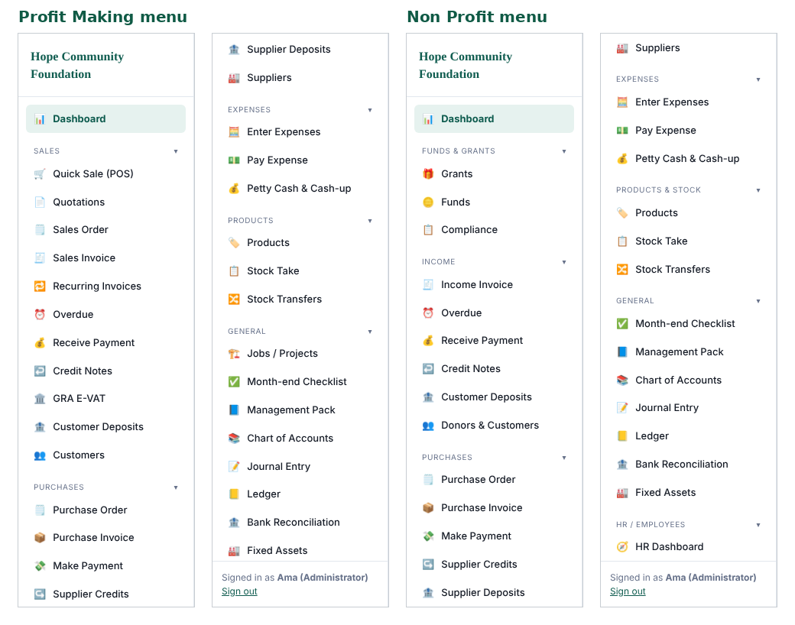
The menu in Profit Making and Non Profit mode

2. Getting started

2.1 The 30-day free trial
Every new company gets a 30-day free trial with all main features. A banner on the Dashboard shows the days left and offers three buttons: Enter licence key, Request more time and WhatsApp us. When the trial ends there is a 7-day grace period in which you can still open and read your records but not post new transactions. Subscribe before the grace period ends to keep working without interruption.

2.2 Subscribing and activating a licence key
1. Contact the developer on WhatsApp (0546 533 134) or by email (2aprintsservice@gmail.com) and choose a plan. The Payroll add-on is priced separately.
2. Pay as agreed. You receive a licence key by email.
3. In the program, click Enter licence key on the trial banner (or the licence prompt that appears when the trial has ended).
4. Paste the key exactly as received and confirm. The program contacts the licence server and shows your plan and expiry date.
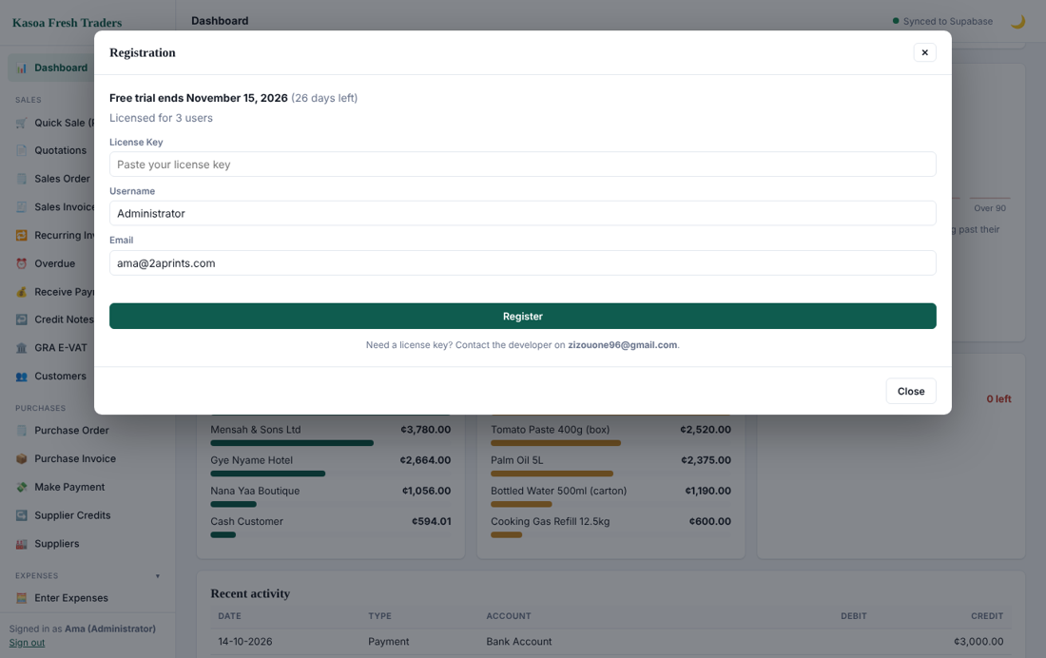
Registration window where the licence key is entered
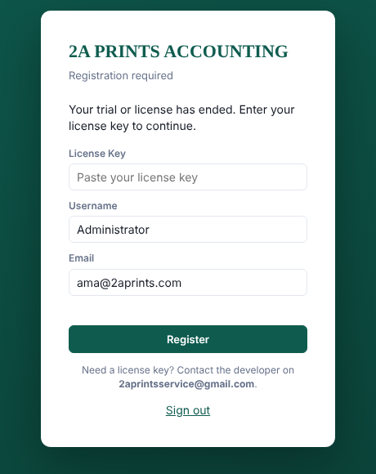
Screen shown when a subscription is required
Keep the key safe. If it fails, check that you copied it with no spaces and that your internet is on, then use WhatsApp us.

2.3 Installing the program
1. Download the installer for your system: a Windows .exe, a Mac .dmg or a Linux AppImage.
2. Windows: double-click the .exe and follow the prompts. If Windows SmartScreen warns about an unknown publisher, click More info then Run anyway.
3. Mac: open the .dmg and drag the app into Applications. On first launch, right-click the app and choose Open.
4. Linux: make the AppImage executable (right-click, Properties, Allow executing) and open it.
5. The program updates itself when a newer version is published; accept the update prompt when it appears.
If you received the installer in several numbered parts, put all parts and the join script in one folder and run the join script first. It rebuilds the full installer.

2.4 Creating your account
On the first screen choose Need an account? Sign up. Enter your name, email and a password, then confirm. The first person to sign up becomes the company Administrator.
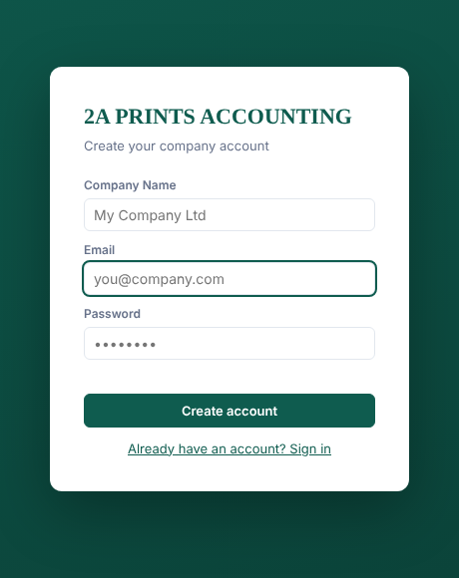
Sign-up card

2.5 Signing in
Enter your email and password and click Sign in. Tick Remember username to save your email on this computer. If you forget your password, click Forgot password? and follow the email link.
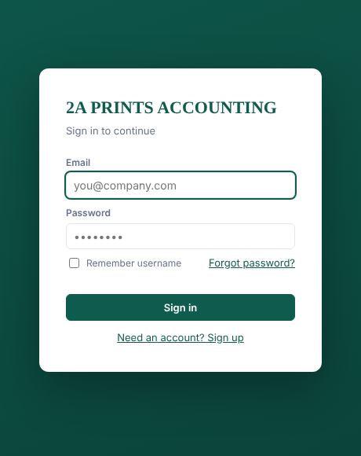
Sign-in card
After sign-in you land on the Dashboard.
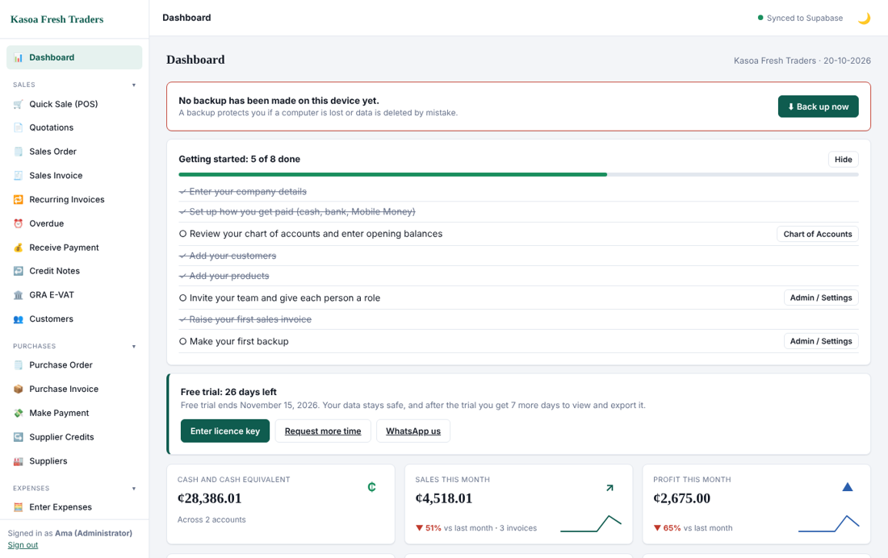
The Dashboard
The left menu lists every area you have rights to, in groups: Sales, Purchases, Expenses, Products, General, HR / Employees, Payroll, Reports and System. The top bar shows the sync status ("Synced") and a moon icon that switches between light and dark screens. Your name and role appear at the bottom of the menu together with Sign out.

3. Setting up your company
Open Admin / Settings from the menu. It has six tabs: Company Information, General Settings, Accounts Settings and Defaults, Defaults, Invoice & Receipt Design, and User Rights. Do the setup once, in this order, before recording transactions.

3.1 Company Information
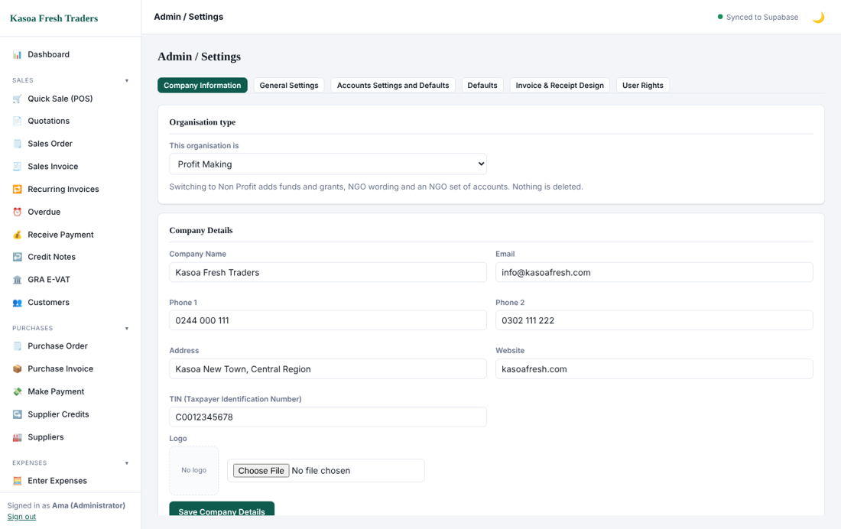
Company Information tab
1. Organisation type. Choose Profit Making (the normal choice) or Non Profit (see section 12). You can switch later; nothing is deleted.
2. Fill in Company Name, Email, Phone 1 and 2, Address and Website. These print on invoices and reports.
3. Enter the TIN (Taxpayer Identification Number). It appears on tax invoices and GRA reports.
4. Choose a Logo file. A square or wide PNG or JPG works best.
5. Click Save Company Details.

3.2 General Settings
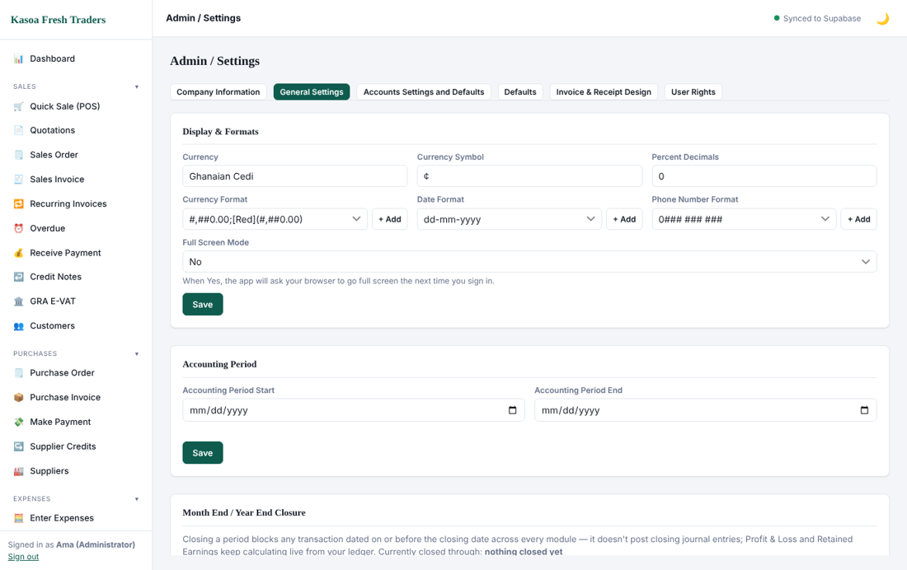
General Settings tab
- Display & Formats: currency name and symbol (Ghanaian Cedi, ¢), number format, date format (dd-mm-yyyy is the default), phone number format and full-screen mode. Click Save.
- Accounting Period: set the start and end date of your financial year. Reports default to this period.
- Month End / Year End Closure: closing a period blocks any transaction dated on or before the closing date. It does not stop closing journal entries. See section 9.
Payment approval. Enter an amount to require approval for supplier payments (Make Payment and Pay Expense) of that amount or more when they are made by someone without Full rights on that module. Leave it at 0 to switch this off. See section 7.3.
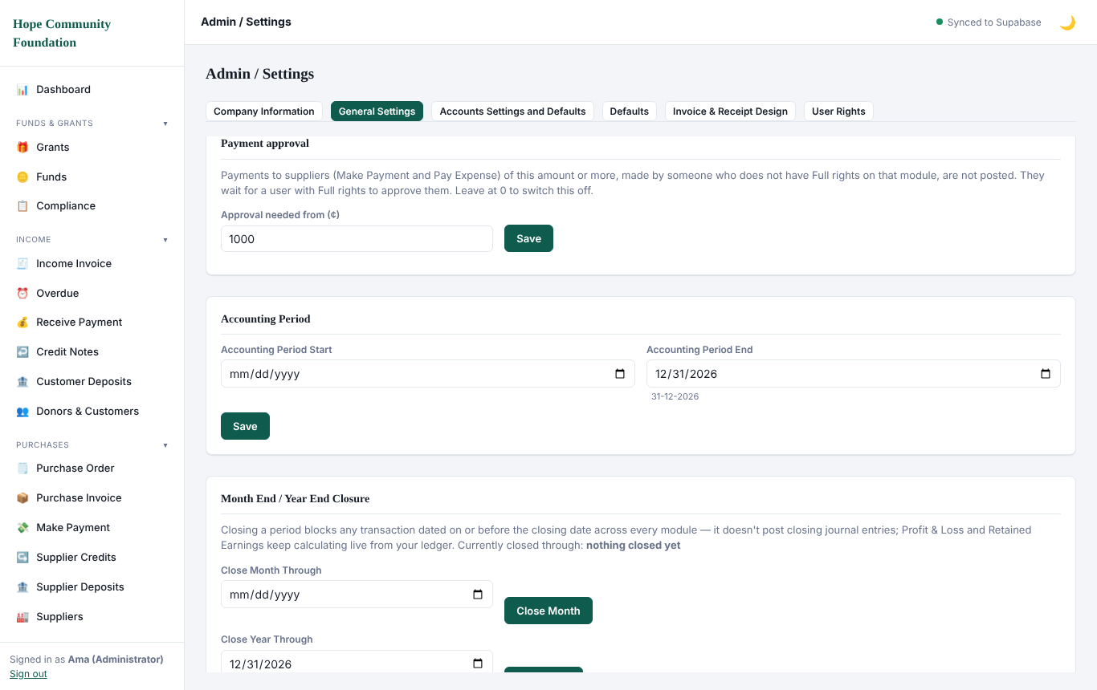
Payment approval setting in General Settings

3.3 Accounts Settings and Defaults
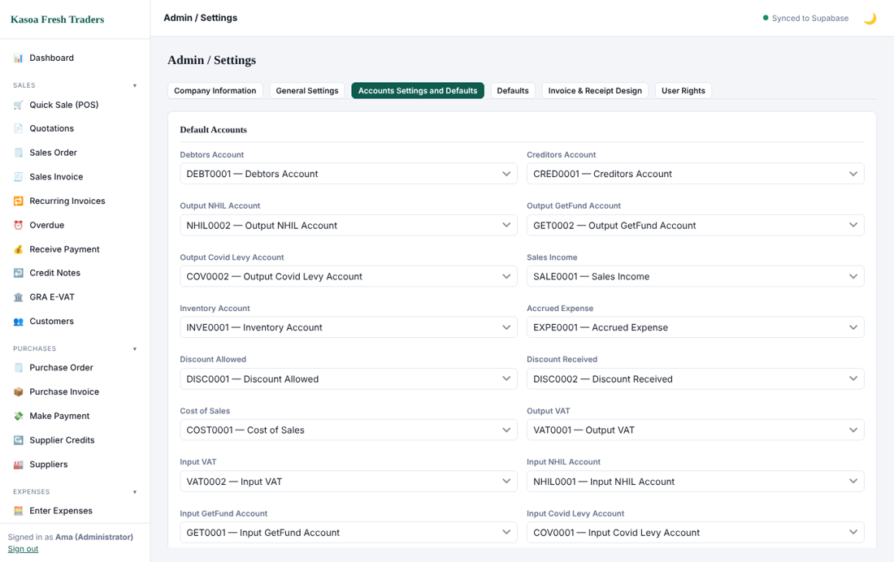
Default accounts
This tab tells the program which ledger account to use automatically: Debtors, Creditors, Sales Income, Inventory, Cost of Sales, Discount Allowed and Received, Accrued Expense, and the output and input tax accounts (VAT, NHIL, GetFund, COVID levy). The standard chart of accounts is already linked, so change these only if your accountant has changed the chart.

3.4 Defaults
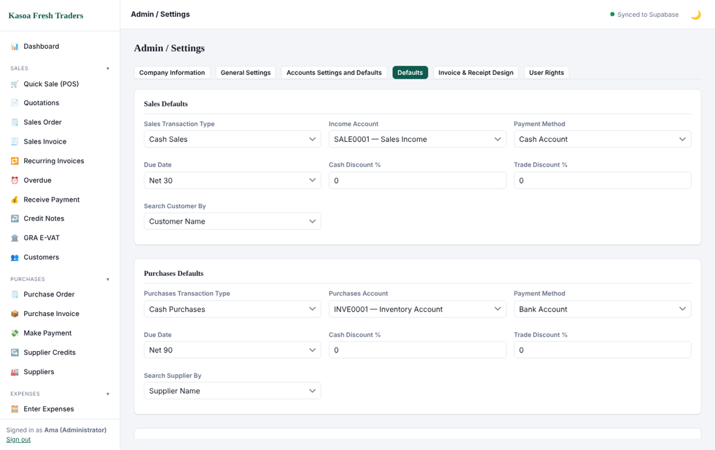
Sales and Purchases defaults
Defaults save typing. For Sales set the usual transaction type, income account, payment method, due date terms (for example Net 30), discounts, and whether you search customers by name or code. Purchases has the same set (for example Net 90). You can override any default on an individual transaction.

3.5 Invoice & Receipt Design
Choose the layout, colours and footer text of printed invoices, receipts and statements. Use Preview before saving.

3.6 Chart of accounts
Open the Accounts list from the menu (Ledger area) to see every account. Accounts are grouped as Asset, Liability, Equity, Income, Cost of Sales and Expense.
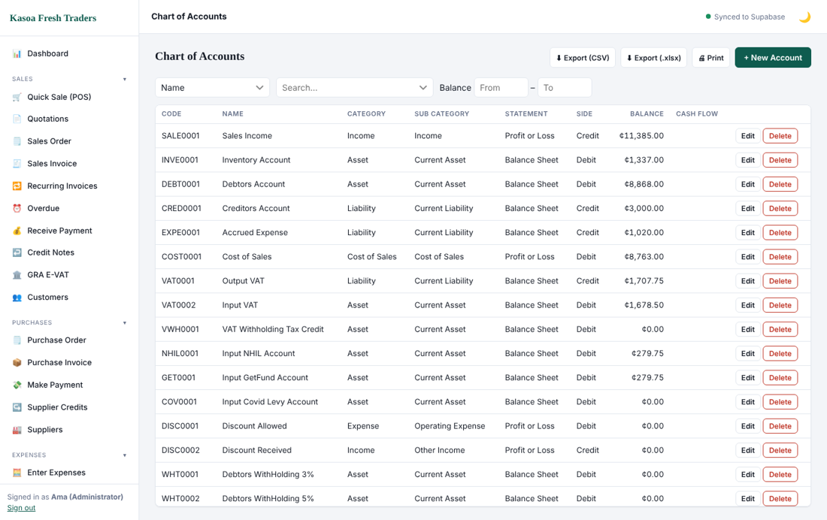
Chart of accounts
To add one, click New account, choose the category and sub-category, give it a name and save. The program assigns the code.
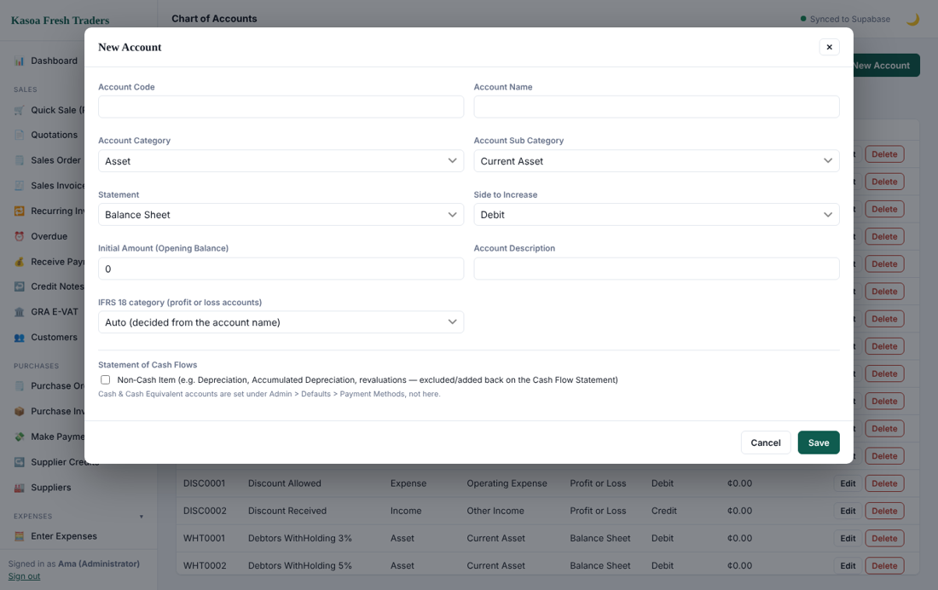
New account form
Do not delete an account that already has entries; make it inactive instead.

3.7 Opening balances
Bring your starting position into the books with a journal dated the day before you begin (section 9.1): debit cash, bank, stock, debtors and fixed assets, credit creditors, loans and capital. Opening customer and supplier balances are best entered as opening invoices so that ageing reports work.

4. Users, roles and rights
Every person who signs in is a user with a role. Only an Administrator can add users and change rights.
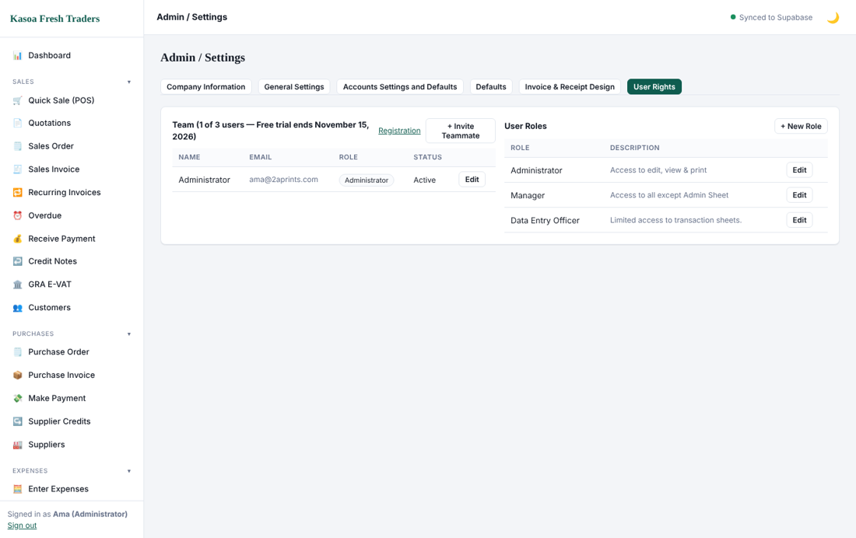
User Rights tab

4.1 Adding a user
1. Open Admin / Settings, then User Rights.
2. Click Add user, enter the person's name and email, and choose a role.
3. Send them the sign-up link. When they register with that email they join your company with that role.

4.2 Roles and rights
A role is a list of rights. For each area (Sales, Purchases, Expenses, Products, Funds and Grants, Banking, Reports, HR, Payroll, System) you choose one of four levels:
- Full: add, change and delete.
- Edit: add and change, but not delete.
- View: look only.
- No Access: the menu item is hidden.
Only the Administrator role has Full by default. Every other role keeps Edit until an administrator chooses Full for it. Delete buttons are hidden for anyone who does not have Full on that module. The Set every module to box fills the whole list in one step, and each section of the list has its own heading.
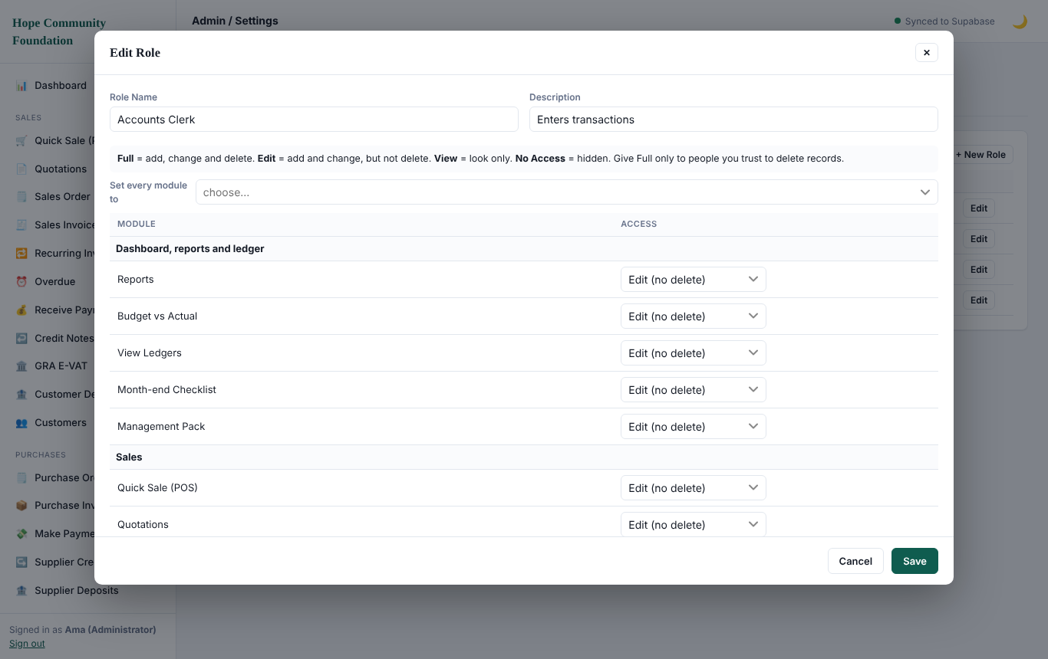
Role form with the Full, Edit, View and No Access levels
Suggested roles:
Role | Typical rights
Administrator | Full rights on everything, including users and settings; the only role that can delete
Accountant | Edit on all transactions and reports (no deleting), no user management
Sales / Cashier | Sales, POS and receipts; view customers and stock
Store keeper | Stock, purchases view and transfers
HR / Payroll | HR and Payroll only (needs the Payroll add-on)
Viewer | View and reports only

Give each person the smallest set of rights they need. Review them whenever staff change, and remove access when someone leaves.
Because only Full can delete, other users correct mistakes with credit notes and reversing journals, or ask an administrator. In the desktop app, a safety copy of the books is saved to the Backup folder before a delete (at most once every 30 minutes). Set the Backup folder under Admin.

4.3 Accountability
Every posting records who made it and when. The Audit Log (section 13) shows the history.

5. Customers, suppliers and products
Create these records before you sell or buy. They are the building blocks of every invoice.

5.1 Customers
Open Customers under Sales.
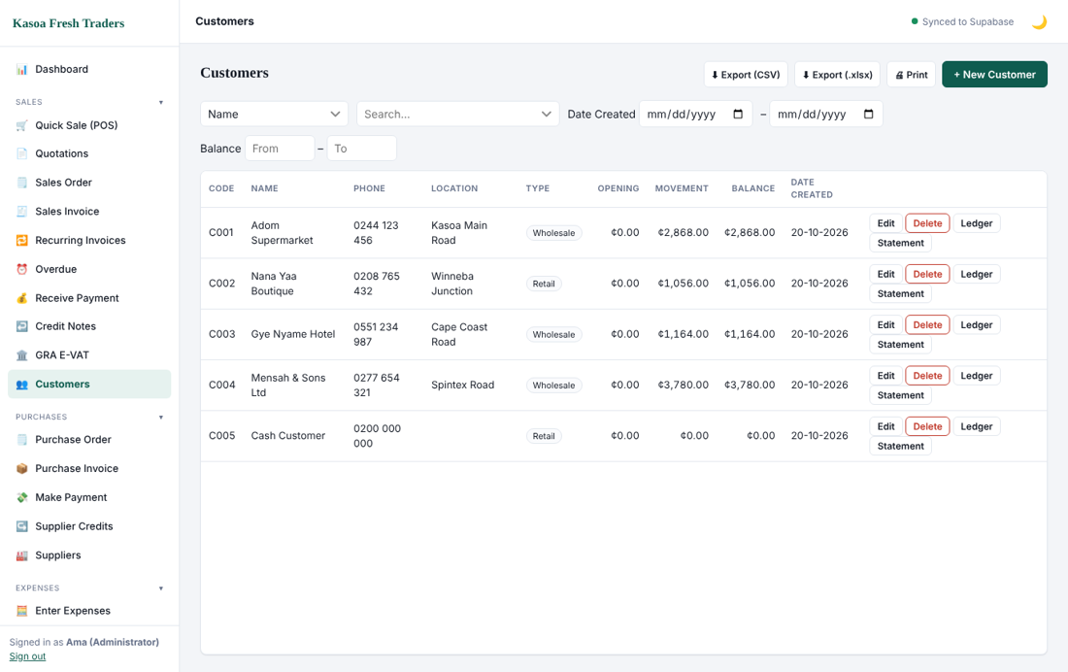
Customers list
1. Click New customer.
2. Enter a code and name. Add phone, email, address and TIN if the customer needs a tax invoice.
3. Set a credit limit and payment terms if you sell on credit. The program warns you (and can hold the sale) when a customer is over the limit or has overdue invoices.
4. Save.
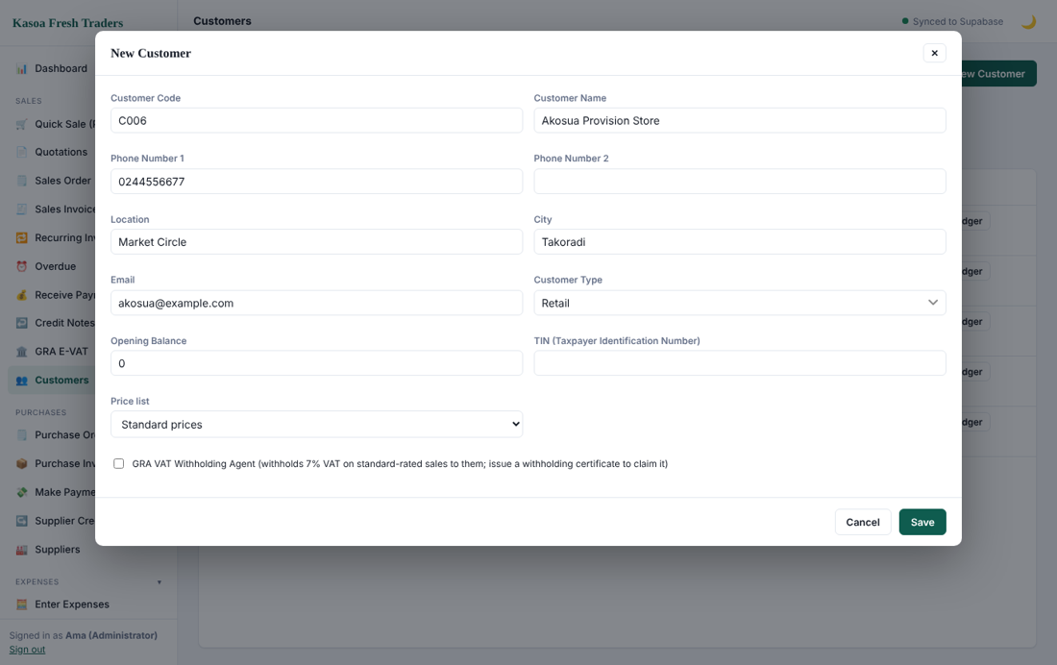
Customer form
Open a customer's ledger to see every invoice, receipt and credit note, with a running balance. You can print or share it as a statement.
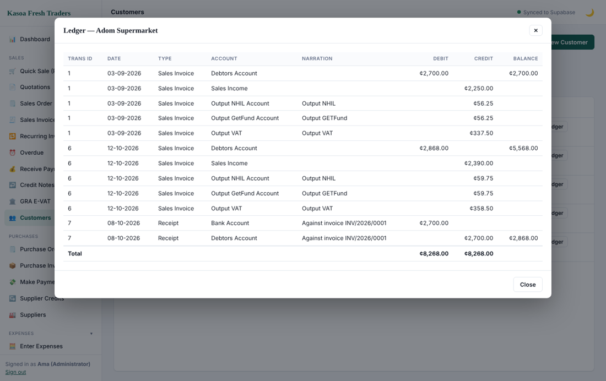
Customer ledger

5.2 Suppliers
Open Suppliers under Purchases. The form is the same as for customers: code, name, contact details, TIN and terms. Choose the supplier type (for example Expenses Supplier or Goods Supplier) so that it appears in the right pick-lists.
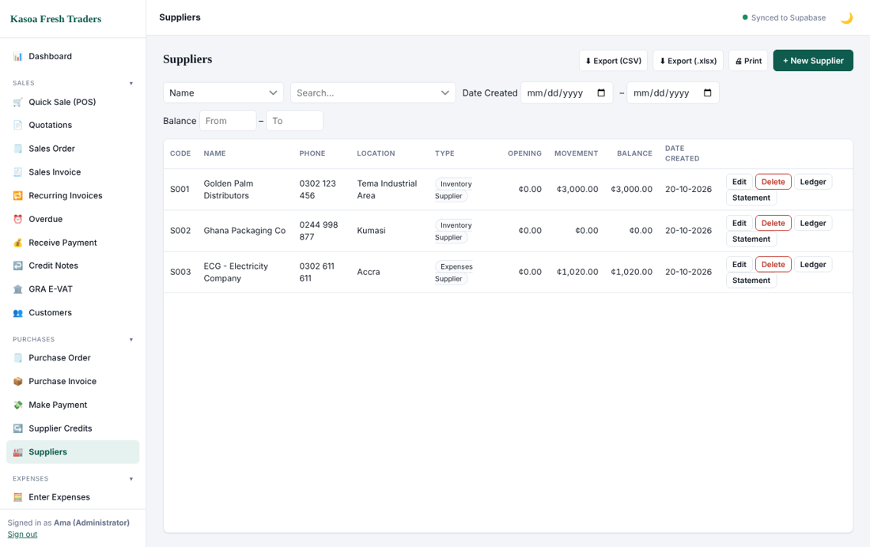
Suppliers list

5.3 Products and services
Open the products list from the Products group in the menu.
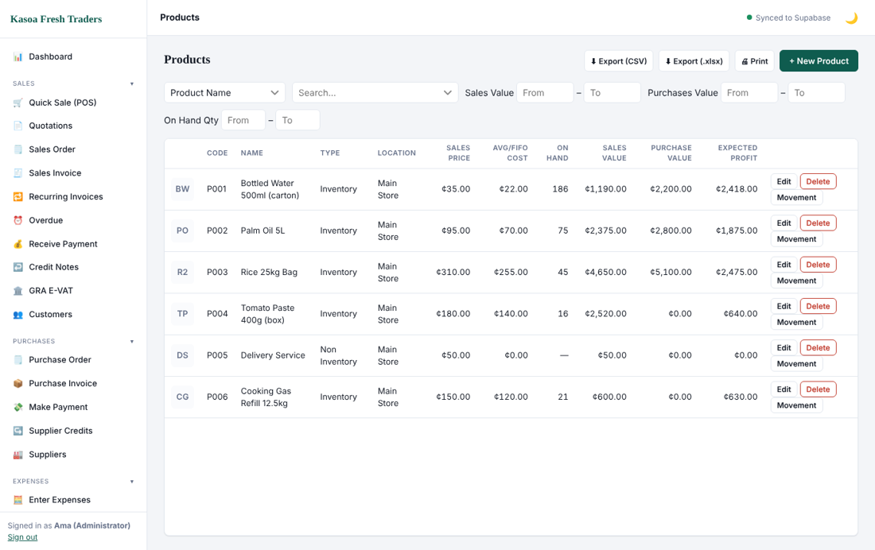
Products list
1. Click New product.
2. Enter a code, name and unit.
3. Choose whether it is a stocked item (quantity tracked) or a service (no stock).
4. Enter the sales price and the latest cost, and the tax treatment.
5. For stocked items enter the opening quantity and its value. The program uses weighted average cost.
6. Save.
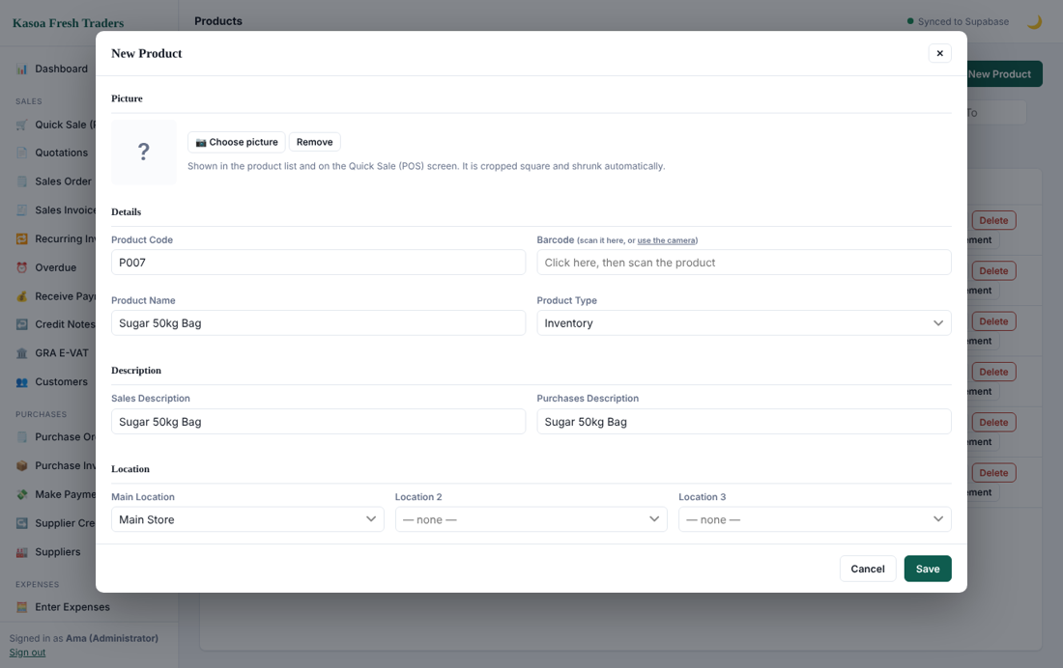
Product form
Tips: use short unique codes; keep names consistent so that searching is easy; set a re-order level if you want low-stock warnings.

6. Selling
All sales are under the Sales group in the menu.
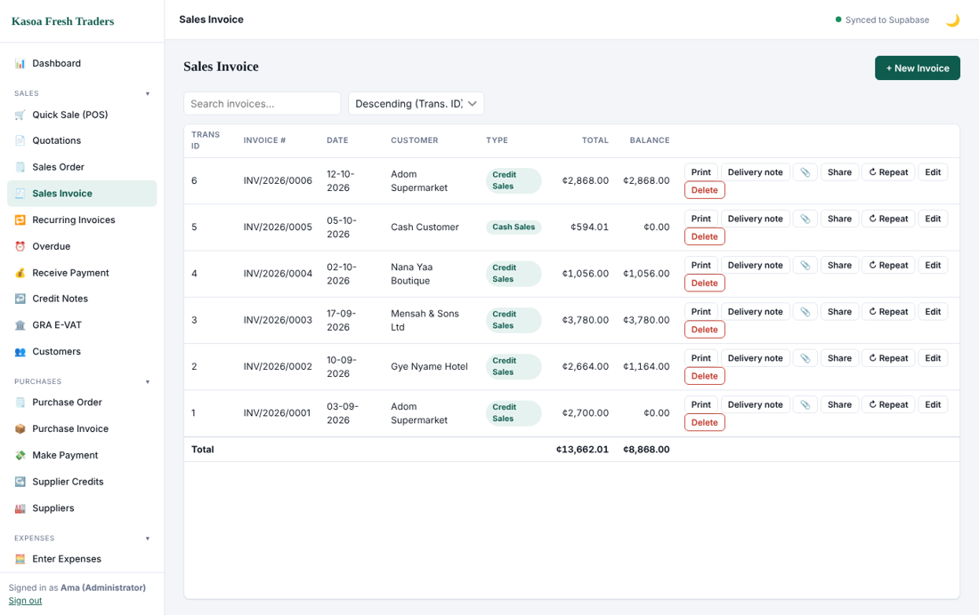
Sales Invoice list

6.1 Raising a sales invoice
1. Click Sales Invoice, then New.
2. Pick the customer. Date, terms and payment method come from your defaults.
3. Add lines: choose a product, enter quantity and price. The program fills the description and tax.
4. Add a discount if needed. VAT, NHIL, GetFund and COVID levy are calculated automatically from the product's tax setting.
5. Check the totals at the bottom, then Save & Close (or Save & New to continue).
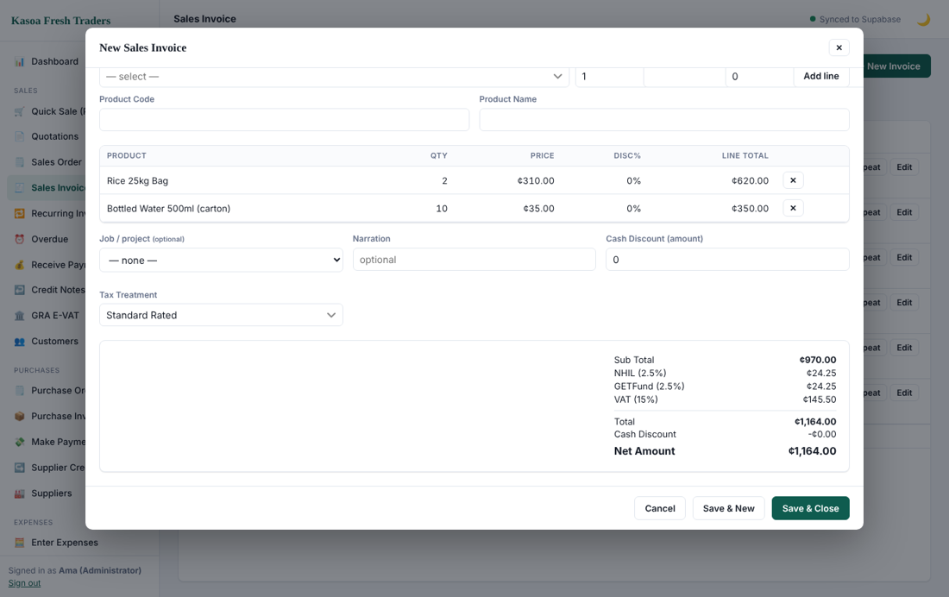
Sales form with totals
Saving posts the entries: debit Debtors (or cash/bank for a cash sale), credit Sales Income and the output tax accounts, and it reduces stock and records cost of sales.

6.2 Printing and sharing
Open the invoice and click Print or Save as PDF. Use Share to send it by email or WhatsApp.
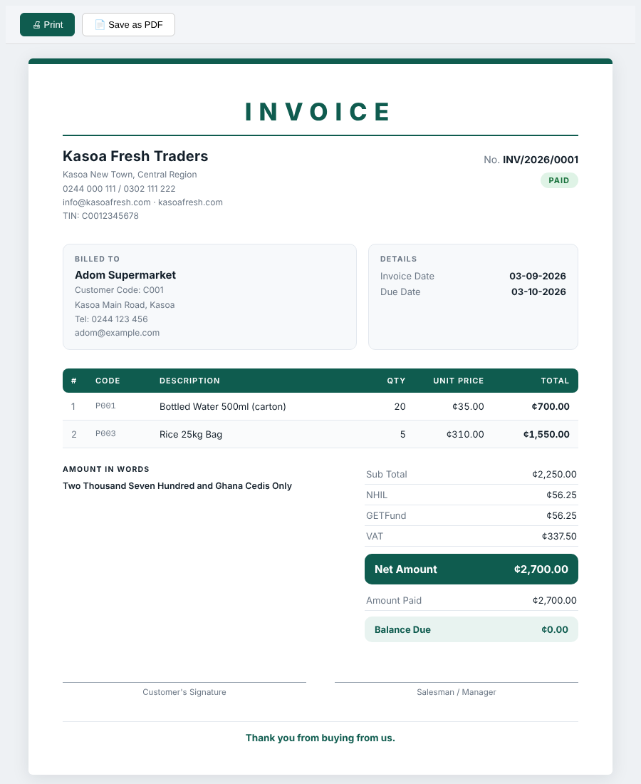
Printed invoice

6.3 Receiving payment
Open Receive Payment, choose the customer, pick the invoices being paid, enter the amount and the account it was paid into (cash, bank or mobile money), and save. Part payments are allowed. The invoice status changes to Part Paid or Paid.
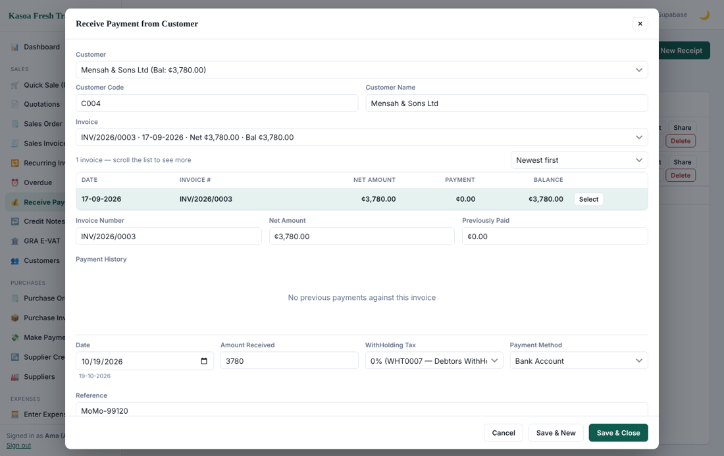
Receive payment

6.4 Quick Sale (POS)
Use Quick Sale (POS) at the counter. Tap products to add them, choose the payment method and complete the sale. A receipt prints and stock reduces immediately. At the end of the day use the cash-up screen to count the till.
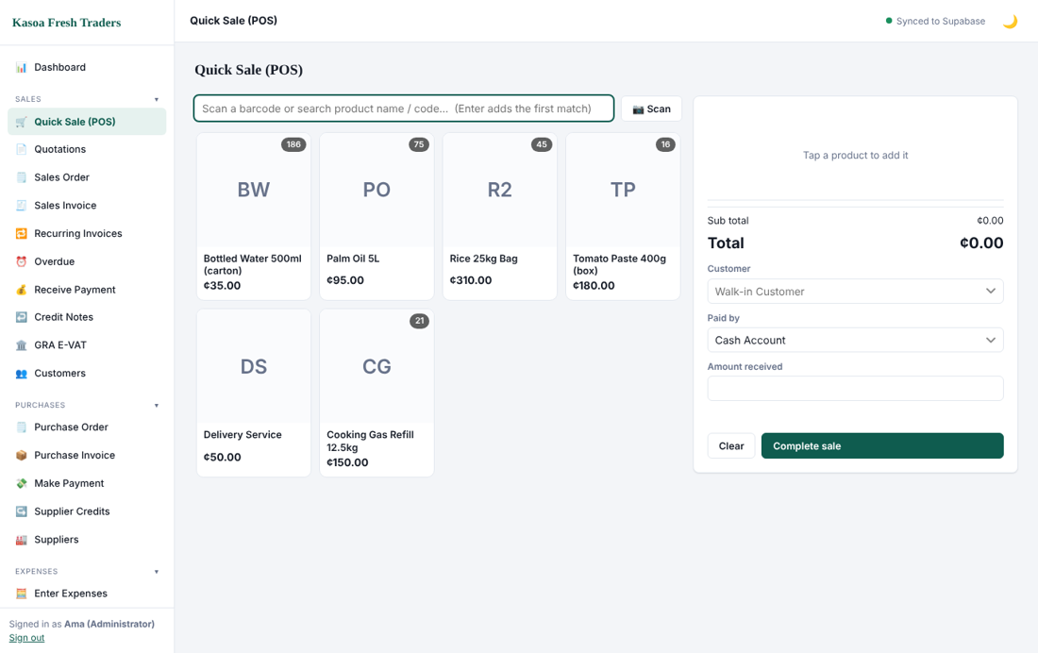
POS

6.5 Quotations and sales orders
A Quotation is an offer that posts nothing. A Sales Order records a confirmed order. Convert either into an invoice when the goods or services are delivered, so you do not retype lines.
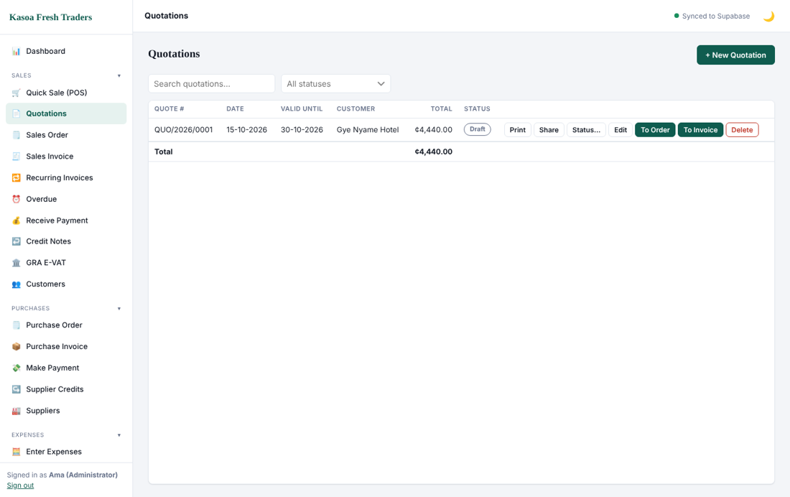
Quotations

6.6 Recurring invoices
For rent, retainers or subscriptions, create a Recurring Invoice: choose customer, lines and frequency (weekly, monthly, and so on). The program prepares the invoice on each due date for you to confirm.

6.7 Overdue invoices and credit control
Overdue lists every unpaid invoice past its due date, oldest first, with days late. Use it every week to chase payments. If a customer has an overdue invoice the program warns you before a new sale, and a user with the right can override.
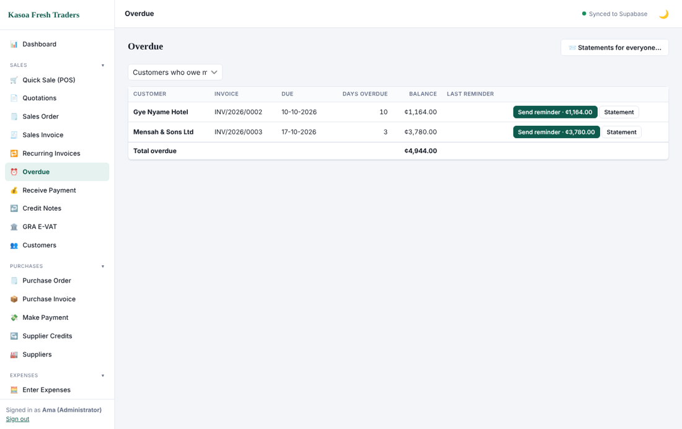
Overdue

6.8 Credit notes
When a customer returns goods or is overcharged, raise a Credit Note against the invoice. It reduces what they owe, returns stock where applicable and reverses tax. Never edit a posted invoice to do this.
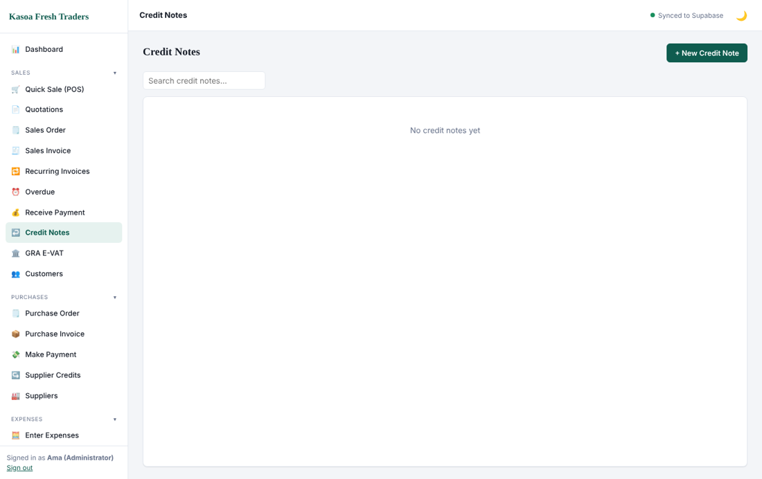
Credit notes

6.9 GRA E-VAT
If your business is registered for E-VAT, open GRA E-VAT to see invoices ready to send and their submission status. Keep your TIN correct in Company Information.
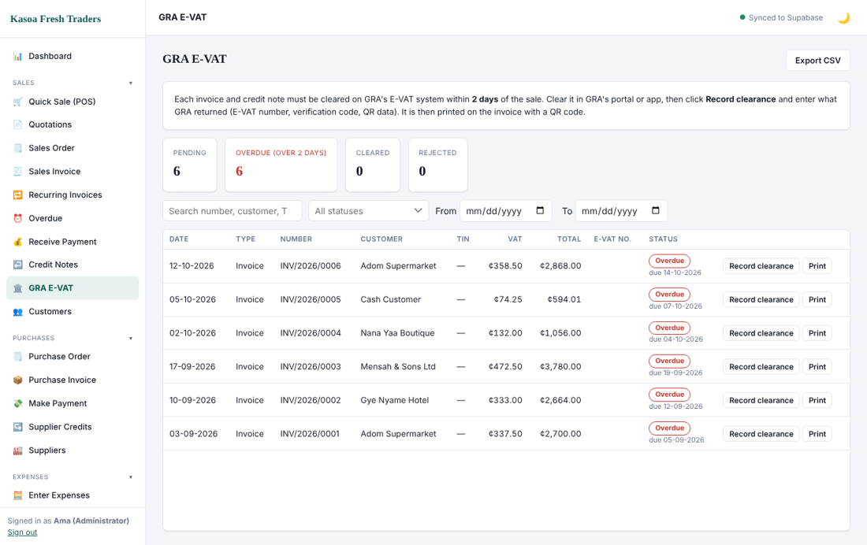
GRA E-VAT

6.10 Customer deposits
Use Customer Deposits under Sales when a customer pays before you invoice. The money is kept as a liability (the Customer Deposits account is created the first time you use it). When you raise the invoice, apply the deposit to it, or refund what is left.

7. Buying and expenses

7.1 Purchase orders
A Purchase Order tells a supplier what you want to buy. It posts nothing. When goods arrive, convert it into a purchase invoice.

7.2 Purchase invoices
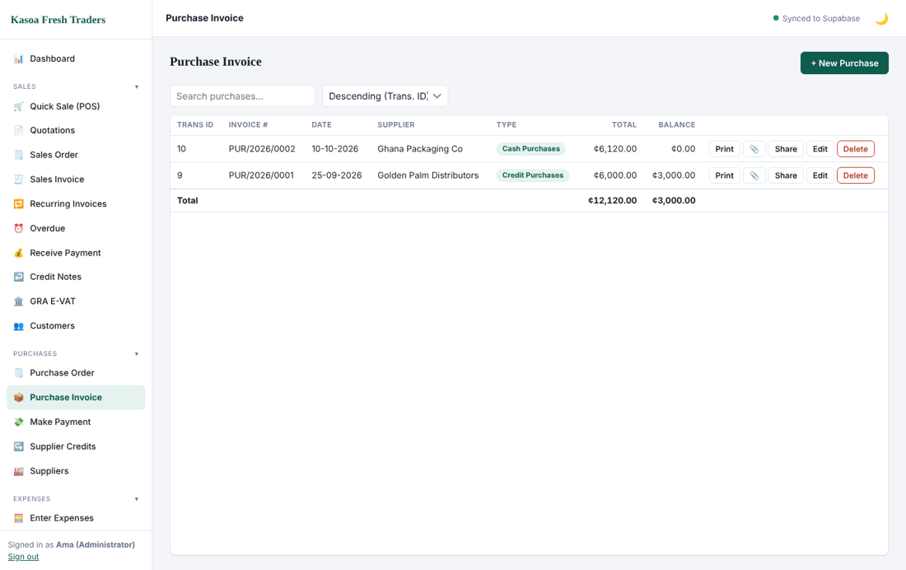
Purchase invoice list
1. Open Purchase Invoice, then New.
2. Choose the supplier and the transaction type: Credit Purchases (you will pay later) or Cash Purchases (paid now, choose the payment account).
3. Enter the supplier's invoice number exactly as printed on their invoice.
4. Add product lines with quantity and cost, plus any input tax.
5. Save.
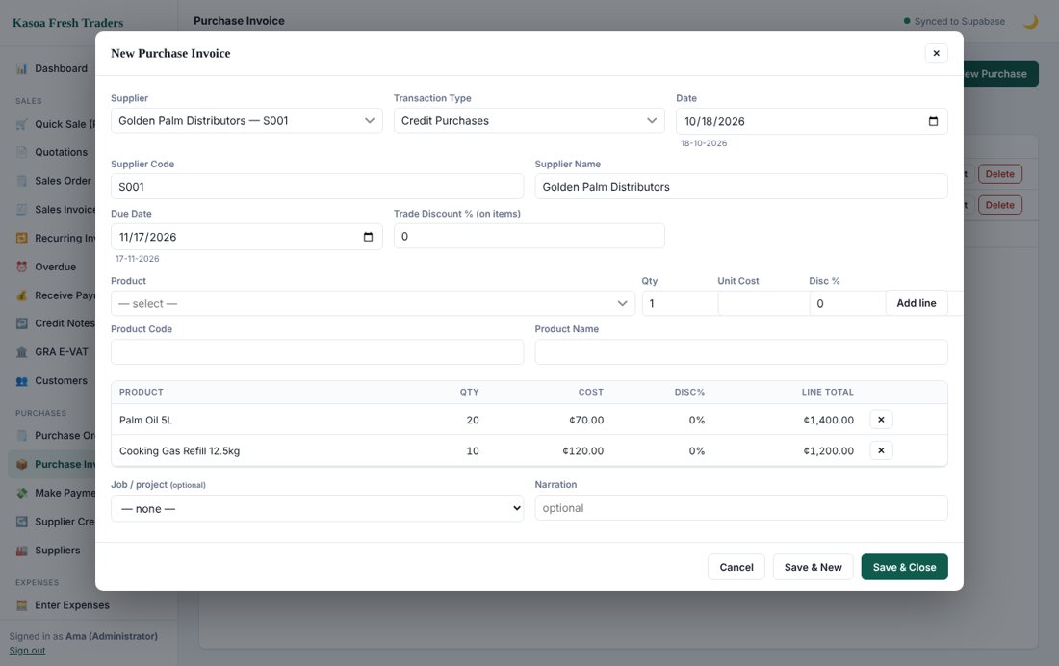
Purchase form
Stock increases and the latest cost updates. For a credit purchase the supplier's balance (Creditors) goes up.

7.3 Paying suppliers
Open Make Payment, choose the supplier, tick the invoices you are paying, enter the amount, payment method and account, and save. If the payment is subject to withholding tax, enter the WHT rate; it is recorded for the WHT register (section 10).
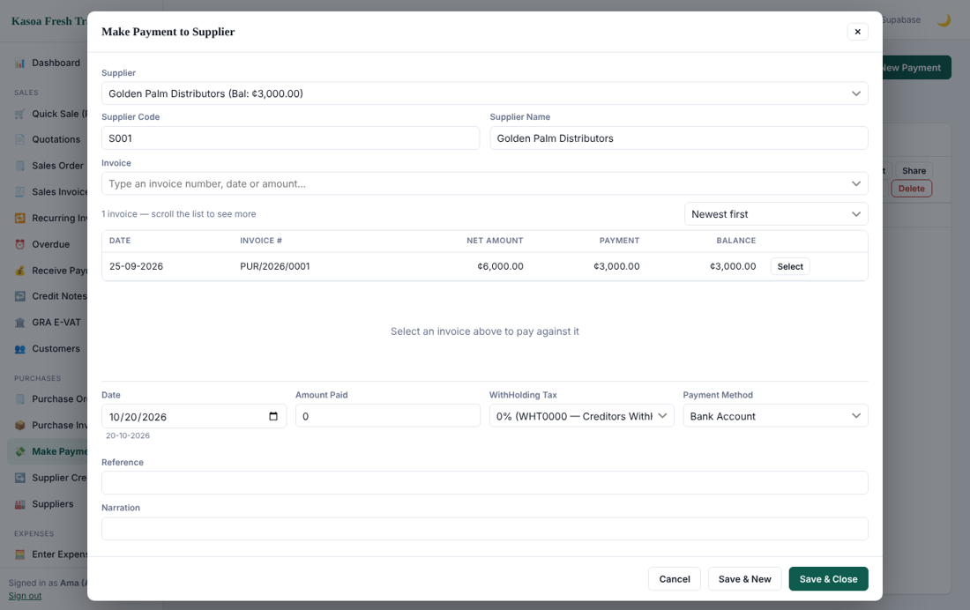
Make payment
The invoice list shows invoices with a balance first. Use the filter to show fully paid invoices or all of them.
If your administrator has set a payment approval limit (section 3.2), a payment at or above that amount made by someone without Full rights is not posted. It is sent for approval and appears in a Waiting for approval box above the list. A user with Full rights clicks Approve, which opens the payment ready to save; it is posted only when they save it. Reject cancels the request, and the person who asked can Withdraw it. The same applies to Pay Expense.
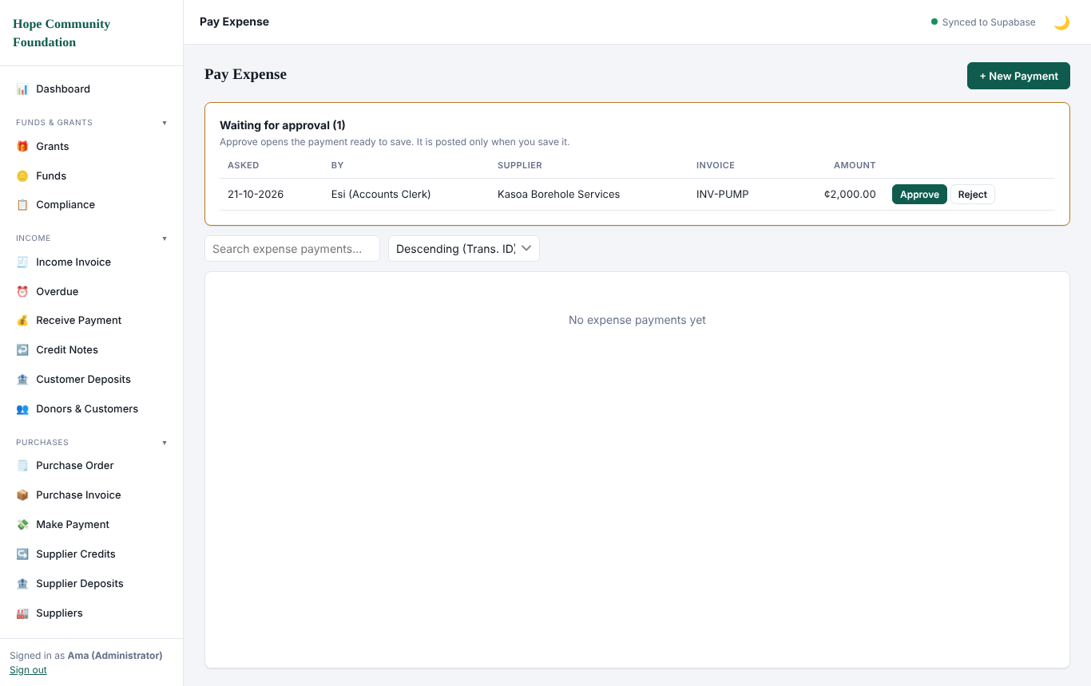
Pay Expense with a payment waiting for approval

7.4 Supplier credits
Use Supplier Credits when you return goods or the supplier gives a discount after invoicing. It reduces what you owe.

7.5 Expenses
Use Enter Expenses for costs that are not stock: rent, fuel, salaries paid outside payroll, airtime, repairs and so on.
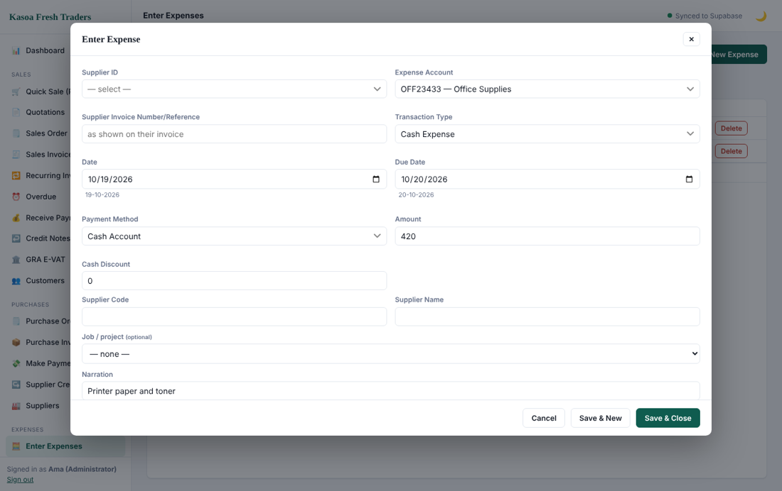
Expense form
1. Open Enter Expenses and click New.
2. Choose the Supplier, the Expense Account (for example Administration Costs) and the Transaction type: Cash Expense (paid now) or a credit expense.
3. Enter the supplier invoice or reference number, date and due date.
4. For a cash expense choose the payment method and account.
5. Enter the amount and a narration, then save.
A credit expense is later paid with Pay Expense so that it clears from the supplier's balance.

7.6 Petty cash
Use the petty cash screens to record the float, spend from it and top it up. The balance always equals the cash in the box.
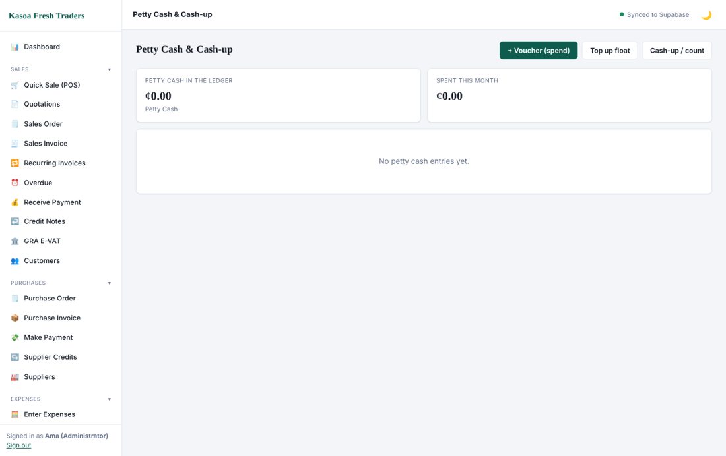
Petty cash
Click Edit on a voucher or a top-up to correct it; its ledger entries are posted again and the cash balance is checked. A cash-up count cannot be edited, but an administrator can delete it. The voucher form has Save & New for entering several vouchers in a row.
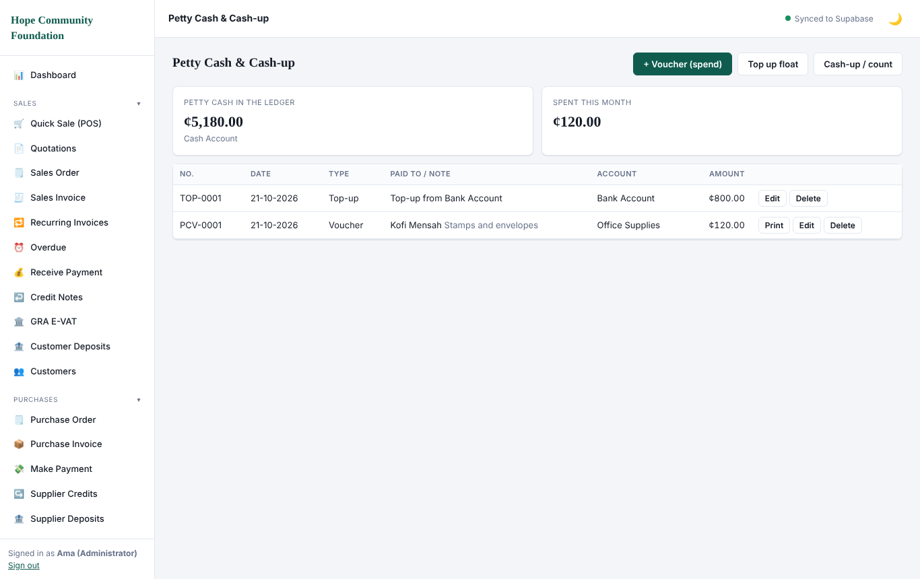
Petty cash list with Edit buttons

7.7 Supplier deposits
Use Supplier Deposits under Purchases when you pay a supplier in advance. The money is kept as an asset (the Supplier Deposits account is created the first time you use it). When the supplier's invoice arrives, apply the deposit to it, or record a refund if the supplier returns the money.

8. Stock
Stock is valued at weighted average cost and updates automatically when you post purchases, sales, credit notes and adjustments.

8.1 Stock take
Count physical stock and compare it with the system.
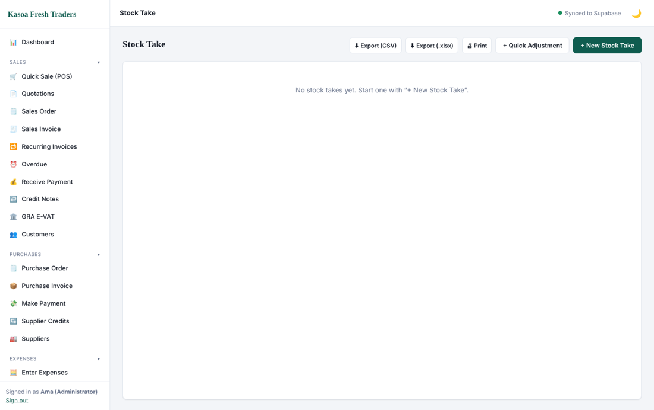
Stock take
1. Open Stock Take and start a new one.
2. Enter the counted quantity for each product.
3. Review the differences. A positive difference is a gain, a negative one a loss.
4. Post the take to adjust quantities and book the gain or loss.
Use Quick Adjust for a single product (damaged or expired goods, for example).

8.2 Transfers
Move stock between stores or branches without changing its value.
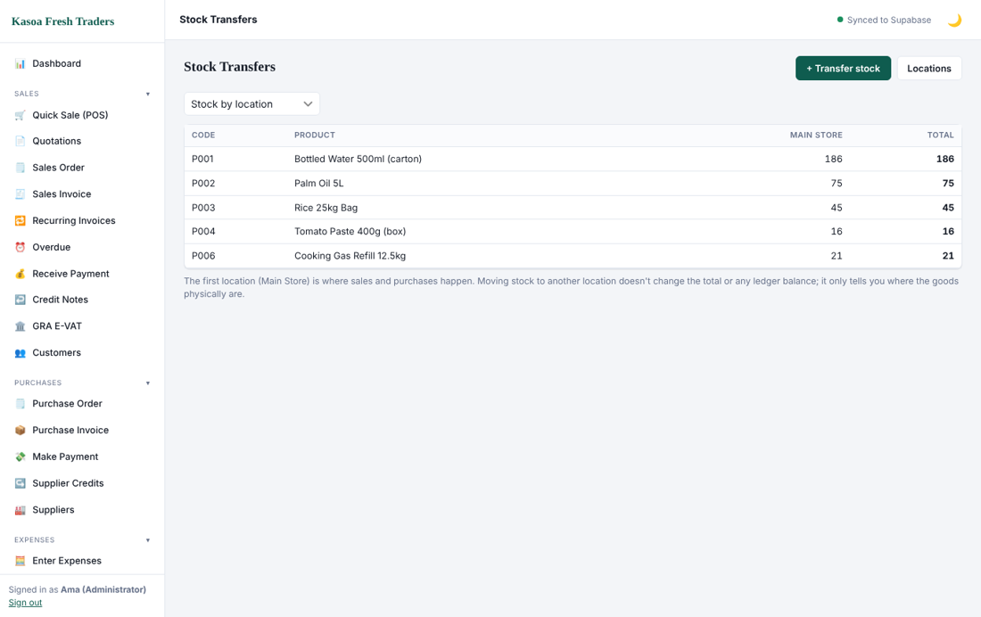
Transfers

8.3 Stock reports
The Stock Summary report shows quantity and value per product. Use it to check your Inventory account in the Trial Balance: the two should agree. See section 10.
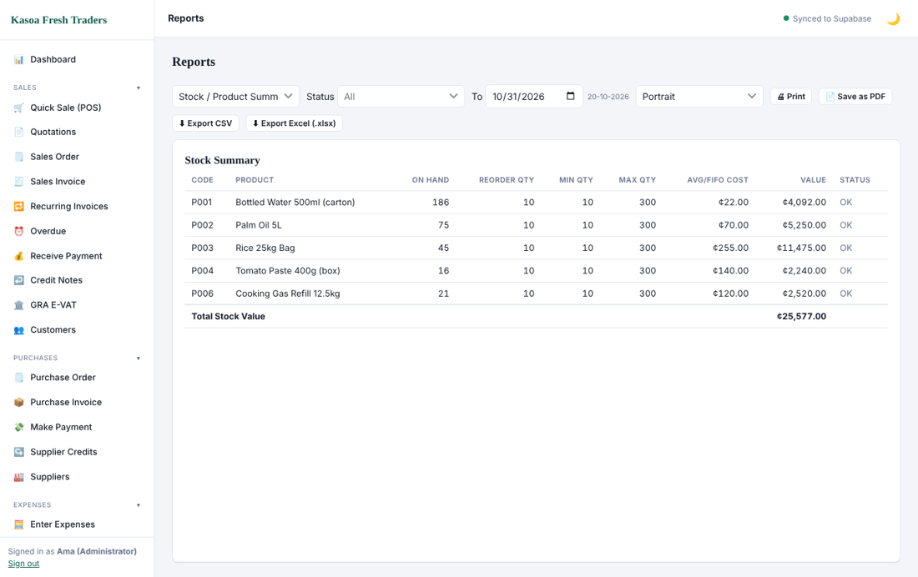
Stock summary

9. Banking, journals, ledger, fixed assets and month-end

9.1 Journals
A journal moves value between accounts directly. Use it for opening balances, capital introduced, corrections and year-end adjustments.
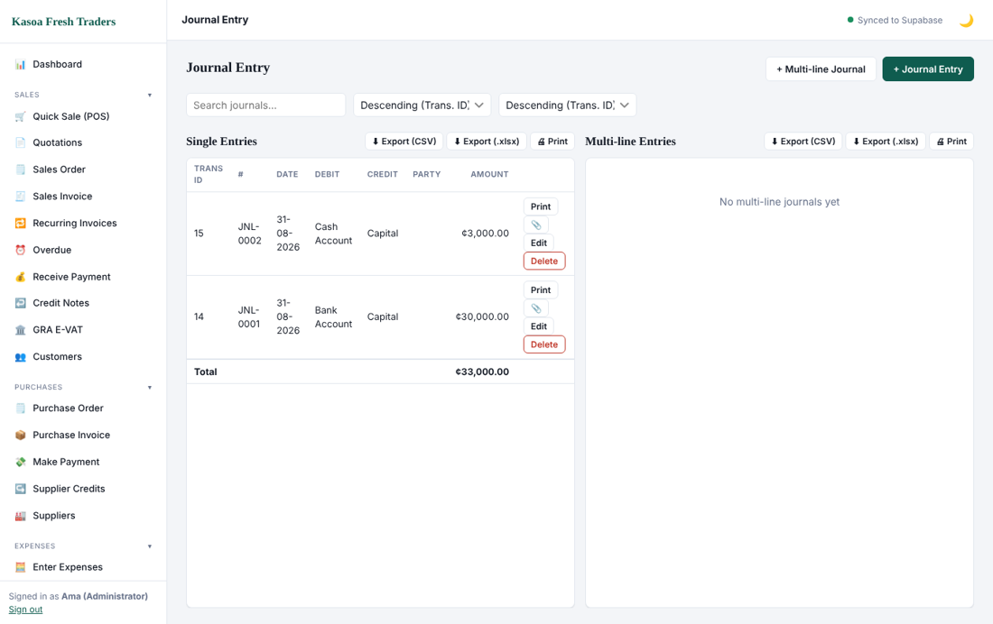
Journal entry
1. Open Journal Entry.
2. For a simple journal choose the account to debit, the account to credit, the amount and a narration. For a multi-line journal use the multiple journal form.
3. The total debits must equal the total credits. Save.

9.2 The ledger
Open the Ledger to see the entries of any account in date order with a running balance. Click a line to open the source transaction.
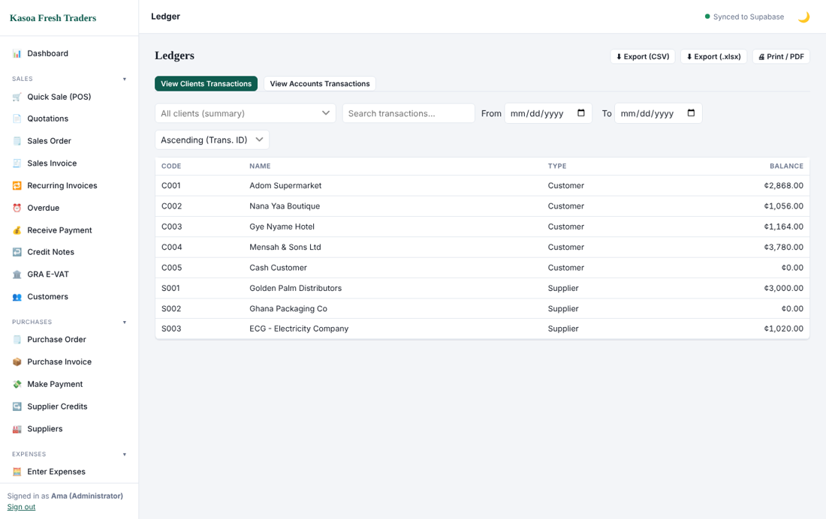
Ledger

9.3 Bank reconciliation
Reconcile each bank account monthly against the bank statement.
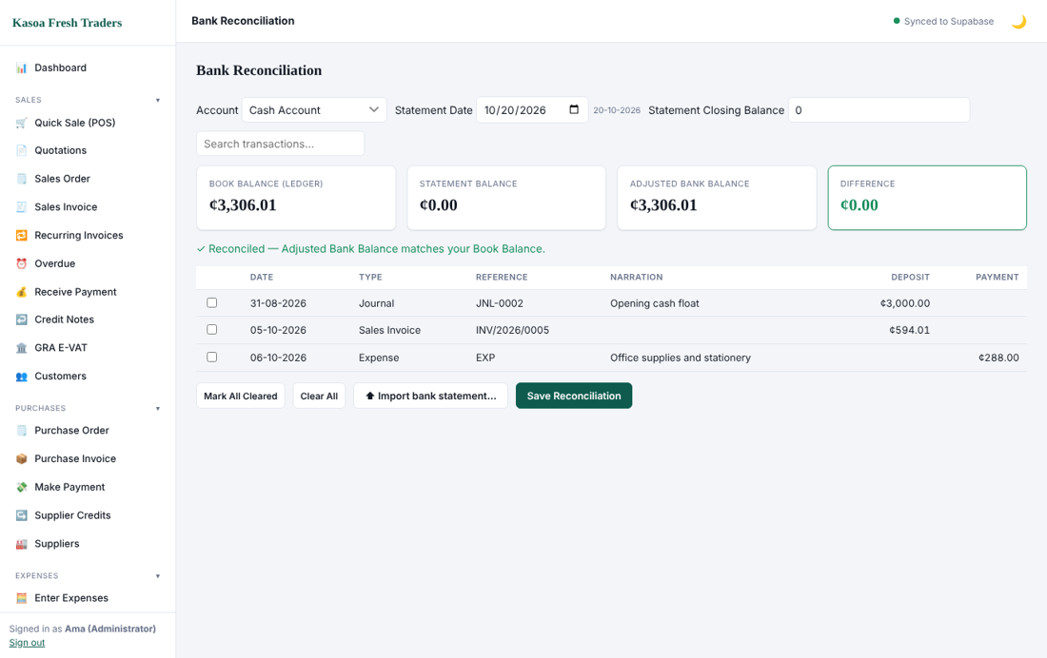
Bank reconciliation
1. Open Bank Reconciliation and choose the account and statement date.
2. Enter the statement closing balance.
3. Tick every line that appears on the bank statement.
4. When the difference is zero, save the reconciliation.
Items you have not ticked are outstanding (cheques not yet cashed, deposits in transit). Statement lines can be imported from a file to save ticking.

9.4 Fixed assets and depreciation
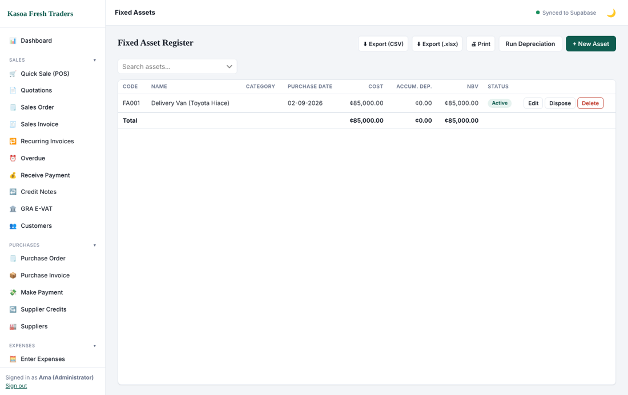
Fixed assets
Register each asset with its cost, date, depreciation method and rate. Run depreciation for the period; the program posts the depreciation expense and accumulated depreciation. Record disposals when an asset is sold or scrapped.

9.5 Budgets
Set a budget per account and period, then compare it with actuals.
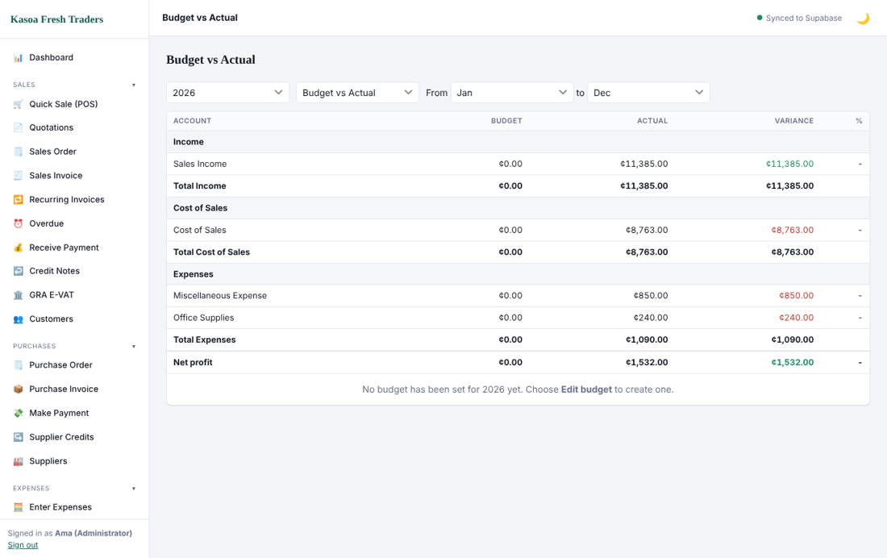
Budget

9.6 Month-end checklist
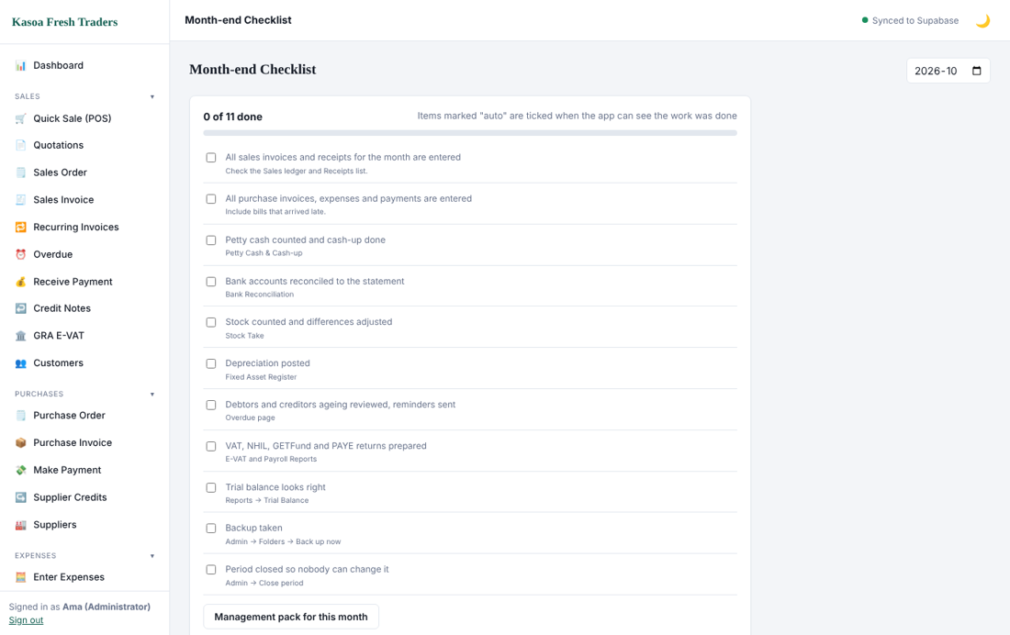
Month end
1. Post every invoice, receipt, payment and expense for the month.
2. Reconcile every bank and mobile-money account.
3. Count petty cash and stock where needed.
4. Run depreciation and any accrual or prepayment journals.
5. Print the Trial Balance and check that it balances.
6. Review VAT and the monthly GRA returns (section 10).
7. Close the period in Admin / Settings, General Settings, Month End / Year End Closure. After this, nobody can post to dates on or before the closing date.
At year end close the final month the same way. Profit and Loss and Retained Earnings continue to calculate from the ledger.

10. Reports
Open Reports from the menu. Choose a report from the list at the top, set the From and To dates, and choose Portrait or Landscape. Every report can be printed, saved as PDF, or exported to CSV or Excel (.xlsx).
Report | What it tells you | Use it for
Trial Balance | Debit and credit balance of every account | Checking the books balance before reporting
Profit & Loss | Income less cost of sales and expenses | Whether you made a profit
Balance Sheet | Assets, liabilities and equity at a date | Your financial position
Cash Flow | Cash in and out by source | Why cash changed
VAT Reconciliation | Output tax less input tax | Preparing the VAT return
GRA Monthly Returns | Totals formatted for monthly GRA filing | PAYE, SSNIT, WHT and VAT filing
WHT Register | Withholding tax deducted from payments | Remitting to GRA
Aged Debtors / Creditors | Who owes you and whom you owe, by age | Collections and payment planning
Customer Sales, Expenses History | Sales per customer, spending per account | Analysis
Stock Summary | Quantity and value per product | Stock control
Tax Estimate | Estimated income tax on profit | Planning tax payments

10.1 Trial Balance
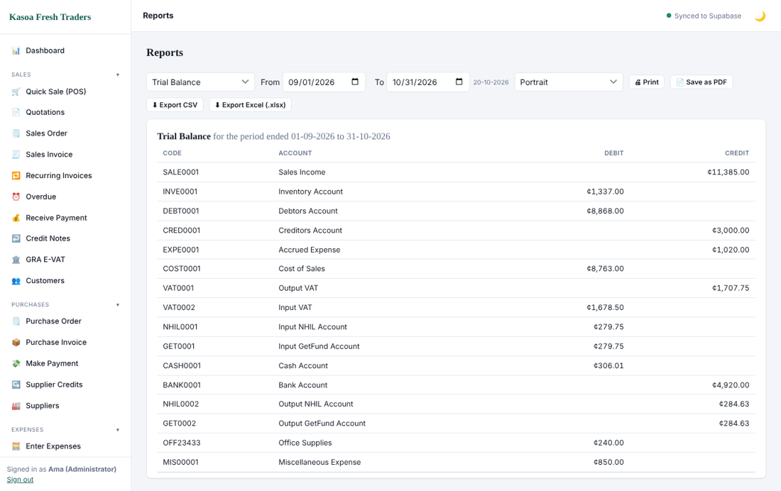
Trial Balance
Total debits must equal total credits. If they do not, contact support before reporting.

10.2 Profit & Loss
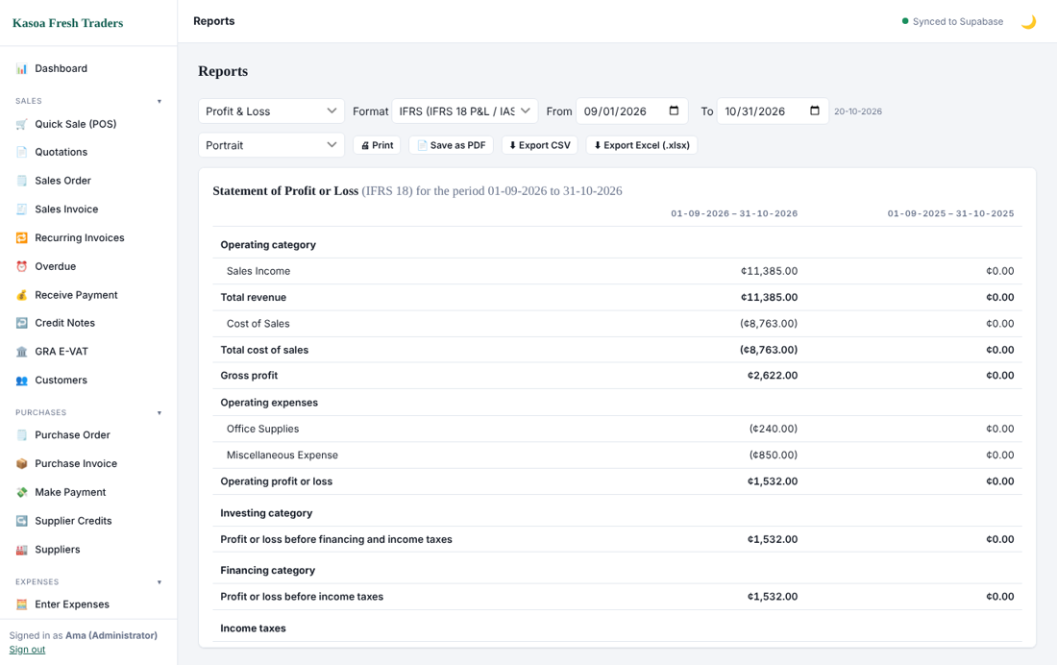
Profit and Loss
It shows Sales, less Cost of Sales equals Gross Profit, less Expenses equals Net Profit. Use the format switch for the classic layout. Click a line to see its transactions.

10.3 Balance Sheet
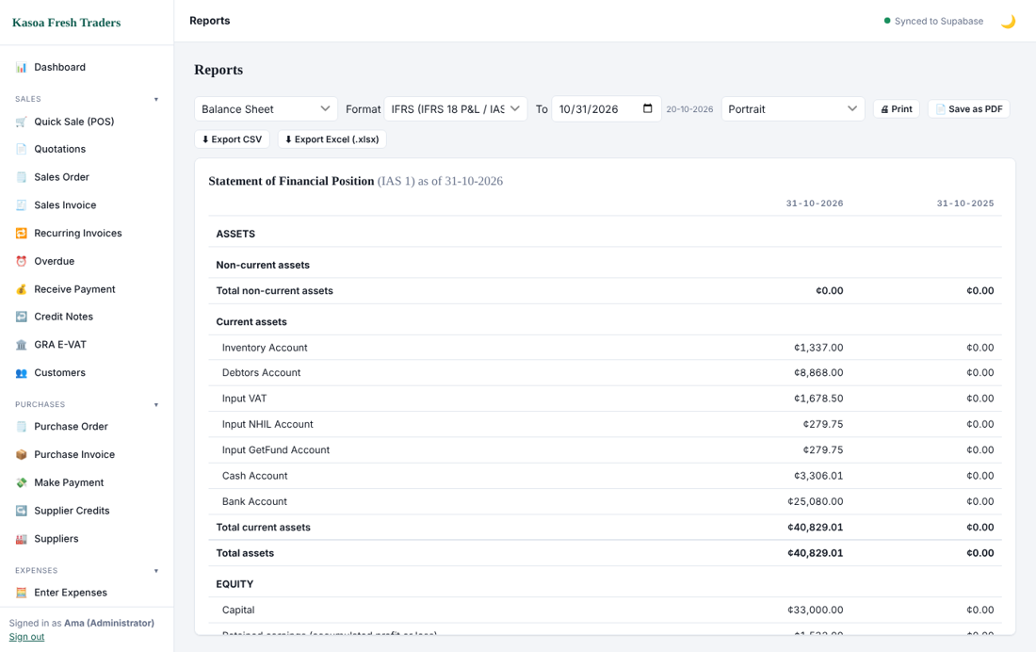
Balance Sheet
Assets must equal Liabilities plus Equity. Current-year profit is included in equity automatically.

10.4 Cash Flow
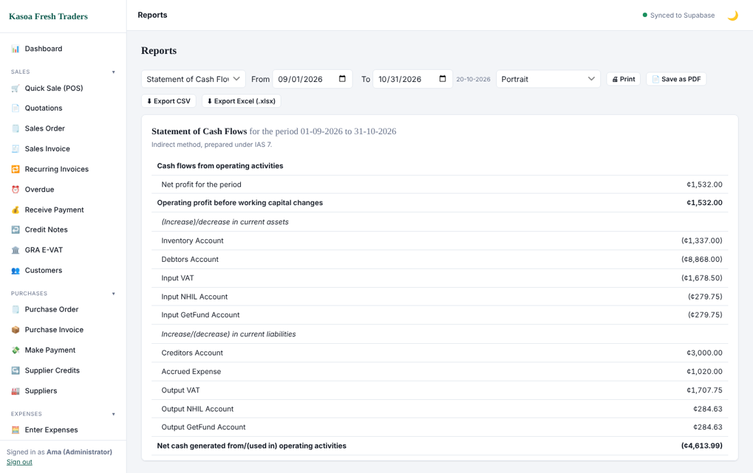
Cash Flow

10.5 VAT reconciliation and GRA returns
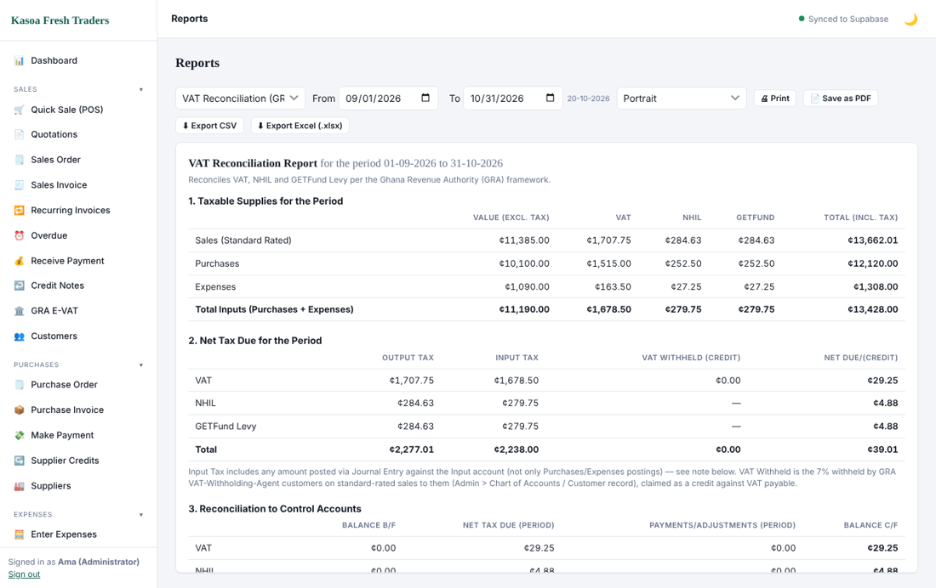
VAT reconciliation
The VAT report separates output VAT, NHIL, GetFund and COVID levy from the input amounts you can claim. The GRA Monthly report brings the month's tax figures together so that you can copy them into the GRA portal.
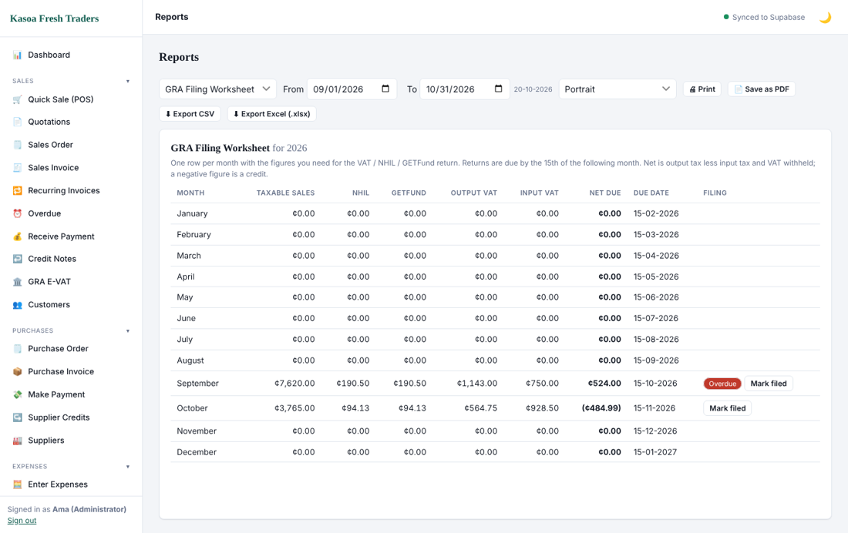
GRA monthly returns

10.6 Aged debtors
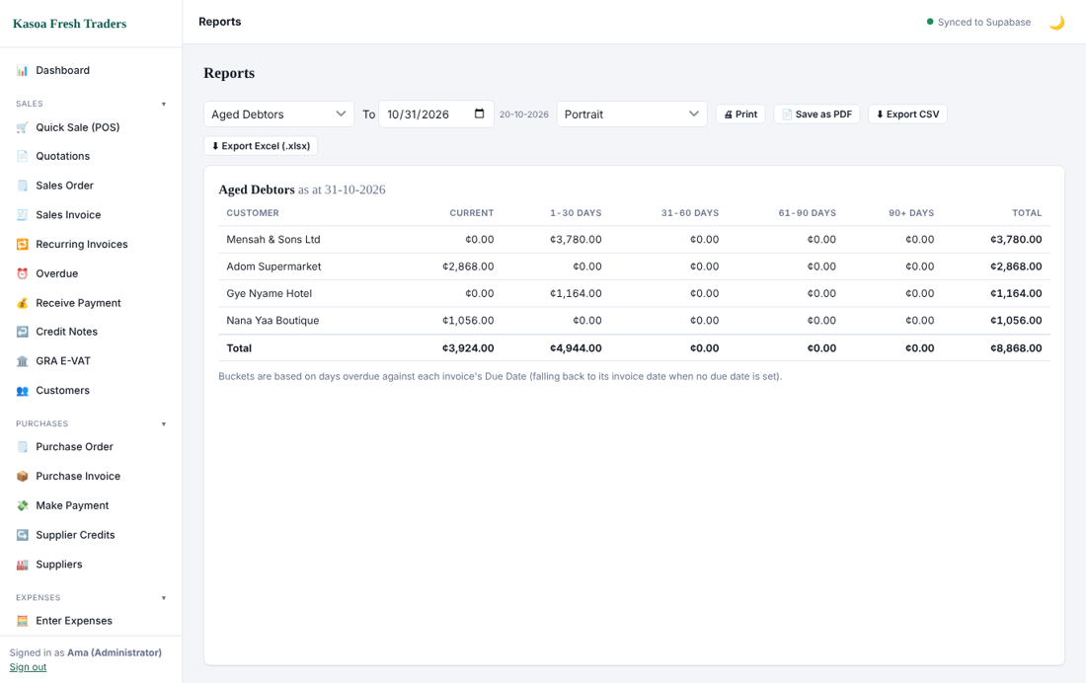
Aged debtors
Buckets show current, 30, 60, 90 and over-90-day balances per customer.

10.7 Tax estimate
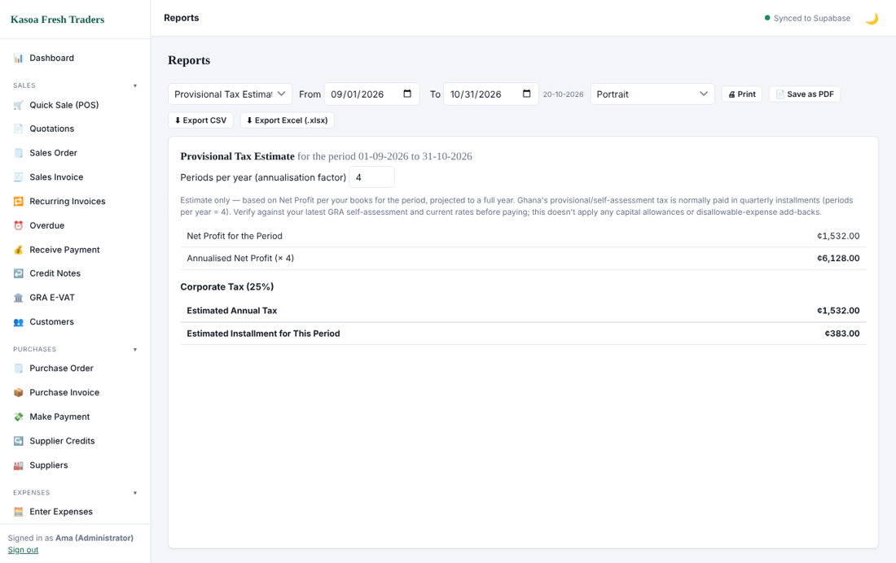
Tax estimate
The estimate is a planning aid, not a tax computation. Your accountant must confirm the figure before you pay or file.

10.8 Management pack
The management pack prints the key reports together with a cover page for owners, banks and auditors.

10.9 Exporting and printing
Use Print for paper and Save as PDF for a file. Export CSV and Export Excel give you the table for further analysis. Dates in exports follow your General Settings format.

11. HR and Payroll
HR and Payroll are optional. HR (staff records, leave, loans, attendance) is part of the main program. Payroll (payslips, PAYE, SSNIT) is a paid add-on that needs its own licence. Give access only to people who may see staff pay.

11.1 HR dashboard and employees
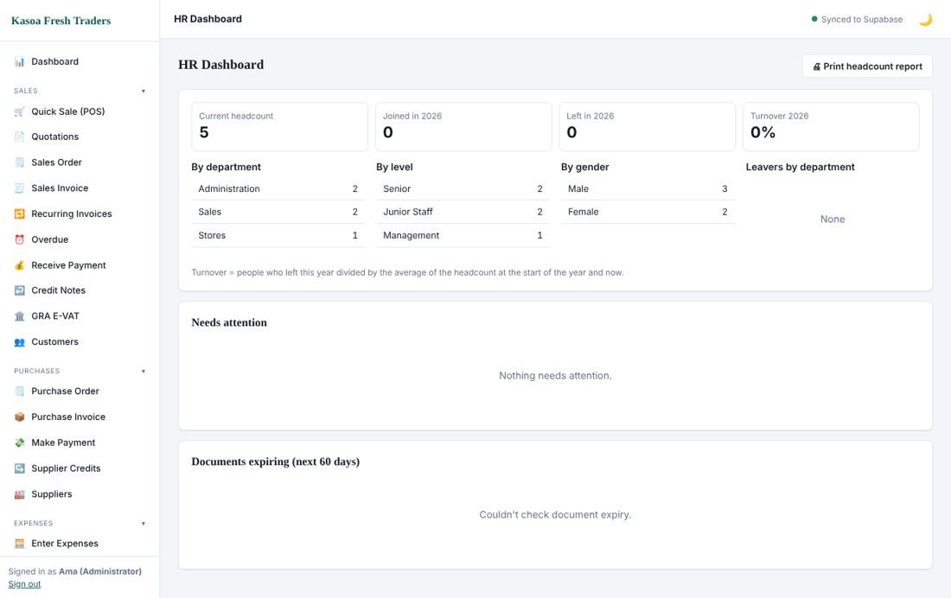
HR dashboard
Open Employees to see your staff, then click New employee.
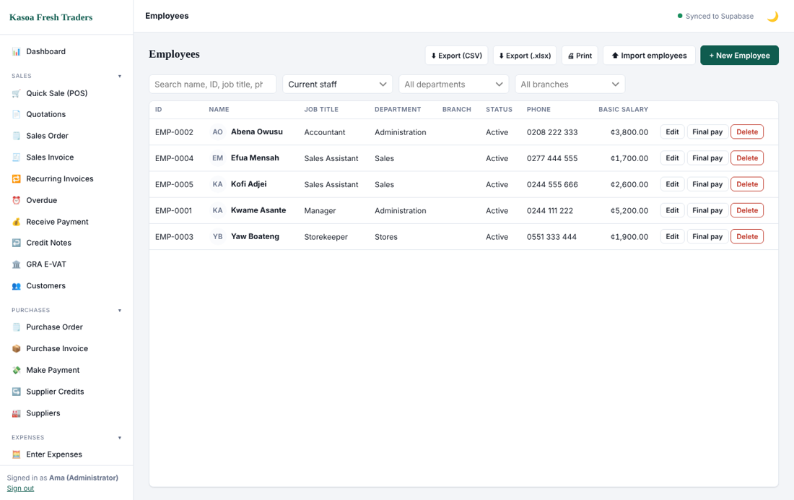
Employees
1. Enter personal details: full name, gender, date of birth, phone and address.
2. Enter job details: department, position, start date and employment type.
3. Enter pay details: basic salary and allowances, bank details, SSNIT number and TIN.
4. Save.
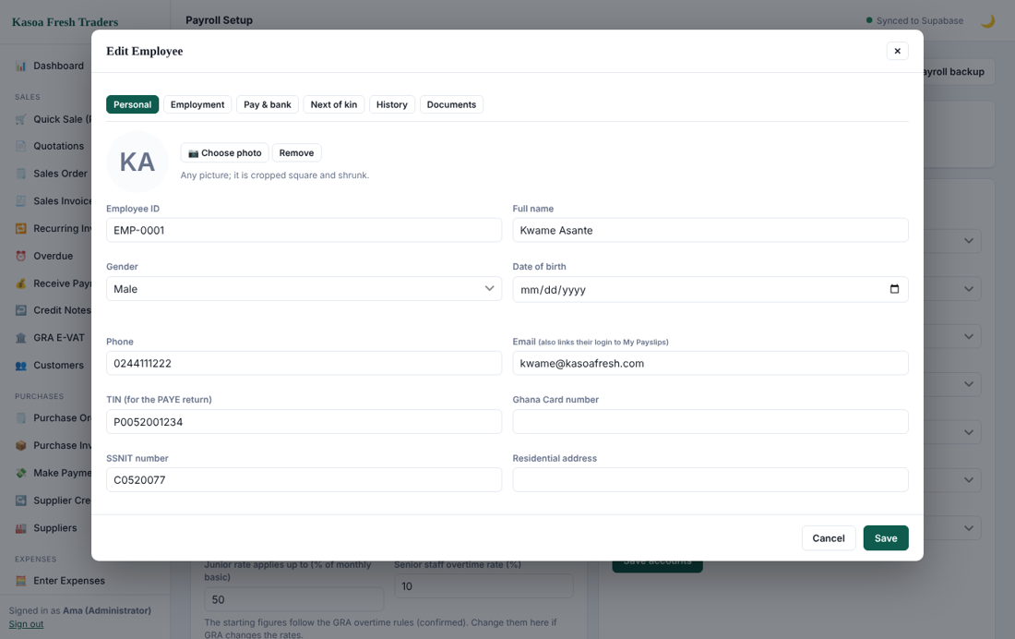
Employee form
You can import many employees from a spreadsheet using the import option on the Employees screen.

11.2 Leave, requests, loans and attendance
- Leave: record leave types and balances; approve or reject requests. Approved leave updates the balance.
- Requests: staff requests waiting for a manager's decision.
- Loans: record staff loans and monthly deductions. Payroll deducts them automatically.
- Attendance: daily check-in and check-out records.
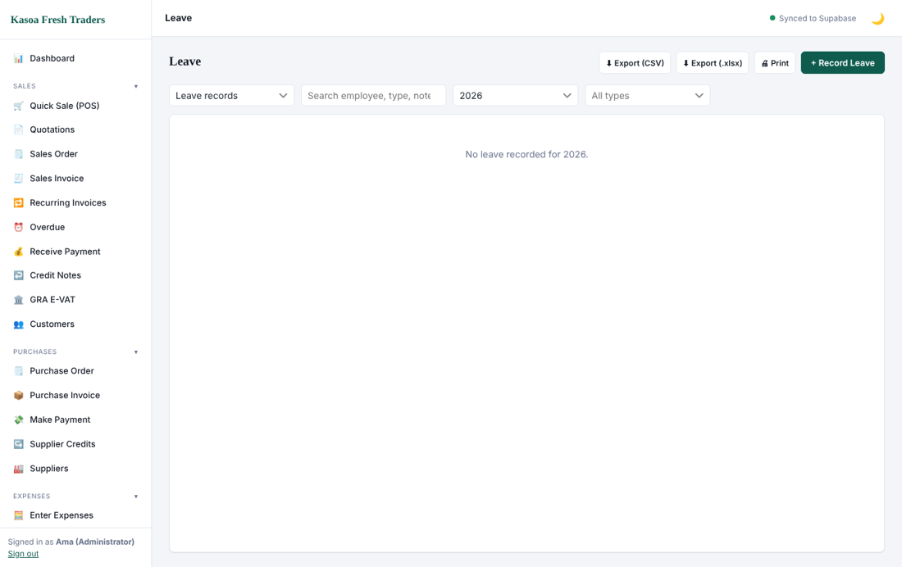
Leave

11.3 Payroll setup
Before the first pay run confirm the tax tables (PAYE bands and SSNIT rates) in Payroll Setup and the accounts payroll posts to.

11.4 Running payroll
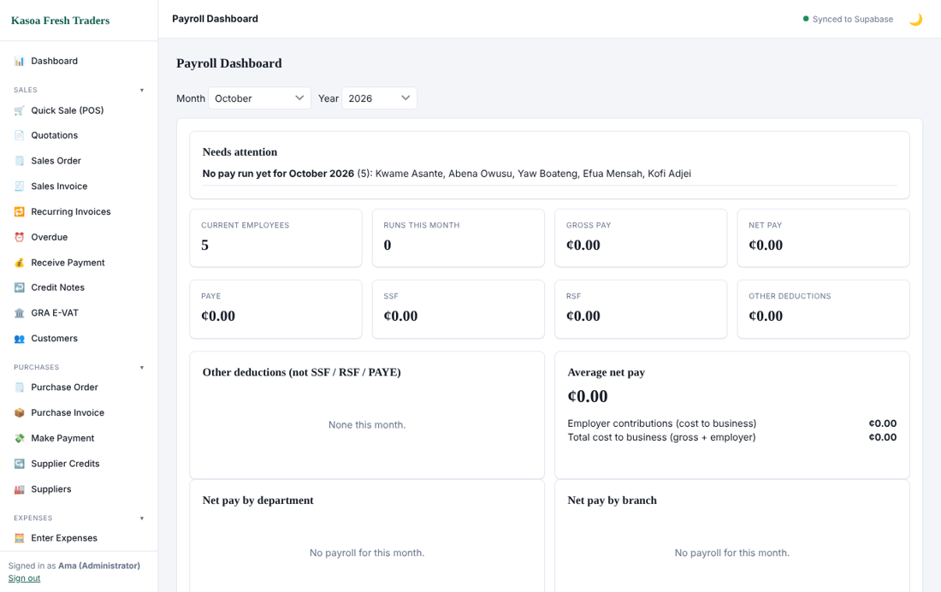
Payroll dashboard
1. Open Pay Runs and start a new run for the month.
2. Review each employee's gross pay, allowances, deductions, SSNIT, PAYE and net pay.
3. Adjust a figure where needed (overtime, absence, one-off bonus).
4. Approve the run.
5. Post the payroll to accounts. The program debits salaries and employer SSNIT and credits PAYE, SSNIT and net salaries payable.
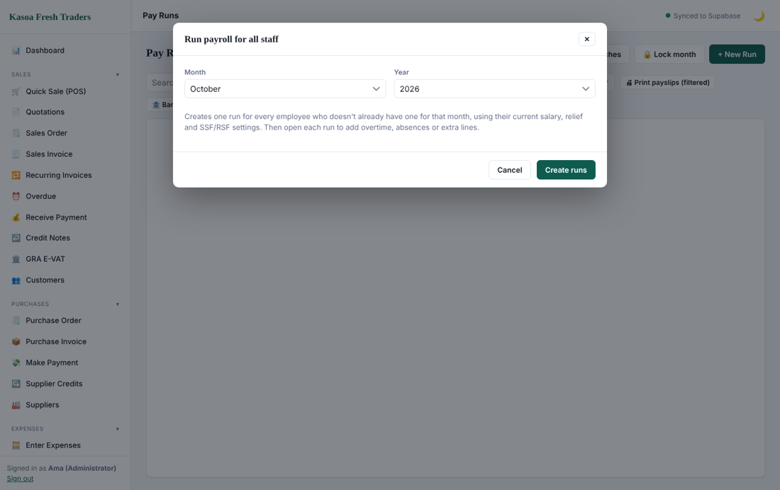
Run payroll

11.5 Payslips
Open a pay run and click an employee to print or share the payslip.
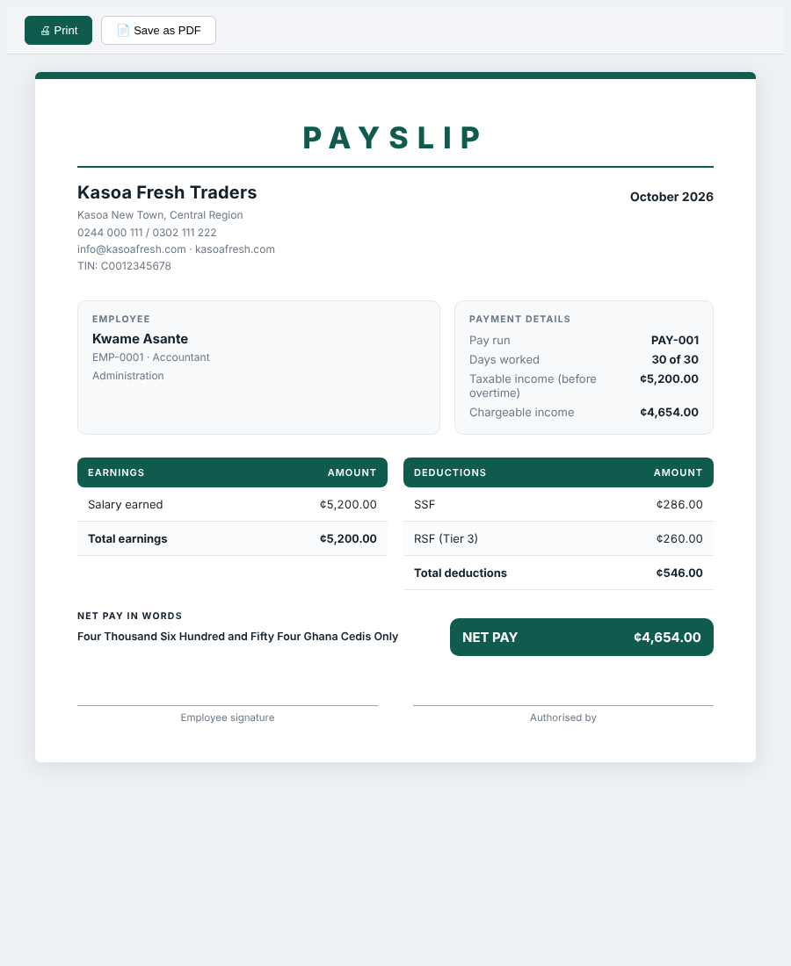
Payslip

11.6 Paying and remitting
Pay net salaries from the bank with Make Payment or an expense payment against the salaries payable account. Remit PAYE to GRA and SSNIT to the SSNIT office by the due dates, then record those payments the same way. Payroll reports (PAYE schedule, SSNIT schedule, pension) support the filings.

12. NGO / Non Profit mode
Non Profit mode is for NGOs, churches, associations and foundations. It keeps the same accounting engine but adds funds, grants, donor reporting and non-profit statements. The screenshots in this section come from a sample organisation, Hope Community Foundation.

12.1 Choosing the mode
After your first sign-in the program asks whether the organisation is Profit Making or Non Profit.
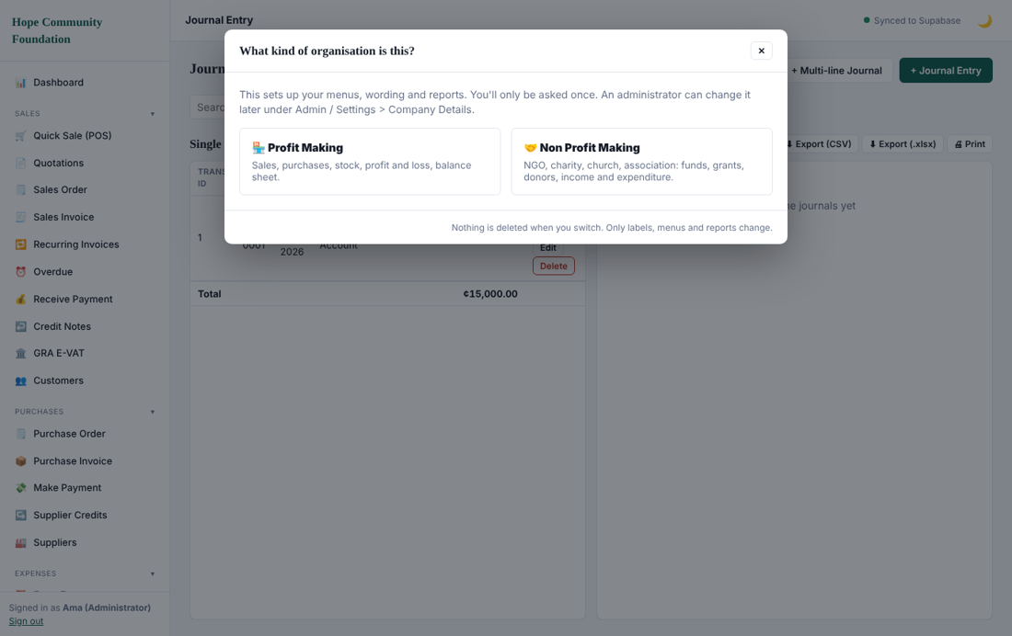
Choose organisation type
The choice is saved in Admin / Settings, Company Information, Organisation type. You can change it later; nothing is deleted. Choosing Non Profit adds the NGO menus (Grants, Funds, Compliance), NGO wording (Income and Expenditure, Donors) and an NGO set of accounts.
In Non Profit mode the menu starts with a Funds & Grants group (Grants, Funds, Compliance). Under Admin, Company Information, you can hide menus a Non Profit does not use, such as Quick Sale, Quotations, Sales Order, Recurring Invoices, Jobs and GRA E-VAT. Other menus you can hide are Overdue, Credit Notes, Purchase Order, Supplier Credits, Petty Cash, Fixed Assets, Bank Reconciliation, Budget vs Actual, Month-end Checklist, Management Pack, Currencies and Audit Log, and the whole HR / Employees or Payroll group.

12.2 Grants
A grant is money given for an agreed purpose. Open Grants and click New grant.
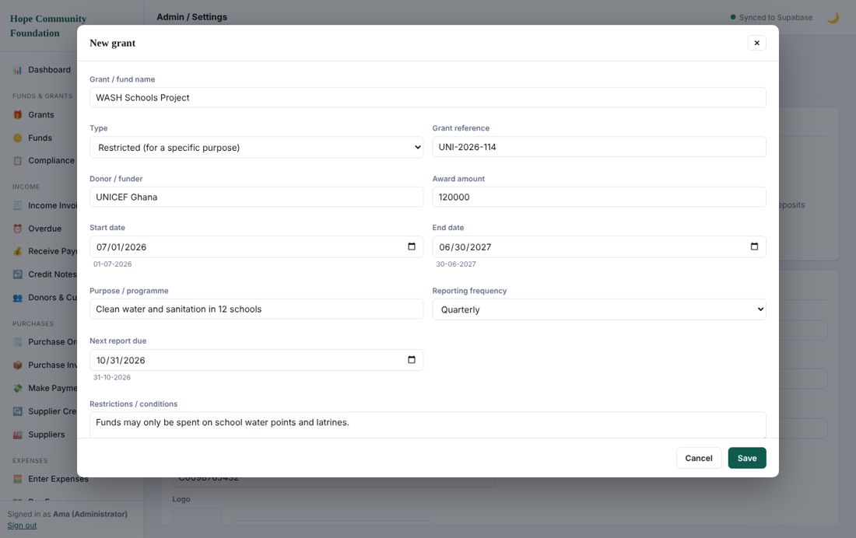
Grant form
1. Enter the grant name, donor, award amount, start and end dates, purpose and reference.
2. If the grant is in another currency choose it and enter the fixed exchange rate agreed with the donor.
3. Enter the reporting frequency and next report date. The program reminds you when a donor report is due.
4. Add budget lines: pick an expense account and the amount approved for it.
5. Add expected instalments (tranches) with date and amount.
6. Write any donor conditions, then save.
The grants list shows award, received, spent (paid), committed, available and status for each grant, with an attention panel for upcoming reports, grants about to end and compliance deadlines.
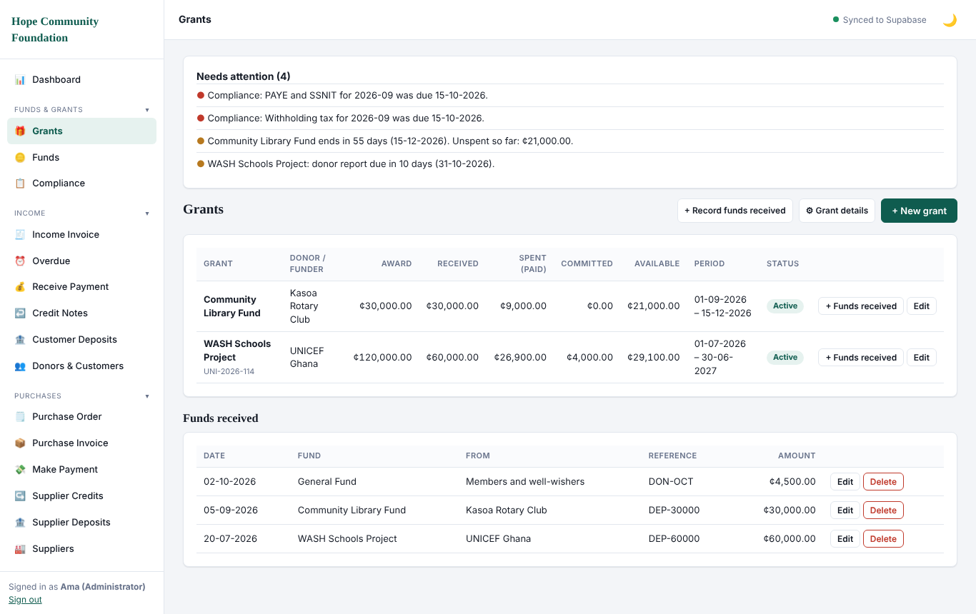
Grants list with Spent, Committed and Available
Spent (paid) is money that has gone out. Committed is bills charged to the grant that are not paid yet. Available is received minus spent minus committed. Use Edit in the Funds received table to correct a receipt.
The grant detail fields (donor reference, report frequency and so on) can be customised: click Grant details to add, rename or hide fields to suit your donors.
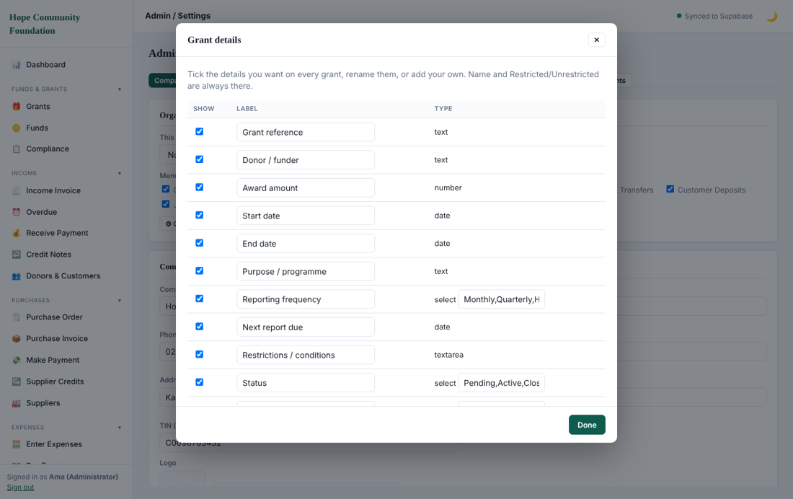
Customise grant fields

12.3 Funds and receiving money
A fund holds money for a purpose. Each grant creates a restricted fund. You can add others, such as a Building Fund, and the General Fund holds unrestricted money.
To record money received click Record funds received, choose the fund, donor, date, amount, reference and the bank account. This credits the fund as income.
The Funds screen shows the same columns for every fund: income, spent (paid), committed and available.
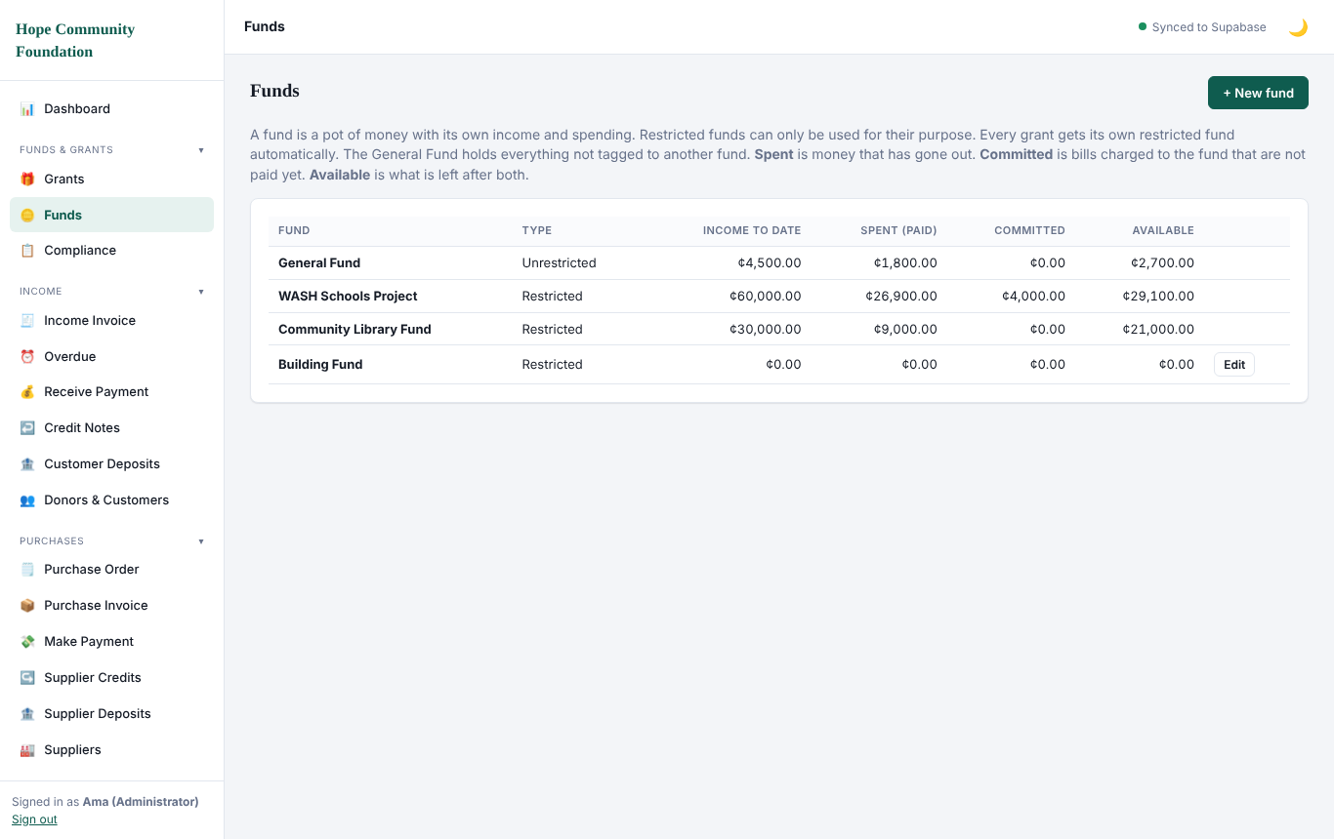
Funds list

12.4 Tagging spending to a fund
Every transaction form shows a Fund box at the top. Choose the grant or fund that pays for the cost; leave it as General Fund for ordinary running costs.
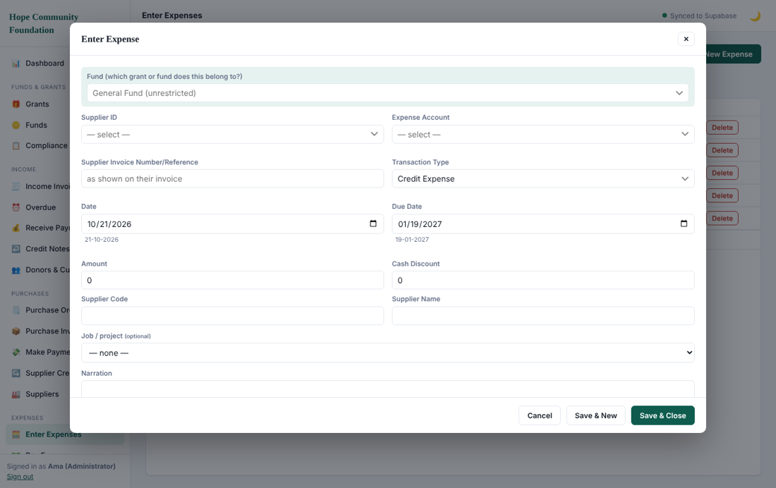
Fund picker on the expense form
A credit purchase or credit expense charged to a grant is Committed, not Spent, because the money has not gone out. When you pay the supplier, only the amount paid moves from Committed to Spent; the payment takes the fund from the original bill. Cash purchases and expenses count as Spent straight away. Purchases and stock bought for resale also count against the fund they are charged to.
If a restricted fund has spent or promised more than it received, a warning appears when you save, and the fund is listed in the Needs attention box.
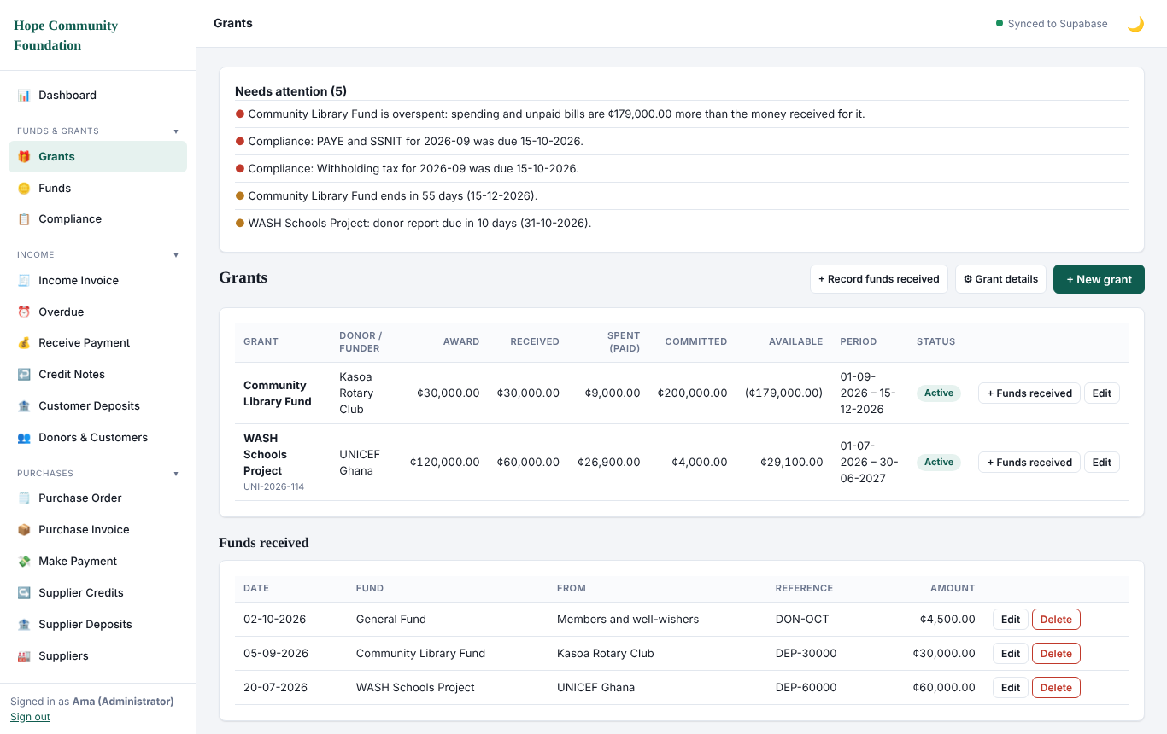
Overspend warning in Needs attention
Budget lines track against actual spending, so you see what is left on each line.

12.5 NGO reports
In Reports the list changes to non-profit reports:
- Statement of Income and Expenditure with Unrestricted, Restricted and Total columns.
- Statement of Financial Position with funds shown as Unrestricted and Restricted.
- Receipts and Payments Account on a cash basis.
- Fund Movement (brought forward, income, spent, carried forward).
- Notes to the Accounts with editable policy wording.
- Grant Report and Donor Report with budget against actual and instalment status.
- Cost Split between programme and administration costs.
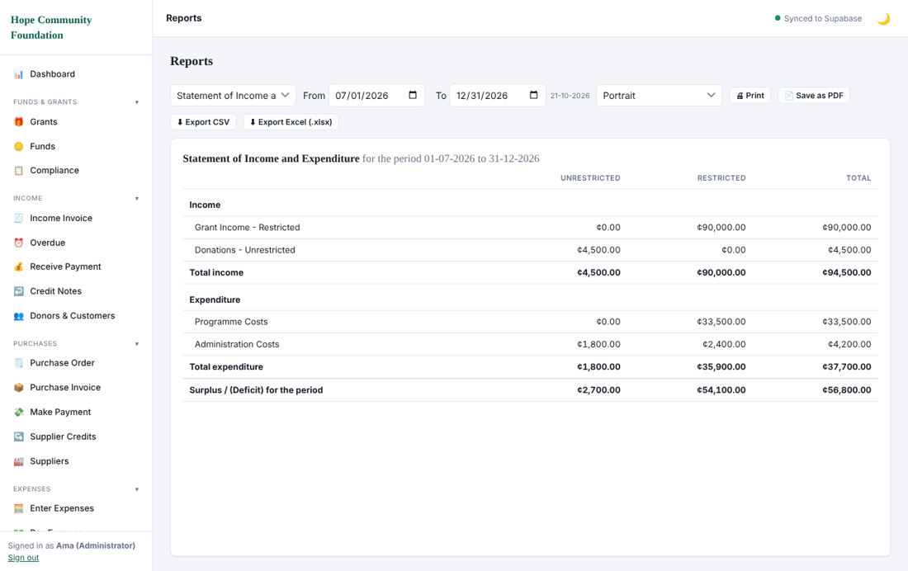
Statement of Income and Expenditure
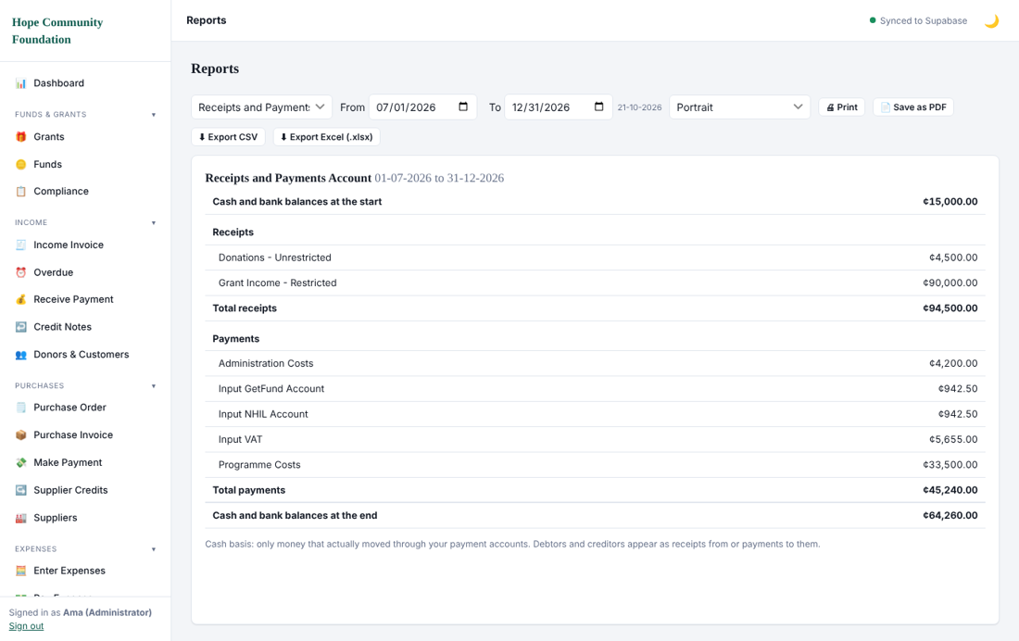
Receipts and Payments
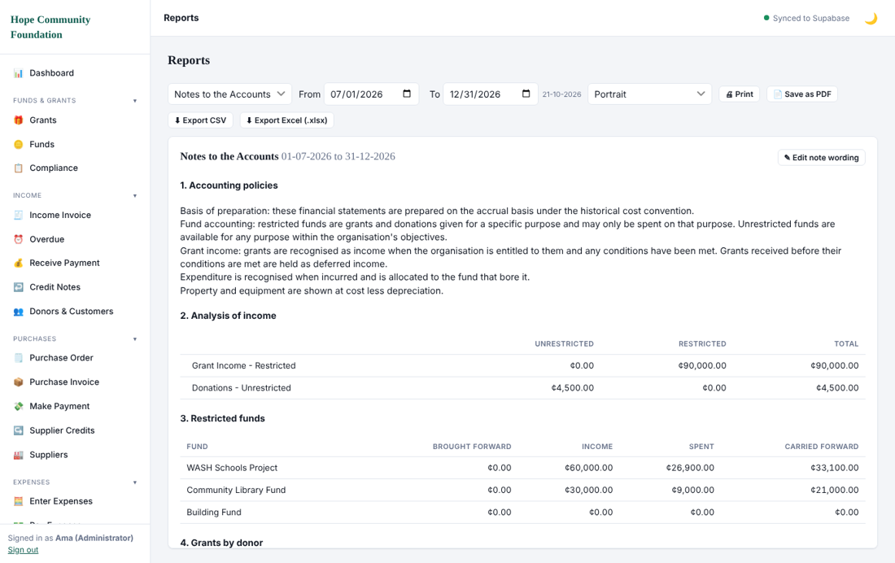
Notes to the Accounts
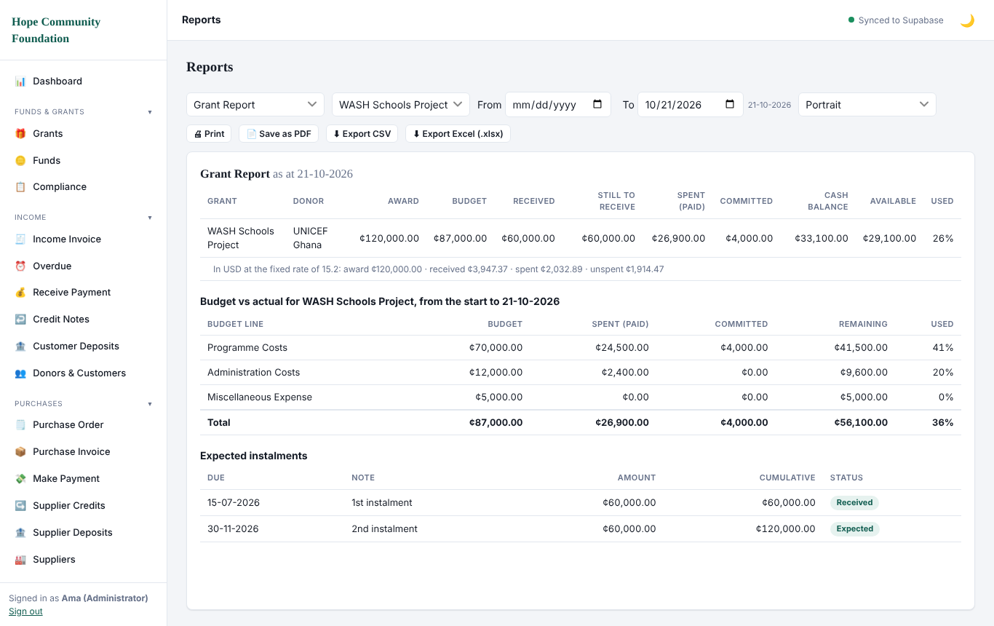
Grant report with Spent, Committed, Cash balance and Available
The Grant Report shows spent (paid), committed, cash balance (received minus spent) and available. For one grant, the budget lines table shows spent and committed for each line. The financial statements still record a cost when it is incurred.

12.6 Compliance checklist
The Compliance screen lists recurring obligations such as PAYE, SSNIT and withholding tax, with due dates by month, so that nothing is missed. Tick items as you file them. Check the dates against your own tax advice, because rules can change.
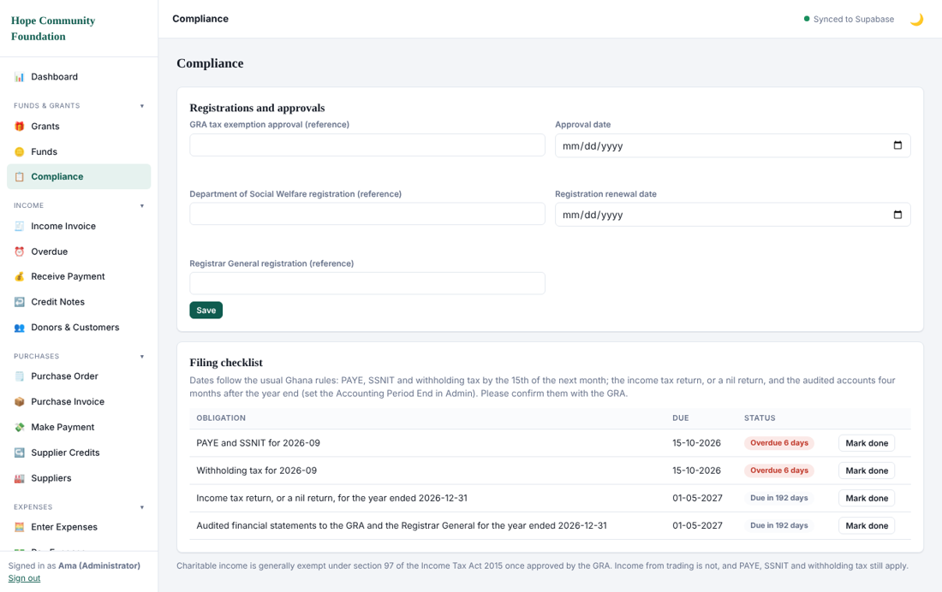
Compliance

13. Currencies, backups, audit log and tips

13.1 Foreign currencies
List the currencies you use in the currencies screen with their exchange rate to the cedi. Update rates when they change. Transactions in a foreign currency are converted at the rate in force when you save them.
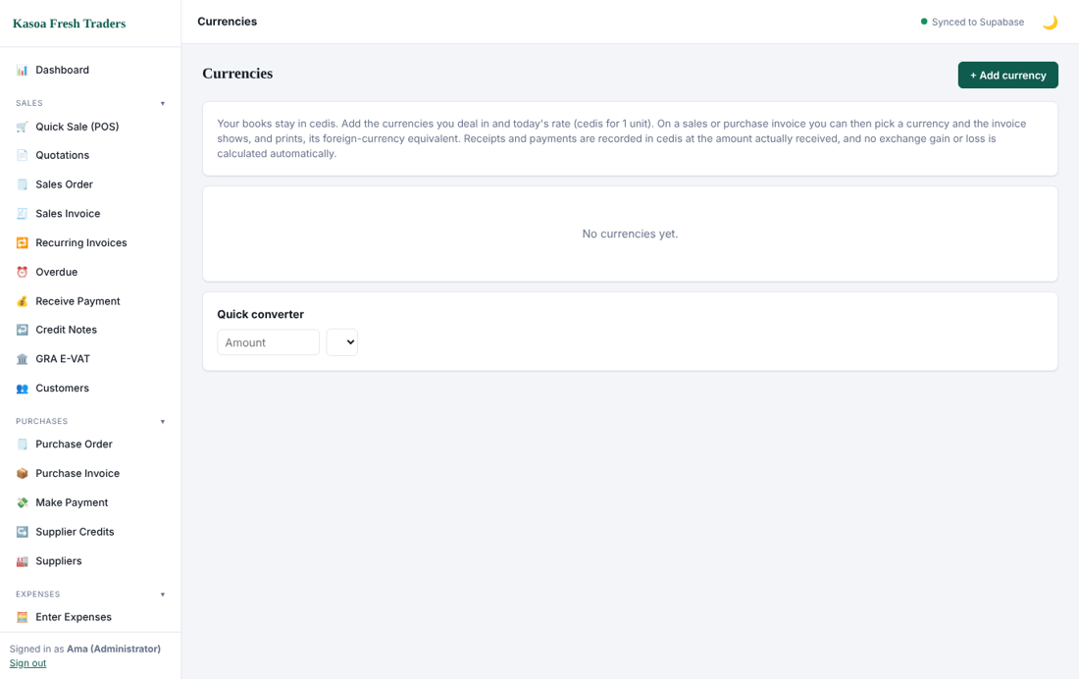
Currencies

13.2 Backups and data safety
Your books are stored in your online company database and saved as you work. Keep your own copies as well: export key reports to PDF or Excel at every month end, and keep the installer and licence key in a safe place.

13.3 Audit log
The audit log records who did what and when, including deletions.
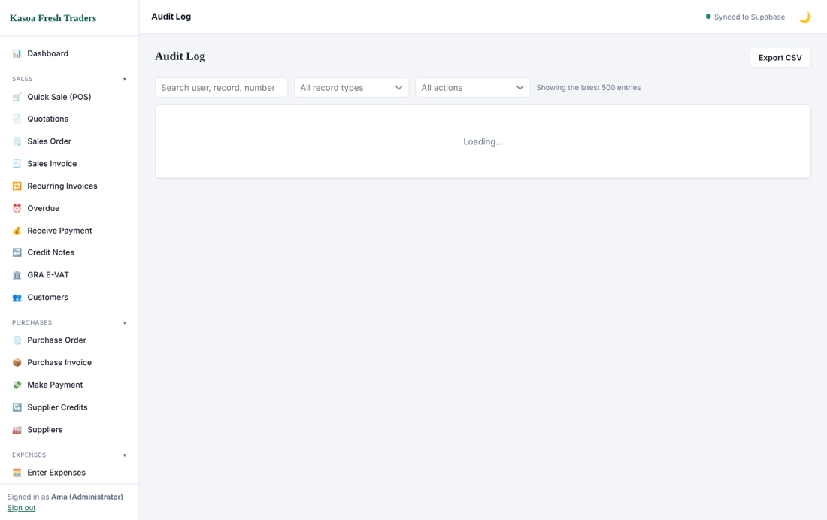
Audit log

13.4 Good habits
- Record transactions the same day.
- Never delete a posted document; use a credit note or a reversing journal.
- Reconcile the bank every month.
- Close each month after reporting.
- Give every person their own sign-in; never share passwords.
- Review user rights every quarter.
- Check the Trial Balance before filing any return.

14. Troubleshooting and support
Problem | What to do
Cannot sign in | Check the email and password. Use Forgot password?. Check your internet.
Screen says the subscription is required | Your trial or licence has ended. Click Enter licence key, or contact support.
Licence key is refused | Re-copy it without spaces. Confirm the internet is on. Contact support with a screenshot.
"Period is closed" when posting | The date is on or before the closing date. Use a later date, or ask the Administrator to reopen the period.
Cannot save an expense or purchase | Check that Supplier, Account, Invoice number, Amount and Due date are filled. The message at the bottom tells you which.
Sale is blocked for a customer | The customer is over the credit limit or has an overdue invoice. Collect payment, or ask an authorised user to override.
Trial Balance does not balance | Contact support before filing anything.
A menu item is missing | Your role does not have the right. Ask the Administrator.
Numbers look wrong in a report | Check the From and To dates, and that all documents are posted.
The program shows an update prompt | Accept it. Updates install themselves.

Contact
Email: 2aprintsservice@gmail.com
WhatsApp: 0546 533 134
When you contact support, state your company name, the screen you were on, what you expected, and attach a screenshot. Never send your password.

