Supplementary Files
Synergistic effects of laccase and pectin on the color changes and functional properties of meat analogs containing beet red pigment
Kiyota Sakai*, Yukihide Sato, Masamichi Okada, Shotaro Yamaguchi

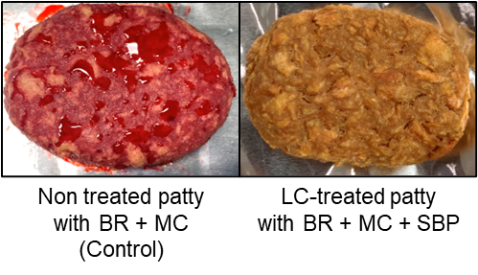
Figure S1. The appearance of meat analog patties immediately after grilling.
Non-treated patty with BR + MC (Control). LC-treated patty with BR +MC + SBP.

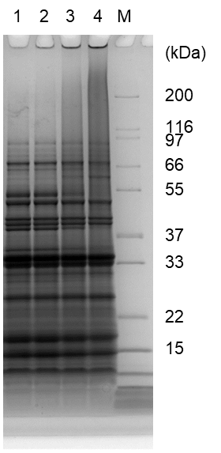
Figure S2. Synergistic effect of LC combined with BR on the formation of protein crosslinks in meat analog patties.
SDS-PAGE analysis was performed on pea protein and BR treated with 250 U of LC. Lane 1: non-treated pea protein; Lane 2: LC-treated pea protein; Lane 3: LC-treated pea protein and SBP; Lane 4: LC-treated pea protein, BR, and SBP.

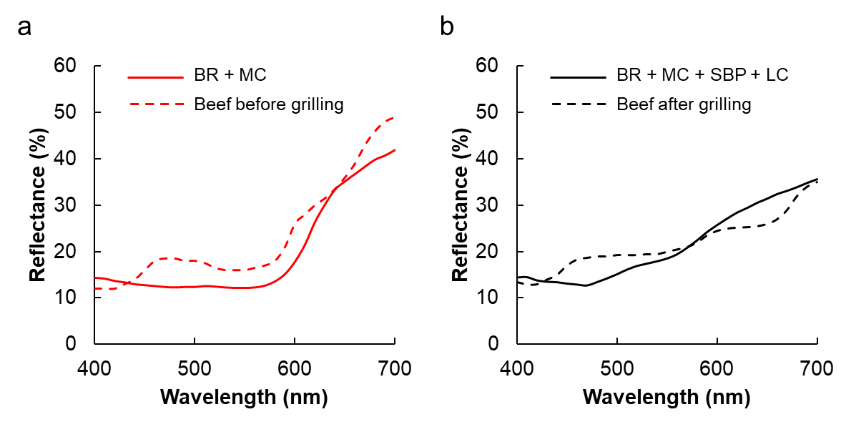
Fig. S3. Reflectance of meat analog patties and beef patties.
(a) The comparison between non-treated patty containing BR and beef patty before grilling. (b) The comparison between LC-treated patties containing BR + MC + SBP and beef patty before grilling.

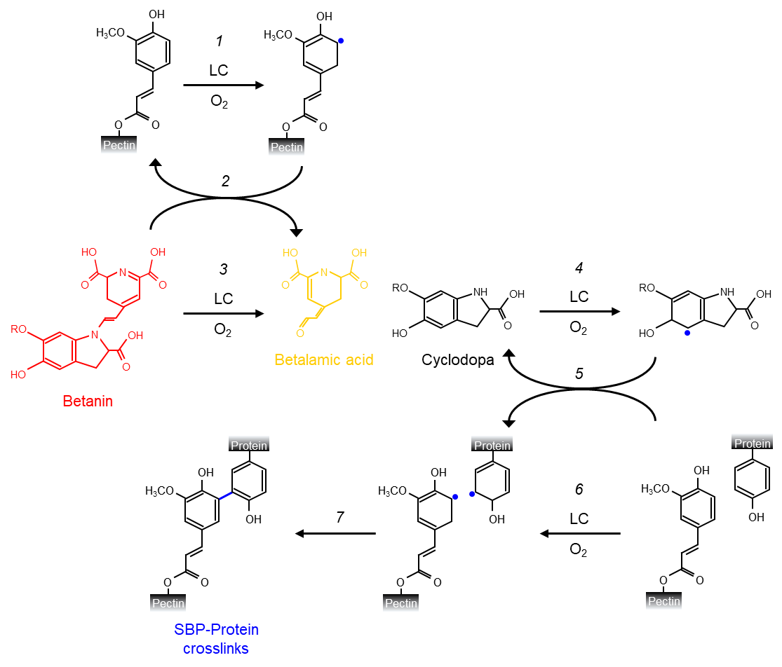
Figure S4. Putative reactions involved in browning and crosslinking reactions in plant-based meat analog patties.
Reaction 1: Oxidation reaction catalyzed by LC; Reaction 2: Indirect oxidation reaction induced by radicalized ferulic acids in SBP; Reaction 3: BR browning reaction by LC; Reaction 4: Oxidation reaction by LC; Reaction 5: Indirect oxidation reaction by radicalized cyclodopa; Reaction 6: oxidation reaction by LC; Reaction 7: SBP-protein crosslinking reaction by phenoxy radicals.

Table S1. Mixing amounts of additives or enzymes in plant-based meat analog patties.
Formulation | Wet TVP  (g) | Ground beef  (g) | Water  (g) | Oil  (g) | PPI  (g) | BR  (g) | MC  (%) | SBP  (%) | LC  (U/g TVP)
Non treated patty with BR + MC (Control) | 25 | - | 5 | 8 | 2.5 | 0.5 | 2 | - | -
LC-treated patty with BR + MC | 25 | - | 5 | 8 | 2.5 | 0.5 | 2 | - | 50
LC-treated patty with BR + SBP | 25 | - | 5 | 8 | 2.5 | 0.5 | - | 2 | 50
LC-treated patty with BR + MC + SBP | 25 | - | 5 | 8 | 2.5 | 0.5 | 2 | 2 | 50
Beef patty | - | 35 | 5 | - | - | - | 2 | - | -

