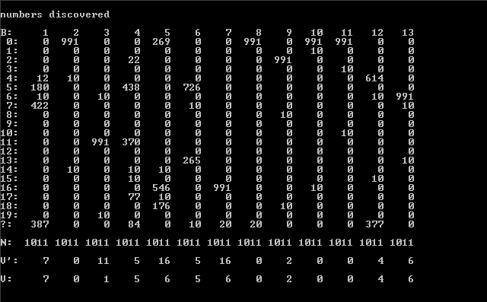

This debug/development output shows the numbers discovered in a scan of a Glanbia milk carton. This shows that the signal is quite noisy. The method of decoding is using closest neighbour with a squared Euclidean evaluation procedure.

The output reads as follows:

The row B: 1 2 3 4 …. 13 refers to the numbers in the code 1 to 13, the frequency of discovered numbers are in the columns beneath. The column below B: refers to the values of the discovered numbers, the numbers under 10 have even parity and 10 or greater have odd parity. The row “?” refers to the frequency of “inconclusive”. The row N is the total scans and V’ is the decoded number before applying remainder 10 division. The row v: refers to the best “guess” of the barcode.

Reading the 5th [identified as B:.4] column we obtain the following:

This is the fourth number to the right in the barcode. The digit 2 with even parity was discovered code in the code 22 times, digit 5 with even parity 438 times, digit 1 with odd parity 370 times, digit 4 with odd parity 10 times, digit 5 with odd parity 10 times digit 7 with odd parity 77 times and “inconclusive” 84 times. The total scanned was 1011 and the winner of the vote for that position was 5 which is the mode of that column.

The most likely estimate of the complete code is “7015656020046” and the true number is “5011056020046”. I have underscored the incorrect digits.

The column for the fifth number demonstrates the action of the voting mechanism; there were 726 occurrences of 5 with even parity and 265 occurrences of 3 with odd parity. 5 is selected as this is the mode of the set and it turns out that in this instance this is the correct number.

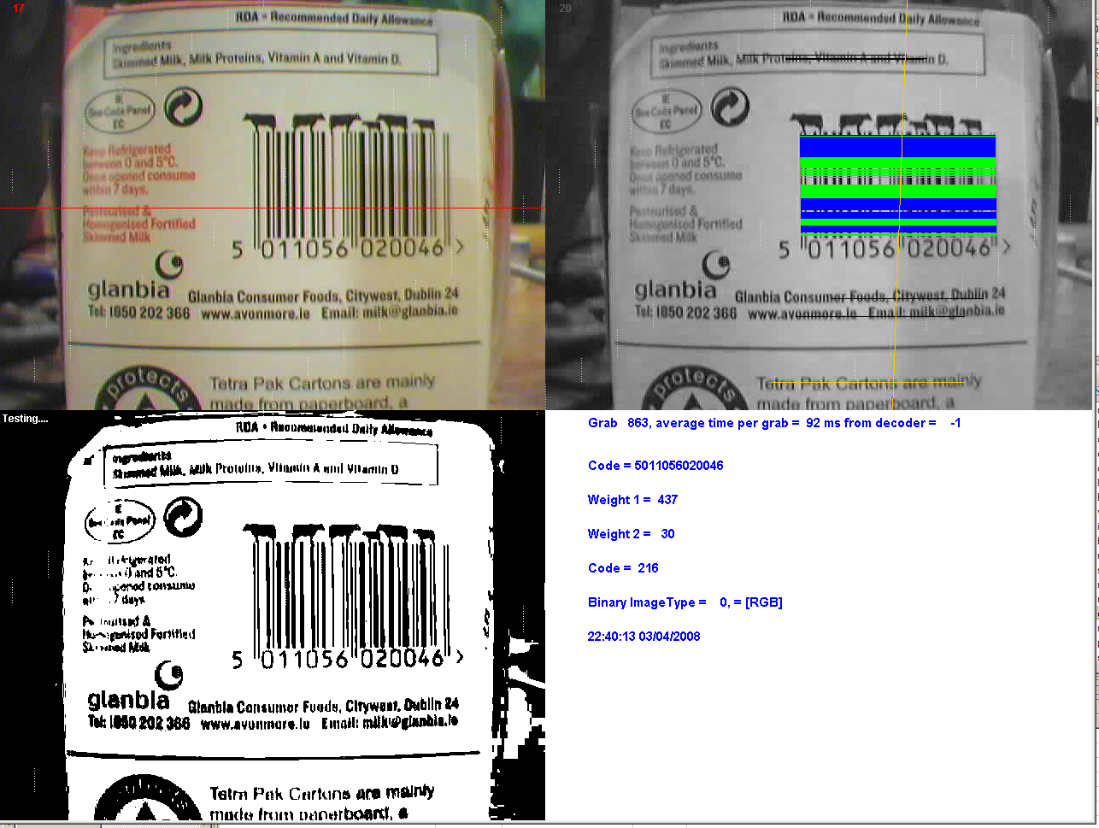

Scan of a Glanbia milk carton with the binary image created from the RGB [Red Green Blue] information. Note in the top right hand panel the outlier false positives generated from the text of ingredients, the text of the address and the text of the composition of Tetra Paks. The green lines in the picture on the top right indicate a valid barcode with no ambiguity regarding the digit values, the blue lines indicate scans with at least one error reading a digit.

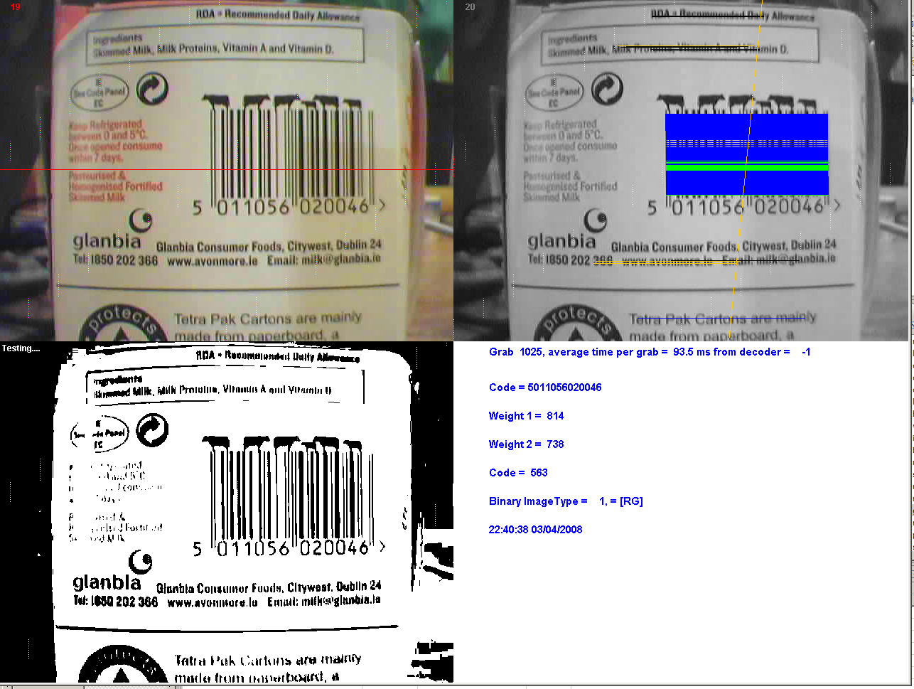

Scan of a Glanbia milk carton with the binary image created from the RG information. Again note in the top right hand panel the outlier false positives generated from the text of ingredients, the text of the address and the text of the composition of Tetra Paks, Notice in the binary image the text regarding refrigeration which is in red on the carton is partly filtered out in comparison the RGB image.

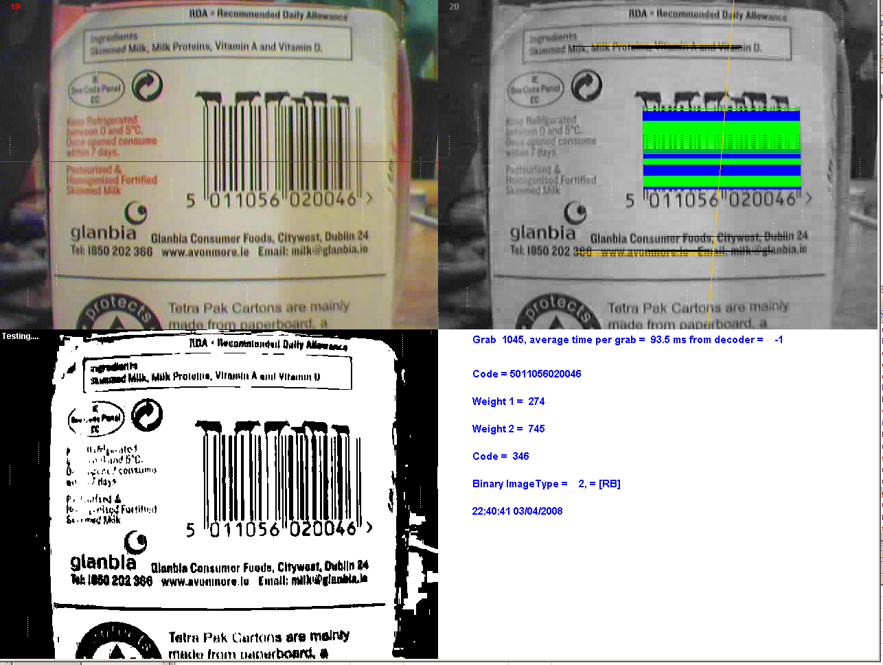

Scan of a Glanbia milk carton with the binary image created from the RB information. Again note in the top right hand panel the outlier false positives generated from the text of ingredients, the text of the address and the text of the composition of Tetra Paks.

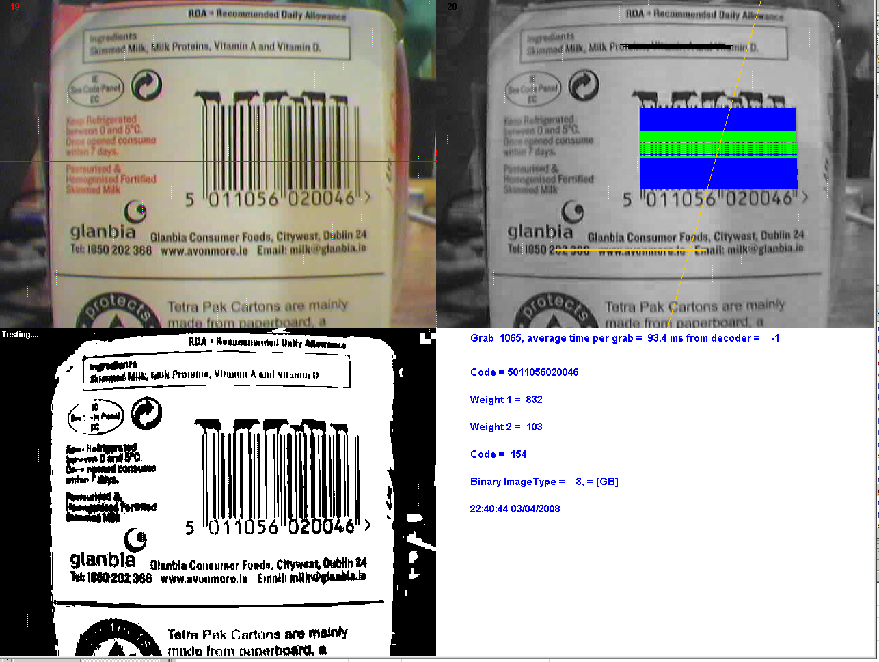

Scan of a Glanbia milk carton with the binary image created from the GB information. Again note in the top right hand panel the outlier false positives generated from the text of ingredients, the text of the address and the text of the composition of Tetra Paks.

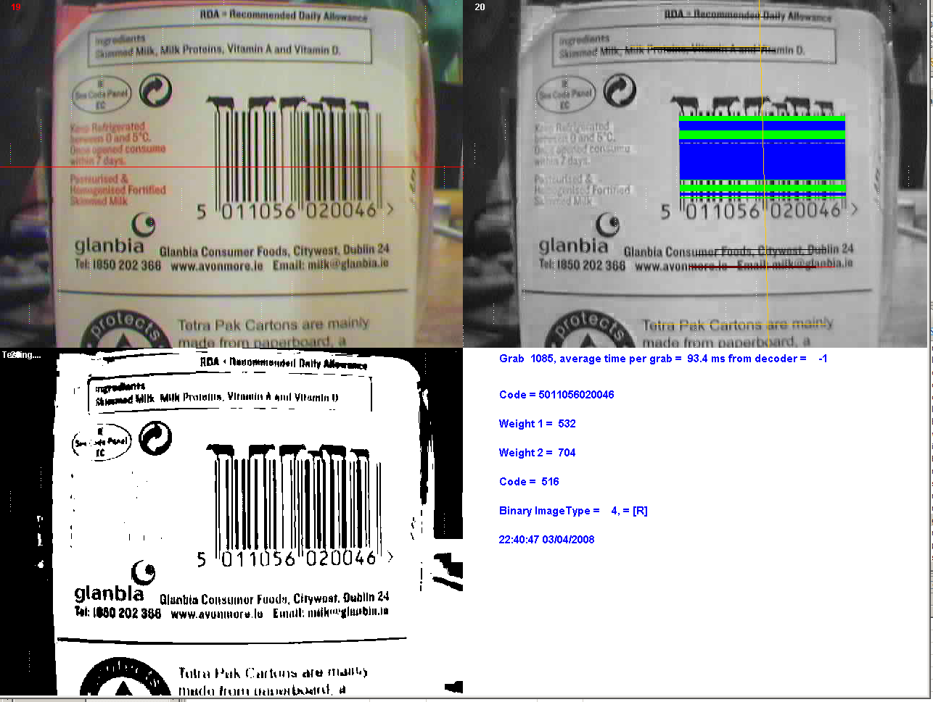

Scan of a Glanbia milk carton with the binary image created from the R only information. Again note in the top right hand panel the outlier false positives generated from the text of ingredients, the text of the address and the text of the composition of Tetra Paks. Note that the Refrigeration information which is written in red is almost entirely missing due to the filtering action of the red only component.

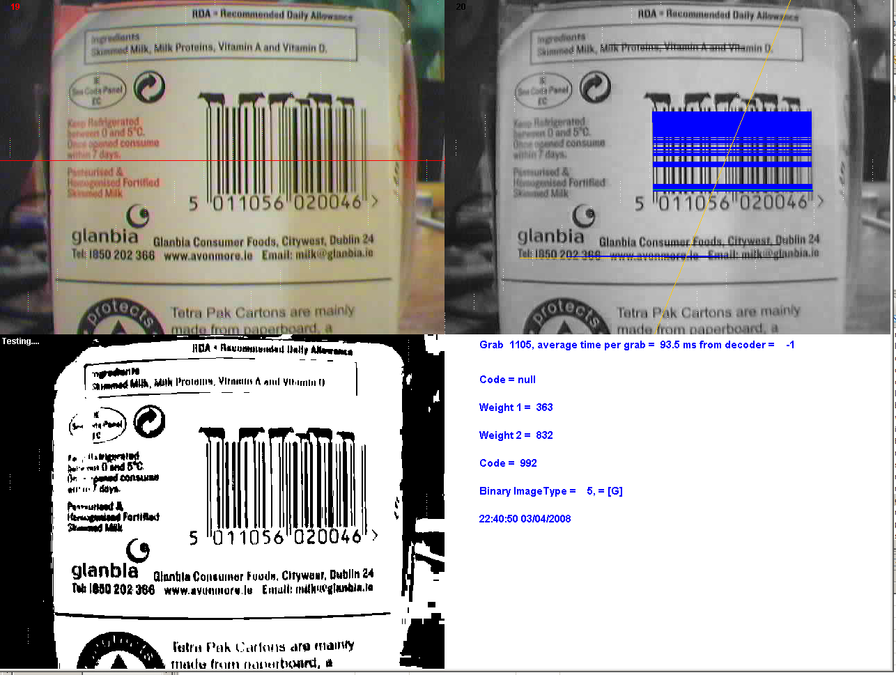

Scan of a Glanbia milk carton with the binary image created from the G only information. Again note in the top right hand panel the outlier false positives generated from the text of ingredients, the text of the address and the text of the composition of Tetra Paks. Note that none of the scans yielded a valid barcode even after the voting selection and that the system returned null as indicated by the second line of the output panel.

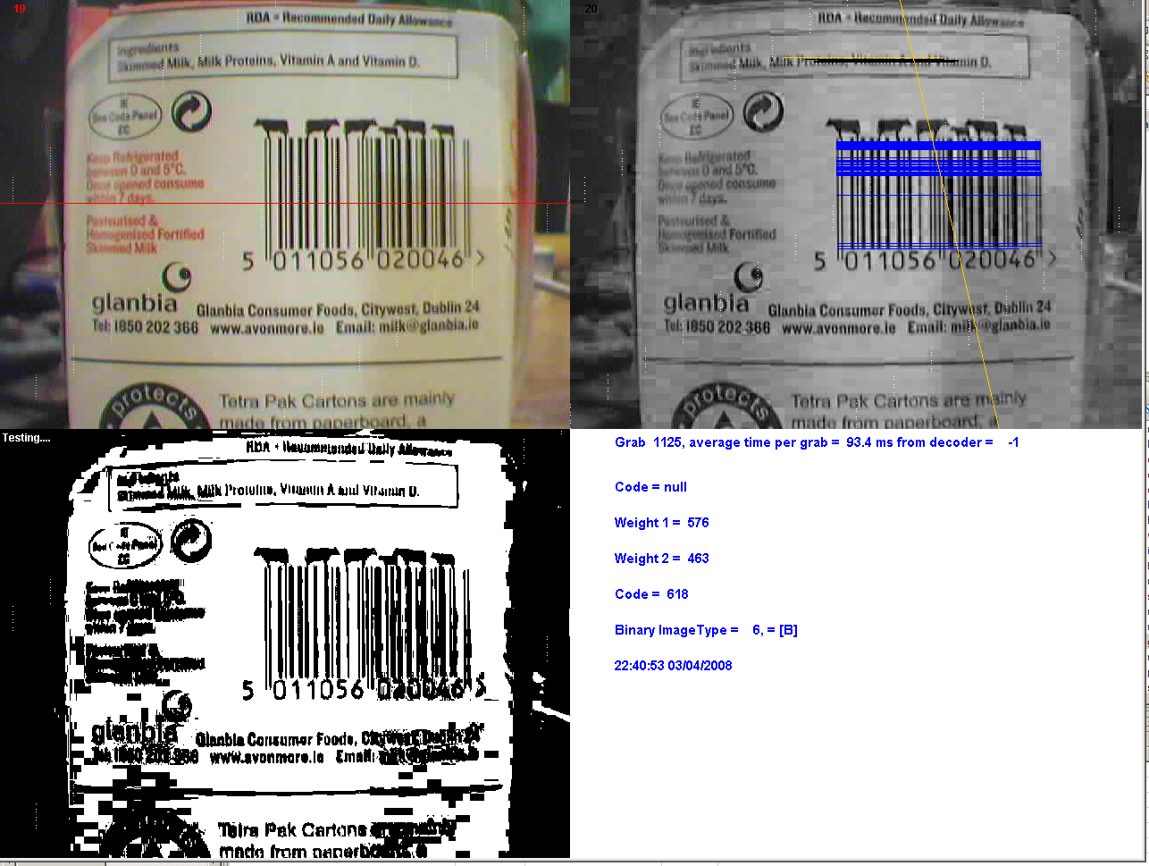

Scan of a Glanbia milk carton with the binary image created from the B only information. Again note in the top right hand panel the outlier false positives generated from the text of ingredients. Note that none of the scans yielded a valid barcode even after the voting selection and that the system returned null as indicated by the second line of the output panel. Also note the very noisy binary image.

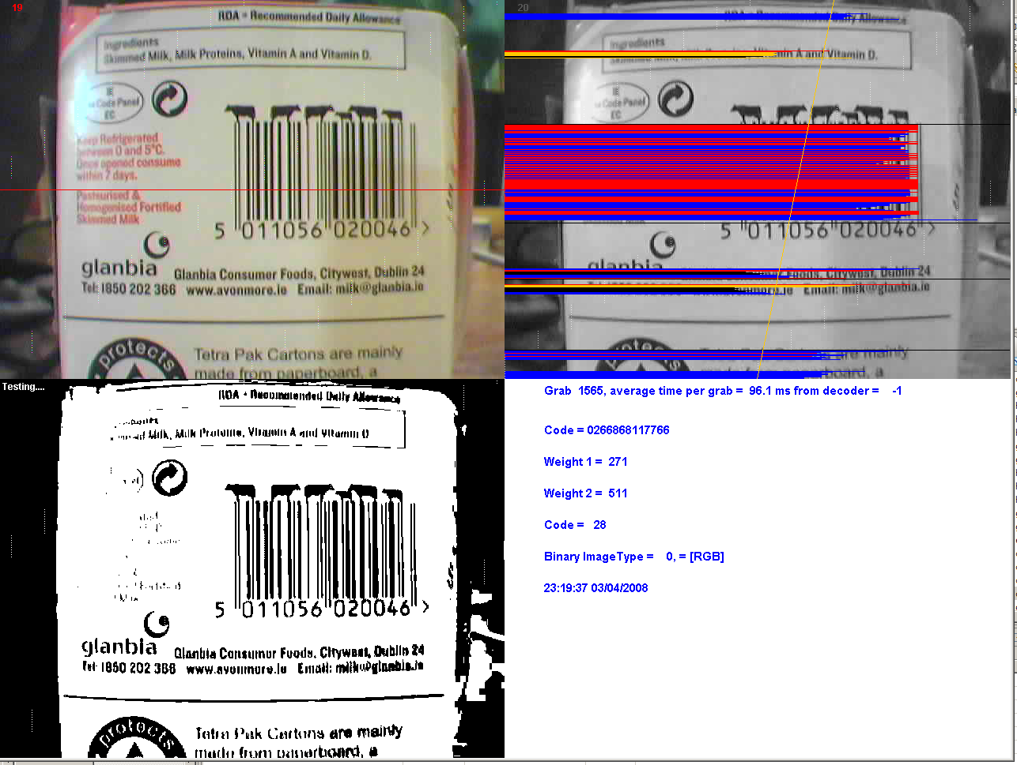

Scan of a Glanbia milk carton with the binary image created from the RGB information and relaxed outlier detection. The detected code in this instance was “0266868117766”. The true code is “5011056020046” the matching of the last digit must be purely coincidental. This number was accepted by the system as valid as the checksum calculates correctly, when the confidence interval is validation is implemented it is expected that this output will be rejected.

