# SenseTile in the City: Road-Wær

Anara Sandygulova  
School of Computer Science and Informatics  
University College Dublin  
[anara.sandy@gmail.com](mailto:anara.sandy@gmail.com)

# Abstract

Dublin roads must be improved. From now on citizens can contribute to improving roads. This report presents the Road-Wær project. Wær is a portmanteau, from two English words: wear and ware. Therefore, Road-Wær is a soft*ware* device that one can *wear*. A Road-Wær iPhone application has been developed as a part of the project. This report summarizes the application’s design and implementation, particularly focusing on how the iPhone hardware features are used in the application.

The Road-Wær application is meant to improve a city’s roads in the long-run through the involvement of a city’s citizen drivers. Using this application while driving or cycling, people report the locations of severe potholes and bumps. Consequently, through their collective feedback, everyday people make their lives comfortable by improving the city’s infrastructure.

# Introduction

In today’s fast-moving world people spend more and more time on-the-go, particularly in their cars on the roads. A variety of road-related problems must be solved: from the irksome, ever-present problems of traffic, lack of parking space, and lightning, to important problems as road maintenance and safety.

Drivers’ vigilance is not the only cause of road accidents. Particularly, the quality of roads plays a major role in people being physically safe. Road conditions contribute to fatalities in 2.5% of all fatal accidents in Ireland [1]. Unfortunately, most Dublin roads are in a poor state of repair. Contributing factors include surface failures like potholes, surface irregularities in construction, faults due to environmental conditions like seasonal heat and cold cycles, local failures such as road slip due to heavy rain, and incidental damage caused by the use of salt to expedite deicing. All of these problems contribute to roads that are poorly maintained, inefficient, and often downright dangerous [2].

Problems with roads are noted by those responsible for them and are sometimes reported by citizens. The Road Safety Authority, the Road Maintenance Service and National Road Authority are unable to guarantee that all the reported problems will be fixed soon, or at all, due to tight budgets, limited personnel, and other constraints [3].

What if citizens are able to participate and help solve one of the main road problems? What if people have information about the location of dangerous bumps, severe potholes at their fingertips? What if we could help the government prioritize repair work and make our lives easier and safer? This project, Road-Wær, gives people an opportunity to contribute and inform the government as the state of its primary transportation infrastructure.

## Domain Analysis

Before any software development took place, a domain analysis of the system is advised. The Road-Wær application domain analysis involved identifying, collecting, organizing the relevant information of the Road-Wær application area, based upon brainstorming of the Road-Wær project concepts and scenarios in which they are involved. Therefore, it made the software development more structured, and provided a uniform nomenclature for the core concepts of the system.

# The Road-Wær Application

## The SenseTile Platform: MIA

The project is called ‘SenseTile in the city: Road-Wær’ because the original plan was to use the SenseTile platform [4], a multi-model sensing device designed at University College Dublin. Unfortunately, this was not possible because of delays from the hardware manufacturing company responsible for providing the SenseTile platform. This forced us to explore alternative ideas with similar functionality.

## An Alternative Platform: The iPhone

iPhone is an Internet–connected smartphone that combines hardware features like accelerometer, GPS, camera, voice control, 3G, Wi-Fi. The iPhone SDK version 3.0 was released on March 17, 2009, just in time for ODCSSS, with over 1000 new APIs, particularly APIs allowing developers to work with maps and location. The iPhone’s hardware features matched the requirements of this project. Therefore, our solution was to develop an iPhone application, rather than a SenseTile application.

## :Picture 6.pngUser Identification and Authentification

On start-up, the Road-Wær application asks the user to log in or sign up with a new username (see Figure 1). The iPhone’s SQLite database stores usernames and a driver’s other data. A Wær-Event is a road maintenance problem. It occurs when the vehicle encounters a problem like, hitting the pothole or going on speedbump. Consequently, each user has a set of Road- Wær events associated with him or her, and each event records the time, location, and nature of the event in question.

Figure 1

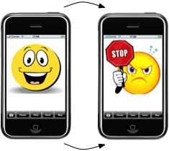

**iPhone Interface**

Since the Road-Wær is an iPhone application, it must have a rich interface design to be comfortable and user-friendly. Several designs of the main view of the application have been proposed. At the moment, the driver sees a smiley, happy face on the smooth road, and an angry or upset face when a Wær-Event is detected (see Figure 2). Refining this interface with user feedback is an obvious place for UI improvement.

Figure 2

## Vehicle Types

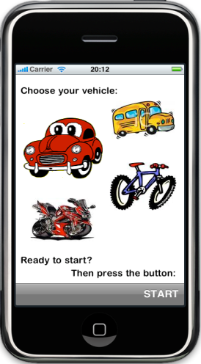The Road-Wær application supports four main types of vehicles: bicycle, motorbike, bus and car (see Figure 3). Those types of vehicles have very different mass, velocity, and acceleration, so they must be taken into consideration separately. For instance, bicycle behavior is different from the behavior of car when hitting a pothole. The cyclist, and consequently the iPhone’s accelerometer, feels a pothole in a different way than a driver in the car. Unsurprisingly, in the Road-Wær application a driver chooses her vehicle type for a given trip. Buses and cars have suspensions that make the bumps feel softer. Consequently, accelerometer detection has to be considered taking into account a vehicle type.

Figure 3

**Accelerometer Detection**

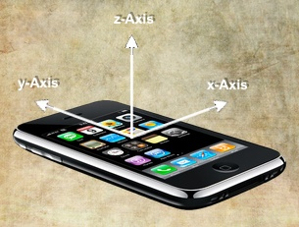An iPhone responds to motion using a built-in accelerometer. It detects the acceleration along the X, Y and Z-axes (see Figure 4). Depending on the position of the device coordinates vary. In order to overcome this obstacle of forcing the user to place the iPhone in horizontal or vertical position, the magnitude of the acceleration is calculated. In three dimension space, the magnitude of a vector m = {x, y, z} is its length, computed using the equation:

Figure 4

**:images:anara.TIF**

The basic operating principle of the Road-Wær application is as follows:

1. The application collects acceleration data at 10 Hz. We determined this frequency through experimentation, as it is sufficient to detect and classify Wær-Events.
2. The acceleration’s magnitude is checked if it is in the range of ‘smooth road’ values that are different for each type of vehicle.
3. When the value of magnitude is out of this range, a Wær-Event is created.
4. The creation of a Wær-Event triggers location detection.
5. A pin indicating the event type is and its location is placed on the map.

## Location, Location, Location

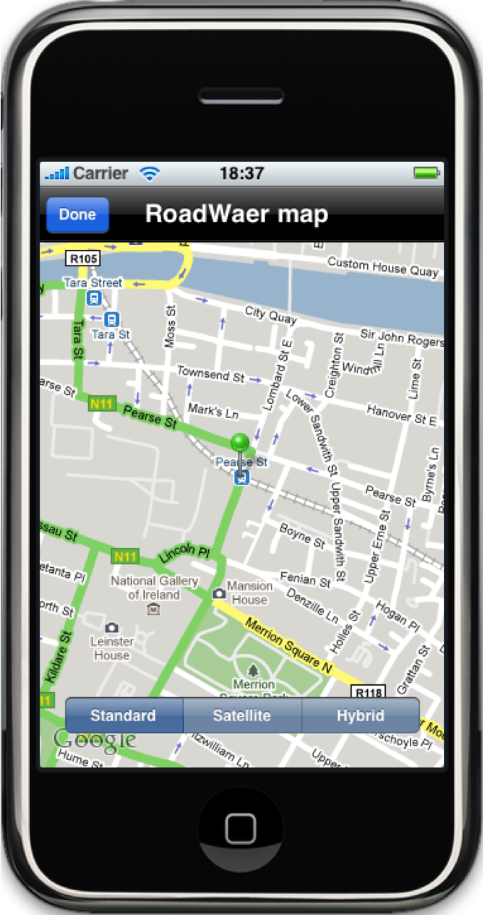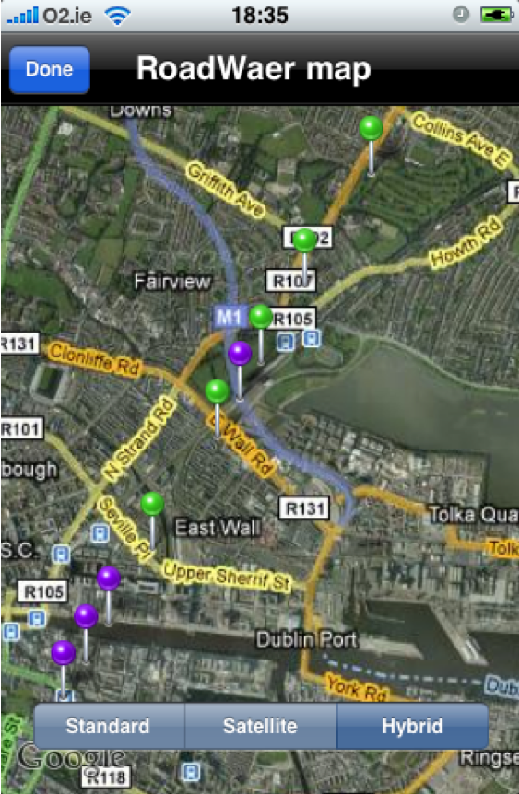

## The iPhone3G finds the phone’s location quickly and accurately via GPS, Wi-Fi, and cellular towels. GPS (Global Positioning System) technology uses information from earth-orbiting satellites to find locations. A-GPS (Assisted GPS) on iPhone 3GS goes a step further, finding the closest satellites to more quickly identify current position. If user is not within a clear line of sight to a GPS satellite, the iPhone finds its location via Wi-Fi. Again, if the user is not in range of a Wi-Fi hotspot, the iPhone finds its position using cellular towers [5].

In the Road-Wær application, a Wær-Event triggers real-time current location detection. The user interface displays the smiley face when the road is smooth, and an upset or even angry face when the vehicle hits the Wær-Event. Therefore, driver does not only feel the bump physically, but with this iPhone application also sees the interface changes, hears the sound and vibrating of the phone. At the end of the trip the user can view the Wær-Events’ latitude, longitude, and time information in a table, and manage this data. What is more, the user is able to view the actual map in Standard, Hybrid or Satellite view with the pins of Wær-Event locations: purple color for speedbumps and green ones for other types of Wær-events (see Figure 5). Furthermore, the user is able to update all data (latitude, longitude, magnitude, time, classification of all the Wær-Events) to the Road-Wær server. From the web server, using the Google Map API, locations of (perhaps aggregated across users) Wær-Events are displayed on Google Maps.

Figure 5

## Classifying Noisy Acceleration Data

A Wær-Event is a general term identifying a rough place on the road, combining all kinds of road maintenance problems. A Wær-Event could be a bump, a speedbump, a pothole, a ripple, a construction, a loose gravel, etc. Currently, the Road-Wær application distinguishes a speedbump from a pothole.

We collected accelerometer data from the roads for four types of vehicles and analyzed a graph of such data to find the most relevant classifier values. Classifier values are magnitude values that classify the Wær-Event. For instance, a bicycle’s reaction to a pothole is a very small magnitude value, so the pothole classifier is 0.5g. The speedbump classifier is 1.5g for the bicycle, whereas it is 1.3g for the car. Figure 6 shows the accelerometer data for the bicycle with marks for potholes and speedbumps.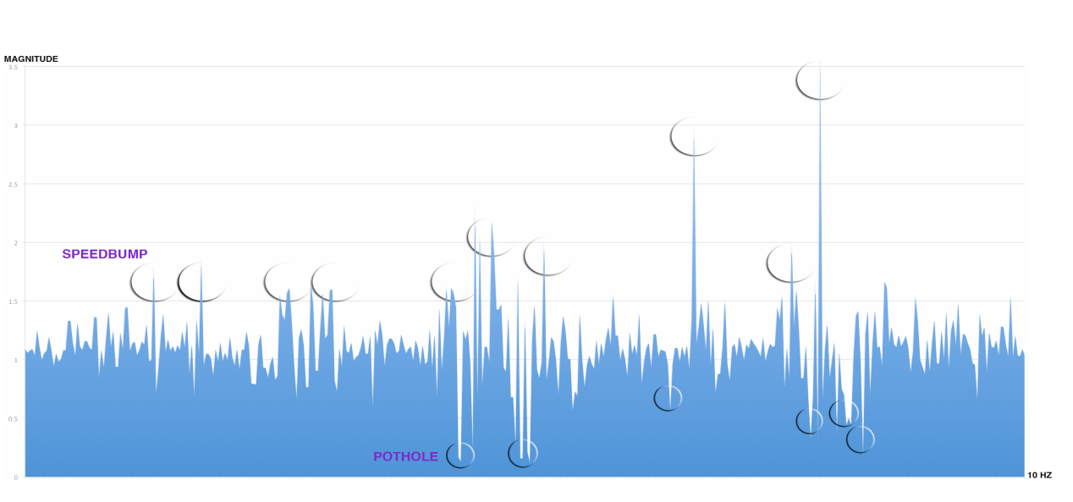

Figure 6. Bicycle Accelerometer Data

On the other hand, the accelerometer data for the car is smoother and does not vary sharply (see Figure 7).

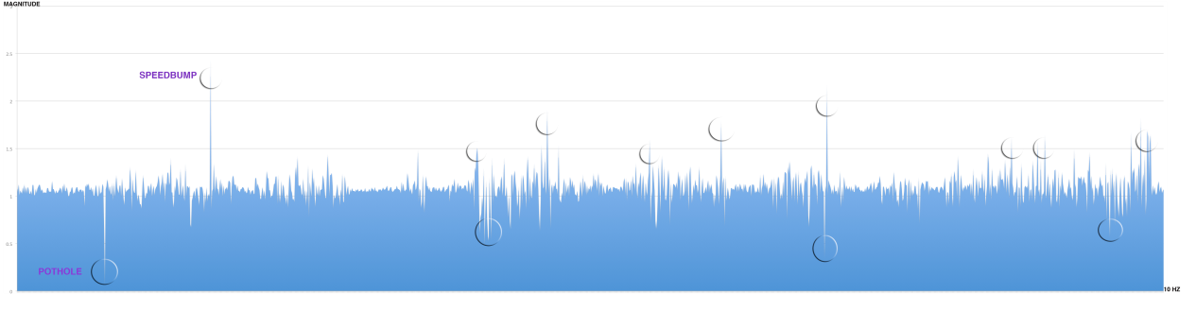

Figure 7. Car Accelerometer Data

There will likely be changes in the values of classifiers after some more investigation and testing, particularly as vehicles of the same type (e.g., a car) vary in mass and suspension (consider comparing a new BMV to an old Mini).

Moreover, analysis of neighborhood- rather than point-values will also improve the classification and increase the chances in its accuracy. This analysis will considerer neighboring magnitude values that might be useful in distinguishing subtleties of road conditions, say a bump from a speedbump. Speedbumps are usually of a fixed size, thus accelerometer magnitudes at the moment of going on and off the speedbump, and the time between the beginning and the end of a speedbump, will be relatively consistent within a given velocity range. We expect that this data is enough to have an advanced improved classification.

**Photographing Road Conditions**

We believe that visual representation makes more sense and stirs up emotions and reactions of people rather than just raw numbers. The Road-Wær application lets the driver use the iPhone camera to take a picture of the road and save it to the main photo album. For example, having pressed the button PAUSE not to shake the device by accident, cyclist can stop and take a shot of a severe pothole. Those pictures might be useful later for a Road- Wær website, or might be used to show to the insurance companies or friends evidence of the road conditions that contributed to an accident.

**Using Mock Objects for Testing**

iPhone development provides an iPhone simulator for testing purposes. Unfortunately, it is impossible to simulate the acceleration and changes in the location on that simulator. Our solution was to create mock objects to exercise such behavior.

In object-oriented programming, mock objects are simulated objects that mimic the behavior of real objects in controlled ways [6]. In Road-Wær application there are two modes of accelerometer and location to choose from: real and faked. Even while in the user is in the real environment, one might choose a faked location mode to simulate the movement of a vehicle. Another example usage is when one uses an iPod Touch, as it does not have 3G coverage and a persistent Internet connection.

# Related Work

This section surveys related work on data collection in sensor networks. The Road-Wær system is different from the previous sensor networks systems in that it will be spread and open to the public for collecting data from roads. The algorithm and acceleration data analysis we develop are quite different from the previous approaches to road surface assessment.

The Pothole Patrol system uses the inherent mobility of the participating vehicles, opportunistically gathering data from vibration and GPS sensors, and processing the data to assess road surface conditions. Jakob Eriksson et al [8] at MIT Computer Science and Artificial Intelligence Laboratory have deployed Pothole Patrol on 7 taxis running in the Boston area.

CarTel is a mobile sensor computing system designed by Bret Hull et al. [9] at MIT Computer Science and Artificial Laboratory to collect, process, deliver, and visualize data from sensors located on mobile units such as automobiles. CarTel has been deployed on six cars, running on a small scale in Boston and Seattle for over a year.

Like CarTel, Pothole Patrol uses a delay-tolerant network stack, which means that the data is stored in the stack on the system.

To monitor road and traﬃc conditions in such a setting, Microsoft Research group [10] in India present Nericell, a system that performs rich sensing by piggybacking on smartphones that users carry with them in normal course. They have a prototype of Nericell, minus GSM-based localization, running on Windows Mobile 5.0 Pocket PCs.

## The AccelGraph iPhone Application

The AccelGraph iPhone Application was used for collecting accelerometer data for different types of vehicles. Since it has the functionality of sending the data as e-mail, it has been very helpful. Having this application running and keeping track of potholes and speedbumps and the time the vehicle hit them we collected the data seen in the earlier graphs.

# Conclusion

## Analyzing a City: Collecting and Collating Data

In one imagined future, the Road-Wær application must be reasonably spread to the driving public for collecting data. How many total iPhone users are there? A reasonable guess as to the current numbers of iPhones in use worldwide is 12-16 millions, which could well double or triple by the end of 2009 [7]. Road-Wær is a real contribution toward making citizens’ road experiences more pleasurable and not an irritation or, even worse, dangerous.

# Acknowledgements

I would like to deeply thank the various people who, during the summer months, provided me with useful and helpful assistance. Firstly, I am very grateful to my supervisor, Dr. Joseph Kiniry, for all his time, continuous support and guidance; motivation and enthusiastic advice; help in making this project exist and function. Also, thanks to Dr. Vieri Bianco and Dragan Stosic for their help and encouragement throughout the project. Many thanks also go to Dr. Aaron Quigley and Dr. Gabriel-Miro Muntean for their effort and organization of the ODCSSS internship.

# References

[1]<http://www.irishtimes.net/newspaper/motors/2008/1126/1227486578452.html>

[2] <http://www.odcsss.ie/content/sensetile-city-road-w%C3%A6r>

[3] <http://www.nra.ie/AboutUs/BoardMembers/>

[4] <http://sensetile-trac.ucd.ie/>

[5] [www.apple.com](http://www.apple.com)

[6] <http://en.wikipedia.org/wiki/Mock_object>

[7] <https://www.mahalo.com/answers/technology-and-internet/how-many-total-iphone-users-are-there>

[8] J. Eriksson, L. Girod, B. Hull, R. Newton, S. Madden, and H. Balakrishnan. The Pothole Patrol: Using a Mobile Sensor Network for Road Surface Monitoring. In MobiSys, 2008.

[9] B. Hull, V. Bychkovsky, Y. Zhang, K. Chen, M. Goraczko, E. Shih, H. Balakrishnan, and S. Madden. CarTel: A Distributed Mobile Sensor Computing System. In Proc. ACM SenSys, Nov. 2006

[10] Prashanth Mohan , Venkata N. Padmanabhan , Ramachandran Ramjee, Nericell: using mobile smartphones for rich monitoring of road and traffic conditions, Proceedings of the 6th ACM conference on Embedded network sensor systems, November 05-07, 2008, Raleigh, NC, USA

Books:

1. Dave Mark, Jeff LaMarche. Beginning iPhone Development: Exploring iPhone SDK. Apress. 2009

2. Erica Sadun. The iPhone Developer’s Cookbook. Addison-Wesley Professional. 2008

3. Apple Inc. The Objective-C 2.0 Programming Language. 2009

4. NeXT Publications. NeXTSTEP Object –Oriented Programming and the Objective-C Language. Addison-Wesley Publishing Company. 1993

Online Tutorials:

1. iPhone SDK 3.0 - Playing with Map Kit http://kelsocartography.com/blog/?p=2345

2. 12 SQLite Resources for iPhone developers. <http://www.mobileorchard.com/iphone-sqlite-tutorials-and-libraries/>

3. 31 iPhone Application with source code. <http://www.mobileorchard.com/31-iphone-applications-with-source-code/>

4. Accelerometer Simulator. <http://code.google.com/p/accelerometer-simulator/>