Petrography

Host rocks in Hutti gold deposit are mafic (metabasalt) and felsic metavolcanic rocks. Detail petrography study of those rocks are described here,

1. Metabasalt
2. Felsic metavolcanic rock

**Metabasalt**

Petrography study is done on 3 types of metabasalt, type I is fresh metabasalt (from main haulage cross-cuts), type II is contact of the metabasalt and biotite-schist (from drive cross-cuts) and type III is altered metabasalt (from drive).

Type I metabasalt is relatively fresh (unaltered) rock located in main haulage cross-cuts. The rock is medium grained amphibolite and is made up predominantly of amphibole mineral and opaques as 80-90%. Amphibole minerals show elongated flaky form. Quartz, carbonate and epidote as minor constituent present as 10-20% in this rock. This rock does not show deformational features. Quartz grains are dispersed throughout the section and carbonate grains are observed as veins. Epidote grains are fuzzy grains which show very low pleochroism and blue interference colour seems to be zoesite shown in fig. 1(c).

Type II rock is contact of the amphibolite and biotite-schist from drive cross-cuts. This is medium grained rock and has amphibole and biotite as major constituents. Amphibole and biotite zone are separated by quartz and calcite vein. Few opaques and epidote are present in amphibole domain. In biotite zone, quartz and calcite veins are predominant. Chlorite minerals are present in s-c plane shown in fig. 2(b). Opaque shows chlorite fringe in fig. 2(c).

Type III is altered metabasalt from drive. This is coarse grained rock. The rock is predominantly made up of amphibole, plagioclase and quartz. It also contains sphene and opaques are as minor constituents. The rock shows alteration.

**Felsic metavolcanic rock**

This is a mylonitic rock. It is medium grained rock made up of plagioclase feldspar, quartz, sericite in decreasing order of abundance, chlorite, epidote and opaques are minor constituents. The rock shows mylonitic features, mantle porphyroclast of plagioclase feldspar of 30µm to50µm are predominant and sericite,quartz, plagioclase feldspar, opaques and epidote are common as groundmass. Sericite is concentrate along C-plane. Quartz present as dispersed and ribbon form. Quartz ribbon consists of interlocking equigranular grains of strain free quartz of 5µm to 10µm sizes indicating that the quartz ribbon are a result of strain recovery of previously sheared grains are observed elongation parallel to the C-plane. Opaque grains are observed elongation parallel to the C-plane. Epidote present along with sericite and is not frequently seen.

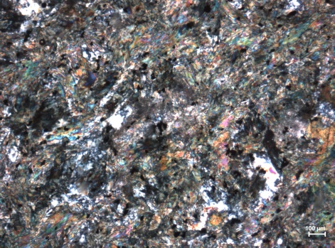 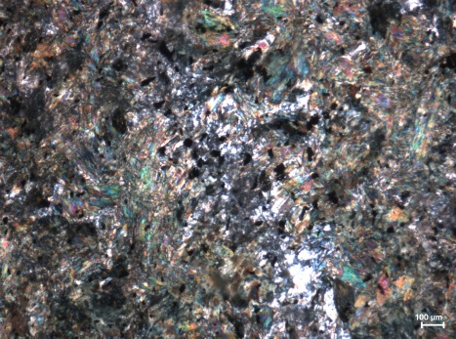 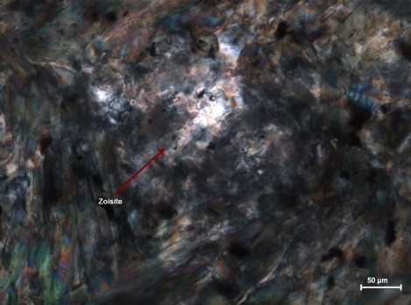

Fig.1 Photomicrographs of less altered metabasalt: a and b. amphiboles with calcite, quartz, and opaues, c. amphiboles with zoisite.

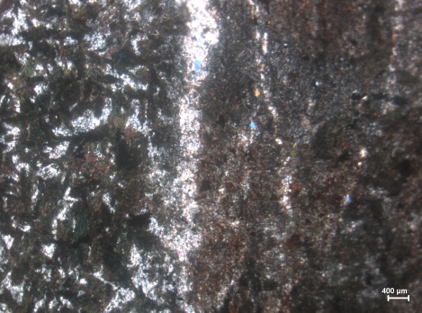 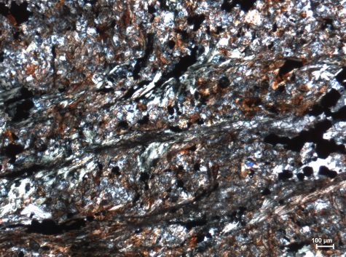 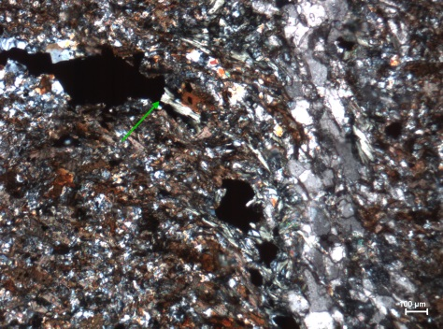

Fig.2 Photomicrographs of contact of metabasalt and biotite schist: a. amphibole grains and biotite grains are parted by quartz vein, b. biotite and chlorite grains show s-c plane, c. opaque grain with chlorite fringe.

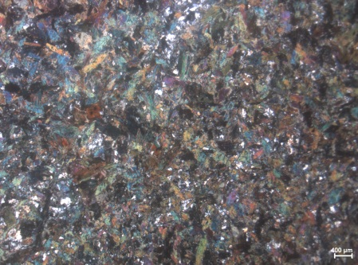 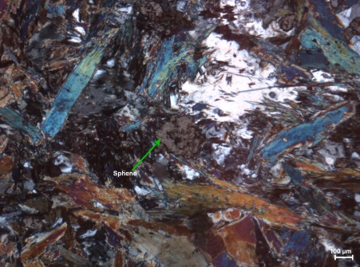 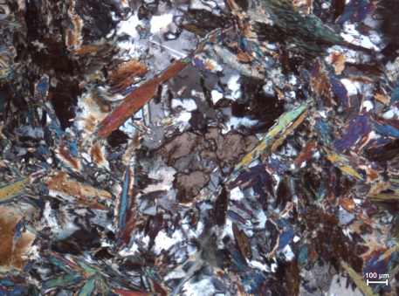

Fig.3 Photomicrographs of altered metabasalt: a. amphibole, biotite, quartz, plagioclase feldspar, opaques grains asssemlages, b. Sphene, c. Sphene and plagioclase feldspar with hornblende.