KinjalGawali_DSA_21jan2025

### **1. Types of Data Structures**

### **What are the main types of data structures, and can you provide an example of each?**

—---------->

Data structures are broadly classified into two main categories:

#### **a) Primitive Data Structures**

* These store a single value and are directly operated upon by machine instructions.
* Examples: int, char, float, double.

**Example:**  
int x = 10;

char ch = 'A';

float pi = 3.14;

* **Use:** These are the fundamental building blocks for storing and manipulating data.

#### **b) Non-Primitive Data Structures**

* More sophisticated structures derived from primitive data types.
* Can be categorized into:
  1. **Linear Data Structures:** Data elements are arranged in a sequential manner.
     + Examples: Arrays, Linked Lists, Stacks, Queues.

**Example (Array):**  
int arr[] = {1, 2, 3, 4, 5};

* 1. **Non-Linear Data Structures:** Elements are connected in an arbitrary order.
     + Examples: Trees, Graphs.

**Example (Tree):**  
struct Node {

int data;

Node* left;

Node* right;

};

* **Use:** Non-primitive data structures provide efficient data management and enable complex operations like searching and sorting.

### **2. Importance of Data Structures**

### **Why are data structures important in programming? Discuss how they affect algorithm efficiency.**

—--------------->

Data structures are crucial in programming because:

1. **Efficient Data Management:** They help in storing, retrieving, and processing data efficiently.
2. **Better Algorithm Performance:** Choosing the right data structure improves algorithm speed and reduces complexity.
3. **Memory Utilization:** Proper use helps minimize memory wastage.
4. **Code Reusability:** Well-designed structures promote modular and reusable code.
5. **Real-world Applications:** Used in databases, operating systems, AI, and more.

#### **Effect on Algorithm Efficiency:**

* The efficiency of an algorithm depends on the choice of data structures.
* **Example:** Searching in an unsorted array takes O(n), but in a sorted binary search tree, it takes O(log n).

### **3. Characteristics of Arrays**

### **What are the key characteristics of an array in c++? How does it differ from other data structures like linked lists?**

—----------------->

An **array** is a collection of elements of the same type stored in contiguous memory locations.

#### **Key Characteristics:**

1. **Fixed Size:** Defined at compile time, cannot be resized.
2. **Homogeneous Elements:** All elements are of the same data type.
3. **Contiguous Memory Allocation:** Elements are stored in adjacent memory cells.
4. **Indexing:** Access elements using index numbers (0-based indexing).
5. **Efficient Access:** O(1) time complexity for retrieving elements.

#### **Comparison with Linked Lists:**

| **Feature** | **Arrays** | **Linked Lists** |
| --- | --- | --- |
| Memory | Contiguous allocation | Non-contiguous allocation |
| Insertion/Deletion | Slow (O(n)) | Fast (O(1) at head) |
| Access Time | O(1) | O(n) |
| Flexibility | Fixed size | Dynamic size |

**Example in C++:**

int arr[5] = {10, 20, 30, 40, 50};

cout << arr[2]; // Output: 30

### **4. Fundamental Concepts of Algorithms**

### **Define an algorithm and explain its fundamental concepts. How do data structures play a role in algorithm design?**

An **algorithm** is a step-by-step procedure for solving a problem.

#### **Fundamental Concepts:**

1. **Input:** The data provided to the algorithm.
2. **Output:** The result after processing.
3. **Definiteness:** Each step must be clear and unambiguous.
4. **Finiteness:** Must terminate after a finite number of steps.
5. **Effectiveness:** Each step should be feasible to perform.

#### **Role of Data Structures in Algorithm Design:**

* Choosing the right data structure helps optimize search, sorting, and storage operations.
* **Example:**
  + Searching in an unsorted array takes O(n), while a binary search tree reduces it to O(log n).

**Example of an Algorithm (Finding Max in Array):**

int findMax(int arr[], int size) {

int max = arr[0];

for (int i = 1; i < size; i++) {

if (arr[i] > max) {

max = arr[i];

}

}

return max;

}

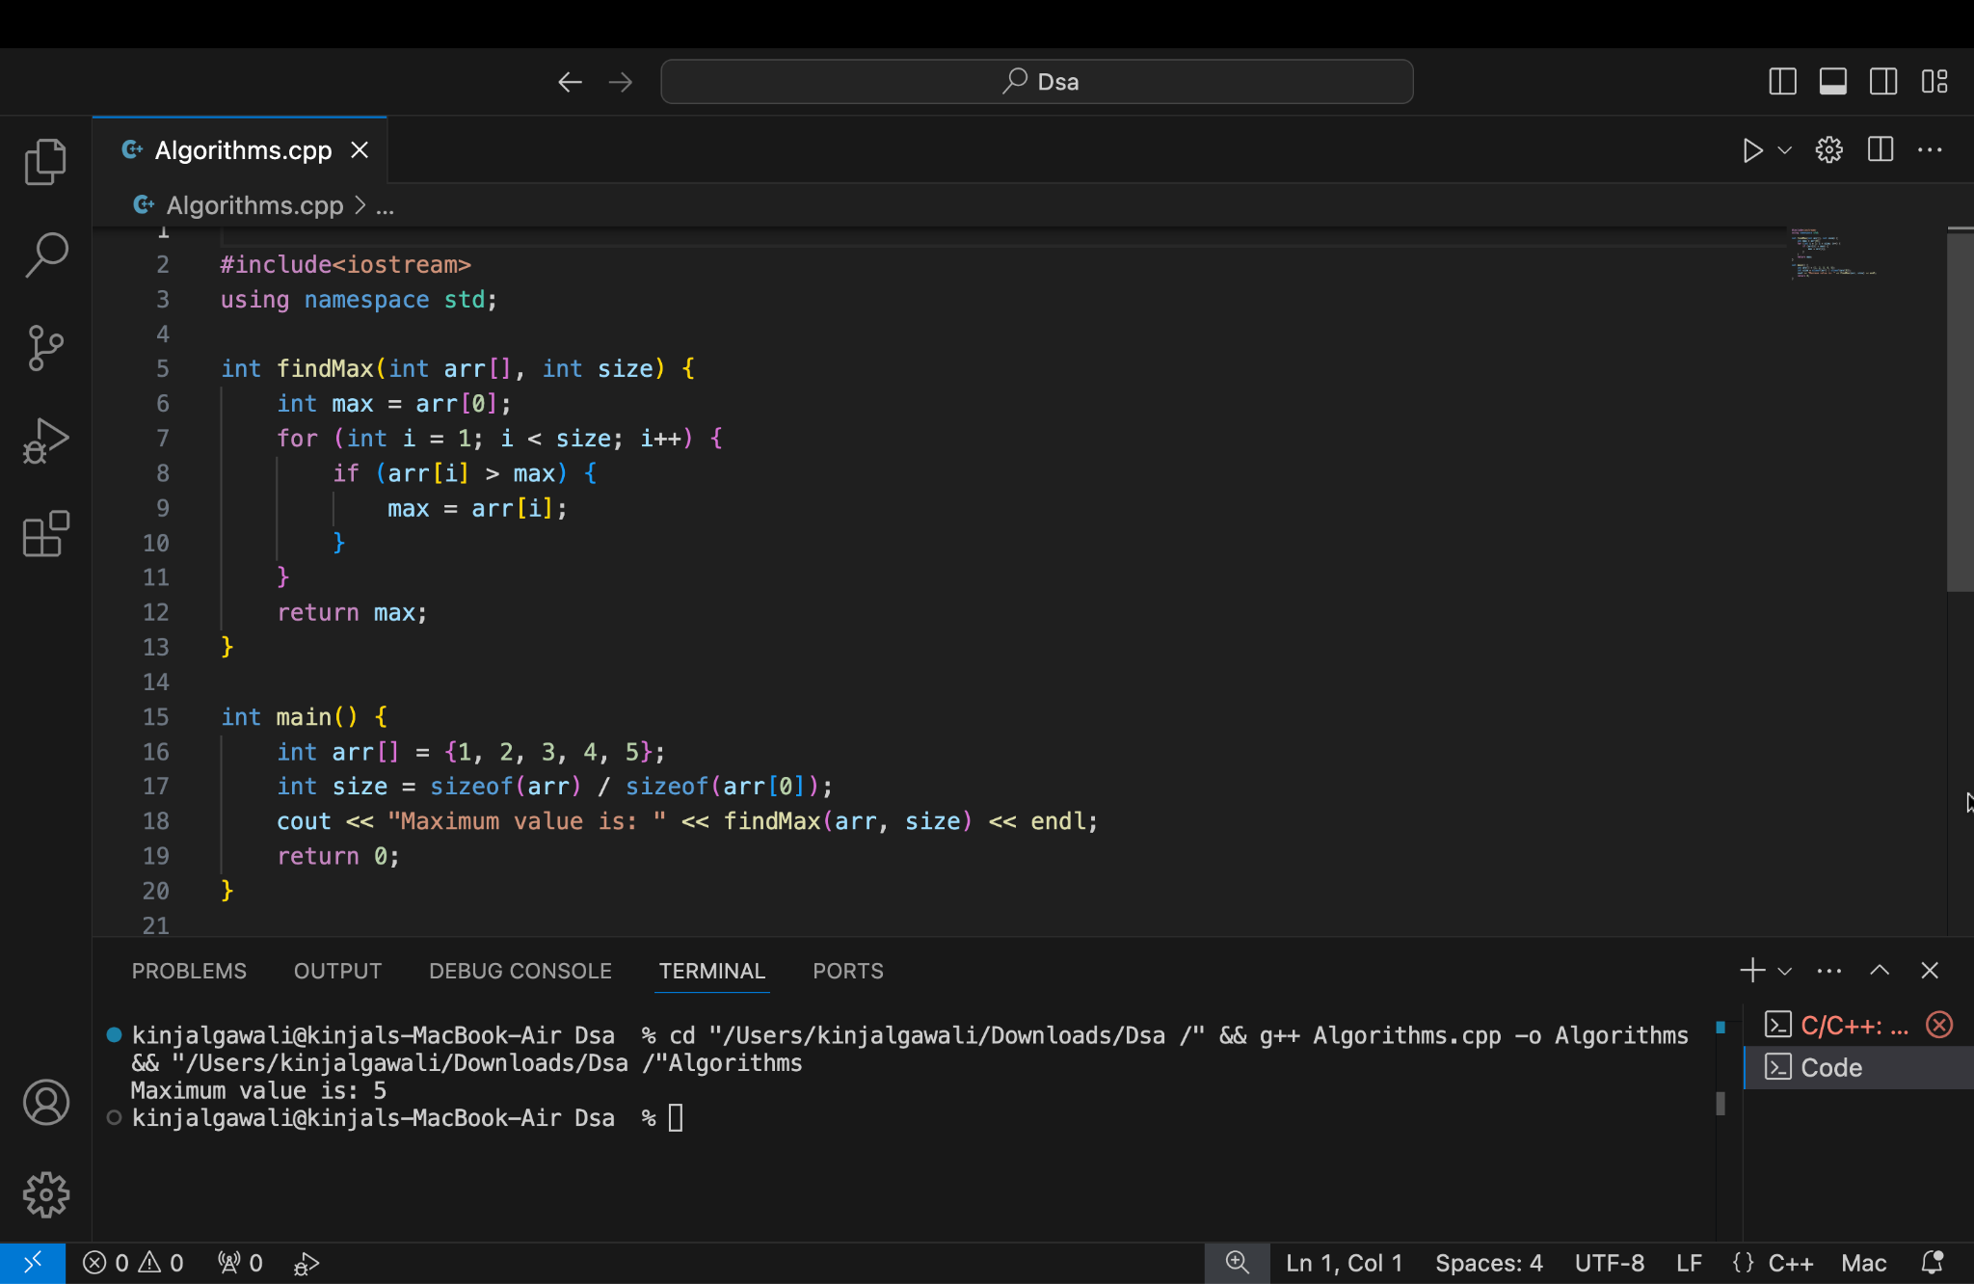

### **5. Array Implementation in C++**

### **How do you declare and initialize an array in c++? Provide an example of creating an array of integers.**

—-------------->

#### **Declaration and Initialization:**

Arrays in C++ can be declared and initialized in various ways.

**1. Declaration:**  
int arr[5]; // Declaration without initialization

**2.Initialization:**  
int arr[5] = {1, 2, 3, 4, 5}; // Declaration with initialization

**3.Partial Initialization:**  
int arr[5] = {1, 2}; // Remaining elements set to 0

**4.Using Loop:**  
for (int i = 0; i < 5; i++) {

arr[i] = i * 10;

}

#### **Example of Creating an Array of Integers:**

#include <iostream>

using namespace std;

int main() {

int numbers[5] = {10, 20, 30, 40, 50};

cout << "The second element is: " << numbers[1] << endl;

return 0;

}

**Output:**

The second element is: 20

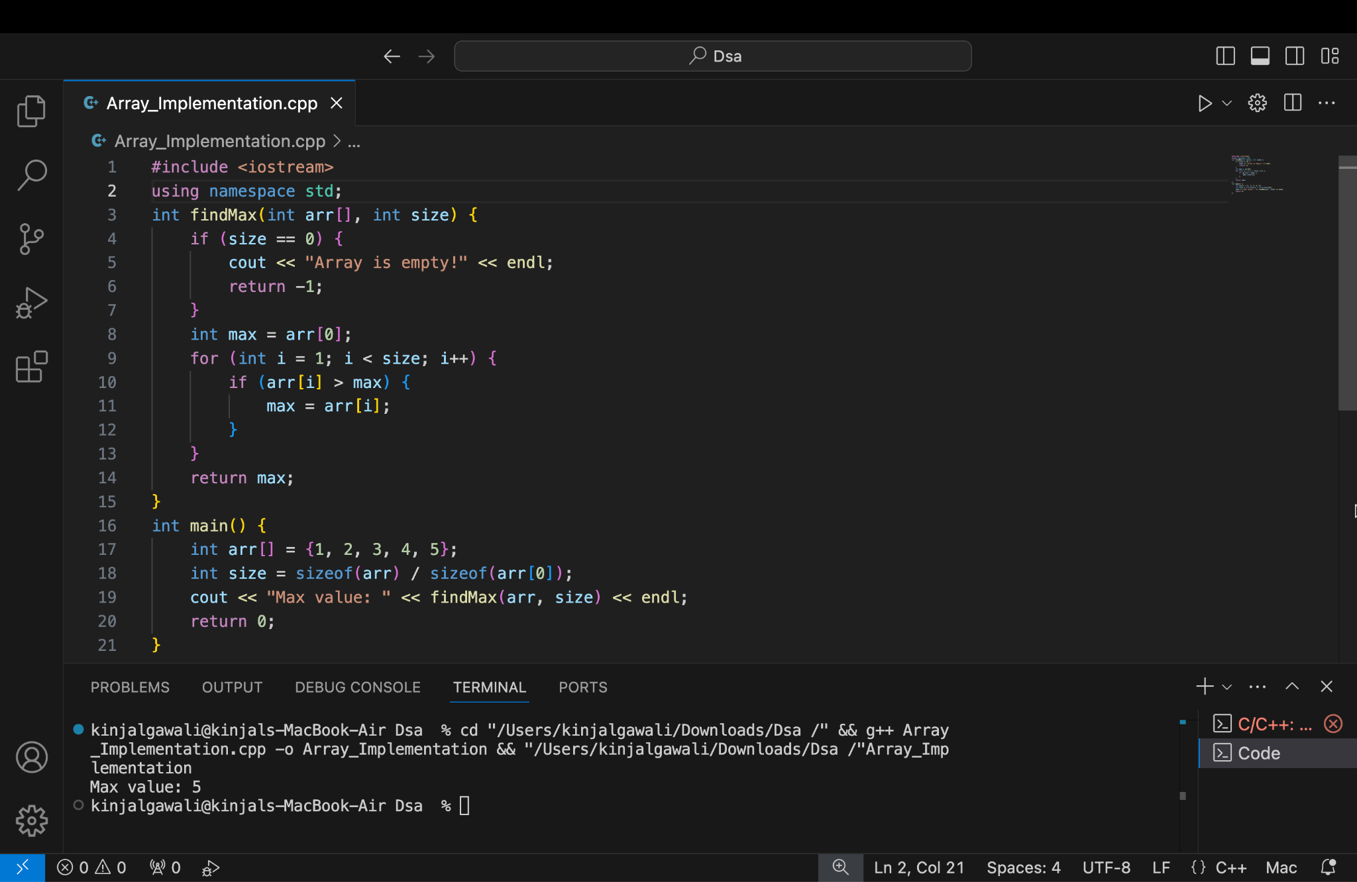

#### **Common Uses of Arrays:**

1. **Storing multiple values of the same type.**
2. **Used in searching and sorting algorithms.**
3. **Efficient data access using indices.**
4. **Widely used in database applications and system-level programming.**

## ************