
PolicyDesk
Online Policy Renewal Portal for an Insurance Broker
Software Engineering & Project Management
Case Study No. 79

Student Name: | Kinjal Gawali
Roll Number: | 150096724116
Cohort: | Mark Zuckerberg
University: | ITM Skills University
Batch: | 2024-28

Table of Contents
1. Introduction 3
2. Software Requirements Specification 3
3. UML Design 6
4. Project Plan 10
5. Scope and Phasing 14
6. Test Plan and Test Evidence 15
7. Risk Register 17
8. Lessons Learned 19
9. Conclusion 19
10. Final Completeness Check 19

1. Introduction
65,000  Policies | 22%  Current Lapse Rate | 12%  Target Lapse Rate | 6  Insurers | 30 Days  Portal Build | 10 Days  Testing

1.1 Background
An insurance broker manages 65,000 motor and health policies for its customers. Every policy has to be renewed once a year. At present, renewal reminders are sent manually by the agents, and this takes a lot of their time.

1.2 Problem Statement
About 22% of the policies lapse because customers forget their renewal dates. Agents spend hours on manual reminders, but the process still depends on the agent's time and the customer's memory. When a policy lapses, the customer loses insurance cover and the broker loses business.

1.3 Proposed Solution
PolicyDesk is an online portal for managing policy renewals. The portal will:
- send automatic renewal reminders to customers;
- let customers do an online quote comparison from 6 insurers (A to F);
- accept online payment of the renewal premium;
- let customers download the renewed policy.
Insurers A, B, C and D will be connected through APIs. Insurers E and F share their rates as Excel rate cards, which are uploaded manually. The Managing Director wants all 6 insurers available at launch.

1.4 Objectives
- Reduce the policy lapse rate from 22% to 12% within one year.
- Remove manual reminder work by automating reminders.
- Give customers a single place to compare quotes, pay and download the policy.
- Build the portal in 30 days and complete testing in 10 days after the integrations finish.

2. Software Requirements Specification
This SRS follows a compact IEEE 830 structure. Anything that is not given in the case study is marked as ASSUMPTION.

2.1 Scope
PolicyDesk covers only the renewal of existing motor and health policies: reminders, quote comparison from 6 insurers, online payment and policy download. It does not cover selling new policies or claim handling (see Section 5.4).

2.2 Stakeholders / Users
Stakeholder | Role and interest
Customer (policyholder) | Main user. Receives reminders, compares quotes, pays and downloads the policy.
Agent / Admin | Uploads Excel rate cards for Insurers E and F, checks renewal and lapse reports.
Managing Director | Project sponsor. Wants all 6 insurers at launch and the lapse rate reduced from 22% to 12%.
Insurers A–F | Provide quotes: A–D through API, E–F through Excel rate cards.
Payment gateway | External service that processes the online payment.
Project team | Project Manager, Business Analyst, developers, tester and designer.

2.3 Functional Requirements
ID | Requirement
FR-01 | The system shall authenticate a customer with the registered mobile number and a one-time password (OTP) before showing any policy.
FR-02 | The system shall display the customer's policies with policy number, type (motor/health), insurer, expiry date and current premium.
FR-03 | The system shall send renewal reminders by email and SMS at 30, 15 and 7 days before the policy expiry date.
FR-04 | The system shall fetch renewal quotes for a policy from all 6 insurers (A–D through API, E–F from uploaded Excel rate cards).
FR-05 | The system shall display the quotes side by side and allow sorting by premium and by insurer.
FR-06 | The system shall allow the customer to select one quote and confirm a renewal summary before payment, for policies inside the renewal window.
FR-07 | The system shall accept online payment of the renewal premium through a payment gateway and show payment success or failure.
FR-08 | The system shall change the policy status to 'Renewed' and generate a payment receipt only after a successful payment.
FR-09 | The system shall allow the customer to download the renewed policy document as a PDF.
FR-10 | The system shall allow an agent to upload an Excel rate card for Insurer E or F and shall reject files with invalid data (for example a blank or negative premium).
The reminder days (30, 15, 7) in FR-03 are an ASSUMPTION; the case study only says that customers forget renewal dates.

2.4 Non-Functional Requirements
ID | Category | Requirement with measurable target | How it will be checked
NFR-01 | Quote accuracy | The premium shown for each insurer shall match the insurer's API response or uploaded rate card in 100% of the sampled quotes (difference of ₹0). | Compare sample quotes with source data
NFR-02 | Availability | The portal shall be available at least 99.5% of the time each month, excluding planned maintenance (about 3.6 hours downtime in a 30-day month). | Uptime monitoring
NFR-03 | Payment security | All payment pages shall use HTTPS (TLS 1.2 or higher) and the system shall store 0 card numbers or CVVs; card data is handled only by the payment gateway. | Security review and database check
NFR-04 | Performance | The quote comparison page shall show results within 5 seconds for 95% of requests, and other pages within 3 seconds, for up to 500 concurrent users. | Load test
NFR-05 | Usability | A first-time customer shall complete a renewal (login to payment) in at most 6 steps and under 5 minutes; at least 90% of test users shall finish without help. | Usability test with sample users
NFR-06 | Maintainability / reliability | A new insurer shall be added by writing one new adapter without changing the quote comparison code; if one insurer does not reply within 10 seconds, quotes from the other insurers shall still be shown in 100% of fault tests. | Code review and fault-injection test

2.5 Constraints
- Portal build takes 30 days; testing takes 10 days after the integrations finish.
- Integration durations: A = 6, B = 7, C = 8, D = 10, E = 15, F = 18 days. A–D use APIs; E–F use Excel rate cards uploaded manually.
- Only two insurer integrations can be done in parallel.
- The Managing Director wants all 6 insurers at launch.
- Business target: lapse rate from 22% to 12% within one year.

2.6 Assumptions
The case study does not give the following details, so they are taken as assumptions for this report:
- ASSUMPTION A1: Renewal window is 30 days before expiry up to the expiry date; there is no grace period.
- ASSUMPTION A2: Customer records are assumed to be available from the broker's existing policy database.
- ASSUMPTION A3: A load of up to 500 concurrent users is assumed for performance testing because the case study does not specify a user-load target.
- ASSUMPTION A4: The numeric NFR targets and reminder intervals are proposed targets for this report.

2.7 MoSCoW Prioritisation
ID | Requirement | Priority | Reason
FR-01 | OTP login | Must Have | Policies must be protected
FR-02 | View policy details | Must Have | Needed to start a renewal
FR-03 | Renewal reminders | Must Have | Main solution to forgotten renewal dates
FR-04 | Quotes from 6 insurers | Must Have | Core feature in the case study
FR-05 | Side-by-side comparison and sorting | Must Have | Customer needs to choose a quote
FR-06 | Select quote and confirm | Must Have | Needed before payment
FR-07 | Online payment | Must Have | Renewal is not complete without payment
FR-08 | Status update and receipt | Must Have | Proof of renewal
FR-09 | Download policy PDF | Should Have | Important, but can be e-mailed in the first release
FR-10 | Excel rate-card upload | Should Have | Needed only for E–F; becomes Must Have if E–F are at launch
EX-01 | Agent dashboard / lapse report | Should Have | Needed to measure the 22% to 12% target
EX-02 | WhatsApp reminders | Could Have | Extra channel, not asked in the case study
EX-03 | Mobile app | Won't Have | Web portal is enough for this release
EX-04 | New policy sales, claims | Won't Have | Out of scope; project is for renewals only
EX-01 to EX-04 are additional features and are not part of the 10 functional requirements.

2.8 Requirement Traceability Matrix
FR | Requirement (short) | Use case | Test case(s)
FR-01 | OTP login | Login with OTP | TC-01, TC-02
FR-02 | View policy details | View Policy Details | TC-03
FR-03 | Renewal reminders | Send Renewal Reminder | TC-04
FR-04 | Fetch quotes from 6 insurers | Compare Quotes | TC-05, TC-06
FR-05 | Compare and sort quotes | Compare Quotes | TC-07
FR-06 | Select quote and confirm | Renew Policy | TC-08
FR-07 | Online payment | Make Online Payment | TC-09, TC-10
FR-08 | Status 'Renewed' and receipt | Renew Policy | TC-11
FR-09 | Download policy PDF | Download Policy | TC-12
FR-10 | Upload and validate rate card | Upload Rate Card | TC-13, TC-14

3. UML Design
The five diagrams use the same actors, classes and workflow, so they can be read together.

3.1 Use Case Diagram
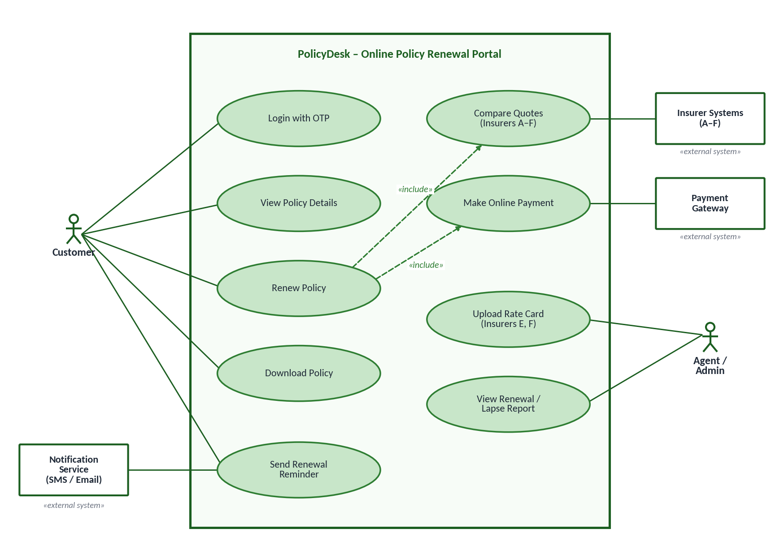
Figure 3.1: Use case diagram of PolicyDesk
The Customer is the main actor. The Agent / Admin uploads the Excel rate cards for Insurers E and F and checks the lapse report. Insurer systems, the payment gateway and the notification service are external systems. 'Renew Policy' includes 'Compare Quotes' and 'Make Online Payment'.

3.2 Class Diagram
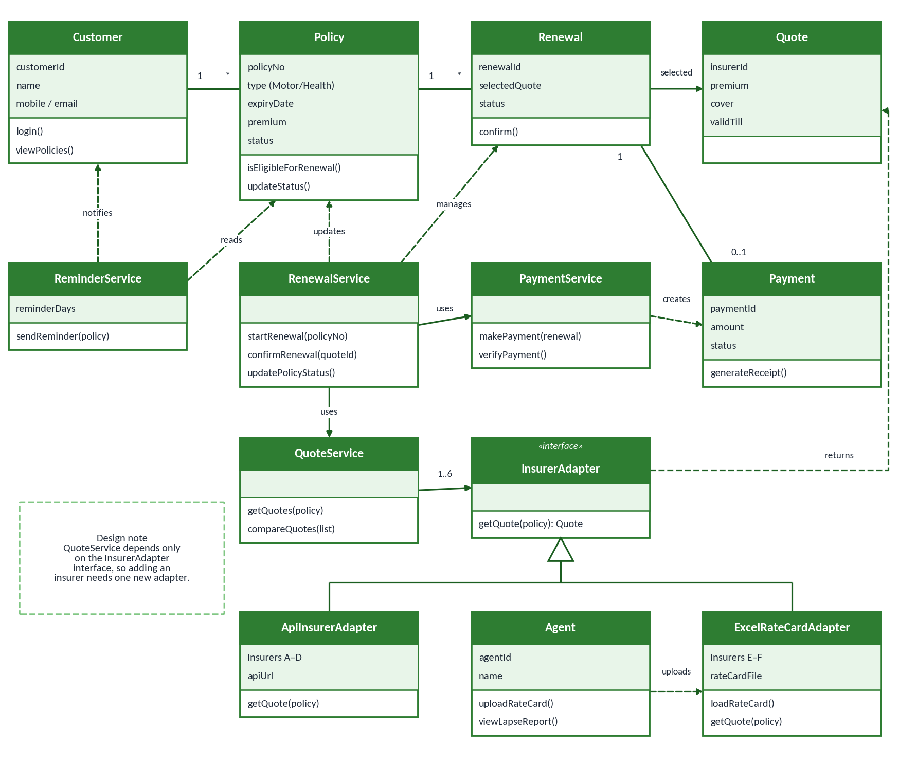
Figure 3.2: Class diagram
A Customer has many Policies and a Policy can have many Renewals. RenewalService controls the renewal, QuoteService collects quotes through the InsurerAdapter interface, and PaymentService creates the Payment. ApiInsurerAdapter serves Insurers A–D and ExcelRateCardAdapter serves Insurers E–F.

3.3 Sequence Diagram – Compare Quotes and Renew a Policy
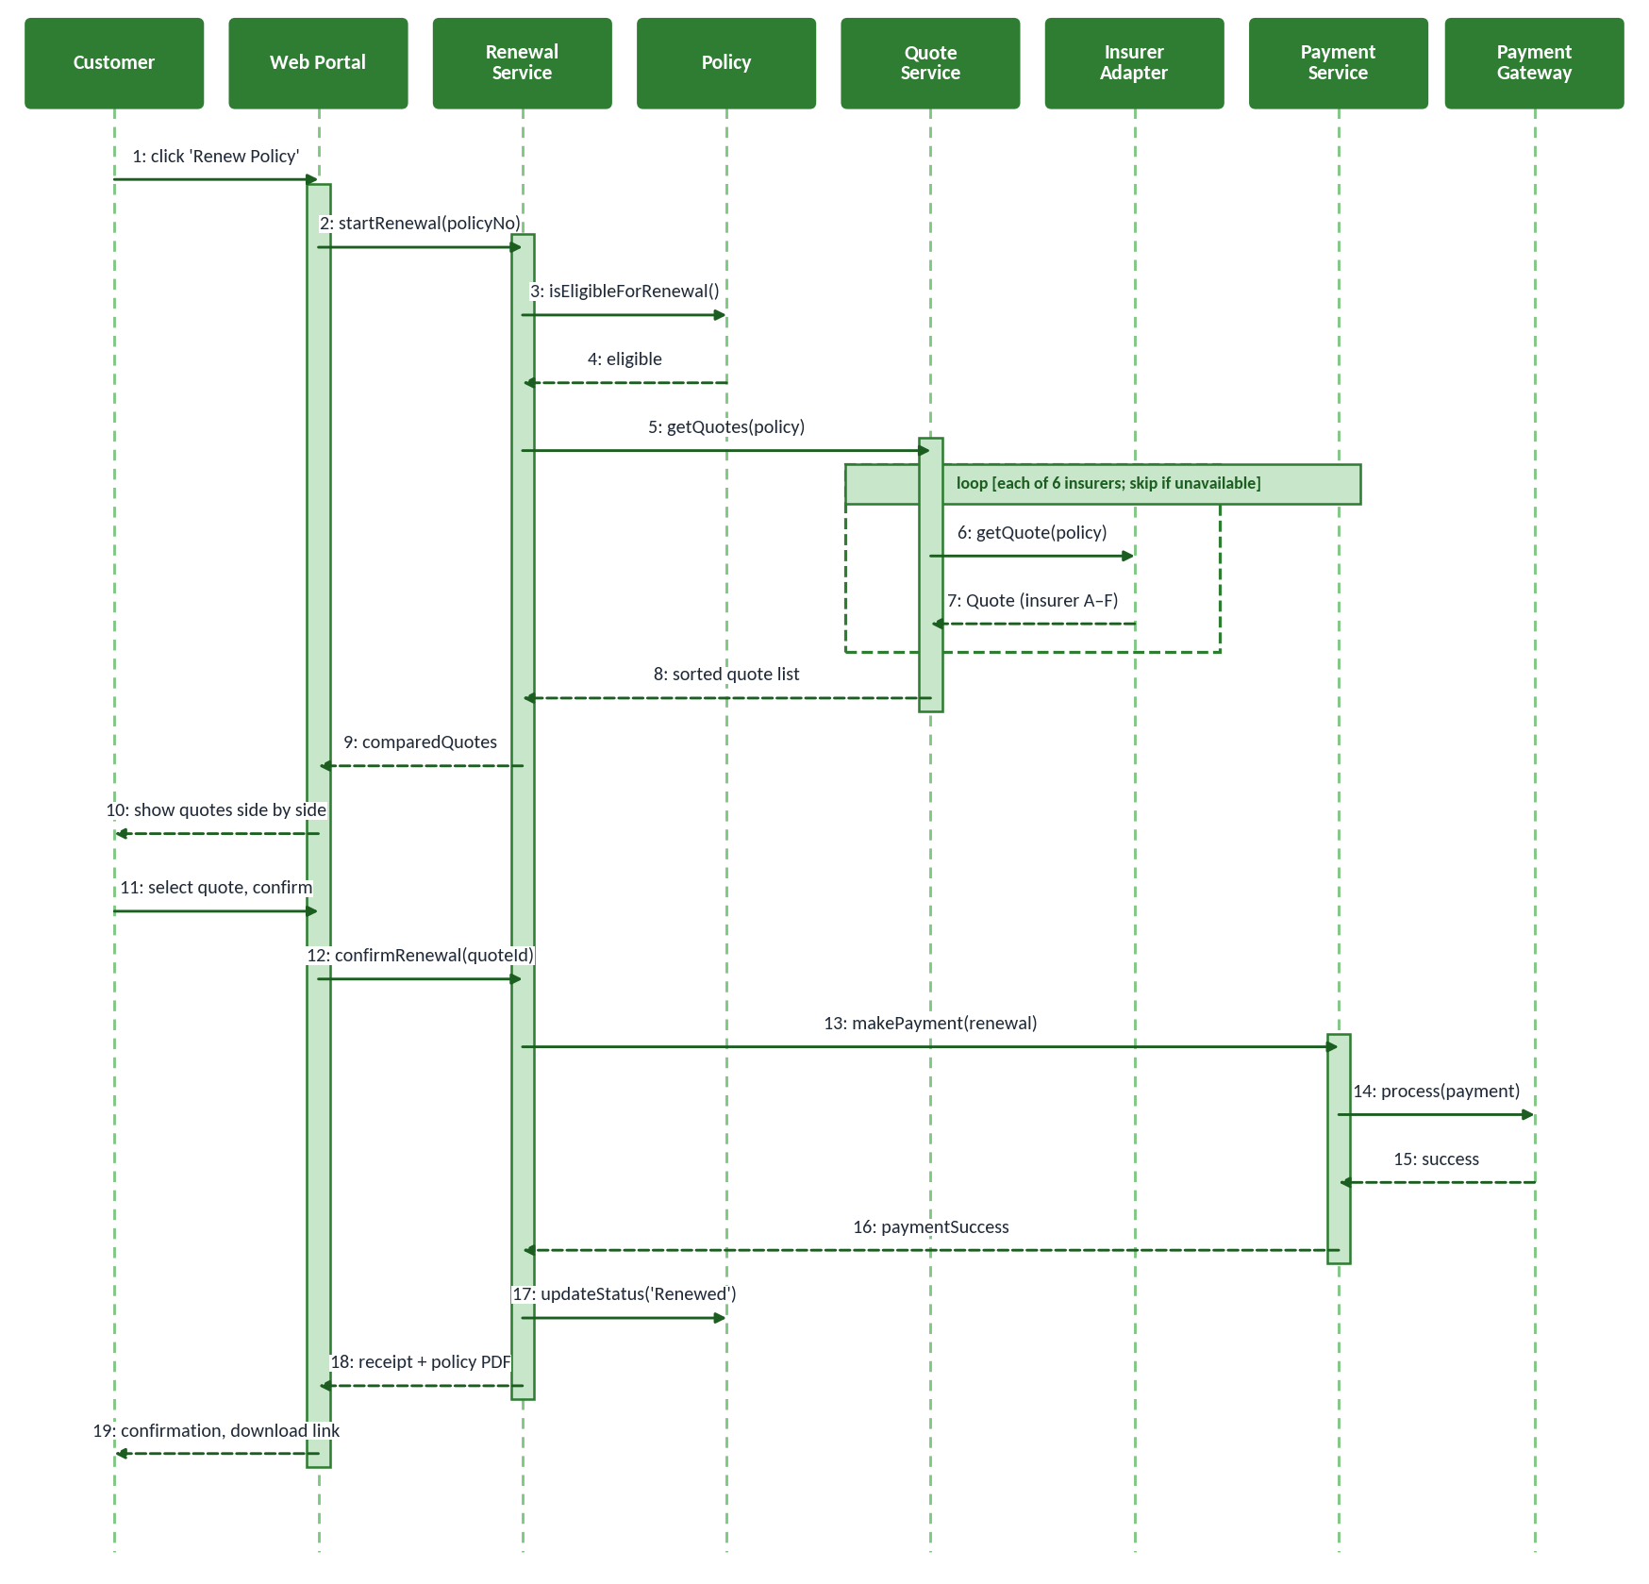
Figure 3.3: Sequence diagram – Compare quotes and renew a policy
The sequence shows the main flow: eligibility check, quotes from all insurers through the adapters, quote selection, payment through the gateway and the status change to 'Renewed'. The loop sends one request per insurer; if an insurer is unavailable its quote is skipped and the other quotes are still shown.

3.4 Activity Diagram – Policy Renewal
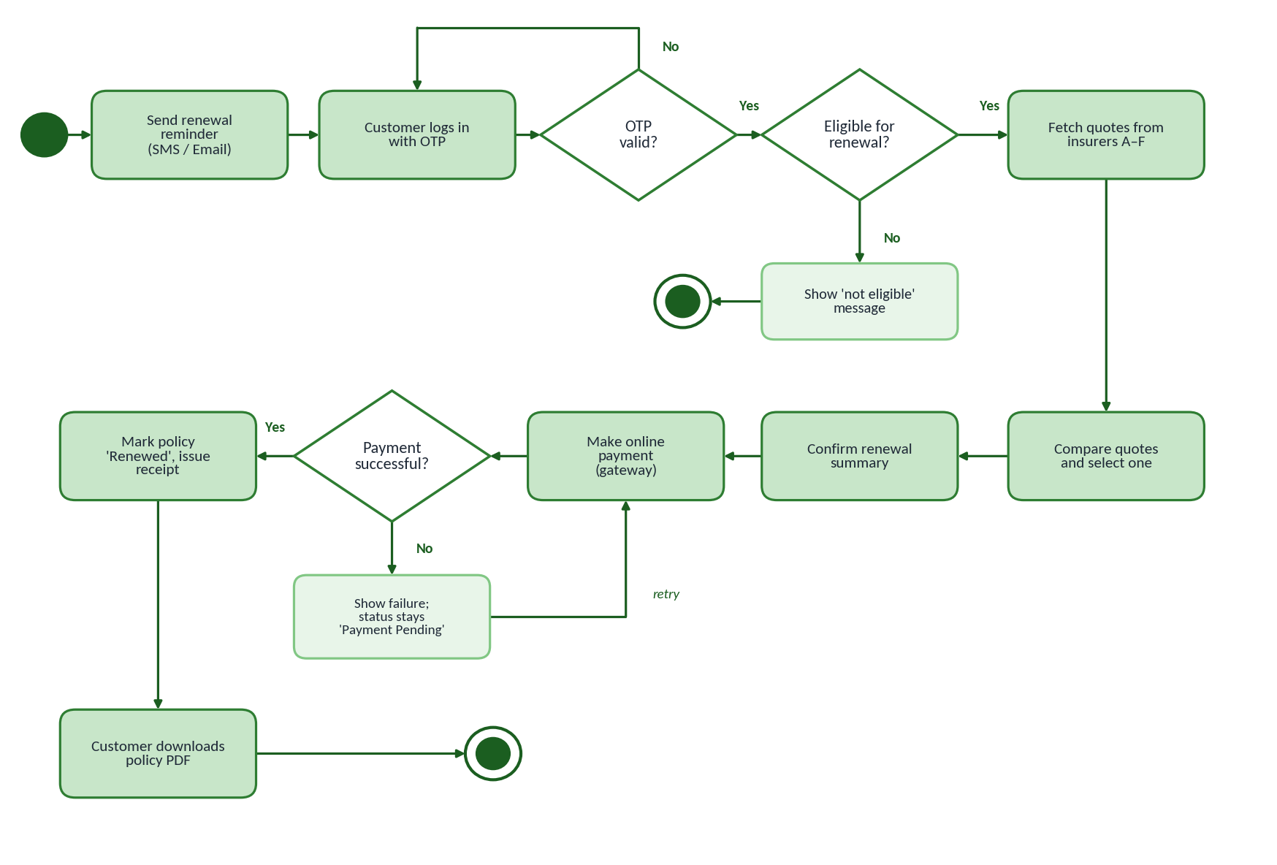
Figure 3.4: Activity diagram – Policy renewal
The activity diagram follows the same steps as the sequence diagram. There are two decisions that can stop or repeat the flow: the OTP check and the payment check. A failed payment keeps the policy in 'Payment Pending' so that the customer can retry.

3.5 State Diagram – Policy Renewal
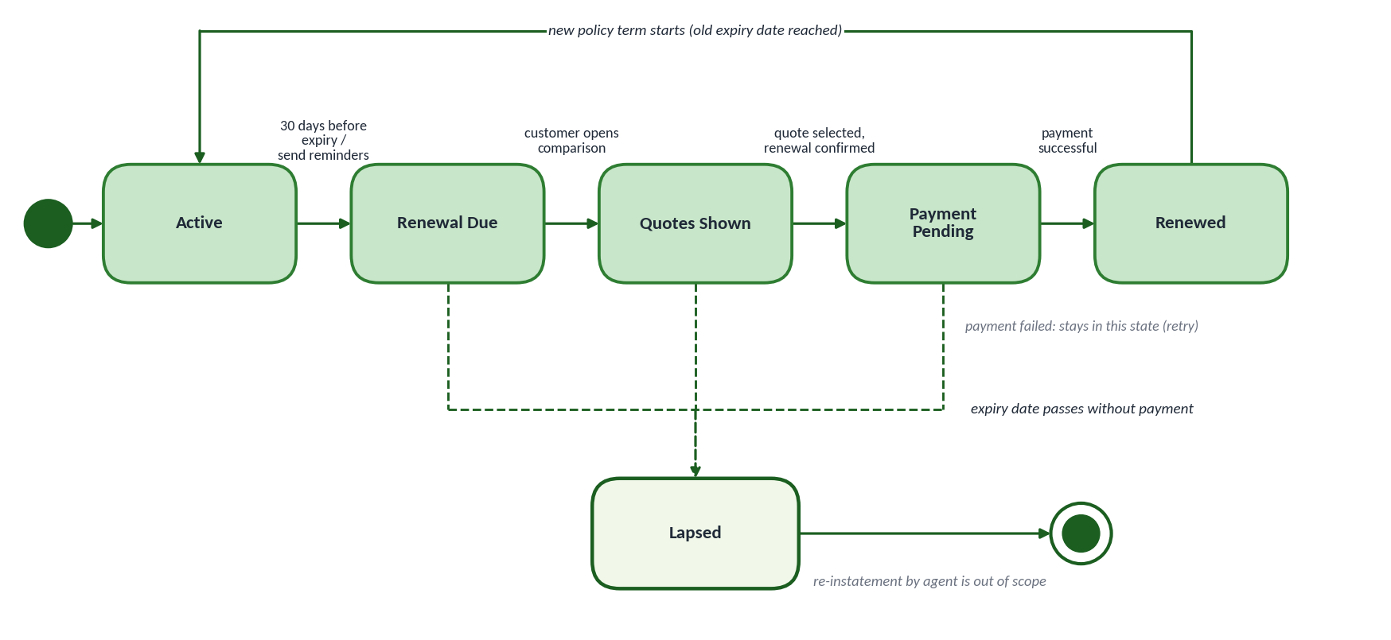
Figure 3.5: State diagram – Policy renewal lifecycle
A policy is Active until the renewal window opens (30 days before expiry, ASSUMPTION A1). It then moves through Renewal Due, Quotes Shown and Payment Pending to Renewed. If the expiry date passes without payment, the policy becomes Lapsed. These states are the values of Policy.status in the class diagram.

3.6 Design Notes: Coupling and Cohesion
- Loose coupling: QuoteService talks only to the InsurerAdapter interface, not to a particular insurer. A change in an insurer's API or Excel format affects only its own adapter.
- Adapter approach: every insurer has one adapter with the same method, getQuote(policy). Insurers A–D use ApiInsurerAdapter and E–F use ExcelRateCardAdapter. A new insurer needs only one new adapter, and E–F can also be added after launch without changing quote comparison.
- High cohesion: each module does one job – ReminderService (reminders), QuoteService (collect and compare quotes), PaymentService (payments), RenewalService (renewal workflow).

4. Project Plan

4.1 Work Breakdown Structure
Work package | Sub-tasks
1 Requirements | 1.1 Stakeholder meetings 1.2 SRS document 1.3 Requirement sign-off
2 Design | 2.1 UML design 2.2 Database design 2.3 Screen (UI) design
3 Portal Development (30 days) | 3.1 Login and policy view 3.2 Reminder module 3.3 Quote comparison 3.4 Payment module 3.5 Policy download
4 Insurer Integration | 4.1 API adapters for A–D 4.2 Excel adapters for E–F 4.3 Rate-card upload and validation
5 Testing (10 days) | 5.1 Test case design 5.2 System and integration testing 5.3 UAT and defect fixing
6 Deployment | 6.1 Production set-up 6.2 Load 65,000 policy records 6.3 Go-live and agent training

4.2 WBS Work Breakdown Chart
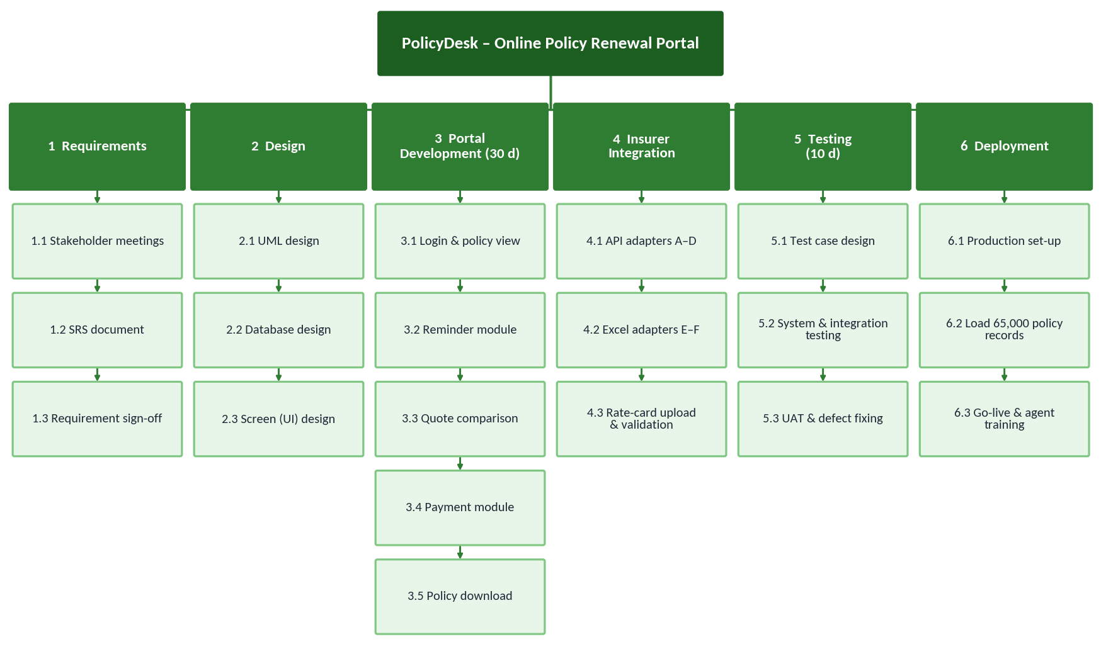
Figure 4.1: WBS chart

4.3 Resource Allocation
The case study does not give team size, so the table below is an ASSUMPTION. Two Integration Developers are needed because two integrations run in parallel.
Role | Number (ASSUMPTION) | Main responsibility | Active phase
Project Manager | 1 | Plan, track schedule and risks, talk to insurers and the MD | Whole project
Business Analyst | 1 | SRS, requirement changes, UAT support | Requirements, testing
UI/UX Designer | 1 | Screens for login, quotes, payment | Design, development
Developer | 3 | Portal modules (login, reminders, quote comparison, payment, download) | Portal build
Integration Developer | 2 | Insurer adapters (API and Excel), rate-card upload | Integration
Tester | 2 | Test cases, system testing, defect retesting | Testing

4.4 Project Scheduling
Inputs from the case study:
Task | Duration (days) | Note
Portal build | 30 | Given
Insurer A / B / C / D integration | 6 / 7 / 8 / 10 | API integrations
Insurer E / F integration | 15 / 18 | Excel rate card, manual upload
Testing | 10 | Starts after integrations finish
Scheduling assumptions (the case study does not give detailed dependencies):
- ASSUMPTION S1: Day 0 is the start of the portal build. Requirements and design are finished before Day 0.
- ASSUMPTION S2: Integrations start after the portal build (Day 30), because the adapters plug into the portal's quote module.
- ASSUMPTION S3: At most two integrations run at the same time (two Integration Developers), and each developer does one integration after another.
- ASSUMPTION S4: Testing starts when all integrations of that option are done and takes 10 days. Go-live is a zero-day milestone at the end of testing. Durations are working days.
Options. Option 1: all six insurers A–F at launch. Option 2: only A–D at launch, E–F later.
Splitting work between the two parallel lanes. For the shortest finish, the integrations are shared so that both lanes take almost equal time.
- Option 1: total work = 6 + 7 + 8 + 10 + 15 + 18 = 64 days, so each lane needs at least 64 ÷ 2 = 32 days. Lane 1 = F + C + A = 18 + 8 + 6 = 32; Lane 2 = E + D + B = 15 + 10 + 7 = 32. The minimum is reached.
- Option 2: total work = 6 + 7 + 8 + 10 = 31 days, so at least 16 days are needed (rounded up from 15.5). Lane 1 = D + A = 10 + 6 = 16; Lane 2 = C + B = 8 + 7 = 15.

4.5 Forward Pass
ES = latest EF of the predecessors; EF = ES + duration.
Task | Duration | Depends on | ES | EF
Option 1 – A to F at launch
Portal build | 30 | – | 0 | 30
Insurer F (Excel) | 18 | Portal build | 30 | 48
Insurer E (Excel) | 15 | Portal build | 30 | 45
Insurer C (API) | 8 | Insurer F (same developer) | 48 | 56
Insurer D (API) | 10 | Insurer E (same developer) | 45 | 55
Insurer A (API) | 6 | Insurer C (same developer) | 56 | 62
Insurer B (API) | 7 | Insurer D (same developer) | 55 | 62
Testing | 10 | A and B (last of all six); ES = max(62, 62) | 62 | 72
Go-live (milestone) | 0 | Testing | 72 | 72
Option 2 – A to D at launch, E–F later
Portal build | 30 | – | 0 | 30
Insurer D (API) | 10 | Portal build | 30 | 40
Insurer C (API) | 8 | Portal build | 30 | 38
Insurer A (API) | 6 | Insurer D (same developer) | 40 | 46
Insurer B (API) | 7 | Insurer C (same developer) | 38 | 45
Testing | 10 | A and B; ES = max(46, 45) | 46 | 56
Go-live (milestone) | 0 | Testing | 56 | 56

4.6 Backward Pass
LF = earliest LS of the successors; LS = LF – duration; Float = LS – ES.
Task | LS | LF | Float | Working
Option 1 – A to F at launch
Go-live | 72 | 72 | 0 | Project end
Testing | 62 | 72 | 0 | LF = 72, LS = 72 – 10
Insurer A | 56 | 62 | 0 | LF = LS of Testing = 62
Insurer B | 55 | 62 | 0 | LF = 62
Insurer C | 48 | 56 | 0 | LF = LS of A = 56
Insurer D | 45 | 55 | 0 | LF = LS of B = 55
Insurer F | 30 | 48 | 0 | LF = LS of C = 48
Insurer E | 30 | 45 | 0 | LF = LS of D = 45
Portal build | 0 | 30 | 0 | LF = min(30, 30) = 30
Option 2 – A to D at launch, E–F later
Go-live | 56 | 56 | 0 | Project end
Testing | 46 | 56 | 0 | LF = 56, LS = 56 – 10
Insurer A | 40 | 46 | 0 | LF = 46
Insurer B | 39 | 46 | 1 | LF = 46, LS = 39, ES = 38
Insurer D | 30 | 40 | 0 | LF = LS of A = 40
Insurer C | 31 | 39 | 1 | LF = LS of B = 39, ES = 30
Portal build | 0 | 30 | 0 | LF = min(30, 31) = 30

4.7 Critical Path
The critical path is the longest path from start to go-live. All paths were added up:
Option | Path | Length | Critical?
Option 1 | Portal → F → C → A → Testing = 30 + 18 + 8 + 6 + 10 | 72 | Yes
Option 1 | Portal → E → D → B → Testing = 30 + 15 + 10 + 7 + 10 | 72 | Yes
Option 2 | Portal → D → A → Testing = 30 + 10 + 6 + 10 | 56 | Yes
Option 2 | Portal → C → B → Testing = 30 + 8 + 7 + 10 | 55 | No (1 day float)
In Option 1 both lanes are equal (32 days), so every task is critical. In Option 2 the critical path is Portal build → D → A → Testing. Because integrations take at most 16 days against the 30-day portal build, the portal build always starts the path.
Option | Insurers at launch | Integrations done | Testing | Go-live
Option 1 | A–F (6 insurers) | Day 62 | Day 62 to 72 | Day 72
Option 2 | A–D (4 insurers) | Day 46 | Day 46 to 56 | Day 56

Sensitivity note. If integrations were allowed to start together with the portal build (instead of ASSUMPTION S2), Option 1 would finish integrations at Day 32 and go live at Day 42, and Option 2 would go live at Day 40 (portal build is then critical). The difference between the options becomes small, which is why S2 has been stated clearly.

4.8 Float
Float = LS – ES. Option 1: there are no non-critical tasks; all nine tasks have zero float, so any delay in any integration delays go-live by the same number of days. Option 2: only two tasks have float:
Task (Option 2) | ES | LS | Float | Meaning
Insurer C integration | 30 | 31 | 1 day | Can start 1 day late
Insurer B integration | 38 | 39 | 1 day | Can start 1 day late (the 1 day is shared with C)
The tasks on the critical path (Portal build, D, A, Testing, Go-live) have zero float.

4.9 Gantt Chart
The two charts below are drawn from the forward-pass dates. Each insurer has a zero-duration milestone (◆). Thick borders show critical tasks (float = 0).
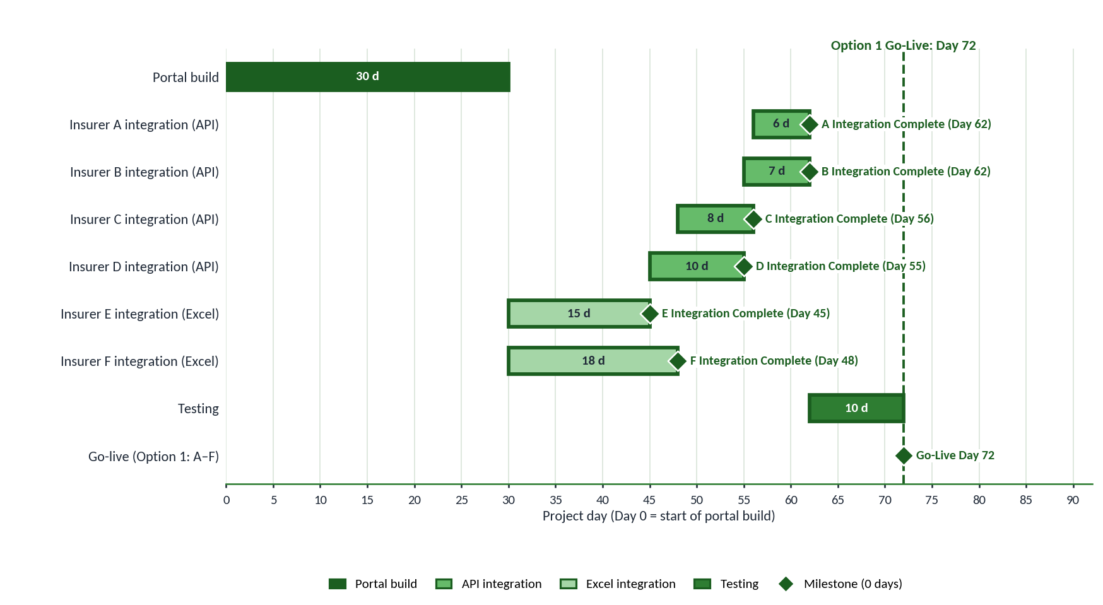
Figure 4.2: Gantt chart – Option 1 (A–F at launch), Go-live Day 72
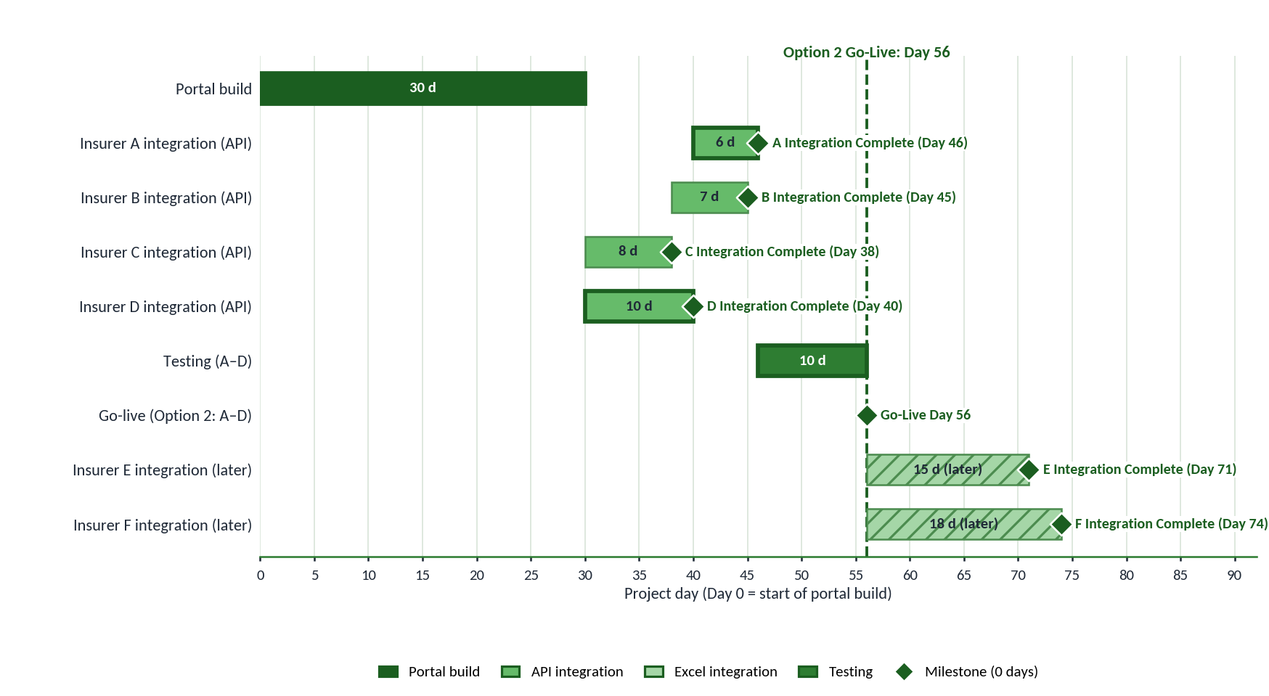
Figure 4.3: Gantt chart – Option 2 (A–D at launch, E–F later), Go-live Day 56
In Figure 4.3, E and F are shown after go-live (hatched). ASSUMPTION: they start at Day 56 on the two free developers, so E finishes on Day 71 and F on Day 74. Testing of E and F is not included in these dates.

5. Scope and Phasing
Requirement from the Managing Director: all 6 insurers at launch. The schedule data from Section 4 gives the following comparison.

5.1 Comparison of the Two Options
Factor | A–F at Launch | A–D at Launch + E–F Later
Time | Go-live on Day 72 | Go-live on Day 56 (16 days earlier). E–F ready by Day 74, 2 days after Option 1's go-live.
Cost / resource effort | 64 days of integration work before launch with 2 Integration Developers (ASSUMPTION) | 31 days of integration work before launch; the other 33 days (E and F) after launch. Total effort is the same (64 days).
Quality | 10 days of testing must cover 4 API insurers and 2 Excel rate cards together | 10 days of testing cover only the 4 API insurers; E–F get separate testing before they are switched on
Technical complexity | API adapters and Excel upload / validation module both needed at launch | Only API adapters at launch; Excel module is added in the second release
Risk | Zero float on every task. A delay in E or F delays go-live day for day. Risks R-01 and R-02 (exposure 20 and 16) are on the launch path. | E–F are off the launch path. Only C and B have 1 day float, but no Excel risk can delay the launch.
Customer impact | Customers see all 6 insurers from the first day (MD requirement is met) | Customers see 4 of 6 insurers for about 16–18 days; reminders and payment are available from day one

5.2 Justification for Phased Integration
Based on the project data, the following facts support integrating E and F after launch:
- Duration: E (15 days) and F (18 days) are the two longest integrations; the API integrations take only 6 to 10 days.
- Type of integration: E and F depend on Excel rate cards that are uploaded manually, so errors and delays are more likely (risks R-01 and R-02).
- Schedule: with all six insurers there is no float anywhere, so the launch date has no safety margin.
- Quality: NFR-01 needs 100% quote accuracy; fewer insurers in the first test cycle makes it easier to check every quote.
- Business target: the 22% lapse is caused by forgotten dates, and reminders (FR-03) do not depend on Insurers E and F.
Conclusion. On the data in this report, Option 2 (A–D first, E–F in a second release) gives an earlier launch with lower risk. Option 1 is still possible: it needs Day 72 and both rate cards received before Day 30. The Managing Director should take the final decision with these numbers.

5.3 In-Scope
In scope | Note
Renewal reminders (email and SMS) | Automatic, replaces manual reminders (FR-03)
Customer login with OTP and policy view | For motor and health policies (FR-01, FR-02)
Quote comparison from 6 insurers | A–D by API, E–F by Excel rate card (FR-04, FR-05)
Online payment and receipt | Through a payment gateway (FR-07, FR-08)
Policy download | PDF of the renewed policy (FR-09)
Rate-card upload for E and F | Done by agents with validation (FR-10)

5.4 Out-of-Scope
Out of scope | Note
Selling new policies | Project covers renewals only
Claim registration and settlement | Not part of the case study
Mobile app | Web portal only in this release (EX-03)
Mid-term changes to a policy | Only renewal at expiry is handled
Re-instating a lapsed policy | Handled by the agent outside the portal
Changes inside insurers' own systems | Broker only reads quotes from insurers

6. Test Plan and Test Evidence

6.1 Test Strategy
Testing takes 10 days after the integrations finish. Each level has a clear purpose:
- Unit and integration testing: adapters, quote comparison and payment module, using insurer test data and the gateway sandbox.
- System testing: all 10 functional requirements through the test cases in 6.2, and the NFR checks from Section 2.4.
- Black-box techniques: boundary value analysis, equivalence partitioning and decision tables (6.3 to 6.6).
- User acceptance testing: agents and sample customers run the full renewal on the test environment.
The Status column and the defect data below are sample assignment evidence; they show how the test results would be recorded.

6.2 Test Cases
Test ID | Req. | Test scenario | Input | Expected result | Status
TC-01 | FR-01 | Login with correct OTP | Registered mobile and valid OTP | Customer dashboard opens | Pass
TC-02 | FR-01 | Login with wrong OTP | Wrong OTP entered 3 times | Error message; login blocked for some time | Fail → Pass (D-01)
TC-03 | FR-02 | View policy list | Customer with 2 policies | Both policies show number, type, insurer, expiry, premium | Pass
TC-04 | FR-03 | Reminder 30 days before expiry | Policy expiring in 30 days | One email and one SMS sent that day | Fail → Pass (D-02)
TC-05 | FR-04 | Get quotes, all insurers available | Policy due in 20 days | 6 quotes returned (A–F) | Pass
TC-06 | FR-04 | One insurer API not responding | Insurer C API times out | 5 quotes shown with message 'Insurer C not available' | Fail → Pass (D-03)
TC-07 | FR-05 | Sort quotes by premium | Click 'Premium: low to high' | Quotes in ascending order of premium | Fail → Pass (D-04)
TC-08 | FR-06 | Select quote on expiry day | Policy with 0 days left; Insurer B quote | Renewal allowed; summary shows insurer and premium | Fail → Pass (D-08)
TC-09 | FR-07 | Successful payment | Valid test payment; Pay clicked twice quickly | Only one payment taken; success message | Fail → Pass (D-06)
TC-10 | FR-07 | Failed payment | Declined test card | Failure message; status stays 'Payment Pending'; retry allowed | Pass
TC-11 | FR-08 | Status after payment | Successful payment | Status 'Renewed'; receipt generated | Pass
TC-12 | FR-09 | Download policy | Click Download on renewed policy | PDF opens with correct policy number and name | Fail → Pass (D-07)
TC-13 | FR-10 | Upload valid rate card | Insurer E Excel file with valid rows | File accepted and rates activated | Pass
TC-14 | FR-10 | Upload invalid rate card | Insurer F file with a negative premium | File rejected; row number shown in error | Fail → Pass (D-05)
'Fail → Pass' means a defect was found, fixed and retested successfully.

6.3 Boundary Value Analysis
The case study does not give exact limits, so both ranges below are an ASSUMPTION for test design: renewal is allowed when days to expiry are 0 to 30 (ASSUMPTION A1), and the premium is valid from ₹1,000 to ₹2,00,000.
Test value | Boundary position | Expected result
A. Policy expiry date – days to expiry (valid range 0 to 30)
–1 day | Just below minimum | Rejected – policy has lapsed
0 day (expiry day) | Minimum | Accepted – renewal allowed
1 day | Just above minimum | Accepted
29 days | Just below maximum | Accepted
30 days | Maximum | Accepted – window opens
31 days | Just above maximum | Rejected – renewal window not open yet
B. Premium field in ₹ (valid range 1,000 to 2,00,000)
999 | Just below minimum | Rejected – premium too low
1,000 | Minimum | Accepted
1,001 | Just above minimum | Accepted
1,99,999 | Just below maximum | Accepted
2,00,000 | Maximum | Accepted
2,00,001 | Just above maximum | Rejected – premium too high

6.4 Equivalence Partitioning
Input | Partition | Type | Test value | Expected result
Policy expiry date (days to expiry)
EC-D1 | Less than 0 (expired) | Invalid | –5 | Rejected – lapsed
EC-D2 | 0 to 30 | Valid | 15 | Renewal allowed
EC-D3 | More than 30 | Invalid | 45 | Rejected – too early
EC-D4 | Blank or not a date | Invalid | 'abc' | Error message
Premium amount (₹)
EC-P1 | Less than 1,000 | Invalid | 500 | Rejected
EC-P2 | 1,000 to 2,00,000 | Valid | 25,000 | Accepted
EC-P3 | More than 2,00,000 | Invalid | 3,00,000 | Rejected
EC-P4 | Blank, negative or text | Invalid | –2,000 / 'abc' | Error message

6.5 Decision Table – Renewal Eligibility
C = condition, Y = yes, N = no, – = does not matter.
Condition / Action | R1 | R2 | R3 | R4 | R5
C1: Customer verified by OTP | Y | N | Y | Y | Y
C2: Policy is active | Y | – | N | Y | Y
C3: Expiry within renewal window (0–30 days) | Y | – | – | N | Y
C4: No outstanding dues | Y | – | – | – | N
Actions
Allow renewal and show quotes | ✔
Ask customer to log in |  | ✔
Show 'policy not active' |  |  | ✔
Show 'renewal window not open / lapsed' |  |  |  | ✔
Ask customer to clear dues first |  |  |  |  | ✔

6.6 Decision Table – No-Claim Bonus (NCB)
ASSUMPTION — Sample NCB Business Rules for Test Design. The case study does not give NCB rules. These sample rules (for motor policies only) are used only to design test cases; the percentages are not from the case study.

Condition / Action | R1 | R2 | R3 | R4
C1: Claim made in the last policy year | Y | N | N | N
C2: Renewed before expiry (no break in cover) | – | N | Y | Y
C3: Claim-free years | – | – | Less than 2 | 2 or more
Action (NCB discount on premium)
NCB discount | 0% | 0% | 20% | 35%

6.7 Defect Log
Sample assignment evidence – representative defects found during the test cycle.
ID | Test | Defect description | Severity | Found | Status
D-01 | TC-02 | No lock after 3 wrong OTP attempts | High | Testing | Closed
D-02 | TC-04 | Reminder SMS sent twice for the same policy | Low | Testing | Closed
D-03 | TC-06 | Blank quote list when Insurer C times out | High | Testing | Closed
D-04 | TC-07 | Sort order not applied to the quote list | Medium | Testing | Closed
D-05 | TC-14 | Negative premium accepted from rate card | High | Testing | Closed
D-06 | TC-09 | Double click on Pay created two payment requests | High | Testing | Closed
D-07 | TC-12 | Downloaded PDF name does not contain the policy number | Low | Testing | Closed
D-08 | TC-08 | Policy on its expiry day treated as lapsed (boundary error) | Medium | Testing | Closed
D-09 | – | Reminder SMS delayed for one customer (ASSUMPTION: found after release) | Low | After release | Open

6.8 Defect Density
Assignment Test Evidence / Assumption. The case study does not give the software size or defect counts. The values below are sample values: size = 10 KLOC (ASSUMPTION) and defects found in testing = 8 (from the defect log).
Defect density = Number of defects ÷ Size in KLOC
= 8 ÷ 10 = 0.8 defects per KLOC (testing phase)
Including the 1 post-release defect: 9 ÷ 10 = 0.9 defects per KLOC

6.9 Defect Removal Efficiency (DRE)
DRE = Defects removed before release ÷ (Defects removed before release + Defects found after release) × 100. The counts are sample assignment evidence: 8 before release and 1 after release (D-09).
DRE = 8 ÷ (8 + 1) × 100 = 88.9%
About 89% of the defects were removed before release in this sample.

7. Risk Register
Exposure = Probability × Impact on a 1–5 scale (1 = very low, 5 = very high). Risks are ranked by exposure.
ID | Risk | P | I | Exposure | Response | Owner
R-01 | Rate-card errors in Excel files (Insurers E, F) | 4 | 5 | 20 | Validation in upload module; check against insurer sample quotes | Integration Developer
R-02 | Excel rate-card delay (E, F) | 4 | 4 | 16 | Ask for rate cards at start; fix Day-30 deadline; use Option 2 if late | Project Manager
R-03 | Quote accuracy risk (wrong premium shown) | 3 | 5 | 15 | Compare quotes with insurer data in every test cycle (NFR-01) | Tester
R-04 | Insurer API delay (A–D) | 3 | 4 | 12 | Get API test access early; use mock services meanwhile | Integration Developer
R-05 | Integration defects | 4 | 3 | 12 | Unit tests for each adapter; early integration testing | Integration Developer
R-06 | Payment failure / security risk | 2 | 5 | 10 | Certified gateway; no card data stored; retry on failure | Developer
R-07 | Requirement changes | 3 | 3 | 9 | Sign-off on SRS; change control through the Project Manager | Business Analyst
R-08 | Customer adoption / reminder effectiveness | 3 | 3 | 9 | Reminders at 30, 15, 7 days; check monthly lapse rate against 12% target | Project Manager
R-09 | Resource availability | 2 | 4 | 8 | Confirm two Integration Developers; name a backup | Project Manager
R-10 | Testing delay | 2 | 3 | 6 | Prepare test cases before integrations end | Tester

7.1 Probability-Impact Matrix
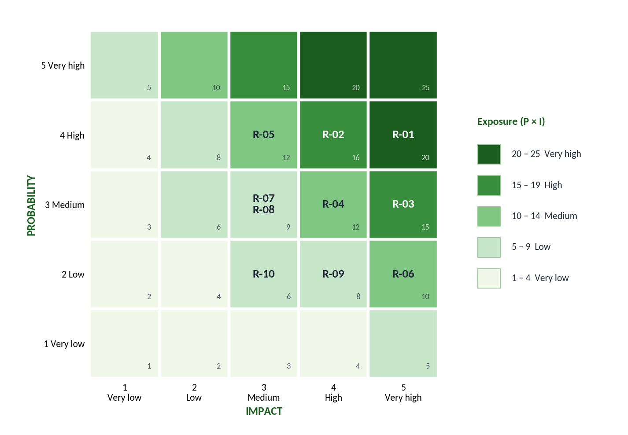
Figure 7.1: 5 × 5 probability-impact matrix (darker = higher exposure)

7.2 Top 3 Risks – RMMM
Risk | Mitigation | Monitoring | Management / Contingency | Owner
R-01 Rate-card errors (exposure 20) | Fixed Excel template; upload checks for blank, negative or out-of-range premium (FR-10) | Number of rows rejected per upload; quote checks in each test cycle | Correct the file and re-upload; switch off the insurer's quotes until fixed | Integration Developer
R-02 Excel rate-card delay (exposure 16) | Request E and F rate cards at project start with Day-30 deadline | Weekly follow-up with Insurers E and F | Go live with A–D (Option 2) and add E–F later | Project Manager
R-03 Quote accuracy (exposure 15) | Adapter unit tests with insurer sample data; peer review of premium logic | Quote mismatch count in testing (target 0) | Hide the affected insurer's quote; fix and retest before showing again | Tester

7.3 Issue Log
Issues are problems that have already happened; they are kept separate from the risks above. Sample Assignment Issue Evidence.
ID | Issue | Phase | Action taken | Status | Owner
I-01 | Sample rate card from Insurer E had the premium column in a different format | Integration | Common template agreed with insurer; validation updated | Closed | Integration Developer
I-02 | Payment gateway test credentials arrived late | Development | Escalated to gateway provider; mock gateway used meanwhile | Closed | Project Manager
I-03 | Test reminder emails went to spam folder | Testing | Email template and sender settings changed | Closed | Developer
I-04 | Final Excel rate card for Insurer F not yet received in the agreed format | Integration | Reminder sent to insurer; escalated to MD if no reply | Open | Project Manager

8. Lessons Learned
- Identify insurer dependencies early. Insurer E and F rate cards and the API test access decide the schedule, so they must be requested on Day 0.
- Validate Excel integrations. Manual rate cards need upload checks, otherwise they directly affect quote accuracy.
- Link requirements to test cases. The traceability matrix showed that every FR has at least one test case.
- Watch the critical path closely. With all six insurers every task is critical (zero float), so any delay moves go-live.
- Keep risks and issues separate. Risks are planned for in advance; issues need action now.
- Write assumptions clearly. Items like the 30-day renewal window, NCB rules and team size are not in the case study and were marked as assumptions.

9. Conclusion
The broker manages 65,000 motor and health policies and 22% of them lapse because customers forget renewal dates. PolicyDesk solves this with automatic reminders, quote comparison from 6 insurers, online payment and policy download. The main project challenge is the insurer integrations: four are API-based (6 to 10 days) and two use Excel rate cards (15 and 18 days). The schedule calculation shows go-live on Day 72 for all six insurers and Day 56 for A–D only, so the phased option has less schedule risk. Testing with boundary values, equivalence classes and decision tables, together with a risk register and issue log, supports a safe launch. If the portal works as planned, the lapse rate can be reduced from 22% to the target of 12% within one year.

10. Final Completeness Check
Item | Sec. | Item | Sec. | Item | Sec.
✓ 10 Functional Requirements | 2.3 | ✓ Gantt Chart | 4.9 | ✓ Test Cases | 6.2
✓ 6 Measurable NFRs | 2.4 | ✓ 6 Insurer Milestones | 4.9 | ✓ Defect Log | 6.7
✓ MoSCoW | 2.7 | ✓ Forward Pass | 4.5 | ✓ DRE | 6.9
✓ Requirement Traceability Matrix | 2.8 | ✓ Critical Path | 4.7 | ✓ Defect Density | 6.8
✓ Use Case Diagram | 3.1 | ✓ Float | 4.8 | ✓ Risk Register | 7
✓ Class Diagram | 3.2 | ✓ A–F Go-Live Calculation (Day 72) | 4.5, 4.7 | ✓ Probability-Impact Matrix | 7.1
✓ Sequence Diagram | 3.3 | ✓ A–D Go-Live Calculation (Day 56) | 4.5, 4.7 | ✓ RMMM | 7.2
✓ Activity Diagram | 3.4 | ✓ Scope & Phasing | 5 | ✓ Issue Log | 7.3
✓ State Diagram | 3.5 | ✓ BVA | 6.3 | ✓ Lessons Learned | 8
✓ WBS | 4.1, 4.2 | ✓ Equivalence Classes | 6.4
✓ Resource Allocation | 4.3 | ✓ Decision Tables | 6.5, 6.6

