Untitled
2026-01-19
read.csv("C:/Users/stark/Downloads/Boston.csv")
install.packages("ggplot2",repos = "http://cran.us.r-project.org")
## Installing package into 'C:/Users/stark/AppData/Local/R/win-library/4.5'
## (as 'lib' is unspecified)
## package 'ggplot2' successfully unpacked and MD5 sums checked
##
## The downloaded binary packages are in
## C:\Users\stark\AppData\Local\Temp\RtmpgvIGIy\downloaded_packages
library(ggplot2)
## Warning: package 'ggplot2' was built under R version 4.5.2
Q1: Report the “class” of the data set. How many rows and columns are in this data set? What do the rows and columns represent?
Ans: There are 506 rows and 15 columns. Each row represents a different town within Boston. Each column is an attribute of the regions. ‘crim’ : per capita crime rate by town ‘zn’ : proportion of residential land zoned for lots over 25000 sq. ft. ‘indus’ : proportion of non-retail business acres per town ‘chas’ : Charles River boolean variable, 1 when tract bounds river ‘nox’ : nitrogen oxides concentration (parts per 10 million) ‘rm’ : average number of rooms per dwelling ‘age’ : proportion of owner occupied units built pre 1940 ‘dis’ : weighted mean of distances to 5 Boston employment centres ‘rad’ : index of accessibilty to radial highways ‘tax’ : full-value property tax rate per $10000 ‘ptratio’: pupil-teacher ratio by town ‘black’ : 100(Bk-0.63)^2, where Bk is the proprtion of black people by town ‘lstat’ : lower status of the population (percent) ‘medv’ : median value of owner-occupied homes in $1000
df1 = data.frame(read.csv("C:/Users/stark/Downloads/Boston.csv"))
class(df1)
## [1] "data.frame"
The class is a data frame.
Q2: Create a smaller data set with the variables median value of owner-occupied homes, per capita crime rate, nitrogen oxides concentration, proportion of blacks and percentage of lower status of the population. Choosing median value of owner occupied homes as the response and the rest as the predictors, make scatter plots of the response versus each predictor. Present the scatter plots in different panels of the same graph. Comment on your findings.
df = data.frame(medv=df1$medv, crim=df1$crim, nox=df1$nox, black=df1$black, lstat=df1$lstat)
par(mfrow=c(2,2))
plot(x=df$crim,y=df$mdv,
xlab="crim",
ylab="medv",
main="Crime Rate vs Median Value of Homes Scatterplot",
col="skyblue",
pch=20)
plot(x=df$black,y=df$mdv,
xlab="black",
ylab="medv",
main="Impact of Black People in towns vs Median Value of Homes Scatterplot",
col="mediumaquamarine",
pch=20)
plot(x=df$lstat,y=df$mdv,
xlab="lstat",
ylab="medv",
main="Population percentage belonging to Lower Status vs Median Value of Homes Scatterplot",
col="palegreen",
pch=20)
plot(x=df$nox,y=df$mdv,
xlab="nox",
ylab="medv",
main="Concentration of Nitrogen Oxides vs Median Value of Homes Scatterplot",
col="turquoise",
pch=20)
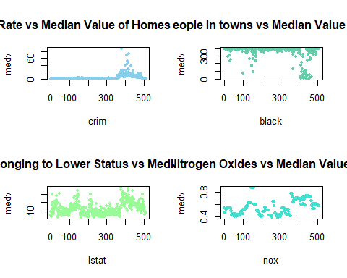
Q3: Which suburb of Boston has lowest median value of owner-occupied homes? What are the values of the other predictors mentioned in (2), for that suburb. How do these values compare to the overall ranges for those pre-dictors? Comment on your findings. Hint: Mention which percentile these values belong to.
minmed=min(df1$medv)
low_sub=df1[df1$medv==minmed,]
low_sub
## X crim zn indus chas nox rm age dis rad tax ptratio black
## 399 399 38.3518 0 18.1 0 0.693 5.453 100 1.4896 24 666 20.2 396.90
## 406 406 67.9208 0 18.1 0 0.693 5.683 100 1.4254 24 666 20.2 384.97
## lstat medv
## 399 30.59 5
## 406 22.98 5
Suburb numbers 399, 406 have the lowest median value of 5.
perc = sapply(
setdiff(names(df1), "medv"),
function(v) {
ecdf(df1[[v]])(low_sub[[v]]) * 100
}
)
perc
## X crim zn indus chas nox rm age dis
## [1,] 78.85375 98.81423 73.51779 88.73518 93.083 85.77075 7.70751 100 5.731225
## [2,] 80.23715 99.60474 73.51779 88.73518 93.083 85.77075 13.63636 100 4.150198
## rad tax ptratio black lstat
## [1,] 100 99.01186 88.93281 100.00000 97.82609
## [2,] 100 99.01186 88.93281 34.98024 89.92095
The percentile values do not differ much, except for the black factor. Both these towns have the lowest housing prices, alongside the high crime, high concentration of nitrogen oxides and taxes.
Q4. Does any suburb of Boston stand out for having notably high crime rates, tax rates, or pupil–teacher ratios? Hint: Use a boxplot to detect any outliers. If so, identify the suburbs that show the outlier values.
par(mfrow=c(1,3))
boxplot(df1$crim,main="Crime rate",ylab="crim",col="skyblue")
boxplot.stats(df1$crim)$out
## [1] 13.52220 9.23230 11.10810 18.49820 19.60910 15.28800 9.82349 23.64820
## [9] 17.86670 88.97620 15.87440 9.18702 20.08490 16.81180 24.39380 22.59710
## [17] 14.33370 11.57790 13.35980 38.35180 9.91655 25.04610 14.23620 9.59571
## [25] 24.80170 41.52920 67.92080 20.71620 11.95110 14.43830 51.13580 14.05070
## [33] 18.81100 28.65580 45.74610 18.08460 10.83420 25.94060 73.53410 11.81230
## [41] 11.08740 12.04820 15.86030 12.24720 37.66190 9.33889 10.06230 13.91340
## [49] 11.16040 14.42080 15.17720 13.67810 9.39063 22.05110 9.72418 9.96654
## [57] 12.80230 10.67180 9.92485 9.32909 9.51363 15.57570 13.07510 15.02340
## [65] 10.23300 14.33370
boxplot(df1$tax,main="Tax rate",ylab="tax",col="purple")
boxplot(df1$ptratio,main="Pupil-Teacher Ratio",ylab="ptratio",col="pink")
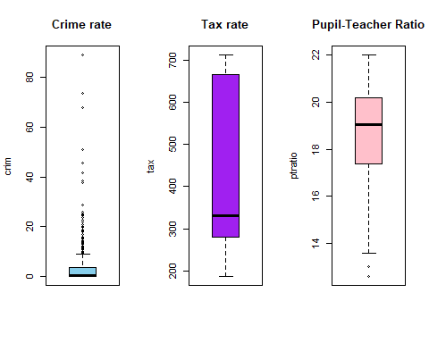
boxplot.stats(df1$ptratio)$out
## [1] 12.6 12.6 12.6 13.0 13.0 13.0 13.0 13.0 13.0 13.0 13.0 13.0 13.0 13.0 13.0
The lowest median home value town belongs to the extreme upper percentiles for crime and tax rate. The pupil–teacher ratio being above the 75th percentile suggests larger class sizes. The combined values of these factors help explain the town’s comparatively low housing prices.

