717_assignment_sem2_4
Kinjal Das
2026-02-18
Problem Set3: 5:
library(MASS)
attach(fgl)
str(fgl)
## 'data.frame': 214 obs. of 10 variables:
## $ RI : num 3.01 -0.39 -1.82 -0.34 -0.58 ...
## $ Na : num 13.6 13.9 13.5 13.2 13.3 ...
## $ Mg : num 4.49 3.6 3.55 3.69 3.62 3.61 3.6 3.61 3.58 3.6 ...
## $ Al : num 1.1 1.36 1.54 1.29 1.24 1.62 1.14 1.05 1.37 1.36 ...
## $ Si : num 71.8 72.7 73 72.6 73.1 ...
## $ K : num 0.06 0.48 0.39 0.57 0.55 0.64 0.58 0.57 0.56 0.57 ...
## $ Ca : num 8.75 7.83 7.78 8.22 8.07 8.07 8.17 8.24 8.3 8.4 ...
## $ Ba : num 0 0 0 0 0 0 0 0 0 0 ...
## $ Fe : num 0 0 0 0 0 0.26 0 0 0 0.11 ...
## $ type: Factor w/ 6 levels "WinF","WinNF",..: 1 1 1 1 1 1 1 1 1 1 ...
5a:
summary(lm(RI ~ .,fgl[,-10]))
##
## Call:
## lm(formula = RI ~ ., data = fgl[, -10])
##
## Residuals:
## Min 1Q Median 3Q Max
## -4.9898 -0.4273 -0.0264 0.4187 4.3833
##
## Coefficients:
## Estimate Std. Error t value Pr(>|t|)
## (Intercept) -64.73269 67.03935 -0.966 0.33539
## Na 1.39526 0.65505 2.130 0.03436 *
## Mg 1.84423 0.67547 2.730 0.00688 **
## Al 0.03262 0.69834 0.047 0.96278
## Si 0.16851 0.67740 0.249 0.80380
## K 1.38287 0.68998 2.004 0.04636 *
## Ca 3.11677 0.66837 4.663 5.61e-06 ***
## Ba 2.98281 0.67600 4.412 1.65e-05 ***
## Fe 0.42627 0.77869 0.547 0.58468
## ---
## Signif. codes: 0 '***' 0.001 '**' 0.01 '*' 0.05 '.' 0.1 ' ' 1
##
## Residual standard error: 1.004 on 205 degrees of freedom
## Multiple R-squared: 0.8948, Adjusted R-squared: 0.8907
## F-statistic: 217.9 on 8 and 205 DF, p-value: < 2.2e-16
pval = round(summary(lm(RI ~ .,fgl[,-10]))$coefficients[-1,4],5)
pval
## Na Mg Al Si K Ca Ba Fe
## 0.03436 0.00688 0.96278 0.80380 0.04636 0.00001 0.00002 0.58468
The p-values show that the oxides of Calcium most significantly impact the Refractive Index.
5b:
m1 = (lm(RI ~ Ca))
summary(m1)
##
## Call:
## lm(formula = RI ~ Ca)
##
## Residuals:
## Min 1Q Median 3Q Max
## -5.1658 -0.9515 -0.1842 0.8354 6.8121
##
## Coefficients:
## Estimate Std. Error t value Pr(>|t|)
## (Intercept) -15.12400 0.77868 -19.42 <2e-16 ***
## Ca 1.72932 0.08586 20.14 <2e-16 ***
## ---
## Signif. codes: 0 '***' 0.001 '**' 0.01 '*' 0.05 '.' 0.1 ' ' 1
##
## Residual standard error: 1.783 on 212 degrees of freedom
## Multiple R-squared: 0.6568, Adjusted R-squared: 0.6551
## F-statistic: 405.6 on 1 and 212 DF, p-value: < 2.2e-16
The R^2 =0.6568 implies that on an average calcium can approximately estimate 65.68% of the variation in the Refractive Index.
5c:
m2 = lm(RI ~ ., fgl)
summary(m2)
##
## Call:
## lm(formula = RI ~ ., data = fgl)
##
## Residuals:
## Min 1Q Median 3Q Max
## -5.2131 -0.3786 -0.0186 0.3697 4.0317
##
## Coefficients:
## Estimate Std. Error t value Pr(>|t|)
## (Intercept) 11.68095 67.73022 0.172 0.863248
## Na 0.60928 0.66840 0.912 0.363100
## Mg 1.32017 0.67269 1.963 0.051086 .
## Al -0.92790 0.70416 -1.318 0.189098
## Si -0.61637 0.68460 -0.900 0.369022
## K 0.74007 0.68789 1.076 0.283286
## Ca 2.47150 0.66700 3.705 0.000273 ***
## Ba 1.97569 0.70198 2.814 0.005374 **
## Fe 0.36329 0.73879 0.492 0.623442
## typeWinNF 0.09996 0.17352 0.576 0.565209
## typeVeh -0.88579 0.26111 -3.392 0.000835 ***
## typeCon 0.39910 0.39687 1.006 0.315810
## typeTabl 0.39263 0.42512 0.924 0.356822
## typeHead 1.58234 0.43890 3.605 0.000394 ***
## ---
## Signif. codes: 0 '***' 0.001 '**' 0.01 '*' 0.05 '.' 0.1 ' ' 1
##
## Residual standard error: 0.9503 on 200 degrees of freedom
## Multiple R-squared: 0.9081, Adjusted R-squared: 0.9021
## F-statistic: 152 on 13 and 200 DF, p-value: < 2.2e-16
Observations: 1) Calcium is still significant at 0.001 level of significance. 2) For a full model we obtain R^2 = 0.9081 implying that the fit accounts for approximately 90.81% of the total variation in RI of the glass. 3) Since the adjusted R^2 is higher for model 2 (=0.9021) than model 1 (=0.6551), we use the adjusted R^2 to compare (the number of predictors is also accounted for in this measure).
Problem Set 4:
1:
rm(list=ls())
library(ISLR)
## Warning: package 'ISLR' was built under R version 4.5.2
library(stargazer)
## Warning: package 'stargazer' was built under R version 4.5.2
##
## Please cite as:
## Hlavac, Marek (2022). stargazer: Well-Formatted Regression and Summary Statistics Tables.
## R package version 5.2.3. https://CRAN.R-project.org/package=stargazer
attach(Credit)
str(Credit)
## 'data.frame': 400 obs. of 12 variables:
## $ ID : int 1 2 3 4 5 6 7 8 9 10 ...
## $ Income : num 14.9 106 104.6 148.9 55.9 ...
## $ Limit : int 3606 6645 7075 9504 4897 8047 3388 7114 3300 6819 ...
## $ Rating : int 283 483 514 681 357 569 259 512 266 491 ...
## $ Cards : int 2 3 4 3 2 4 2 2 5 3 ...
## $ Age : int 34 82 71 36 68 77 37 87 66 41 ...
## $ Education: int 11 15 11 11 16 10 12 9 13 19 ...
## $ Gender : Factor w/ 2 levels " Male","Female": 1 2 1 2 1 1 2 1 2 2 ...
## $ Student : Factor w/ 2 levels "No","Yes": 1 2 1 1 1 1 1 1 1 2 ...
## $ Married : Factor w/ 2 levels "No","Yes": 2 2 1 1 2 1 1 1 1 2 ...
## $ Ethnicity: Factor w/ 3 levels "African American",..: 3 2 2 2 3 3 1 2 3 1 ...
## $ Balance : int 333 903 580 964 331 1151 203 872 279 1350 ...
1a: (i)
plot(Limit,Age,pch=20)
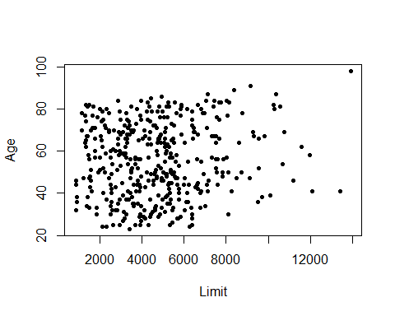
No apparent linear relationship..
plot(Limit,Rating,colour="cyan",pch=20)
## Warning in plot.window(...): "colour" is not a graphical parameter
## Warning in plot.xy(xy, type, ...): "colour" is not a graphical parameter
## Warning in axis(side = side, at = at, labels = labels, ...): "colour" is not a
## graphical parameter
## Warning in axis(side = side, at = at, labels = labels, ...): "colour" is not a
## graphical parameter
## Warning in box(...): "colour" is not a graphical parameter
## Warning in title(...): "colour" is not a graphical parameter
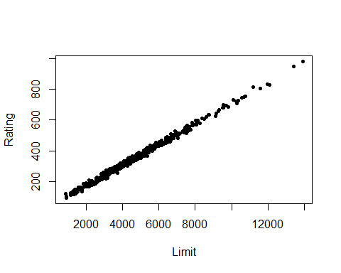
Apparent very strong positive linear relationship.
1b:
m1 = lm(Balance~ Age + Limit)
m2 = lm(Balance~ Age + Limit + Rating)
m3 = lm(Balance~ Limit + Rating)
stargazer(m1,m2,m3,type="text")
##
## ==============================================================================================
## Dependent variable:
## --------------------------------------------------------------------------
## Balance
## (1) (2) (3)
## ----------------------------------------------------------------------------------------------
## Age -2.291*** -2.346***
## (0.672) (0.669)
##
## Limit 0.173*** 0.019 0.025
## (0.005) (0.063) (0.064)
##
## Rating 2.310** 2.202**
## (0.940) (0.952)
##
## Constant -173.411*** -259.518*** -377.537***
## (43.828) (55.882) (45.254)
##
## ----------------------------------------------------------------------------------------------
## Observations 400 400 400
## R2 0.750 0.754 0.746
## Adjusted R2 0.749 0.752 0.745
## Residual Std. Error 230.532 (df = 397) 229.080 (df = 396) 232.320 (df = 397)
## F Statistic 594.988*** (df = 2; 397) 403.718*** (df = 3; 396) 582.820*** (df = 2; 397)
## ==============================================================================================
## Note: *p<0.1; **p<0.05; ***p<0.01
1c:
r1 = summary(lm(Age~Limit))$r.squared
r2 = summary(lm(Rating~Age))$r.squared
r3 = summary(lm(Limit~Rating))$r.squared
R_sq = c(r1,r2,r3)
R_sq
## [1] 0.01017837 0.01064302 0.99376921
vif = 1/(1-R_sq)
model = c("Age on Limit","Rating on Age","Limit on Rating")
data.frame(model,vif)
## model vif
## 1 Age on Limit 1.010283
## 2 Rating on Age 1.010758
## 3 Limit on Rating 160.493293
We see that strong multicollinearity exists between Limit and Rating, indicated by high VIF (>10); other pairs (age and limit) ,(age and rating) have no apparent multicollinearity.
2:
rm(list=ls())
library(MASS)
attach(Boston)
model = lm(medv ~ crim + nox + black + lstat)
summary(model)
##
## Call:
## lm(formula = medv ~ crim + nox + black + lstat)
##
## Residuals:
## Min 1Q Median 3Q Max
## -15.564 -4.004 -1.504 2.178 24.608
##
## Coefficients:
## Estimate Std. Error t value Pr(>|t|)
## (Intercept) 30.053584 2.170839 13.844 <2e-16 ***
## crim -0.059424 0.037755 -1.574 0.116
## nox 3.415809 3.056602 1.118 0.264
## black 0.006785 0.003408 1.991 0.047 *
## lstat -0.918431 0.050167 -18.307 <2e-16 ***
## ---
## Signif. codes: 0 '***' 0.001 '**' 0.01 '*' 0.05 '.' 0.1 ' ' 1
##
## Residual standard error: 6.183 on 501 degrees of freedom
## Multiple R-squared: 0.5517, Adjusted R-squared: 0.5481
## F-statistic: 154.1 on 4 and 501 DF, p-value: < 2.2e-16
plot(resid(model),pch=20, ylab= "Residuals", main= "Residual Plot for the Fitted Model")
abline(h=0,col="aquamarine", lty=2)
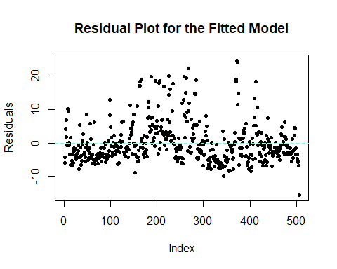
The Residual plot does not reveal any pattern (which is favourable). We see some high values positive in the residuals. We standardize the Residuals and then check for the residuals whose absolute value is greater than 3 (indicating outliers).
std_res = rstandard(model)
outliers = which(abs(std_res) > 3)
cat("Outliers observation number:\n",outliers)
## Outliers observation number:
## 167 187 196 205 226 258 263 268 284 369 370 372 373 413
We check for leverage points through hat points.
hatv = hatvalues(model)
thres1 = 2*5/nrow(Boston)
cat("Threshold value:", thres1)
## Threshold value: 0.01976285
lev_p = which(hatv > thres1)
cat("\n\nLeverage point observation number:\n",lev_p)
##
##
## Leverage point observation number:
## 9 33 49 103 142 143 144 145 146 147 148 149 150 151 152 153 154 155 156 157 160 215 374 375 381 386 387 388 399 401 405 406 411 412 413 414 415 416 417 418 419 420 424 425 426 427 428 430 431 432 433 434 435 437 438 439 446 451 455 456 457 458 467 491
We check for the influential points (through Cook’s distance)
cooks_d = cooks.distance(model)
thres2 = 4/nrow(Boston)
cat("Threshold value:", thres2)
## Threshold value: 0.007905138
influence_p = which(cooks_d > thres2)
cat("\n\nLeverage point observation number:\n",influence_p)
##
##
## Leverage point observation number:
## 9 49 142 149 153 162 163 164 167 187 196 204 205 215 226 234 258 262 263 268 284 369 370 371 372 373 374 375 381 406 410 411 413 415 427 428 439

