K J Somaiya Institute of Technology
An Autonomous Institute Permanently Affiliated to University of Mumbai.
A Project Based Learning
Report On

“HydroPulse-SVR: El Niño-Based KRS Reservoir Inflow Deficit Prediction Using Support Vector Regression”
SUBMITTED BY
Kinjal Joshi – (TY B, Roll No. 60)
Garvit Kanani – (TY B, Roll No. 61)
Raj Vitmal – (TY B, Roll No. 71)

Guide
Dr. Milind Nemade

Department of Artificial Intelligence and Data Science
2026-27

 | 
K J Somaiya Institute of Technology
UNIVERSITY OF MUMBAI

CERTIFICATE

This is to certify that the project titled “HydroPulse-SVR: El Niño-Based KRS Reservoir Inflow Deficit Prediction Using Support Vector Regression” is completed under my supervision and guidance in partial fulfilment of the requirements of the course Project Based Learning - Minor Project Lab-1, by the following students:

Kinjal Joshi – (Roll No. 60)
Garvit Kanani – (Roll No. 61)
Raj Vitmal – (Roll No. 71)

The course is a part of semester V of the Department of Artificial Intelligence and Data Science during the academic year 2026-2027. The said work has been assessed and is found to be satisfactory.

Dr. Milind Nemade  (Internal Guide name and sign.) | (External Examiner name and sign.)

College Seal

Acknowledgement
We would like to express our sincere gratitude to everyone who supported us during the preparation of this project, “HydroPulse-SVR: El Niño-Based KRS Reservoir Inflow Deficit Prediction Using Support Vector Regression”.
First of all, we thank our Principal, Dr. Vivek Sunnapwar, for providing an encouraging academic environment and the facilities of K J Somaiya Institute of Technology that made this work possible.
We are deeply grateful to Dr. Milind Nemade, Head of the Department and our project guide, for his valuable guidance, constant encouragement and constructive suggestions at every stage of the project. His review comments helped us to improve both the technical content and the presentation of this report.
We also sincerely thank Prof. Pravin Patil, our Project Coordinator, for his support, timely instructions and for organising the project-based learning activities so smoothly.
We thank all the faculty members of the Department of Artificial Intelligence and Data Science for their help and cooperation. We are also thankful to the organisations whose open data made this work possible, namely NOAA Climate Prediction Center, the World Bank Climate Change Knowledge Portal and the India Water Resources Information System.
Finally, we thank our friends for their cooperation and motivation, and our families for their patience, understanding and constant support throughout this work.

Abstract
Reservoir inflow in the Cauvery basin depends on monsoon rainfall, which can in turn be influenced by the El Niño–Southern Oscillation (ENSO). A shortfall in inflow to the Krishnarajasagara (KRS) reservoir reduces the water available for irrigation, drinking water supply and downstream hydropower generation. This project, HydroPulse-SVR, develops a Support Vector Regression (SVR) model that predicts the next-month KRS reservoir inflow deficit percentage from ENSO indices (ONI, SOI and lagged ONI), catchment rainfall, current and previous reservoir inflow, reservoir storage and seasonal features.
Data for 2011–2020 from NOAA CPC/ENSOcast, World Bank ERA5 and India-WRIS were converted to a monthly basis, merged and transformed into 11 input features. The 116 usable samples were split chronologically into 57 training (49.1%), 24 validation (20.7%) and 35 testing (30.2%) samples. An SVR model with a radial basis function kernel, tuned with GridSearchCV and TimeSeriesSplit, achieved on the held-out test months (January 2018 – November 2020) an RMSE of 60.17 and an MAE of 43.94 percentage points with an R² of 0.402, which is better than Linear Regression, Ridge Regression, Random Forest and a Persistence baseline.
The predicted deficit is converted into a five-level hydropower-risk indicator and presented through an interactive six-page Streamlit dashboard. The accuracy is modest and the study is limited to one reservoir and ten years of data, so the output is intended as a decision-support indicator and not as a stand-alone forecast. Extension to more reservoirs and actual generation data is identified as future work.

Table of Contents
Sr. No. | Content | Page No.
1 | Introduction | 1
1.1 | Background | 1
1.2 | Study Area | 1
1.3 | Problem Statement | 2
1.4 | Motivation | 2
1.5 | Proposed Solution | 2
1.6 | Scope of the Project | 3
1.7 | Organisation of the Report | 3
2 | Aim & Objective | 3
2.1 | Aim | 3
2.2 | Primary Objective | 3
2.3 | Specific Objectives | 3
2.4 | Expected Outcomes | 4
3 | Literature Survey | 4
3.1 | Review of Related Work | 4
3.2 | Supporting Literature | 8
3.3 | Research Gap Summary | 8
4 | Social Impact/Effect of Problem | 9
4.1 | Water Availability | 9
4.2 | Hydropower Generation and Grid Stability | 9
4.3 | Downstream Cascade Impact | 9
4.4 | Value of an Early Indicator | 10
4.5 | Responsible Use | 10
5 | System Design | 10
5.1 | System Overview | 10
5.2 | Data Sources and Parameters | 11
5.3 | Dataset Summary | 14
5.4 | Feature Engineering and Target | 16
5.5 | Support Vector Regression (SVR) | 16
5.6 | Model Design | 19
5.7 | Evaluation Metrics | 20
5.8 | Hydropower Risk Indicator | 21
5.9 | Dashboard Design | 21
6 | Flow Chart | 21
7 | System Implementation | 23
7.1 | Technology Stack | 23
7.2 | Implementation Steps | 23
7.3 | Dashboard Implementation | 23
8 | Results and Analysis | 26
8.1 | Experimental Setup | 26
8.2 | Model Comparison | 27
8.3 | SVR Test-Set Performance | 27
8.4 | Analysis and Discussion | 27
8.5 | Limitations | 28
9 | Conclusion | 28
9.1 | Conclusion | 28
9.2 | Future Scope | 29
10 | References | 29

1. Introduction

1.1 Background
El Niño–Southern Oscillation (ENSO) is a recurring climate phenomenon in the tropical Pacific that can influence rainfall and monsoon conditions. Changes in rainfall affect river flow and reservoir inflow, and changes in reservoir inflow in turn affect the water available for hydropower generation. This cause-and-effect chain, shown in Fig. 1, is the basic concept of the project: El Niño → Rainfall Change → Reservoir Inflow Change → Hydropower Risk.
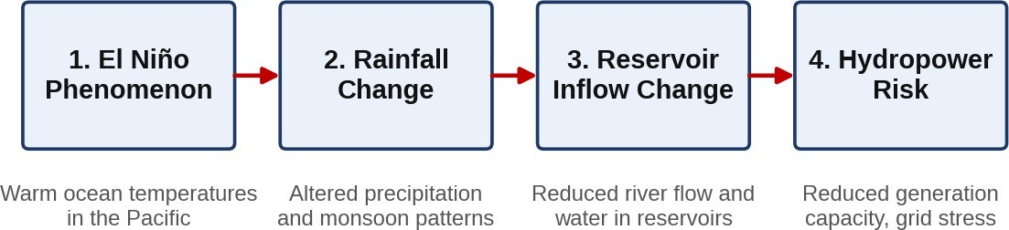
Fig. 1: Chain reaction from El Niño to hydropower risk
ENSO has three phases: El Niño (the warm phase), La Niña (the cool phase) and a neutral state in between. The phase is monitored with climate indices. The Oceanic Niño Index (ONI) is a three-month running mean of sea-surface temperature anomalies in the Niño 3.4 region of the equatorial Pacific; values of +0.5 °C or above are associated with El Niño and values of −0.5 °C or below with La Niña [5]. The Southern Oscillation Index (SOI) describes the atmospheric side of the same phenomenon through the normalised difference in sea-level pressure between Tahiti and Darwin, and it generally moves in the opposite direction to ONI. Both indices are used in this project.
The link between ENSO and the Indian monsoon is not constant over time. Kumar et al. [8] analysed a 140-year record and reported that the inverse relationship between ENSO and the Indian summer monsoon has weakened in recent decades. For this reason, the project does not rely on ENSO indices alone; it combines them with rainfall, reservoir inflow, reservoir storage and seasonal information. In this way, the model can still make use of ENSO information when it is helpful, while relying on local hydrological conditions when the ENSO signal is weak.

1.2 Study Area
The case study is the Krishnarajasagara (KRS) reservoir in Karnataka, India, which lies in the Cauvery river basin. As described in the project dashboard, KRS has an installed dam capacity of 4.8 MW and primarily regulates water for regional irrigation and municipal drinking supplies. The observation period used in the project is 2011–2020.
KRS also acts as the primary master control reservoir for the entire Cauvery basin: its discharge directly dictates head and power generation across the major downstream cascade hydroelectric stations, namely Shivanasamudra (96 MW), Shimsha (17.2 MW) and Mettur Dam (200 MW). A change in the water entering KRS therefore does not remain a local matter; it is passed on to every station that depends on the water released from it. This combination of a single, well-defined reservoir with a clear downstream chain of power stations makes KRS a suitable case study for linking climate information to hydropower risk.

1.3 Problem Statement
Reservoir inflow is difficult to predict because it depends on several interacting factors: El Niño conditions, rainfall, previous reservoir inflow, reservoir storage and seasonal variations. El Niño conditions describe the large-scale climate state that can shift monsoon behaviour. Rainfall is the direct source of water in the catchment. Previous reservoir inflow carries the memory of the catchment, because wet or dry spells tend to persist from one month to the next. Reservoir storage shows how much water is already held, and seasonal variation captures the strong yearly monsoon cycle. None of these factors is sufficient on its own, and their combined effect is non-linear.
The problem addressed by this project is therefore: How can historical ENSO, rainfall and KRS reservoir data be used to predict the next-month KRS reservoir inflow deficit percentage?

1.4 Motivation
Reservoir water availability is strongly influenced by rainfall and climate conditions, and El Niño can affect monsoon and rainfall patterns. Lower rainfall can result in lower reservoir inflow, and lower reservoir inflow may indicate an increased risk to future hydropower water availability. At the same time, the relationships between these quantities are not simple straight-line relationships, which is where Machine Learning can help: it can identify relationships between climate and reservoir conditions directly from historical data.
The motivation is to use historical climate and reservoir data to estimate the next-month inflow deficit and provide an easy-to-understand hydropower-risk indicator. A forecast that is available one month ahead and is expressed as a single percentage and a risk level is far easier for a reservoir or power-system operator to use than a raw time series of climate indices.

1.5 Proposed Solution
The proposed solution, named HydroPulse-SVR, is a Support Vector Regression (SVR) based Machine Learning model that predicts the next-month KRS inflow deficit and presents the result through an interactive Streamlit dashboard. ENSO, rainfall and reservoir data are cleaned, converted to a common monthly basis, merged and turned into 11 input features. The features are standardised and passed to an SVR model with a radial basis function (RBF) kernel, whose output is converted into a hydropower-risk indicator.
The predicted inflow deficit is used as a proxy indicator of downstream hydropower generation risk. The system does not predict generation (MWh/GWh) directly; this is listed as future scope in Section 9.2.

1.6 Scope of the Project
The scope of the present work is intentionally focused. It covers one reservoir (KRS), a ten-year observation period (2011–2020), a monthly time step and a one-month-ahead forecast horizon. The target variable is the inflow deficit percentage, and the hydropower-risk indicator is derived from it. Actual generation data, other reservoirs and longer forecast horizons are outside the present scope and are discussed as limitations and future work.

1.7 Organisation of the Report
Chapter 2 states the aim and objectives. Chapter 3 reviews related literature and identifies the research gap. Chapter 4 discusses the social impact of reservoir inflow deficits. Chapter 5 describes the system design, including the data, features, the Support Vector Regression technique, the evaluation metrics, the risk indicator and the dashboard. Chapter 6 presents the project flow chart, and Chapter 7 explains the implementation. Chapter 8 reports the results and analysis, Chapter 9 gives the conclusion and future scope, and Chapter 10 lists the references.

2. Aim & Objective

2.1 Aim
To develop HydroPulse-SVR, a Support Vector Regression based system that predicts the next-month KRS reservoir inflow deficit from El Niño and hydrological information, and presents it as a hydropower-risk indicator through an interactive dashboard.

2.2 Primary Objective
To develop a Support Vector Regression model for predicting next-month KRS reservoir inflow deficit using El Niño and hydrological information.

2.3 Specific Objectives
To achieve the primary objective, the work is divided into the following specific objectives:
- Combine ENSO, rainfall and KRS reservoir data, so that climate and local hydrological information are available in a single dataset.
- Convert the data into a consistent monthly dataset, because the three data groups are not published at the same time resolution.
- Create climate, hydrological and seasonal features, including lagged ENSO values, previous inflow and a cyclic encoding of the calendar month.
- Train and evaluate an SVR-RBF model using a chronological split and time-series cross-validation.
- Compare SVR with other Machine Learning baseline models (Linear Regression, Ridge Regression, Random Forest and a Persistence baseline).
- Develop an interactive Streamlit dashboard for visualisation and prediction.
- Represent the predicted inflow deficit as a hydropower-risk indicator that can be understood without Machine Learning knowledge.

2.4 Expected Outcomes
The expected outcome of the project is a working prediction pipeline and dashboard for KRS, together with an honest assessment of how well the model performs on months it has not seen. The project also aims to show whether a relatively simple model such as SVR can outperform standard baselines on a small monthly dataset, and to document the limits of the approach so that it is used only as a decision-support indicator.

3. Literature Survey

3.1 Review of Related Work
Recent studies related to ENSO, hydropower and machine-learning-based forecasting are reviewed in this section. Four studies were selected because each of them addresses one important part of the problem: streamflow forecasting for hydropower basins, the impact of ENSO on hydropower, climate-based hydropower prediction with Support Vector Regression, and improved SVR variants for streamflow forecasting. Each study is discussed below in terms of its objective, the data and parameters used, the method, the main findings, the research gap with respect to this project, and what HydroPulse-SVR implements to address that gap. A summary is given in Table 1, which also lists the parameters used in each study.

3.1.1 Machine learning-based streamflow forecasting in Colombian hydropower basins [1]
Pulgarín-Morales and Schwenzer (Hydrology Research, 2026) studied machine-learning-based forecasting of streamflow in Colombian hydropower basins at daily and monthly scales. The motivation is that streamflow determines the water that reaches hydropower reservoirs, so a reliable forecast supports reservoir operation and generation planning. The two time scales are complementary: daily forecasts support short-term operation, whereas monthly forecasts are useful for planning and for assessing seasonal water availability.
The study works with hydrological (streamflow) information from hydropower basins and applies machine-learning models to forecast it. It reports good forecasting performance when hydrological data are used. The practical message for this project is that machine learning is a suitable tool for hydropower inflow forecasting and that a monthly time step is meaningful for planning.
As reviewed for this project, the study concentrates on streamflow forecasting and does not use climate indicators such as ENSO as inputs, and it does not convert the forecast into a risk indicator. HydroPulse-SVR addresses this by combining ENSO indices, rainfall and reservoir data, and by predicting the next-month inflow deficit, which is expressed relative to the normal inflow of each calendar month and can therefore be turned directly into a risk level.

3.1.2 ENSO effects on hydropower and climate adaptation strategies [2]
Pulgarín-Morales and Krueger (Journal of Hydrology: Regional Studies, 2025) examined how ENSO affects hydropower and which adaptation strategies are used, through four Colombian case studies located in the upper and middle Magdalena basins and the Sinú basin. The work combines hydrological and electricity-related information with stakeholder interviews. It found that the middle Magdalena region is the most vulnerable to climatic variability, followed by the upper Magdalena and then the Sinú, and that power companies make use of ENSO-related hydrological variability when managing generation. The adaptation measures identified are mainly operational and technical, with limited involvement of local communities.
The impact of ENSO on generation is quantified in this study as a reduction of 25–50% in generation during El Niño years [2], which shows the scale of the problem that motivates the present project. The study is an impact and adaptation analysis, however, and it does not provide a predictive machine-learning model. It therefore tells operators that ENSO matters, but it does not give them a forecast for the coming month. HydroPulse-SVR builds an SVR model to predict the inflow deficit and provides an early risk indicator through a dashboard, which is the predictive step that this study leaves open.

3.1.3 Estimation of hydroelectric power generation and analysis of climate factors [3]
Çakıcı (Gazi University, 2024) forecast hydroelectric power generation and analysed the influence of climate factors using deep-learning and machine-learning methods, with the Süreyyabey hydroelectric power plant in Yozgat Province, Turkey as the case study. Monthly climate and generation records for the period 2007–2021 were used, with climate data from the regional meteorology directorate and two input sets of 11 and 12 climate parameters. Three approaches were compared: Long Short-Term Memory (LSTM) networks, Support Vector Regression (SVR) and a hybrid LSTM–SVR model, with Bayesian optimisation used to tune the hyper-parameters. Performance was measured with the correlation coefficient (R), the root mean square error (RMSE) and the mean absolute error (MAE).
The study reports that SVR gave the lowest error and the shortest training time among the models tested. This is important for the present project because it shows that SVR is competitive on small monthly datasets, which is exactly the situation at KRS (120 months). The limitation relative to this project is that the prediction target is generation and not inflow deficit, the climate inputs come from a local meteorological station rather than from ENSO indices, and the work provides neither an interactive dashboard nor a risk analysis. HydroPulse-SVR uses SVR for inflow deficit prediction and adds a Streamlit dashboard with risk analysis.

3.1.4 Enhanced machine-learning model via twin support vector regression [4]
Fu et al. (Energy Reports, 2023) developed an enhanced machine-learning model based on Twin Support Vector Regression (TSVR) for streamflow time-series forecasting of a hydropower reservoir. In a twin formulation, two smaller optimisation problems are solved to obtain a lower and an upper bound function instead of one large problem, which can improve training speed and flexibility. The study reports improved forecasting accuracy for the reservoir streamflow series.
The contribution of this work is mainly methodological: it improves the SVR algorithm itself. It is not designed around ENSO teleconnection information, a deficit-based risk indicator or an interactive decision-support dashboard. For this project, a standard SVR with an RBF kernel is chosen instead, because it is simpler, available in a standard library [10], and effective for the small dataset used. The emphasis of HydroPulse-SVR is on the application: combining ENSO, rainfall and KRS reservoir data to predict the inflow deficit and present it as a risk indicator.
Table 1 on the next page summarises these four studies. It lists, for each study, the parameters used, the key findings, the research gap, and what this project implements. The last row shows the parameters of the present work for direct comparison.
Table 1: Literature review and research gap

Sr. No. | Study (authors, venue, year) | Parameters / data and methods used | Key findings / contributions | Research gap | What we are implementing
1 | Machine learning-based streamflow forecasting in Colombian hydropower basins at daily and monthly scales  L. Pulgarín-Morales and J. Schwenzer, Hydrology Research, 2026 [1] | Hydrological (streamflow) data of hydropower basins; machine-learning models; daily and monthly time scales. | Used ML models for daily/monthly streamflow forecasting in hydropower basins; showed good performance with hydrological data. | Focused only on streamflow forecasting; did not include climate indicators such as ENSO. | Combine ENSO, rainfall and reservoir data; predict next-month inflow deficit using SVR.
2 | ENSO effects on hydropower and climate adaptation strategies in four Colombian case studies  L. Pulgarín-Morales and T. Krueger, Journal of Hydrology: Regional Studies, 2025 [2] | ENSO events; hydrological and electricity-related information; stakeholder interviews; four case studies (upper and middle Magdalena, Sinú). | Quantified ENSO impacts: 25–50% generation drop in El Niño years; middle Magdalena most vulnerable; adaptation mainly operational. | Did not provide a predictive ML model; focused on impact analysis, not forecasting. | Build an SVR model to predict inflow deficit; provide an early risk indicator through a dashboard.
3 | Estimation of hydroelectric power generation forecasting and analysis of climate factors with deep learning methods  F. N. Çakıcı, Gazi University, 2024 [3] | 11 and 12 climate parameters; monthly data 2007–2021 (Yozgat, Turkey); LSTM, SVR and hybrid LSTM–SVR; Bayesian optimisation; metrics R, RMSE, MAE. | Showed the influence of climate factors on generation; SVR gave the lowest error and shortest training time. | Prediction was for generation (not inflow deficit); local station climate inputs; no interactive dashboard or risk analysis. | Use SVR for inflow deficit prediction; add a Streamlit dashboard with risk analysis.
4 | Enhanced ML model via twin support vector regression for streamflow time-series forecasting of hydropower reservoir  X. Fu et al., Energy Reports, 2023 [4] | Reservoir streamflow time series; Twin Support Vector Regression (TSVR) with two bound functions. | Developed an enhanced TSVR-based model; improved accuracy for streamflow time-series forecasting. | Methodological focus on the algorithm; not built around ENSO information, a deficit-based risk indicator or a dashboard. | Use standard SVR with RBF kernel (simpler and effective for our data); apply to KRS inflow deficit with ENSO, rainfall and reservoir data.
5 | Present work: HydroPulse-SVR (KRS reservoir, Karnataka, India) | 11 inputs: ONI, SOI, ONI lag-2, ONI lag-3, rainfall, current and previous inflow, storage, month (sine and cosine), current deficit; monthly data 2011–2020; SVR-RBF; RMSE, MAE, R². | Test RMSE 60.17, MAE 43.94 percentage points and R² 0.402 (Jan 2018–Nov 2020); SVR better than all baselines. | Addresses the gaps of rows 1–4 in a single pipeline. | Next-month inflow deficit prediction, five-level hydropower-risk indicator and six-page Streamlit dashboard.

3.2 Supporting Literature

3.2.1 ENSO and the Indian monsoon [8]
Kumar, Rajagopalan and Cane (Science, 1999) examined the historical record of about 140 years and found that the inverse relationship between ENSO and the Indian summer monsoon has weakened in recent decades. In simple terms, an El Niño year was once a reliable warning of a weak monsoon, but this statistical link has become less dependable. This finding supports the design choice of using ENSO lag features together with local rainfall and reservoir variables rather than ENSO alone. If the ENSO signal is weaker in some years, the local variables (rainfall, previous inflow and storage) can still carry the information needed for the next-month forecast.

3.2.2 Support Vector Regression [9]
Smola and Schölkopf (Statistics and Computing, 2004) give a tutorial overview of support vector machines for function estimation, including the ε-insensitive loss function on which SVR is based. In this formulation, errors smaller than ε are ignored, and the function is kept as flat as possible, which gives good generalisation on small datasets. The tutorial also explains how kernel functions allow non-linear relationships to be learned through a linear method in a higher-dimensional feature space. This project applies SVR with a radial basis function (RBF) kernel; the technique is explained in detail in Section 5.5.

3.2.3 Implementation library [10]
The scikit-learn library of Pedregosa et al. (Journal of Machine Learning Research, 2011) provides the standard Python implementations of SVR, feature scaling, time-series cross-validation and hyper-parameter search that are used in the project. Using a widely tested library makes the results easy to reproduce and compare.

3.2.4 Data sources [5]–[7]
Three public sources supply the data. The NOAA Climate Prediction Center and ENSOcast provide the ENSO indices ONI and SOI [5]. The World Bank Climate Change Knowledge Portal provides monthly rainfall derived from the ERA5 reanalysis [6]. The India Water Resources Information System (India-WRIS) provides reservoir inflow and storage for the KRS gauge [7]. Their use and importance are discussed in Section 5.2.

3.3 Research Gap Summary
The review shows that existing work either (i) forecasts streamflow without climate indicators, (ii) analyses ENSO impacts without a predictive model, (iii) forecasts generation without an inflow-deficit risk indicator or an interactive dashboard, or (iv) improves SVR variants without applying them to an ENSO–reservoir problem with a decision-support output.
Table 1 also shows that the parameters used differ strongly between studies: some use only hydrological series, some use climate parameters of a local meteorological station, and some use no predictive parameters at all. None of them combines ENSO indices (including lagged ONI), catchment rainfall, current and previous reservoir inflow, reservoir storage and seasonal terms as inputs for the next-month inflow deficit. HydroPulse-SVR addresses this by combining ENSO, rainfall and KRS reservoir data in a single SVR-based pipeline, converting the prediction into a hydropower-risk indicator, and delivering it through an interactive dashboard.

4. Social Impact/Effect of Problem
Reservoir inflow deficits are not only a technical problem; they spread through water, energy and livelihood systems that depend on the same reservoir. This chapter discusses how a shortfall in KRS inflow affects drinking water and irrigation, hydropower generation, the downstream cascade of power stations, and the people who depend on them.

4.1 Water Availability
KRS regulates water for regional irrigation and municipal drinking supplies. A deficit in inflow reduces the water that can be stored and later released for these uses. Farmers depend on timely releases for crops, and towns depend on the reservoir for drinking water, so a shortage affects both livelihoods and basic needs. In the project dashboard, the suggested action under a critical deficit is to prioritise drinking water supply, which reflects the order of importance that operators must follow when water is scarce.

4.2 Hydropower Generation and Grid Stability
Reduced inflow constrains reservoir storage and downstream discharge, which can lead to reduced generation capacity, power shortages and grid instability. Pulgarín-Morales and Krueger [2] reported a 25–50% drop in generation in El Niño years, which shows the scale of the impact that ENSO can have on hydropower. Hydropower is often used to follow changes in electricity demand, so when water is short the grid loses a flexible source of supply at the moment it may be needed most.

4.3 Downstream Cascade Impact
Inflows entering KRS dictate the discharge released downstream to the cascade power plants listed in the dashboard: Shivanasamudra (96 MW), Shimsha (17.2 MW) and Mettur Dam (200 MW). A large inflow deficit therefore implies reduced tailrace discharge and potential generation curtailment across the cascade. Because the stations are connected through the same flow of water, the effect of a single shortage is multiplied along the river.

4.4 Value of an Early Indicator
A next-month deficit estimate gives reservoir and power operators advance notice to plan releases and generation. For a critical deficit, the dashboard's decision-support text recommends prioritising drinking water supply and throttling non-peaking hydroelectric generation. Even a modest amount of advance warning allows these decisions to be taken calmly and in good time instead of as an emergency response.

4.5 Responsible Use
Because ENSO-driven variability makes inflow uncertain and the current model accuracy is modest (Chapter 8), the predicted deficit should be treated as a decision-support indicator alongside operational data and expert judgement, not as the sole basis for decisions. Decisions about water allocation affect many people, and an automated estimate should never replace the judgement of the responsible engineers.

5. System Design

5.1 System Overview
HydroPulse-SVR is organised in four layers, shown in Fig. 2: data sources, data processing, modelling, and presentation. ENSO, rainfall and KRS reservoir data are cleaned, converted to a common monthly basis, merged and converted into features. The features are standardised and passed to an SVR-RBF model, whose output (next-month inflow deficit) is converted into a hydropower-risk indicator and displayed in the Streamlit dashboard.
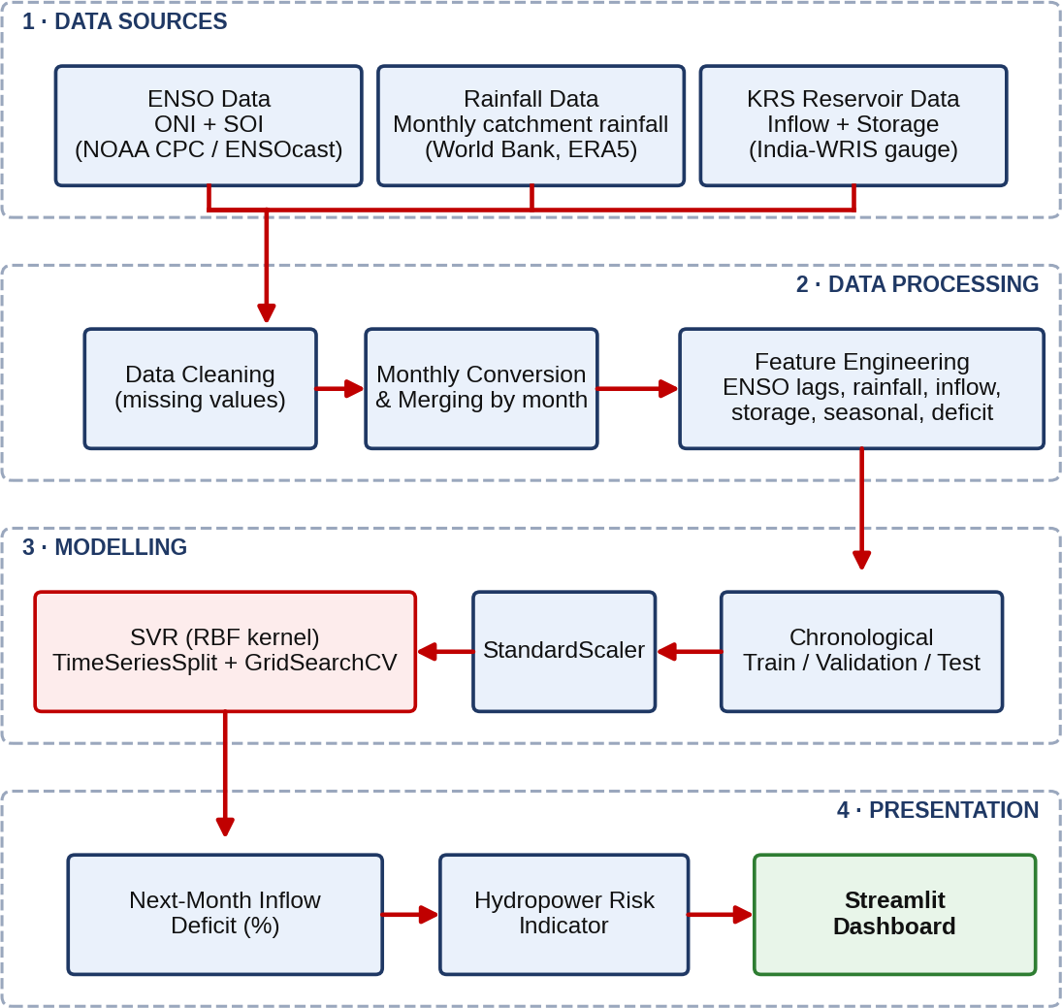
Fig. 2: System architecture of HydroPulse-SVR
The first layer holds the three data sources. The second layer performs data cleaning (handling of missing values), monthly conversion and merging by month, and feature engineering. The third layer splits the data chronologically, standardises the features, and trains and tunes the SVR-RBF model using time-series cross-validation. The fourth layer converts the predicted next-month deficit into a risk indicator and presents it through the dashboard. Keeping the layers separate makes it easy to replace one part, for example the model, without changing the others.

5.2 Data Sources and Parameters

5.2.1 Data sources
Three groups of data are used: ENSO data, rainfall data and KRS reservoir data. The variables and their sources are listed in Table 2.
Table 2: Data used in the project
Sr. No. | Data group | Variables | Source
1 | ENSO data | Oceanic Niño Index (ONI), Southern Oscillation Index (SOI) | NOAA Climate Prediction Center / ENSOcast [5]
2 | Rainfall data | Monthly catchment rainfall (mm) | World Bank (ERA5 monthly rainfall) [6]
3 | KRS reservoir data | Reservoir inflow (MCM) and storage (% of FRL) | India Water Resources Information System (KRS gauge) [7]
The ENSO indices describe the state of the climate system and are supplied at monthly resolution. The rainfall series is catchment rainfall derived from ERA5 reanalysis, a globally consistent climate dataset, and is available as monthly totals. The reservoir data come from the KRS gauge of India-WRIS and give the inflow in million cubic metres (MCM) and the storage as a percentage of the full reservoir level (FRL). The reservoir data are converted to a monthly basis so that all sources share the same time step.

5.2.2 Parameters used
From these data, the project uses 11 input parameters and one target parameter. Their names, units, time resolution, source and role are given in Table 3. All parameters are on a monthly time step. The unit MCM stands for million cubic metres, and FRL stands for full reservoir level.
Table 3: Parameters used in the project
Sr. No. | Parameter | Unit | Time step | Source | Role
1 | Oceanic Niño Index (ONI) | °C | Monthly | NOAA CPC / ENSOcast | Input
2 | Southern Oscillation Index (SOI) | Index value | Monthly | NOAA CPC / ENSOcast | Input
3 | ONI lag-2 (value two months earlier) | °C | Monthly | Derived from ONI | Input
4 | ONI lag-3 (value three months earlier) | °C | Monthly | Derived from ONI | Input
5 | Catchment rainfall | mm | Monthly | World Bank (ERA5) | Input
6 | Reservoir inflow (current month) | MCM | Monthly | India-WRIS | Input
7 | Reservoir inflow lag-1 (previous month) | MCM | Monthly | Derived from inflow | Input
8 | Reservoir storage | % of FRL | Monthly | India-WRIS | Input
9 | Seasonal term: sine of calendar month | Unitless | Monthly | Derived from date | Input
10 | Seasonal term: cosine of calendar month | Unitless | Monthly | Derived from date | Input
11 | Current inflow deficit D(t) | % | Monthly | Derived from inflow | Input
12 | Next-month inflow deficit D(t+1) | % | Monthly | Derived from inflow | Target
The parameters can be grouped as follows. The climate group contains ONI, SOI and the two lagged values of ONI; the lags allow the model to use the fact that ocean conditions can influence rainfall with a delay of some months. The hydrological group contains catchment rainfall, current and previous inflow, and storage. The seasonal group contains the sine and cosine of the calendar month, which describe the position within the year without creating an artificial jump between December and January. The last input is the current inflow deficit, which tells the model how the reservoir stands at present. The target is the inflow deficit one month ahead.

5.2.3 Importance of the data sources and parameters
The quality and relevance of the data decide how much a model can learn, so each data group has a clear purpose. ENSO data are important because they are the climate signal that motivates the project; they give early information about conditions in the Pacific that may later change monsoon rainfall. Because the effect of ENSO is delayed, the lagged ONI values are included instead of only the current value.
Rainfall data are important because rainfall is the direct source of water in the catchment and links the large-scale climate signal to what actually happens locally. Reservoir inflow and storage are important because they describe the real state of the system. Previous inflow shows how persistent wet or dry conditions are, and storage shows how much buffer the reservoir has. The seasonal terms are important because inflow in the Cauvery basin follows a strong yearly pattern, and the model must separate a normal seasonal low from an unusual deficit.
Using all three data groups together is the central idea of the project. As discussed in Section 3.2, the relationship between ENSO and the Indian monsoon is not constant, so ENSO alone would be unreliable. Local rainfall and reservoir data make the model robust when the ENSO signal is weak. Finally, converting all data to the same monthly time step and merging them by month is important, because inputs measured at different time steps cannot be used together in a regression model. Reliable, public and well-documented sources also make the work reproducible.

5.3 Dataset Summary

5.3.1 Dataset summary
The data cover the period 2011–2020, which is 120 months. Because lagged inputs and a next-month target are needed, four months cannot be used as complete samples (the first months, for which the three-month lag is not available, and the last month, for which no next-month target exists), which leaves 116 usable samples for the Machine Learning model. The dataset is summarised in Table 4.
Table 4: Dataset summary
Sr. No. | Item | Value
1 | Period | 2011–2020
2 | Total months | 120
3 | Usable ML samples | 116
4 | Training samples | 57
5 | Validation samples | 24
6 | Testing samples | 35
7 | Number of input parameters | 11
8 | Target parameter | Next-month inflow deficit (%)

5.3.2 Training, validation and testing split
The usable samples were split chronologically into training, validation and test sets, so that the model is always tested on later months than it was trained on. The split in numbers and percentages is given in Table 5. Of the 116 usable samples, 57 (49.1%) are used for training, 24 (20.7%) for validation and 35 (30.2%) for testing; the percentages add up to 100%. The training and validation samples together form the 81 pre-test samples (69.8% of the data) used to tune and fit the final model, and the 35 test samples (30.2%) are kept aside and used only to report the final performance.
Table 5: Training, validation and testing split
Sr. No. | Subset | Samples | Percentage of 116 samples | Period (by input month) | Purpose
1 | Training | 57 | 49.1% | Apr 2011 – Dec 2015 | Learning and hyper-parameter tuning
2 | Validation | 24 | 20.7% | Jan 2016 – Dec 2017 | Model selection
3 | Testing | 35 | 30.2% | Jan 2018 – Nov 2020 | Final evaluation on unseen months
 | Total | 116 | 100% | Apr 2011 – Nov 2020
The periods in Table 5 follow from the chronological order and the number of samples in each subset. The test months of January 2018 to November 2020 are stated in the project results; the other two periods are obtained by counting backwards from them.

5.3.3 Importance of the dataset and the split
The size and structure of the dataset strongly influence how far the results can be trusted. A monthly dataset of 120 months is small by Machine Learning standards, which is one of the reasons why a model such as SVR, which works well with limited data, was chosen, and why the results are interpreted with caution in Chapter 8.
The chronological split is important because the data form a time series. If the months were shuffled randomly, the model could be trained on months that lie after some of the months used for testing; it would then in effect learn from the future, and the reported accuracy would look better than it really is. By testing only on later months, the evaluation imitates real use, in which the model predicts a month that has not yet happened. The separate validation set is important because model choices such as hyper-parameters must not be made on the test set; otherwise the test result would no longer be an independent measurement. Finally, the test period of 2018–2020 contains the most recent years and a mixture of ENSO conditions, so it gives a realistic, although limited, picture of performance.

5.4 Feature Engineering and Target
The 11 model inputs have been listed in Table 3. Only ONI has explicit ENSO lags (lag-2 and lag-3). The rainfall input is the catchment rainfall of the month, reservoir inflow is used both for the current and for the previous month, reservoir storage is taken as it is, the seasonal information is encoded by the sine and cosine of the calendar month, and the current inflow deficit is included so that the model knows the present state of the reservoir. The seasonal terms for a month number m are:
sin(2πm/12) and cos(2πm/12) (1)
The target is the next-month deficit. For month t, the deficit is defined as the percentage by which the inflow falls below the normal inflow of the same calendar month:
D(t) = 100 × [N(m) − inflow(t)] / N(m) (2)
where N(m) is the mean inflow for calendar month m over 2011–2016. A positive deficit therefore means inflow below normal, and a negative value means a surplus. The target D(t+1) is clipped at the 2nd and 98th percentiles of the full dataset, so that a few extreme months do not dominate the training.

5.5 Support Vector Regression (SVR)
Support Vector Regression is the Machine Learning technique at the centre of HydroPulse-SVR. This section explains the idea of SVR, its mathematical formulation, the role of kernels and hyper-parameters, and the reasons why it was selected for this problem.

5.5.1 Concept and intuition
Support Vector Regression is the regression version of the Support Vector Machine (SVM), originally developed for classification. In ordinary linear regression, the line is chosen to minimise the squared error over all points, so every point, including noisy ones, influences the result. SVR takes a different view. It fits a function and surrounds it by a tube of width ε (epsilon). Points that lie inside the tube are considered to be predicted well enough and cause no penalty at all. Only points outside the tube are penalised, and only by the distance by which they lie outside it [9]. At the same time, SVR keeps the function as flat (smooth) as possible, which prevents it from following noise. Fig. 3 illustrates this idea.
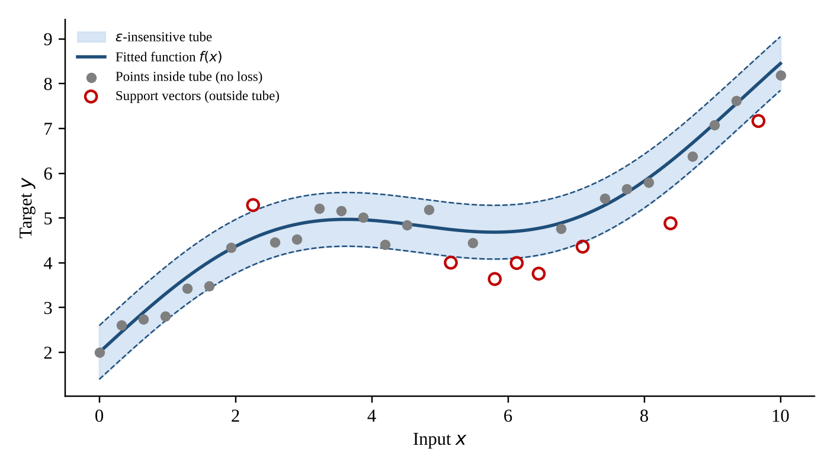
Fig. 3: Schematic of SVR: the ε-insensitive tube and support vectors (illustrative data, not project data)
The points that lie on or outside the boundary of the tube are called support vectors. They are the only training points that determine the final function; all points inside the tube could be removed without changing the result. This is why the model is called a support vector method, and it is also one reason why SVR is relatively robust against many ordinary observations that follow the general pattern.

5.5.2 The ε-insensitive loss function
The penalty used by SVR is the ε-insensitive loss. For a prediction error ξ, which is the difference between the actual and predicted value, the loss is zero when the error is within ε and grows linearly beyond it [9]:
|ξ|_{ε} = 0 if |ξ| ≤ ε; |ξ| − ε otherwise
In contrast to the squared loss of least squares regression, this loss grows only linearly outside the tube, which makes SVR less sensitive to occasional large errors. For KRS inflow deficit, where a few extreme months occur during very wet or very dry spells, this is a useful property.

5.5.3 Mathematical formulation
For training samples (x_{i}, y_{i}), i = 1, …, n, where x_{i} is the vector of 11 scaled inputs and y_{i} is the next-month deficit, SVR looks for a function of the form
f(x) = ⟨w, φ(x)⟩ + b (3)
where φ is a mapping of the inputs into a feature space, w is a weight vector and b is a bias term. The weights are found by solving the optimisation problem
minimise ½ ‖w‖² + C Σ_{i=1}^{n} ( ξ_{i} + ξ_{i}* ) (4)
subject to y_{i} − ⟨w, φ(x_{i})⟩ − b ≤ ε + ξ_{i}
⟨w, φ(x_{i})⟩ + b − y_{i} ≤ ε + ξ_{i}*
ξ_{i}, ξ_{i}* ≥ 0
The first term, ½‖w‖², keeps the function flat. The slack variables ξ_{i} and ξ_{i}* measure how far a point lies above or below the tube, and the parameter C decides how strongly such violations are penalised. A small C favours a smooth function that tolerates errors, and a large C forces the function to fit the training points more closely.
The problem is solved in its dual form, using Lagrange multipliers α_{i} and α_{i}* with 0 ≤ α_{i}, α_{i}* ≤ C. The final prediction function is
f(x) = Σ_{i=1}^{n} ( α_{i} − α_{i}* ) K(x_{i}, x) + b (5)
Only support vectors have a non-zero coefficient (α_{i} − α_{i}*), so the prediction depends only on them. The function K is the kernel, which is explained next.

5.5.4 Kernel trick and the RBF kernel
The relationship between climate, rainfall and inflow is non-linear: for example, the same rainfall can produce very different inflow depending on the season and the storage. A straight line cannot describe such behaviour. The kernel trick allows SVR to learn non-linear relationships without computing the mapping φ explicitly. The kernel K(x, x′) gives the inner product of the two points in the feature space and can be understood as a measure of similarity between two input vectors. This project uses the radial basis function (RBF) kernel:
K(x, x′) = exp( −γ ‖x − x′‖² ) (6)
The kernel value is 1 for identical points and decreases towards 0 as the distance between the points grows. The parameter γ (gamma) controls how quickly this happens. A large γ means that only very close points influence each other, which gives a flexible but possibly over-fitted function. A small γ means that distant points also influence each other, which gives a smoother function. In scikit-learn the setting gamma = scale sets γ from the number of features and the variance of the data [10].

5.5.5 Hyper-parameters of SVR
The behaviour of the model is controlled by three hyper-parameters, summarised in Table 6. They are not learned from the data directly; they are chosen by searching over a grid of values with cross-validation (Section 5.6).
The three hyper-parameters interact with each other and cannot be judged separately. For example, a large C together with a large γ allows the function to follow every small fluctuation of the training data and therefore tends to over-fit, whereas a small C together with a small γ produces a very smooth function that may miss real seasonal changes. The value of ε sets how precisely the function must follow the data: a wider tube ignores more of the month-to-month noise in the inflow deficit but also reduces the sensitivity of the model. For this reason, the combinations are compared using time-ordered validation and not by their training error, and the best combination is the one that predicts later months well.
Table 6: Effect of the SVR-RBF hyper-parameters
Sr. No. | Hyper-parameter | Meaning | Small value | Large value
1 | C | Penalty for points outside the tube | Smooth function, more errors tolerated, risk of under-fitting | Close fit to training data, risk of over-fitting
2 | ε (epsilon) | Half-width of the tube in which errors are ignored | Narrow tube, more support vectors, finer fit | Wide tube, fewer support vectors, coarser fit
3 | γ (gamma) | Reach of a single training point in the RBF kernel | Smooth, wide influence, risk of under-fitting | Very local influence, risk of over-fitting

5.5.6 Why SVR was chosen for this project
Several reasons support the choice of SVR. First, the dataset is small (116 samples), and SVR is known to perform well on small and medium datasets because it controls model complexity through the flatness term and the parameter C. Second, the relationship between the inputs and the inflow deficit is non-linear, and the RBF kernel can represent it. Third, the ε-insensitive loss reduces the influence of small errors and makes the model less sensitive to noise in the observations. Fourth, SVR is simple to train and tune with standard tools [10]. Fifth, the literature reviewed in Chapter 3 shows that SVR performs competitively in hydropower-related forecasting [3].

5.5.7 Limitations of SVR
SVR also has limitations that must be kept in mind. It needs the inputs to be scaled, because the RBF kernel is based on distances, and features with large numerical values would otherwise dominate. Its performance depends on the choice of C, ε and γ, which makes careful tuning necessary. It gives a single prediction and no direct measure of uncertainty. Finally, a kernel SVR is less easy to interpret than a linear model, because the contribution of each input to the prediction is not directly visible. These limits are one more reason why the output is used as a decision-support indicator.

5.6 Model Design
Feature scaling. Because SVR with an RBF kernel uses distances, the inputs are standardised with StandardScaler. The scaler is fitted on the 81 pre-test rows (training and validation) and then applied to the 57-row tuning subset and the held-out test set. Each value x is transformed to
z = (x − μ) / σ (7)
where μ is the mean and σ the standard deviation of the feature.
Hyper-parameter tuning. GridSearchCV is used with a four-fold TimeSeriesSplit with a one-month gap on the 57 tuning rows. The TimeSeriesSplit always trains on earlier months and validates on later months, and the gap avoids direct overlap between the two. The search covers 4 values of C, 6 values of γ and 4 values of ε, i.e. 96 combinations, shown in Table 7. The final SVR and baseline models are then fitted on the 81 pre-test rows.
Table 7: SVR-RBF configuration and search values
Sr. No. | Parameter | Meaning | Search values
1 | Kernel | Similarity function | RBF
2 | C | Regularisation strength | 10, 50, 100, 200
3 | γ (gamma) | RBF kernel width | 0.005, 0.01, 0.02, 0.05, 0.1, scale
4 | ε (epsilon) | Width of the ε-insensitive tube | 0.5, 1, 2, 5
Baseline models. To judge whether SVR is a sensible choice, it is compared with four baselines. Linear Regression fits a straight-line relationship between the inputs and the target. Ridge Regression is a linear model with a penalty on large coefficients, which makes it more stable when inputs are correlated. Random Forest is an ensemble of decision trees that can capture non-linear relationships without scaling. The Persistence baseline simply predicts next month's deficit as the current month's deficit and is the simplest possible forecast; a useful model should do better than it.

5.7 Evaluation Metrics
Model performance on the held-out test set is measured using the following metrics, where y_{i} is the actual value, ŷ_{i} the predicted value, ȳ the mean of the actual values and n the number of test samples. The Root Mean Square Error (RMSE) penalises large errors more strongly, the Mean Absolute Error (MAE) is the average size of the error, and R² shows how much of the variation of the actual values is explained by the model.
RMSE = √[ (1/n) Σ ( y_{i} − ŷ_{i} )² ] (8)
MAE = (1/n) Σ | y_{i} − ŷ_{i} | (9)
R² = 1 − Σ ( y_{i} − ŷ_{i} )² / Σ ( y_{i} − ȳ )² (10)
RMSE and MAE are expressed in percentage points of inflow deficit; lower values are better. An R² of 1 means a perfect prediction, and a value near 0 means that the model is no better than always predicting the mean. The dashboard additionally reports a "Within ±20% band" error tolerance rate, which is the share of test months in which the prediction is within 20 percentage points of the actual deficit.

5.8 Hydropower Risk Indicator
The predicted deficit is converted into a five-level hydropower-risk indicator using the thresholds in Table 8. A negative deficit is a surplus, and larger positive deficits mean a higher risk to downstream water availability.
Table 8: Hydropower risk categories
Sr. No. | Risk category | Predicted deficit range | Meaning
1 | Surplus | Below 0% | Inflow above normal
2 | Low | 0% to below 20% | Close to normal
3 | Moderate | 20% to below 40% | Noticeable deficit
4 | High | 40% to below 60% | Large deficit
5 | Severe | 60% and above | Very large deficit
A predicted deficit of +35.1% therefore maps to Moderate Risk (level 2). Some earlier screenshots in Chapter 7 use the former labels, which are noted in their captions.

5.9 Dashboard Design
The Streamlit dashboard has six pages, selected from the navigation panel, as listed in Table 9.
Table 9: Dashboard pages
Sr. No. | Page | Purpose
1 | Overview | Executive summary with key indicators (ONI, ENSO phase, inflow, storage, inflow deficit, model R²/RMSE), the four-stage causal mechanism, and a historical inflow-deficit versus ONI chart.
2 | ENSO Analysis | Analysis of ENSO indicators.
3 | Reservoir & Rainfall | Reservoir inflow versus catchment rainfall, coloured by ENSO phase, with a hydrological-year filter.
4 | Model Performance | SVR test metrics and actual-versus-predicted next-month inflow deficit.
5 | Deficit Prediction | What-if explorer that returns the predicted deficit, risk level and downstream cascade impact for user-chosen inputs.
6 | Risk Analysis | Hydropower risk analysis based on the predicted deficit.

6. Flow Chart
The end-to-end workflow of the project is shown in Fig. 4. Data from the three sources flow through cleaning, monthly conversion, merging and feature engineering; the data are then split chronologically, standardised and used to train the SVR-RBF model; the model output is converted into a risk indicator and shown in the dashboard.
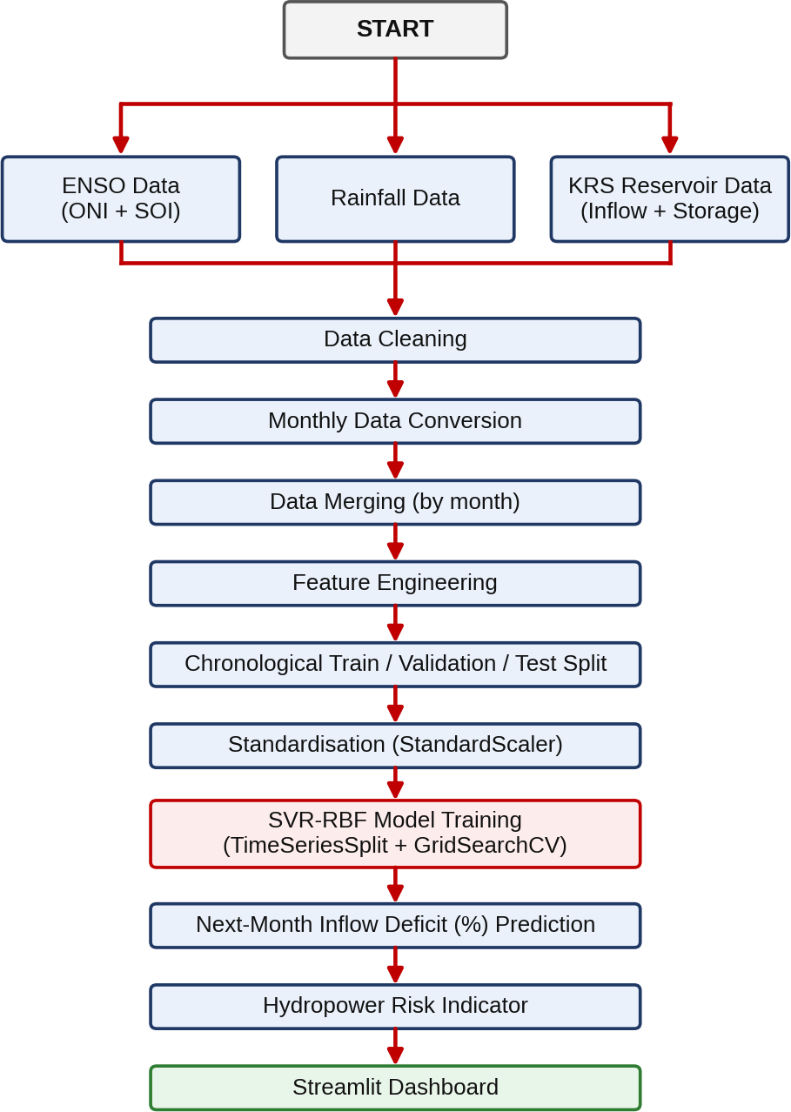
Fig. 4: Project workflow of HydroPulse-SVR
The workflow starts with the collection of three data sources: ENSO data (ONI and SOI), rainfall data and KRS reservoir data (inflow and storage). In the data cleaning step, missing values are handled so that the series are complete. In the monthly data conversion step, all series are brought to the same monthly time step, and in the merging step they are combined into one table by month.
In the feature engineering step, the lagged ENSO values, previous inflow, seasonal terms, current deficit and the next-month target are created. The dataset is then split chronologically into training, validation and test parts (Section 5.3), and the inputs are standardised with StandardScaler. The SVR-RBF model is trained, with its hyper-parameters tuned by GridSearchCV and TimeSeriesSplit.

7. System Implementation

7.1 Technology Stack
The system is implemented in Python. The technologies used for each component are listed in Table 10.
Table 10: Technologies used
Sr. No. | Component | Technology | Purpose
1 | Programming language | Python (dashboard.py) | Data processing, modelling and dashboard code
2 | Machine learning | scikit-learn [10] | SVR, StandardScaler, TimeSeriesSplit, GridSearchCV and baseline models
3 | Dashboard | Streamlit | Interactive web dashboard (runs locally)
4 | Visualisation | Plotly | Interactive charts, scatter plots and gauge indicator

7.2 Implementation Steps
The implementation follows the steps below, which correspond to the flow chart of Chapter 6.
- Data ingestion: gather ENSO/ONI and SOI data, rainfall data, and KRS reservoir inflow and storage data.
- Data preprocessing: clean missing values, convert reservoir data to monthly data, and merge the datasets by month.
- Feature engineering: create ENSO lag features, rainfall, current/previous inflow, storage, seasonal features and the current inflow deficit.
- SVR-RBF model training: tune on 57 chronological training rows using four-fold TimeSeriesSplit (gap = 1). Fit the scaler on all 81 pre-test rows and refit SVR and the learned baselines on these rows before evaluating the 35 test rows.
- Next-month deficit prediction: predict the next-month KRS reservoir inflow deficit percentage.
- Hydropower risk indicator: convert the predicted deficit into an easy-to-understand risk indicator and display the results in the Streamlit dashboard.

7.3 Dashboard Implementation
The dashboard uses a dark-themed analytics console layout with a navigation panel and a case-study profile (reservoir: KRS Dam, Karnataka; river basin: Cauvery Basin, India; observation range: 2011–2020; target: Inflow Deficit t+1 (%); proposed model: SVR with RBF kernel). A status box shows that the SVR model engine is active (trained). The pages are described below.

7.3.1 Overview Page
The earlier Overview capture (Fig. 5) shows ONI −0.90 °C, inflow 305 MCM, storage 89.8% FRL and deficit −24.2%. Its model indicators belong to the previous model version; current saved results are R² 0.402 and RMSE 60.17 percentage points. The page also shows the four-stage climate-to-risk mechanism.
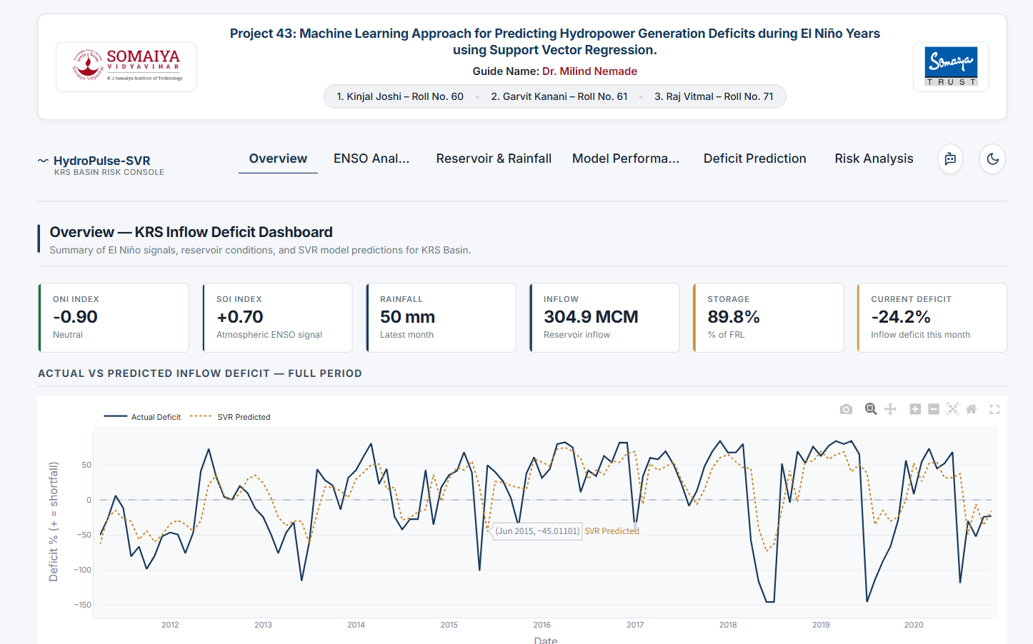
Fig. 5: Overview page
Further down the page, a chart compares the historical inflow deficit (%) with the Oceanic Niño Index (scaled ×30) over the observation period, next to a case-study panel that describes the hydrological setting of KRS and its downstream cascade plants. The data sources are listed in the page footer: NOAA CPC / ENSOcast, India WRIS KRS gauge and World Bank ERA5 monthly rainfall.

7.3.2 ENSO Analysis Page
The ENSO Analysis page explores the climate indices. Fig. 6 shows the monthly ONI timeline, drawn as bars coloured by phase (El Niño above zero, La Niña below zero), with the El Niño and La Niña threshold lines. The strong El Niño of about 2015–2016 is clearly visible.
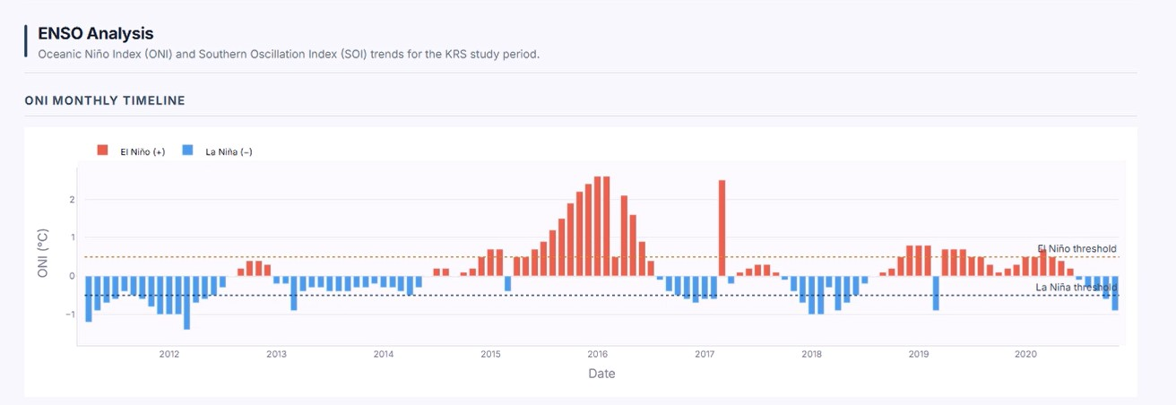
Fig. 6: ENSO Analysis page: monthly ONI timeline

7.3.3 Reservoir & Rainfall Page
This page plots reservoir inflow (MCM) against catchment rainfall (mm), with points coloured by ENSO phase (La Niña, Neutral, El Niño) and a dashed linear trend line, so that the effect of rainfall and ENSO phase on inflow can be inspected visually. A hydrological-year filter allows individual years to be examined.
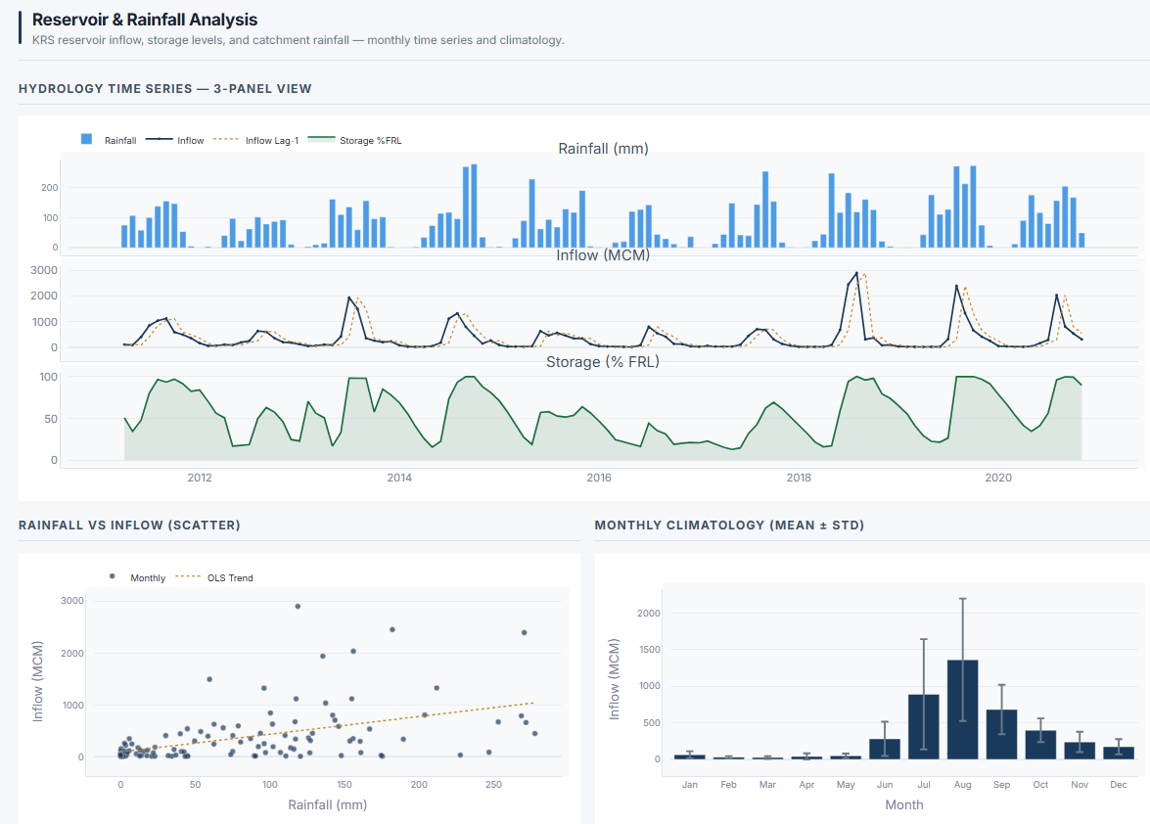
Fig. 7 : Reservoir & Rainfall Analysis

7.3.4 Model Performance Page
The Model Performance page reports held-out results (Jan 2018–Nov 2020): RMSE 60.17, MAE 43.94 percentage points, R² 0.402 and 37.1% within ±20 percentage points. It also plots the actual versus the predicted next-month inflow deficit. The display scope switches between test months and the full observation period.
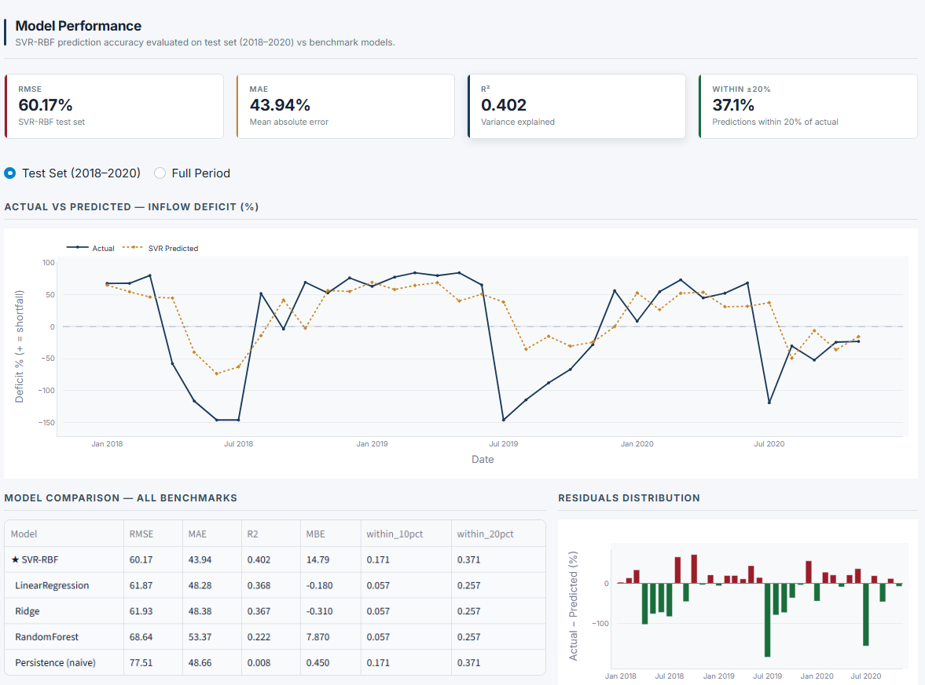
Fig. 8: Model Performance Page

7.3.5 Deficit Prediction Page
The Deficit Prediction page is a what-if explorer. The user sets the ENSO indices (ONI, SOI, ONI lag-2 and lag-3), the hydrological parameters (rainfall, inflow, previous inflow and storage) and the seasonal state (calendar month and current deficit), and the trained SVR-RBF model returns the predicted next-month deficit, the risk level and a gauge. In the capture in Fig. 7, the inputs give a predicted deficit of +12.5%, which falls in the Low risk range. The page also shows downstream context and the scaled feature vector.
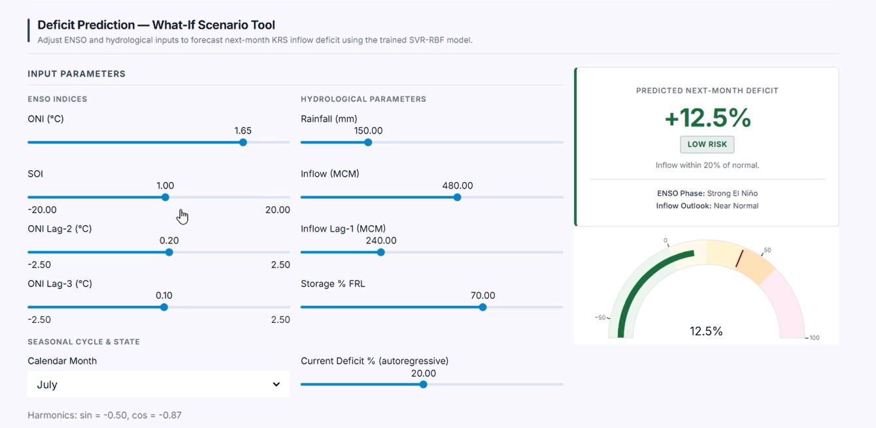
Fig. 8: Deficit Prediction page: what-if scenario tool
An earlier scenario with storage 50.0% FRL gave a predicted deficit of +35.1% and was shown with the former "Critical" label. Under the current thresholds (Section 5.8), +35.1% maps to Moderate Risk (level 2).

7.3.6 Risk Analysis Page
The Risk Analysis page summarises deficit categories and patterns. As shown in Fig. 8, the 116 months fall into 55 months of surplus/low risk (47.4%), 14 months of moderate risk (12.1%), 20 months of high risk (17.2%) and 27 months of severe risk (23.3%). A month-by-year heat map of the deficit shows the seasonal pattern and the years with the largest deficits.
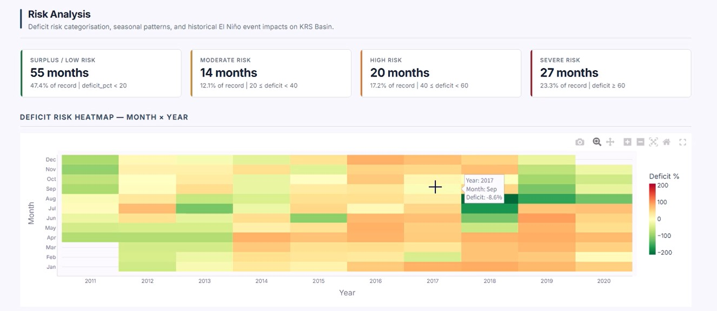
Fig. 9: Risk Analysis page: risk categories and deficit heat map (month × year)
A historical year-wise and month-wise analysis lets the user select a year and see, for each month, the ONI, ENSO phase, rainfall, inflow, storage, actual deficit and SVR prediction, together with the average and maximum predicted deficit and the number of high-risk months (Fig. 10).
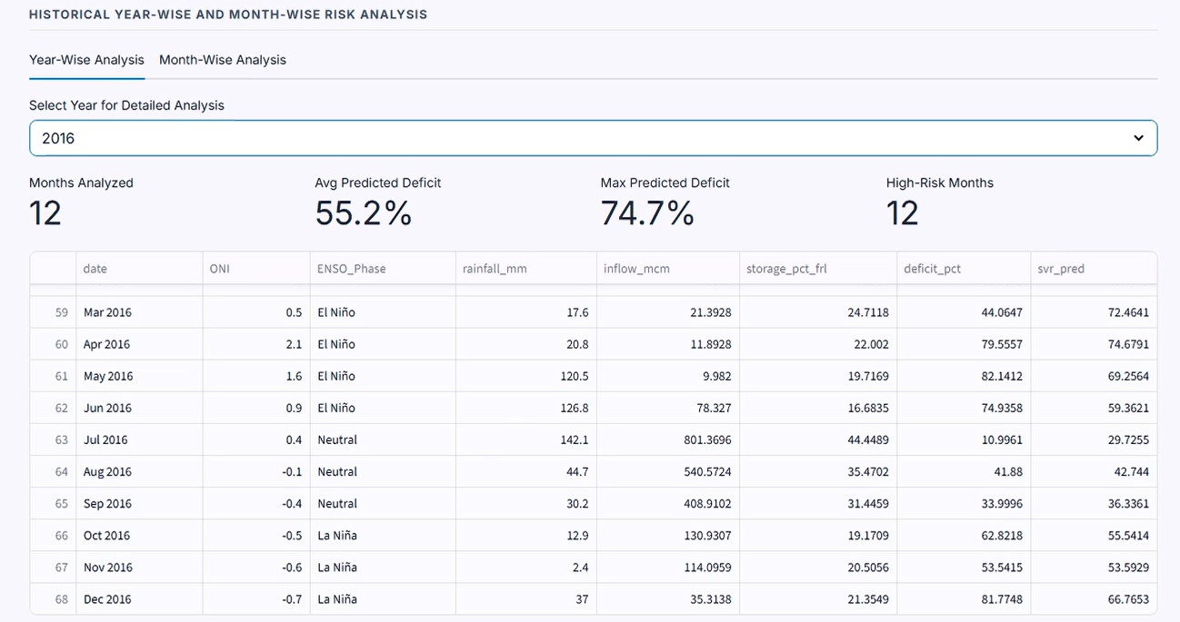
Fig. 10: Year-wise risk analysis
7.3.7 HydroPulse AI Assistant
The HydroPulse Assistant is an intelligent, domain-aware conversational decision-support system embedded within the dashboard interface to bridge the gap between machine learning predictions and actionable water resource governance. Seamlessly integrated with the project's live data engine, the assistant operates over actual Krishna Raja Sagara (KRS) reservoir metrics, multi-source climatological datasets (including ONI and SOI El Niño teleconnections), and the Support Vector Regression (SVR-RBF) forecasting pipeline. Rather than functioning as a static query engine, it dynamically interprets multi-variable hydrological deficit forecasts, contextualizes risk tiers (Normal, Moderate, and Severe Deficit), explains model evaluation metrics (such as RMSE, MAE, and $R^{2}$), and provides comparative historical climate analyses. Designed with an intuitive, responsive slide-out interface supporting multi-turn dialogues in both Light and Dark environments, the assistant empowers dam administrators, hydrologists, and grid planners to interrogate complex predictive indicators in natural language, facilitating timely mitigation strategies against climate-induced hydropower generation shortfalls.
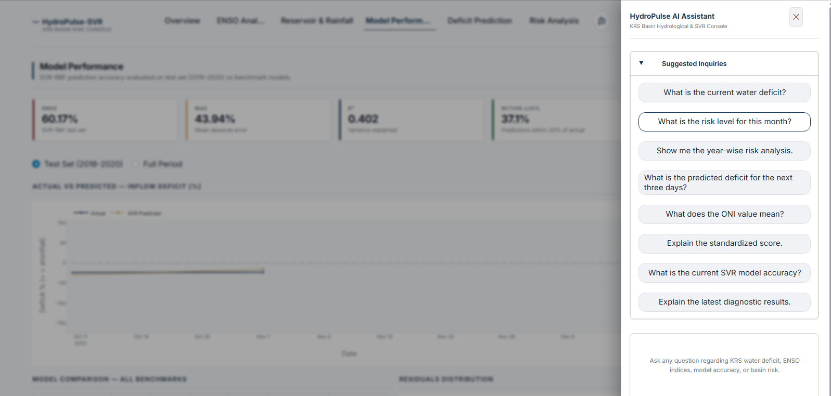
Fig. 10 HydroPulse AI Assistant

8. Results and Analysis

8.1 Experimental Setup
There are 116 usable samples: 57 train, 24 validation and 35 test. Tuning uses 57 rows; final SVR and baseline fitting uses all 81 pre-test rows. Test months are Jan 2018–Nov 2020. Preprocessing caveats are noted in Section 8.4.

8.2 Model Comparison
The SVR-RBF model was compared with Linear Regression, Ridge Regression, Random Forest and a Persistence baseline on the same test set. The results are given in Table 11 and shown graphically in Fig. 10. For RMSE and MAE, lower is better; for R², higher is better.
Table 11: Test-set performance of SVR-RBF and baseline models
Sr. No. | Model | RMSE | MAE | R²
1 | SVR-RBF | 60.17 | 43.94 | 0.402
2 | Linear Regression | 61.87 | 48.28 | 0.368
3 | Ridge Regression | 61.93 | 48.38 | 0.367
4 | Random Forest | 68.64 | 53.37 | 0.222
5 | Persistence | 77.51 | 48.66 | 0.008
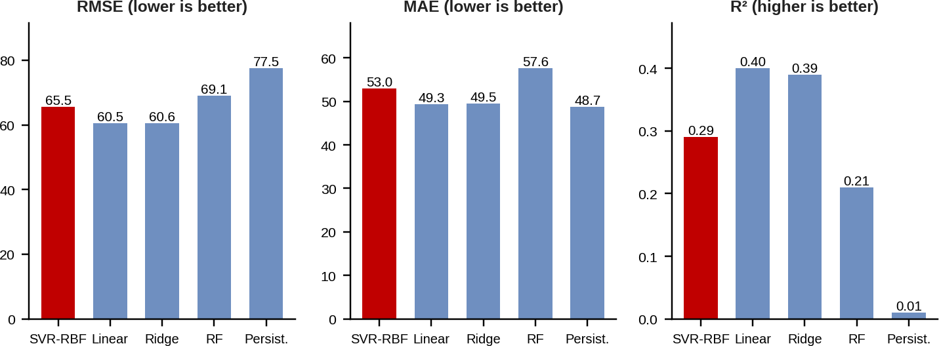
Fig. 10: Comparison of models on RMSE, MAE and R² (RF = Random Forest; SVR-RBF highlighted)

8.3 SVR Test-Set Performance
On the held-out test set (Jan 2018–Nov 2020), SVR-RBF achieves RMSE 60.17 and MAE 43.94 percentage points, with R² 0.402. The share within ±20 percentage points is 37.1%, which corresponds to 13 of the 35 test months, and the model explains about 40.2% of test-set variance.

8.4 Analysis and Discussion
SVR-RBF leads all baselines on RMSE, MAE and R²: 60.17, 43.94 and 0.402. Compared with Linear Regression, its RMSE is lower by about 2.7% and its MAE by about 9.0%; compared with Random Forest, its RMSE is lower by about 12.3%; and compared with Persistence, its RMSE is lower by about 22.4% and its MAE by about 9.7%. The advantage over the linear models is small, which indicates that the non-linear RBF kernel adds some value but that a large part of the variation remains unexplained.
Linear and Ridge Regression are close to each other, with R² 0.368 and 0.367. Random Forest has RMSE 68.64 and R² 0.222, which may indicate that it over-fits the small training set. Persistence has the highest RMSE (77.51), with MAE 48.66 and R² 0.008, which shows that simply repeating the current deficit is not a good forecast. SVR and Persistence each achieve 37.1% within ±20 points, so the improvement of SVR comes mainly from reducing large errors.
The evaluation has to be read with the following points in mind. Tuning uses 57 rows and final fitting uses 81 pre-test rows. The test set contains 35 rows from one reservoir and one test period. Preprocessing limits the evaluation: scaling uses all pre-test rows before cross-validation, normals include 2016, and target clipping uses full-data quantiles. Strict leakage-free evaluation and ENSO attribution remain unverified, so the reported figures should not be taken as proof that ENSO alone drives the predictions.

8.5 Limitations
Only one reservoir (KRS) and one ten-year period (2011–2020) are used, so the findings cannot yet be generalised to other reservoirs or to other climate periods. The predicted inflow deficit is a proxy for hydropower risk; actual generation data are not yet included, and the relationship between deficit and generation has therefore not been tested.
The project is still in progress, so the figures reported here are those obtained at the time of writing and may change as the model and dashboard are refined. The accuracy of the model is modest (R² 0.402), and the output should be used as a decision-support indicator together with operational data and expert judgement.

9. Conclusion

9.1 Conclusion
This project developed a complete Machine Learning pipeline for predicting the next-month inflow deficit of the KRS reservoir. ENSO indices, catchment rainfall and reservoir information were combined into a single monthly dataset, converted into 11 input features, and used to train a Support Vector Regression model with an RBF kernel. The model was compared with Linear Regression, Ridge Regression, Random Forest and a Persistence baseline, and it gave the best results on all three metrics on the held-out test months, with an RMSE of 60.17 and an MAE of 43.94 percentage points and an R² of 0.402.
An interactive Streamlit dashboard was developed to present the data, the model performance and a what-if prediction tool, and the next-month inflow deficit was used as an indicator of potential hydropower risk. The accuracy of the model is modest, and the evaluation is limited by the small dataset, a single reservoir and some preprocessing choices. The result is therefore best understood as a working prototype and a decision-support indicator, which shows that climate and reservoir information can be combined in a simple and understandable way to give early warning of inflow shortages.

9.2 Future Scope
The work can be extended in several directions. The dataset can be extended by adding more reservoirs of the Cauvery basin, such as Harangi, Kabini and Hemavathi, and by using a larger historical period, which would allow the model to be tested on more varied conditions and would improve the reliability of the conclusions.
The project can also be brought closer to operational use by including actual hydropower generation data and predicting actual generation in MWh/GWh instead of using the inflow deficit as a proxy. Longer forecasting horizons can be tested, and more advanced Machine Learning models such as LSTM can be explored when larger datasets are available. A strictly leakage-free evaluation, in which scaling, normals and clipping are computed only from the training data, would further strengthen the results.

10. References
[1] Pulgarín-Morales, L. and Schwenzer, J., “Machine learning-based streamflow forecasting in Colombian hydropower basins at daily and monthly scales,” Hydrology Research, 2026. doi:10.2166/nh.2026.236.
[2] Pulgarín-Morales, L. and Krueger, T., “ENSO effects on hydropower and climate adaptation strategies in four Colombian case studies,” Journal of Hydrology: Regional Studies, 2025.
[3] Çakıcı, F. N., “Estimation of hydroelectric power generation forecasting and analysis of climate factors with deep learning methods: a case study in Yozgat Province in Turkey,” Gazi University, 2024.
[4] Fu, X., Feng, Z., Cao, H., Feng, B., Tan, Z., Xu, Y. and Niu, W., “Enhanced machine learning model via twin support vector regression for streamflow time series forecasting of hydropower reservoir,” Energy Reports, 2023, pp. 2623–2639. doi:10.1016/j.egyr.2023.09.071.
[5] NOAA Climate Prediction Center – Oceanic Niño Index and ENSO information.
[6] World Bank Climate Change Knowledge Portal – Climate and rainfall data.
[7] India Water Resources Information System – Reservoir and hydrological data.
[8] Kumar, K. K., Rajagopalan, B. and Cane, M. A., “On the weakening relationship between the Indian monsoon and ENSO,” Science, vol. 284, no. 5423, pp. 2156–2159, 1999.
[9] Smola, A. J. and Schölkopf, B., “A tutorial on support vector regression,” Statistics and Computing, vol. 14, no. 3, pp. 199–222, 2004.
[10] Pedregosa, F. et al., “Scikit-learn: Machine learning in Python,” Journal of Machine Learning Research, vol. 12, pp. 2825–2830, 2011.

