**The Question is on which Customers the company should focus?**

We have 3 segments of customers. Below plot shows profit gain of each segment over given years that are 2016,2017,2018. Company should focus on the customers who are loyal to them and provide good amount of profit over the years as well as the customers causing loss to the company.

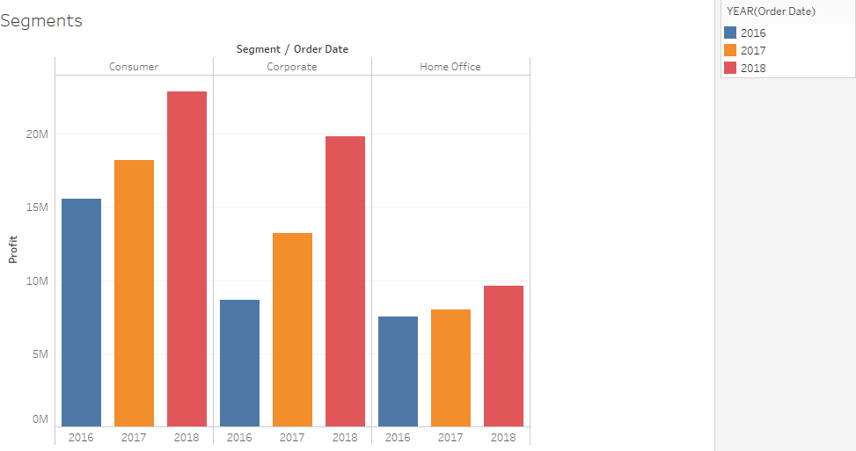

For all 3 year it behaves same, that is from segment Consumer we have maximum profit and from segment home office we have minimum profit.

But profit rate is increasing over the years in each category of customers, especially in corporate segment.

Now let’s focus on each customer’s behavior through their id.

This is the plot of customer id vs profit gain by them sorted in decreasing order so 1st graph of each segment shows the customers with maximum profit and 2nd graph shows the customers with minimum profit.

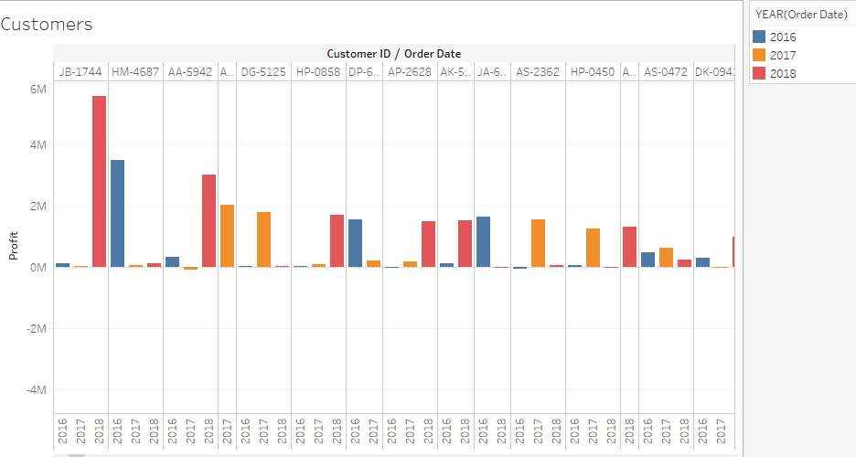

Each customer’s profit per year is in one column and from that we can see that these are the customers who have been loyal to the company and have provided profit most of the time and sometimes really good amount of it.

Above graph is sorted in decreasing order of total profit gain by each customer and we can see that we got maximum profit in 2018 plus the profit gain is more in year 2018. Hence, we can see that company’s profit margin is raising.

Now let’s see about loss. Below graph is of customers with minimum profit.

Maximum loss is also from the year 2018 but other than the maximum loss from the one customer in year 2017 loss were frequent.

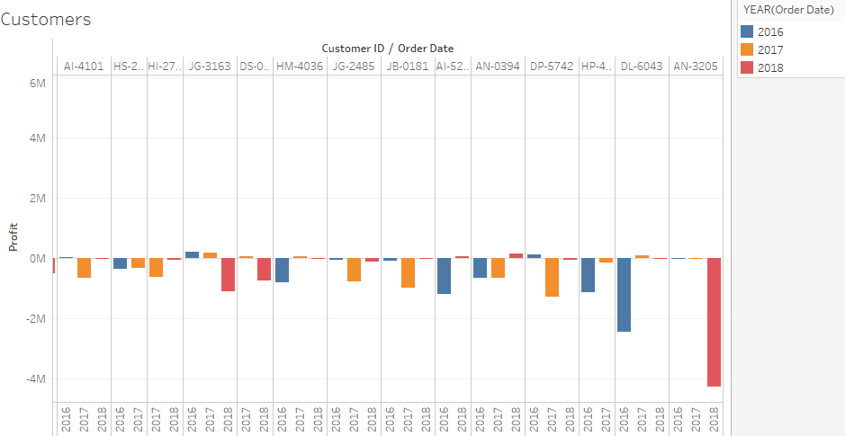

Note that a customer causing loss is frequent customer but may provide small amount of profit in past or following years. That can be seen from the below graph.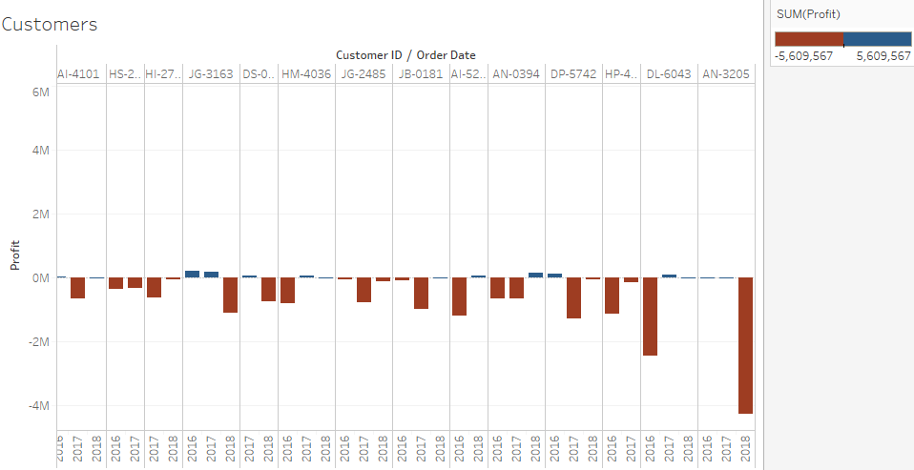

Below graph shows overall behavior of segments with amount of sales and Discount over 3 years, where color shows the degree of profit.

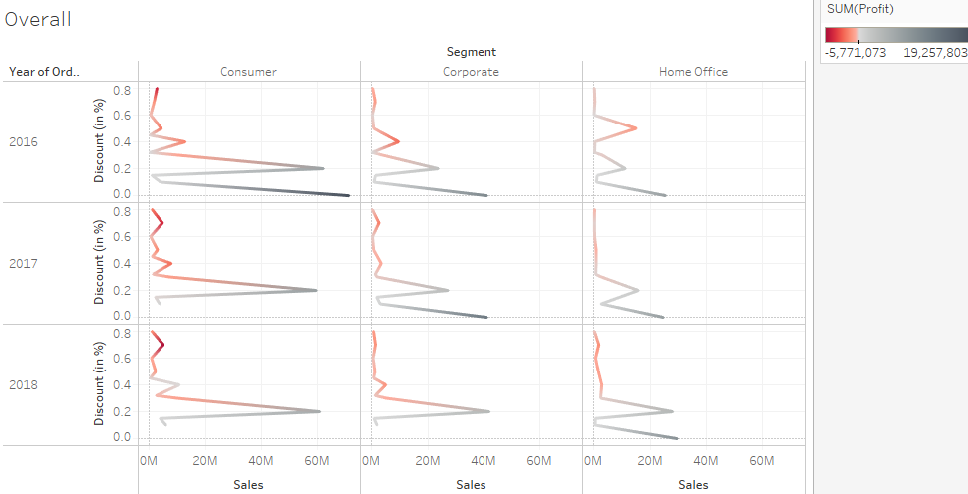

From the above graph we can see that over all years and segments the more discount the company provide less amount of profit they gain, sometimes losses too. Specially to consumers it is advisable to provide small amount of discount for good amount of sales as well as small amount of profit. High amount of profit results into loss more often.

There is negative correlation of degree (-0.22) between the variables profit and discount but that is not enough strong correlation to say that more amount of discount will always end up being loss for the company. But there is correlation between them, of low degree but it is there so we can’t just ignore that fact.

[ Note: -0.22 is overall correlation on whole data. Individually the correlation for each segment separately is also between [-0.19, -0.25].]

Hence, company should focus on the customers which are profitable for the company in with no or less amount of discount as well as a loyal customer.