

|  |
| --- |
| UNIVERSITY PERFORMANCE MANAGEMENT SYSTEM |
|  |
| AED ASSIGNMENT-3  Authors: Forum Bhatt Kinjal Thakkar Nikita Gaurihar |

# Introduction

The objective of this assignment is to develop and convert a university object-model design into a system, by utilizing techniques to improve the quality of education in a university setting, with the help of feedback from the alumni, faculty rankings and course rankings. In the proposed Performance System model, we take into consideration several parameters like ratings, grades, feedback, etc. so that the university can analyze its education system and trace outputs to align with the current industry trends. We take into consideration the courses, faculty, and employers, and how contribute to the growth of students over a period of 5 years. The relevance of the courses and GPA to industrial performance is considered. The UML and sequence diagrams aid in understanding the flow and approach of the system. The dashboard that’s created, gives a way for administrators to monitor and compare the results of success based on all the factors so that they can make necessary changes to further improve the performance of students in their university.

# Model Entity Descriptions University: The master class of this model is the University class. This class will contain the information of multiple universities affiliated with it. It will have University Administrator class which will have information about different colleges, students, alumni data, feedbacks and survey details.

University Administrator:   
The university administrator will hold the records of different colleges that fall under the master class – University.

College:   
This Superclass having different subclasses such as, Department, College Administrator, Student directory, and Degree requirements. On comparing and assigning rankings, the University Administrator will forward that particular data to respective colleges.

College Administrator:

This will function as an internal administrator at the college level, which will possess all the records of departments that fall under the listed colleges. Also, the information obtained from the survey taken from the alumni of the respective college will be redirected to the college administrator. It will also compare and rank the departments on the basis of the survey that has been recorded. The output will be obtained in form of a feedback regarding the courses offered to departments.

College Student Directory:   
It will be a list of all the students in respective colleges and their primary information in form of an array list.

Department:   
The Department will stack information for degree requirements, faculty, course catalog and jobs. It will receive the feedback for the courses and faculty.

Department Student Directory:   
Department Student Directory is an Array list that contains all the basic information of the students in the respective department.

Degree Requirements:   
It is used to define the criteria of obtaining the degree by collecting the performance information from the transcripts of the students. The class will calculate the GPA to determine whether or not the student fulfills the criterion of minimum GPA requirement.

Jobs:   
The Jobs class holds all the information about Current jobs and Job offerings in the Department. It consists of details of the Job positions that are vacant or filled.

Faculty:   
This entity is connected to the Job titles that comes under the Job Class. The faculty class will maintain the information of the faculty at a particular College’s Department, which will contain the details of Faculty’s history of the Subjects offered taught over the last 5 years.

Feedback Class uses the information of Alumni that were under the particular Faculty and that information will be useful for particular Department to make decisions regarding that particular Faculty.

Course Catalog:   
Every Department will have a Course Catalog. The Course Catalog is an Array list that contains all the courses available under the Department with necessary course details.

Courses:   
Course is a class having all the information about the courses offered by the Department. It is a class that will have two extended classes - Thesis Class and Non-Thesis Class. The Thesis Class will contain the subjects related to Research work whereas the Non-Thesis Class will contain subjects will be bifurcated as Core and Electives. Information of these courses will be useful in the Review class which will eventually help Department class to frame decisions regarding the courses offered by them.

Course Offerings:   
This class contains details regarding the courses that are offered by particular Faculty in a semester. It will have details regarding the course schedule and the class location of the particular Course. It will also serve as a representation of the scenario for the class ’Total Seats available’ and ‘Seats occupied’.

Rank/Compare:   
Rank/Compare will be responsible to compare and rank different colleges, under the University, according to the Survey information collected. This class will also collect information from the Feedback. It will then transfer the calculated results to the College Administrator.

Transcript:   
The Transcript class contains all the data of all the courses the student took during their time at the University. It contains information about the grades of a particular Student for every course in each semester.

Feedback:   
The Feedback class is used to get feedback from the students

about the Courses and their respective Faculty. The Feedback is given by current students and not the Alumni. All the students are asked to give their feedback on the courses they have taken and the respective faculty as soon as the course concludes. This feedback will be directed to the College Administrator. The College Administrator will review the feedback and then will take necessary action towards the Faculty or the Course of that particular Department. This class will indirectly help in improving the current state of the Courses or the Faculty.

Survey:   
The Survey class is used to get the Survey information from the Alumni regarding their current status. The survey includes questions about the Alumni’s Current Job Status, Current salary, Relevance of the courses taken in college to today’s Job technology. The Alumni are asked to fill out the survey 5 years after their graduation from the particular college. This Survey will be directed to the Registrar and the College Administrator. This class will indirectly help in improving the current state of the College.

# Process Flow Model

* The process flow and ranking of this model is divided on two levels - College Level and University level.
* Firstly, the alumni of the college who has completed 5 years upon graduation are reviewed under a survey that consist of examining parameters in regards to their current job scenario. The interrogation for evaluation will cover class attributes like ‘Placed or not placed’, ‘Course Relevance’, ‘Current Job Position’, ‘Promotions received’, ‘Current Salary’. Each question will be assigned a specific score ranging from 1 to 5. The total of the scores is calculated and an aggregate will be computed on taking the total number of people examined under the survey. The score is forwarded to the University Administrator which is then used to rank different colleges according to the ranks calculated.
* For the college level scenario, Current Students are provided with a Feedback. The Feedback form consists of questions such as Faculty Rating, Course Rating, Assignment Quality, Department Facilities and Research Work. These questions on ratings are used to evaluate the Feedback result. Each question has a score ranging from 1 to 5. The aggregate score for a particular College is computed by dividing the sum of scores by total number of students filling the feedback form. This score is forwarded to the College Administrator and Department of the College. This score is then evaluated by the College Administrator. The College Administrator then determines the rank of the Course, Department and Faculty.

# Class Diagram

# 

# UML Sequence Diagram For Survey

# 

# UML Sequence Diagram For Feedback

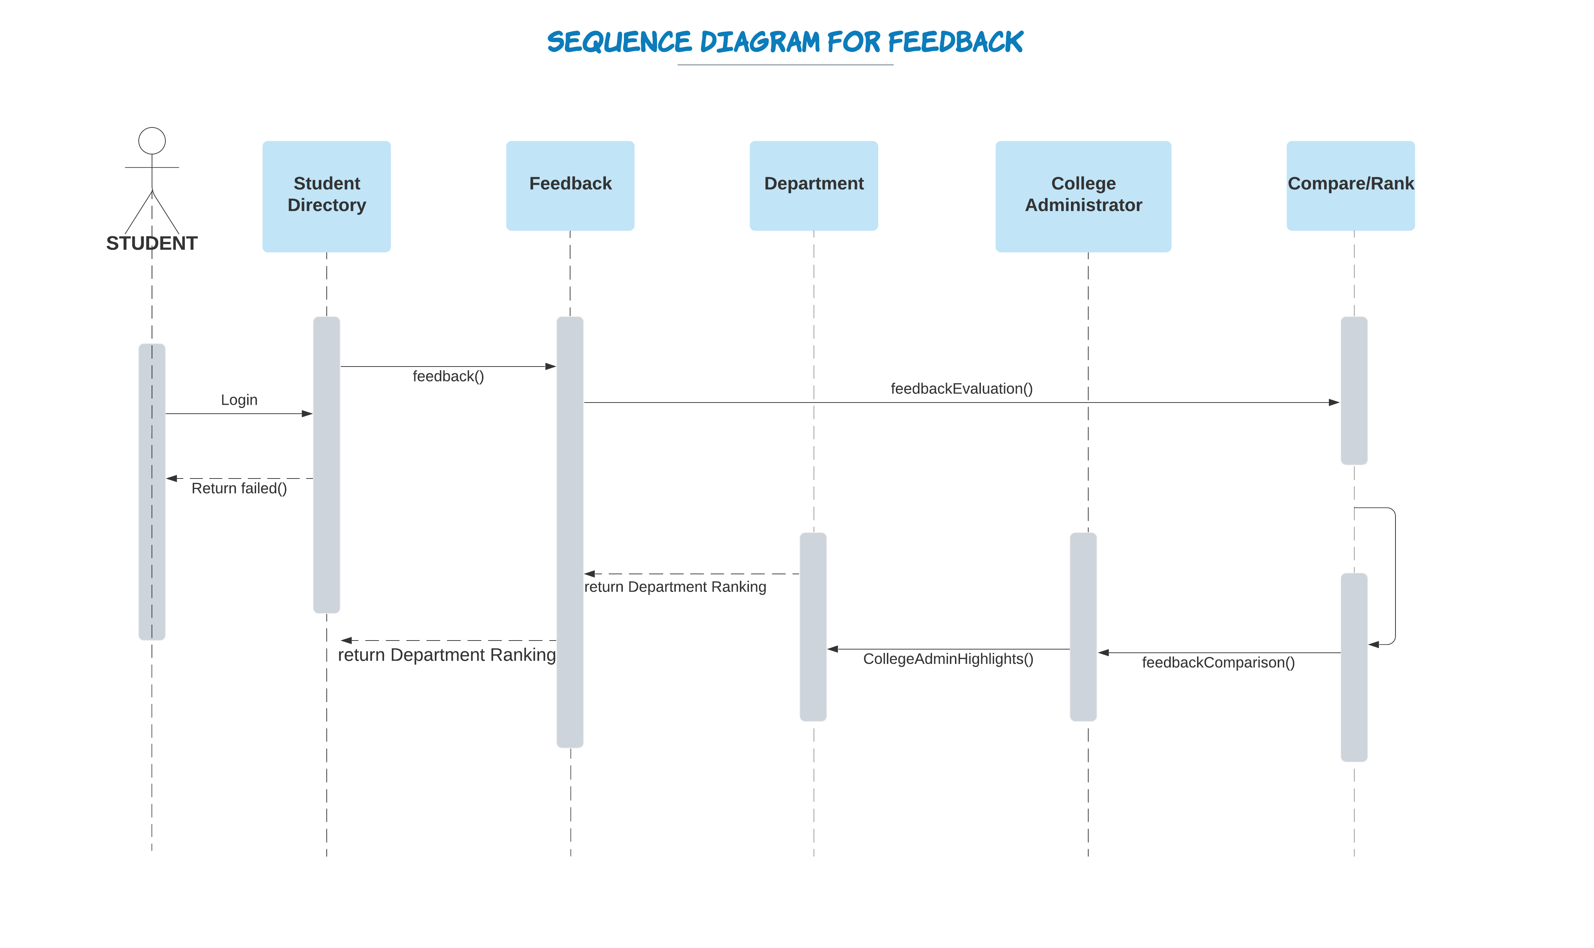

# Application UI:

# 

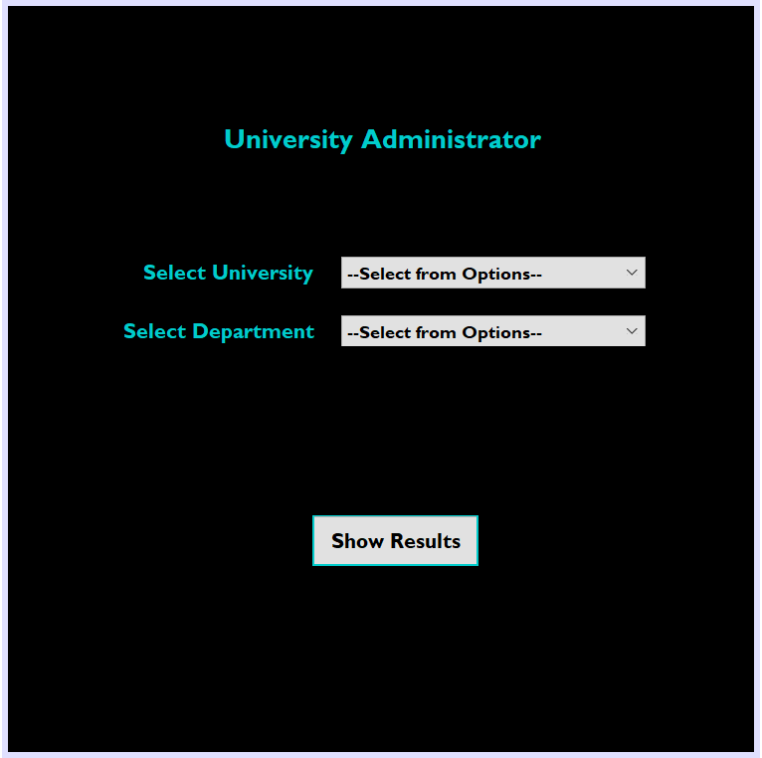

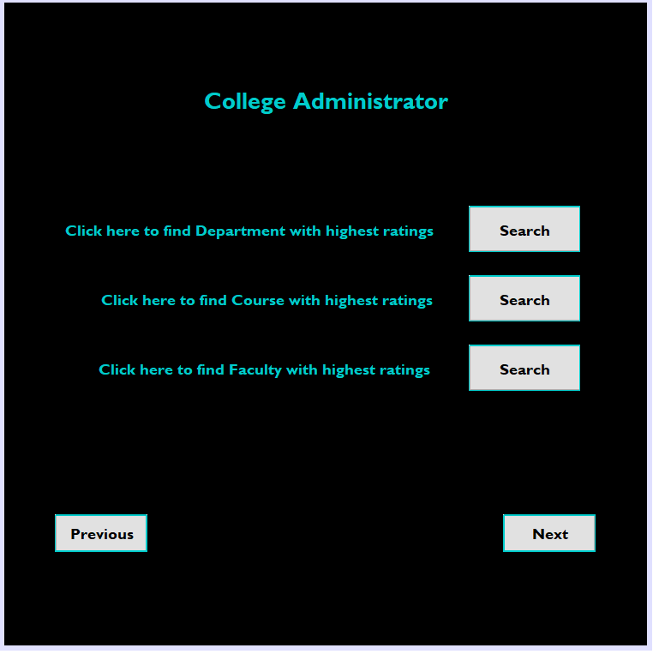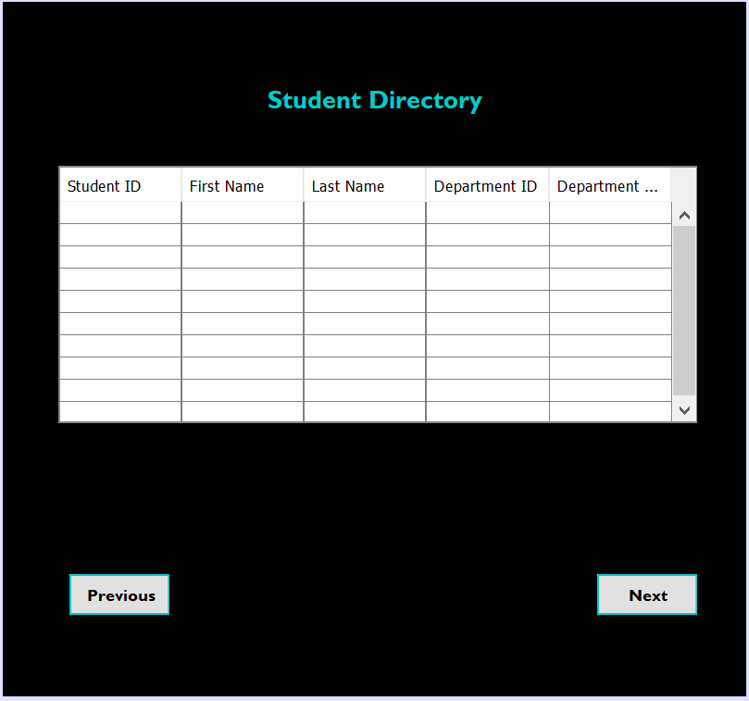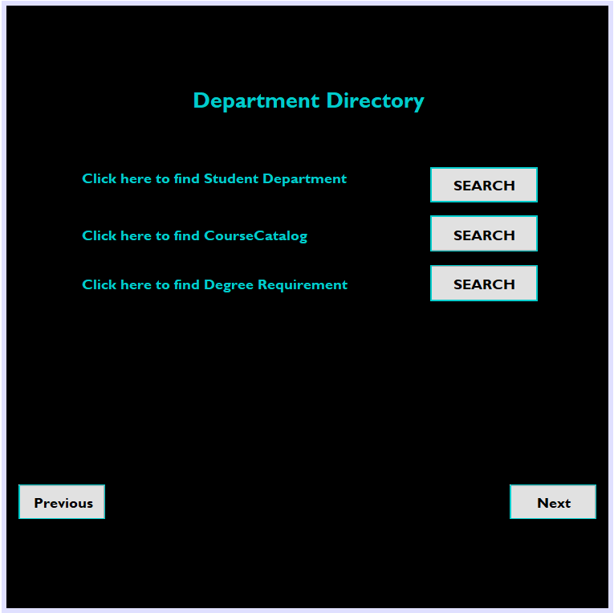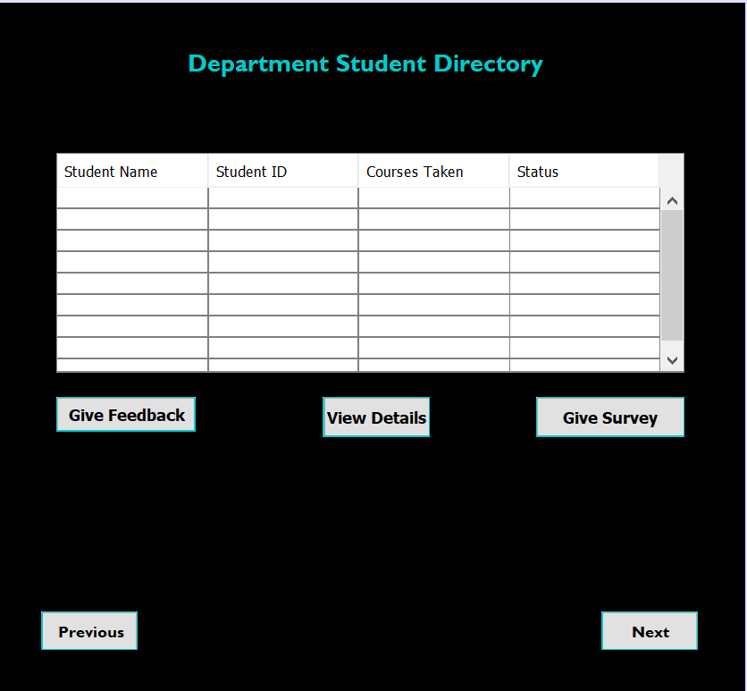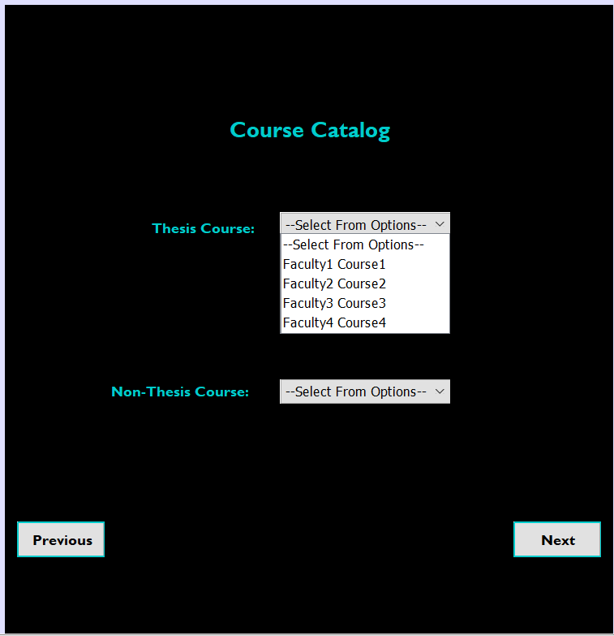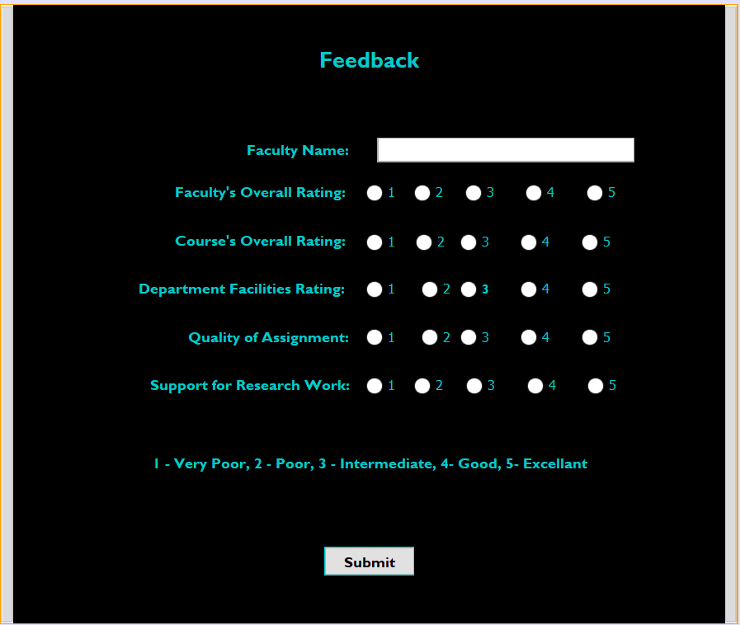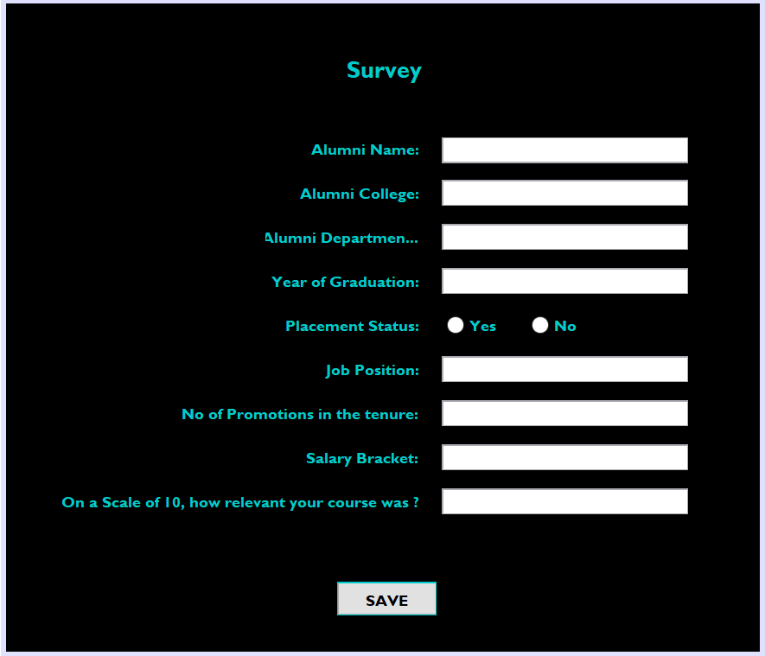

# Performance and Analysis Trends:

# 

# Conclusion and Future Scope:

# The University model of the is developed along with the Class diagram and a UML Sequence diagram. Further, an explanation of the model entities is provided which includes the different classes and their respective functionalities. The future scope of this assignment can be contemplated as an implementation of a ranking system application that compares several Colleges and Universities thereby helping students in choosing a university in alignment to their career goals.