Purpose: This application create encrypted password and saves as encrypted on database side so only user can have access or view their password.

This application has also another page where user can encrypted password for their account

**Add Password Webpage.**

* This page where you able to save password for Google, Yahoo or any social sites.
* This application has two page 1. Where you can save your password 2. Where you can retrieve your password as encrypted.

Database information

* Table Name : Add Password
* Table Column
* [ID]
* [NameSite]
* [UserName]
* [SitePassword]
* [Notes]

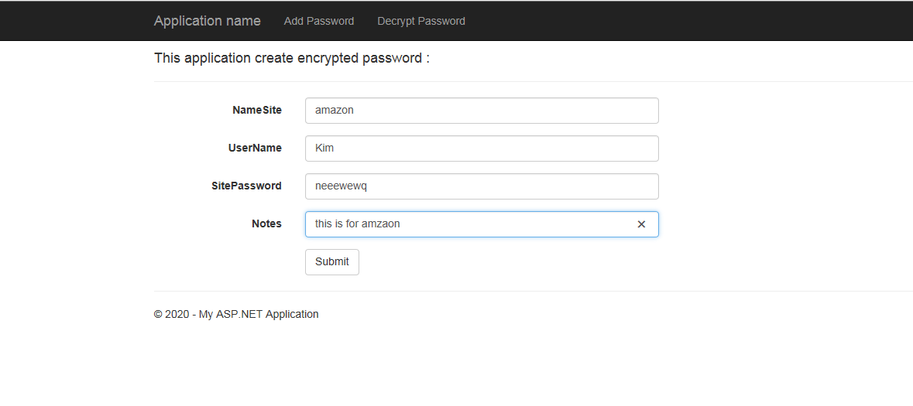

From database:



ID NameSite UserName SitePassword Notes

1 google kim LcbP9Sp1xQGT/P4QT0y1KOiBiWJ3dzt+T8+pZBstvYy7vu/OWb6C8pgUK8Gt8II/+C2b/JtzNgdXrWRiHToNLnajDYx57Dg= new

2 Yahoo Kim cGFzc2VlZQ== this is for yahoo site

3 amazon Kim bmVlZXdld3E= this is for amzaon

4 hotmail kim cnRldGVydGV0 this is for yahoo

5 google courage a2tra2xrbGFrc2Rsc2FrZDQ2NTQ1NjQ2NQ== this is for google site

6 amazon courage a2tqa2o1NDQ1NDU= this is for amazon

**Decrypt Webpage.**

* This page allows user to fetch their password in decrypted format so only user can see their real password.

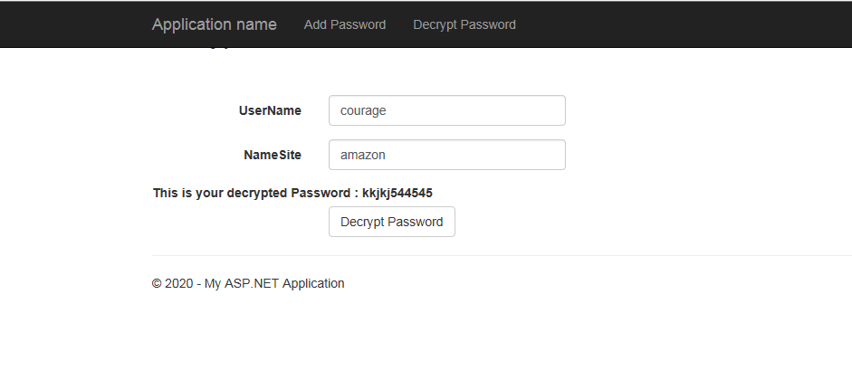

**New Changes to add catch in MVC application:**

1. LastPass Application :

Added [OutputCache(Duration=60)] for below method

public ActionResult AddNewPassword()

public ActionResult Decrypt()

1. LibraryManagement :

public ActionResult Login()

public ActionResult Registration()

public ActionResult Index(string searchby, string searching)

public ActionResult CreateBooks()

public ActionResult CheckOut(int? ID, int? BookID, int? librarycopyid)