

Royal University of Bhutan
College of science and
Technology
CSF101

Python Programming Assignment-
PART A & B

ASSIGNMENT 2
SWE YEAR 1

Assigned on: 2nd Nov 2025
Submission Date: 16th Nov 2025
Tutor: Ms. Sonam Yamgchen

Submitted by: Kinley Tshering
Std code: 02240348

Introduction
This project includes two python programs that show how basic searching and sorting algorithms work. The searching program uses Linear Search, which checks each item one by one, and Binary Search, which searches faster by dividing a sorted list into halves. The sorting program uses Bubble Sort to arrange names, Insertion Sort to sort test scores, and Quick Sort to sort book prices using recursion. Both programs display the original data, the results, and helpful details for the user. Through these programs, we learn how data can be found and arranged in an easy and efficient way using simple Python algorithms.
Part A: Searching Algorithms Implementation
Searching algorithms are important techniques used to locate specific data within a collection of elements. This part of the assignment focuses on implementing two common searching algorithms Linear Search and Binary Search using simple static lists. A menu-driven Python program was created to allow users to choose which search to perform, enter a target value, and view the output.
1. linear Search – find student id
Linear Search checks each element in a list one by one until the target value is found or until the list ends.
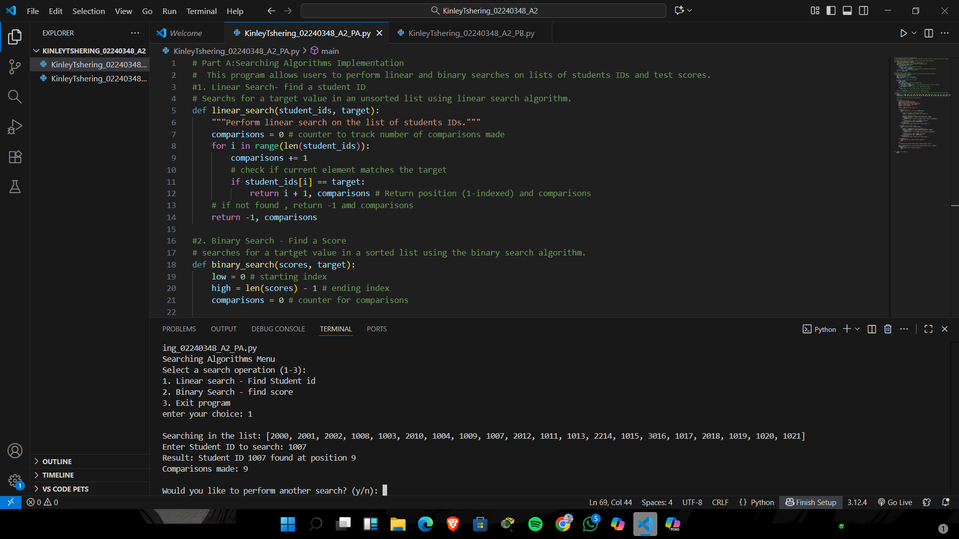

2. Binary Search – Find score
Binary Search is a more efficient algorithm but requires the list to be sorted.
It repeatedly divides the list into halves until the target value is found.
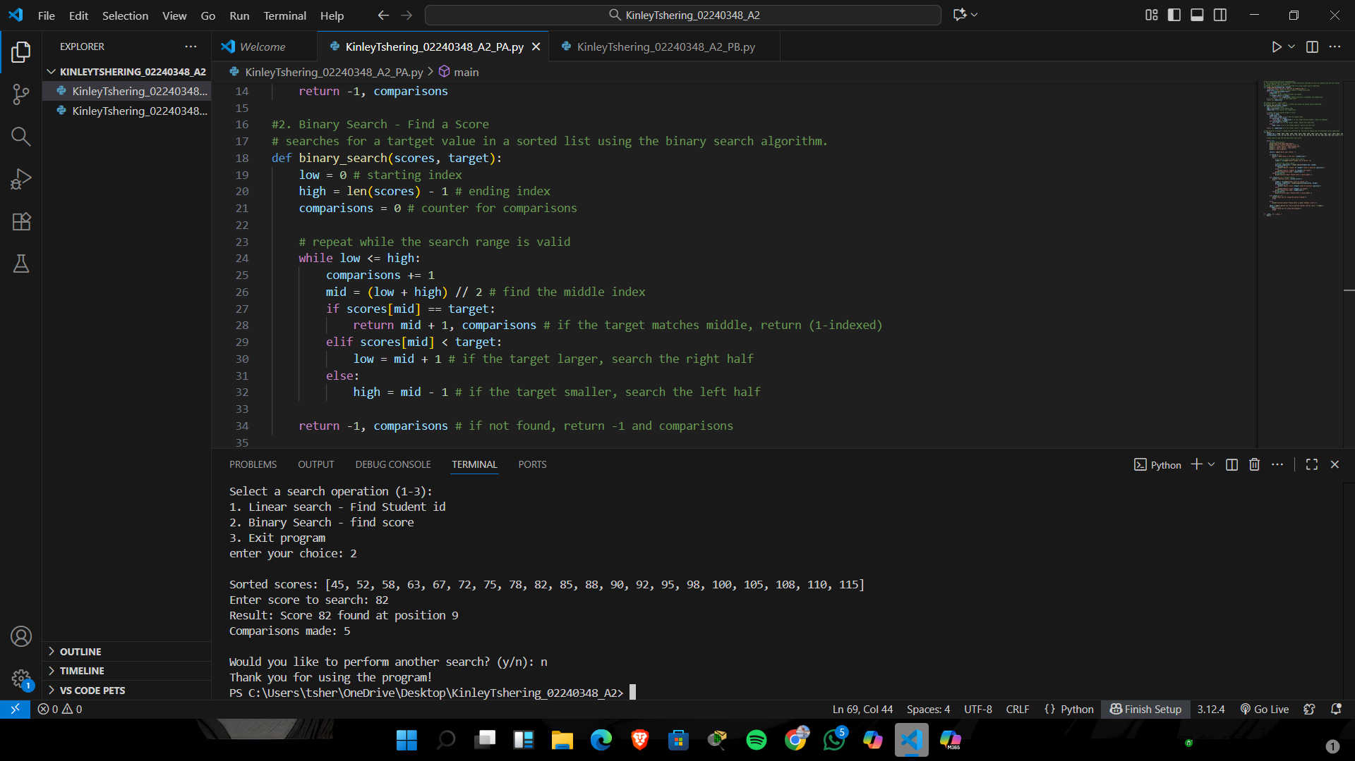
3. Main()
The main() function displays a menu that allows users to select and run any of these utilities until they choose to exit.
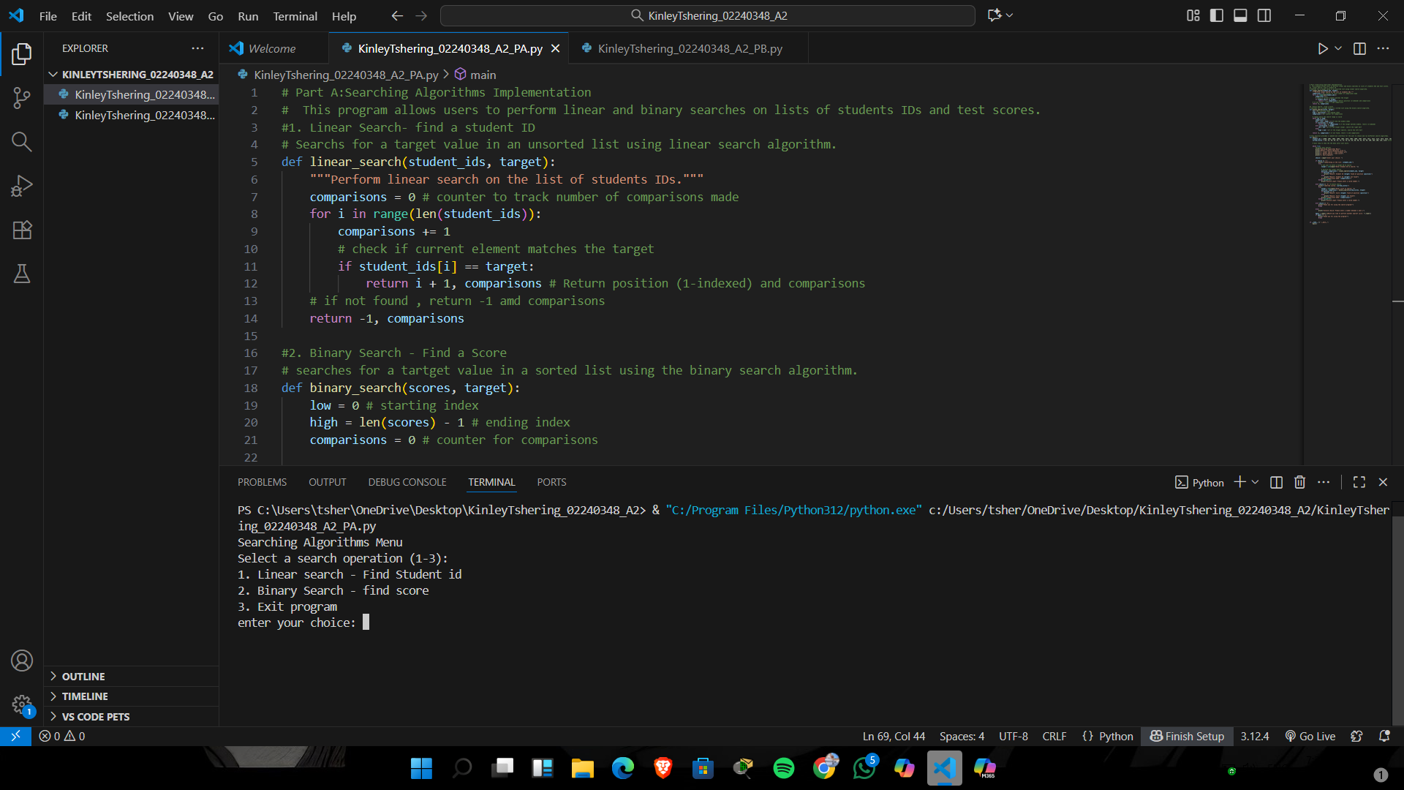
Part B: Sorting Algorithms Implementation
This project focuses on implementing different sorting algorithms in Python to arrange lists of data in an organized way. The program includes Bubble Sort for sorting student names alphabetically, Insertion Sort for arranging test scores in ascending order, and Quick Sort for sorting book prices using a fast recursive method. Each sorting option shows the original list before sorting and the final sorted list after the algorithm is applied. This part helps us understand how different sorting techniques work and how they can be used to organize information efficiently.

1. Bubble Sort – Sorting Student Names
Bubble Sort repeatedly compares adjacent elements and swaps them if needed.
Unsorted Names Example:
["Kado", "Bobchu", "Zamu", "Nado", "Lemo", ...]
Sorted Names Example:
["Bobchu", "Kado", "Lemo", "Nado", "Zamu", ...]

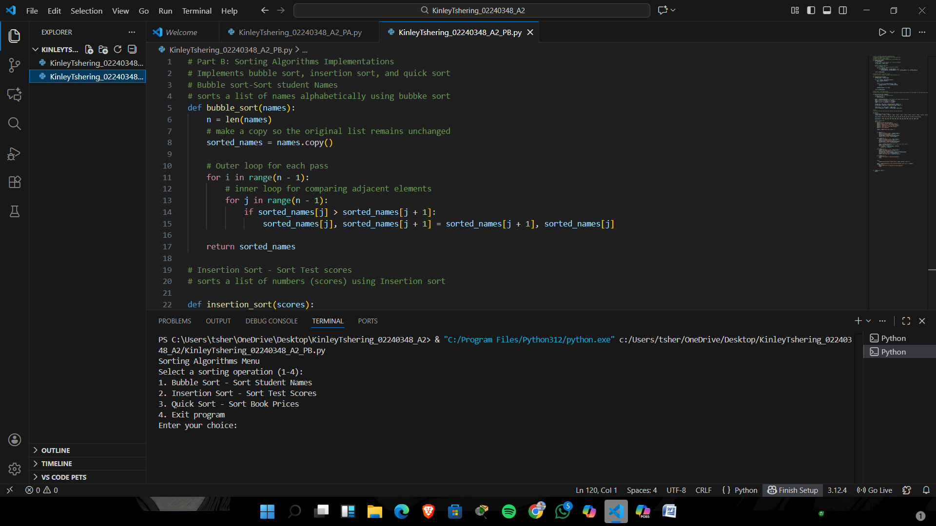

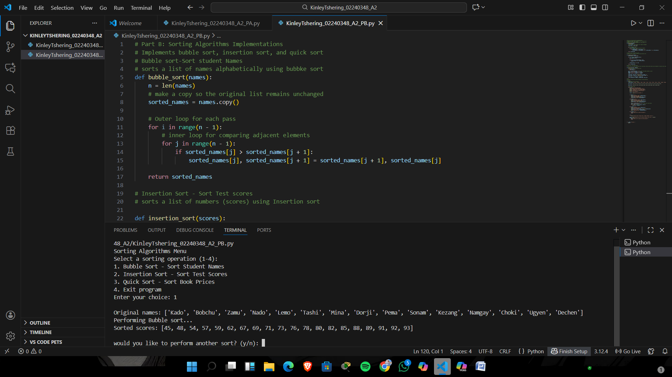

2. Insertion Sort – sorting Test Scores
Insertion Sort builds the sorted list one item at a time.
Unsorted Scores:
[78, 45, 92, 67, 88, 54, 73, ...]
Sorted Scores:
[45, 54, 67, 73, 78, 88, 92, ...]
Top 5 Scores:
- 93
- 92
- 91
- 89
- 88
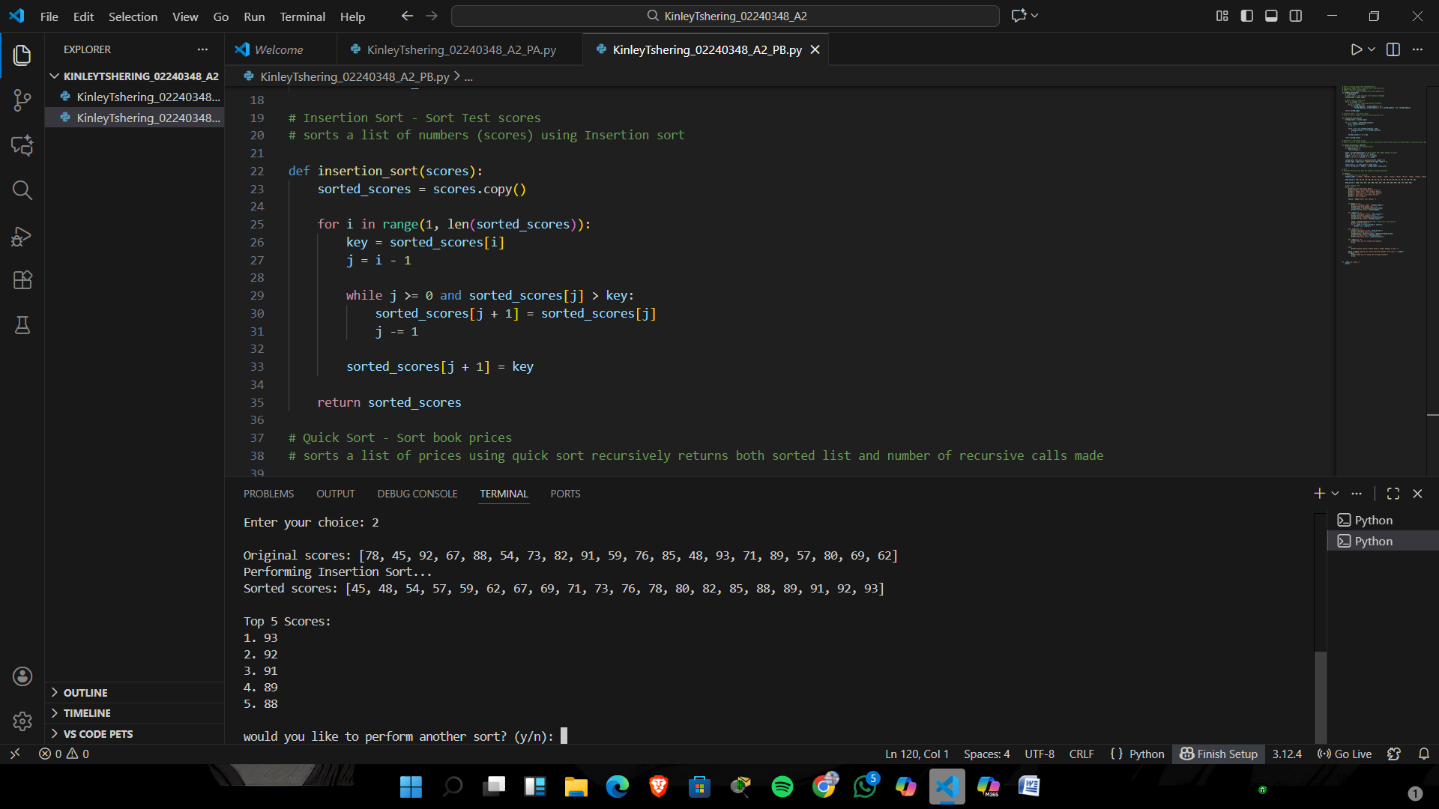

3. Quick Sort – Sorting Book Prices
Quick Sort is a fast divide-and-conquer sorting algorithm.
Unsorted Prices:
[450, 230, 678, 125, 890, ...]
Sorted Prices:
[125, 230, 450, 678, 890, ...]
Recursive Calls Example:
28 calls
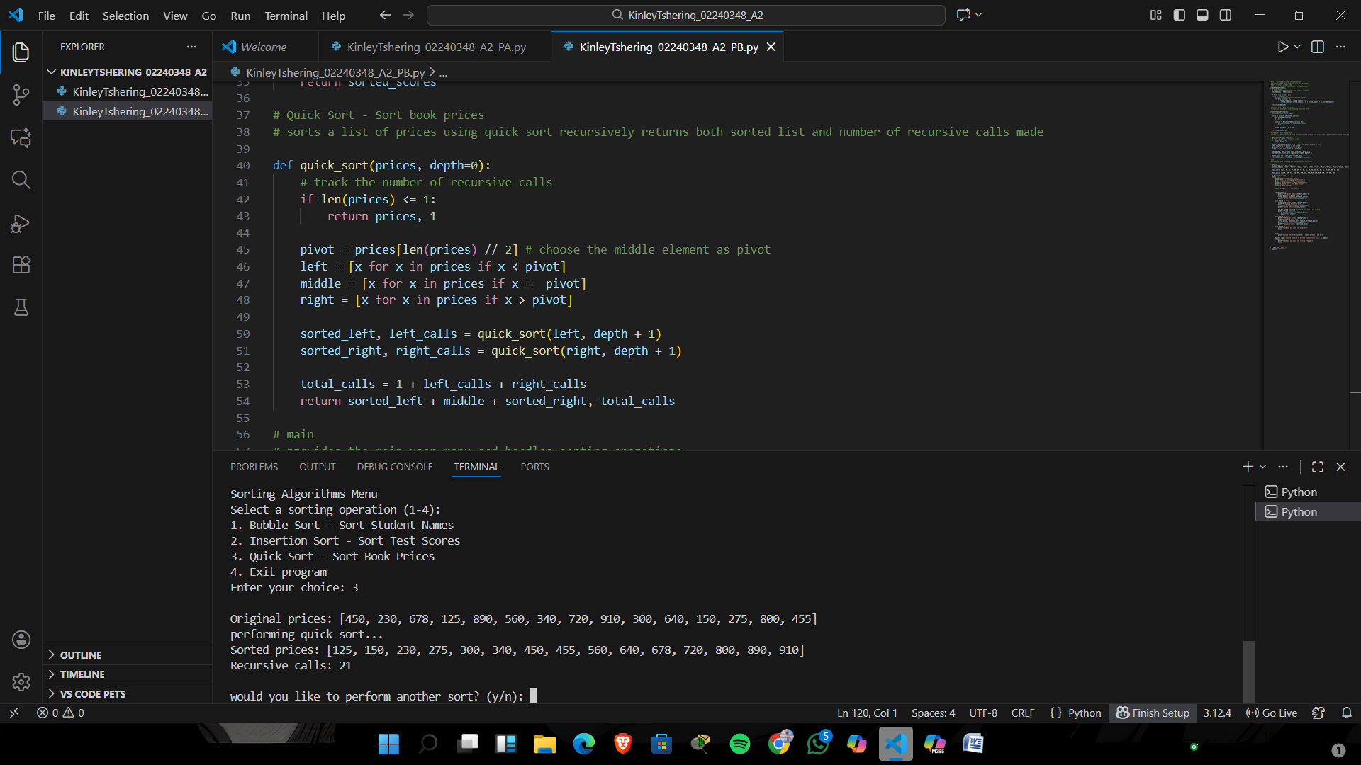

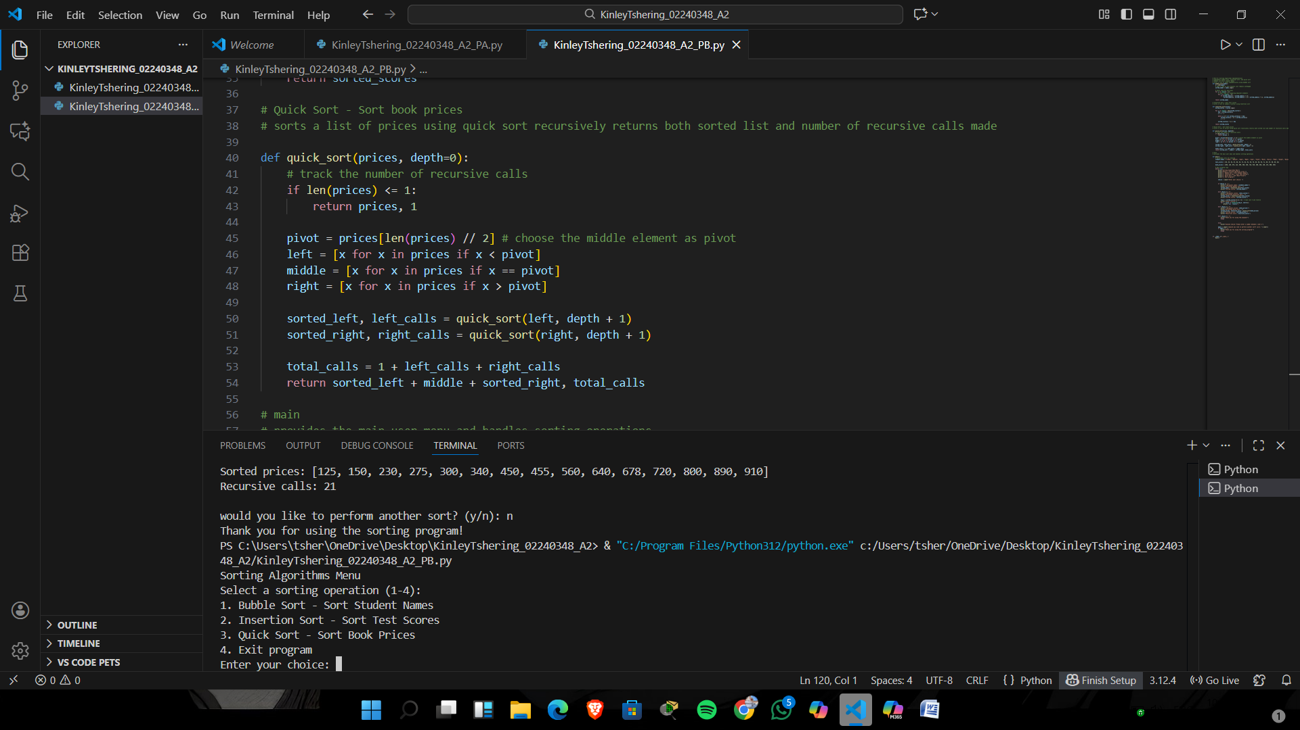
Part A- Searching Algorithms Implementation (working code)
# Part A:Searching Algorithms Implementation
# This program allows users to perform linear and binary searches on lists of students IDs and test scores.
#1. Linear Search- find a student ID
# Searchs for a target value in an unsorted list using linear search algorithm.
def linear_search(student_ids, target):
"""Perform linear search on the list of students IDs."""
comparisons = 0 # counter to track number of comparisons made
for i in range(len(student_ids)):
comparisons += 1
# check if current element matches the target
if student_ids[i] == target:
return i + 1, comparisons # Return position (1-indexed) and comparisons
# if not found , return -1 amd comparisons
return -1, comparisons

#2. Binary Search - Find a Score
# searches for a tartget value in a sorted list using the binary search algorithm.
def binary_search(scores, target):
low = 0 # starting index
high = len(scores) - 1 # ending index
comparisons = 0 # counter for comparisons

# repeat while the search range is valid
while low <= high:
comparisons += 1
mid = (low + high) // 2 # find the middle index
if scores[mid] == target:
return mid + 1, comparisons # if the target matches middle, return (1-indexed)
elif scores[mid] < target:
low = mid + 1 # if the target larger, search the right half
else:
high = mid - 1 # if the target smaller, search the left half

return -1, comparisons # if not found, return -1 and comparisons

# this function provides a comand-line interface for the user to choose and run different search algorithms.
def main():
student_ids = [2000, 2001, 2002, 1008, 1003, 2010, 1004, 1009, 1007, 2012, 1011, 1013, 2214, 1015, 3016, 1017, 2018, 1019, 1020, 1021] # unsorted list of 20 student IDs
sorted_scores = [45, 52, 58, 63, 67, 72, 75, 78, 82, 85, 88, 90, 92, 95, 98, 100, 105, 108, 110, 115]# sorted list of 20 test scores

# main loop to show the the menu until user exits.

while True:
#display menu options
print("Searching Algorithms Menu")
print("Select a search operation (1-3):")
print("1. Linear search - Find Student id")
print("2. Binary Search - find score")
print("3. Exit program")

choice = input("enter your choice: ")

if choice == '1':
print(f"\nSearching in the list: {student_ids}")
try:
# ask user to enter a target ID to search
target = int(input("Enter Student ID to search: "))

# perform the linear search
position, comparisons = linear_search(student_ids, target)
if position != -1:
print(f"Result: Student ID {target} found at position {position}")
else:
print(f"Result: Student ID {target} not found")
print(f"Comparisons made: {comparisons}")
except ValueError:
print("Invalid input! Please enter a valid number.")

elif choice == '2': # binary search
print(f"\nSorted scores: {sorted_scores}")
try:
target = int(input("Enter score to search: "))
position, comparisons = binary_search(sorted_scores, target)
if position != -1:
print(f"Result: Score {target} found at position {position}")
else:
print(f"Result: Score {target} not found")
print(f"Comparisons made: {comparisons}")
except ValueError:
print("Invalid input! Please enter a valid number.")

elif choice == '3':
print("Thank you for using the search program!")
break

else:
print("Invalid choice! Please enter a number between 1 and 3.")

again = input("\nWould you like to perform another search? (y/n): ").lower()
if again != 'y':
print("Thank you for using the program!")
break

if __name__ == "__main__":
main()

Part B – Sorting Algorithms Implimentation (working code)
# Part B: Sorting Algorithms Implementations
# Implements bubble sort, insertion sort, and quick sort
# Bubble sort-Sort student Names
# sorts a list of names alphabetically using bubbke sort
def bubble_sort(names):
n = len(names)
# make a copy so the original list remains unchanged
sorted_names = names.copy()

# Outer loop for each pass
for i in range(n - 1):
# inner loop for comparing adjacent elements
for j in range(n - 1):
if sorted_names[j] > sorted_names[j + 1]:
sorted_names[j], sorted_names[j + 1] = sorted_names[j + 1], sorted_names[j]

return sorted_names

# Insertion Sort - Sort Test scores
# sorts a list of numbers (scores) using Insertion sort

def insertion_sort(scores):
sorted_scores = scores.copy()

for i in range(1, len(sorted_scores)):
key = sorted_scores[i]
j = i - 1

while j >= 0 and sorted_scores[j] > key:
sorted_scores[j + 1] = sorted_scores[j]
j -= 1

sorted_scores[j + 1] = key

return sorted_scores

# Quick Sort - Sort book prices
# sorts a list of prices using quick sort recursively returns both sorted list and number of recursive calls made

def quick_sort(prices, depth=0):
# track the number of recursive calls
if len(prices) <= 1:
return prices, 1

pivot = prices[len(prices) // 2] # choose the middle element as pivot
left = [x for x in prices if x < pivot]
middle = [x for x in prices if x == pivot]
right = [x for x in prices if x > pivot]

sorted_left, left_calls = quick_sort(left, depth + 1)
sorted_right, right_calls = quick_sort(right, depth + 1)

total_calls = 1 + left_calls + right_calls
return sorted_left + middle + sorted_right, total_calls

# main
# provides the main user menu and handles sorting operations

def main():
# Hardcoded lists for testing
student_names = ["Kado", "Bobchu", "Zamu", "Nado", "Lemo", "Tashi", "Mina", "Dorji", "Pema", "Sonam", "Kezang", "Namgay", "Choki", "Ugyen", "Dechen"]

test_scores = [78, 45, 92, 67, 88, 54, 73, 82, 91, 59, 76, 85, 48, 93, 71, 89, 57, 80, 69, 62]

book_prices = [450, 230, 678, 125, 890, 560, 340, 720, 910, 300, 640, 150, 275, 800, 455]

# Main program loop
while True:
print("Sorting Algorithms Menu")
print("Select a sorting operation (1-4):")
print("1. Bubble Sort - Sort Student Names")
print("2. Insertion Sort - Sort Test Scores")
print("3. Quick Sort - Sort Book Prices")
print("4. Exit program")

choice = input("Enter your choice: ")

if choice == '1':
print(f"\nOriginal names: {student_names}")
print("Performing Bubble sort...")
sorted_names = insertion_sort(test_scores)
print(f"Sorted scores: {sorted_names}")

elif choice == '2':
print(f"\nOriginal scores: {test_scores}")
print("Performing Insertion Sort...")
sorted_scores = insertion_sort(test_scores)
print(f"Sorted scores: {sorted_scores}")

top_5 = sorted_scores[-5:][::-1] # take last 5 and reverse
print("\nTop 5 Scores:")
for i, score in enumerate(top_5, start=1):
print(f"{i}. {score}")

elif choice == '3':
print(f"\nOriginal prices: {book_prices}")
print("performing quick sort...")
sorted_prices, recursive_calls = quick_sort(book_prices)
print(f"Sorted prices: {sorted_prices}")
print(f"Recursive calls: {recursive_calls}")

elif choice == '4':
print("Thank you for using the program!")
break

else:
print("Inavald choice! Please enter a number between 1 and 4.")

again = input("\nwould you like to perform another sort? (y/n): ").lower()
if again != 'y':
print("Thank you for using the sorting program!")
break

if __name__=="__main__":
main()

Github Repoistory URL
https://github.com/kinley05/KinleyTshering_02240348_A2.git
Conclusion
In conclusion, this project helped demonstrate how basic searching and sorting algorithms work and how they can be applied to solve everyday data-handling problems. The searching algorithms showed how values can be found either step-by-step or using a faster method on sorted data, while the sorting algorithms showed different ways to arrange information in a clear and organized order. By running and understanding these programs, we gain a better understanding of how algorithms function, how they differ in speed and method, and why they are important in programming. This project also improves problem-solving skills and provides a strong foundation for learning more advanced algorithms in the future.

Reference
https://k4y0x13.github.io/CSF101-Programming-Methodology/intro.html
https://www.tutorialspoint.com/python

