MySQL replication playbooks

1. Setup replication
2. Master host has sample db

1. Slave host

1. Run ansible playbook to setup the replication

1. Replication in slave is done

1. Failover replication
2. Records in master

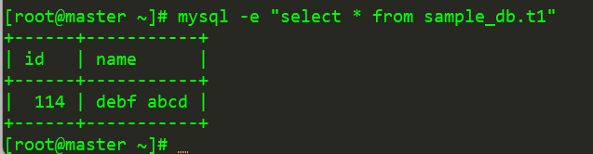

1. Records in slave

1. Start failover

1. Stop db in master



1. Records in slave

1. Add record in slave successfully

1. Failback replication
2. Records in slave

1. Start failback

1. Records in master after failback

1. Insert record into master

1. Slave show the new record

