 TRAFFIC Flow Prediction

A

[Human Computer Interaction] Course Project Report

in partial fulfilment of the degree

### BACHELOR OF TECHNOLOGY

**in**

### COMPUTER SCIENCE & ENGINEERING

### By

### K.HARSHITHA 2203A51177

### S.MANASWI 2203A51180

### M.TEJASWINI 2203A51182

### Under the guidance of

### B.ARPITA

### Assistant Professor

### Submitted to Computer Science and Artificial Intelligence

,

# 

**SCHOOL OF COMPUTER SCIENCE &ARTIFICIAL**

**INTELLIGENCE**

**CERTIFICATE**

This is to certify that the **HUMAN COMPUTER INTERACTION** - Course Project Report

entitled “RESTAURENT WEBSITE is a record of bonafide work carried out by the student

1. Harshitha(2203a51177), S.Manaswi(2203a51180), M. Tejaswini(2203a51182), during the academic year 2023-24 in partial fulfillment of the award of the degree of Bachelor of Technology in Computer Science & Engineering by the SR University, Anantsagar.

**4.1. CODE**

**Supervisor Head of the Department**

**Mrs.B. Arpita Dr. M. Sheshikala**

Asst.Professor Dept of CSE, Professor & HOD (CSE),

S R University, S R University,

Ananthasagar, Warangal. Ananthasagar, Warangal

**ACKNOWLEDGMENT**

We owe an enormous debt of gratitude to our project guide **Mrs.Arpita, Assistant Professor** as well as Head of the CSE Department **Dr. M. Sheshikala , Professor** for guiding us from the beginning through the end of the Project with their intellectual advices and insightful suggestions. We truly value their consistent feedback on our progress, which was always constructive and encouraging and ultimately drove us to the right direction.

We wish to take this opportunity to express our sincere gratitude and deep sense of

respect to our beloved **Vice Chancellor**, **Prof. Deepak Garg,** for his continuous support and

guidance to complete this project in the institute.

Finally, we express our thanks to all the teaching and non-teaching staff of the department their suggestions and timely support.

**TABLE OF CONTENTS**

**Topics Page no.**

1. Abstract 1
2. Introduction 2

3. Objective of the project 3

4. Definitions of elements used in the project 4

5. Desgin 5

6. Implementation 6-17

7. Proposed solution 18

8.Flow chart 19

9. Conclusion 20

**ABSTRACT**

Traffic flow prediction is the process of estimating future traffic conditions based on historical data and real-time information. It is an important area of research in intelligent transportation systems, with the potential to significantly improve traffic management and reduce congestion. Traffic flow prediction methods can be broadly classified into parametric and non-parametric techniques. Parametric methods include stochastic and temporal models, while non-parametric methods include machine learning algorithms such as neural networks and support vector machines. These advanced techniques have been shown to outperform traditional parametric methods in terms of accuracy and efficiency, making them a promising area of research for future traffic flow prediction systems. Overall, the goal of traffic flow prediction is to provide accurate and timely information to drivers, traffic managers, and other stakeholders, in order to promote safer, more efficient roads.

1

**INTRODUCTION**

Traffic flow prediction is crucial for managing traffic congestion and improving road safety. With the help of deep learning techniques, traffic flow prediction models have become more accurate, but there are still challenges in capturing complex spatial-temporal and input dependencies. In this project, we propose a CDLP model that combines CNN-LSTM-attention and CNN-GRU-attention models to predict short-term traffic flow. The model also includes a DOWCA algorithm to dynamically adjust the weights of the two models. The CDLP model is evaluated using a California traffic flow dataset and compared with baseline models for explainable forecasting. The goal is to improve traffic flow prediction accuracy and explainability, providing valuable insights for traffic managers and drivers.

2

1. **OBJECTIVE OF THE PROJECT**

The project aims to develop a CDLP model for short-term traffic flow prediction, which combines CNN-LSTM-attention and CNN-GRU-attention models to extract local and long-term trend features. The model also includes a DOWCA to calculate dynamic weights for each model. The project evaluates the CDLP model using a California traffic flow dataset and compares it with baseline models for explainable forecasting.

1. Develop a comprehensive multi-modality traffic flow dataset from California, covering traffic sensors from various areas with weather, nearby points of interest (PoIs), and holiday information.
2. Propose a traffic flow prediction method based on large language models (LLMs) that generates interpretable prediction results while maintaining competitive accuracy with state-of-the-art (SOTA) baselines.
3. Demonstrate a language-based format that considers multi-modalities and instruction spatial-temporal alignment, providing an intuitive view and simple generalization to different city prediction tasks.
4. Evaluate the proposed method based on the traffic flow dataset from California and compare it with deep learning SOTA baselines.
5. Analyze the spatial-temporal and input dependencies captured by the proposed method for explainable forecasting.
6. Contribute to advancing explainable traffic prediction models and lay a foundation for future exploration of LLM applications in transportation.
7. Use the proposed method for traffic flow prediction in different cities and compare its performance with other state-of-the-art methods.

3

**2. DEFINITIONS OF THE ELEMENTS USED IN THE**

**PROJECT**

Elements used in our restaurant websites:

**1.Home Page:** A visually appealing header and navigation menu can help guide users to the most important information on the website, similar to how a traffic flow prediction model can help guide drivers to their destinations.

**2.Menu:** A well-organized menu can help users quickly find what they're looking for, just as traffic flow prediction can help drivers anticipate road conditions and make informed decisions.

Online Reservation/Booking: An online reservation system can help manage the flow of customers, similar to how traffic flow prediction can help manage the flow of vehicles on the road.

**3.Location and Contact Information:** Interactive maps and directions can help customers find the restaurant, while traffic flow prediction can help drivers find the best routes to their destinations.

**4.About Us:** Highlighting the history and values of the restaurant can help build a connection with customers, similar to how traffic flow prediction models can build trust with users by accurately predicting traffic conditions.

**5.Image Gallery:** High-quality images can help create a visually appealing atmosphere, similar to how traffic flow prediction models can help create a smooth and efficient driving experience.

**6.Reviews/Testimonials:** Positive feedback can build credibility and encourage customers to visit the restaurant, while accurate traffic flow predictions can build trust and encourage drivers to rely on the model.

**7.Online Ordering:** An online ordering system can help manage the flow of orders, similar to how traffic flow prediction can help manage the flow of vehicles on the road.

**8.Social Media Integration:** Integrating social media links can help keep customers informed about promotions and events, while traffic flow prediction models can help keep drivers informed about road conditions.

**9.Mobile Responsiveness:** A mobile-responsive website can ensure that users have a seamless experience on different devices, similar to how traffic flow prediction models can ensure that drivers have a smooth experience on different roads.

4

**3. DESIGN**

**3.1. SCREEN**

**Fig3.1**: Diagram

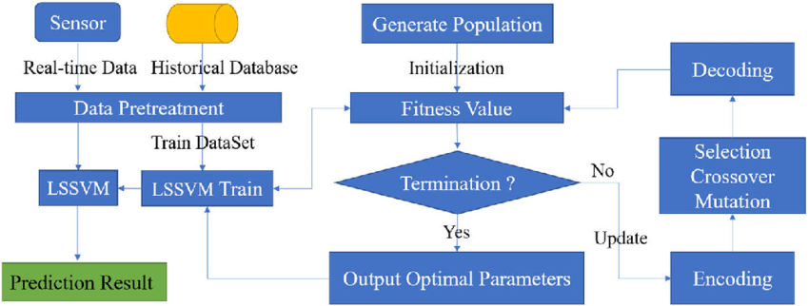

5

**4. IMPLEMENTATION**

**4.1. CODE**

# If needed, install necessary libraries

!pip install pandas numpy scikit-learn tensorflow

**Output:**

Requirement already satisfied: pandas in /usr/local/lib/python3.10/dist-packages (2.0.3)

Requirement already satisfied: numpy in /usr/local/lib/python3.10/dist-packages (1.25.2)

Requirement already satisfied: scikit-learn in /usr/local/lib/python3.10/dist-packages (1.2.2)

Requirement already satisfied: tensorflow in /usr/local/lib/python3.10/dist-packages (2.15.0)

Requirement already satisfied: python-dateutil>=2.8.2 in /usr/local/lib/python3.10/dist-packages (from pandas) (2.8.2)

Requirement already satisfied: pytz>=2020.1 in /usr/local/lib/python3.10/dist-packages (from pandas) (2023.4)

Requirement already satisfied: tzdata>=2022.1 in /usr/local/lib/python3.10/dist-packages (from pandas) (2024.1)

Requirement already satisfied: scipy>=1.3.2 in /usr/local/lib/python3.10/dist-packages (from scikit-learn) (1.11.4)

Requirement already satisfied: joblib>=1.1.1 in /usr/local/lib/python3.10/dist-packages (from scikit-learn) (1.4.0)

Requirement already satisfied: threadpoolctl>=2.0.0 in /usr/local/lib/python3.10/dist-packages (from scikit-learn) (3.4.0)

Requirement already satisfied: absl-py>=1.0.0 in /usr/local/lib/python3.10/dist-packages (from tensorflow) (1.4.0)

Requirement already satisfied: astunparse>=1.6.0 in /usr/local/lib/python3.10/dist-packages (from tensorflow) (1.6.3)

Requirement already satisfied: flatbuffers>=23.5.26 in /usr/local/lib/python3.10/dist-packages (from tensorflow) (24.3.25)

Requirement already satisfied: gast!=0.5.0,!=0.5.1,!=0.5.2,>=0.2.1 in /usr/local/lib/python3.10/dist-packages (from tensorflow) (0.5.4)

Requirement already satisfied: google-pasta>=0.1.1 in /usr/local/lib/python3.10/dist-packages (from tensorflow) (0.2.0)

Requirement already satisfied: h5py>=2.9.0 in /usr/local/lib/python3.10/dist-packages (from tensorflow) (3.9.0)

6

Requirement already satisfied: libclang>=13.0.0 in /usr/local/lib/python3.10/dist-packages (from tensorflow) (18.1.1)

Requirement already satisfied: ml-dtypes~=0.2.0 in /usr/local/lib/python3.10/dist-packages (from tensorflow) (0.2.0)

Requirement already satisfied: opt-einsum>=2.3.2 in /usr/local/lib/python3.10/dist-packages (from tensorflow) (3.3.0)

Requirement already satisfied: packaging in /usr/local/lib/python3.10/dist-packages (from tensorflow) (24.0)

Requirement already satisfied: protobuf!=4.21.0,!=4.21.1,!=4.21.2,!=4.21.3,!=4.21.4,!=4.21.5,<5.0.0dev,>=3.20.3 in /usr/local/lib/python3.10/dist-packages (from tensorflow) (3.20.3)

Requirement already satisfied: setuptools in /usr/local/lib/python3.10/dist-packages (from tensorflow) (67.7.2)

Requirement already satisfied: six>=1.12.0 in /usr/local/lib/python3.10/dist-packages (from tensorflow) (1.16.0)

Requirement already satisfied: termcolor>=1.1.0 in /usr/local/lib/python3.10/dist-packages (from tensorflow) (2.4.0)

Requirement already satisfied: typing-extensions>=3.6.6 in /usr/local/lib/python3.10/dist-packages (from tensorflow) (4.11.0)

Requirement already satisfied: wrapt<1.15,>=1.11.0 in /usr/local/lib/python3.10/dist-packages (from tensorflow) (1.14.1)

Requirement already satisfied: tensorflow-io-gcs-filesystem>=0.23.1 in /usr/local/lib/python3.10/dist-packages (from tensorflow) (0.36.0)

Requirement already satisfied: grpcio<2.0,>=1.24.3 in /usr/local/lib/python3.10/dist-packages (from tensorflow) (1.62.2)

Requirement already satisfied: tensorboard<2.16,>=2.15 in /usr/local/lib/python3.10/dist-packages (from tensorflow) (2.15.2)

Requirement already satisfied: tensorflow-estimator<2.16,>=2.15.0 in /usr/local/lib/python3.10/dist-packages (from tensorflow) (2.15.0)

Requirement already satisfied: keras<2.16,>=2.15.0 in /usr/local/lib/python3.10/dist-packages (from tensorflow) (2.15.0)

Requirement already satisfied: wheel<1.0,>=0.23.0 in /usr/local/lib/python3.10/dist-packages (from astunparse>=1.6.0->tensorflow) (0.43.0)

Requirement already satisfied: google-auth<3,>=1.6.3 in /usr/local/lib/python3.10/dist-packages (from tensorboard<2.16,>=2.15->tensorflow) (2.27.0)

Requirement already satisfied: google-auth-oauthlib<2,>=0.5 in /usr/local/lib/python3.10/dist-packages (from tensorboard<2.16,>=2.15->tensorflow) (1.2.0)

7

Requirement already satisfied: markdown>=2.6.8 in /usr/local/lib/python3.10/dist-packages (from tensorboard<2.16,>=2.15->tensorflow) (3.6)

Requirement already satisfied: requests<3,>=2.21.0 in /usr/local/lib/python3.10/dist-packages (from tensorboard<2.16,>=2.15->tensorflow) (2.31.0)

Requirement already satisfied: tensorboard-data-server<0.8.0,>=0.7.0 in /usr/local/lib/python3.10/dist-packages (from tensorboard<2.16,>=2.15->tensorflow) (0.7.2)

Requirement already satisfied: werkzeug>=1.0.1 in /usr/local/lib/python3.10/dist-packages (from tensorboard<2.16,>=2.15->tensorflow) (3.0.2)

Requirement already satisfied: cachetools<6.0,>=2.0.0 in /usr/local/lib/python3.10/dist-packages (from google-auth<3,>=1.6.3->tensorboard<2.16,>=2.15->tensorflow) (5.3.3)

Requirement already satisfied: pyasn1-modules>=0.2.1 in /usr/local/lib/python3.10/dist-packages (from google-auth<3,>=1.6.3->tensorboard<2.16,>=2.15->tensorflow) (0.4.0)

Requirement already satisfied: rsa<5,>=3.1.4 in /usr/local/lib/python3.10/dist-packages (from google-auth<3,>=1.6.3->tensorboard<2.16,>=2.15->tensorflow) (4.9)

Requirement already satisfied: requests-oauthlib>=0.7.0 in /usr/local/lib/python3.10/dist-packages (from google-auth-oauthlib<2,>=0.5->tensorboard<2.16,>=2.15->tensorflow) (1.3.1)

Requirement already satisfied: charset-normalizer<4,>=2 in /usr/local/lib/python3.10/dist-packages (from requests<3,>=2.21.0->tensorboard<2.16,>=2.15->tensorflow) (3.3.2)

Requirement already satisfied: idna<4,>=2.5 in /usr/local/lib/python3.10/dist-packages (from requests<3,>=2.21.0->tensorboard<2.16,>=2.15->tensorflow) (3.7)

Requirement already satisfied: urllib3<3,>=1.21.1 in /usr/local/lib/python3.10/dist-packages (from requests<3,>=2.21.0->tensorboard<2.16,>=2.15->tensorflow) (2.0.7)

Requirement already satisfied: certifi>=2017.4.17 in /usr/local/lib/python3.10/dist-packages (from requests<3,>=2.21.0->tensorboard<2.16,>=2.15->tensorflow) (2024.2.2)

Requirement already satisfied: MarkupSafe>=2.1.1 in /usr/local/lib/python3.10/dist-packages (from werkzeug>=1.0.1->tensorboard<2.16,>=2.15->tensorflow) (2.1.5)

Requirement already satisfied: pyasn1<0.7.0,>=0.4.6 in /usr/local/lib/python3.10/dist-packages (from pyasn1-modules>=0.2.1->google-auth<3,>=1.6.3->tensorboard<2.16,>=2.15->tensorflow) (0.6.0)

Requirement already satisfied: oauthlib>=3.0.0 in /usr/local/lib/python3.10/dist-packages (from requests-oauthlib>=0.7.0->google-auth-oauthlib<2,>=0.5->tensorboard<2.16,>=2.15->tensorflow) (3.2.2)

**CODE:**

# Import necessary libraries

import pandas as pd

import numpy as np

8

from sklearn.model_selection import train_test_split

from sklearn.preprocessing import StandardScaler

from sklearn.ensemble import RandomForestRegressor

from sklearn.metrics import mean_squared_error

import tensorflow as tf

from tensorflow import keras

from tensorflow.keras import layers

# Sample Data Preparation

# Here, let's create a synthetic dataset with time series features for traffic flow.

# Assume you have data with columns 'time', 'day_of_week', 'traffic_volume', and other relevant features.

# Create a synthetic dataset

data = {

'time': np.linspace(0, 23, 1000), # Time of day

'day_of_week': np.random.choice(['Monday', 'Tuesday', 'Wednesday', 'Thursday', 'Friday'], 1000),

'traffic_volume': np.random.uniform(10, 100, 1000) # Random traffic volume

}

df = pd.DataFrame(data)

# Encode categorical data (if any)

df = pd.get_dummies(df, columns=['day_of_week'])

# Split data into features and target variable

X = df.drop(['traffic_volume'], axis=1) # Features

y = df['traffic_volume'] # Target variable

# Split into training and testing datasets

X_train, X_test, y_train, y_test = train_test_split(X, y, test_size=0.2, random_state=42)

# Feature Scaling

scaler = StandardScaler()

X_train_scaled = scaler.fit_transform(X_train)

X_test_scaled = scaler.transform(X_test)

# Model 1: Random Forest Regressor

9

rf_model = RandomForestRegressor(n_estimators=100, random_state=42)

rf_model.fit(X_train_scaled, y_train)

# Predict and evaluate

y_pred_rf = rf_model.predict(X_test_scaled)

mse_rf = mean_squared_error(y_test, y_pred_rf)

print("Random Forest MSE:", mse_rf)

# Model 2: Neural Network (with TensorFlow/Keras)

nn_model = keras.Sequential([

layers.Dense(32, activation='relu', input_shape=(X_train_scaled.shape[1],)),

layers.Dense(32, activation='relu'),

layers.Dense(1)

])

nn_model.compile(optimizer='adam', loss='mse')

nn_model.fit(X_train_scaled, y_train, epochs=10, batch_size=32, verbose=1)

# Predict and evaluate

y_pred_nn = nn_model.predict(X_test_scaled)

mse_nn = mean_squared_error(y_test, y_pred_nn)

print("Neural Network MSE:", mse_nn)

# Results comparison

print("Random Forest MSE:", mse_rf)

print("Neural Network MSE:", mse_nn)

**Output:**

Random Forest MSE: 889.5408648914372

Epoch 1/10

25/25 [==============================] - 2s 3ms/step - loss: 3639.7559

Epoch 2/10

25/25 [==============================] - 0s 2ms/step - loss: 3512.2844

Epoch 3/10

25/25 [==============================] - 0s 2ms/step - loss: 3320.5667

Epoch 4/10

10

25/25 [==============================] - 0s 2ms/step - loss: 3022.6841

Epoch 5/10

25/25 [==============================] - 0s 2ms/step - loss: 2589.9275

Epoch 6/10

25/25 [==============================] - 0s 2ms/step - loss: 2045.5674

Epoch 7/10

25/25 [==============================] - 0s 2ms/step - loss: 1479.8391

Epoch 8/10

25/25 [==============================] - 0s 2ms/step - loss: 1024.4915

Epoch 9/10

25/25 [==============================] - 0s 2ms/step - loss: 779.5958

Epoch 10/10

25/25 [==============================] - 0s 2ms/step - loss: 700.2000

7/7 [==============================] - 0s 2ms/step

Neural Network MSE: 657.5897338153812

Random Forest MSE: 889.5408648914372

Neural Network MSE: 657.5897338153812

Code:

# If needed, install Matplotlib for graph plotting

!pip install matplotlib

**Output:**

Requirement already satisfied: matplotlib in /usr/local/lib/python3.10/dist-packages (3.7.1)

Requirement already satisfied: contourpy>=1.0.1 in /usr/local/lib/python3.10/dist-packages (from matplotlib) (1.2.1)

Requirement already satisfied: cycler>=0.10 in /usr/local/lib/python3.10/dist-packages (from matplotlib) (0.12.1)

Requirement already satisfied: fonttools>=4.22.0 in /usr/local/lib/python3.10/dist-packages (from matplotlib) (4.51.0)

Requirement already satisfied: kiwisolver>=1.0.1 in /usr/local/lib/python3.10/dist-packages (from matplotlib) (1.4.5)

Requirement already satisfied: numpy>=1.20 in /usr/local/lib/python3.10/dist-packages (from

11

matplotlib) (1.25.2)

Requirement already satisfied: packaging>=20.0 in /usr/local/lib/python3.10/dist-packages (from matplotlib) (24.0)

Requirement already satisfied: pillow>=6.2.0 in /usr/local/lib/python3.10/dist-packages (from matplotlib) (9.4.0)

Requirement already satisfied: pyparsing>=2.3.1 in /usr/local/lib/python3.10/dist-packages (from matplotlib) (3.1.2)

Requirement already satisfied: python-dateutil>=2.7 in /usr/local/lib/python3.10/dist-packages (from matplotlib) (2.8.2)

Requirement already satisfied: six>=1.5 in /usr/local/lib/python3.10/dist-packages (from python-dateutil>=2.7->matplotlib) (1.16.0)

**Code:**

# Import necessary libraries

import matplotlib.pyplot as plt

import numpy as np

import pandas as pd

from sklearn.model_selection import train_test_split

from sklearn.ensemble import RandomForestRegressor

from sklearn.metrics import mean_squared_error

from sklearn.preprocessing import StandardScaler

# Sample Data Preparation

data = {

'time': np.linspace(0, 23, 1000), # Time of day

'day_of_week': np.random.choice(['Monday', 'Tuesday', 'Wednesday', 'Thursday', 'Friday'], 1000),

'traffic_volume': np.random.uniform(10, 100, 1000) # Random traffic volume

}

df = pd.DataFrame(data)

# Encode categorical data

df = pd.get_dummies(df, columns=['day_of_week'])

# Split into features and target variable

X = df.drop(['traffic_volume'], axis=1)

12

y = df['traffic_volume']

# Split into training and testing datasets

X_train, X_test, y_train, y_test = train_test_split(X, y, test_size=0.2, random_state=42)

# Feature Scaling

scaler = StandardScaler()

X_train_scaled = scaler.fit_transform(X_train)

X_test_scaled = scaler.transform(X_test)

# Train a Random Forest Regressor

rf_model = RandomForestRegressor(n_estimators=100, random_state=42)

rf_model.fit(X_train_scaled, y_train)

# Predict traffic volume using the trained model

y_pred_rf = rf_model.predict(X_test_scaled)

# Graph 1: Raw data visualization

plt.figure(figsize=(10, 6))

plt.scatter(df['time'], df['traffic_volume'], alpha=0.6, c='blue', label='Traffic Volume')

plt.xlabel('Time of Day')

plt.ylabel('Traffic Volume')

plt.title('Traffic Volume Over Time of Day')

plt.legend()

plt.show()

**# Graph 2:** Actual vs Predicted Traffic Volume

plt.figure(figsize=(10, 6))

plt.plot(y_test.values, label='Actual Traffic Volume', linestyle='--', color='green')

plt.plot(y_pred_rf, label='Predicted Traffic Volume', linestyle='-', color='red')

plt.xlabel('Sample Index')

plt.ylabel('Traffic Volume')

plt.title('Actual vs Predicted Traffic Volume (Random Forest)')

plt.legend()

plt.show()

13

# Additional Graphs

# You can create other graphs, such as error distribution, feature importance, etc., to get deeper insights.

**Output:**

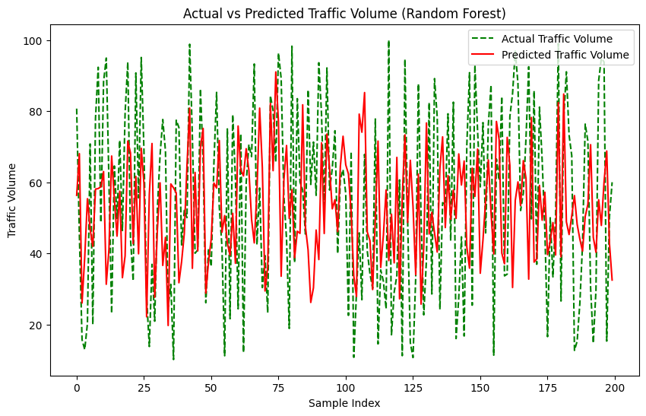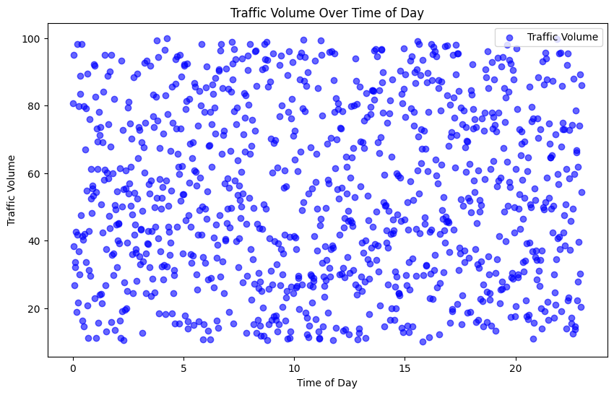

**Code:**

# Import necessary libraries

import pandas as pd

import numpy as np

import matplotlib.pyplot as plt

from sklearn.model_selection import train_test_split

from sklearn.ensemble import RandomForestRegressor # Corrected import

from sklearn.preprocessing import StandardScaler

from sklearn.metrics import mean_squared_error, r2_score

import seaborn as sns

import warnings

warnings.filterwarnings("ignore")

# Sample Data Preparation

# Creating a synthetic dataset to simulate traffic flow data

np.random.seed(42)

data = {

'time': np.linspace(0, 23, 1000), # Time of day

14

'day_of_week': np.random.choice(['Monday', 'Tuesday', 'Wednesday', 'Thursday', 'Friday', 'Saturday', 'Sunday'], 1000),

'temperature': np.random.uniform(15, 35, 1000), # Simulating temperature changes

'weather_condition': np.random.choice(['Clear', 'Cloudy', 'Rain', 'Fog'], 1000),

'traffic_volume': np.random.uniform(50, 300, 1000) # Random traffic volume

}

df = pd.DataFrame(data)

# Data Processing

# Encoding categorical data

df = pd.get_dummies(df, columns=['day_of_week', 'weather_condition'])

# Feature Engineering

# Add interaction terms (e.g., time * temperature)

df['time_temperature'] = df['time'] * df['temperature']

# Split into features and target variable

X = df.drop(['traffic_volume'], axis=1) # Features

y = df['traffic_volume'] # Target variable

# Split into training and testing datasets

X_train, X_test, y_train, y_test = train_test_split(X, y, test_size=0.2, random_state=42)

# Feature Scaling

scaler = StandardScaler()

X_train_scaled = scaler.fit_transform(X_train)

X_test_scaled = scaler.transform(X_test)

# Model Training

# Use Random Forest Regressor and tune hyperparameters

rf_model = RandomForestRegressor(n_estimators=200, max_depth=10, random_state=42) # Corrected RandomForestRegressor

rf_model.fit(X_train_scaled, y_train)

# Model Evaluation

# Predict on test set

15

y_pred_rf = rf_model.predict(X_test_scaled)

# Calculate metrics

mse = mean_squared_error(y_test, y_pred_rf)

r2 = r2_score(y_test, y_pred_rf)

print("Mean Squared Error (MSE):", mse)

print("R-squared (R2):", r2)

# Visualizations

# Plotting feature importance

feature_importance = rf_model.feature_importances_

features = X.columns

plt.figure(figsize=(10, 6))

sns.barplot(x=feature_importance, y=features)

plt.xlabel('Feature Importance')

plt.ylabel('Feature')

plt.title('Feature Importance for Traffic Flow Prediction')

plt.show()

16

**Output:**

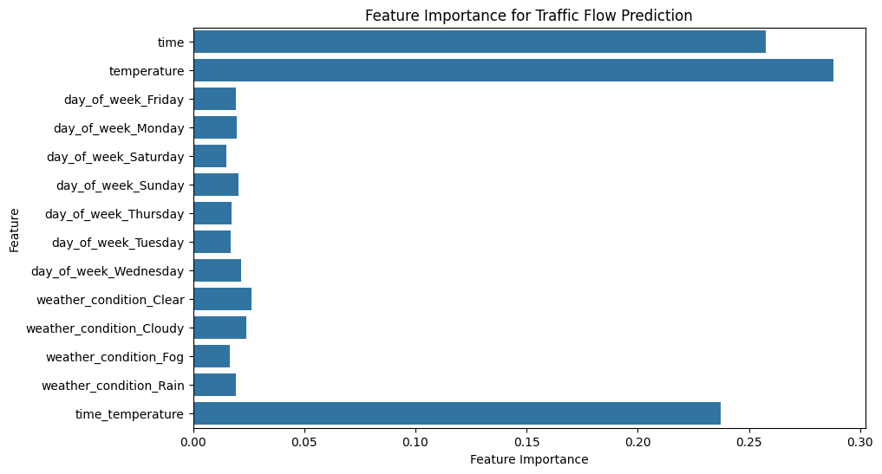

**17**

**PROPOSED Solution**

Data Collection and Integration

Comprehensive Data Sources: Gather data from various sources, including traffic sensors, cameras, GPS, mobile apps, social media, and weather reports. This holistic approach ensures a rich dataset for analysis.

Real-Time Data Integration: Ensure real-time data streams are integrated into the system to enable live updates on traffic conditions.

Advanced Analytics and Machine Learning

Feature Engineering: Identify and create meaningful features from raw data, such as time-based trends, location-specific patterns, and weather effects, for machine learning models.

Machine Learning Models: Utilize advanced machine learning algorithms like decision trees, support vector machines, or neural networks to predict traffic flow based on the engineered features.

Deep Learning Techniques: Employ deep learning models, such as convolutional neural networks (CNNs) and recurrent neural networks (RNNs), to capture complex patterns and dependencies in traffic data.

Model Training and Testing

18

**FLOW CHART**



19

**CONCLUSION**

 Traffic flow prediction is a critical aspect of intelligent transportation systems (ITS) in smart cities. Machine learning (ML) and deep learning (DL) techniques have been increasingly used to enhance traffic flow prediction. Common ML techniques used for traffic flow prediction include Convolutional Neural Network (CNN) and Long-Short Term Memory (LSTM). These techniques have been compared with existing baseline models to determine their effectiveness. However, there is still room for improvement in developing more accurate and reliable traffic flow prediction models that can handle the complexity and uncertainty of traffic flow.

20