Step 1: Register (Instructor)

Click on “Register” from navbar or use this path *http://localhost:4567/register*

Create a Username, Password, and select your role as an instructor

Step 2: Log-In (Instructor)

Login with the username and password you created from previous step

Now you have access to instructor home page

You can upload csv, upload websites, and download vote report.

Step 3 Upload CSV

Click on “Upload CSV” from navbar

Click on “Choose File” button to upload .csv file

Make sure your CSV file is formatted as below image

“Username” at column [0], “password” at column [1], “role” at column [2]

The only roles are “student” or “instructor”

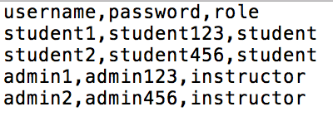

Step 4 Upload Websites

Click on “Upload Websites” from navbar

Click on “Choose File” button to upload .zip folder

Make sure to upload only zip-folder with .zip extension

Below is the example of the sample directory

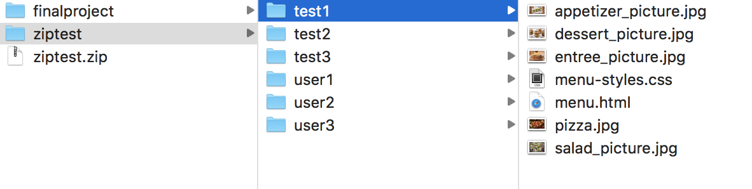

Step 5 Logout (Instructor)

Step 6 Student login

Use student account from CSV file or create new account by registering

Once you login, you will be able to see all different websites if instructor has uploaded websites beforehand

Student has only access to vote page

Step 7 Vote

Click on “Vote” from navbar

You can rank websites 1st, 2nd, or 3rd place

Make sure 1st, 2nd, and 3rd place websites ranking are different users websites.

Step 8 logout (student)

Step 9 Instructor login

Step 10 Vote Report

Click on “Vote Report” from navbar

You can view report here or download report