**Assignment 2**

**CIS355** – Spring 2018

**Point Value**: 100 points

**Assignment Due Date**: **In class Thursday, Feb 15, 2018**

**Submission Instruction**

This assignment contains a written part and programming part. For the written part, please write the questions and your answers to those questions on a Microsoft Word document and convert it to a pdf file. The name of the file should be HW2_YourLastname_YourFirstname.pdf. For the programming part, please write a C++ program using pthread (POSIX) library in a C++ file. The name of the file should be HW2_Programming_YourLastname_YourFirstname.cpp. Please zip both the pdf file and .cpp file into one zip file named HW2_YourLastname_YourFirstname.zip. Please submit the zip file on Schoology by 11:59pm and a hard copy of the pdf file to the instructor in lecture.

**Short answers**

1. What is a process (**5 points**) and what is the user address space of a process? (**5 points**)

**A process is a program in execution. The user address space of a process is the set of virtual address that an operating system makes available to a process**

1. What are the 5 states of a process (**5 points**)? Please draw the process state diagram.

**The 5 states of a process include: New-the process is created, Ready-the process is waiting to run, Running- the process instructions are being executed, Waiting- the process is waiting for some event s to occur, and Terminated- the process has finished execution.**

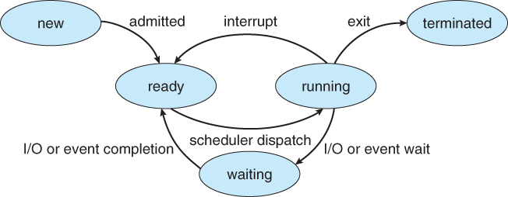

1. What is a process context-switch **(5 points**)? Please explain what actions taken by the kernel when process 1 is replaced by process 2. (**5 points)**

* **A process context switch is the switching of the central processing unit (CPU) from one process/thread to another process/thread.**
* **Context switching between kernel threads typically requires saving the value of the CPU registers from the thread being switched out and restoring the CPU registers of the new thread being scheduled.**

**Actions taken:** 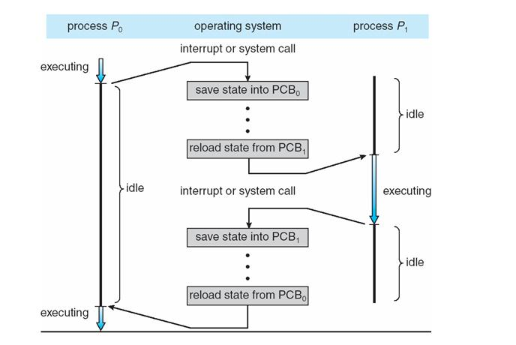

1. What is long-term scheduler **(5 points**)? What is short-term scheduler? **(5 points**)

* **The long-term scheduler determines which programs are admitted to the system for processing. It selects processes from the queue and loads them into memory for execution.**
* **The short-term scheduler decides which of the ready, in-memory processes is to be executed (allocated a CPU) after a clock interrupt, an I/O interrupt, an operating system call or another form of signal.**

1. What are the possible reasons for a process to change from running state into the waiting state? Please list at least five reasons. **(10 points).**
   * + 1. Waiting for input/output
       2. A process with higher priority is scheduled
       3. Not enough memory for the process
       4. if it waits for a locked resource
       5. set to run for a certain amount of time before switching to a different process
2. What is a thread **(5 points**)? What are the components of program state are shared across threads in a multithreaded process? **(5 points**) What are the components are unique to each thread in a multithreaded Process **(5 points)**?

* **A thread is a sequential execution stream within a process.**
* **The threads of a multithreaded process share heap memory global variables, and page table.**
* **Each thread has its separate set of register values and a separate stack segments.**

1. Is it possible to have concurrency, but not parallelism? Please explain your answer. **(10 points)**

* **Yes, it is possible to have concurrency but not parallelism. Concurrency means that more than one process or thread is progressing at the same time. However, it does not imply that the processes are running simultaneously. The scheduling of tasks allows for concurrency, but parallelism is supported only on systems with more than one processing core.**

1. Please design and write a C++ multithreaded program using POSIX thread library to find the number of prime numbers between 1 and 10,000,000 (10 million) and find out how many microseconds it takes in this computation process. Assume your computer has 4 CPUs and you create 4 threads from your main thread? **(30 points)**