1. Below is a screenshot of at least 4 virtual machines that I have created in VirtualBox. I have a SEEDUbuntu machine, which runs on Ubuntu operating system, Kali, which is a Linux based machine, Metasploitable2 which has Windows 7 operating system, and then two virtual machines which have their respected Windows versions in their titles(2003 and 7).

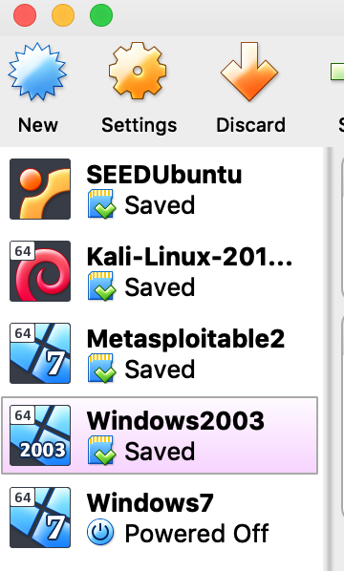

2) Below is a screenshot of my Kali virtual machine. As you can see, it is properly downloaded in VirtualBox and is ready to go.

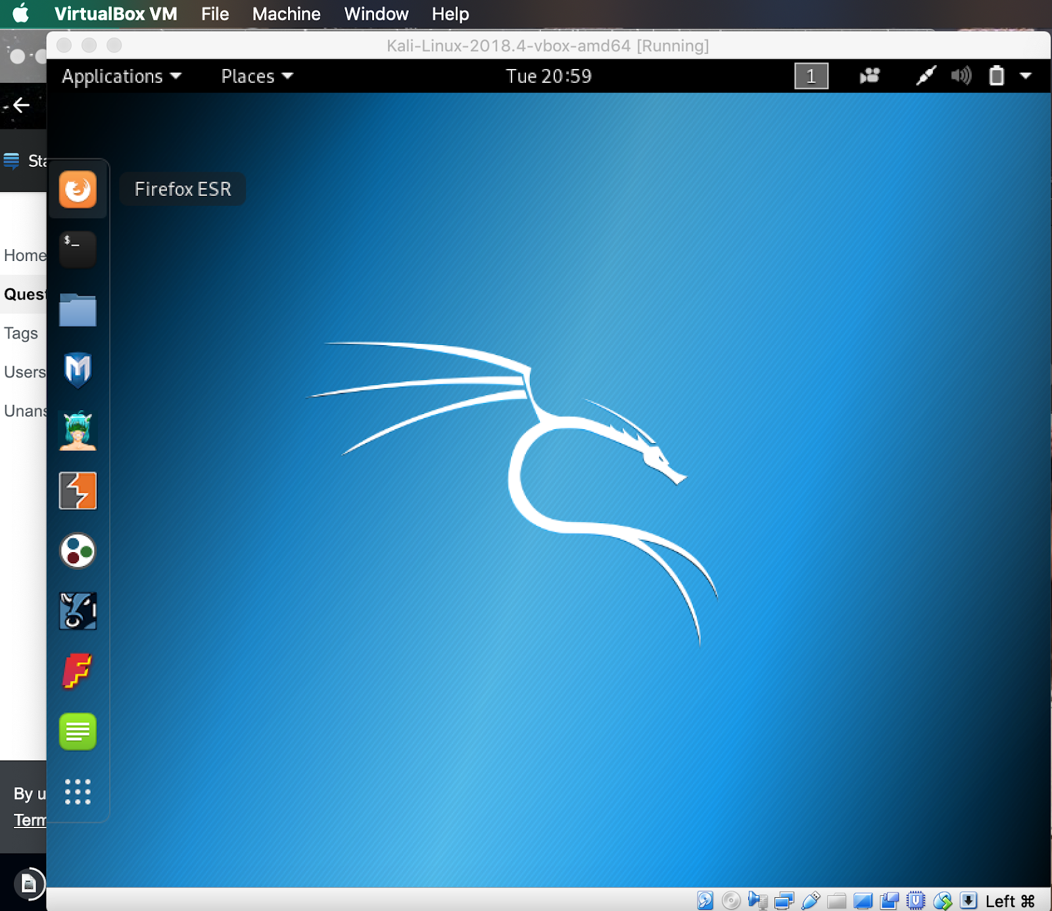

3) Below is the step-by-step process of my Windows 2003 virtual machine setup in VirtualBox. After downloading the iso file from the USB provided in class, I got the virtual machine created and have completed all the steps in setting up this virtual machine.

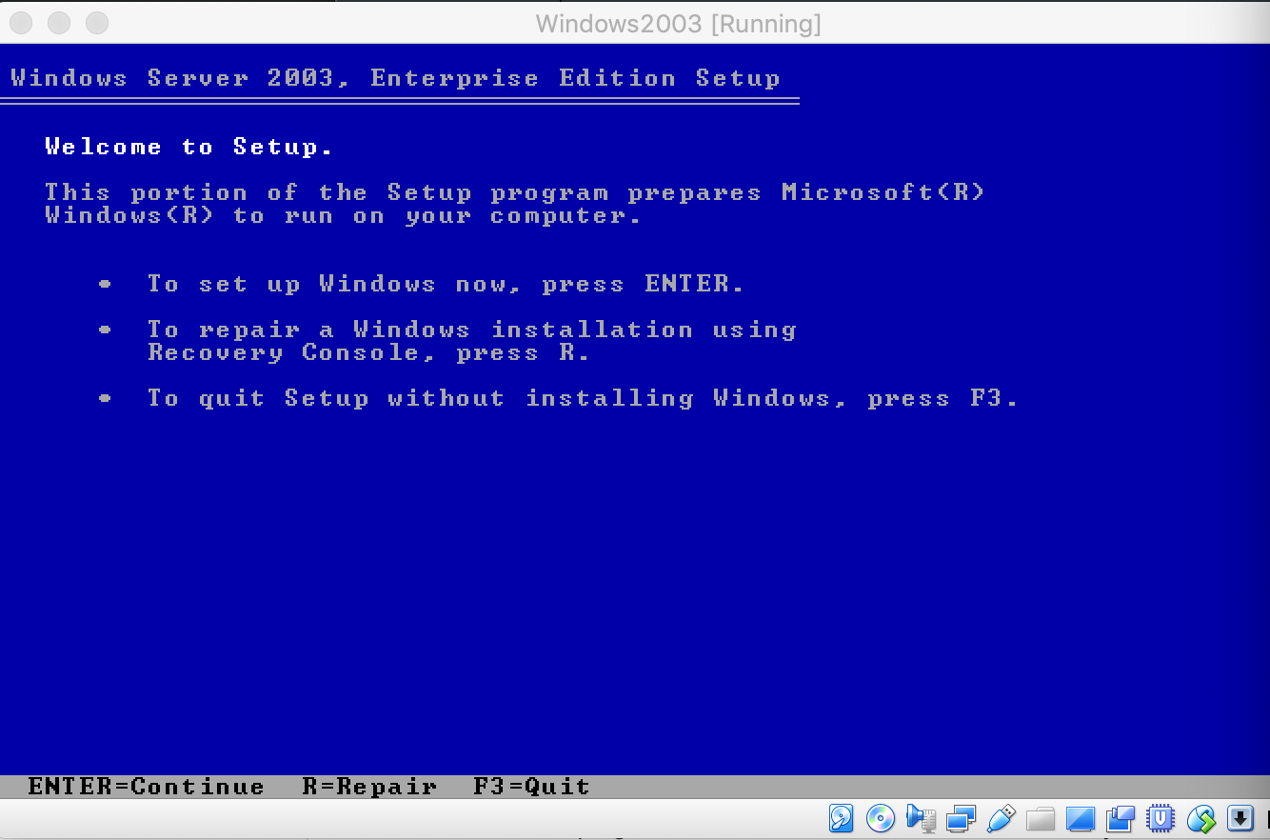

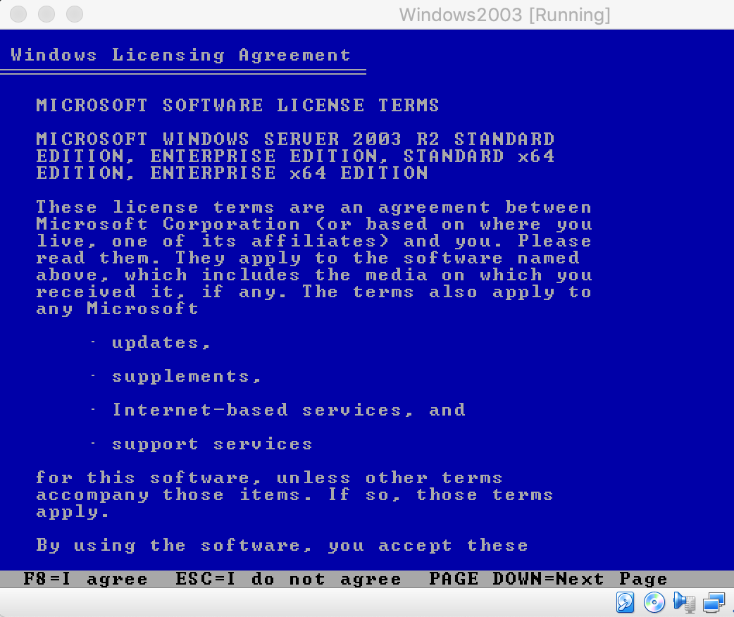

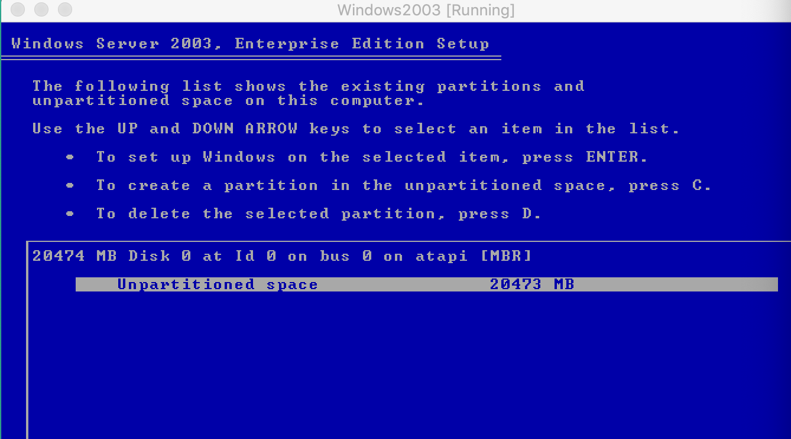

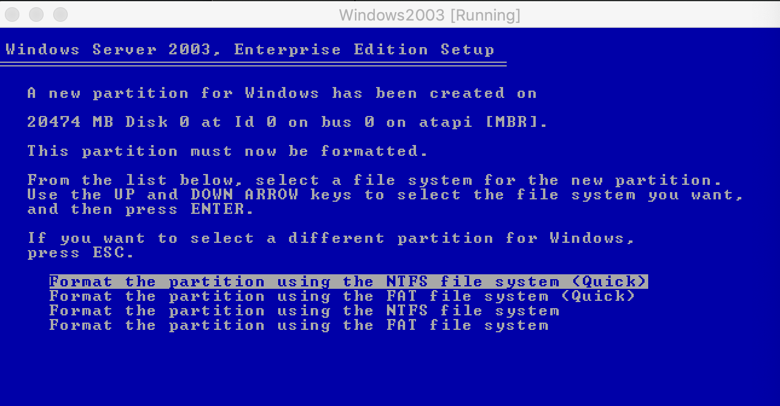

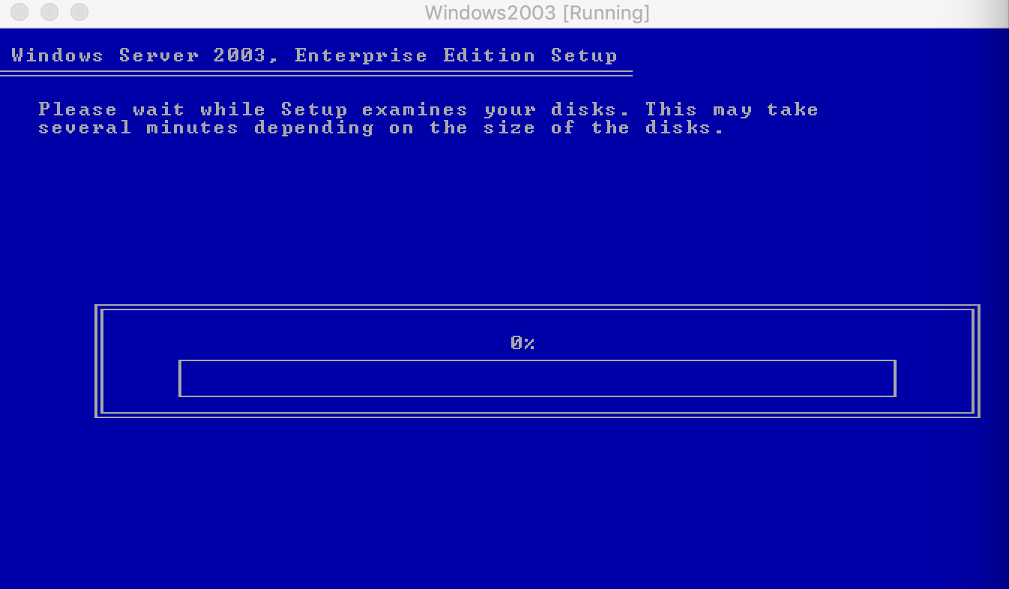

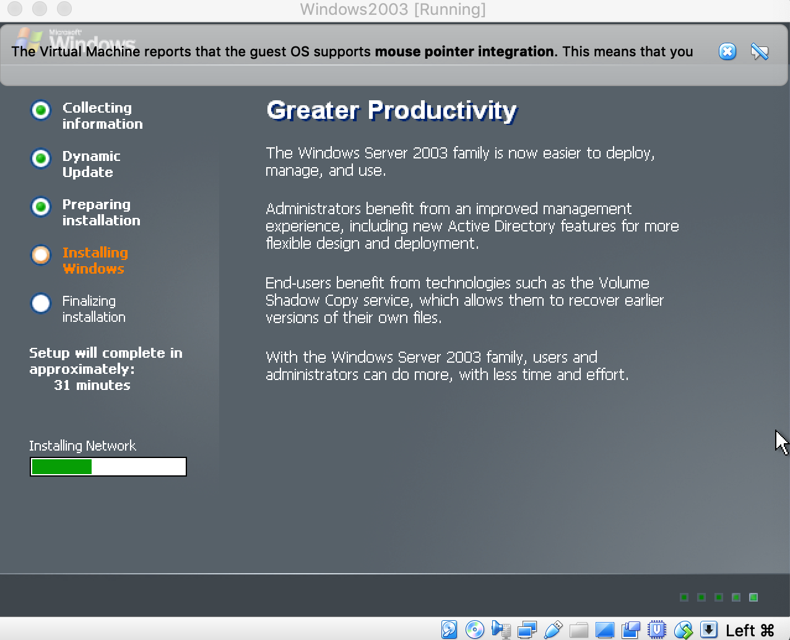

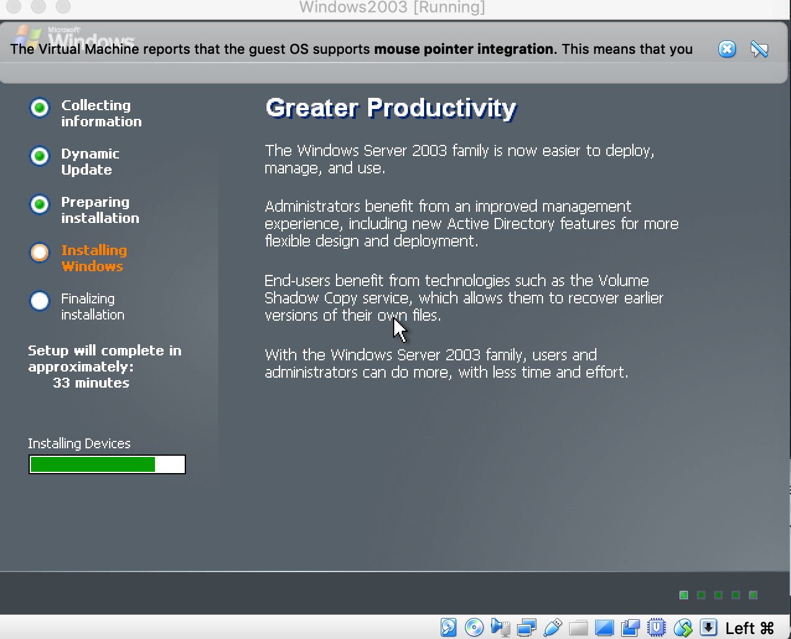

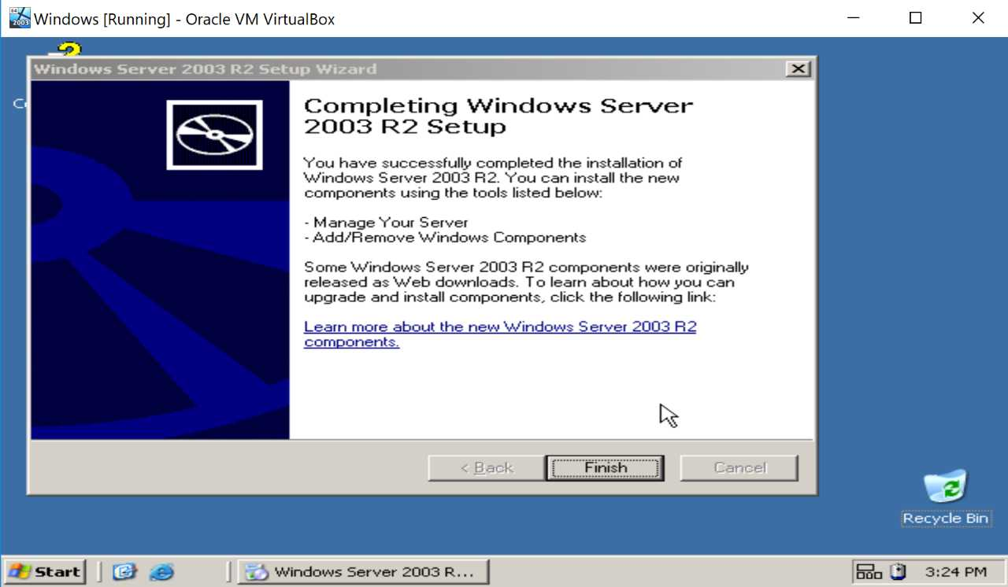

4) Below is the Metasploitable2 virtual machine verification. The first screenshot shows the screen of what happens when you start the virtual machine from VirtualBox. The user must verify with entering the correct login and password which are given to you in the prompt. After logging into Metasploitable, I used the command “ifconfig” to make sure the machine is functioning properly.

