1) The screenshot below shows the Linux command used to add a new user “Kelli” on my Kali machine. I then used the “passwd Kelli” command to customize a password for the user “Kelli.

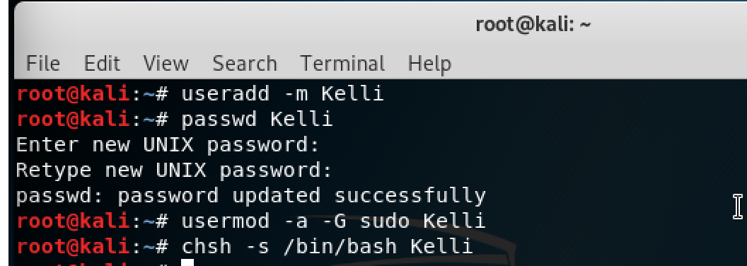

* The screenshot below confirms that the new user “Kelli has been added.

Macintosh HD:Users:Kelli:Desktop:Screen Shot 2019-02-15 at 12.37.40 PM.png

* The screenshot below is the command I used to switch from root to Kelli. It confirms that I am now logged in as Kelli.

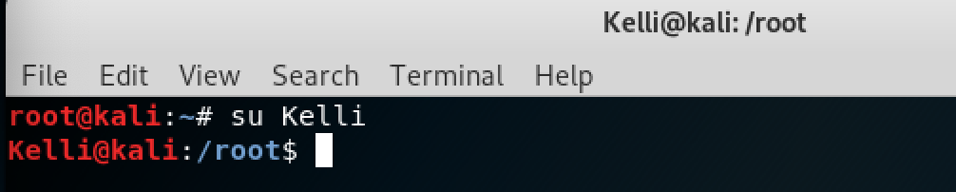

2) The screenshot below shows the command I needed to use in order to create a new file named “file1”. I included the second command “ls –a” to confirm that file1 has been added to the /root/Documents directory.

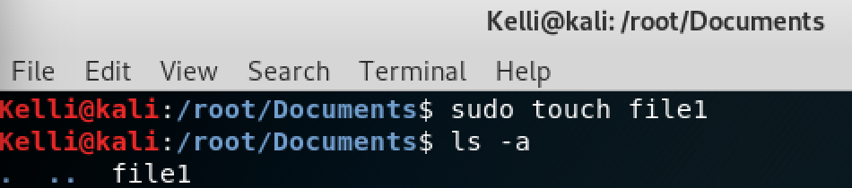

* The screenshot below shows the command you need to use to edit file1. I chose to use the “nano” editor.



* The screenshot below shows the content inside my file1. It shows my keyword listed 10 times.

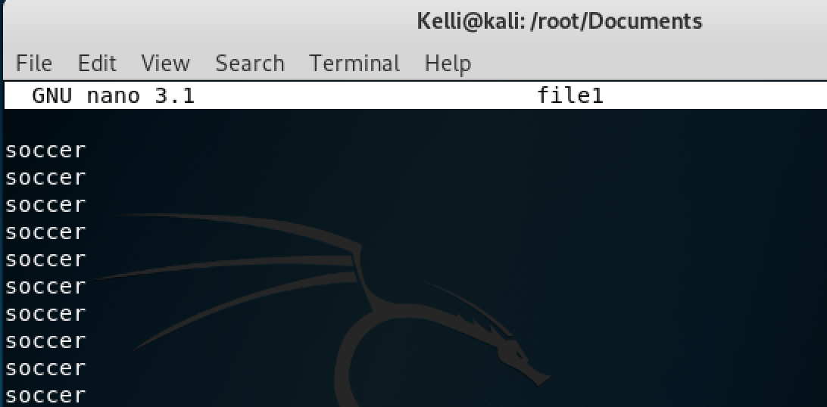

* To change the permissions of file1 so that it can only be read, written, and executed by its owner, I used the “chmod” command. 7 represents read, write, execute for owner, while the two 0’s don’t give any permissions to group or others.

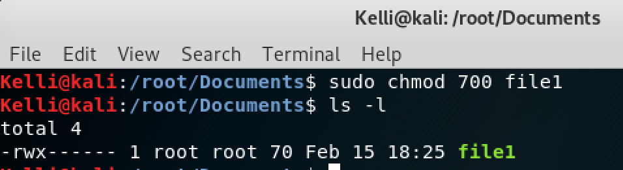

3) The screenshot below shows the command I needed to use in order to create a new file named “file2”. I included the second command “ls –a” to confirm that file2 has been added to the /root/Documents directory.

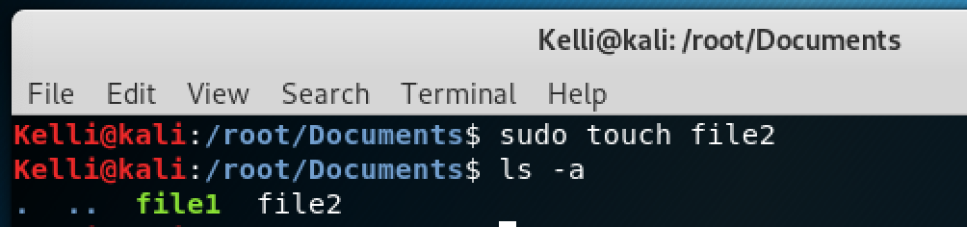

* The screenshot below is the command I used to retrieve all instances of my keyword from file1 and output all the instances to file2.

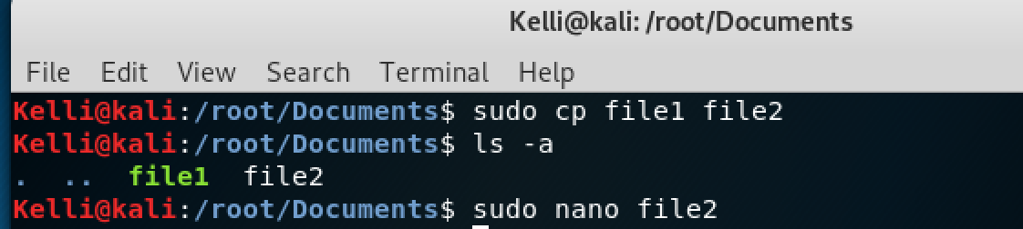

* The screenshot below confirms that the content from file1 has been copied and pasted into file2.

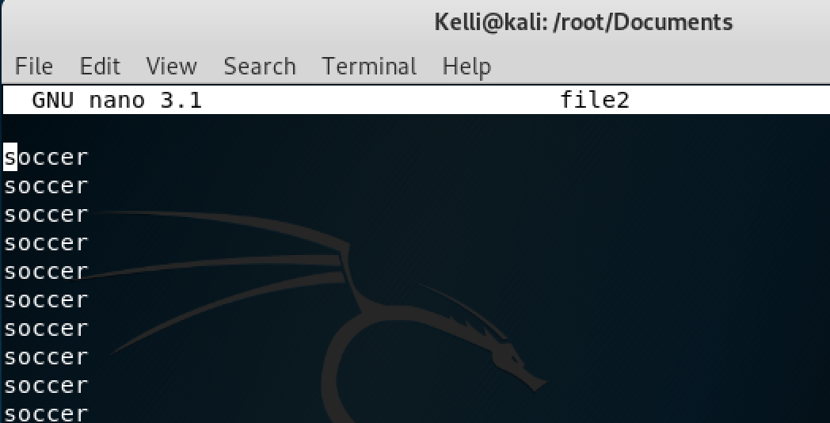

4) In order to transfer file2 between a listener and a listenee using netcat, I first opened my Metaploitable machine and ran this command: “ nc -1p 1234 >file2

* Then I ran this command on my Kali machine: “ nc –w 192.168.56.101 1234 > file2
* To find out the transmission rate I used the following command on my Kali machine: “time yes|nc –v –v –n 192.168.56.101 2222 > file2

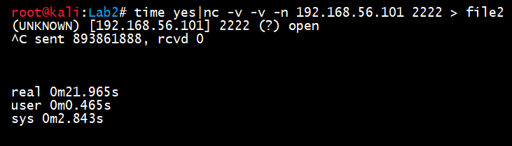

Kali machine sent 893861888 bytes while my Metasploitable machine received 893862648 bytes. I multiplied this by 8 to see the number of bits, which is 7,150,901,184. This number divided by the time of 21.965s equals 325,558,897.52 bits/sec or 40.69 Mb/Sec

5) The screenshot below is the command used to get into the file that is used for adding new cron jobs/tasks.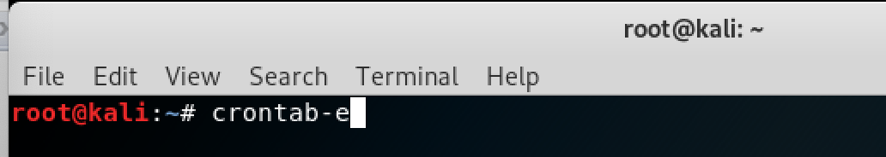

* The last line in this file is the cron task I created that will be executed the 15th minute of every hour.

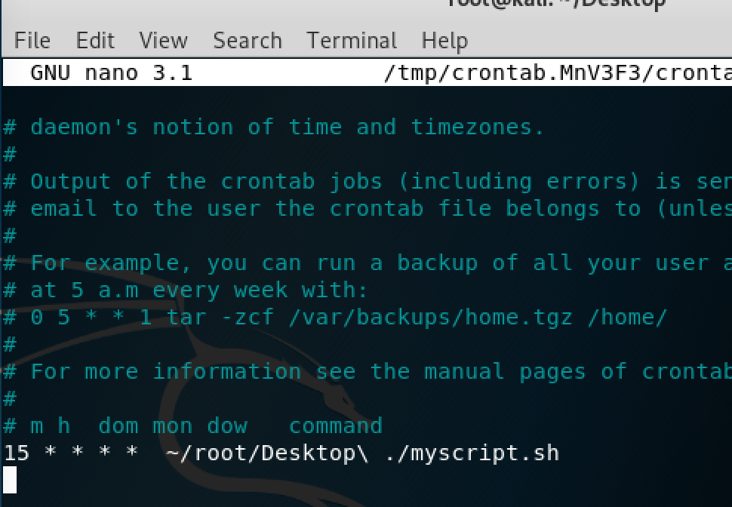

* Below is a very simple bash script that I created called “myscript.sh”. It is under the /root/Desktop directory. In order to create this script I used the “sudo touch myscript.sh” command. Then to edit the script, I used “ sudo nano myscript.sh

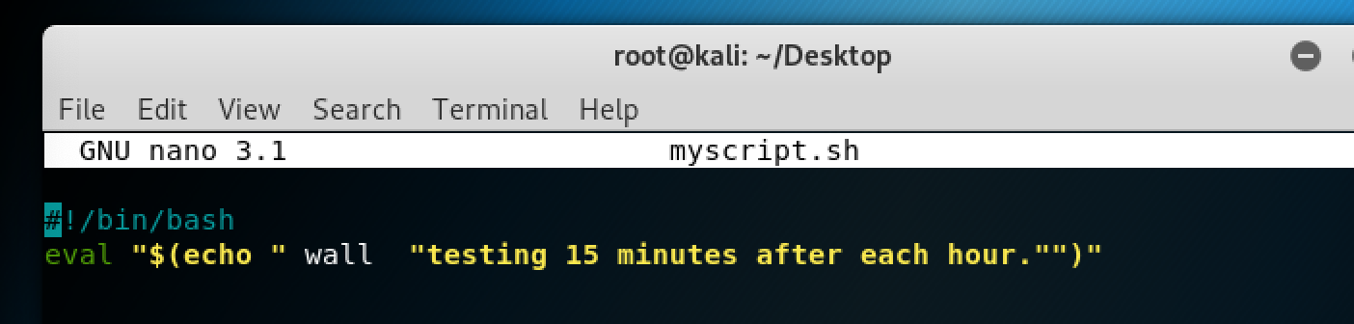

* In order to run a bash script you need to compile it. The “chmod + x(execute)” name of script allows a change in permission and lets a user compile the script. The “./myscript.sh” command is the actual command that runs the script.

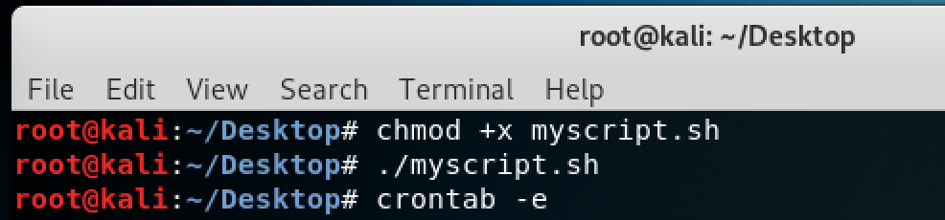

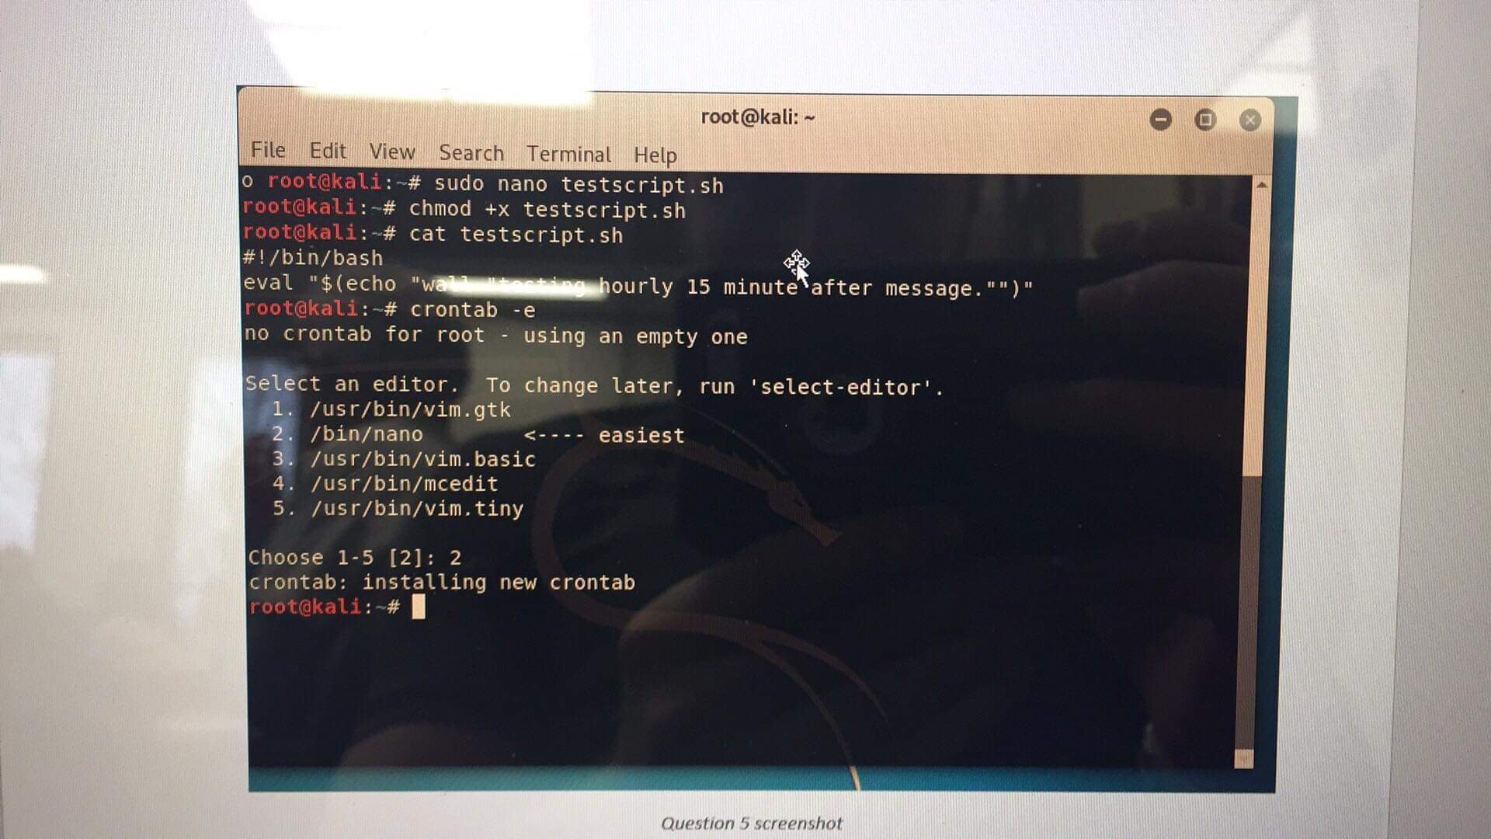

* Verification that shows the cron task will be executed properly. “crontab: installing new crontab”.