Table of Contents

Automation Prerequisite 1

Automation Execution 1

1) On Sauce Labs 1

PS C:\Projects\ProtractorDemo> protractor conf\conf_SAUCE.js --specs .\suits\newFeature\CommandCenter.spec.js 1

2) On Selenium Grid 2

Start Grid 2

Start Node 3

PS C:\Projects\ProtractorDemo> protractor conf\conf_SELGRID.js --specs .\suits\regression\CommandCenter.spec.js 4

Test result 6

Page Object Model 6

# Automation Prerequisite

1. C:\ProgramData\ChromeDriver_81\chromedriver.exe
2. C:\Projects\ProtractorDemo\resources\GridServer\selenium-server-standalone-3.4.0.jar
3. Sauce Lab user / Key
4. Editor – Visual Source Safe
5. Node.js
6. Packages - Webdriver, protractor, protractor-jasmine-html-reporter

# Automation Execution

## 1) On Sauce Labs

### PS C:\Projects\ProtractorDemo> protractor conf\conf_SAUCE.js --specs .\suits\newFeature\CommandCenter.spec.js

[13:30:03] I/launcher - Running 1 instances of WebDriver

[13:30:03] I/sauce - Using SauceLabs selenium server at https://ondemand.saucelabs.com:443/wd/hub

Started

Command Center TC 1 Passed

.Command Center TC 2 Passed

.

2 specs, 0 failures

Finished in 10.805 seconds

[13:30:21] I/sauce - SauceLabs results available at http://saucelabs.com/jobs/5772f2777e5d4b128abca5ebee8e3236

[13:30:22] I/launcher - 0 instance(s) of WebDriver still running

[13:30:22] I/launcher - chromelatest #01 passed

## 2) On Selenium Grid

java -jar selenium-server-standalone-3.4.0.jar -role hub -host localhost

### Start Grid

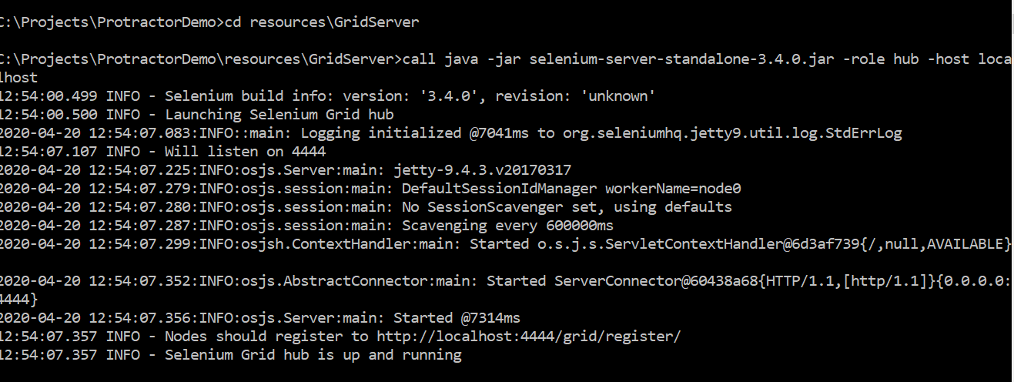

Verify the Selenium Grid is started

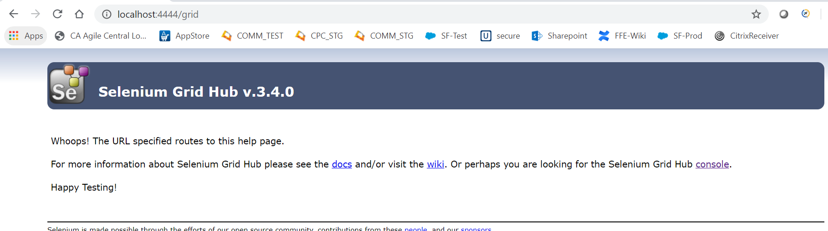

Click on console

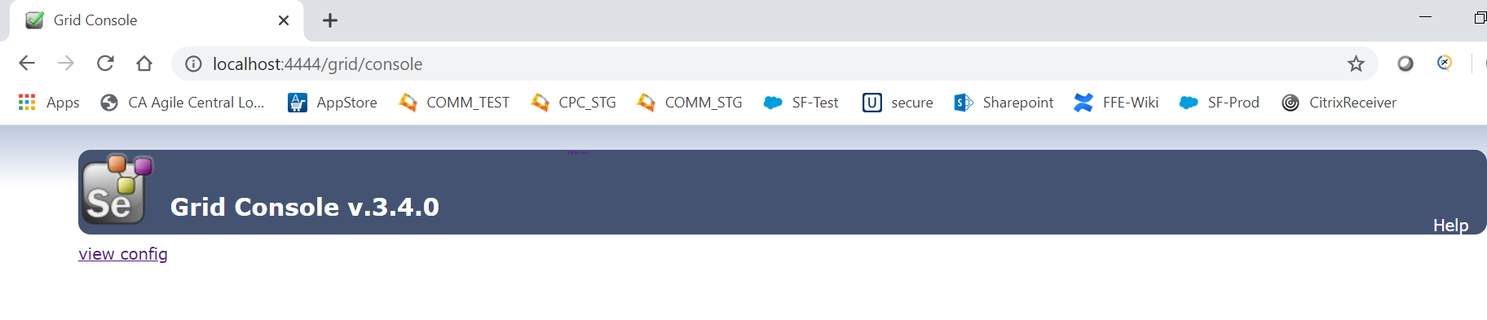

### Start Node

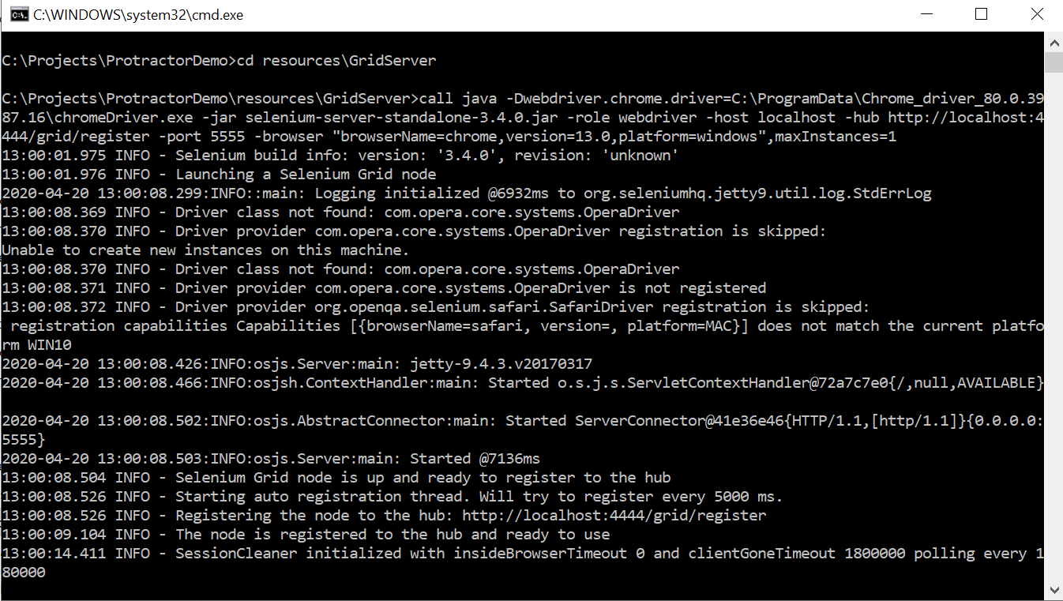

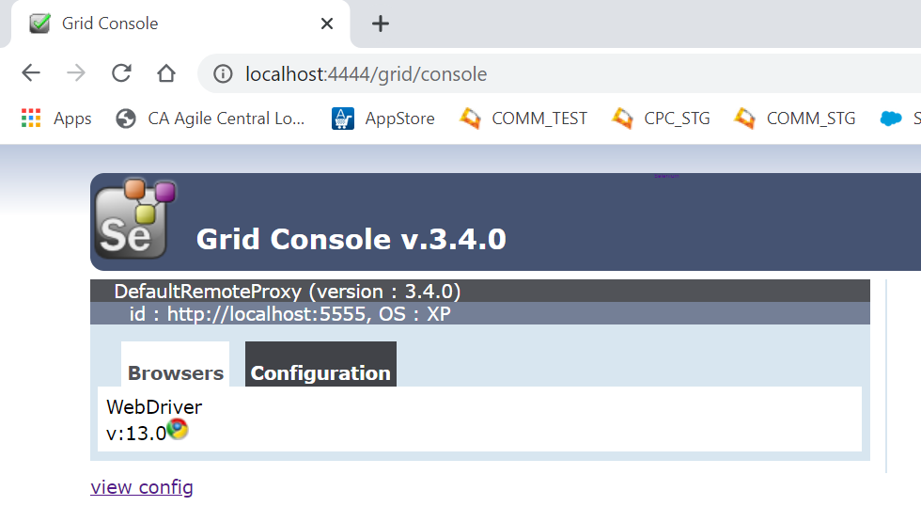

Execution

### PS C:\Projects\ProtractorDemo> protractor conf\conf_SELGRID.js --specs .\suits\regression\CommandCenter.spec.js

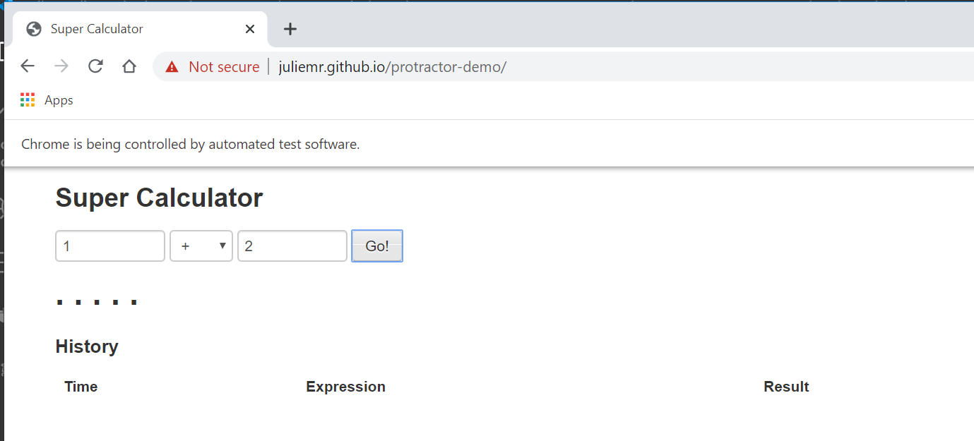

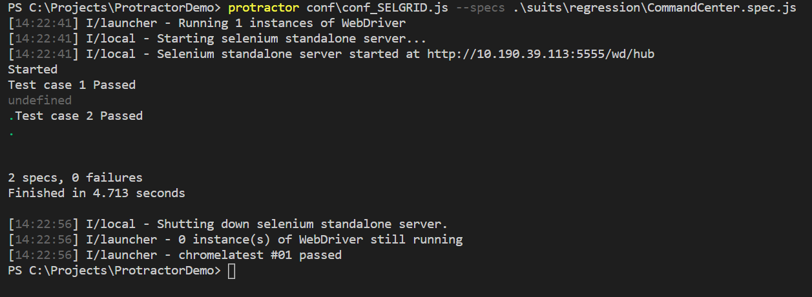

In case of Failed Testcases

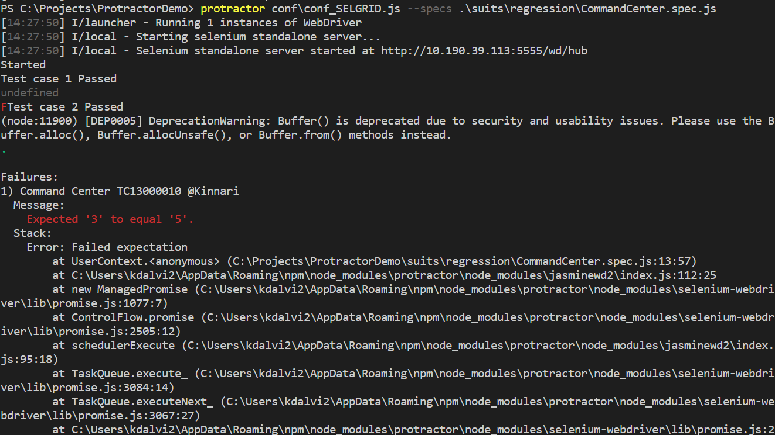

The screen shot will be available at

C:\Projects\ProtractorDemo\screenshots

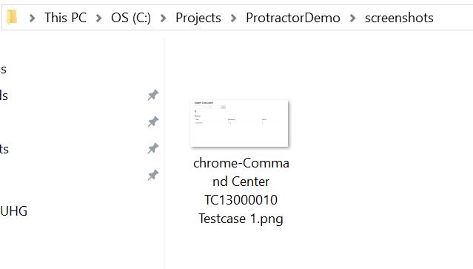

# Test result

will be available at Project folder

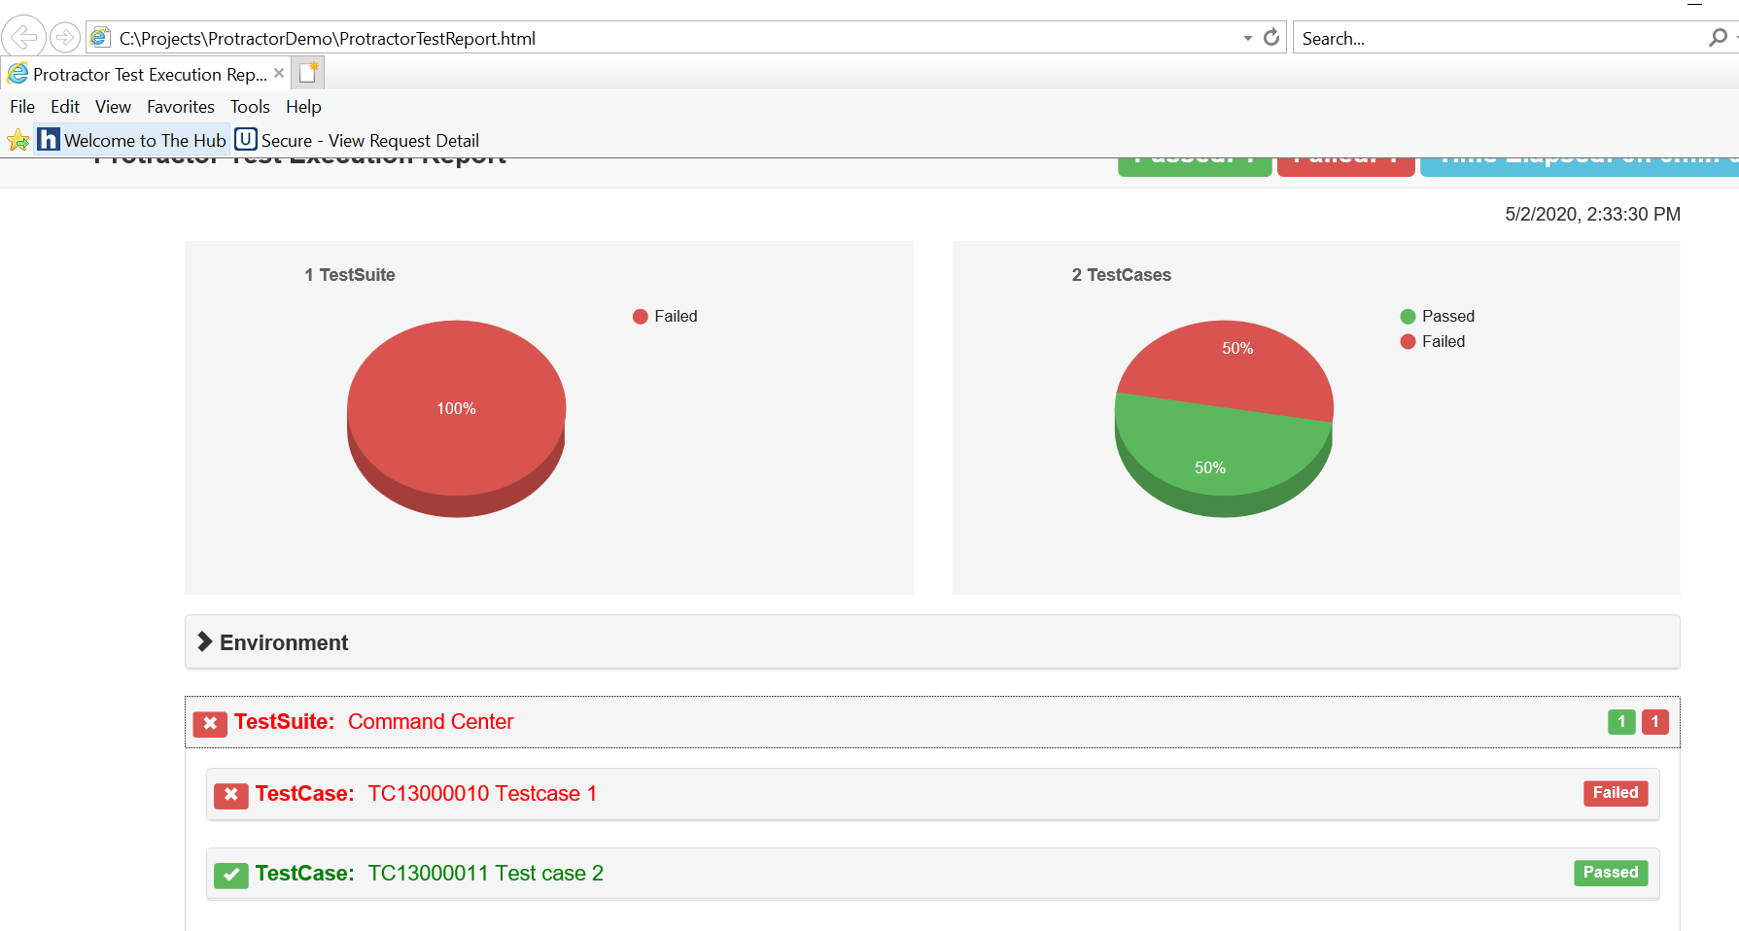

# Page Object Model

is implemented

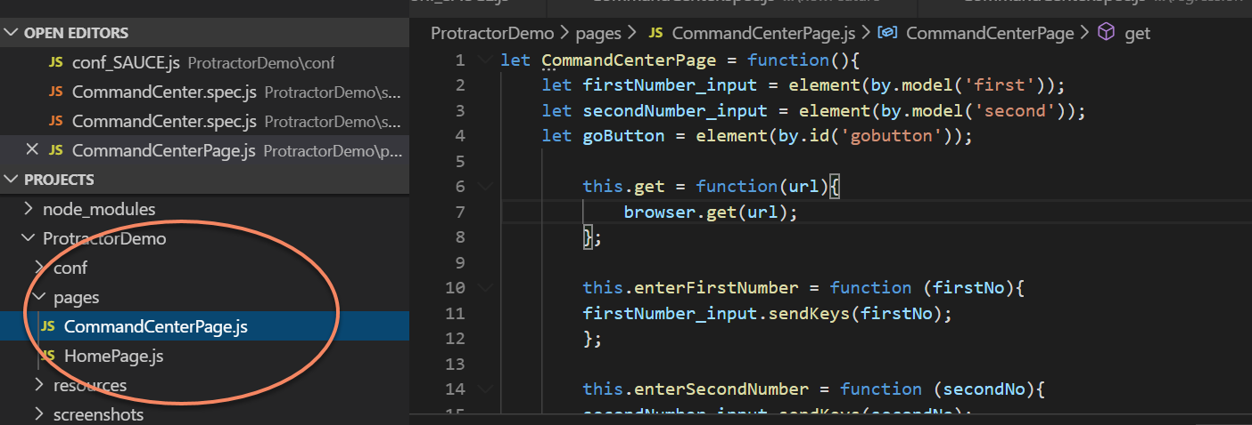

And exporting

let CommandCenterPage = function(){

    let firstNumber_input = element(by.model('first'));

    let secondNumber_input = element(by.model('second'));

    let goButton = element(by.id('gobutton'));

        this.get = function(url){

            browser.get(url);

        };

        this.enterFirstNumber = function (firstNo){

        firstNumber_input.sendKeys(firstNo);

        };

        this.enterSecondNumber = function (secondNo){

        secondNumber_input.sendKeys(secondNo);

        };

        this.clickGo = function(){

            goButton.click();

        };

        this.verifyResult = function(result) {

            let out = (element(by.binding('latest')));

            expect(out.getText()).toEqual(result);

            console.log("Test By KD Executed on Command Center" + out + "Pass")

        };

};

module.exports = CommandCenterPage;

Import In Test “**CommandCenter.spec**” as

var CommandCenter = require('../../pages/CommandCenterPage.js');

var commandcenter = new CommandCenter();

// spec.js

describe('Command Center', function() {

  //TC13000010 Verify Feature Command Center 1

      it('TC13000010 Testcase 1', function() {

        commandcenter.get('http://juliemr.github.io/protractor-demo/');

        commandcenter.enterFirstNumber(1);

        commandcenter.enterSecondNumber(2);

        commandcenter.clickGo();

        expect(element(by.binding('latest')).getText()).toEqual('5');//This is to Fail

        console.log("Test case 1 Passed");

      });

    //TC13000011 Verify Feature Command Center 2

      it('TC13000011 Test case 2 ', function() {

        browser.get('http://juliemr.github.io/protractor-demo/');

        expect(browser.getTitle()).toEqual('Super Calculator');

        console.log("Test case 2 Passed");

      });

});