Day 31 – Azure VM Scale Set Hands-On

1. Apache_output (Application Running)
The application was successfully accessed using the Public IP address of the Load Balancer. When the IP address was entered in the browser, the custom application page 'LiftShift-Application' was displayed.
Screenshot 1: Application running in web browser
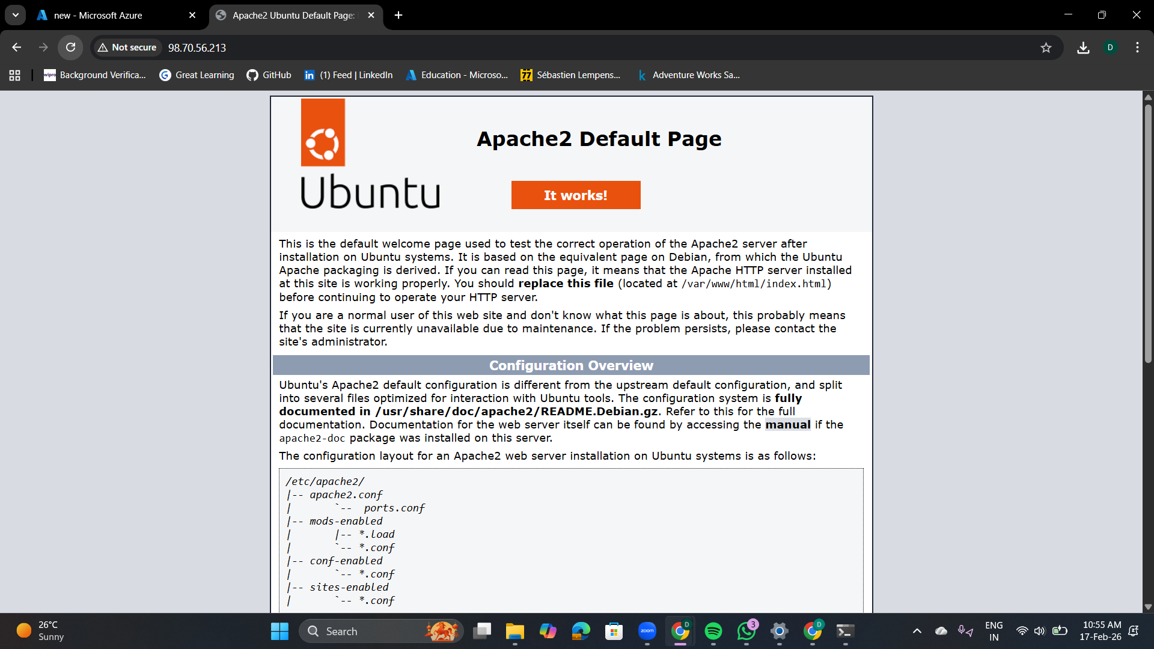

2. SSH Connected
SSH connection was successfully established using the downloaded private key (.pem file). The Ubuntu terminal was accessed using the azureuser account, confirming that port 22 is properly configured.
Screenshot 2: SSH terminal connected to VM
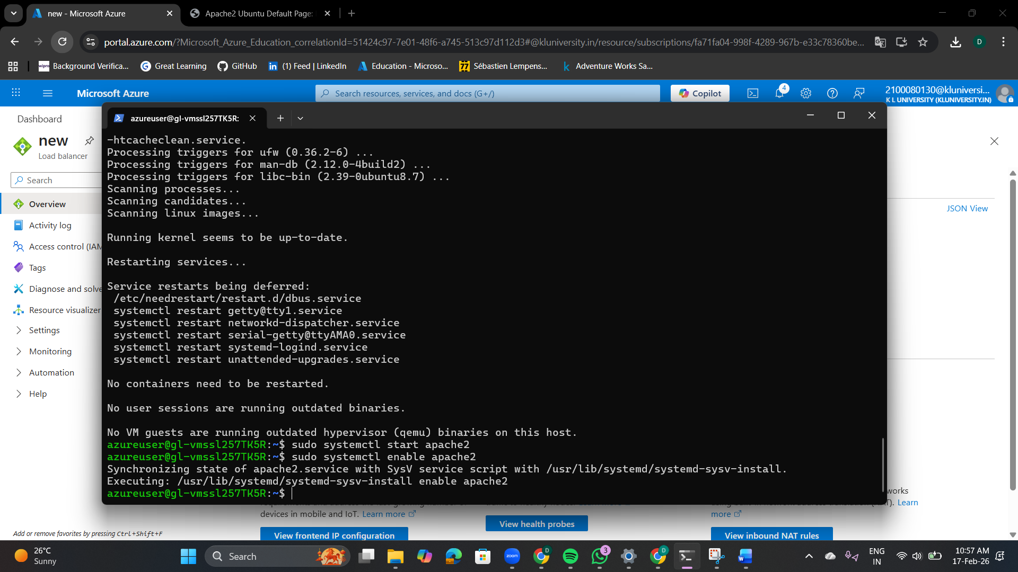

3. VM_Running
The VM Scale Set Instances section shows that two virtual machine instances are running and healthy. This confirms successful deployment and scaling configuration.
Screenshot 3: VM Scale Set instances showing Running status
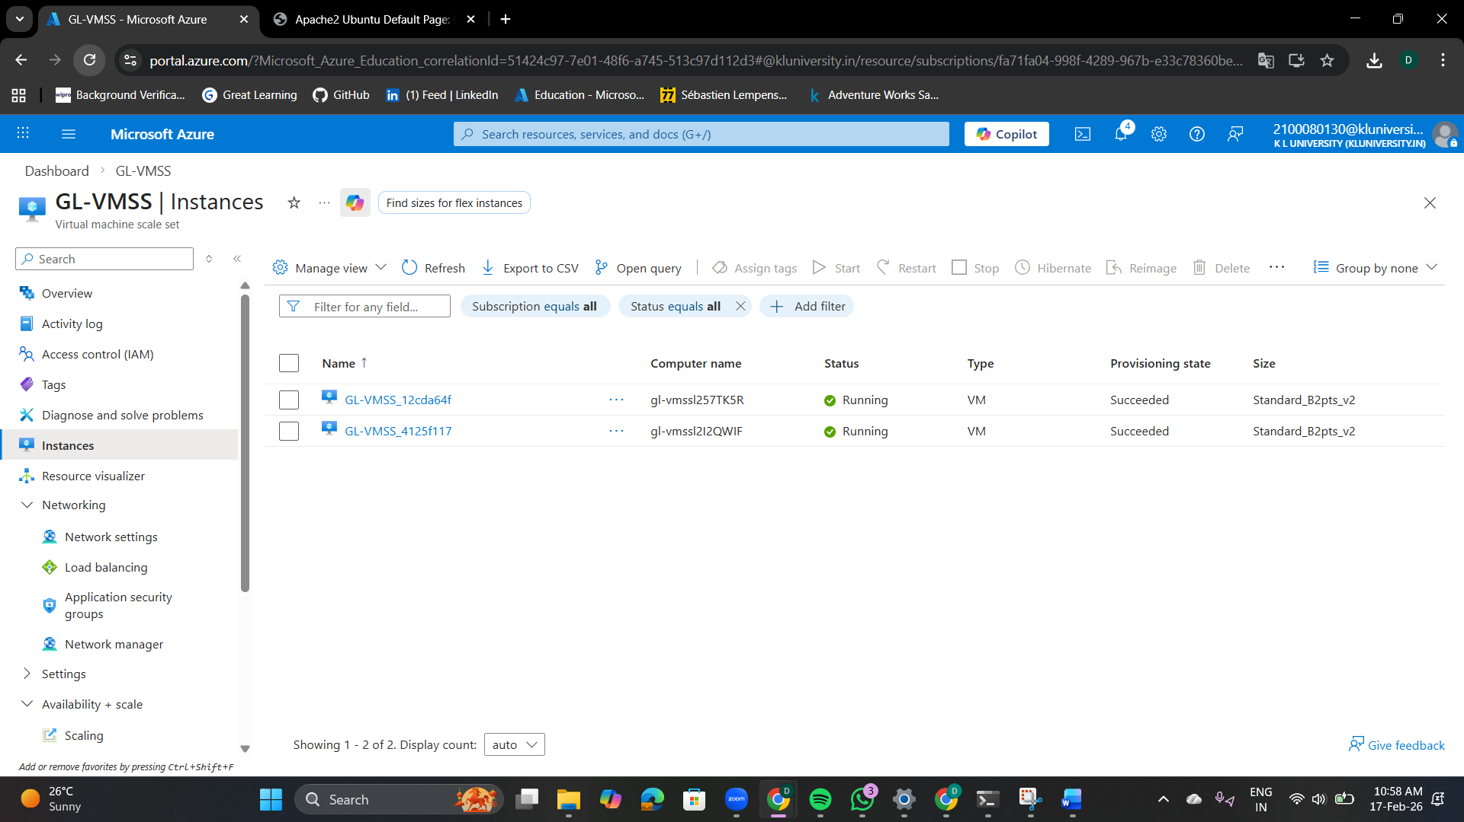

4. Deleting Resources
After successful testing, the resource group GL-VMSS-RG was deleted to prevent additional charges. All associated resources including VMSS, Load Balancer, Virtual Network, and Public IP were removed.
Screenshot 4: Resource group deletion confirmation
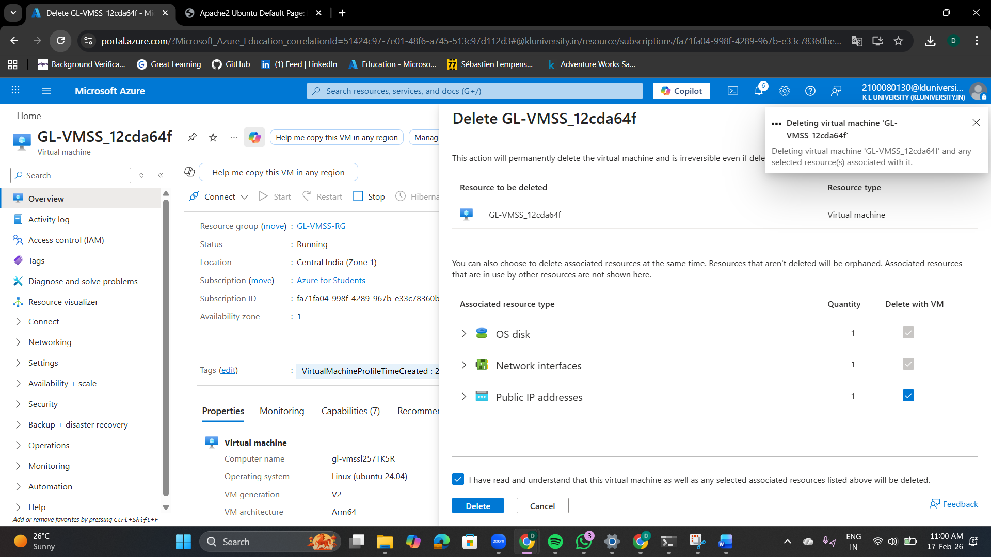

Conclusion
The VM Scale Set was successfully created, the custom application was deployed using a bootstrap script, firewall rules were configured, the application was accessed through a web browser, SSH connectivity was verified, and all resources were deleted properly.

