EduPulse Discover and AI Student Services
  - Product and implementation specification
Document purpose | Primary audience | Recommended release path
Define a trusted personalized learning and opportunity feed for students. | Product, engineering, college coordinators, and leadership. | Reliable content MVP first, then personalization, then AI expansion.

1 Executive Summary
EduPulse should become a personalized learning and opportunity feed where students can quickly find relevant, trustworthy information without searching across Instagram, WhatsApp groups, websites, and notice boards. The product should use its own approved content ecosystem rather than copying or scraping social-media reels.
The recommended release strategy is deliberate: build a reliable Discover feed with verified content and clear targeting first; introduce simple rule-based personalization once interaction data exists; then add AI agents that can search approved content, explain material, organize deadlines, and support student learning under strict permissions.

Product Decisions
Decision | Rationale
Own the content feed | Accept uploads and permitted links from teachers, colleges, partners, and students instead of using Instagram as the primary source.
Trust before personalization | Every opportunity needs its source, deadline, eligibility, author, and verification state before it reaches a student feed.
Start with transparent scoring | Use branch, interests, engagement, freshness, and verification signals before attempting a complex AI recommendation model.
Keep AI inside the backend | React never receives AI provider secrets or direct access to private student records. Spring Boot controls all data retrieval and actions.

2 Product Vision and Scope
The product promise is simple: students should open EduPulse and see at least one useful learning item, verified announcement, or time-sensitive opportunity within seconds.

First Release Scope
Capability | First release | Later enhancement
Content | 30 to 90 second learning videos, opportunity cards, official notices, and text summaries. | Creator following, learning series, rich articles, and external partner feeds.
Trust | Coordinator review, verification badges, source URL, deadline, eligibility, and last verified date. | Audit workflows, automated stale-content alerts, and institution-level verification.
Feed | For You, Learn, Opportunities, Official, Latest, and Saved sections. | Multi-objective ranking, creator diversity, semantic discovery, and localized feeds.
Student actions | View, like, save, share, report, and create reminder requests. | Applications tracker, peer study groups, and goal-based learning paths.
AI | Search approved content, explain a reel, generate practice questions, and show saved deadlines. | Transcripts, content tagging, duplicate detection, semantic recommendations, and career-roadmap coaching.

Out of Scope for the First Release
- Scraping, copying, or re-uploading Instagram content without permission.
- An autonomous AI system that publishes notices, declares an opportunity genuine, applies on a student’s behalf, or sends notifications without confirmation.
- A black-box recommendation algorithm that cannot be explained or adjusted by the product team.

3 Student Experience

Onboarding and Personalization Inputs
During registration or the first Discover visit, ask for course, branch, year of study, interests, preferred language, and career goal. Keep this concise and editable. A student who skips onboarding should receive popular verified content rather than an empty screen.
Discover section | Student value | Primary content
For You | A focused starting point based on profile and activity. | Relevant learning reels, verified notices, and timely opportunities.
Learn | Short educational explanations by subject and skill level. | Coding, exam preparation, concepts, and study tips.
Opportunities | A trustworthy place to find deadlines and application details. | Internships, scholarships, placements, competitions, and events.
Official | Information students should not miss. | College and department notices from approved staff.
Saved | A personal action queue. | Saved reels, opportunity cards, and reminder-linked items.

Representative Student Journey
- A B.Tech CSE student chooses Java, SQL, React, AI, placements, English, and internship as profile preferences.
- The student opens Discover and sees a Java Streams reel, SQL practice prompts, an eligible internship card, and a verified department notice.
- The student saves the internship, asks EduPulse to summarize the eligibility, and chooses a reminder one day before the deadline.
- The feed later favors related topics while preserving space for urgent official notices and new verified items.

4 Content Trust and Moderation
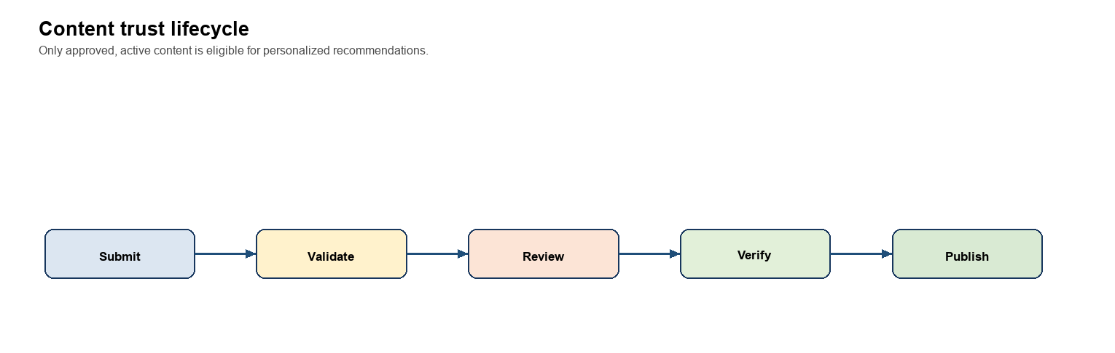
Figure 1. Content moves through a controlled lifecycle before it can affect a student feed.
Content may be created by students, faculty, coordinators, colleges, partner organizations, educational creators, or the EduPulse editorial team. Public educational sources may be linked or referenced where permissions allow. Public content should be original or used with clear permission; the platform should not rely on copied social-media media.

Roles and Permissions
Role | Allowed actions | Not allowed
Student | Watch, search, save, like, submit, report, and request reminders. | Approve content, verify their own submission, or access another student’s saved items.
Faculty | Submit learning content and see their review status. | Publish institution-wide official notices unless explicitly granted the coordinator role.
Coordinator | Review department content, approve or reject, and publish official notices. | Approve content outside their college or department scope.
Admin | Manage categories, users, reports, verification policy, and audit logs. | Bypass recorded source and verification requirements for opportunities.

Required Opportunity Fields
Internship, scholarship, placement, competition, and event content must include a source link, organization, deadline, eligibility, target audience, posted-by record, verification level, and last verified date. The UI should display these details prominently and state that eligibility matches are likely matches, not guaranteed approval.

5 Technical Architecture
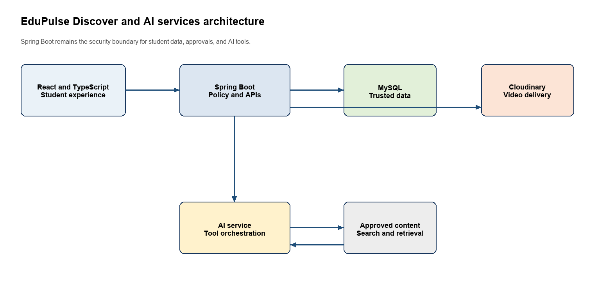
Figure 2. Core architecture. Spring Boot is the policy boundary for identity, approved data, Cloudinary signing, and AI tools.
The initial architecture is React and TypeScript for the student and staff experience; Spring Boot for APIs, authorization, recommendation logic, and AI orchestration; MySQL or Railway SQL for trusted metadata and interaction history; and Cloudinary for video storage, transformations, thumbnails, and delivery.

Cloudinary Video Upload Flow
- React asks Spring Boot for a short-lived upload signature.
- Spring Boot authenticates the JWT, checks the role and upload limits, and returns signed Cloudinary parameters.
- React uploads the file directly to Cloudinary and shows progress.
- React sends the returned public ID, URLs, thumbnail, and metadata to Spring Boot.
- Spring Boot creates a PENDING content item; it becomes visible only after review and approval.
- MVP limits: maximum file size 100 MB, accepted formats MP4, MOV, and WebM, duration at most 90 seconds.
- When a video is unavailable, show its thumbnail, title, explanation, retry, and report controls. Do not show a blank black reel.

6 Data Model
Use version-controlled MySQL migrations. The database is the trusted source of state; it must not be reconstructed from browser local storage or client-supplied user IDs.
Table | Purpose | Key fields
users | Identity and role records. | id, college_id, role, status, created_at
student_preferences | Editable student targeting profile. | user_id, course, branch_id, year_of_study, languages, interests, career_goal
content_items | Single source of truth for every feed item. | author_id, content_type, title, video_url, status, verification_level, deadline_at, published_at, expires_at
content_targets | Controls audience eligibility. | content_id, college_id, course, branch_id, year_of_study
content_tags | Subject and recommendation tags. | content_id, tag_id
content_interactions | Records view, like, share, save, and report signals. | user_id, content_id, interaction_type, occurred_at
saved_content | Fast, explicit saved state. | user_id, content_id, saved_at
content_reviews | Review decision and audit trail. | content_id, reviewer_id, decision, reason, reviewed_at
content_reports | Safety and quality review queue. | content_id, reporter_id, reason, status, resolved_at
notifications | Scheduled and delivered reminders. | user_id, content_id, type, scheduled_at, delivered_at, preference_state

Content Item Metadata
Every content item should support title, description, creator, subject, course, branch, difficulty, tags, language, duration, view count, likes, created date, published date, expiry date, source URL, source name, verification level, and Cloudinary public ID. Opportunity items additionally require deadline and eligibility details.

7 API Design
All protected endpoints derive the acting user from the validated JWT. Do not accept a userId query parameter or browser-stored role as authorization evidence.
Area | Endpoint | Purpose
Profile | GET /api/me | Return the authenticated user and allowed capabilities.
Preferences | PUT /api/me/preferences | Create or update learning, language, and career preferences.
Discover | GET /api/discover/feed?section=for-you&cursor=&limit= | Return a cursor-paginated, policy-filtered feed.
Content | GET /api/discover/content/{id} | Show the detail record, source, verification, and actions.
Search | GET /api/discover/search?q=&branchId= | Search approved content with safe filters.
Actions | POST or DELETE /api/content/{id}/like and /save | Record student actions against the authenticated student.
Reminder | POST /api/content/{id}/reminder | Create a reminder only after the student confirms timing.
Upload | POST /api/uploads/signature | Return a short-lived, authorized Cloudinary upload payload.
Creator | POST /api/content and GET /api/content/mine | Submit and manage the creator’s own content.
Review | GET /api/review/pending and POST /api/review/{contentId}/approve | Controlled moderator queue and decision endpoints.

8 Recommendation Design
Recommendation begins with filtering, then transparent scoring. Filtering prevents ineligible, pending, expired, or wrongly targeted content from entering the candidate set. Scoring then orders valid candidates for the student.

Eligibility Filter
- Status is APPROVED and the item is active and not expired.
- College, course, branch, year, and language targeting allow the student to receive it.
- The content complies with source and verification requirements for its type.

Initial Scoring Model
Signal | Score | Reason
Branch match | +40 | Makes the primary feed relevant to the student’s programme.
Selected-interest tag match | +25 | Respects the student’s explicit onboarding choices.
Previously watched or saved topic | +15 | Uses demonstrated interest without needing advanced AI.
Official or verified source | +10 | Promotes content with stronger trust signals.
Recently published | +10 | Keeps new content visible, especially time-sensitive opportunities.
Repeatedly watched | -20 | Reduces repetition after sufficient exposure.
Same creator saturation | -15 | Protects feed variety and prevents one creator from dominating.

Reserve feed capacity for urgent official announcements, opportunity deadlines, new verified content, and limited exploration outside the student’s usual topics. Show an explanation such as 'Because you selected SQL and saved Java content' when it can be stated simply and accurately.

9 AI Agents for Students
Start with one EduPulse Study and Discover Assistant. It should answer from approved EduPulse content and official links whenever possible. Additional agents should be introduced only after the underlying content, source checks, and student interactions are working reliably.
Agent | Student request | Permitted data and guardrail
Study and Discover Assistant | Find beginner SQL reels, explain a reel, create practice questions, or make a 7-day study plan. | Approved learning content, student preferences, saved items. Never invent sources or reveal other students’ data.
Opportunity Assistant | Show internships or scholarships I may be eligible for. | Verified opportunities, branch, year, and stated skills. Uses 'likely eligible', always shows source, deadline, and last-verified date.
Deadline Planner | What deadlines do I have this week? | The authenticated student’s saved items and official events. Must ask for confirmation before creating reminders or notifications.
Career Coach | What should I learn for a Java internship? | Career goal, declared skills, approved resources. Provides learning paths; never promises a job outcome.
Campus Information Assistant | When is the internal exam? | Only official academic calendar and approved college notices. Shows source and publication date.
Content Curator for staff | Suggest title, tags, transcript, summary, and target audience for an upload. | Upload metadata and transcript. A human remains responsible for approval and verification.

Restricted AI Tool Contract
Backend tool | Purpose | Authorization rule
getMyStudentProfile | Read the current student’s editable preferences. | JWT identity only; return the minimum fields needed.
searchApprovedLearningContent | Find approved learning items. | Apply content targeting and active-status filters before returning results.
searchVerifiedOpportunities | Find relevant active opportunities. | Return source, deadline, eligibility, and verification facts with each item.
getMyDeadlines | List the student’s saved reminders and verified deadlines. | Never reveal another student’s calendar or saved items.
getOfficialCollegeNotices | Retrieve official notices for the student’s scope. | Restrict to the student’s college and department audience.
prepareReminder | Prepare a reminder action. | Do not persist or notify until the student explicitly confirms.

- The AI must not publish notices, verify scholarships, change user data, send notifications, delete items, or apply to opportunities without explicit user confirmation and backend authorization.
- AI provider credentials remain in server-side configuration. The React client calls Spring Boot, not the model provider directly.

10 Data Visualization and Analytics
Use analytics to improve student outcomes and content quality, not to create a busy dashboard. Every chart should answer one decision question, provide a readable text alternative, and avoid exposing private student-level data to staff who do not need it.

Recommended Tooling
Tool | Use in EduPulse | Recommendation
Recharts | React student and staff product charts such as progress, weekly learning activity, and deadline timelines. | Use first. Its component model fits the existing React and TypeScript frontend.
Apache ECharts | Complex administrative views, large datasets, multi-series charts, and advanced visualization needs. | Adopt only if Recharts cannot meet a proven product requirement. Do not run both libraries for basic charts.
Metabase | Internal read-only operational dashboards over MySQL for the product, content, and leadership teams. | Use after the MVP for fast internal reporting, filters, and drill-downs without rebuilding every report in the application.

Recharts is a composable React chart library, Apache ECharts provides a broad set of chart types for more advanced data analysis, and Metabase supports interactive, filterable dashboards for internal teams. Reference links: https://recharts.github.io/en-US/ ; https://echarts.apache.org/en/index.html ; https://www.metabase.com/docs/latest/dashboards/start

Dashboard Plan
Audience | Decision supported | Useful visuals
Student | What should I study and act on next? | Weekly learning activity line chart, saved-deadline timeline, topic progress bars, and a clear upcoming-action list.
Coordinator | Is approved content reaching the intended audience and is moderation on time? | Pending-review count, approval turnaround, content coverage by branch, report-resolution trend, and deadline inventory.
Product and leadership | Is Discover useful and trusted? | Weekly active students, view-to-save funnel, reminder conversion, verified-content share, opportunity click-through, and retention cohorts.

Analytics API Principles
- Return aggregate measures for dashboards, for example GET /api/analytics/student-progress?range=30d and GET /api/admin/analytics/content-quality?collegeId=.
- Use server-side aggregation, date-range filters, and role-scoped datasets. Do not deliver raw interaction records to the browser simply to draw a chart.
- For every chart, include a table or accessible summary, meaningful labels, color-independent status cues, and a mobile-friendly fallback.

11 Security Privacy and Reliability
Area | Required control
Authentication | Issue and validate JWTs in Spring Boot. The backend reads the authenticated user from the token for every protected action.
Authorization | Apply role and college or department checks in services and repositories. Never trust role, permission, or user ID sent by React.
Secrets | Keep Cloudinary and AI provider secrets in backend environment configuration. Exclude them from source control, React builds, and browser storage.
Content safety | Require moderation, reporting, status transitions, audit records, source fields, and expiry dates for time-sensitive content.
Student privacy | Minimize data returned to AI tools and analytics. Access only the authenticated student’s own profile, reminders, and saved data.
Reliability | Provide loading, empty, error, unavailable-video, and retry states. A feed without a perfect match falls back to popular verified content.

12 Delivery Plan
Phase | Outcome | Exit criteria
1 Foundation | Secure identity, preferences, migrations, and feature structure. | JWT user derivation is enforced; admin fallback tokens and frontend secrets are removed; migrations run in a fresh environment.
2 Content MVP | Upload, approval, trusted metadata, and chronological Discover feed. | Creator can submit; coordinator can review; approved item appears only for its targets; unavailable video has a fallback.
3 Student value | Filters, saved content, likes, reports, reminders, and opportunity cards. | A student can save an official opportunity, review its source and deadline, and create a confirmed reminder.
4 Personalization | Interaction tracking and explainable rule-based For You ranking. | Feed respects targets, scoring rules, official-item reserve space, diversity, and fallback content.
5 AI and scale | Study assistant, curator, transcripts, and expanded recommendations. | AI tools enforce student scope; generated tags are reviewable; no privileged action happens without confirmation.

Quality and Security Test Plan
- A student cannot approve content, access another student’s saved items, or change the target audience through a manipulated request.
- A coordinator can approve only the content inside their authorized college or department scope.
- Expired opportunities disappear from student feeds and search results but remain auditable for staff.
- Upload validation rejects unsupported format, oversized file, invalid duration, or unauthorized role.
- Feed results include only APPROVED, active content that matches the student’s allowed targets.
- Missing media shows thumbnail, title, and recovery actions rather than a blank player.
- AI tool calls return only authorized data, and reminder creation requires explicit confirmation.
- Frontend tests use accessible labels and stable data-testid selectors rather than fragile exact-text selectors.

13 Measures of Success
Measure | Why it matters | Early target behavior
Time to useful item | Tests the core product promise. | A relevant verified item appears in the first feed load.
Verified-content share | Measures trust and moderation maturity. | Official and verified items are visible without drowning out learning variety.
Save and reminder rate | Signals practical student value beyond passive views. | Students save opportunities and return before deadlines.
Moderation turnaround | Protects freshness and creator experience. | Pending content receives an accountable decision quickly.
Return usage | Shows whether EduPulse becomes part of a student’s routine. | Students revisit Discover for learning, deadlines, and opportunities.

Definition of Done
The first meaningful release is complete when a student can open EduPulse, find a relevant learning reel or verified opportunity, understand its source and status, save it or set a confirmed reminder, and receive a feed that is targeted without exposing private data or relying on unapproved external media.

