Knowvia AI Agents and Implementation Roadmap
  - Application assessment and practical next steps
Purpose | Document structure | Evidence reviewed
Turn the current application into a reliable student platform. | Part One AI agents. Part Two product and engineering implementation. | React frontend, Spring Boot service, test assets, build output, and the existing product design.

Executive Direction
Knowvia already has the beginnings of a campus platform: a React and TypeScript frontend, a Spring Boot service, Cloudinary media handling, JWT session support, role concepts, notifications, automated browser tests, and monitoring assets. The next release should not begin with an advanced AI recommender. It should first make the current platform trustworthy, persistent, and maintainable.
This roadmap separates work into two product tracks. Part One describes AI agents that directly help students. Part Two lists the security, content, user experience, data, and delivery work that must be completed so those agents and the wider platform have reliable information to use.
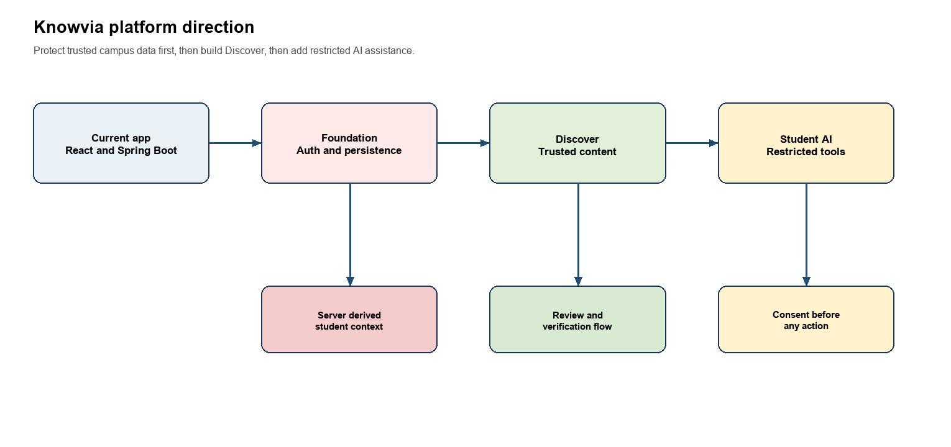
Figure 1. Recommended order of delivery for Knowvia.

Current Application Assessment
What is available now | Why it is useful | What needs attention next
React Vite frontend | The TypeScript check and production build completed successfully. The current build produces a single initial JavaScript bundle of about 650 KB before gzip. | Split the 12631 line src front tsx screen into feature modules and lazy-load less frequently used screens.
Spring Boot service | The service includes JWT parsing, user roles, Cloudinary integration, MySQL entities, caching, notifications, audit records, tests, Prometheus, and Grafana assets. | Keep this codebase as the backend source of truth. Consolidate the backend source into one clearly named Knowvia service location before adding major features.
Tech and Culture reels | A vertical video feed, uploads, thumbnails, retry states, likes, saves, and reminders are already represented in the UI. | Turn this into Discover with educational content types, verified metadata, moderation, and student-specific targeting.
Tests and audits | Playwright, Lighthouse, k6, JaCoCo, and an OWASP header audit are present. | Repair the Maven wrapper test command, then run frontend and backend tests automatically for every release.

Critical Foundation Findings
Finding | Observed in the current app | Required decision
Authorization is incomplete | The JWT filter exists, but the global Spring Security rule permits every request. Reel, post, and notification controllers do not consistently declare role checks. | Make protected routes authenticated by default. Explicitly allow only login, password recovery, health checks, and intentionally public content.
Client supplied identity is trusted | Post and reel creation accept author, college, and branch IDs from requests and fall back to fixed values. Notification endpoints also accept a user ID in the path. | Derive the acting user, college, branch, and role from the JWT security context. Treat client IDs only as optional content targeting requests that the server validates.
Browser storage is application data | Views, likes, saves, reminders, deletion flags, notifications, and profile-related state are stored in local storage in the large frontend file. | Keep local storage only for harmless UI preferences. Move student actions and all shareable state to MySQL through authenticated APIs.
Brand migration is partial | The UI shows Knowvia, while legacy token and browser-storage keys still remain for compatibility. | Create a one-time migration and use only Knowvia naming for new keys, API labels, dashboards, logs, repositories, and product copy.

Part One AI Agents
Use one assistant first, not a collection of autonomous agents. The first assistant should search trusted Knowvia content, explain it clearly, and help the authenticated student take simple, confirmed actions. Specialist agents can be added after content verification, permissions, and interaction data are dependable.

Recommended Agent Sequence
Agent | Student value | Minimum data required | Priority
Study and Discover Assistant | Find relevant learning content, explain a reel, create practice questions, and make a realistic study plan. | Approved learning items, transcripts or notes, preferences, saved content, and active deadlines. | First
Campus Information Assistant | Answer questions about official academic notices, calendars, and department updates. | Approved official notices, college calendar, targeted branch and year data. | First
Opportunity Assistant | Find internships, scholarships, competitions, and placements the student is likely eligible for. | Verified opportunities, eligibility rules, official source links, student branch, year, and declared skills. | Second
Deadline Planner | Show saved deadlines, build an action list, and prepare reminder requests. | Authenticated student reminders, saved content, active opportunities, and notification preferences. | Second
Career Coach | Suggest a skill roadmap, projects, and relevant learning resources for a career goal. | Student goals and skills plus approved career resources. It should not promise employment outcomes. | Third
Content Curator for staff | Suggest a title, tags, transcript, summary, difficulty, and target audience for a new upload. | Upload content and approved taxonomy. A coordinator remains responsible for publication and verification. | Third

Study and Discover Assistant First Release
Place an Ask Knowvia control on Discover, an opportunity detail page, and the student dashboard. It should answer questions such as Find three beginner SQL videos, Summarize this scholarship, Create five questions from this reel, What deadlines do I have this week, and Make a seven day React study plan.
Server tool | Permitted result | Safety condition
getMyStudentProfile | The current student’s course, branch, year, interests, languages, and career goal. | Use the authenticated JWT identity. Return only fields needed for the answer.
searchApprovedLearningContent | Approved, active learning items that match the student’s allowed audience. | Apply status, expiry, college, branch, year, and language filters before the model sees results.
searchVerifiedOpportunities | Active opportunities with source, deadline, eligibility, and last-verified data. | Say likely eligible, never guaranteed eligible. Always return the official source link.
getMyDeadlines | The current student’s saved reminders and relevant verified deadlines. | Never expose another student’s records or send a notification merely because the model requested it.
getOfficialCollegeNotices | Approved notices targeted to the student’s college and department. | Show source, publication date, and expiry date for every answer.
prepareReminder | A proposed reminder time and content item. | Save or notify only after an explicit confirmation step in the user interface.

AI Safety Rules
- The React client sends the student question to Spring Boot. Spring Boot calls the model provider and runs the allowed tools. Model keys and tool credentials never enter the browser.
- AI answers must prefer approved Knowvia content and official source links. If reliable information is not available, the assistant should say so instead of guessing.
- The assistant must not publish content, mark an opportunity verified, change a profile, delete data, submit applications, or send notifications without clear user confirmation and normal backend authorization.
- Staff review remains mandatory for AI suggested tags, summaries, captions, or targeting before a post receives an official badge.

Part Two Product and Engineering Implementation

Foundation Work Before Discover
Order | Implementation work | Definition of complete
P0 | Secure the Spring Boot route policy. Replace the global permit all rule with explicit public routes and role based protection. Narrow CORS to the deployed frontend origins. | An unauthenticated request cannot modify content, read student-specific notifications, list users, or register a device token.
P0 | Derive actor context from the JWT. Remove request fallbacks for fixed author, college, and student IDs from content, notification, save, like, and reminder flows. | Changing a client request body cannot impersonate another author or access another student’s data.
P0 | Move persistent student actions from local storage to MySQL. Keep local storage only for UI-only settings such as video mute preference or draft text. | Likes, saves, reminders, reports, and notification read state survive logout, new browsers, and other devices.
P0 | Centralize deployment configuration. Put API host, allowed origins, Cloudinary configuration, JWT secrets, mail settings, and AI keys in server-side environment variables. | Production uses HTTPS and environment-specific configuration without hardcoded local host assumptions.
P1 | Repair backend test execution and add a CI pipeline for frontend type check, build, backend tests, and migration validation. | A clean developer or CI environment runs the full test suite with a single documented command.

Discover Product Work
Evolve the existing Tech and Culture screen into Knowvia Discover. Keep the strong vertical video interaction, but organize it around student value instead of only media type. The student should have For You, Learn, Opportunities, Official, Latest, and Saved sections.
Feature | What to implement | Why it matters
Content types | LEARN, OPPORTUNITY, SCHOLARSHIP, COLLEGE NOTICE, CAREER, EVENT, and EXAM TIP. | A reel and a scholarship need different metadata and different trust rules.
Content workflow | DRAFT, PENDING, APPROVED, REJECTED, ARCHIVED, plus COMMUNITY, STAFF, and OFFICIAL verification levels. | Students see accurate, accountable content rather than instant public uploads.
Targeting | College, course, branch, year, language, topic, difficulty, and expiry date. | A relevant CSE internship can reach the intended audience without hiding urgent official notices.
Opportunity detail | Source link, organization, eligibility, deadline, last-verified date, save action, and confirmation-based reminder. | Makes high-value information trustworthy and actionable.
Reporting | Report misleading, expired, duplicate, or inappropriate content. Give coordinators a resolution queue and audit record. | Creates an operational feedback loop instead of relying only on manual discovery.

Required Data Model
Table | Responsibility | Important fields
student_preferences | A student profile for targeting and assistance. | user_id, course, branch_id, year_of_study, languages, interests, career_goal
content_items | The authoritative record for every Discover item. | author_id, type, title, description, status, verification_level, source_url, deadline_at, published_at, expires_at
content_targets | An explicit, queryable audience rule. | content_id, college_id, course, branch_id, year_of_study
content_tags | Topics used by filter, search, and recommendations. | content_id, tag_id
content_interactions | Server-side view, like, save, share, report, and completion signals. | user_id, content_id, interaction_type, occurred_at
content_reviews | A moderator decision trail. | content_id, reviewer_id, decision, reason, reviewed_at
saved_content and reminders | Personal student actions and scheduled deadlines. | user_id, content_id, reminder_at, state, delivered_at

Frontend Refactoring Plan
The current src front tsx file contains the application shell, home feed, reels, notifications, profiles, search, moderation views, and supporting helpers in one very large module. Begin the product work by extracting feature folders. This reduces risk when the Discover and AI work is added.
Folder | Responsibility
features discover | Discover page, filters, feed cards, content details, saved items, and recommendation explanations.
features creator | Upload flow, metadata form, Cloudinary signature request, progress, and submission status.
features moderation | Review queue, source checks, expiry actions, reports, and verification badges.
features assistant | Ask Knowvia panel, message history, confirmation dialogs, and response citations.
services | Typed API clients, session refresh, error mapping, and feature-specific requests.
types and constants | Shared content, status, role, event, filter, and API contract definitions.

Recommendation and Notification Design
Start with an explainable rule based feed. Filter out unapproved, expired, or incorrectly targeted content. Then rank remaining content with branch match, selected interests, watched or saved topics, verification level, freshness, repeated exposure, and creator diversity. Reserve feed space for urgent official notices and approaching deadlines.
Signal | Starting weight | Reason
Branch match | +40 | Primary relevance to a student’s course of study.
Interest tag match | +25 | Honors explicit onboarding choices.
Watched or saved topic | +15 | Uses real student behavior without advanced AI.
Verified or official source | +10 | Promotes trust.
Recently published | +10 | Keeps current information visible.
Repeatedly watched | -20 | Avoids showing the same item too often.
Same creator saturation | -15 | Preserves variety and discovery.

- Send notifications only for official audience notices, saved reminder times, deadline windows, and a creator’s approval or rejection decision.
- The existing device token work is a foundation. Add consent, token lifecycle management, notification preferences, delivery status, and a quiet-hours policy before enabling broad push delivery.

Analytics and Data Visualization
Do not add many chart libraries at once. Add Recharts to the React application for the initial student and coordinator dashboards. Keep internal product reporting separate from the student experience; Metabase is suitable later for operations dashboards over MySQL. Use Apache ECharts only if a demonstrated administrative visualization needs its larger chart range.
Audience | Question to answer | Recommended visualization
Student | What should I do next? | Upcoming deadline timeline, weekly learning activity line chart, topic progress bars, and a readable action list.
Coordinator | Is content reliable and reaching students? | Review backlog, approval turnaround, verified content share, reports by state, and coverage by branch.
Product team | Is Discover delivering value? | Weekly active students, view to save funnel, reminder conversion, content completion, and return usage trend.

- Expose aggregate, role-scoped analytics APIs. Do not send raw student interaction records to the browser just to draw charts.
- Every chart needs a text summary or table, clear labels, mobile layout, and a color-independent status indicator.
- Store the event definitions once. A completed view, save, reminder, and report must mean the same thing across the mobile UI, product dashboard, and internal reporting.

Delivery Plan
Phase | Focus | Release outcome
Phase One | Security and persistence | Protected routes, JWT-derived actor context, no fixed identity fallbacks, trusted server storage, and repaired test execution.
Phase Two | Discover content MVP | Creator submission, moderation, approved content, targeting, official notices, opportunity cards, and an empty-state fallback.
Phase Three | Student actions | Likes, saves, reports, reminders, notification preferences, and reliable cross-device state.
Phase Four | Personalization and dashboards | Explainable For You ranking, activity tracking, coordinator metrics, and Recharts dashboards.
Phase Five | AI assistant | Study and Discover Assistant with restricted backend tools and confirmation for any action.
Phase Six | Specialist agents | Opportunity Assistant, Deadline Planner, Career Coach, and staff Content Curator after the required data is dependable.

Definition of Success
- A student can open Knowvia and receive a relevant approved learning item, official notice, or opportunity without relying on browser-only state.
- Every high-value opportunity shows an official source, deadline, eligibility, verification status, and last-verified date.
- A student can save an item and receive a confirmed reminder from any signed-in device.
- A coordinator can review and publish only content inside their authorized college or department scope.
- The Study and Discover Assistant answers from content the student is allowed to see and cannot perform changes without confirmation.

