topic name

Submitted in partial fulfilment of the requirements of

MC3 – Technical Paper Writing & Intellutual Property Rights
III/IV B.Tech CSE (Data Science), V Semester

Submitted by
MUSYAM AKASH VENKAT (Y24CD123) KARRE NAVADEEP (Y24CD084)
KOLLI VENKATA SIVA ASHOK REDDY (Y24CD093)



DEPARTMENT OF COMPUTER SCIENCE & ENGINEERING (DATA SCIENCE)

R.V.R. & J.C. COLLEGE OF ENGINEERING
(Autonomous)
NAAC A+ Grade, Approved by A.I.C.T.E., Affiliated to Acharya Nagarjuna University
Chandramoulipuram, Chowdavaram, GUNTUR – 522 019

OCTOBER 2026

R.V.R. & J.C. COLLEGE OF ENGINEERING (Autonomous)

DEPARTMENT OF COMPUTER SCIENCE AND ENGINEERING (DATA SCIENCE)

CERTIFICATE
This is to certify that the research paper titled “Granularity and Timing in Permission-Aware Retrieval-Augmented Generation: A Controlled Study of the Security–Utility–Efficiency Trade-off” and the case study report titled “Intellectual Property Rights in IoT-Based Innovations” are the bonafide works of MUSYAM AKASH VENKAT (Y24CD123), KARRE NAVADEEP (Y24CD084) and KOLLI VENKATA SIVA ASHOK REDDY
(Y24CD093), who carried out the work under my supervision and submitted it as part of MC3 – Technical Paper Writing & IPR during the academic year 2026–2027.

Dr. Ch. Suneetha  Professor & Faculty In-charge | Dr. M.V.P. Chandra Sekhara Rao  Professor & HOD, CSE (DS)

TABLE OF CONTENTS

S. No. | Title | Page No.
1 | Granularity and Timing in Permission-Aware Retrieval-Augmented Generation: A Controlled Study of the Security–Utility–Efficiency Trade-off | 4
2 | Plagiarism / Similarity Analysis Report | 9
3 | Case Study Report: Intellectual Property Rights in IoT-Based Innovations | 11

Granularity and Timing in Permission-Aware Retrieval-Augmented Generation: A Controlled Study of the Security–Utility–Efficiency Trade-off

Musyam Akash Venkat  Email id | Karre Navadeep  Email id | Kolli Venkata Siva Ashok Reddy Email id

Department of Computer Science & Engineering (Data Science) RVR & JC College of Engineering Guntur, India

Abstract—Retrieval-Augmented Generation (RAG) is increasingly deployed over private, access-controlled corpora in which different pieces of content carry different sensitivity levels. Most existing permission-aware RAG systems enforce authorization at the document level. The limited work that examines finer granularity rarely measures how much additional protection chunk-level control provides, under which conditions, and at what cost.
This paper presents a controlled empirical study of five authorization pipelines: no access control, document-level filtering by role union, document-level filtering by the most restrictive chunk role (conservative), post-rerank chunk-level filtering, and pre-rerank chunk-level filtering. The evaluation uses 500 questions from the HotpotQA distractor validation split under a hierarchical three-role RBAC model (Employee, Manager, HRAdmin). The rate of mixed-sensitivity documents is varied systematically across three targets (15%, 30%, 45%), which were realized
at 8.2%, 16.4%, and 24.6% after synthetic ACL assignment.
We find that the union-based document-level baseline leaks unauthorized content at a rate that grows roughly linearly with the mixed-document rate, from 7.1% to 20.1% Access-Control Violation Rate (ACVR) for the Employee role and from 3.5% to 8.8% for Manager. Both chunk-level pipelines and the conservative document-level baseline hold ACVR at 0.00% across every condition tested. Post-rerank and pre-rerank chunk-level filtering select identical final contexts and therefore produce indistinguishable Over-Blocking Rate, Exact Match, and F1. Enforcement timing does not change what reaches the model under an independently scoring cross-encoder; it does, however, change cost. Pre-rerank filtering reduces mean reranking latency by approximately 66% for Employee, 37% for Manager, and negligibly for HRAdmin. Chunk-level enforcement imposes no measurable answer-quality penalty relative to either document-level baseline.
These results reframe the design question in permission-aware RAG: granularity determines whether leakage occurs at all, and scales with how often sensitivity is mixed inside a single document; timing relative to reranking is not a security lever under a standard cross-encoder, but is a substantial efficiency lever, especially for lower-privilege roles.
Index Terms—Retrieval-Augmented Generation, Fine-Grained Access Control, Role-Based Access Control, Information Security, Reranking, Chunk-Level Authorization

I.INTRODUCTION
Retrieval-Augmented Generation has become a standard approach for building large language model applications that ground their answers in an external knowledge base rather than relying solely on parametric memory [3], [6]. A typical pipeline embeds a query, retrieves candidate passages from a vector index, reranks them, and passes the top passages to an LLM for answer generation. This design allows an application to stay current with domain knowledge without retraining the underlying model.
When RAG is deployed inside an organization, a new problem appears that public knowledge bases do not face: the underlying documents are not equally visible to every user. Corporate knowledge bases routinely mix public policy with internal technical notes, employee records, financial figures, and confidential human-resources material, sometimes within the same file. The relevance of a passage to a query says nothing about whether the requester is authorized to see it. If an unauthorized passage reaches the LLM context window, the model can reproduce or paraphrase that content in its answer. Access control must therefore operate during retrieval and context selection, not merely as a post-hoc filter on the generated answer.
Most permission-aware RAG systems enforce authorization at the document level: a user receives either an entire document or none of it. This approach integrates easily with existing Identity and Access Management (IAM) infrastructure, but it rests on the assumption that a document’s sensitivity is uniform. That assumption fails precisely for the documents where access control matters most, for example an employee handbook that interleaves general leave policy with restricted salary tables, or a project wiki page that mixes public status updates with an internal incident postmortem.
A smaller body of work has begun to examine authorization at the level of individual retrieval chunks [1]. What has been missing is a controlled, quantitative account of how much granularity is worth, how that value changes as the frequency of mixed-sensitivity documents increases, and how the placement of the authorization check relative to reranking affects the overall trade-off. Permission-aware RAG design is fundamentally a three-way trade-off among security (unauthorized content that reaches the model), utility (authorized content that is needlessly withheld, and final answer quality), and efficiency (computational cost imposed on downstream components such as the reranker). Prior work has typically reported only one or two of these dimensions, and almost never as a function of a

controllable corpus property such as the mixed-sensitivity rate.
This paper does not claim that chunk-level authorization is itself a novel idea. Our contribution is, to the best of our knowledge, the first controlled quantitative characterization of how authorization granularity (document versus chunk) and enforcement timing (pre-versus post-rerank) jointly shape the security–utility–efficiency trade-off, and how that trade-off shifts as the rate of mixed-sensitivity documents changes. We also introduce and evaluate a conservative document-level baseline that labels each document with the single most restrictive role required by any of its chunks. This policy is already used informally in some production systems; our results show that it completely closes the leakage gap relative to chunk-level filtering, at the cost of higher over-blocking.
We evaluate five pipelines (No-ACL, Doc-Union, Doc-Conservative, Post-rerank chunk-level, and Pre-rerank chunk-level) on 500 questions from the HotpotQA distractor validation split under a hierarchical three-role RBAC model, with synthetic chunk-level ACLs regenerated at three target mixed-sensitivity rates.
Contributions
- A five-pipeline experimental framework spanning document-versus-chunk granularity and pre-versus-post-rerank timing, including a conservative document-level baseline not previously compared against chunk-level filtering in this literature.
- Demonstration, at 500-question scale and across three mixed-sensitivity regimes, that union-based document-level leakage grows roughly linearly with the mixed-document rate (Employee ACVR: 7.1% → 14.6% → 20.1%), while chunk-level filtering and conservative document-level filtering hold leakage at 0.00% throughout.
- Evidence that post-rerank and pre-rerank chunk-level filtering are equivalent in final context selection, Over-Blocking Rate, Exact Match, and F1 under an independently scoring cross-encoder, so the practical distinction between them is efficiency rather than security or quality.
- A quantified efficiency result showing that the latency advantage of pre-rerank filtering is role-dependent: approximately 66% lower mean reranking latency for Employee, 37% for Manager, and negligible for HRAdmin.
- Confirmation that chunk-level authorization imposes no measurable Exact Match or F1 cost relative to document-level baselines; essentially all of the answer-quality gap observed is attributable to the presence of any access control, not to the choice between document-level and chunk-level enforcement.
The remainder of the paper is organized as follows. Section II reviews related work. Section III formalizes the access-control model and threat model. Section IV describes the five authorization pipelines. Section V presents the experimental setup. Section VI reports results.
Section VII discusses implications. Section VIII covers limitations and future work, and Section IX concludes.

RELATED WORK
- Retrieval-Augmented Generation
RAG conditions generation on passages retrieved from an external corpus [6], separating factual grounding from parametric memory and allowing the knowledge base to be updated without retraining. Dense retrievers [7], [8] and retrieval-augmented pre-training [9] underpin this approach. Gao et al. [3] survey the broader landscape and note that access control remains under-studied relative to retrieval quality. Our work adopts the standard embed–retrieve–rerank–generate pipeline and asks how the authorization step should be designed once the corpus is access-controlled.
- Permission-Aware and Secure RAG
A smaller body of work studies RAG over access-controlled corpora, typically by filtering retrieval results against a user’s permissions before they reach the LLM. Jeong and Lee [1] describe an IAM-based approach for multi-resource environments operating at the level of whole resources. Our study extends this line of work along two axes that document-level systems do not need to consider: authorization granularity below the document, and the ordering of the authorization check relative to reranking.
- Access-Control Models and Fine-Grained Control
Role-Based Access Control (RBAC) grants permissions to roles rather than individual users [22], [23]. Attribute-Based Access Control (ABAC) generalizes decisions to attributes of the user, resource, and environment [19], and policy languages such as XACML [20] standardize their expression. Fine-grained access control below the level of a whole record has a long history in database systems; Hippocratic databases, for example, enforce disclosure limits at the cell level [21]. We carry the same principle (authorization below the boundary of the natural document) into the RAG retrieval pipeline and systematically measure the resulting leakage, over-blocking, and efficiency trade-off.
- Research Gap
Existing permission-aware RAG work largely stops at the document level and does not report how the benefit of finer granularity scales with the prevalence of mixed-sensitivity documents. To the best of our knowledge, no prior empirical study jointly examines the timing question (pre- versus post-rerank) together with leakage, over-blocking, and reranking cost, nor benchmarks a conservative document-level policy against chunk-level filtering. Table I positions this work relative to the closest prior studies; the present paper addresses both gaps.
TABLE I: POSITIONING RELATIVE TO RELATED WORK

Work | Granularity | Timing | Mixed rate varied | Cons. baseline
Jeong & Lee (2025) [1] | Document | No | No | No
Gao et al. (2023) [3] | N/A | No | No | No
This work | Doc + Chunk | Yes | Yes | Yes

PROBLEM FORMULATION AND THREAT MODEL
Let D be a collection of documents and C the set of chunks obtained by segmenting each document. Each chunk c ∈ C belongs to exactly one document and carries an access-control list A(c). Let q be a user query and u a user with role set r(u). The authorization predicate is
Authorized(c, u) = 1 if r(u) ∩ A(c) ≠ ∅, and 0 otherwise. (1)
Retrieval returns the top-N chunks RN(q) by embedding similarity. Under chunk-level authorization the authorized candidate set is
C~A~(q, u) = { c ∈ R~N~(q) | Authorized(c, u) = 1
}. (2)
The final context is obtained by reranking CA and retaining the top-K.
For the union document-level policy, a document is accessible if any of its chunks is accessible. For the conservative document-level policy, a document is accessible only if every chunk is accessible (equivalently, the document inherits the most restrictive role among its chunks).
Threat model. We consider an honest-but-curious authorized user whose goal is to surface content that the access-control policy would deny if requested directly. We measure leakage into the model’s context at generation time (ACVR). Prompt injection [4], compromise of the
authorization store, embedding leakage, and training-data memorization [5] lie outside the scope of this study.

AUTHORIZATION PIPELINES
All five pipelines share the same retrieval and reranking components. Fig. 1 provides an overview of the complete architecture.
- No-ACL. Retrieve top-N = 20, rerank, keep top-K =
5. No authorization check. Serves as an insecure upper-bound reference for answer quality.
- Doc-Union. After retrieval, keep only chunks whose parent document is accessible under the union-of-roles policy, then rerank.
- Doc-Conservative. Identical to Doc-Union except that document accessibility requires the user’s role to satisfy the most restrictive chunk in the document.
- Post-rerank. Retrieve top-N, rerank all candidates, then drop unauthorized chunks and keep the top-K of the remainder.
- Pre-rerank. Retrieve top-N, immediately drop unauthorized chunks, then rerank only the authorized subset and keep the top-K.
As reported in Section VI, Post-rerank and Pre-rerank selected identical final contexts on every question and role combination. This follows from the independent scoring of the cross-encoder: the relative order of the authorized subset is unaffected by the presence of unauthorized candidates that are later discarded.

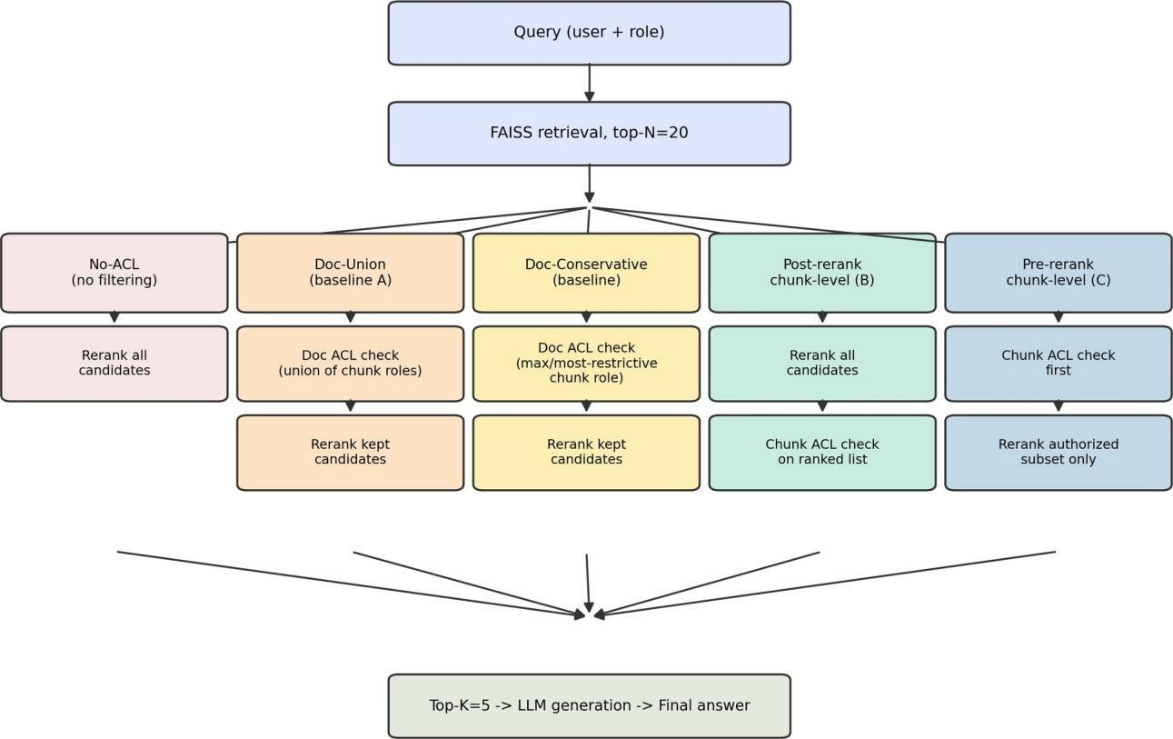
Fig. 1: Overview of the five authorization pipelines. All pipelines share the same FAISS retrieval stage (top-N = 20). They differ only in whether and where the access-control check is applied relative to reranking.

EXPERIMENTAL SETUP
- Dataset and Models
We sample 500 questions from the HotpotQA distractor validation split [15]. Documents are split into chunks of two to three sentences, yielding 4,921 unique documents and 8,516 chunks. Chunks are embedded with all-MiniLM-L6-v2 [11] and indexed with FAISS [13]. Retrieval depth is N = 20; reranking uses the cross-encoder ms-marco-MiniLM-L-6-v2 [14], [17]; generation uses a Flan-T5-family model [2], [10].
- Access-Control Model
We employ a hierarchical RBAC model with roles Employee ⊂ Manager ⊂ HRAdmin. Synthetic ACLs are regenerated at three target mixed-sensitivity rates (15%, 30%, 45%), which were realized at 8.2%, 16.4%, and 24.6%. We report all results against the realized rates.
- Metrics
We report Access-Control Violation Rate (ACVR), Over-Blocking Rate, Permission Coverage, Recall against the authorized supporting set, Exact Match (EM), F1, and reranking latency and token volume. We de-emphasize strict set-equality match, which is uninformative at fixed K against a variable-size ground-truth set.

RESULTS
- Leakage Scales with Mixed-Document Rate under Doc-Union
Doc-Union ACVR for the Employee role grows from 7.10% to 14.59% to 20.07% as the realized mixed rate rises from 8.2% to 16.4% to 24.6% (Table II, Fig. 2). The Manager role exhibits the same pattern at lower absolute levels. Both chunk-level pipelines and Doc-Conservative hold ACVR at exactly 0.00% in every cell.
TABLE II: ACVR (%) BY PIPELINE, ROLE, AND REALIZED MIXED-DOCUMENT RATE

Realized | Role | No-ACL | Doc-Union | Doc-Cons. | Post | Pre
8.2% | Employee | 66.84 | 7.10 | 0.00 | 0.00 | 0.00
 | Manager | 33.92 | 3.52 | 0.00 | 0.00 | 0.00
 | HRAdmin | 0.00 | 0.00 | 0.00 | 0.00 | 0.00
16.4% | Employee | 68.08 | 14.59 | 0.00 | 0.00 | 0.00
 | Manager | 34.32 | 6.00 | 0.00 | 0.00 | 0.00
 | HRAdmin | 0.00 | 0.00 | 0.00 | 0.00 | 0.00
24.6% | Employee | 66.84 | 20.07 | 0.00 | 0.00 | 0.00
 | Manager | 34.48 | 8.76 | 0.00 | 0.00 | 0.00
 | HRAdmin | 0.00 | 0.00 | 0.00 | 0.00 | 0.00
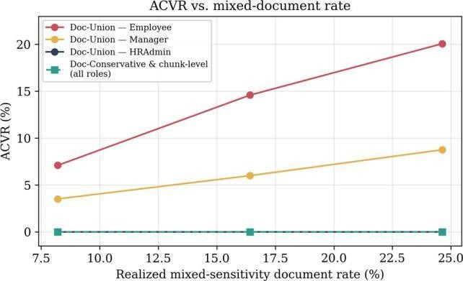
Fig. 2: Access-Control Violation Rate (ACVR) as a function of the realized mixed-sensitivity document rate. Doc-Union leakage grows roughly linearly for both Employee and Manager roles, while Doc-Conservative and both chunk-level pipelines remain at 0.00% across all conditions.
- Conservative Document Policy Closes Leakage at Higher Over-Blocking Cost
Doc-Conservative matches the 0.00% ACVR of chunk-level filtering by construction. At the highest mixed rate, however, its Over-Blocking Rate for Employee is markedly higher than that of the two chunk-level pipelines (Fig. 3). The conservative policy therefore eliminates leakage by discarding entire documents rather than individual restricted passages.
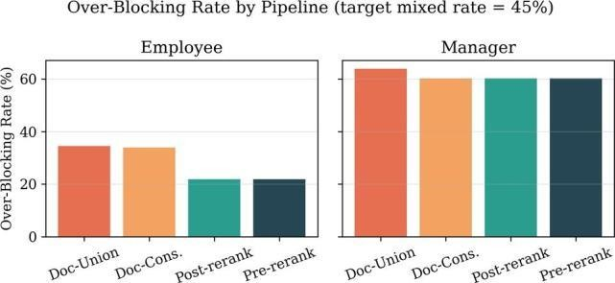
Fig. 3: Over-Blocking Rate at the highest mixed-sensitivity rate (target 45%). Doc-Conservative eliminates leakage but incurs substantially higher over-blocking than chunk-level filtering for the Employee role.
- Pre-rerank and Post-rerank Are Equivalent in Context Selection
Across all role × mixed-rate cells, Post-rerank and Pre-rerank produced identical Over-Blocking Rate, Recall, EM, and F1. The equivalence is a direct consequence of independent pairwise scoring by the cross-encoder.
- Efficiency Advantage of Pre-rerank Is Role-Dependent
Pre-rerank reduces latency by roughly two-thirds for Employee and by more than one-third for Manager (Fig. 4, Table III). HRAdmin sees no difference because its Permission Coverage is already 100%.

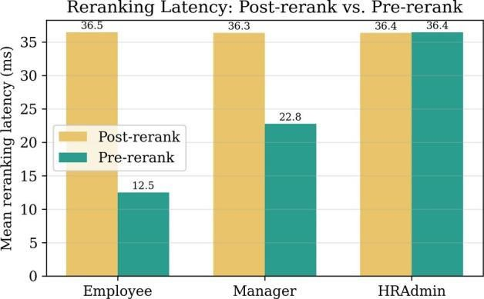
Fig. 4: Mean reranking latency of Post-rerank versus Pre-rerank filtering. Pre-rerank yields substantial savings for lower-privilege roles whose Permission Coverage is well below 100%.
TABLE III: MEAN RERANKING LATENCY (ms) AVERAGED ACROSS MIXED RATES

Role | Post-rerank | Pre-rerank | Reduction
Employee | 36.47 | 12.53 | 65.6%
Manager | 36.34 | 22.77 | 37.3%
HRAdmin | 36.35 | 36.37 | ≈ 0%

- No Measurable Quality Cost from Finer Granularity
At the highest mixed rate, EM and F1 for the four access-controlled pipelines lie in a narrow band (Fig. 5). The larger gap relative to No-ACL reflects the inherent cost of restricting the model to authorized evidence, not a cost of choosing chunk-level over document-level enforcement.
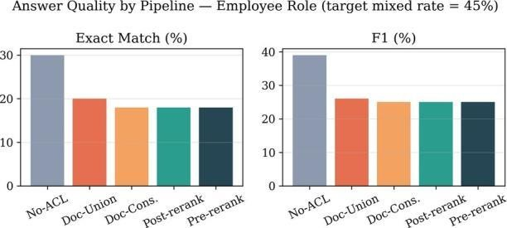
Fig. 5: Answer quality (Exact Match and F1) for the Employee role at the highest mixed-sensitivity rate. The four access-controlled pipelines perform similarly; the larger gap relative to No-ACL reflects the inherent cost of restricting the model to authorized evidence.

DISCUSSION
Granularity is the primary security lever, and its value scales with the mixed-document rate. A conservative document-level policy is a legitimate lower-engineering-cost alternative when higher over-blocking is acceptable. Under an independently scoring cross-encoder, timing relative to reranking is purely an efficiency question; the latency savings of pre-rerank filtering are largest precisely for the lower-privilege roles that also face the highest leakage risk under naive document-level policies.

LIMITATIONS AND FUTURE WORK
This study addresses authorization only at retrieval and context selection. Prompt injection, authorization-store compromise, embedding leakage, and training-data memorization are out of scope.
Chunk-level labels were assigned synthetically, which enables controlled variation of the mixed-sensitivity rate but means that absolute leakage numbers are properties of the generator and corpus. The realized mixed rates fell
below the nominal targets (8.2%/16.4%/24.6% versus 15%/30%/45%). Results depend on a single embedding model, reranker, and generator; the exact pre-/post-rerank equivalence is specific to independent pairwise scoring. We report point estimates rather than formal significance tests.
Future work includes higher mixed-rate regimes, list-wise rerankers, hard top-K-before-filter implementations of post-rerank filtering, and evaluation on corpora with authentic human-assigned sensitivity labels.

CONCLUSION
We studied how authorization granularity and enforcement timing jointly shape the security, utility, and efficiency of permission-aware RAG across a controlled range of mixed-sensitivity rates. On 500 HotpotQA questions, union-based document-level leakage grew from 7.1% to 20.1% (Employee) as the realized mixed rate rose from 8.2% to 24.6%, while chunk-level and conservative document-level policies held leakage at 0.00%. Pre-rerank and post-rerank filtering were equivalent in context selection and answer quality, differing only in cost, with pre-rerank delivering the largest savings for the most restricted roles. These results indicate that granularity, not timing, is the primary lever for eliminating document-level leakage; that a conservative document policy is a pragmatic alternative when higher over-blocking is tolerable; and that the choice between pre- and post-rerank chunk-level filtering should be made on efficiency grounds.

ACKNOWLEDGMENT
The authors thank RVR & JC College of Engineering for computational resources and support.

REFERENCES
- J. Jeong and S.-G. Lee, “Permission-aware RAG: Identity and access management (IAM)-based access filtering in multi-resource environments,” IEEE Access, vol. 13, pp. 192819–192835, 2025, doi: 10.1109/ACCESS.2025.3628960.
- H. W. Chung et al., “Scaling instruction-finetuned language models,” J. Mach. Learn. Res., vol. 25, no. 70, pp. 1–53, 2024.
- Y. Gao et al., “Retrieval-augmented generation for large language models: A survey,” arXiv:2312.10997, 2023.
- K. Greshake et al., “Not what you’ve signed up for: Compromising real-world LLM-integrated applications with indirect prompt injection,” in Proc. AISec, 2023.
- N. Carlini et al., “Extracting training data from large language models,” in Proc. USENIX Security, 2021.
- P. Lewis et al., “Retrieval-augmented generation for knowledge-intensive NLP tasks,” in Proc. NeurIPS, 2020.
- V. Karpukhin et al., “Dense passage retrieval for open-domain question answering,” in Proc. EMNLP, 2020.
- O. Khattab and M. Zaharia, “ColBERT: Efficient and effective passage search via contextualized late interaction over BERT,” in Proc. SIGIR, 2020.
- K. Guu et al., “REALM: Retrieval-augmented language model pre-training,” in Proc. ICML, 2020.
- C. Raffel et al., “Exploring the limits of transfer learning with a unified text-to-text transformer,” J. Mach. Learn. Res., vol. 21, no. 140, pp. 1–67, 2020.
- N. Reimers and I. Gurevych, “Sentence-BERT: Sentence embeddings using Siamese BERT-networks,” in Proc. EMNLP-IJCNLP, 2019.
- J. Devlin et al., “BERT: Pre-training of deep bidirectional transformers for language understanding,” in Proc. NAACL-HLT, 2019.
- J. Johnson, M. Douze, and H. Jégou, “Billion-scale similarity search with GPUs,” IEEE Trans. Big Data, vol. 7, no. 3, pp. 535–547, 2021.

- R. Nogueira and K. Cho, “Passage re-ranking with BERT,” arXiv:1901.04085, 2019.
- Z. Yang et al., “HotpotQA: A dataset for diverse, explainable multi-hop question answering,” in Proc. EMNLP, 2018.
- A. Vaswani et al., “Attention is all you need,” in Proc. NeurIPS, 2017.
- P. Bajaj et al., “MS MARCO: A human generated machine reading comprehension dataset,” arXiv:1611.09268, 2016.
- P. Rajpurkar et al., “SQuAD: 100,000+ questions for machine comprehension of text,” in Proc. EMNLP, 2016.
- V. C. Hu et al., “Guide to attribute based access control (ABAC) definition and considerations,” NIST SP 800-162, 2014.
- OASIS, “eXtensible Access Control Markup Language (XACML) Version 3.0,” 2013.
- K. LeFevre et al., “Limiting disclosure in Hippocratic databases,” in Proc. VLDB, 2004.
- R. S. Sandhu et al., “Role-based access control models,” Computer, vol. 29, no. 2, pp. 38–47, 1996.
- D. F. Ferraiolo and D. R. Kuhn, “Role-based access controls,” in Proc. National Computer Security Conf., 1992.

PLAGIARISM / SIMILARITY ANALYSIS REPORT

Document | Research Paper and Case Study Report
Research paper topic | Granularity and Timing in Permission-Aware Retrieval-Augmented Generation: A Controlled Study of the Security–Utility–Efficiency Trade-off
Authors | Musyam Akash Venkat (Y24CD123), Karre Navadeep (Y24CD084), Kolli Venkata Siva Ashok Reddy (Y24CD093)
Institution | R.V.R. & J.C. College of Engineering (Autonomous), Department of CSE (Data Science)

PURPOSE OF THIS REPORT
This appendix provides a preliminary similarity/plagiarism assessment of the submitted research paper. It is based on a review of the text contained in the supplied PDF and a targeted web search for the paper title, key terminology, and cited permission-aware RAG literature. It is an academic screening report and is not a replacement for an institutional Turnitin, iThenticate, or other licensed similarity check.

SUMMARY OF RESULT

Assessment item | Result
Official plagiarism percentage | Not determinable from this review
Exact-title web match | No exact-title match identified in the targeted search
Closely related published work | Yes — Jeong & Lee, IEEE Access (2025)
Citation of related work in submitted PDF | Yes — listed as Reference [1]
Manual review status | Recommended before academic submission

RELATED-SOURCE FINDING
The web review identified “Permission-Aware RAG: Identity and Access Management (IAM)-Based Access Filtering in Multi-Resource Environments” by Jooyoung Jeong and Sang-Goo Lee, published in IEEE Access in 2025. The paper discusses permission-aware RAG, access control, retrieval, multi-hop question answering, and enterprise information security. The submitted PDF itself cites this work as Reference [1].
The existence of a related source does not by itself establish plagiarism. Similarity in technical terminology, research problem, methods, datasets, or background concepts can be legitimate when properly cited. A plagiarism determination requires comparison of the submitted wording against a source corpus and the institution’s similarity rules.

PRELIMINARY SIMILARITY OBSERVATIONS

Area | Observation | Risk
Topic / research area | Strong thematic overlap with existing permission-aware RAG research. | Medium
Terminology | Terms such as RAG, IAM/RBAC, access control, HotpotQA, FAISS and reranking are established technical terms. | Low

References | The submitted paper explicitly cites relevant prior work, including Jeong & Lee and foundational RAG papers. | Low
Experimental framing | The submitted paper presents a specific five-pipeline comparison and mixed-sensitivity evaluation; this should be supported by the authors’ own experimental logs and code. | Medium
Exact wording similarity | No institutional database comparison was performed; therefore no percentage should be claimed. | Undetermined

ACADEMIC INTEGRITY CHECKLIST
    - Ensure every borrowed idea, result, dataset, model, or method is appropriately cited.
    - Use quotation marks and page-level attribution for any verbatim wording retained from a source.
    - Rewrite background and related-work discussion in the authors’ own words rather than making only superficial word substitutions.
    - Clearly distinguish the authors’ original experimental contribution from established RAG, RBAC, reranking, and access-control concepts.
    - Verify that all numerical results (for example ACVR, latency reductions, EM and F1 values) are generated by, or traceable to, the stated experiment.
    - Verify that figures and tables are original or have the required permission and attribution.
    - Run the final document through the institution’s approved Turnitin/iThenticate system before submission.

SOURCE IDENTIFIED DURING WEB REVIEW
Jeong, J., & Lee, S.-G. (2025). Permission-Aware RAG: Identity and Access Management (IAM)-Based Access Filtering in Multi-Resource Environments. IEEE Access, 13, 192819–192835. DOI: 10.1109/ACCESS.2025.3628960.
The submitted PDF lists this work as Reference [1], which is consistent with the source relationship identified during the review.

INSTITUTIONAL SIMILARITY INDEX

Tool used (Turnitin / iThenticate)
Similarity index | %
Date of check
Verified by (Faculty)

LIMITATION AND DECLARATION
This report does not certify that the paper is plagiarism-free and does not assign a fabricated similarity percentage. The assessment is limited to the supplied PDF and the targeted, publicly accessible web sources reviewed for this appendix. Commercial and institutional plagiarism databases may identify additional matches that are not visible in this screening.
Prepared as a preliminary academic similarity screening appendix — October 2026.

CASE STUDY REPORT

Intellectual Property Rights in IoT-Based Innovations

Course | MC3 – Technical Paper Writing & IPR
Program | III/IV B.Tech CSE (Data Science), V Semester
Institution | R.V.R. & J.C. College of Engineering (Autonomous)

INTRODUCTION
The Internet of Things (IoT) connects sensors, embedded devices, communication networks, cloud platforms and software applications to collect, exchange and process data. Because an IoT product can contain hardware inventions, embedded software, industrial designs, brands, technical documentation, algorithms, data and confidential know-how, a single innovation may involve several forms of intellectual property (IP). WIPO describes IP as covering creations such as inventions, computer programs, designs, trademarks and other commercial signs [1].
This case study examines how an IoT-based innovation can be identified, protected and commercially managed through appropriate IP strategies. The focus is on the relationship between technical innovation and rights such as patents, copyright, trademarks, industrial designs and trade secrets.

CASE STUDY SCENARIO
Consider a hypothetical startup, SmartSense Innovations, developing an IoT-based smart agriculture platform. The system uses soil-moisture, temperature and humidity sensors installed in agricultural fields. A gateway transfers sensor readings to a cloud service, where software analyses the data and provides irrigation recommendations through a mobile application. The startup also develops a compact sensor enclosure, a proprietary communication method for low-power operation, a dashboard, a mobile application and a brand identity.
The company must decide which parts of the innovation should be patented, copyrighted, registered as designs or trademarks, or maintained as confidential information. It must also check whether its technology risks infringing third-party rights before commercialization.

IDENTIFICATION OF INTELLECTUAL PROPERTY
The first step is to map each valuable component of the platform to the form of IP protection that best fits it. Table 1 summarizes this mapping for SmartSense Innovations.

Table 1: IP protection mapped to IoT components

IoT component | Potential IP protection | Reason
New sensor / hardware mechanism | Patent | Protects a qualifying technical invention.
Embedded software and mobile app | Copyright | Protects original computer programs and related creative expression.
Unique physical enclosure | Industrial design | Protects the ornamental/aesthetic aspects where legal requirements are met.
Company / product name and logo | Trademark | Distinguishes the goods or services from those of competitors.

Proprietary algorithm and calibration methods | Trade secret / confidential know-how | Can protect confidential information when secrecy is maintained.
Technical drawings and documentation | Copyright / related rights | Can protect original technical drawings and written expression.

PATENT STRATEGY FOR THE IOT INNOVATION
A patent may be appropriate where the startup has a qualifying technical invention. WIPO explains that patents provide exclusive rights for inventions and that patent applications disclose technical information to the public [2]. For the SmartSense scenario, potentially patentable subject matter could include a novel sensor architecture, a new low-power communication mechanism, or a technical method that solves a specific engineering problem. The company should conduct a prior-art search before filing and obtain professional patent advice because patentability requirements are jurisdiction-specific.
IoT products may also rely on communication standards. Where standard-essential patents are relevant, licensing can become important because a standard-compliant product may depend on patented technology. WIPO notes that standard-essential patents can be important for interoperability and may involve FRAND licensing considerations [3].

COPYRIGHT AND SOFTWARE
The IoT platform’s source code, mobile application code, software documentation and certain original graphical or technical materials may attract copyright protection, subject to applicable law. WIPO identifies computer programs, databases and technical drawings among works that can be covered by copyright [1]. The startup should maintain source-code records, contributor agreements and clear ownership terms for employees, contractors and development partners.

TRADEMARKS AND INDUSTRIAL DESIGNS
The startup’s product name, company name and logo can be considered for trademark protection. A trademark helps distinguish one enterprise’s goods or services from those of competitors [1]. The external appearance of the sensor enclosure or other product components may also be considered for industrial-design protection where the applicable legal requirements are satisfied. WIPO identifies industrial designs as protection for the ornamental or aesthetic aspect of an article [1].

TRADE SECRETS AND CONFIDENTIAL INFORMATION
Some IoT assets may be more valuable when kept confidential rather than disclosed in a patent. Examples include proprietary calibration techniques, manufacturing know-how, non-public datasets, internal security procedures and certain algorithms. WIPO notes that IoT devices can collect large amounts of data and that how and what data is collected may, in suitable circumstances, contribute to trade-secret protection when confidentiality is maintained [4].
The company should use confidentiality agreements, access controls, employee policies, secure repositories and need-to-know permissions to preserve secrecy. Trade-secret protection can be lost if confidential information is publicly disclosed [4].

IP MANAGEMENT CHALLENGES IN IoT
IoT products raise several recurring IP management challenges, summarized in Table 2.

Table 2: IP management challenges in IoT

Challenge | Impact on the IoT company
Multiple technologies in one product | Different components may require different IP strategies and ownership checks.
Rapid technological change | Products evolve quickly, making timely IP decisions important.
Third-party components and open-source software | Licenses and third-party rights must be reviewed before commercial release.
Data and confidentiality | Sensitive datasets and know-how require controlled access and appropriate contractual safeguards.
Global markets | IP rights and filing requirements vary by jurisdiction.
Interoperability and standards | Standards may introduce patent and licensing considerations.

RECOMMENDED IP PROTECTION PLAN
Step 1 – Identify assets: Prepare an IP inventory covering hardware, software, designs, brands, datasets and confidential know-how.
Step 2 – Establish ownership: Confirm ownership and assignment terms for employees, contractors, universities, vendors and development partners.
Step 3 – Conduct prior-art and clearance searches: Search relevant patents, trademarks and other public information before investing in filing or commercialization.
Step 4 – Select protection: Use patents for qualifying inventions, copyright for protected creative/software expression, trademarks for brand identifiers, industrial designs for eligible visual designs, and trade-secret controls for confidential information.
Step 5 – Protect confidentiality: Restrict access to sensitive information and use appropriate confidentiality agreements.
Step 6 – Plan commercialization: Consider licensing, assignment, partnerships and technology-transfer arrangements. WIPO notes that licensing allows use of IP under agreed conditions, while assignment transfers ownership [6].
Step 7 – Monitor and enforce: Track potential infringement and maintain records of registrations, licenses and ownership. This helps the company respond if a third party misuses its IP [1].

CASE ANALYSIS
For SmartSense Innovations, a combined IP strategy is more appropriate than relying on a single right. A novel technical mechanism may justify patent evaluation, while software code and documentation can be addressed through copyright. The product identity can be protected through trademarks, the appearance of the device may qualify for industrial-design protection, and confidential algorithms or know-how may be maintained as trade secrets. This layered approach reflects the fact that modern IoT systems combine hardware, connectivity, software, data and commercial identity.
The main lesson is that IP planning should begin during the innovation process rather than after product launch. Public disclosure before an appropriate patent strategy is in place can affect patent rights in some jurisdictions, while uncontrolled disclosure can undermine trade-secret protection [2], [4]. Inventors and

organizations should therefore coordinate technical development, documentation, confidentiality and IP filing decisions.

CONCLUSION
IoT-based innovations create significant opportunities for new products and services, but they also create a complex intellectual-property landscape. Effective protection requires identifying each valuable component of the innovation and selecting an appropriate combination of patents, copyright, trademarks, industrial designs and trade secrets. WIPO’s work on IoT patent landscapes also illustrates the breadth of patent activity across networking, computing, infrastructure and application technologies [5].
For students and emerging IoT entrepreneurs, the central principle is simple: protect the innovation before exposing it, document ownership clearly, respect third-party rights, and choose the IP mechanism that matches the asset.

REFERENCES
- World Intellectual Property Organization (WIPO), "What is Intellectual Property?" 2020. [Online]. Available: https://www.wipo.int/publications/en/details.jsp?id=4528. [Accessed: Oct. 26, 2026].
- World Intellectual Property Organization (WIPO), "Frequently Asked Questions: Patents." [Online]. Available: https://www.wipo.int/en/web/patents/faq_patents. [Accessed: Oct. 26, 2026].
- World Intellectual Property Organization (WIPO), "Standard Essential Patents." [Online]. Available: https://www.wipo.int/en/web/patents/topics/sep. [Accessed: Oct. 26, 2026].
- World Intellectual Property Organization (WIPO), "WIPO Guide to Trade Secrets and Innovation," 2024. [Online]. Available: https://www.wipo.int/publications/en/details.jsp?id=4748. [Accessed: Oct. 26, 2026].
- World Intellectual Property Organization (WIPO), "Internet of Things: Patent Landscape Analysis." [Online]. Available: https://www.wipo.int/edocs/pubdocs/en/internet_of_things.pdf. [Accessed: Oct. 26, 2026].
- World Intellectual Property Organization (WIPO), "Technology Transfer Agreements." [Online]. Available: https://www.wipo.int/en/web/technology-transfer/agreements. [Accessed: Oct. 26, 2026].
Note: This is an academic case study for MC3 – Technical Paper Writing & IPR. Specific legal protection and patentability depend on the applicable national law and the facts of an actual invention.

