In recent years, alongside experimental approaches, mathematical model have been employed to investigate intracellular signaling processes. Simulation research, which seeks to validate hypotheses based on experimental results, is increasingly recognized as a valuable complement to experimental studies. In this section, we reevaluate the hypothesis that regulatory T cells are involved in the transition from inﬂammatory microglia to anti-inﬂammatory microglia from a mathematical modeling (kinetics) standpoint. We denote the quantities of inﬂammatory microglia, anti-inﬂammatory microglia, and regulatory T cells as $M_{1}$, $M_{2}$, and Treg, respectively. Here, we describe the dynamics of $M_{1}$, $M_{2}$, and Treg using the following rate equations as the simplest scenario:

$\frac{dM_{1}}{dt}=αf_{1}\left(t\right)-βf_{2}(M_{1},T_{reg})$ (1)

$\frac{dM_{2}}{dt}=βf_{2}(M_{1},T_{reg})$ (2)

$\frac{dT_{reg}}{dt}=f_{3}\left(t\right)$*.* (3)

Equation (1) describes the dynamics of $M_{1}$. Based on observations that microglia monotonically increase up to a certain limit during sepsis, the function $f_{1}\left(t\right)$ is assumed to be a monotonically increasing function with an upper limit. Additionally, the second term in Equation (1) represents the transition from inﬂammatory microglia to anti-inﬂammatory microglia, and it is an increasing function with respect to $M_{1}$ and $T_{reg}$. Equation (2) represents the dynamics of $M_{2}$. It should be noted that (1) + (2) is conserved. Finally, Equation (3) represents the dynamics of $T_{reg}$. Since it is known that regulatory T cells continue to increase during sepsis, $f_{3}>0$. From the Fig.1, it can be observed that at the onset of sepsis, inﬂammatory microglia ($M_{1}$) increase sharply. After a suﬃcient increase in $M_{1}$, anti- inﬂammatory microglia ($M_{2}$) gradually increase, leading to a decrease in inﬂammatory microglia cells. The rate of decrease of inﬂammatory microglia depends strongly on the form of $f_{2}$ and the parameter $β$. To determine these, it is necessary to elucidate the mechanisms of regulatory T cells and anti- inﬂammatory microglia. Furthermore, by comparing the time series of regulatory T cells and anti- inﬂammatory microglia quantities, quantitative predictions become feasible.

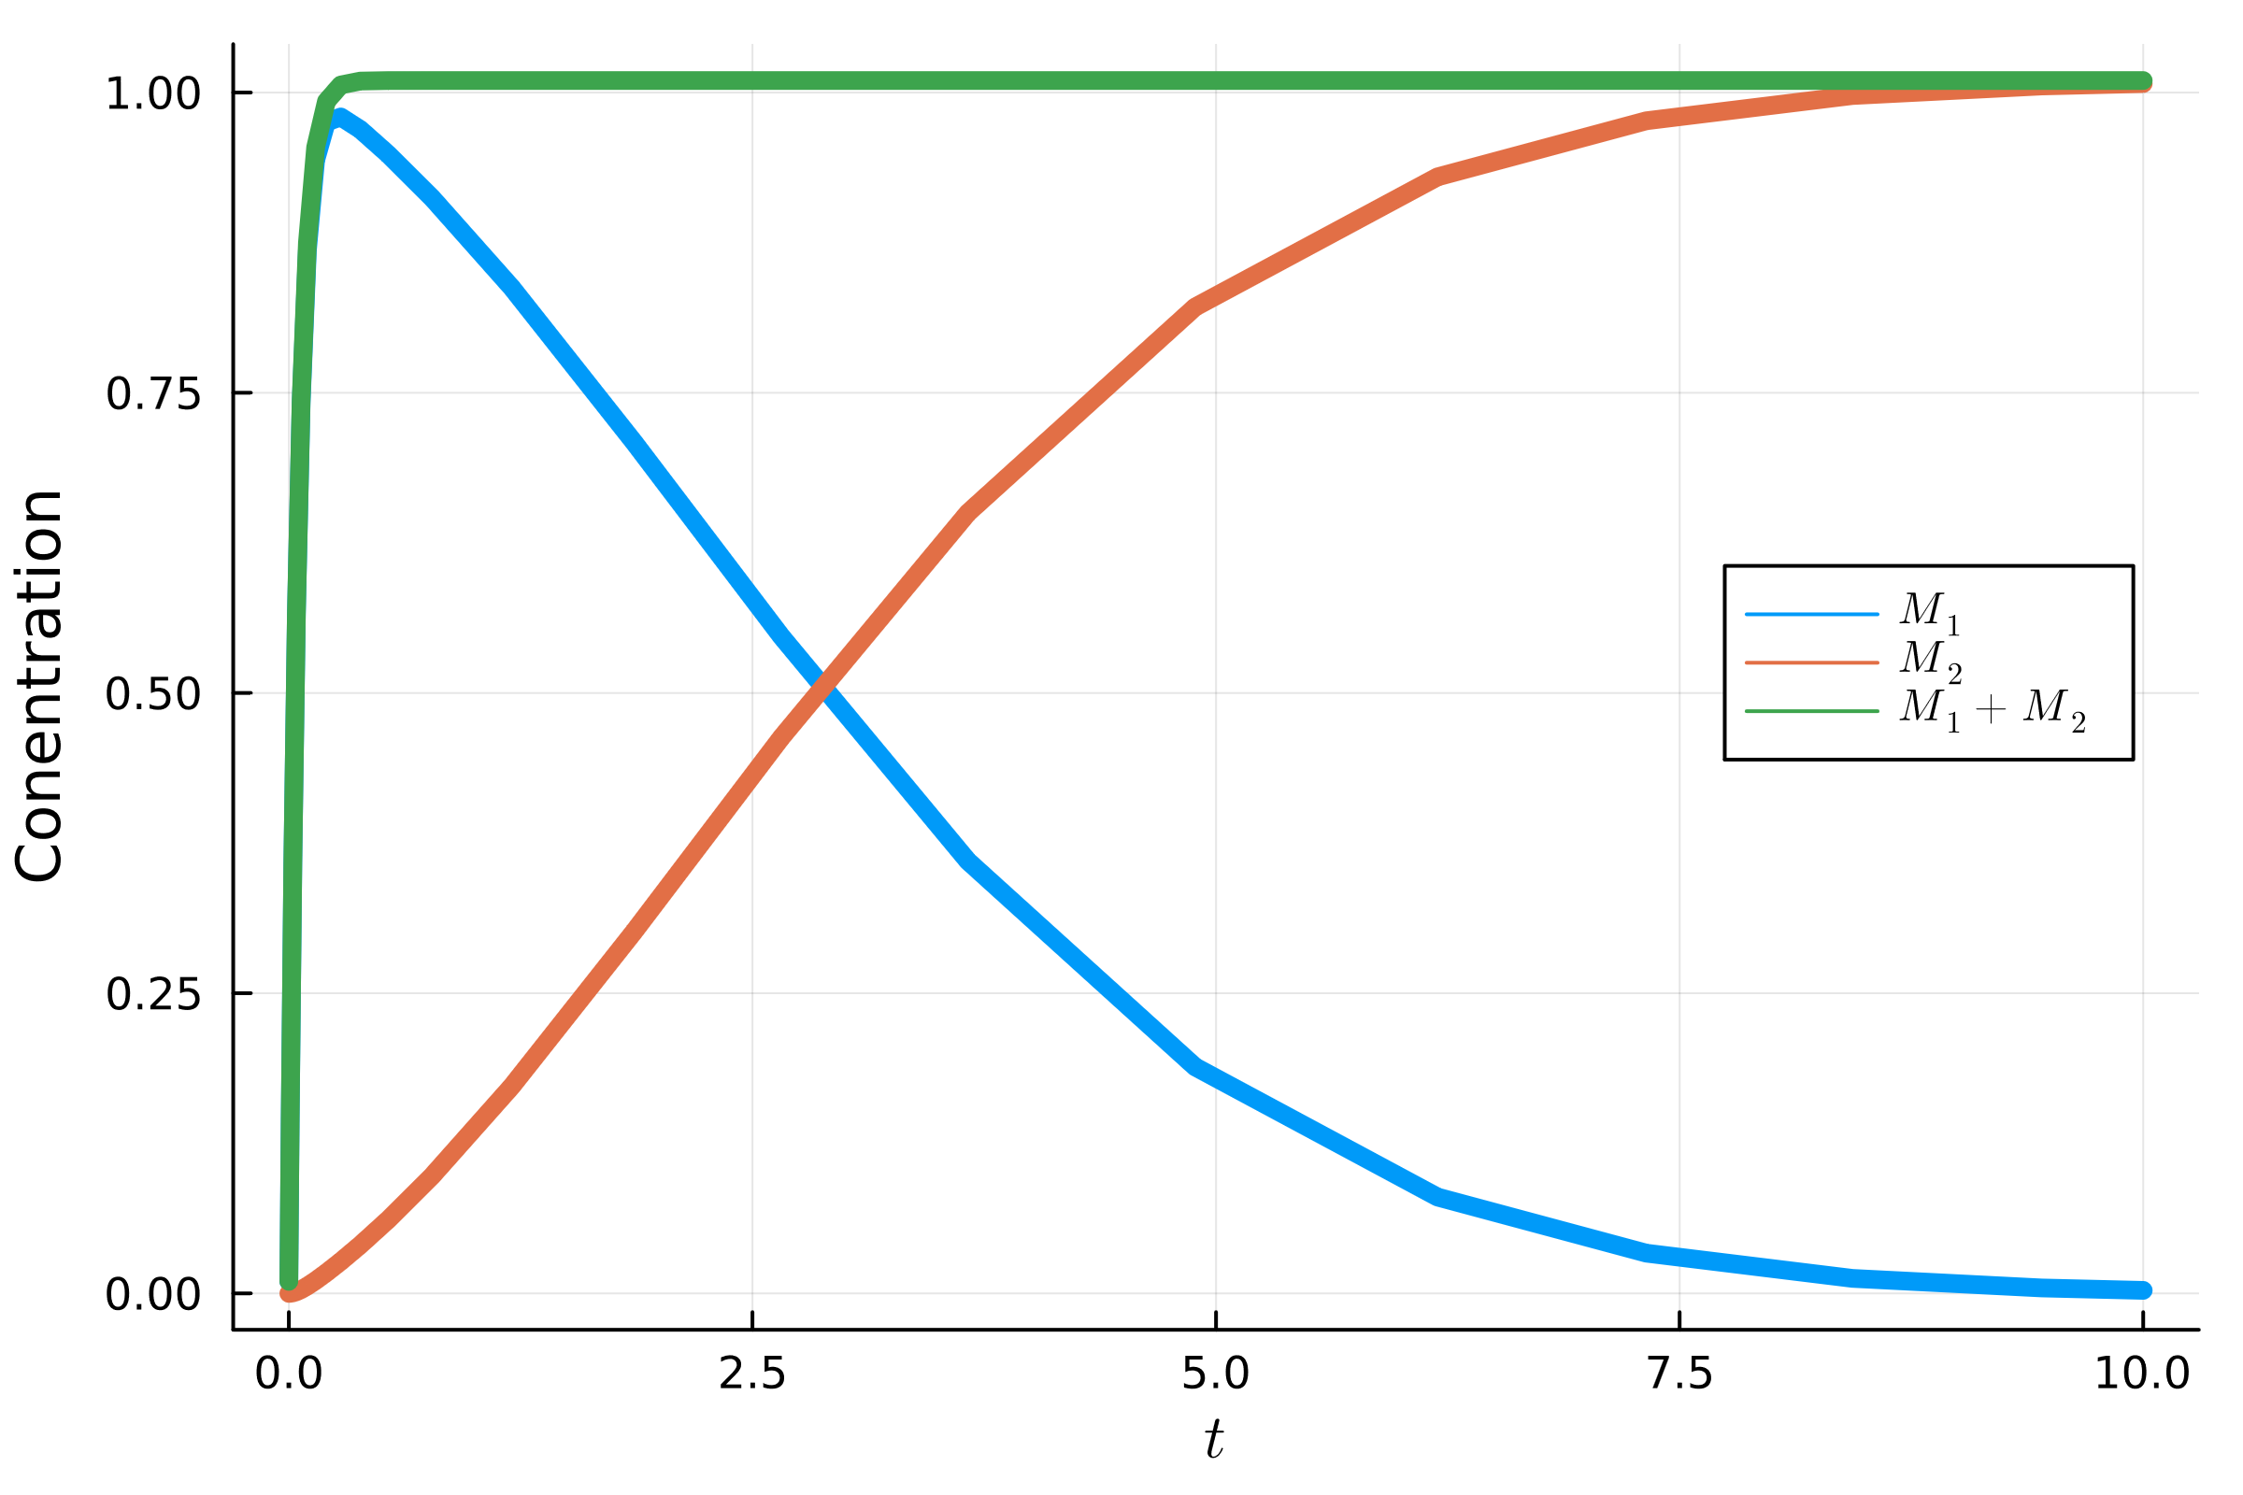

Fig.1 Time series of *M*1, *M*2 and *M*1 + *M*2. The functional form is *f*1(*t*) := *γ* exp (*−γT* ), *f*2(*M*1*, Treg* ) := *M*1*Treg* ,and parameters are *α* =, *β* = 0*.*1 and *γ* = 20*.*0.