

A Pipelined RISC CPU

Aquarius

(SuperH-2 ISA Compatible CPU Core)

Thorn Aitch

Rev 1.1 July 21, 2003



Copyright
Aquarius RTL codes and related documents are copyrighted by the author, but placed into the public domain.
Designs can be altered while keeping list of modifications "the same as in GNU" No money can be earned by selling the designs themselves, but anyone can get money by selling the implementation of the design, such as ICs based on some cores, boards based on some schematics or Layouts, and even GUI interfaces to text mode drivers. "The same as GPL SW" Any update to the design should be documented and returned to the design. Any derivative work based on the IP should be free under OpenIP License. Derivative work means any update, change or improvement on the design. Any work based on the design can be either made free under OpenIP license or protected by any other license. Work based on the design means any work uses the OpenIP Licensed core as a building black without changing anything on it with any other blocks to produce larger design. There is NO WARRANTY on the functionality or performance of the design on the real hardware implementation.

On the other hand, the SuperH-2 ISA (Instruction Set Architecture) executed by Aquarius is rigidly the property of Renesas Technology Corp., which has established on April 1st, 2003 by merging semiconductor groups of Hitachi and Mitsubishi. Then you have responsibility to judge if there are not any infringements to Renesas’s rights regarding your Aquarius adoption into your design. By adopting Aquarius, the user assumes all responsibility for its use.

Trademark
Aquarius is a name of 5-stages pipelined RISC CPU core that can execute SuperH-2 ISA. Aquarius is not registered trademark. If you officially use the name of Aquarius to external world, you have responsibility to care the legal issues.

Royalty Release
I will not request you any royalties or other financial obligation for your Aquarius adoption to your design and production. But you have responsibility to judge the usage of SuperH-2 ISA, legally. I strongly recommend you should ask Renesas Technology Corp. when you decide to adopt Aquarius into your products.

Patent Notice
I have not cared that the information contained in this document and Aquarius deliverables cause infringement on the patent, copyright, trademark or trade secret rights of others. You have all responsibilities for determining if your design and products infringe on the intellectual property rights of others.

Disclaimers
Aquarius deliverables including this document are not guaranteed. They may cause any damages to many things, for example, loss of properties, data, money, profits, life, or business. By adopting Aquarius, the user assumes all responsibility for its use.
Aquarius deliverables are permanently preliminary, and is subject to change.

Contact to Author
After release of Aquarius onto the OpenCores Organization site, you will be able to contact me via the organization’s site. The email address is thorn_aitch@opencores.org.
If you find any bugs and strange descriptions, please feel free to inform me.

Trademark
SuperH™ is a trademark of Renesas Technology Corp.
Virtex™ is a trademark of Xilinx, Inc.
Stratix™ is a trademark of Altera, Corp.
Each another proper noun might be a trademark of each rights holders.

Revision History
Rev 0.1: May 1, 2003 by Thorn Aitch Draft
Drafting out a tentative document

Rev 1.0: July 12, 2003 by Thorn Aitch Release Version
A First Release Version

Rev 1.1: July 21, 2003 by Thorn Aitch Addition of an application
A Program for calculation of Circular Constant (Pi) is added.

Index
Part1. Using Aquarius 8
1. Introduction 9
1.1. What is Aquarius 9
1.2. Purpose of this Project 10
1.3. Structure of Chapters in this document 11
2. Specification Overview 12
2.1. Aquarius Instruction Set Architecture 12
2.2. Interrupts and Exceptions 12
2.3. Differences between Aquarius and SuperH-2 13
2.4. Aquarius Block Diagram 14
2.5. Examples of Aquarius based SoC 16
3. Preparation 18
3.1. PC environment 18
3.2. Cygwin 18
3.3. Icarus Verilog 18
3.4. GNU Assembler and C Compiler for SuperH-2 18
3.5. FPGA development tool 20
3.6. FPGA Board 20
4. Deliverables 21
4.1. Document 21
4.2. RTL Resources 21
4.3. Verification Resources 23
4.4. FPGA related Resources 24
5. Aquarius CPU Interface Specification: “cpu.v” 26
5.1. Aquarius CPU IN/OUT Signals 26
5.2. System Signals 26
5.3. “WISHBONE” Compliant Bus Signals 27
5.4. Hardware Event Signals (Interrupt) 30
5.5. SLEEP signal for Low Power Mode 32
6. Simulation Test Bench 34
6.1. Top Layer: “top.v” 34
6.2. Simulation Test Bench: “test.v” 34
6.3. Parallel I/O Port (PIO): “pio.v” 34
6.4. Serial I/O (UART): “uart.v” 37
6.5. System Controller (SYS): “sys.v” 39
6.6. On Chip Memory: “memory.v” 42
6.7. Simulation Tools and Flows 43
7. FPGA Implementation 45
7.1. FPGA System 45
7.2. Circuit of FPGA Board 46
7.3. Circuit of Interface Board 46
7.4. FPGA Configuration 49
7.5. Results of FPGA Configuration 49
7.6. Application Programs on the FPGA System 51

Part2. Inside Aquarius CPU 56
8. Aquarius CPU Overview 57
8.1. Aquarius Block Diagram 57
8.2. Aquarius CPU IN/OUT Signals 59
9. Overview of Pipeline Control 60
9.1. Pipeline and Stage 60
9.2. Pipeline of each Instruction 61
9.3. Register Conflict 64
9.4. Memory Access Conflict 64
9.5. Who issues IF? Who issues ID? 65
10. Decoder Unit 66
10.1. IN/OUT Signals 66
10.2. Structure of Decoder Unit 68
10.3. Shifting Control Signals 72
10.4. Pipeline Stall 74
10.5. Register Forwarding 77
10.6. Examples of Pipeline Control 77
10.7. Control of Program Counter 77
11. Memory Access Control Unit 82
11.1. IN/OUT Signals 82
11.2. WISHBONE’s ACK and Aquarius’ SLOT 82
11.3. Instruction Fetch Cycle 83
11.4. Memory Access Cycle 84
11.5. IF-MA Conflict 86
11.6. Bus Width of Instruction Fetch Cycle (IF_WIDTH) 87
11.7. Read Modify Write Cycle (for Instruction TAS.B) 87
11.8. State Machine of Memory Access Control Unit 88
12. Data Path Unit 90
12.1. IN/OUT Signal Table 90
12.2. Structure of Data Path 92
13. Multiplier Unit 95
13.1. IN/OUT Signal Table 95
13.2. Algorithm of Multiplication 95
13.3. Structure of Multiplier Unit 98
13.4. Control of Multiplication Unit 99
13.5. How to implement Saturating Accumulation 100
14. Appendix: Aquarius Instruction Codes 105

Part1. Using Aquarius

Introduction

What is Aquarius
Aquarius is a Core IP (Intellectual Property) of pipelined RISC CPU and can execute SuperH-2 instructions. Aquarius and related information are released to OpenCores Organization web site (www.opencores.org). You can freely download all necessary resources and latest updates from the site.

The reasons why I selected SuperH-2 ISA (Instruction Set Architecture) are as follows.
- SuperH is a very popular CPU core. The software development environments such as C compiler have been well prepared. The GNU C compiler for SuperH is very famous and easy to get. The SuperH had been developed by Hitachi, Ltd. Now, semiconductor group of Hitachi has merged with same group of Mitsubish and new semiconductor company “Renesas Technology Corp.” has established in April, 2003.
- SuperH-2 is a CPU for MCU (Micro Controller Unit). Then the CPU need not handle complex exception recovering such as memory fault exception from MMU (Memory Managing Unit). This means SuperH-2 has simple structure, easiness to design, and it does not consume many logic gates and power.
- All SuperH-2 instructions have 16bit length. It also makes the hardware very simple. And most important aspect from 16bit fixed length of instructions is that the object code size compiled from C source programs becomes very small.
- And, I love SuperH.

Aquarius is a free and completed soft IP. So I believe that Aquarius can increase SuperH-2 ISA familiars.

Aquarius consists of RTL descriptions. The language is Verilog-HDL. You can implement Aquarius not only in your System LSI but also in your FPGA system. The Aquarius bus interface follows WISHBONE specification maintained by the OpenCores Organization (www.opencores.org), so you can easily connect Aquarius to many IPs registered in OpenCores web site.

During my Aquarius design, I only referred public SuperH document from Renesas such as SH-2 Programming Manual. Of course I could not reach Renesas’ internal design information, so the Aquarius may NOT have completely same functionality as real SuperH-2 CPU core, however, Aquarius can execute all public instructions of SuperH-2.

The functionality of Aquarius has been verified by both methods of functional vector simulation and long run tests on FPGA board using program codes from GNU C Compiler and Assembler.

I have designed Aquarius without consuming money except for FPGA hardware. I have used free simulation tools and free FPGA configuration tool. You also do not need to buy expensive EDA tools.

I am not an expert designer of CPU core, so the current Aquarius may not have the best performance. I think efficiency of the design such as area consumption and operation frequency can be improved much more. If you find some improvements, please feel free to suggest your ideas to me.

Please enjoy the exciting deep IP design world. You can modify Aquarius to make your original system. I hope Aquarius will help system designers, university students and electronics hobbyists.

Purpose of this Project
The main purpose of Aquarius Project is to provide everyone a pipelined RISC CPU core as one of the IPs for System LSI and FPGA system. You can get information about how to design actual useful RISC CPU.

The Aquarius has SuperH-2 compatible ISA, so I hope that SuperH familiarized people will increase more and more. Many embedded system, for example Robots, Industrial Systems, Measurement Instruments, and many kind of digital information systems controlled by embedded micro controllers, can be realized by SuperH-2 architecture.

I provide Aquarius without any license fee and royalty. You can freely get the latest Aquarius IP codes from OpenCores Organization on the internet whenever you like. And I will introduce you the cheapest but excellent design environments via this document. You will able to modify Aquarius and establish your original IP.

Structure of Chapters in this document
This document consists of 2 parts. The first part describes how to use Aquarius, for example, explanation of interface signals, test bench and FPGA implementation. All readers should read first part. The second part shows inside Aquarius which is way of thought for designing a pipelined RISC CPU. If you want to understand the apparatus of pipelined RISC CPU and want to design your original CPU core, you should read second part, too.

Specification Overview

Aquarius Instruction Set Architecture
Aquarius is based on SuperH-2 Instruction Set Architecture (ISA). The SuperH-2 CPU has RISC-type instruction sets and 16 32bit-general-registers (R0-R15). All instructions have 16bits fixed length. The SuperH-2 is based on 5 stages pipelined architecture, so basic instructions are executed in one clock cycle pitch, which dramatically improves instruction execution speed. The CPU also has an internal 32-bit architecture for enhanced data processing ability such as multiply and accumulation like DSP functionality.
The detail document of SuperH-2 CPU architecture can be found in Renesas web site.
http://www.renesas.com/
Please reach to the SuperH product page and find the SH-2 related product documents. Then search document type of “Programming Manual” and find the “SuperH RISC Engine SH-1/SH-2/SH-DSP Programming Manual”. This manual includes explanations among SH-1, SH2 and SH2-DSP Instruction set. Please check up only SH-2 portions from this manual. But it does not describe about exception and interrupt. For that information, pick up product manual such as “SH7040 series Hardware Manual” and refer to chapters regarding Exception and Interrupt Controller.

Interrupts and Exceptions
Like SuperH-2 CPU, Aquarius can handle interrupt requests, such as NMI (non maskable interrupt) and IRQ (interrupt request). The interrupt priority level can be set from 0 to 16. The interrupt request whose priority level is higher than I bit (I3-I0) in SR (Status Register) will accepted by CPU. The priority of NMI is 16, so it is always accepted. The priority level and the vector number of IRQ can be informed from external circuit such as interrupt controller or system controller. If the priority level is zero, such interrupt will not be accepted. Once the interrupt is accepted, the interrupt exception will start. It copies the interrupt request level to I bit (I3-I0) in SR ,push SR and PC onto stack, fetch the vector address and branch to targeting interrupt service routine. To return from interrupt service routine, use RTE, which pops PC and SR and starts from the address of popped PC.
By the 4 bit priority control scheme, the interrupt can be nested.

The other exceptions such as CPU address error, DMA address error, TRAP Instruction, Illegal Instruction, Slot Illegal Instruction, Manual Reset and Power on Reset are fully supported by Aquarius.

Differences between Aquarius and SuperH-2
Aquarius can execute all public SuperH-2 instructions. But there are some functional differences between Aquarius and real SuperH-2 CPU.

(1) Improvement of Multiplication Cycle
Table 2.1 shows that the execution cycle of the multiplication related instructions of Aquarius are slightly different from SuperH-2’s because I guess the structure of connection between CPU and Multiplier is changed from real SuperH-2. You can find some performance is improved. Especially, the pitch cycle reduction of MAC.L will improve performance of many real time applications. The details of pipeline control will be shown in later chapter.
Instruction | Aquarius | SuperH-2 | Notes
MAC.W @Rm+, @Rn+ | C=2, P=2, L=3 | C=2, P=2, L=2
MAC.L @Rm+, @Rn+ | C=2, P=2, L=4 | C=2, P=4, L=4
MULS/U.W Rm, Rn | C=1, P=1, L=2 | C=1, P=2, L=2
DMULS/U.L Rm, Rn | C=1, P=3, L=2 | C=1, P=4, L=4
MUL.L Rm, Rn | C=1, P=3, L=2 | C=1, P=4, L=4
C (Cycle): Instruction Execution Cycle if there is no contention. This is minimum cycle.
P (Pitch): Instruction Execution Pitch cycle if same instructions are repeated.
L (Latency): Latency cycle until STS, which is located just after me, and stores MACH/MACL to Rn.
Table2.1. Differences of Instruction Execution Cycles between Aquarius and SuperH-2
(2) Detection of Illegal Instruction
The real SuperH-2 decodes all illegal instructions. But in Aquarius, only the FF-line instructions (0xFFxx) are recognized as illegal instructions that bring up “Illegal Instruction Exception”. Other “should-be illegal instructions” are not fully decoded, so these operations are seemed as “Undefined”. Actually, the operation of undefined instructions will be just same as similar code’s instruction. By this shortcut, the usage of area is reduced.
Of course, the Slot Illegal Exception (in the case that a branch instruction placed at the delay slot of delayed branch) is completely detected.
Even if you want Aquarius to detect all illegal instructions, you can easily modify the decode unit’s RTL code.

(3) Instruction Codes for Exception
Some instructions in F-line (0xFxxx) are used for launching exceptions. These are shown in Tabel2.2, which are not defined in actual SuperH ISA. In the CPU decoder, the hardware event, for example interrupt, exchanges a fetched instruction to another code (in Table1.2) which launches exception, and then changes the control sequence from normal instruction’s one to the exception’s. If these instructions exist in program code, corresponding exception will start, but will not have correct operation, such as interrupt priority control. I recommend you not to write the Exception Launch Instructions in program code.
Instruction | Correct Code | Exception Sequence | Notes
0xF7xx | 0xF700 | Power On Rest | Lower 8bit is used as vector No.
0xF6xx | 0xF602 | Manual Reset | Lower 8bit is used as vector No.
0xF3xx | 0xF30A | DMA Address Error | Lower 8bit is used as vector No.
0xF2xx | 0xF209 | CPU Address Error | Lower 8bit is used as vector No.
0xF1xx | 0xF10B | NMI | Lower 8bit is used as vector No.
0xF0xx | 0xF0xx | IRQ | Lower 8bit is used as vector No.
0xFF04 | 0xFF04 | General Illegal | Lower 8bit is used as vector No.
0xFE06 | 0xFE06 | SLOT Illegal | Lower 8bit is used as vector No.
Table2.2 Exception Launch Instruction
(4) ICE Support Instructions
Although the actual SuperH-2 may have dedicated instructions to support the ICE (in circuit emulator), Aquarius do not have, because those instructions are not released generally. In the test bench of Aquarius, I have implemented the “break” function by NMI (non maskable interrupt).

Aquarius Block Diagram
Figure 2.1 shows the block diagram of Aquarius CPU core.
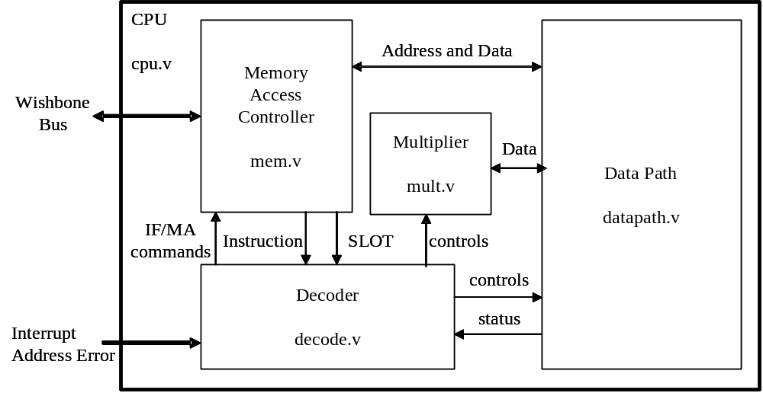
Figure2.1. Block Diagram of Aquarius
Top layer of Aquarius is “CPU” which has WISHBONE compliant bus signals and accepts interruption related signals. The most important system signals such as clock and reset are not shown in this figure.

The Memory Access Controller handles instruction fetch and data read/write access. The operations of Memory Access Controller are fully controlled by Decoder unit. Memory Access Controller sends fetched instruction bit fields to the Decoder unit, and interchanges read/write data and its address with Data Path unit. Aquarius assumes the Wishbone bus is a Non-Harvard bus, then the simultaneous instruction fetch and R/W data access makes bus contention. Memory Access Controller handles such contention smoothly and informs the pipeline stall caused by the bus contention to Decoder unit. Also, the Memory Access Controller can sense each boundary of bus cycles (with wait state) from WISHBONE ACK signal. In Aquarius architecture (may be in SuperH-2 architecture as well), such bus cycle boundary corresponds to the pipeline’s slot edge. So the Memory Access Controller produces the most important pipeline control signal “SLOT” indicating pipeline slot edge.

The Data Path unit has registers you can see in programmer’s model in SuperH-2 manual such as General Registers (R0 to R15), Status Register (SR), Global Base Register (GBR), Vector Base Register (VBR), Procedure Register (PR) and Program Counter (PC). The Multiplication and Accumulate Registers (MACH/MACL) are found in Multiplication unit. The Data Path unit also has necessity operation resources such as ALU (Arithmetic and Logical operation Unit), Shifter, Divider, Comparator, temporary registers, many selectors, interfaces to/from Memory Access Controller and Multiply unit, and several buses to connect each resource. The Data Path is fully controlled by control signals from Decoder unit.

Multiply unit has a 32bit x 16bit multiplier and its control circuits. A 16bit x 16bit multiply operation is executed in one clock cycle. A 32 bit x 32bit multiply operation is done in two clock cycles. Multiply unit also has the Multiplier and Accumulate Registers (MACH/MACL). The MACH/MACL are not only the final result registers of multiply or multiply-and-accumulation but also the temporary registers to hold the 48bit partial multiply result from 32bit x 16bit multiplier for 32bit x 32bit operation. The multiply instruction, for example MULS.L, clears the contents of MACH/MACL in early stage of the instruction operation. However the multiply and accumulate instruction, for example MAC.L, does not clear MACH/MACL before the operation. The MAC.L accumulates its own partial multiply result to initial MACH/MACL and then finalize the operation result. The major difference between multiply (MULS.L) and “multiply and accumulate” (MAC.L) is whether to clear or not to clear the MACH/MACL before the operation. And also, for MAC.L and MAC.W instruction, the accumulation adder in this unit has saturating function.

The Decoder unit is the fundamental CPU controller. It orders Memory Access Controller fetch instructions and then receives the instruction. The Decoder Unit decodes the instruction bit fields and judges the followed operations. Basically, the Decoder unit plays the role only for the instruction ID stage. But it throws many control signals for following EX, MA and WB stages toward Data Path unit, Multiplication unit, and Memory Access Controller. These control signals are kept and shifted with its pipeline flow at each slot edge until reaching to the target stage of the instruction. The Decoder unit detects every conditions of pipeline stalling, and makes each unit of CPU be controlled properly. Also, it controls not only simple 1 cycle instructions but also multi cycle instructions and exception’s sequences such as interrupt and address error.

Detailed design description of each unit is found in Part 2.

Examples of Aquarius based SoC
Figure 2.2 shows some examples of SoC using Aquarius.
- It is a simple micro controller that has CPU, ROM, RAM and some peripherals. Each module is connected by a common Wishbone bus.
- It is same as (1) except it has external bus interface. If the external bus interface is designed properly, it can be connected any memories such as ROM, Burst ROM, SRAM, SDRAM and, if you desire, DDR may be possible.
- If the bus operation frequency is high (for example, over 100MHz), one common Wishbone bus will not catch up with the frequency because of heavy load. In such case, I recommend you to divide the internal bus into as least two, one is the fast speed bus with only CPU and internal fast memories, and the other one is slow speed bus with many slow peripheral modules and external memory interface.

I provide Aquarius deliverables not only as CPU core but also as MCU like (1), which has ROM, RAM, UART, PORT and System Controller (interrupt and exception controller) etc.
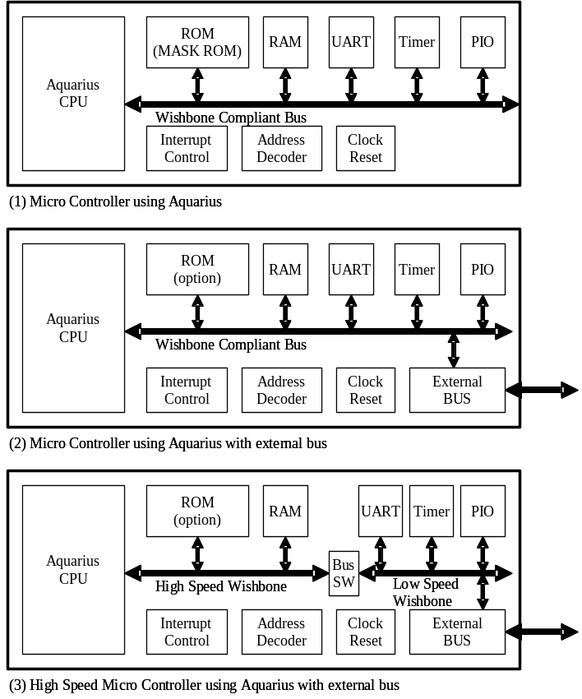
Figure2.2. Examples of System LSI using Aquarius

Preparation
This chapter describes my recommendations regarding necessary preparations before starting development. You do not need any expenses except PC environment and FPGA board.

PC environment
This is the most important tool. Any Windows machines are OK. I still use SONY VAIO Notebook PCG-R505FR/D with Mobile PentiumIII 800MHz, 256MB RAM, and Microsoft Windows XP. Even such machine has enough power to design Aquarius. Of course, you need broadband internet connection such as xDSL to download many required resources.
The reason why I use Windows machine instead of Linux machine is that the most “free” FPGA development tools from FPGA vendors such as Xilinx and Altera run on only Windows environment.

Cygwin
The simulator of Verilog-HDL codes and the compiler/assembler of SuperH-2 run on the UNIX environment. In order all tools to live together in Windows environment, the Cygwin is a good selection. Download the latest Cygwin system from http://www.cygwin.com, and full-install to your PC according to its instructions. After the Cygwin installation, many UNIX/Linux applications and all Windows applications simultaneously run on your PC without circumstances.

Icarus Verilog
I think the most excellent free Verilog simulator is Icarus Verilog. Download Icarus from http://www.icarus.com/eda/verilog/index.html and install it from Cygwin console window according to Icarus’s installation document. If you have installed Cygwin with full packages, you will not encounter any problems.

GNU Assembler and C Compiler for SuperH-2
To make verification program and to develop application program, the SuperH-2 assembler and compiler are necessary for you. Install them as follows.

- Download following files from ftp://ftp.gnu.org/pub/gnu/
binutils-2.13.1.tar.gz
gcc-2.95.3.tar.gz
gdb-5.2.1.tar.gz
- Download following file from http://sources.redhat.com/newlib/
newlib-1.10.0.tar.gz
- Place these 4 files under /usr/local/src.
- Install GNU binutils.
cd /usr/local/src
gzip –dc binutils-2.13.1.tar.gz | tar xvf –
cd binutils-2.13.1
mkdir work
cd work
../configure –-prefix=/usr/local –-target=sh-elf
make
make install
- Install GNU gcc and newlib.
cd /usr/local/src
gzip –dc newlib-1.10.0.tar.gz | tar xvf –
gzip –dc gcc-2.95.3.tar.gz | tar xvf -
cd gcc-2.95.3
ln –s ../newlib-1.10.0/newlib .
mkdir work
cd work
../configure –-prefix=/usr/local –-target=sh-elf --with-gnu-as --with-gnu-ld --with-dwarf2 --disable-multilib --enable-languages=c --with-newlib
make
make install
- Install GNU gdb.
cd /usr/local/src
gzip –dc gdb-5.2.1.tar.gz | tar xvf –
cd gdb-5.2.1
mkdir work
cd work
../configure –-prefix=/usr/local –-target=sh-elf
make
make install

FPGA development tool
To implement your design to FPGA, you need FPGA development tool. The FPGA vendors release excellent free development tool which has editor, logic synthesizer, static timing analyzer, placer & router and configuration binary generator. In Aquarius project, I have been using Xilinx free ISE Webpack 5.x. Download it from following URL site and install it on your Windows environment. It has a nice Verilog syntax editor, so I have mainly used the editor in “Project Navigator” of ISE during Aquarius development.
http://www.xilinx.com/xlnx/xil_prodcat_landingpage.jsp?title=ISE+WebPack

FPGA Board
To verify the logic design, implementing it to FPGA device is very good method. The FPGA plays a role as a hardware logic emulator, so the verification speed is much faster than vector logic simulation. And the CPU in FPGA can execute very large and long program quickly, so the verification quality will be improved.
I bought a board which has Xilinx VirtexE-300 (XCV300E). In my case, the board vendor name is HuMANDATA Ltd, and the product name is XSP-009-300. The site is http://www.hdl.co.jp/ which unfortunately has only Japanese description. But this company opens their technical documents regarding the products on their site, freely.
You can find the board schematic, which can be read even by non-Japanese people, from
http://www.hdl.co.jp/ftpdata/xsp-009/XSP009.sch.pdf .
I think you can find another good FPGA boards from many vendors around you. Or if you can get FPGA device, making a board by “DIY” is a good choice.
I added some external circuit such as LCD display, Hex Key board and I/F to RS232C to above board to make the verification be smooth. The detail circuit is described later.

Deliverables
This chapter shows the all deliverables of Aquarius project.

Document
Aquarius.pdf : this document (Adobe Acrobat Reader)
Aquarius.doc : this document (Microsoft Word)

RTL Resources
Verilog –HDL (RTL) of Aquarius CPU and its test bench
The set of RTL codes of Aquarius includes not only CPU RTL but also Simple MCU RTL that comprises CPU, ROM, RAM, PIO, UART and System Controller. The RTL codes except CPU are used as test bench of CPU. Of course, you can implement all RTL codes into your FPGA, and verify it much more efficiently like as I did. Figure 3.1 shows RTL structure of Aquarius MCU.

Test Bench comprises…
timescale.v Timescale definition. All files include me.
test.v Test Bench
top.v Top layer of MCU
MCUcomprises…
top.v Top layer of MCU
pio.v Parallel IN/OUT Interface
memory.v ROM(8KB) and RAM(8KB) for Verilog simulation.
ROM can be initialized from S-format binary code.
rom.v ROM description created by a converter from S-format.
memory_fpga.v “memory.v” for Xilinx FPGA’s configuration (BlockRAM)
All area (16KB) can be initialized by INIT constraints.
uart.v UART (Universal Asynchronous Receiver/Transmitter)
sasc_brg.v Baud Rate Generator
sasc_top.v UART Body
sasc_fifo4.v 4 step FIFO for UART Buffer
sys.v System Controller that handles interrupts and exceptions
lib.v A clock stop gate (SLEEP instruction) for Verilog sim.
lib_fpga.v “lib.v” for Xilinx FPGA configration
cpu.v Top layer of CPU (Aquarius)
Aquarius CPU comprises…
cpu.v Top layer of CPU (Aquarius)
datapath.v Data Path
register.v General Registers R0-R15
decode.v Instruction Decoder
mem.v Memory Access Controller
mult.v Multiplier
defines.v Constant Parameters referred from CPU

The UART is based on the “Simple Asynchronous Serial Communication Device created by Rudolf Usselmann” downloaded from http://www.opencores.org/cores/sasc/.
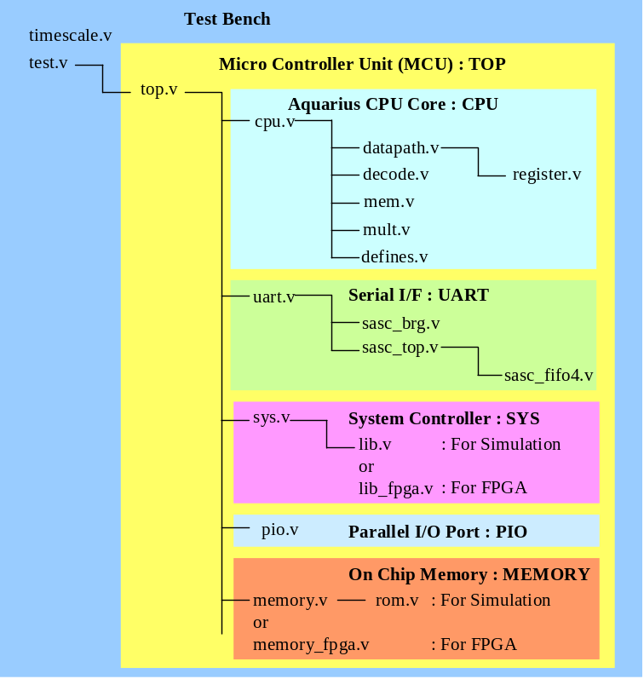
Figure 3.1 RTL Structure

Verification Resources
I also provide simple but useful resources for logic verification and program development.

(1) Assembler Source Programs for Verilog simulation
I provide some example programs for Verilog simulation. You can find them under the directory “sha_testsource”.

(2) Converter from S-format object to Verilog ROM description “rom.v”
The assembler can make S-format object. But it should be linked to Aquarius Verilog test bench. I made a simple binary converter from S-format to Verilog ROM description “rom.v”. This converter is “genrom.c” which is C source program. Compile it on your Cygwin console. Simply, do this.
$ gcc –o genrom.exe genrom.c
The usage is very simple. If your S-format binary name is “test.obj”, you can convert it to Verilog ROM description by typing as follows.
$ ./genrom test.obj
This operation creates “rom.v”, which is an 8Kbyte ROM.
Note that the “genrom” supports the S-Format which has only S0 (comment), S3 (4byte address) and S7 (end of record).

(3) Script to launch Assembler
The script named “asm” launches the GNU assembler, creates object code as an S-format file, and converts the S-Format object to a Verilog ROM description “rom.v”. The “asm” is very short script as follows.
________________________________________________
#!/bin/bash

sh-elf-as -a $1 > lis
sh-elf-as -o a.out $1
sh-elf-objcopy -O srec --srec-forceS3 a.out obj
./genrom obj
________________________________________________
The usage is also simple. If you have assemble source program named “test.src”, simply type as follows.
$ ./asm test.src
This operation creates Verilog ROM description “rom.v” corresponding to “test.src”.

(4) Script to launch Verilog Simulation
After creating “rom.v”, now you can simulate Aquarius. First of all, prepare a text file “test.txt” that lists up all Verilog source files.
The script named “sim” launches the Icarus Verilog Simulator. The “sim” is very short script as follows.
________________________________________________
#!/bin/bash

iverilog –o test –c test.txt
vvp –v test
________________________________________________
By the Aquarius test bench “test.v”, the simulation results is created as “test_result.txt” which is a trace list of bus cycle and important register contents.

FPGA related Resources
To implement Aquarius into Xilinx VirtexE, I have prepared some resources.

(1) Converter from S-format object to Xilinx BlockRAM INIT Constraints
In case of FPGA implementation, ROM should be configured by BlockRAM instead of “rom.v”, which is described by continuous “case” statements, to reduce the consumption of logic cells. The BlockRAM can be initialized by INIT statement in user constraints file (.ucf). So I made a converter from S-format object to INIT statement.
The converter is “genram.c”, which is also a C program, then compile it on your Cygwin console.
$ gcc –o genram.exe genram.c
The usage is very simple. If your S-format binary name is “test.obj”, you can convert it to INIT description by typing as follows.
$ ./genram test.obj
This operation creates “ram.dat”, which is 16Kbyte BlockRAM initialization.
The content of “ram.dat” is as follows.
_________________________________________________________________
INST "MEMORY_Mram_RAM0HH_inst_ramb_0" INIT_00 = 0000000000000000…;
INST "MEMORY_Mram_RAM0HH_inst_ramb_0" INIT_01 = 0000000000000000…;
INST "MEMORY_Mram_RAM0HH_inst_ramb_0" INIT_02 = 2121212121212121…;
INST "MEMORY_Mram_RAM0HH_inst_ramb_0" INIT_03 = 6765636100D02F2F…;
_________________________________________________________________
After creating “ram.dat”, add this content after the tail of your user constraints file (.ucf), or change all old INST statement. Then, configure your FPGA.

(2) An example of User Constraints File (.ucf)
I provide an example of user constraints file (top.ucf) which corresponds to my FPGA system described later.

- Some Applications for FPGA System
Following application programs are provided.
Monitor Program shc_monitor_release_v1/
LCD Test shc_lcdtest/
Interrupt! Clock shc_clock/
Calculation of Pi shc_pi/
Details are described later (FPGA Implementation)

Aquarius CPU Interface Specification: “cpu.v”

Aquarius CPU IN/OUT Signals
The Aquarius CPU (“cpu.v”)’s IN/OUT signals are shown in Table5.1. In Aquarius CPU logic circuit, all signals are positive logic level and the changing timing is always at positive edge of CLK.
Class | Signal Name | Direction | Meaning | Notes
System  Signals | CLK | Input | System clock
System  Signals | RST | Input | Power On Reset
Wishbone  Bus  Signals | CYC_O | Output | Cycle Output
Wishbone  Bus  Signals | STB_O | Output | Strobe Output
Wishbone  Bus  Signals | ACK_I | Input | Device Acknowledge
Wishbone  Bus  Signals | ADR_O[31:0] | Output | Address Output
Wishbone  Bus  Signals | DAT_I[31:0] | Input | Read Data
Wishbone  Bus  Signals | DAT_O[31:0] | Output | Write Data
Wishbone  Bus  Signals | WE_O | Output | Write Enable
Wishbone  Bus  Signals | SEL_O[3:0] | Output | Byte Lane Select
Wishbone  Bus  Signals | TAG0_I (IF_WIDTH) | Input | Fetch Width
Hardware  Event  (interrupt) | EVENT_REQ_I[2:0] | Input | Event Request
Hardware  Event  (interrupt) | EVENT_INFO_I[11:0] | Input | Event Information
Hardware  Event  (interrupt) | EVENT_ACK_O | Output | Event Acknowledge
SLEEP | SLP | Output | Sleep Pulse
Table5.1 Aquarius CPU IN/OUT Signals

System Signals
(1) CLK
The clock input [CLK] coordinates all activities for the internal logic within the WISHBONE interconnect. All output signals are registered at the rising edge of [CLK]. All input signals are stable before the rising edge of [CLK].

(2) RST
The reset input [RST] forces the WISHBONE interface to restart. Furthermore, all internal state machines are forced into an initial state.
When system power-on (cold start), [RST] should be asserted at least for 1 cycle. The Aquarius CPU senses [RST] asynchronously, so any glitch pulse should not be overlaid on [RST] signal. Aquarius Flip Flops are written as follows.
always @(posedge CLK or posedge RST)
{
if (RST)
{
}
else
{
}
}
If your in-house design rule inhibits asynchronous reset at Flip Flops, you can rewrite RTL codes of Aquarius as follows. Aquarius CPU can operate in synchronous reset manner.
always @(posedge CLK)
{
if (RST)
{
}
else
{
}
}

“WISHBONE” Compliant Bus Signals
The bus specification of Aquarius CPU is based on WISHBONE classic bus. It follows “Specification for the WISHBONE System-on-Chip (SoC) Interconnection Architecture for Portable IP Cores Revision: B.3, Released: September 7, 2002”. The detail specification document is found in the OpenCores site.

- CYC_O
The cycle output [CYC_O], when asserted, indicates that a valid bus cycle is in progress. The signal is asserted for the duration of all bus cycles. For example, during a Read Modify Write cycle caused by TAS.B (test and set instruction for semaphore protocol), there are two data transfers. The [CYC_O] signal is asserted during the first data read, and remains its assertion until the last data write. The [CYC_O] signal is useful for bus arbiter to prevent exchanging the current bus master to another device such as DMA controller during the TAS.B read modify write cycle.

- STB_O
The strobe output [STB_O] indicates a valid data transfer cycle. It is used to qualify various other signals on the interface such as [SEL_O]. The SLAVE module asserts either the [ACK_I] signals in response to every assertion of the [STB_O] signal.

- ACK_I
The acknowledge input [ACK_I], when asserted, indicates the normal termination of a bus cycle. The [ACK_I] creates CPU internal signal “SLOT” to indicate the edge of pipeline slot.

- ADR_O[31:0]
The address output array [ADR_O] is used to pass a binary address.

- DAT_I[31:0]
The data input array [DAT_I] is used to read binary data from external devices such as ROM, RAM and peripheral modules.

- DAT_O[31:0]
The data output array [DAT_O] is used to write binary data to external devices such as RAM and peripheral modules.

- WE_O
The write enable output [WE_O] indicates whether the current local bus cycle is a READ or
WRITE cycle. The signal is negated during READ cycles, and is asserted during WRITE cycles.

- SEL_O[3:0]
The select output array [SEL_O] indicates where valid data is expected on the [DAT_I] signal array during READ cycles, and where it is placed on the [DAT_O] signal array during WRITE cycles. The minimum data granularity size is BYTE, so each SEL_O corresponds to each byte lane. The data alignment position is described in detail later.

- TAG0_I (IF_WIDTH)
All SuperH-2 instruction has 16bit length. The memory such as ROM and RAM connected to Aquarius CPU has 32bit data width. So, when CPU fetches its instruction from 32bit width memory, CPU can get 2 instructions. But if the device data width is 16bit, only one instruction can be sent to CPU at once fetch cycle. Latter case may happen when CPU fetches its instruction from 16bit width external bus, for example.
Therefore, WISHBONE glue logic must inform CPU the instruction fetch space’s width.
If the address space is 32bit width, WISHBONE should return IF_WDTH=1, else should return IF_WIDTH=0 before ACK_I signal is asserted.
If CPU fetches instruction from address 0x2, 0x6, 0xa, 0xe, CPU can get only 1 instruction by the fetch cycle. But CPU knows such status, so WISHBONE need not check such case. The WISHBONE glue logic should care only the instruction sending band width that is the data width of accessing address space.
In other words, in case of instruction fetch, IF_WIDTH has its meaning only when lower 2bit of address is 2’b00. The IF_WIDTH informs CPU how many instructions should be fetched. But if the lower 2bit of address is 2’b10, CPU can get only one instruction regardless IF_WIDTH. In latter case, CPU ignores the IF_WIDTH.

[CAUTION] Aquarius CPU assumes that the internal bus width is always 32bit. If you connect the internal WISHBONE to 16bit/8bit external bus or peripheral modules, some glue bus control logic should be created to convert internal 32bit data to/from 8bit/6bit data with proper wait timing controls.

- Data Alignment Position
Aquarius CPU is big-endian. The data width is 32 bit, memory data access granularity is byte, and instruction fetch granularity is 16 bit.
Table5.2 shows the data alignment position on WISHBONE data bus for each access.
In WISHBONE specification data sheet, 32bit operand size is called as “DWORD”, but in SuperH and Aquarius world, 32bit is called as “Long” or “Long Word”.
Note that in case of write operation, the unselected lanes have same write data as valid lane’s one. For example, in WORD writing to address 2(2’b10), the valid lane is bit15-0, but bit31-16 of DAT_O has same data as bit15-0.

Access Type |  | Lane  [31:24]  SEL [3] | Lane  [23:16]  SEL[2] | Lane  [15:8]  SEL[1] | Lane  [7:0]  SEL[0] | Notes
Size | Address  Lower 2bit
Data Read Long | 2’b00 | D[31:24] | D[23:16] | D[15:8] | D[7:0] | DAT_I
Data Read Word | 2’b00 | D[15:8] | D[7:0] | ignored | ignored | DAT_I
Data Read Word | 2’b10 | Ignored | ignored | D[15:8] | D[7:0] | DAT_I
Data Read Byte | 2’b00 | D[7:0] | ignored | ignored | ignored | DAT_I
Data Read Byte | 2’b01 | Ignored | D[7:0] | ignored | ignored | DAT_I
Data Read Byte | 2’b10 | Ignored | ignored | D[7:0] | ignored | DAT_I
Data Read Byte | 2’b11 | Ignored | ignored | ignored | D[7:0] | DAT_I
Data Write Long | 2’b00 | D[31:24] | D[23:16] | D[15:8] | D[7:0] | DAT_O
Data Write Word | 2’b00 | D[15:8] | D[7:0] | D[15:8] | D[7:0] | DAT_O
Data Write Word | 2’b10 | D[15:8] | D[7:0] | D[15:8] | D[7:0] | DAT_O
Data Write Byte | 2’b00 | D[7:0] | D[7:0] | D[7:0] | D[7:0] | DAT_O
Data Write Byte | 2’b01 | D[7:0] | D[7:0] | D[7:0] | D[7:0] | DAT_O
Data Write Byte | 2’b10 | D[7:0] | D[7:0] | D[7:0] | D[7:0] | DAT_O
Data Write Byte | 2’b11 | D[7:0] | D[7:0] | D[7:0] | D[7:0] | DAT_O
Fetch IF_WIDTH=1 | 2’b00 | I0[15:8] | I0[7:0] | I1[15:8] | I1[7:0] | DAT_I
Fetch IF_WIDTH=0 | 2’b00 | I[15:8] | I[7:0] | ignored | Ignored | DAT_I
Fetch IF_WIDTH=* | 2’b10 | ignored | ignored | I[15:8] | I[7:0] | DAT_I

：Corresponding SEL_O[n] is asserted.
Table5.2 Data Alignment Position

Hardware Event Signals (Interrupt)
CPU should accept some requests from hardware events such as interrupt, address error and manual reset. These requests are informed to CPU by EVENT_REQ[2:0] associated with EVENT_INFO[11:0]. The EVENT_REQ[2:0] shows the kind of event request. The meanings are shown in Table5.3. In case of IRQ request, EVENT_INFO[11:0] should also be valid. The upper 4bit of EVENT_INFO shows the priority level of the requesting IRQ, and the lower 8bit of EVENT_INFO shows its vector No. The vector address of IRQ equals to EVENT_INFO[7:0] * 4. Also see Table5.4.
The EVENT_REQ and EVENT_INFO should be asserted and be valid at same timing. CPU samples them at same timing (at the decode stage of pipeline). If the EVENT_REQ do not show IRQ request, CPU ignores the EVENT_INFO. After CPU samples the EVENT_REQ (and EVENT_INFO), CPU asserts EVENT_ACK, which shows that the CPU accepts the hardware event request that is valid just at when EVENT_ACK is being asserted. The EVENT_REQ should be negated or should be change to next request just after EVENT_ACK is asserted.
If the event can not be accepted by CPU; that happens in case of lower priority IRQ than I-bit in SR, interrupt request just after the instruction that masks interrupt (for example LDC/LDC.L), or all hardware exception events just after delayed branch instruction; the EVENT_ACK is not asserted until the request signals can be accepted by CPU. Of course, if the event request is negated before CPU’s sampling, the event request can not be accepted by CPU. The hardware event request timing is shown in Figure5.1 with internal pipeline controls.
Hardware Event | EVENT_REQ[2:0] | Notes
NOP | 3’b111
IRQ | 3’b000 | Also use EVENT_INFO[11:0]
NMI | 3’b001
CPU Address Error | 3’b010
DMA Address Error | 3’b011
Manual Reset | 3’b110
Table5.3 Hardware Event Request Signal: EVENT_REQ[2:0]
Hardware Event Information | Meaning | Notes
EVENT_INFO[11:8] | Priority level of requesting IRQ (4bit)
EVENT_INFO[7:0] | Vector No. of requesting IRQ (8bit)
Table5.4 Hardware Event Information: EVENT_INFO[11:0]
The priority among hardware exceptions should be determined by external circuits, which generates EVENT_REQ and EVENT_INFO. In SuperH-2 products, the priority order of exceptions is as follows.
1st: Power On Reset (Triggered by RST signal.)
2nd: Manual Reset
3rd: CPU/DMA Address Error
4th: NMI
5th: IRQ
The exceptions caused by instruction (Illegal, Slot-Illegal and Trap) have the lowest priority, but the external circuits need not to care, because the decoder unit in CPU detects them.

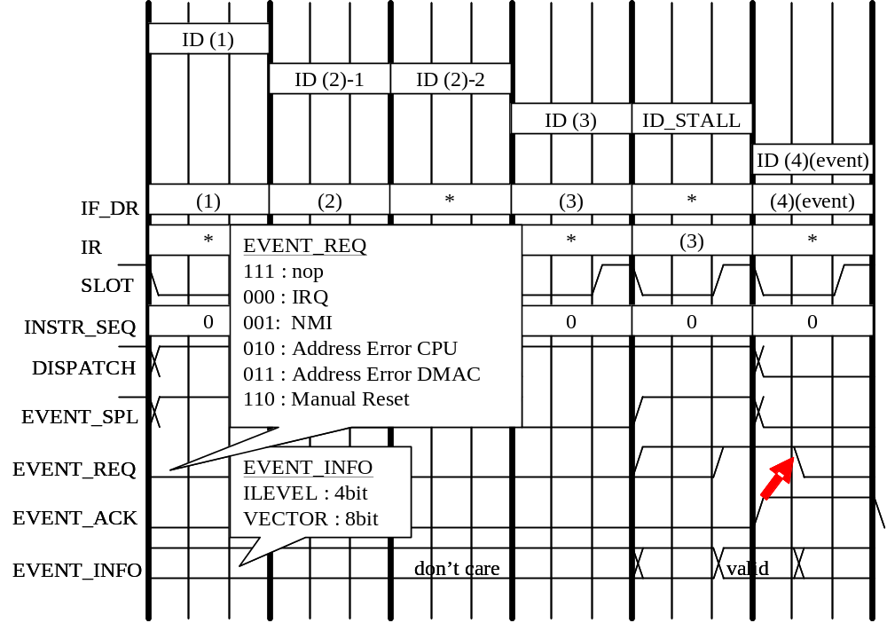
Figure5.1 Hardware Event Request and Sampling Timing

SLEEP signal for Low Power Mode
The SLP output is asserted by SLEEP instruction. The chip can stop its clock by SLP signal and can go to low power mode, if you desire.
The SLEEP timing is shown is Figure5.2. The CLK_SRC is an original clock generated by, for example, XTAL oscillator. The CLK is made from CLK_SRC by a gating logic and the CLK stops during SLEEP state. Of course you can stop CLK_SRC by similar method (But, to wake up CLK_SRC, you may need some delay timer to wait for the stable XTAL oscillation.) And by some wakeup signal such as NMI, the CLK is waked up. At the wakeup timing, if CPU finds a hardware event request, corresponding exception starts. Or, if there is no hardware event, the program starts from next instruction of SLEEP.
The actual low power mode should be implemented by whole chip designer. The Aquarius test bench includes very simple low power control logic, for your reference.

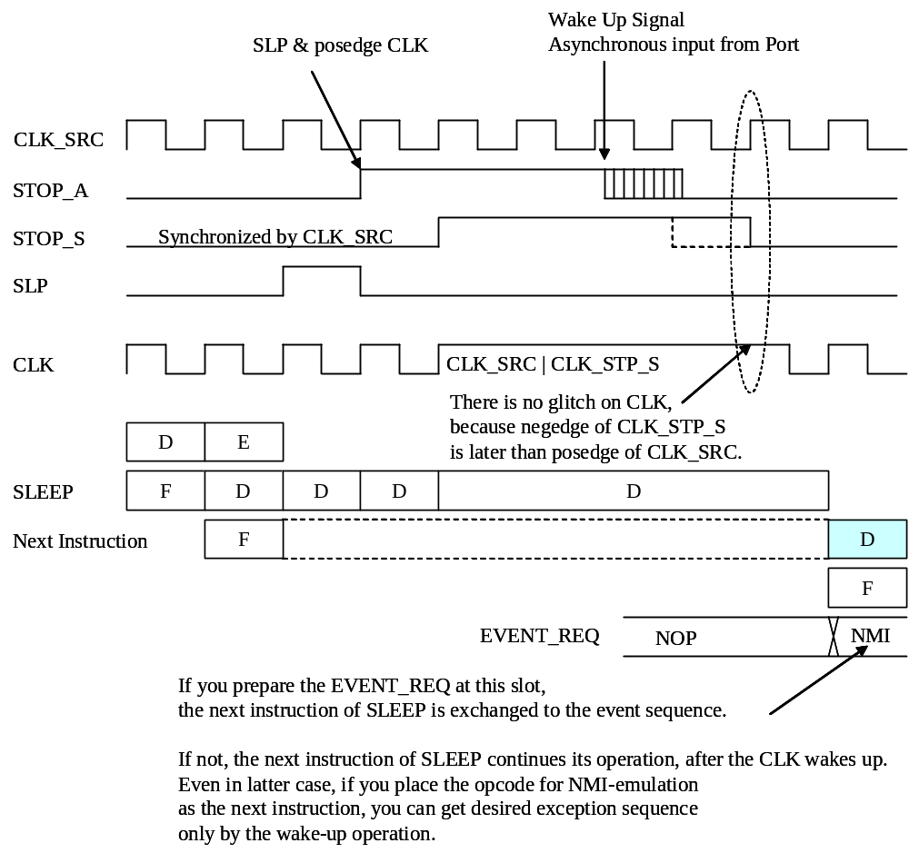
Figure5.2 SLEEP and Low Power Timing

Simulation Test Bench
This chapter describes the Aquarius test bench structure for the verification by the method of vector logic simulation.

Top Layer: “top.v”
As shown in Figure3.1, “top.v” is the top layer of Aquarius MCU. It combines among CPU, UART, System Controller, Parallel Port, and on chip memories.
In this chapter, “memory.v” and “lib.v” are assumed to be used, instead of “memory_fpga.v” and “lib_fpga.v”.
The system address map is shown in Table6.1.The “memory.v” has 8KB ROM (“rom.v”) and 8KB RAM. All CPU instruction should be verified in various memory access cycle and instruction fetch size. So, the memory access cycle and instruction fetch width are determined by its address; i.e. WISHBONE ACK and TAG0_I(IF_WIDTH) are generated in “top.v”.
The peripheral devices such as PIO, UART and SYS are located in 0xABCDxxxx area.
The top layer’s IN/OUT signals are shown in Table6.2. These signals correspond with author’s FPGA configuration. There are several LCD and KEY control signals from PIO module, and UART signals. See later chapter for detail FPGA board circuit.

Simulation Test Bench: “test.v”
The “test.v” is a test bench for Verilog simulation. It creates clock and some input signals (stimuli). Also it generate trace list file as a simulation result named “test_result.txt”. For your own simulation, please modify “test.v”. When you simulate instructions of CPU by Verilog logic simulator, you need not care the operations of LCD, KEY and UART interfaces. You should care only bus transaction, register contents and signal levels and timings, etc. in case that your viewpoint of simulation is in Aquarius CPU operation.

Parallel I/O Port (PIO): “pio.v”
Parallel I/O Port (PIO) “pio.v” IN/OUT signals are shown in Table6.3. PIO has 2 32bit registers to control Port Pins. Parallel I/O Port (PIO) Registers are shown in Figure6.1. There are 4 byte-size registers for PORT Output and 4 byte-size registers for PORT Input. Both registers for PORT Input and PORT Output have same address. If you read each register, you can access PORT Input, and if you write to each register, you can access PORT Output.
Each register is located in side-by-side address, so they can be accessed by byte, word or long operand size. PORT Output registers are reset to 0x00 when power on reset.

Address | Device | Size | Access Cycle | IF Width | Notes
0x00000000-0x00001FFF | ROM | 8KB | 1cyc | 32bit | A
0x00002000-0x00003FFF | RAM | 8KB | 1cyc | 32bit | B
0x00004000-0x0000FFFF | Shadow of 0x00000000-0x00003FFF
0x00010000-0x00011FFF | ROM | 8KB | 4cyc | 32bit | Shadow of A
0x00012000-0x00013FFF | RAM | 8KB | 4cyc | 32bit | Shadow of B
0x00014000-0x0001FFFF | Shadow of 0x00010000-0x00013FFF
0x00020000-0x00021FFF | ROM | 8KB | 1cyc | 16bit | Shadow of A
0x00022000-0x00023FFF | RAM | 8KB | 1cyc | 16bit | Shadow of B
0x00024000-0x0002FFFF | Shadow of 0x00020000-0x00023FFF
0x00030000-0x00031FFF | ROM | 8KB | 4cyc | 16bit | Shadow of A
0x00032000-0x00033FFF | RAM | 8KB | 4cyc | 16bit | Shadow of B
0x00034000-0x0003FFFF | Shadow of 0x00030000-0x00033FFF
0x00040000-0xABCCFFFF | Shadow of 0x00000000-0x0003FFFF
0xABCD0000-0xABCD00FF | PIO | 256B | 4cyc | 32bit
0xABCD0100-0xABCD01FF | UART | 256B | 4cyc | 32bit
0xABCD0200-0xABCD02FF | SYS | 256B | 4cyc | 32bit
0xABCD0300-0xFFFFFFFF | Shadow of 0x00000000-0x0003FFFF
Table6.1 Address Map of the Test Bench

Class | Signal Name | Direction | Meaning | Notes
System  Signals | CLK_SRC | Input | System clock
System  Signals | RST_n | Input | Power On Reset | Negated
Parallel  I/O Port | LCDRS | Output | LCD Register Select | PO[8]
Parallel  I/O Port | LCDRW | Output | LCD Read/Write | PO[9]
Parallel  I/O Port | LCDE | Output | LCD Enable Signal | PO[10]
Parallel  I/O Port | LCDDBO[7:0] | Output | LCD Data Bus Output | PO[7:0]
Parallel  I/O Port | LCDDBI[7:0] | Input | LCD Data Bus Input | PI[7:0]
Parallel  I/O Port | KEYYO[4:0] | Output | KEY Matrix Y Output | PO[20:16]
Parallel  I/O Port | KEYXI[4:0] | Input | KEY Matrix X Input | PI[20:16]
UART | RXD | Input | Receive Serial Data
UART | TXD | Output | Transmit Serial Data
UART | CTS | Input | Clear To Send
UART | RTS | Output | Request To Send
Table6.2 Top Layer IN/OUT Signals
Class | Signal Name | Direction | Meaning | Notes
System  Signals | CLK | Input | System clock
System  Signals | RST | Input | Power On Reset
Wishbone  Bus  Signals | CE | Input | Chip Select (Module Select) | STB
Wishbone  Bus  Signals | WE | Input | Write Enable
Wishbone  Bus  Signals | SEL[3:0] | Input | Byte Lane Select
Wishbone  Bus  Signals | DATI[31:0] | Input | Data Input (Write Data)
Wishbone  Bus  Signals | DATO[31:0] | Output | Data Output (Read Data)
PORT | PI[31:0] | Input | Port Input
PORT | PO[31:0] | Output | Port Output
Table6.3 Parallel I/O Port (PIO) Module IN/OUT Signals

[PORT Output] Address=0xABCD0000 W only reserved
31(7) | 30(6) | 29(5) | 28(4) | 27(3) | 26(2) | 25(1) | 24(0)
reserved | reserved | reserved | reserved | reserved | reserved | reserved | reserved
[PORT Output] Address=0xABCD0001 W only KEYYO (KEY Matrix Y-axis Output)
23(7) | 22(6) | 21(5) | 20(4) | 19(3) | 18(2) | 17(1) | 16(0)
reserved | reserved | reserved | KY4 | KY3 | KY2 | KY1 | KY0
[PORT Output] Address=0xABCD0002 W only LCDCON (LCD Control Output)
15(7) | 14(6) | 13(5) | 12(4) | 11(3) | 10(2) | 9(1) | 8(0)
reserved | reserved | reserved | reserved | reserved | E | R/W | RS
[PORT Output] Address=0xABCD0003 W only LCDOUT (LCD Write Data Output)
7(7) | 6(6) | 5(5) | 4(4) | 3(3) | 2(2) | 1(1) | 0(0)
DW7 | DW6 | DW5 | DW4 | DW3 | DW2 | DW1 | DW0

[PORT Input] Address=0xABCD0000 R only reserved
31(7) | 30(6) | 29(5) | 28(4) | 27(3) | 26(2) | 25(1) | 24(0)
reserved | reserved | reserved | reserved | reserved | reserved | reserved | reserved
[PORT Input] Address=0xABCD0001 R only KEYXI (KEY Matrix X-axis Input)
23(7) | 22(6) | 21(5) | 20(4) | 19(3) | 18(2) | 17(1) | 16(0)
reserved | reserved | reserved | KX4 | KX3 | KX2 | KX1 | KX0
[PORT Input] Address=0xABCD0002 R only reserved
15(7) | 14(6) | 13(5) | 12(4) | 11(3) | 10(2) | 9(1) | 8(0)
reserved | reserved | reserved | reserved | reserved | E | R/W | RS
[PORT Input] Address=0xABCD0003 R only LCDIN (LCD Read Data Input)
7(7) | 6(6) | 5(5) | 4(4) | 3(3) | 2(2) | 1(1) | 0(0)
DR7 | DR6 | DR5 | DR4 | DR3 | DR2 | DR1 | DR0
Figure6.1 Parallel I/O Port (PIO) Registers

Serial I/O (UART): “uart.v”
The top layer has Serial I/O device (UART) “uart.v”, which is SASC (Simple Asynchronous Serial Communication Device) from the opencores.org IP. The SASC is not WISHBONE compliant IP, so some registers are added to connect SASC to WISHBONE bus. UART IN/OUT signals are shown in Table6.4, and its registers are shown in Figure6.2. Each register is located in side-by-side address, so they can be accessed by byte, word or long operand size, but the UARTCON and UARTRXD/TXD should be accessed only by byte operand size.

Class | Signal Name | Direction | Meaning | Notes
System  Signals | CLK | Input | System clock
System  Signals | RST | Input | Power On Reset
Wishbone  Bus  Signals | CE | Input | Chip Select (Module Select) | STB
Wishbone  Bus  Signals | WE | Input | Write Enable
Wishbone  Bus  Signals | SEL[3:0] | Input | Byte Lane Select
Wishbone  Bus  Signals | DATI[31:0] | Input | Data Input (Write Data)
Wishbone  Bus  Signals | DATO[31:0] | Output | Data Output (Read Data)
UART | RXD | Input | Receive Serial Data
UART | TXD | Output | Transmit Serial Data
UART | CTS | Input | Clear To Send
UART | RTS | Output | Request To Send
Table6.4 Serial I/O (UART) IN/OUT Signals
[UART] Address=0xABCD0100 R/W UARTBG0 (Baud rate Generator Div0)
31(7) | 30(6) | 29(5) | 28(4) | 27(3) | 26(2) | 25(1) | 24(0)
B07 | B06 | B05 | B04 | B03 | B02 | B01 | B00
[UART] Address=0xABCD0101 R/W UARTBG1 (Baud rate Generator Div1)
23(7) | 22(6) | 21(5) | 20(4) | 19(3) | 18(2) | 17(1) | 16(0)
B17 | B16 | B15 | B14 | B13 | B12 | B11 | B10
[UART] Address=0xABCD0102 R only UARTCON (TXF=full_o, RXE=empty_o)
15(7) | 14(6) | 13(5) | 12(4) | 11(3) | 10(2) | 9(1) | 8(0)
reserved | reserved | Reserved | reserved | reserved | reserved | TXF | RXF
[UART] Address=0xABCD0103 R only / UARTRXD, W only / UARTTXD
7(7) | 6(6) | 5(5) | 4(4) | 3(3) | 2(2) | 1(1) | 0(0)
TR7 | TR6 | TR5 | TR4 | TR3 | TR2 | TR1 | TR0
Figure6.2 Serial I/O (UART) Registers
The UARTBG0 and UARTBG1 are the registers to determine the serial baud rate. The UARTBG0 and UARTBG1 are reset to 0x00 when power on reset. The expression to calculate the baud rate is shown below.
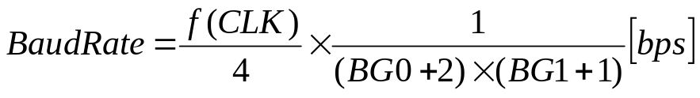
Table6.5 shows some examples of baud rate setting.

Baud Rate [bps] | f (CLK) [MHz] | UARTBG0 | UARTBG1 | Notes
1200 | 20 | 0x12 (18) | 0xCF (207)
2400 | 20 | 0x12 (18) | 0x67 (103)
4800 | 20 | 0x12 (18) | 0x33 (51)
9600 | 20 | 0x12 (18) | 0x19 (25)
Table6.5 Examples of Baud Rate Settings
The UARTCON has 2 flags; TXF and RXE. The TXF is 1 when transmit buffer is full. If TXF=0, you can write next transmit data. The RXE is 1 when receive buffer is empty. If TXE=0, you can read receive data. The TXF and RXE correspond to full_o and empty_o of SASC, respectively. Note that SASC has 4 byte depth FIFOs for both transmit buffer and receive buffer. In case of this top layer, TXF and RXE are not connected as interrupt signals, so you should poll these flags in your program. Generally, such flags should be treated as interrupt requests. You can easily modify the Aquarius RTL codes like this.
The UARTRXD and UARTTXD are the receive buffer and transmit buffer registers, which have same address. Read operation accesses to UARTRXD, and Write operation accesses to UARTTXD.

System Controller (SYS): “sys.v”
The System Controller (SYS) “sys.v” has following functions.
- Generate Exception of Hardware Event.
  - NMI (by Address Break)
  - IRQ (by Interval Timer)
  - CPU Address Error (by watching WISHBONE bus transaction)
- Emulate Exception of Hardware Event.
  - NMI
  - IRQ
  - CPU Address Error
  - DMA Address Error
  - Manual Reset
- Control priority level among the requests of hardware exception.
- Set IRQ priority level and vector number.
- 12it Interval Timer to generate IRQ.
- Bus Address Break Function for debugging capability (NMI).
- Detect CPU Address Error by watching WISHBONE bus signals.
- SLEEP and Low Power Control, according to Figure5.2 manner.
The IN/OUT Signals of SYS are shown in Table6.6.
The SYS has 2 32bit length registers; INTCTL and BRKADR. These are shown in Figure6.3. Both registers should be accessed only by long word operand size. The INTCTL is reset to 0x00000FFF, and the BRKADR is reset to 0x00000000 when power on reset.
Class | Signal Name | Direction | Meaning | Notes
System  Signals | CLK_SRC  CLK  SLP  WAKEUP | Input  Output  Input  Input | System clock Source  CLK , which stops at SLEEP  SLEEP request from CPU  Wakeup Request
System  Signals | RST | Input | Power On Reset
Wishbone  Bus  Signals | CE | Input | Chip Select (Module Select) | STB
Wishbone  Bus  Signals | WE | Input | Write Enable
Wishbone  Bus  Signals | SEL[3:0] | Input | Byte Lane Select
Wishbone  Bus  Signals | ACK | Input | Bus Acknowledge
Wishbone  Bus  Signals | DATI[31:0] | Input | Data Input (Write Data)
Wishbone  Bus  Signals | DATO[31:0] | Output | Data Output (Read Data)
Wishbone  Bus  Signals | STB | Input | Strobe (Bus monitor to BRK)
Wishbone  Bus  Signals | ADR[31:0] | Input | Address (Bus monitor to BRK)
Hardware  Events | EVENT_REQ[2:0] | Output | Event Request
Hardware  Events | EVENT_INFO[11:0] | Output | Event Information (IRQ)
Hardware  Events | EVENT_ACK | Input | Event Acknowledge from CPU
Table6.6 System Controller (SYS) IN/OUT Signals

[SYS] Address=0xABCD0200 R/W INTCON (Interrupt Control)
31 | 30 | 29 | 28 | 27 | 26 | 25 | 24
E_NMI | E_IRQ | E_CER | E_DER | E_MRS | reserved | TMRON | BRKON
23 | 22 | 21 | 20 | 19 | 18 | 17 | 16
ILVL3 | ILVL2 | ILVL1 | ILVL0 | IVEC7 | IVEC6 | IVEC5 | IVEC4
15 | 14 | 13 | 12 | 11 | 10 | 9 | 8
IVEC3 | IVEC2 | IVEC1 | IVEC0 | TMR11 | TMR10 | TMR9 | TMR8
7 | 6 | 5 | 4 | 3 | 2 | 1 | 0
TMR7 | TMR6 | TMR5 | TMR4 | TMR3 | TMR2 | TMR1 | TMR0

[SYS] Address=0xABCD0204 R/W BRKADR (Break Address)
31 | 30 | 29 | 28 | 27 | 26 | 25 | 24
ADR31 | ADR30 | ADR29 | ADR28 | ADR27 | ADR26 | ADR25 | ADR24
23 | 22 | 21 | 20 | 19 | 18 | 17 | 16
ADR23 | ADR22 | ADR21 | ADR20 | ADR19 | ADR18 | ADR17 | ADR16
15 | 14 | 13 | 12 | 11 | 10 | 9 | 8
ADR15 | ADR14 | ADR13 | ADR12 | ADR11 | ADR10 | ADR9 | ADR8
7 | 6 | 5 | 4 | 3 | 2 | 1 | 0
ADR7 | ADR6 | ADR5 | ADR4 | ADR3 | ADR2 | ADR1 | ADR0
Figure6.3 System Controller (SYS) Registers
INTCTL : Interrupt Control Register
E_NMI Emulate NMI. Write only bit. Read 0 only.
When you write 1, NMI exception sequence will start.
E_IRQ Emulate IRQ. Write only bit. Read 0 only.
When you write 1, IRQ exception sequence will start
if the IRQ priority level is higher than I bit in SR.
The priority level and the vector number of the IRQ is specified
by ILVL3-ILVL0 and IVEC7-IVEC0 bits in INTCTL register.
E_CER Emulate CPU Address Error. Write only bit. Read 0 only.
When you write 1, CPU Address Error exception will start.
E_DER Emulate DMA Address Error. Write only bit. Read 0 only.
When you write 1, DMA Address Error exception will start.
E_MRES Emulate Manual Reset. Write only bit. Read 0 only.
When you write 1, Manual Reset exception will start.
TMRON When 1, 12 bit Interval Timer starts.
When 0, the Interval Timer stops.
BRKON When 1, start to compare BRKADR with WISHBONE address,
and if these are equal, request NMI.
ILVL3-ILVL0 IRQ priority level to be requested (makes EVENT_INFO[11:8])
IVEC7-IVEC0 IRQ vector number to be requested (makes EVENT_INFO[7:0])
TMR11-TMR0 12 bit Interval Timer. When 0x000, it requests IRQ.

BRKADR : Break Address Register
ADR31-ADR0 Break address to be compared to WISHBONE address.
It is valid only when BRKON=1.

On Chip Memory: “memory.v”
The memory module “memory.v” has 8KB ROM and 8KB RAM. The address map has been shown in Table6.1. The bit pattern of ROM is specified by “rom.v” description. The memory module’s IN/OUT signals are shown in Table6.7.

Class | Signal Name | Direction | Meaning | Notes
System  Signals | CLK | Input | System clock
System  Signals | RST | Input | Power On Reset
Wishbone  Bus  Signals | CE | Input | Chip Select (Module Select) | STB
Wishbone  Bus  Signals | WE | Input | Write Enable
Wishbone  Bus  Signals | SEL[3:0] | Input | Byte Lane Select
Wishbone  Bus  Signals | ADR[13:0] | Input | Address
Wishbone  Bus  Signals | DATI[31:0] | Input | Data Input (Write Data)
Wishbone  Bus  Signals | DATO[31:0] | Output | Data Output (Read Data)
Table6.7 On-Chip Memory IN/OUT Signals

Simulation Tools and Flows
(1) Have you already installed all tools such as Cygwin, GNU binutils, GNU C compiler and Aquarius deliverables for program development and Verilog simulation?
In following explanations, I assume the tool placing is like below.
~ (home directory)
|----CPU (directory)
|----*.v (Verilog Sources)
|----test.txt (list of Verilog sources for simulation)
|----sim (simulation launch script)
|----asm (assembler launch script)
|----sha_testsource (directory)
|----testalu.src (ALU check program)

(2) To simulate instruction or program, make your assembler source file. Some examples are located in the directory "sha_testsource" of Aquarius deliverables. In these examples, basically, all instruction sequence to be verified are simulated on all memory space attributes among combinations of no-wait or with-wait, and 32bit or 16bit instruction fetch area (IF_WIDTH). Now, suppose you are trying "testalu.src" to check ALU functions.

- Assemble it. From your Cygwin console window, type…
$ cd ~/CPU
$ ./asm sha_testsource/testalu.src
If no errors, you will find following files.
lis assembler list file
obj s-format object file
rom.v Verilog ROM description

- Prepare “test.txt” in which Verilog source file names are listed as follows.

// source file list
defines.v
timescale.v
register.v
datapath.v
mult.v
decode.v
mem.v
cpu.v
rom.v
memory.v
pio.v
sasc_brg.v
sasc_fifo4.v
sasc_top.v
uart.v
lib.v
sys.v
top.v
test.v

Ok, now you can simulate Aquarius Verilog RTL codes. Type...
$ ./sim
If no errors, you will find following file.
test_result.txt simulation result trace list

(5) Check this file. Are you success?
The "test_result.txt" is like this.

COUNT# CR CSAWI SEL- ADR---- DATI---- DATO---- PC------ EVR EVI A|S-INST-Q-D-IFDR-IR--…
00000000 00 xxxxx xxxx xxxxxxxx xxxxxxxx xxxxxxxx xxxxxxxx xxx xxx x|x xxxx x x xxxx xxxx…
00000001 01 xxxxx xxxx xxxxxxxx xxxxxxxx xxxxxxxx xxxxxxxx 111 000 1|1 f700 1 0 xxxx f700…
00000002 01 0001x xxxx xxxxxxxx 00000000 xxxxxxxx xxxxxxxx 111 000 1|1 f700 1 0 xxxx f700…
00000003 01 0001x xxxx xxxxxxxx 00000000 xxxxxxxx xxxxxxxx 111 000 0|1 f700 2 0 xxxx f700…
00000004 01 0001x xxxx xxxxxxxx 00000000 xxxxxxxx xxxxxxxx 111 000 0|1 f700 3 0 xxxx f700…
00000005 01 11101 1111 00000000 00000400 xxxxxxxx xxxxxxxx 111 000 0|1 f700 4 0 xxxx f700…
00000006 01 11101 1111 00000004 fffd0000 xxxxxxxx xxxxxxxx 111 000 0|1 f700 5 0 xxxx f700…
00000007 01 11101 1111 00000400 ee00dd01 xxxxxxxx 00000400 111 000 0|1 f700 6 1 xxxx f700…
………………

This file is created by $fdisplay() statement in test bench script "test.v", and shows WISHBONE bus signals, CPU internal buses and registers et al. in trace list manner. You can modify "test.v" to see other signals.
The simulation stop condition is determined by simulation clock cycle counts in "test.v" description. This "test.v" is one of the examples for you, so you may modify it for your favorite simulation.

FPGA Implementation
This chapter shows you my FPGA system and Aquarius implementation to FPGA.

FPGA System
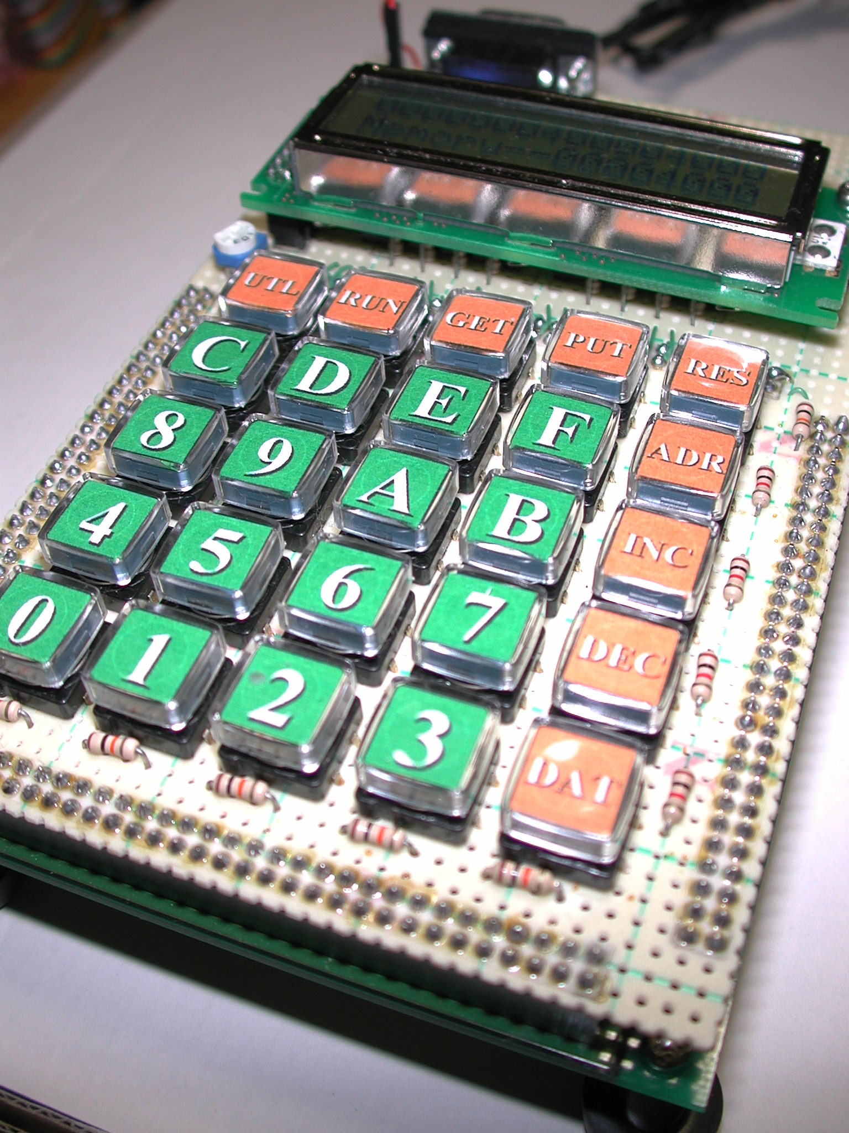
As described before, I have been using existing FPGA board XSP-009-300 manufactured by HuMANDATA, Ltd., which has one Xilinx VirtexE XCV300E. This board also has configuration circuit by JTAG or FLASH ROM, and power supply circuit. I think you can find similar FPGA boards from many venders around you.
I made a FPGA System by connecting handmade interface board, which has LCD display, KEY matrix and RS-232C interface.
Figure 7.1 shows the whole view of FPGA verification system. Figure 7.2 shows both interface board and FPGA board. These 2 boards are connected back to back each other. The system block diagram is Figure7.3.
Figure7.1 FPGA Verification System
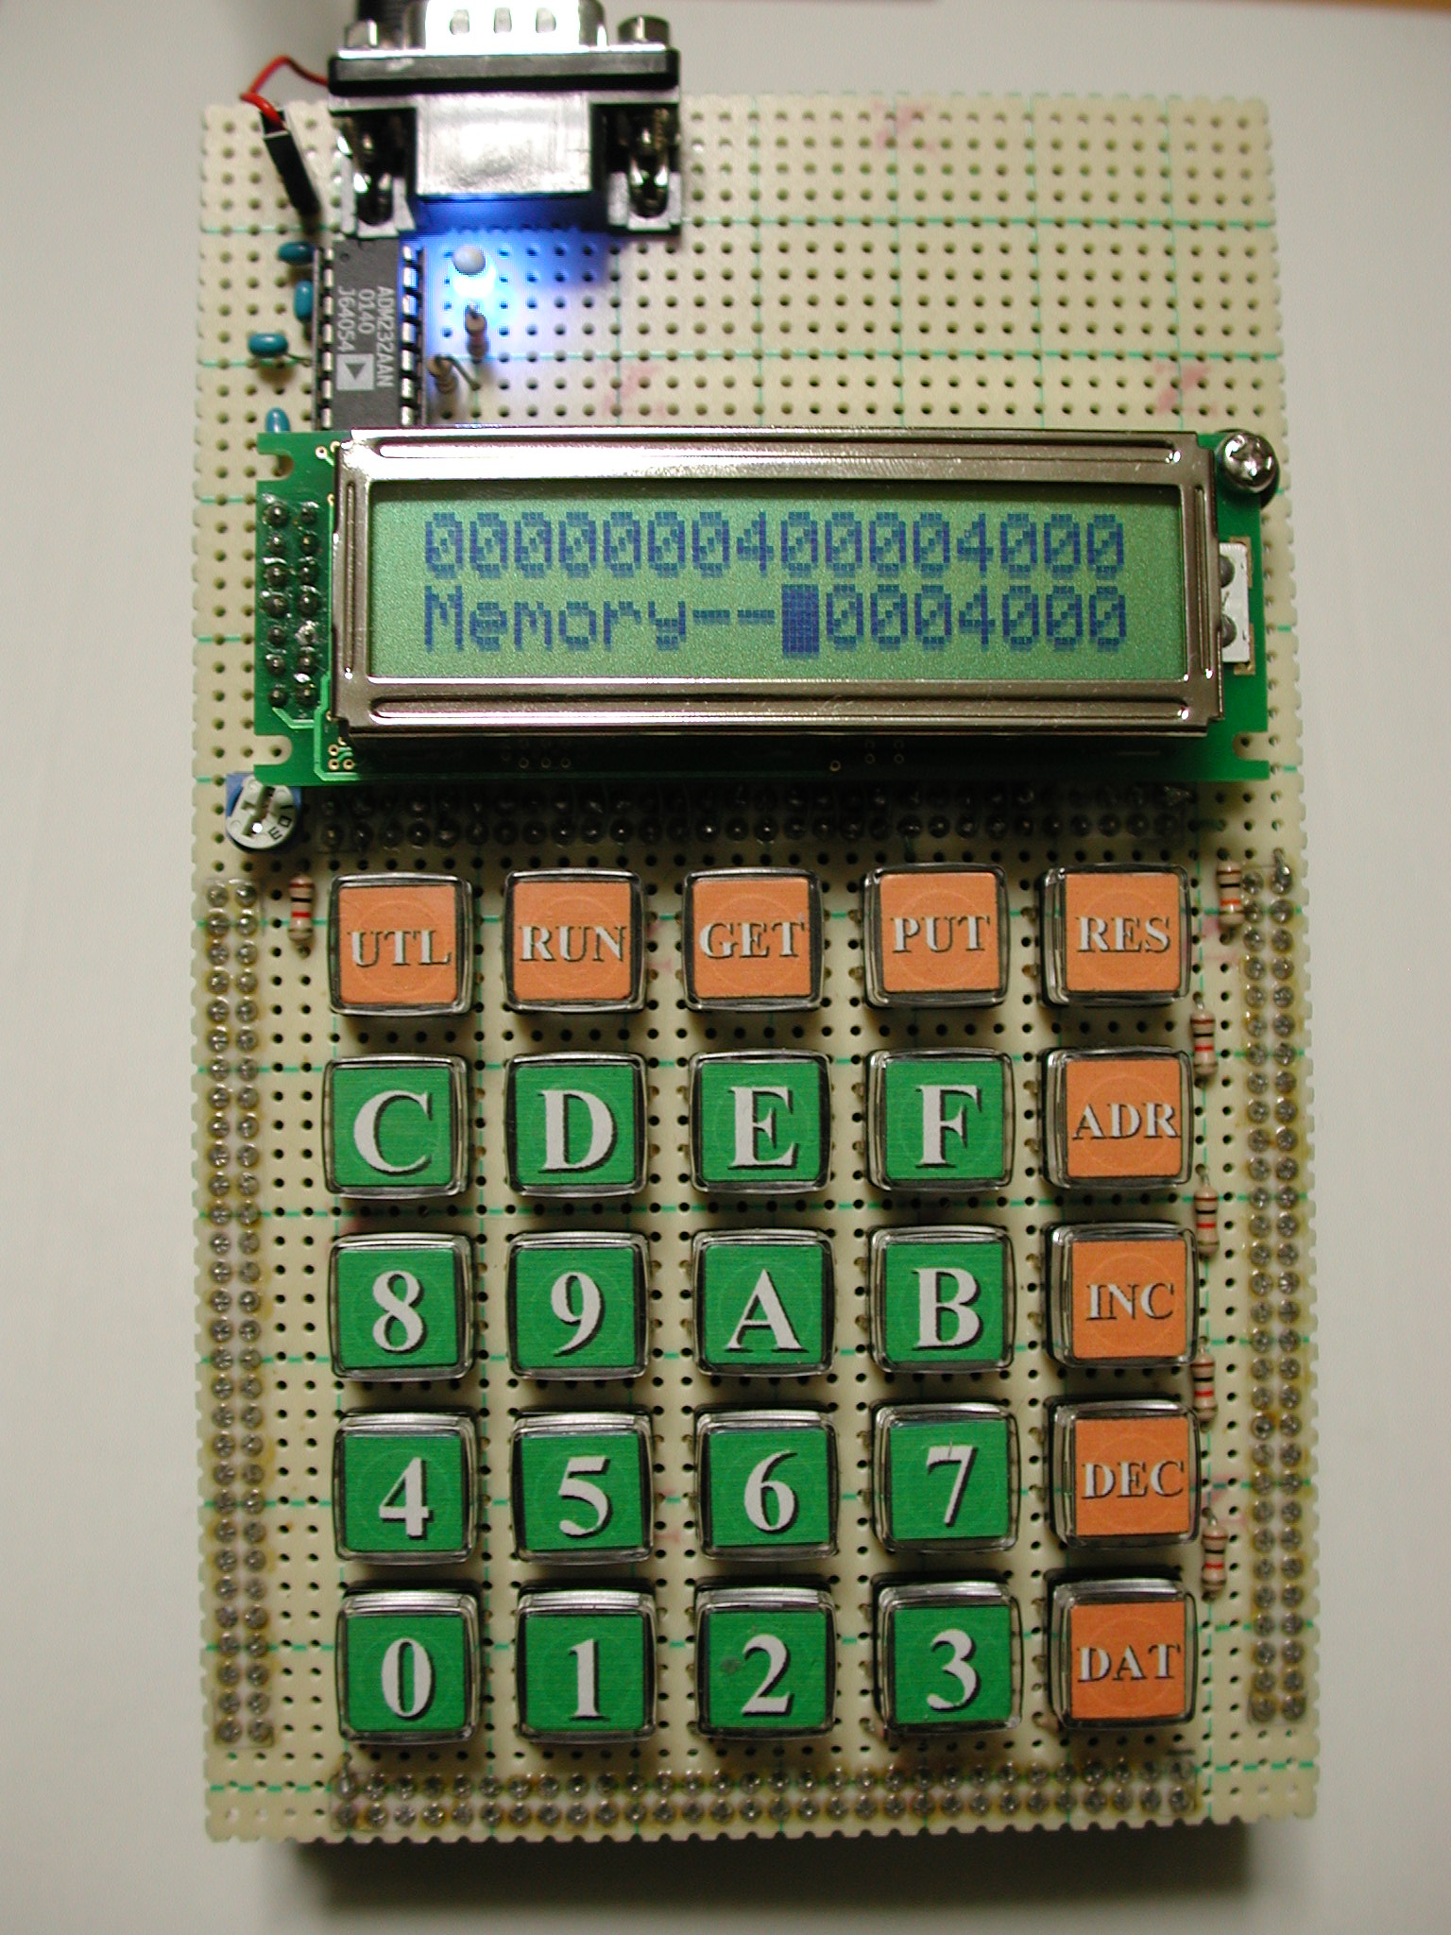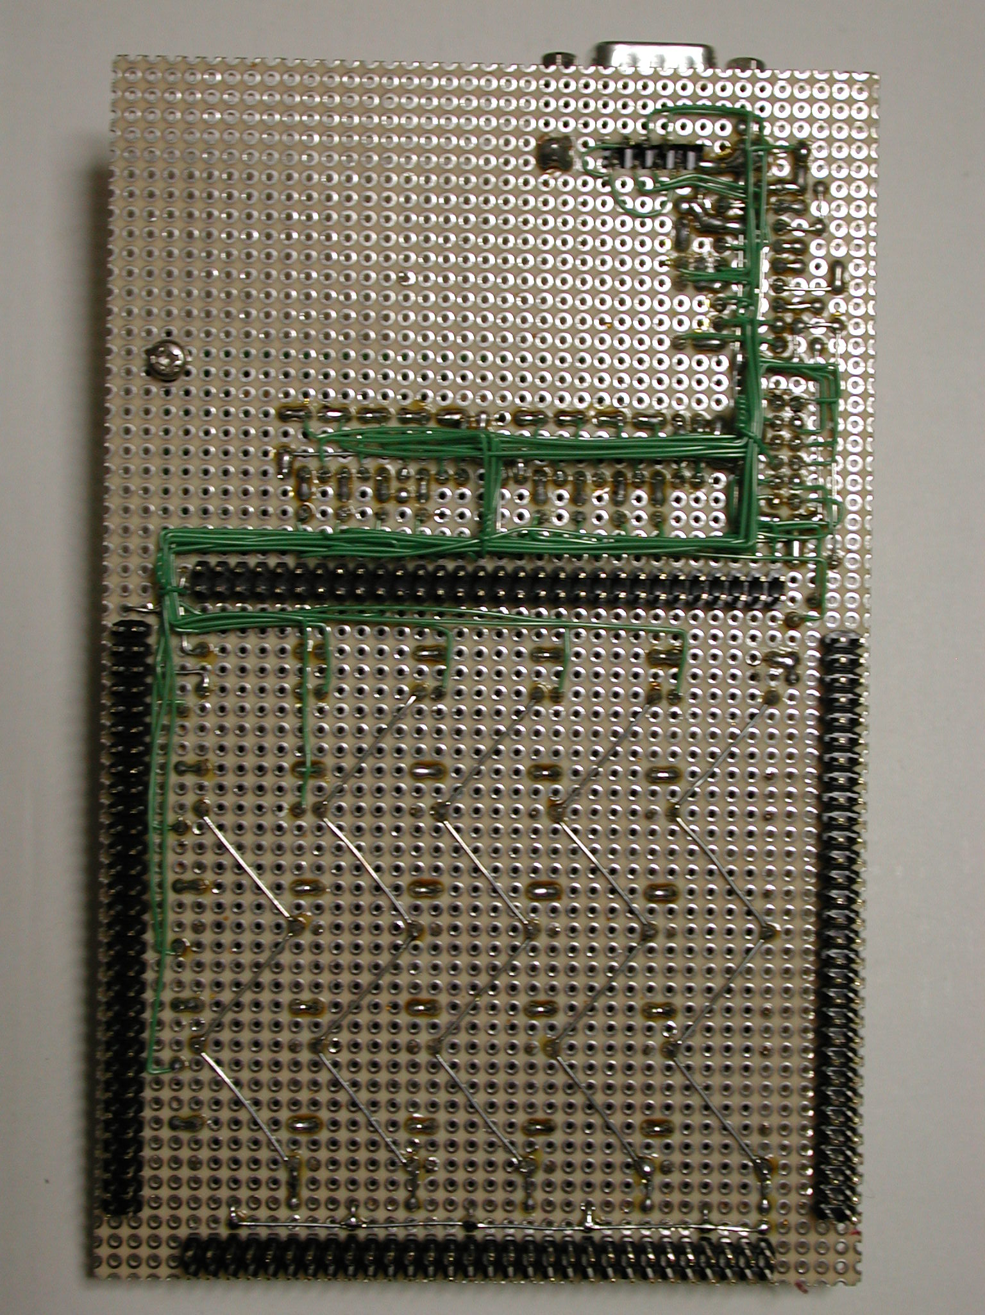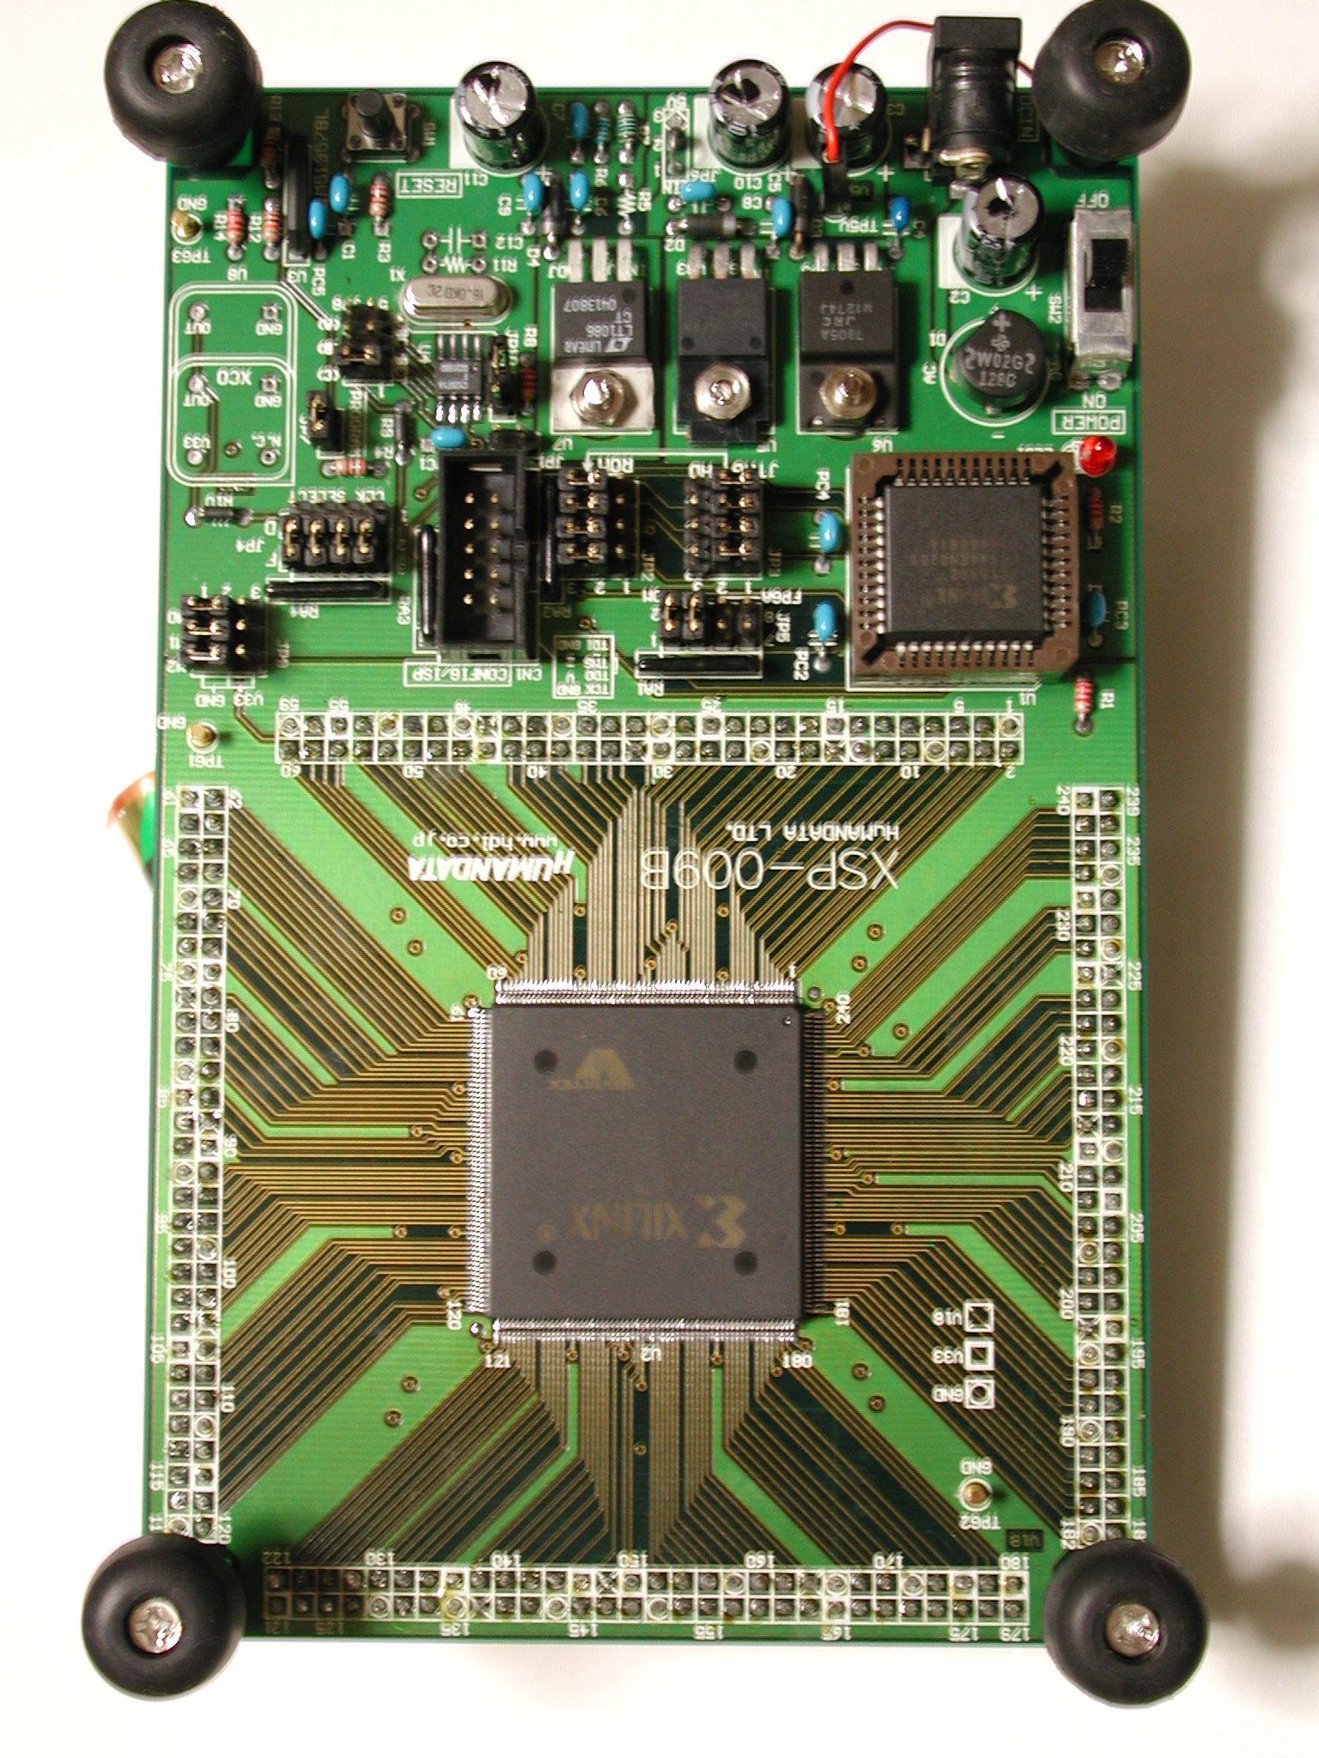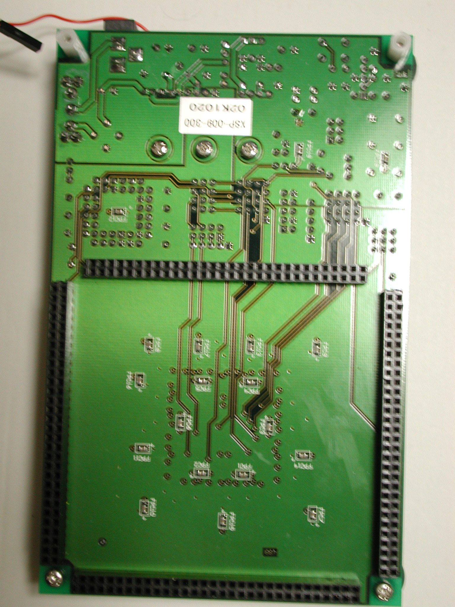
(A) I/F board (B) I/F Board (bottom) (C) FPGA board (D) FPGA board (bottom)
Figure7.2 Picture of Each Board
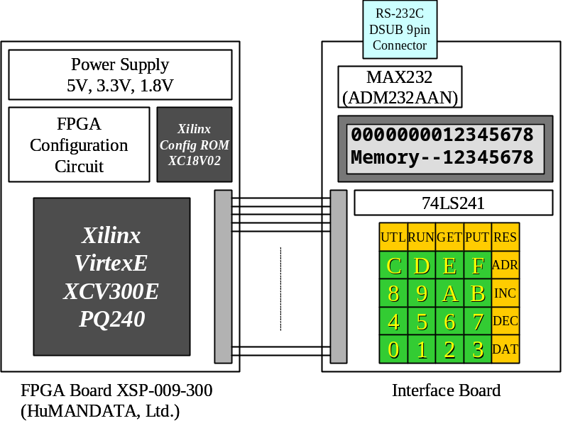
Figure7.3 Block diagram of FPGA System

Circuit of FPGA Board
The circuit schematic of FPGA Board (XSP-009-300) is found in following URL; http://www.hdl.co.jp/ftpdata/xsp-009/XSP009.sch.pdf. In my case, the FPGA operating frequency is set to 20MHz.

Circuit of Interface Board
Figure 7.4 shows the circuit of Interface Board.
(1) LCD Display Interface
As LCD character display, I use SUNLIKE 16 columns x 2 rows LCD Display SC-1602B. It operates by commands via its bus interface. You can find detail documents regarding mechanical data, electrical characteristics, initialization methods and operation commands from http://www.lcd-modules.com.tw/.
The bus interface is bi-direction, so, I use 74LS241 buffers to make interface with the FPGA. Note that 100ohm resistors are inserted between 74LS241 output and FPGA input because the FPGA don’t have 5V tolerant input buffer. Xilinx recommends using current limit resistor at 5V signal input.

(2) RS-232C Interface
To implement the RS-232C Interface, I adopt the MAX232 compatible IC ANALOG DEVICES ADM232AAN. The FPGA interface also needs 5V tolerant resistors. The DSUB-9 connector is linked supposing cross cable.

(3) KEY Matrix Interface
The Key Matrix Interface has 25 keys to input hex data, some commands and reset. The 1Kohm resistors are necessary to avoid conflict on FPGA output pins when multiple keys are pushed. Instead of 1Kohm resisters, it is good idea that you use discrete diodes, connecting each anode to switch and cathode to FPGA port.

(4) FPGA Pin Configuration
In case of above FPGA System, the FPGA’s pin configuration that corresponds to “top.v” is as follows (Also refer to Table6.2). These statements should be described in User Constraints File (.ucf) before you configure the FPGA.
________________________________________________________________________________

NET "CLK_SRC" LOC = "p92";
NET "RST_n" LOC = "p42";
NET "TXD" LOC = "p46";
NET "RXD" LOC = "p47";
NET "RTS" LOC = "p48";
NET "CTS" LOC = "p49";
NET "LCDRW" LOC = "p4";
NET "LCDRS" LOC = "p3";
NET "LCDE" LOC = "p5";
NET "LCDDBO<7>" LOC = "p17";
NET "LCDDBO<6>" LOC = "p13";
NET "LCDDBO<5>" LOC = "p12";
NET "LCDDBO<4>" LOC = "p11";
NET "LCDDBO<3>" LOC = "p10";
NET "LCDDBO<2>" LOC = "p9";
NET "LCDDBO<1>" LOC = "p7";
NET "LCDDBO<0>" LOC = "p6";
NET "LCDDBI<7>" LOC = "p27";
NET "LCDDBI<6>" LOC = "p26";
NET "LCDDBI<5>" LOC = "p24";
NET "LCDDBI<4>" LOC = "p23";
NET "LCDDBI<3>" LOC = "p21";
NET "LCDDBI<2>" LOC = "p20";
NET "LCDDBI<1>" LOC = "p19";
NET "LCDDBI<0>" LOC = "p18";
NET "KEYYO<4>" LOC = "p28";
NET "KEYYO<3>" LOC = "p31";
NET "KEYYO<2>" LOC = "p33";
NET "KEYYO<1>" LOC = "p34";
NET "KEYYO<0>" LOC = "p35";
NET "KEYXI<4>" LOC = "p41";
NET "KEYXI<3>" LOC = "p40";
NET "KEYXI<2>" LOC = "p39";
NET "KEYXI<1>" LOC = "p38";
NET "KEYXI<0>" LOC = "p36"

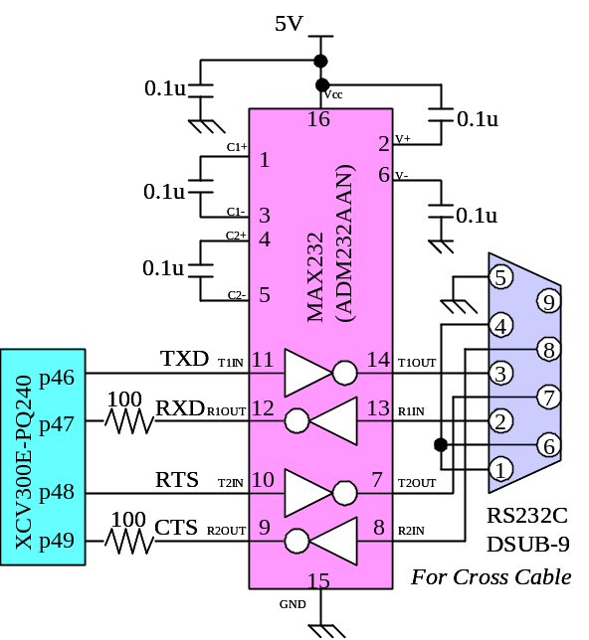
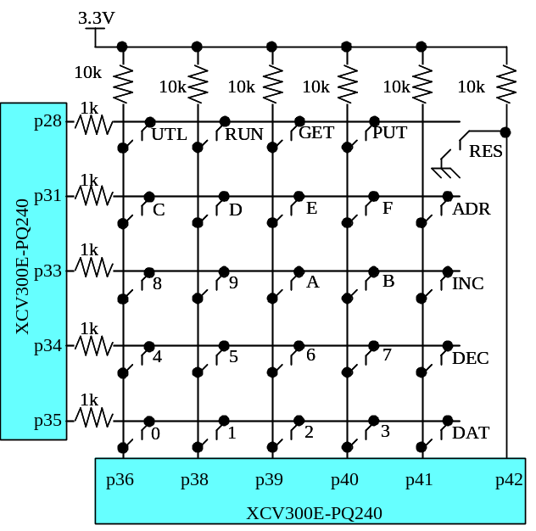
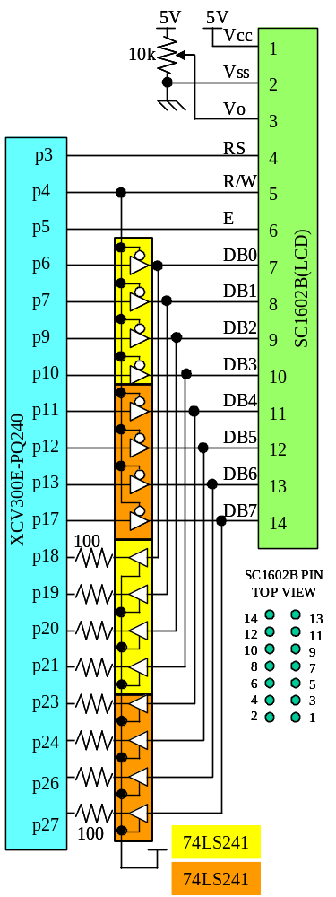

Figure7.4 Circuit of Interface Board

FPGA Configuration
Launch the Xilinx ISE Webpack 5.x, select the device to yours, and add following Verilog sources to your project.

cpu.v
datapath.v
decode.v
defines.v
lib_fpga.v
mem.v
memory_fpga.v
mult.v
pio.v
register.v
sasc_brg.v
sasc_fifo4.v
sasc_top.v
sys.v
test.v
timescale.v
top.v
uart.v

Make user constraints file (top.ucf) to specify pin assignment, timing constraints and BlockRAM initial value. In Aquarius deliverables, I prepare an example file top.ucf. To initialize contents of BlockRAM, use "genram" utility described before and append INST statements to top.ucf (default top.ucf already have INST statement, so you should replace all INST statements to new ones generated by "genram".)
Ok, then compile from the “top” module, and configure your FPGA.

Results of FPGA Configuration
(1) Xilinx VirtexE (XCV300E)
Regarding the FPGA system mentioned above, Table7.1 shows the performance results by Xilinx VirtexE XCV300E-8PQ240, which has 3072 slices. On chip memories are configured by BlockRAM. Under the speed-priority synthesizing, total usage of logic slices is beyond the device, unfortunately. In author’s FPGA System, although the device has been configured by area-priority synthesis, the device operates 20MHz frequency under the typical condition (power supply voltage and ambient temperature).

(2) Altera Stratix (EP1S10)
For technical reference, I tried to configure Aquarius into Altera Stratix EP1S10, which has 10570 logic elements. Table7.2 shows the summary. And the detail utilization of logic cells is shown in Table7.3. In this case, on chip memories are implemented by Synchronous SRAM components and the multiplier (in mult.v) is implemented by internal DSP unit.

Synthesis | Top | Slices | Consumed | Frequency | Notes
Area  20MHz | top.v | 2923 | 95% | 15MHz
Area  20MHz | cpu.v | 2635 | 86% | 15MHz
Speed  20MHz | top.v | 3135 | 102% | 25MHz | XCV300E overflows
Speed  20MHz | cpu.v | 2753 | 90% | 21MHz
Table7.1 Results of Xilinx VertexE (XCV300E-8PQ240) with Webpack ISE 5.2i (SP3)

Synthesis | Top | Cells | Consumed | Frequency | Notes
Normal  No constraints | top.v | 7919 | 75% | 31MHz
Normal  No constraints | cpu.v | 7499 | 71% | 31MHz
Table7.2 Results of Altera Stratix (EP1S10F780C5ES) with Qualtus II 2.2 Web Edition (SP2)
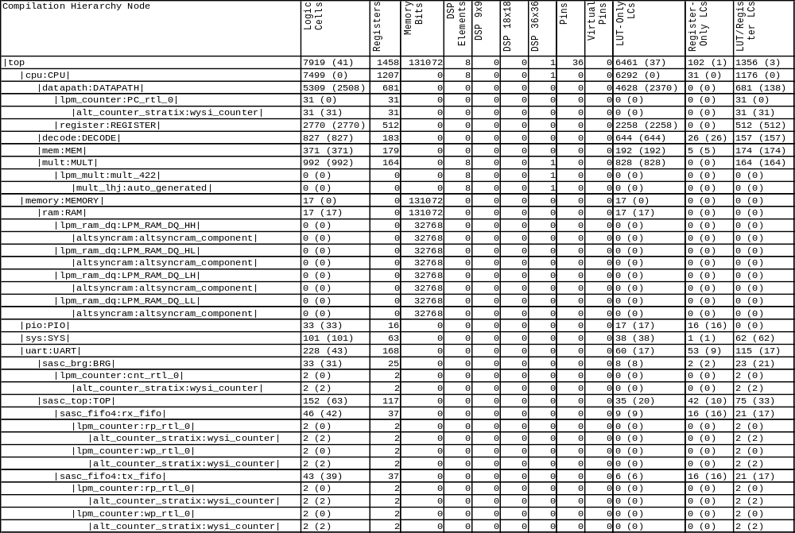
Table7.3 Detail Utilization of Logic Cells in Altera Stratix EP1S10

Application Programs on the FPGA System
I include some simple application programs in Aquarius deliverables. All applications are developed by GNU C compiler for SuperH-2.
Each startup program (crt0.S) and linker script (sh.x) is located in directory “startup” under each application directory. The “Makefile” is prepared for all applications so as to compile and link by typing “$ make”, and to cleanup objects by typing “$ make clean”.

In my FPGA system, the BlockRAM contains several applications provided here (1), (2) and (3). All applications are combined into one object file “ram.srec”. You can make BlockRAM’s INIT statements by “genram” utility.

(1) Monitor Program: directory “shc_monitor_release_v1”
Using LCD display, key board and RS-232C I/F, this monitor program has very basic debug capability such as Memory Editor, Program Loader from PC, Jumping to Program and Debugging utilities such as Setting a Break point and Reading Registers. The source code is “main.c”. This program is located from address 0x00000000 (here is vector table). It starts by power on reset. Below, I simply explain an example session of the monitor. Please refer Figure7.5.

(A) Memory Editor
- Startup
The top line shows memory address and its data. Left 8 hex number is address. Right 8 hex number is data. Always shows only long-word sized data.
The bottom line has 4 byte entry space. You can enter new hex number here.
- Address Increment
The “INC” key increases address by 4 byte, and shows the data at new address.
- Address Decrement
The “DEC” key decreases address by -4 byte, and shows the data at new address.
- Enter Address
- Set Address
If you want to see another address of memory, enter new 4 byte address in bottom line, and push “ADR” key. If your entry is not in multiples of 4, lower 2 bits of address are cleared to 0, to avoid address error.
- Enter Data to be written
- Write Data and Increment Address
If you want to change data in displaying address, enter new 4 byte data in bottom line, and push “DAT” key. Then the memory content is updated and the displayed address increases 4 byte.
- Verify
Use decrement key (and also increment key) to verify the memory contents.

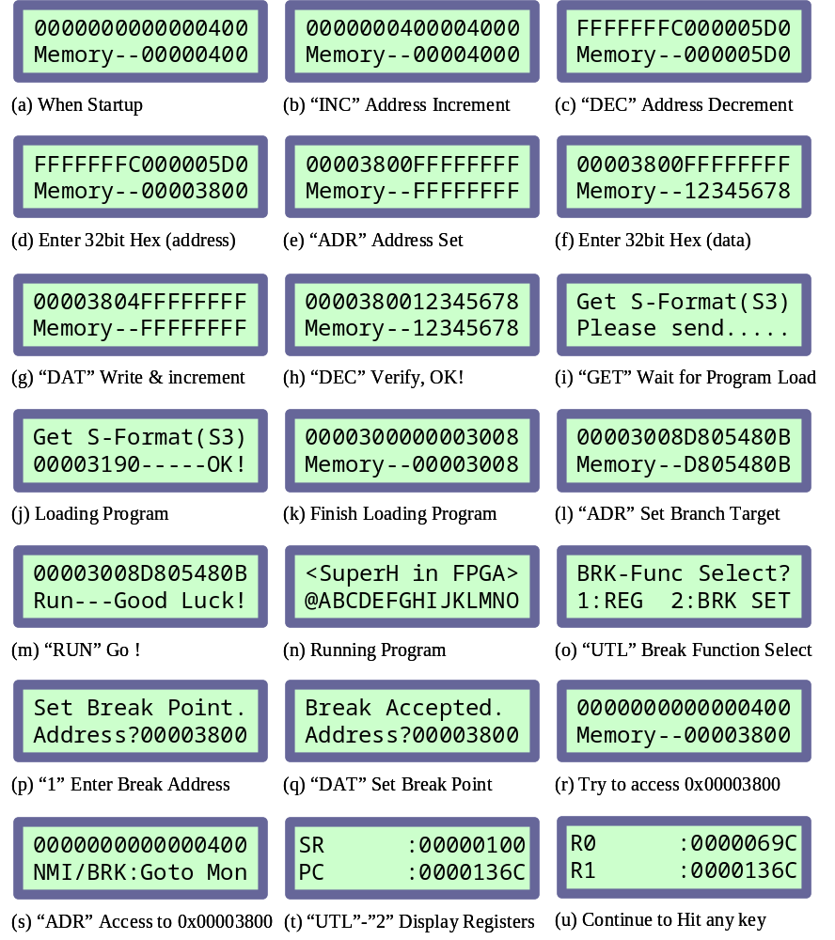
Figure7.5 Example Session of the Monitor Program
(B) Program Loader
- Program Loading from PC
- Now Loading
- Finish Loading
You can download S-Format(S3) object file (ASCII Text file) from PC via RS-232C line. In default, 1200bps, 8bit non-parity. You can change the baud rate by changing monitor program source. (Or directly change UARTBRG0 and UARTBRG1 register by the monitor function.)
The acceptable S-Format records are only S0 (comment), S3 (actual object), S7 (end of record). If you use “asm” script for assembler, or “Makefile” for C program in Aquarius deliverables, they make suitable S-Format object file (*.srec) for this monitor. After preparing object file on your PC, push “GET” key, them the FPGA system waits for sending data. Send object by ASCII file from any proper terminal application in your PC. During transfer, LCD shows top address of every record and the result of check sum test. If the monitor finds checksum error, the transfer will stop. When the monitor receives S7 record, it stops program loading, and shows the address of first record which have been received.
For convenience of explanation, please suppose you downloaded “shc_lcdtest/main.srec”, which is LCD test program.

(C) Run
- Set Target Address
- Go to program
- Now, running program
The top address of LCD test program is 0x00003000. But the top address has vector table. The actual start address is 0x00003008, so, set address to this. Then push “RUN” key, the program will start. This “RUN” function is implemented by JSR instruction. So, if your program ends by RST instruction, the control will return to the monitor. Of course, if you want to stop your program, push “RES” key for reset, any time.

(D) Debug Utility
- Select Break Function
- Enter Break Address
- Set Break Point
- Try a Break
- Break happens
If you want to set break point, push “UTL” key and “2”. And enter the break address you want. To confirm the break operation, push “DAT”. Suppose you set 0x00003800 as break point. Now let’s access 0x00003800 by the monitor. The monitor reports BRK has happened. If you push any key, the control will return to monitor.
The break happens only when the WISHBONE address is just equal to the address you set as break point.
Once break happens, the break setting is cleared (the break address that is set in register “BRKADR” is kept but “BRKON” bit in “INTCON” register is cleared).

- Select Register Reading
- Check all Registers in CPU
You can examine register contents just when the break happens. By “UTL”-“1” key, you can see all CPU registers.

(2) LCD Test: directory “shc_lcdtest”
Display all characters on LCD display. It is a very simple program. The source code is “main.c”. This program is located from address 0x00003000 (here is reset vector). To start it, jump to 0x00003008 by monitor program.

(3) Interrupt! Clock: directory “shc_clock”
This is a digital clock. The time base is interrupt (IRQ) from interval timer. The timer requests IRQ in every 50 x 2^12 [ns] @20MHz operation. The IRQ service routine controls internal software counter, and displays time. The source code is “main.c”. This program is located from address 0x00002000 (here is vector table). To start it, jump to 0x00002400 by monitor program.
You can adjust the clock. Push “DAT” key, enter hour. Again push “DAT”, enter minute. Again “DAT”, enter second. Finally push “DAT”, then, clock starts.

(4) Calculation of Circular Constant (Pi): directory “shc_pi”
This is a program for calculating the Circular Constant (Pi). This source program can make 1024 figures after the decimal fraction. If you have large memory space, you can expand figures to be calculated only by changing the definition of MAXFIGURE.
This program is also a good verification of Aquarius quality.

This program uses the following Matin's formula.
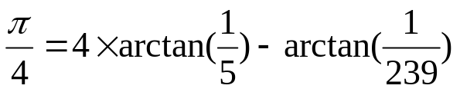
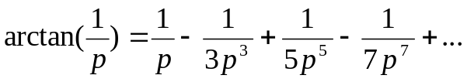
To calculate 1024 figures, it approximately takes 4.5sec at 20MHz. (Aquarius don't have RTC (real time clock) yet, so accurate speed can not be measured.)

Load the s-format object by the Aquarius monitor, and run it from the address 0x00002008.
This program displays the result on LCD display on the Aquarius FPGA System, like as follows. Hit any key to page.

Constant Pi = 3.
1415926535897932
3846264338327950

2884197169399375
1058209749445923

0781640628620899
8628034825342117

0679821480865132
8230664709384460

9550582231725359
4081284811174502

8410270193852110
5559644622948954

9303819644288109
7566593344612847

5648233786783165
2712019091456485

6692346034861045
4326648213393607

2602491412737245
8700660631558817

4881520920962829
2540917153643678

9259036001133053
0548820466521384

1469519415116094
3305727036575959

1953092186117381
9326117931051185

4807446237996274
9567351885752724

8912279381830119
4912983367336244

0656643086021394
9463952247371907

0217986094370277
0539217176293176

7523846748184676
6940513200056812

7145263560827785
7713427577896091

7363717872146844
0901224953430146

5495853710507922
7968925892354201

9956112129021960
8640344181598136

2977477130996051
8707211349999998

3729780499510597
3173281609631859

5024459455346908
3026425223082533

4468503526193118
8171010003137838

7528865875332083
8142061717766914

7303598253490428
7554687311595628

6388235378759375
1957781857780532

1712268066130019
2787661119590921

6420198938095257
2010654858632788

Part2. Inside Aquarius CPU

Aquarius CPU Overview
This chapter shows overview of CPU, again.

Aquarius Block Diagram
Figure 8.1 shows the block diagram of Aquarius CPU core.

Figure8.1. Block Diagram of Aquarius
Top layer of Aquarius is “CPU” which has WISHBONE compliant bus signals and accepts interruption related signals. The most important system signals such as clock and reset are not shown in this figure.

The Memory Access Controller handles instruction fetch and data read/write access. The operations of Memory Access Controller are fully controlled by Decoder unit. Memory Access Controller sends fetched instruction bit fields to the Decoder unit, and interchanges read/write data and its address with Data Path unit. Aquarius assumes the Wishbone bus is a Non-Harvard bus, then the simultaneous instruction fetch and R/W data access makes bus contention. Memory Access Controller handles such contention smoothly and informs the pipeline stall caused by the bus contention to Decoder unit. Also, the Memory Access Controller can sense each boundary of bus cycles (with wait state) from Wishbone ACK signal. In Aquarius architecture (may be in SuperH-2 architecture as well), such bus cycle boundary corresponds to the pipeline’s slot edge. So the Memory Access Controller produces the most important pipeline control signal “SLOT” indicating pipeline slot edge.

The Data Path unit has registers you can see in programmer’s model in SuperH-2 manual such as General Registers (R0 to R15), Status Register (SR), Global Base Register (GBR), Vector Base Register (VBR), Procedure Register (PR) and Program Counter (PC). The Multiplication and Accumulate Registers (MACH/MACL) are found in Multiplication unit. The Data Path unit also has necessity operation resources such as ALU (Arithmetic and Logical operation Unit), Shifter, Divider, Comparator, temporary registers, many selectors, interfaces to/from Memory Access Controller and Multiply unit, and several buses to connect each resource. The Data Path is fully controlled by control signals from Decoder unit.

Multiply unit has a 32bit x 16bit multiplier and its control circuits. A 16bit x 16bit multiply operation is executed in one clock cycle. A 32 bit x 32bit multiply operation is done in two clock cycles. Multiply unit also has the Multiplier and Accumulate Registers (MACH/MACL). The MACH/MACL are not only the final result registers of multiply or multiply-and-accumulation but also the temporary registers to hold the 48bit partial multiply result from 32bit x 16bit multiplier for 32bit x 32bit operation. The multiply instruction, for example MULS.L, clears the contents of MACH/MACL in early stage of the instruction operation. However the multiply and accumulate instruction, for example MAC.L, does not clear MACH/MACL before the operation. The MAC.L accumulates its own partial multiply result to initial MACH/MACL and then finalize the operation result. The major difference between multiply (MULS.L) and “multiply and accumulate” (MAC.L) is whether to clear or not to clear the MACH/MACL before the operation. And also, for MAC.L and MAC.W instruction, the accumulation adder in this unit has saturating function.

The Decoder unit is the fundamental CPU controller. It orders Memory Access Controller fetch instructions and then receives the instruction. The Decoder Unit decodes the instruction bit fields and judges the followed operations. Basically, the Decoder unit plays the role only for the instruction ID stage. But it throws many control signals for following EX, MA and WB stages toward Data Path unit, Multiplication unit, and Memory Access Controller. These control signals are kept and shifted with its pipeline flow at each slot edge until reaching to the target stage of the instruction. The Decoder unit detects every conditions of pipeline stalling, and makes each unit of CPU be controlled properly. Also, it controls not only simple 1 cycle instructions but also multi cycle instructions and exception’s sequences such as interrupt and address error.

Aquarius CPU IN/OUT Signals
The Aquarius CPU (“cpu.v”)’s IN/OUT signals are shown in Table8.1.

Class | Signal Name | Direction | Meaning | Notes
System  Signals | CLK | Input | System clock
System  Signals | RST | Input | Power On Reset
Wishbone  Bus  Signals | CYC_O | Output | Cycle Output
Wishbone  Bus  Signals | STB_O | Output | Strobe Output
Wishbone  Bus  Signals | ACK_I | Input | Device Acknowledge
Wishbone  Bus  Signals | ADR_O[31:0] | Output | Address Output
Wishbone  Bus  Signals | DAT_I[31:0] | Input | Read Data
Wishbone  Bus  Signals | DAT_O[31:0] | Output | Write Data
Wishbone  Bus  Signals | WE_O | Output | Write Enable
Wishbone  Bus  Signals | SEL_O[3:0] | Output | Byte Lane Select
Wishbone  Bus  Signals | TAG0_I (IF_WIDTH) | Input | Fetch Width
Hardware  Event  (interrupt) | EVENT_REQ_I[2:0] | Input | Event Request
Hardware  Event  (interrupt) | EVENT_INFO_I[11:0] | Input | Event Information
Hardware  Event  (interrupt) | EVENT_ACK_O | Output | Event Acknowledge
SLEEP | SLP | Output | Sleep Pulse
Table8.1 Aquarius CPU IN/OUT Signals

Overview of Pipeline Control
This chapter describes the basis of pipeline controls in Aquarius CPU.

Pipeline and Stage
The CPU executes its instructions with pipelined controls as shown in Figure9.1.

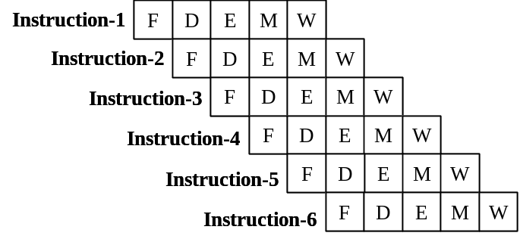
Figure9.1 CPU Pipeline
The pipeline has following 5 stages, basically.

- IF : Instruction Fetch (“F”)
It fetches instruction code from memory. If the bus width is 32bit and the lower 2bit of accessing address is 2’b00, the IF stage can fetch 2 instructions, because the length of each instructions is fixed in 16bit. If the bus width is 16bit or the lower 2bit of accessing address is not 2’b00, the IF stage can fetch only 1 instruction.
- ID : Decode (“D”)
It decodes fetched instruction code and controls whole CPU operation. The ID is the most important stage because all operations in each block of CPU are fully controlled by ID. The ID stage asserts many control signals to EX (datapath.v), MA (mem.v), and WB (datapath.v). Of course if the instruction code is multiplication related one, the ID activates multiplication unit (mult.v). Each control signal is shifted along with pipeline and activates each stage.
The ID also issues coming IF stage, and the IF forwards new instruction to ID stage. Then the CPU operation can continue.
If the hardware event signal is asserted, the ID samples it and switches its operation from fetched instruction’s to the sequence of the hardware event exception.
- EX : Execute
According to controls from ID stage, the EX stage executes register-register operation, or address calculation for next MA stage. It can also issue multiplication related commands to multiplier unit (mult.v).
- MA : Memory Access
According to controls from ID stage, the MA stage reads/writes data from/to memory. The Aquarius CPU has non-Harvard bus, so the simultaneous IF and MA raise the bus contention. In this case, MA has the higher priority, so the IF is stalled by the MA.
- WB : Write Back
According to controls from ID stage, the WB writes back the memory read data to the register Rn. The WB is located at the pipeline tail of memory load instruction.

Pipeline of each Instruction
All instructions do not always have 5 stages. Figure9.2 shows some pipeline examples of typical instructions.

- ALU Operation
The instruction of register-register operation has only 3 stages; IF, ID and EX. The register-register operation is executed in EX stage, including register read, ALU operation, and register write.
- Memory Store
The instruction of store to memory has 4 stages; IF, ID, EX and MA. The memory access address is calculated in EX stage, and the write data is also prepared in EX stage.
- Memory Load
The instruction of load from memory has 5 stages; IF, ID, EX, MA and WB. The memory access address is calculated in EX stage. The load data is stored to register in WB stage. If the register to be written back is NOT same as the register which is used in following instruction, there is no contention, so the pipeline flows without stall.
The EX stage in the later instruction, which uses the written back data in the WB, can be executed at same timing as the WB by the grace of the forwarding apparatus.
- Memory Load with Register Contention
If the register to be written back is SAME as the register which is used in following instruction, the register contention happens. The ID stage of following instruction is stalled.
- Branch Operation
The branch instruction has multiple cycles. In the red square of Figure9.2 (5), you can find 3 pipelines. This means the BT (taken) instruction executes in 3 cycles. Generally, the multiple cycle instructions consist of multiple pipelines. In case of BT, the 1st pipeline calculates the address of branch target, the 2nd pipeline issues instruction fetch of branch target and increments PC, and the 3rd pipeline issues fetch of the next instruction of branch target and increments PC. The details of PC control are described later.
The previous instruction of BT has issued a instruction fetch, but the fetched code will be overwritten by the IF (of branch target) issued by the 2nd pipeline of the BT before sending to ID stage of target instruction. This extra instruction fetch is called “overrun fetch”. The codes fetched by overrun fetch are ignored.
- Delayed Branch
The delayed branch has 2 pipelines. The 1st pipeline calculates the address of branch target, the 2nd pipeline issues instruction fetch of branch target and increments PC.
The IF of instruction in delay slot, which has been issued by the previous instruction of the delayed branch, does not disappear (is not overwritten), then the instruction in delay slot is executed correctly before the branch target instruction.
The branch instruction which consists of 2 pipelines becomes delayed branch with delayed slot, and the branch which has 3 pipelines becomes normal branch.
- Multiplication
The multiplication related instructions have multiplier stage (“m”) on the pipeline tail. If the result register MACH/MACL does not conflict with followed instruction, there is no pipeline stall. The details of pipeline of multiplication are described in later chapter.
- Multiplication with Register Contention
If the result registers MACH/MACL conflict with followed instruction, pipeline stall happens. The details of contention of multiplication related instructions are described in later chapter.

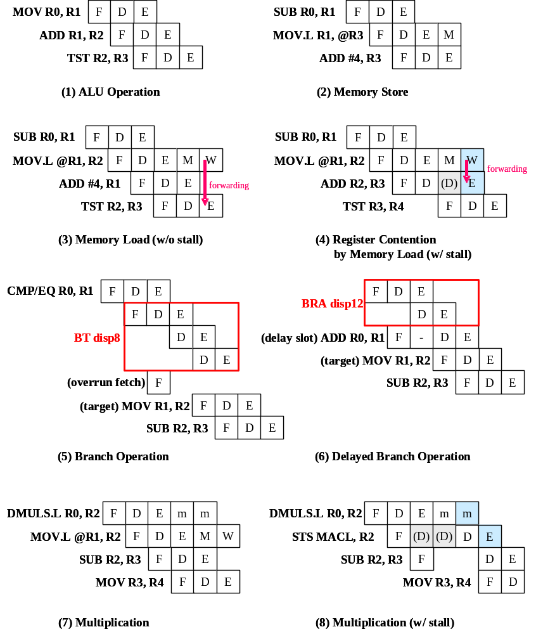
Figure9.2 Pipeline of each Instruction

Register Conflict
As described previous section, the memory load instruction may cause register contention.
See Figure9.2 (3) and (4).

Memory Access Conflict
The Aquarius CPU has non-Harvard bus, so the simultaneous IF and MA raise the bus contention, as shown in Figure9.3.
If the bus width is 32bit and the lower 2bit of accessing address is 2’b00, the IF stage can fetch 2 instructions, and the following IF stage does not need to produce actual memory read cycle. The IF stage, which issues actual bus cycle, is shown as “F”, and the IF stage, which does not issue real bus cycle and take the instruction from internal buffer, is shown as “f” in the figure. The simultaneous “M” and “F” cause the contention and the pipeline is stalled, but “M” and “f” does not conflict.
Note that, if you locate load/store instruction at long word boundary (address=4n), the MA stage of the instruction does not conflict with IF of post instruction (Figure9.3 (1)), otherwise (address=4n+2), it conflicts (Figure9.3 (2)).
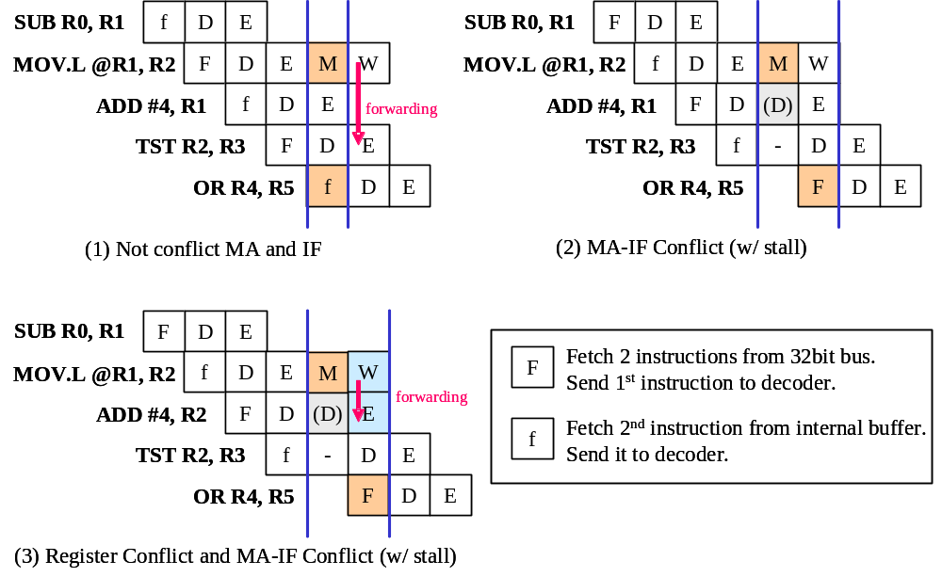
Figure9.3 Conflict between MA and IF

Who issues IF? Who issues ID?
The ID stage fundamentally controls whole CPU operations. No one issues ID stage. ID stage continues by itself.

The ID stage issues not only EX, MA and WB stages, but also the IF stage of followed instruction as shown in Figure9.4. After the power on reset, at the last sequence of power on reset exception, the IF stages of 1st instruction and 2nd instruction are issued by the last two decode stages in the exception sequence. Each IF stage of all followed instructions is issued by similar manner.
By the issued IF, the corresponding ID stage can get next instruction so that each ID can keep its continuance.

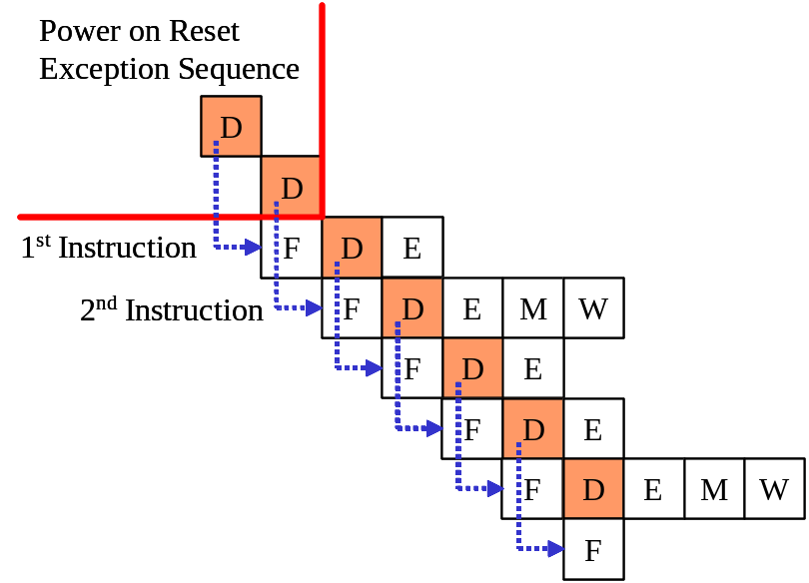
Figure9.4 IF Issue

Decoder Unit
This chapter describes the details of decoder unit (decode.v).

IN/OUT Signals
Table10.1 shows all in/out signals of decoder unit.

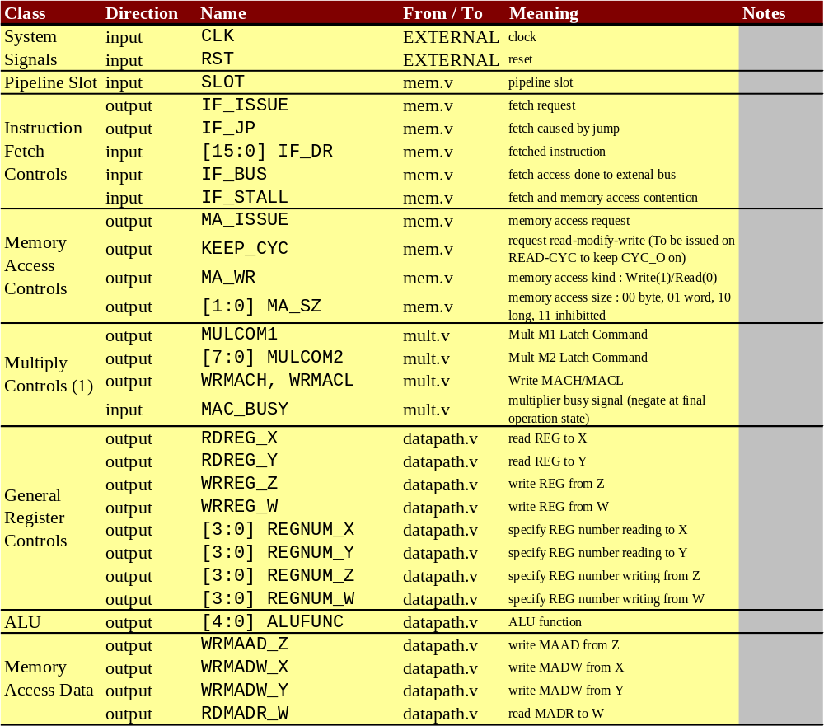
Table10.1 Decoder IN/OUT signals (1)
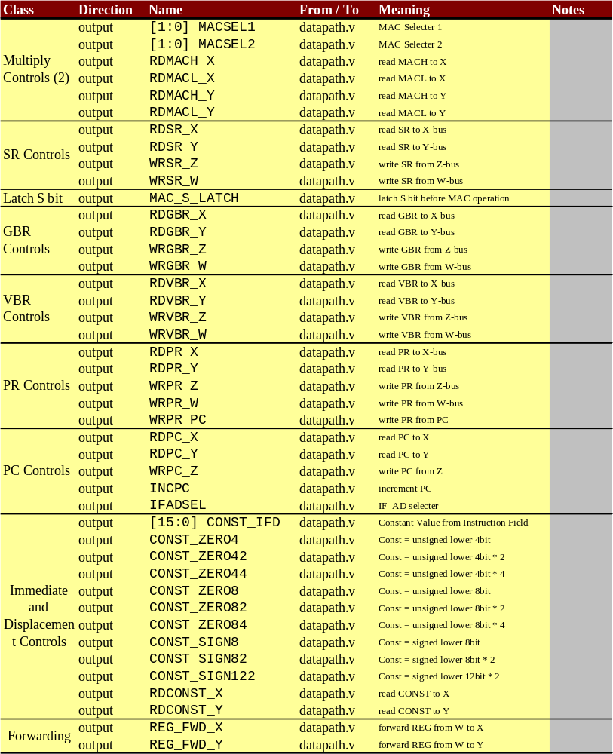
Table10.1 Decoder IN/OUT signals (2)
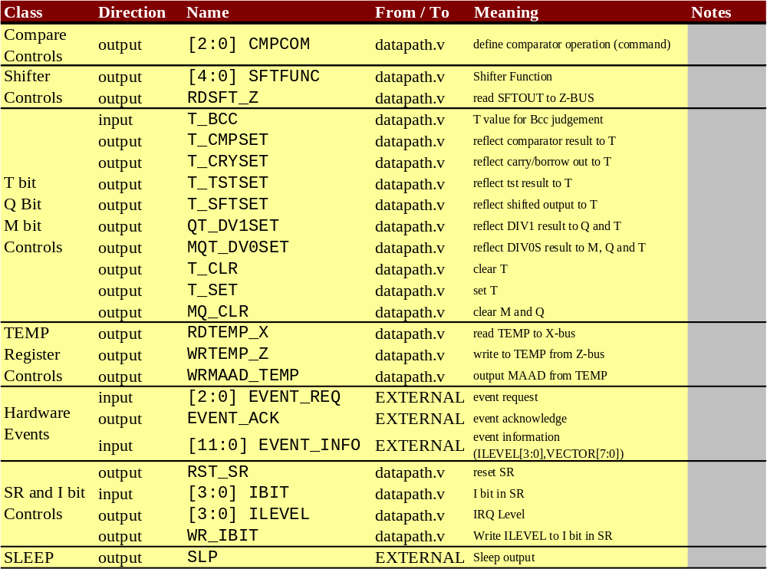
Table10.1 Decoder IN/OUT signals (3)

Structure of Decoder Unit
Figure10.1 shows whole structure of decoder unit. The huge truth table generates all control signals for each block in CPU. The huge truth table (combinational circuit) receives 2 input signal groups. One is INSTR_STATE[15:0] and the other is INSTR_SEQ[3:0].

The INSTR_STATE[15:0] shows the instruction code that should be processed in decoder unit. The IR register is reset by RST signal, so that the initial state of INSTR_STATE[15:0] is set to `POWER_ON_RESET(16’hF700).

The INSTR_STATE[15:0] is basically same as IF_DR, which is fetched instruction code. But if interrupt or hardware exception event is detected, the INSTR_STATE[15:0] is replaced to corresponding exception code according to EVENT_REQ[2:0] and EVENT_INFO[11:0] , then the signal IF_DR_EVT[15:0] is created. Here, the some necessary controls for masking interrupt or hardware exception are performed, that is,
(1) All exceptions are masked after delayed branch (i.e. the instruction in branch slot is never replaced to exception sequence) using DELAY_SLOT signal which comes from the huge truth table..
(2) Some specific instructions such as LDC/LDC.L mask interrupt (i.e. an instruction just after the instruction which masks interrupt is never replaced to interrupt sequence) using MASKINT signal from huge truth table.
(3) If the priority level of IRQ is less than I bit in SR, the interrupt request should be ignored.

The IF_DR is updated by memory controller regardless of instruction sequence because the decoder itself requests IF as its own operation. So, IF_DR (IF_DR_EVT) should be latched to IR register, if the instruction needs multiple cycles (including memory waits and pipeline stalls).

The INSTR_SEQ[3:0] has its meanings only when the executing instruction has multiple cycles. Its default value is 4’b0000, and the multi-cycle instruction increments INSTR_SEQ to make multiple pipelines as shown in, for example, Figure9.2 (BT, BRA).
The reset state of INSTR_SEQ (when RST asserted) is set to 4’b0001 to begin power on reset sequence, because the value 4’b0000 has specific meaning for the control of the decoder’s state machine, as shown in later (Table10.2).

The combination of INSTR_STATE and INSTR_SEQ specify whole control signal states via the huge truth table. This combinational circuit also outputs a signal DISPATCH. Its assertion indicates that the pipeline stage of instruction is final. If the DISPATCH is asserted, INSTR_STATE should be updated according to IF_DR or proper exception code (IF_DR_EVT), and INSTR_SEQ should be reset to zero.

The detail state controls are shown in Table10.2. The way of controls depends on status of pipeline stall. The signals NEXT_ID_STALL and ID_STALL indicate the status of pipeline stall. The signal meanings are describes in later section.

Figure10.2 shows a operation image of the decoder state machine. And Figure10.3 shows a basic example of ID stage operation.

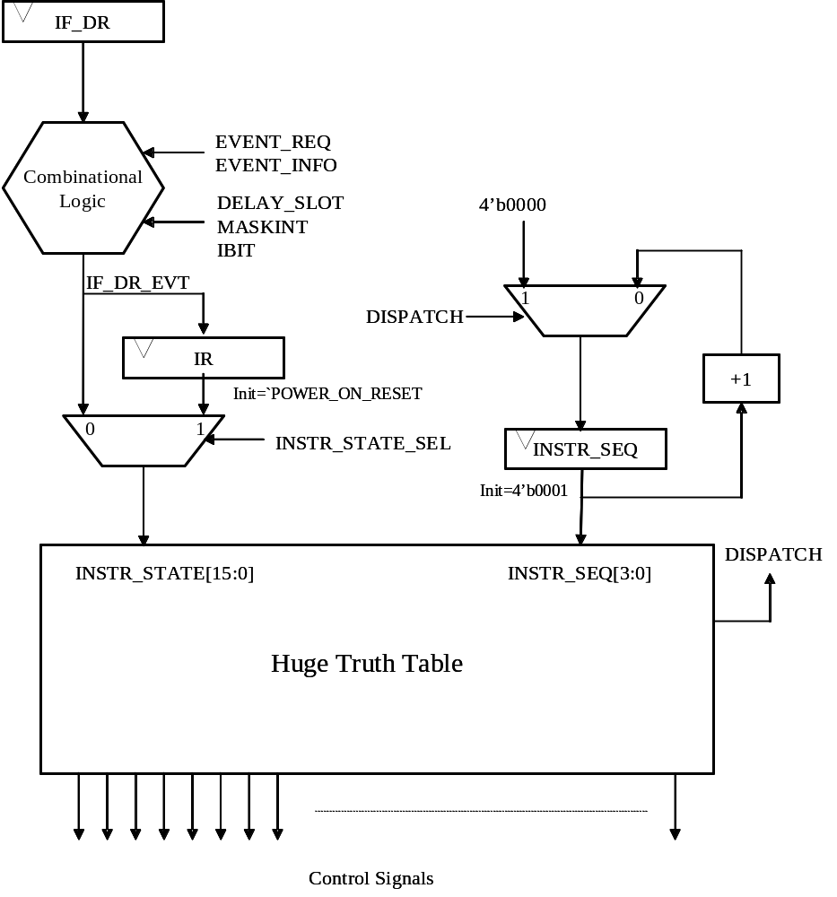
Figure10.1 State Machine in Decoder Unit
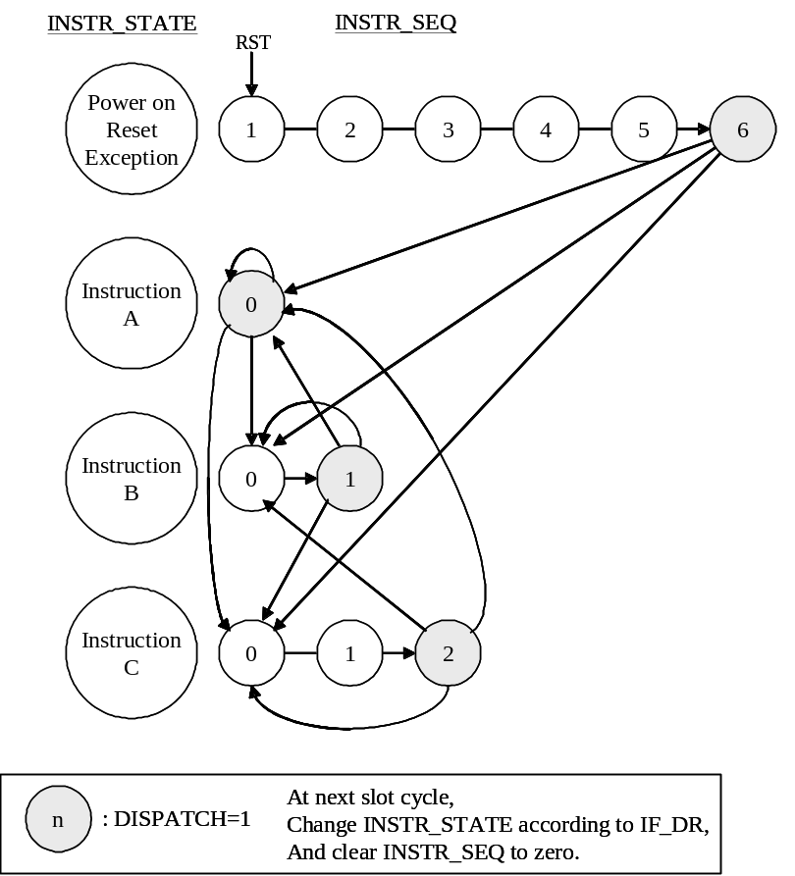
Figure10.2 State Transition
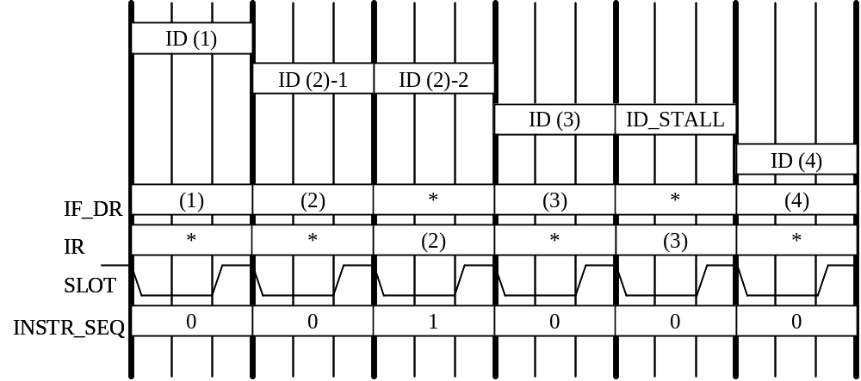
Figure10.3 Basic Operation of State Machine in Decoder Unit
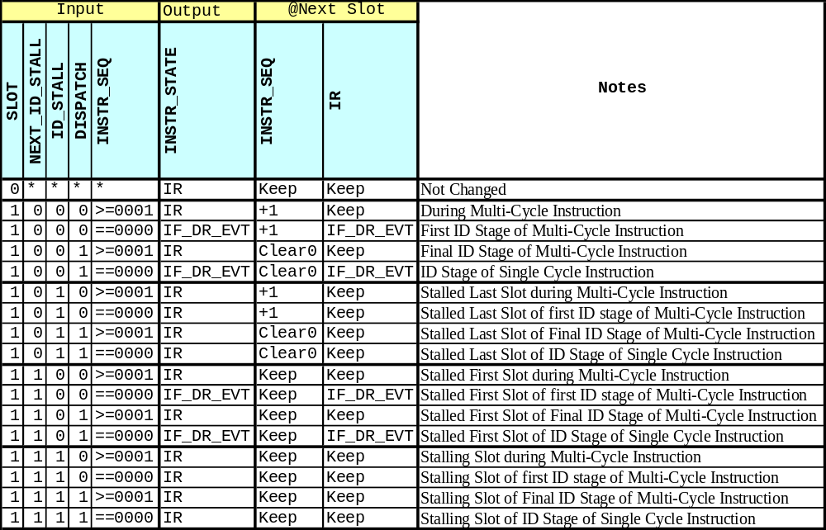
Table10.2 State Controls of Decoder Unit

Shifting Control Signals
The decoder unit makes many control signals to control whole CPU blocks. These control signals are generated by the huge truth table as described above. The output timing of all control signals is always on ID stage. But these signals should control not only ID stage operations but also EX, MA and WB stage operations. So the signals which control EX or WB should be shifted as shown in Figure10.4. Actually, the flip-slops shown in Figure10.5 are used to shift each control signal.

Note that MA controls are performed in EX stage because how to issue the MA can be determined in EX stage, in which address of MA is calculated and write data is prepared.

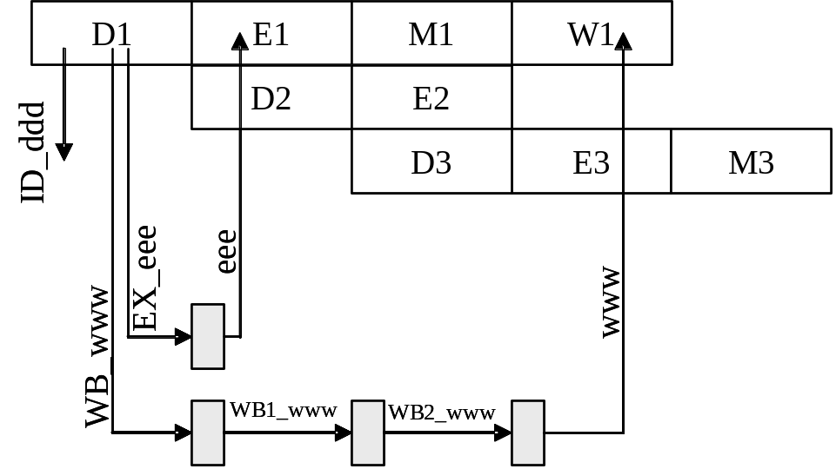
Figure10.4 Shifting Control Signals

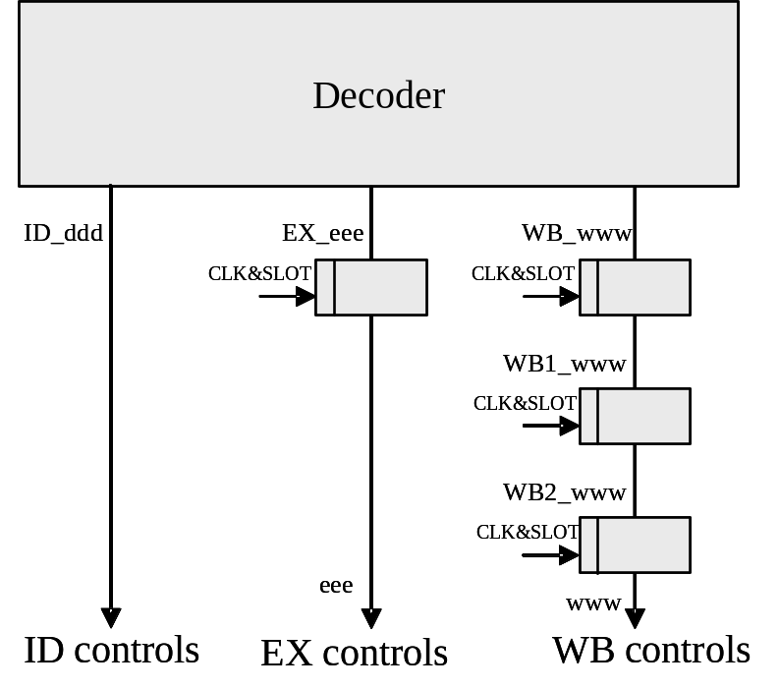
Figure10.5 Shifting Circuit

Pipeline Stall
The pipeline is stalled by following 4 reasons.

[1] Wait States on Instruction Fetch (IF) or Data Access (MA)
All pipeline slots are synchronized to memory access. The signal SLOT from mem.v indicates the each slot edge. If there is no memory access or there is memory access without wait state, the pipeline slot do not stalls (SLOT=1). If there is memory access with wait state, the pipeline stalls (SLOT=0) until SLOT signal is asserted (it means the wait state finishes). So the clock inputs of whole flip-flops for controls are gated by SLOT signal. Only by this clock gating, such kind of pipeline stall is fully controlled. See Figure10.6.

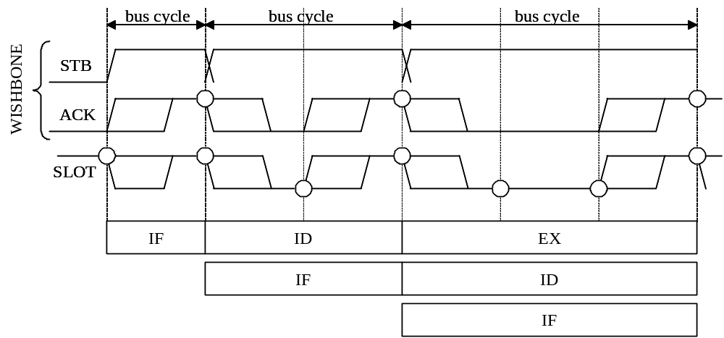
Figure10.6 Bus Wait State and Slot control
[2] Conflict IF and MA
As you know, the simultaneous IF and MA conflicts and make the pipeline stalls as shown in Figure9.3. The memory access controller (mem.v) detects IF-MA conflicts and informs the events to decoder unit using a signal IF_STALL. The circuit for conflict detection receives IF_STALL, then controls pipeline stalling.

[3] Multiplication Contention
As shown in, for example, Figure9.2 (8), the multiplication related instruction may cause pipeline stall. This is controlled by using MAC_BUSY signal from mult.v and signals WB_MAC_BUSY, EX_MAC_BUSY and MAC_STALL_SENSE from the huge truth table in decoder unit. By the methods described in later section, the multiplication related stall signal MAC_STALL is generated. The circuit for conflict detection receives MAC_STALL, then controls pipeline stalling.

[4] Register Contention
Memory load instruction may cause register contention with followed instruction which uses the write back data of the previous load instruction. The circuit for conflict detection watches pipeline control signals as shown in Figure10.7 and make a conflict indicate signal REG_CONF. In this case, MOV.L @R0,R1 and ADD R1, R2 cause R1 conflict. At the ID stage of ADD, the control signal to read R1 (EX_RDREG_X or EX_RDREG_Y) for ADD instruction and the shifted control signal to write back to R1 (WB1_WRREG_W) for MOV.L instruction are asserted simultaneously. This means there is R1 confliction, so the ID stage of ADD should be stalled.

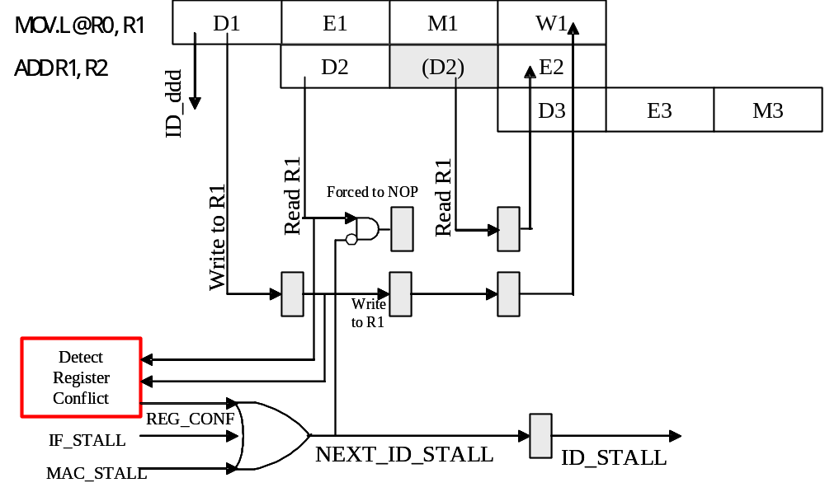
Figure10.7 Detecting Register Conflict
Regarding above [2] [3] [4], IF_STALL, MAC_STALL and REG_CONF are ored and the NEXT_ID_STALL is created.
The NEXT_ID_STALL means that the ID stall continues by at least next slot.
Note that the ID stage with NEXT_ID_STALL=1 should force to NOP the control signals for each CPU block because the stage has no meanings regarding execution of the instruction.
If NEXT_ID_STALL is asserted, the ID_STALL should be asserted at the next slot.
See Figure10.8 regarding some examples of the stall control.
The meanings of combination of NEXT_ID_STALL and ID_STALL are shown in Table10.3.

NEXT_ID_STALL | ID_STALL | Meanings | Control Signals
0 | 0 | No Pipeline Stalls | Active
0 | 1 | ID is stalled. The stalled slot is final one. | Active
1 | 0 | ID is stalled. The stalled slot is first one. | Force to NOP
1 | 1 | ID is stalled. The stalled slot will continue. | Force to NOP
Table10.3 Combination of NEXT_ID_STALL and ID_STALL
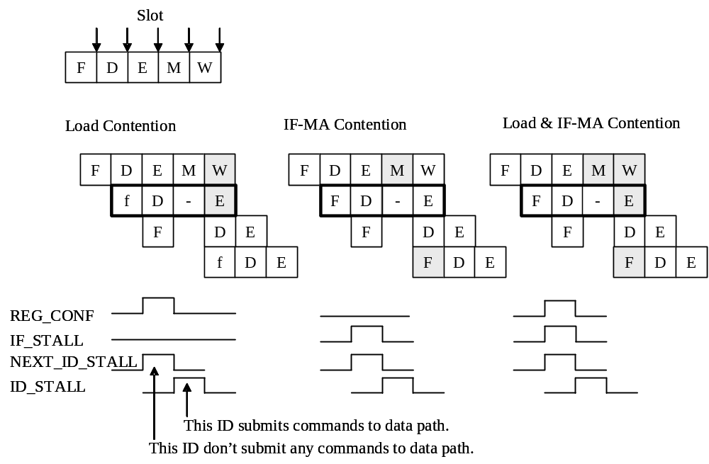
Figure10.8 Controls of ID stall

Register Forwarding
As shown in Figure9.2 and Figure9.3, register forwarding should be implemented not to reduce CPU cycle performance. After the memory load instruction, the register forwarding may be needed. This situation can be detected by watching some control signals. This is very similar to the detection of register conflict. If register content should be forwarded from Write Back Bus (W-BUS) to Register Read Bus X (X-BUS) in the data path unit, the signal REGFWD_X is asserted. If register content should be forwarded from W-BUS to Register Read Bus Y (Y-BUS), the signal REGFWD_Y is asserted. Actual forwarding transfer is performed in data path unit. Also see the chapter of data path unit.
Some examples are described in next section.

Examples of Pipeline Control
From Figure10.9 to Figure10.11 shows some examples of pipeline controls including stall control and register forwarding.

- Memory Load Contention (Figure10.9)
The Slot4 detects register contention, then REG_CONF is asserted. The ID at slot4 (ADD) is stalled. The Slot6 forwards write back data of MOV.L to EX stage of ADD.
- Contention of IF and MA (Figure10.10)
The EX of MOV.L asserts MA_ISSUE, and the IF of ADD asserts IF_ISSUE. This means the IF-MA confliction. Then, the memory access controller returns IF_STALL at slot4 and the ID in slot4 (ADD) is stalled.
- Delayed Branch (Figure10.11)
The 1st EX of BRA (slot4) makes fetch address of SUB (target), and 2nd EX make fetch address of AND.

Control of Program Counter
As described in last chapter, the ID stage issues IF stage. This is rigidly true. But the timing of changing PC has 2 cases.
[1] When program runs straight forward, the PC is incremented at ID stage.
[2] When program branches, the PC is changed at EX stage.
Figure10.12 shows good example of PC controls including exception sequence and branch operation.
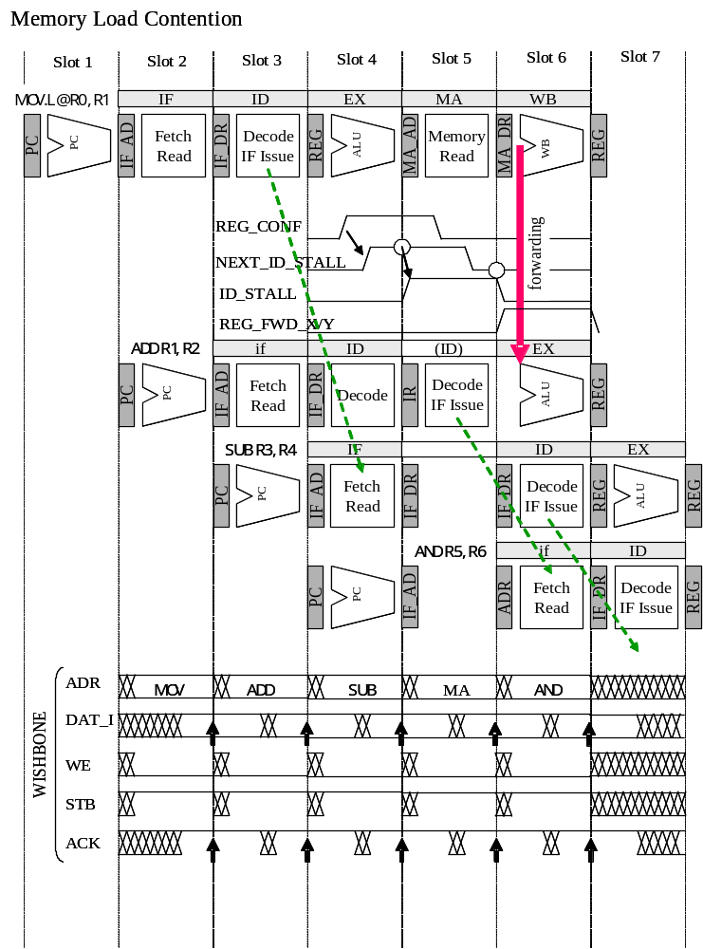
Figure10.9 Memory Load Contention
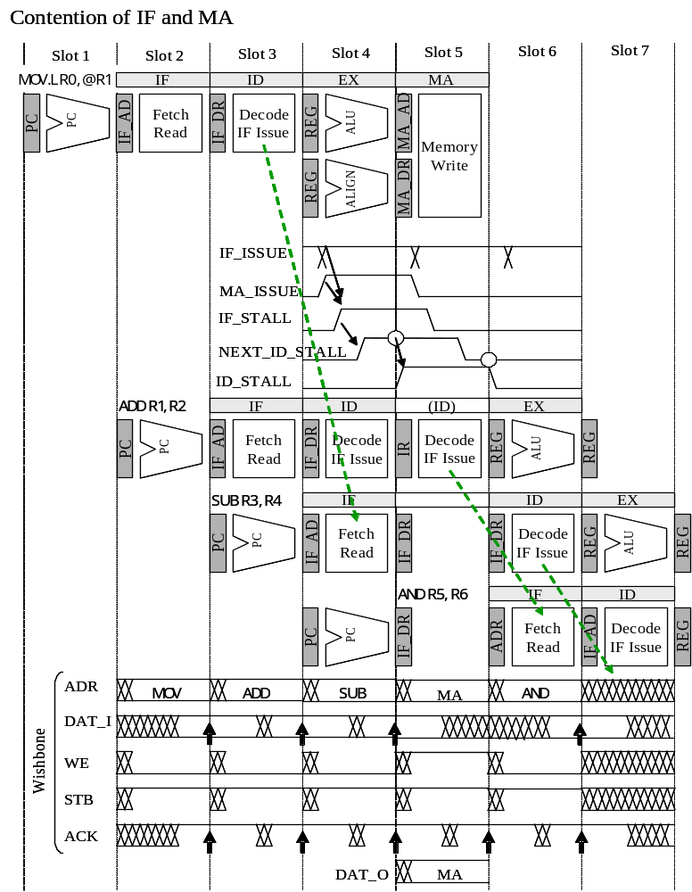
Figure10.10 Contention of IF and MA
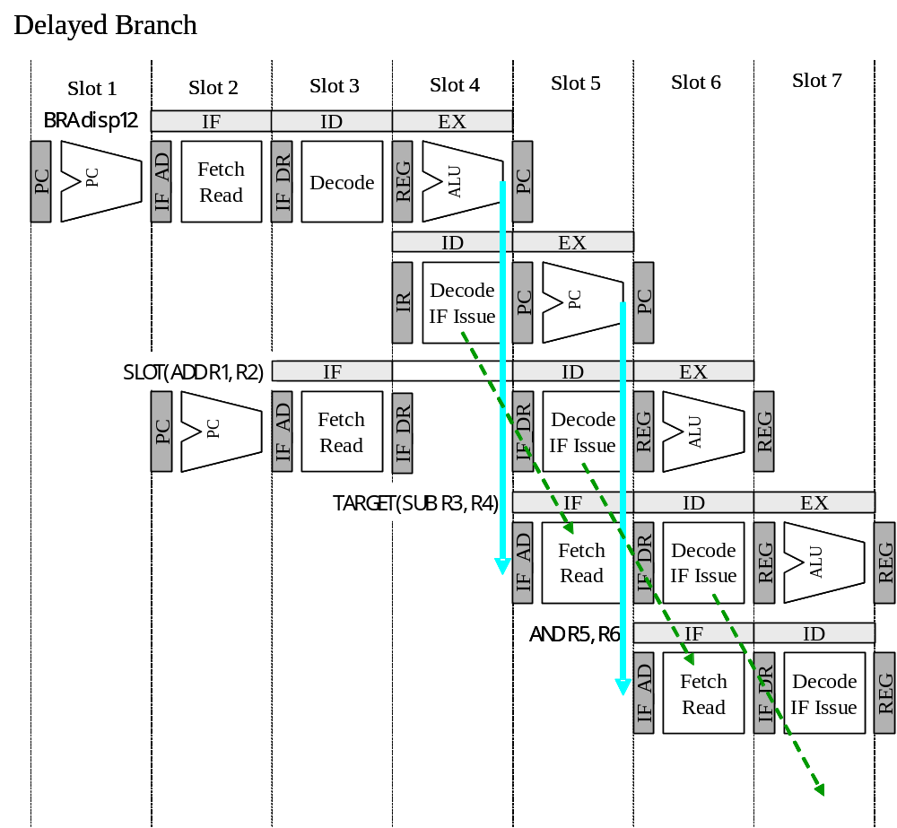
Figure10.11 Control of Delayed Branch
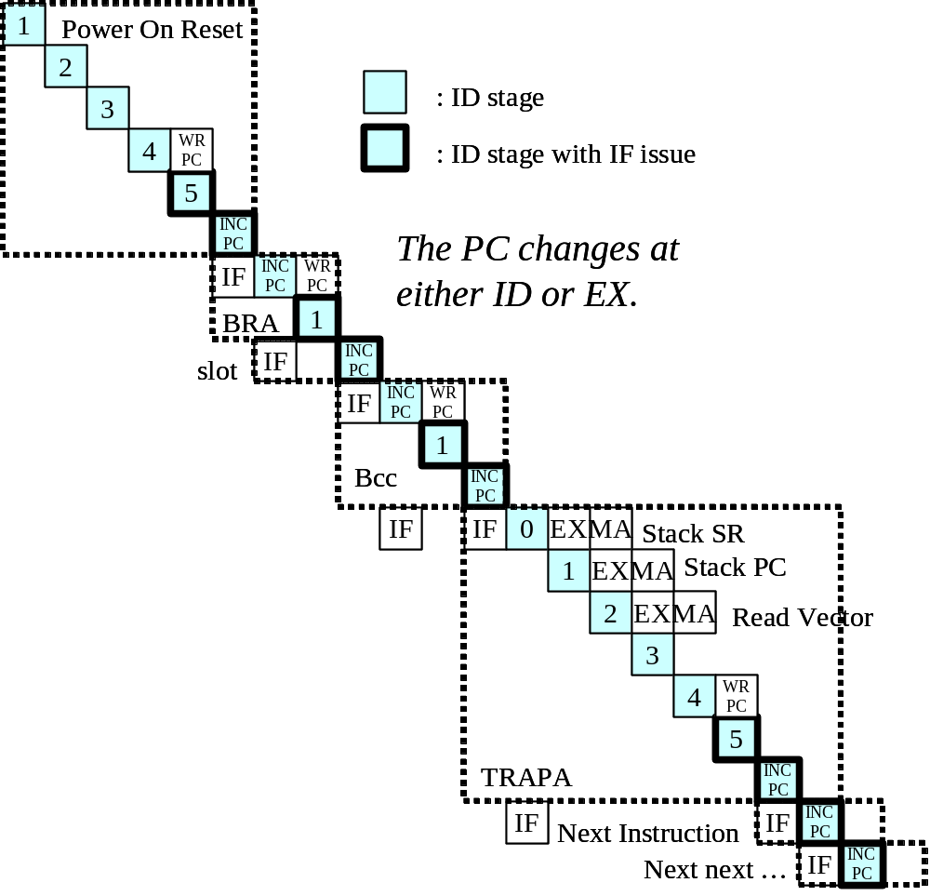
Figure10.12 PC Controls

Memory Access Control Unit
This chapter describes the details of memory access control unit (mem.v).

IN/OUT Signals
Table11.1 shows all in/out signals of memory access control unit.
(Although a signal IF_BUS goes to decoder unit, it is not used.)
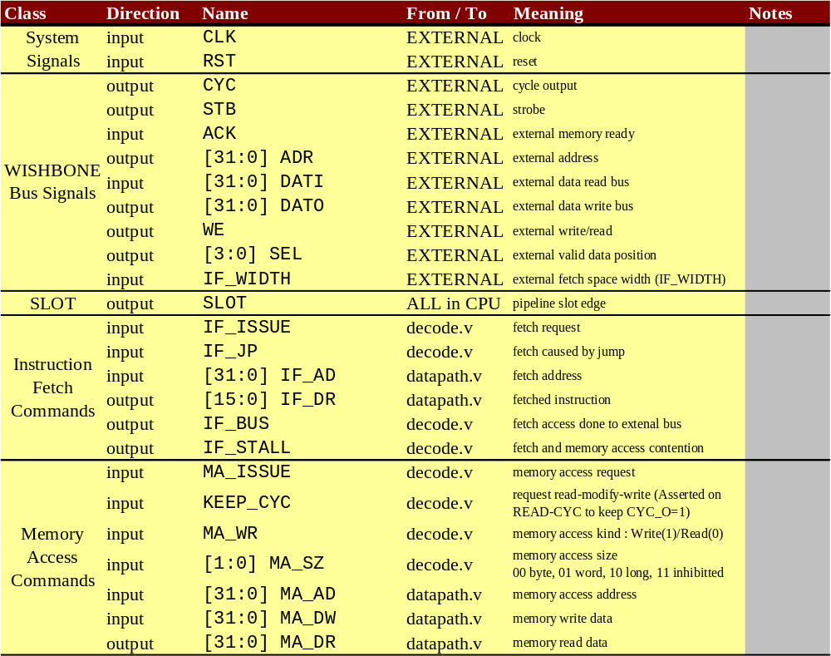
Table11.1 Memory Access Control Unit IN/OUT Signals

WISHBONE’s ACK and Aquarius’ SLOT
As described last chapter, the signal SLOT indicates the pipeline slot edges, and is created from WISHBONE’s ACK signal in the memory access control unit. The clocks of each flip-flop in Aquarius CPU are gated by SLOT signal, so that the pipeline stall derived from memory access cycle is easily controlled.
The waveform of SLOT is very similar to ACK, except that the SLOT is asserted if there is no memory access cycle, as shown in Figure11.1’s second slot. If external memory is accessed, the waveform of SLOT follows to ACK signal.

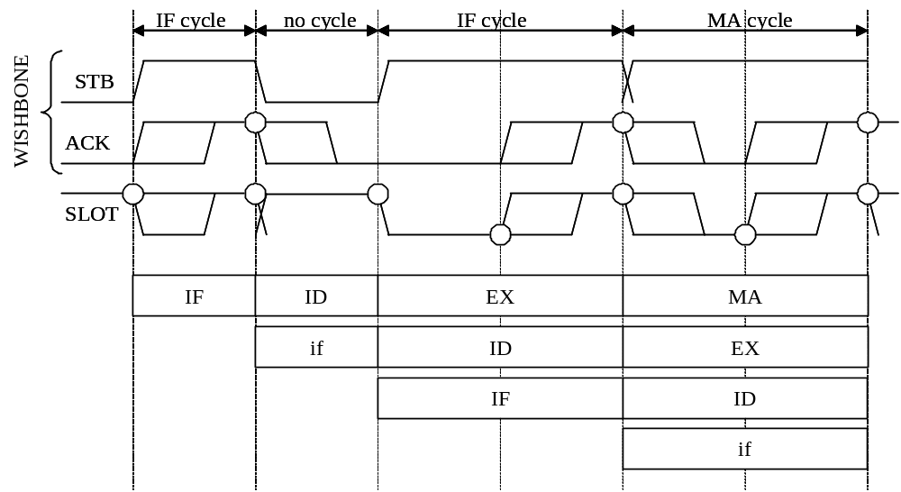
Figure11.1 WISHBONE’s ACK and Aquarius’ SLOT

Instruction Fetch Cycle
The decoder unit requests instruction fetch to the memory access control unit. Some examples of instruction fetch controls are shown in Figure11.2.
The instruction fetch starts at next slot of IF_ISSUE=1. When IF_ISSUE=1, IF_AD[31:0] and IF_JP should be valid state. IF_AD[31:0] shows the address of instruction which the decoder unit want to get.
If external bus width is 32bit (IF_WIDTH=1), 2 instructions are fetched simultaneously. This means the memory access control unit creates actual memory access for instruction fetch every two slots, using internal fetch buffer. But if the instruction fetch is created by Jump or Branch, the fetch should actually access the memory even if the internal fetch buffer has been valid. So, Jumping operation by instruction or exception sequence should inform such state to memory access control unit by asserting IF_JP with IF_ISSUE.
The fetched instruction IF_DR[15:0] is valid at next slot of corresponding IF cycle.
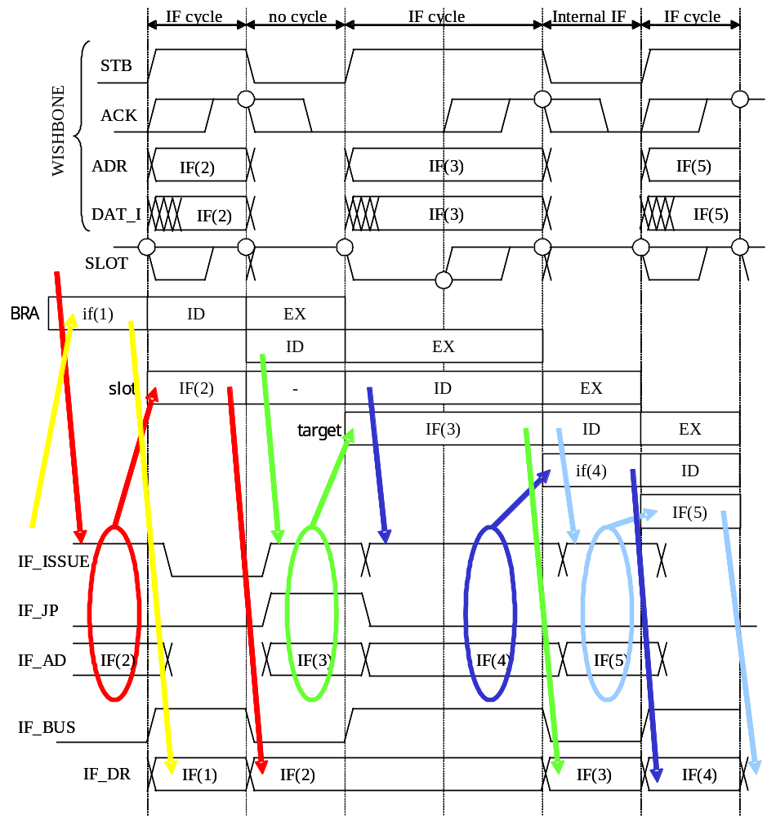
Figure11.2 Instruction Fetch Cycle

Memory Access Cycle
Figure11.3 shows memory access control. Similar to instruction fetch, MA starts at next slot of MA_ISSUE=1. Some attribute information such as access size MA_SZ[1:0], access direction MA_RW, address MA_AD[31:0] and, if write access, write data MA_WD[31:0] should be valid when IF_ISSUE=1.
The write data in MA_DW[31:0] should be valid in its LSB side when access size is smaller than long word. The read data MA_DR[31:0] is valid with sign extended at next slot of corresponding MA cycle.
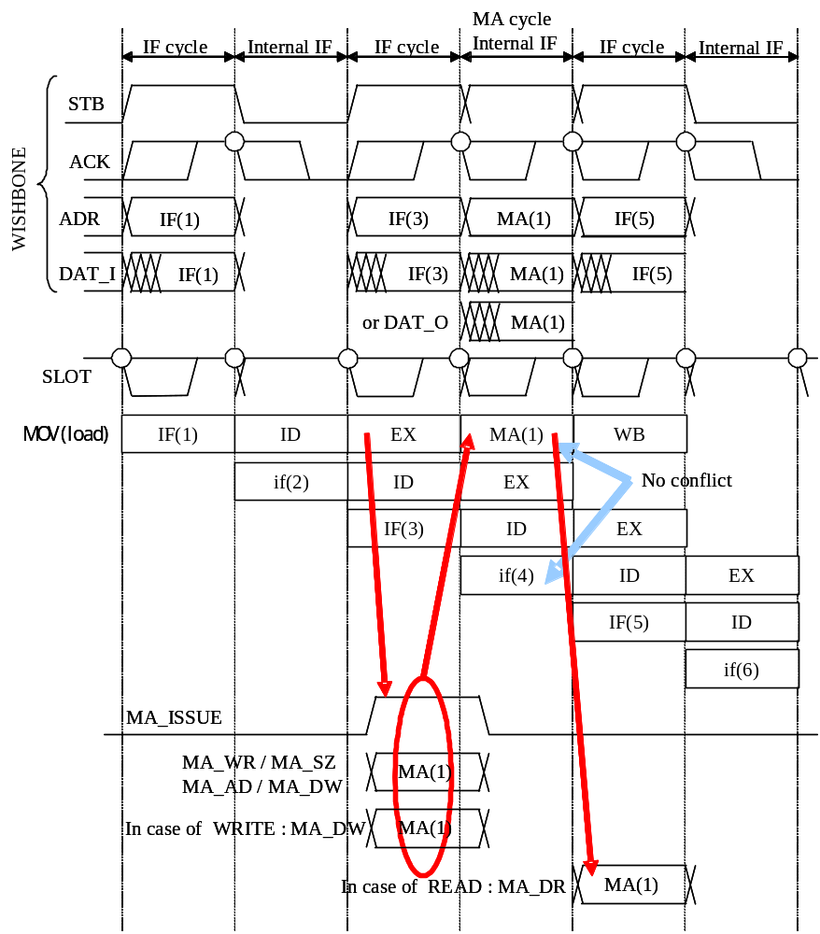
Figure11.3 Memory Access Cycle

IF-MA Conflict
Figure 11.4 shows the IF-MA conflict. At 3rd slot, IF_ISSUE and MA_ISSUE are asserted at same time. If the IF should get a instruction from external memory (not from internal instruction buffer), IF_ISSUE=1 & MA_ISSUE1 means IF-MA contention.
When IF and MA conflict, the memory access control unit asserts the signal IF_STALL and inform such situation to the decoder unit. The memory access control unit starts MA cycle first, and after the MA, it begins IF cycle.
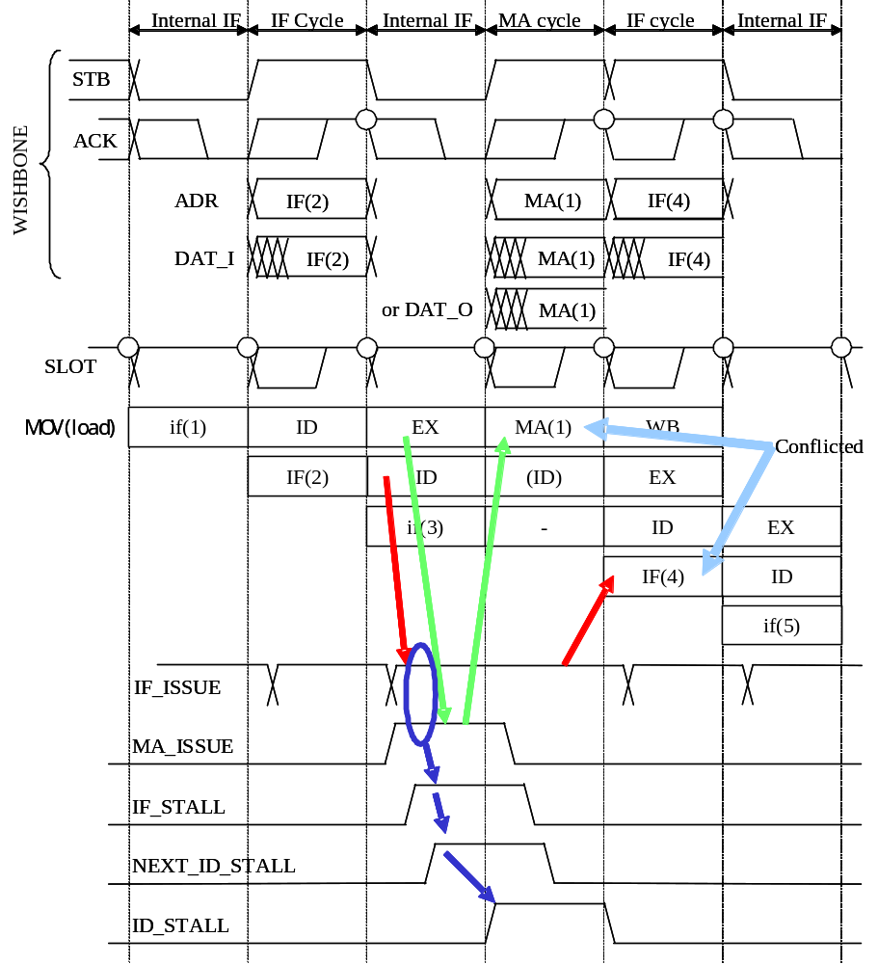
Figure11.4 IF-MA Conflict

Bus Width of Instruction Fetch Cycle (IF_WIDTH)
If data width of instruction fetch space is 32bit, the WISHBONE bus should return IF_WIDTH=1, or it should return IF_WIDTH=0. If IF_WIDTH=0, internal fetch buffer of the memory access control unit can get only one instruction, so next instruction fetch requested by decoder unit should produce actual memory access, as shown in Figure11.5.
Note that IF_WIDTH has its meaning only when lower 2bit of fetch address is 2’b00 as described in Part1.
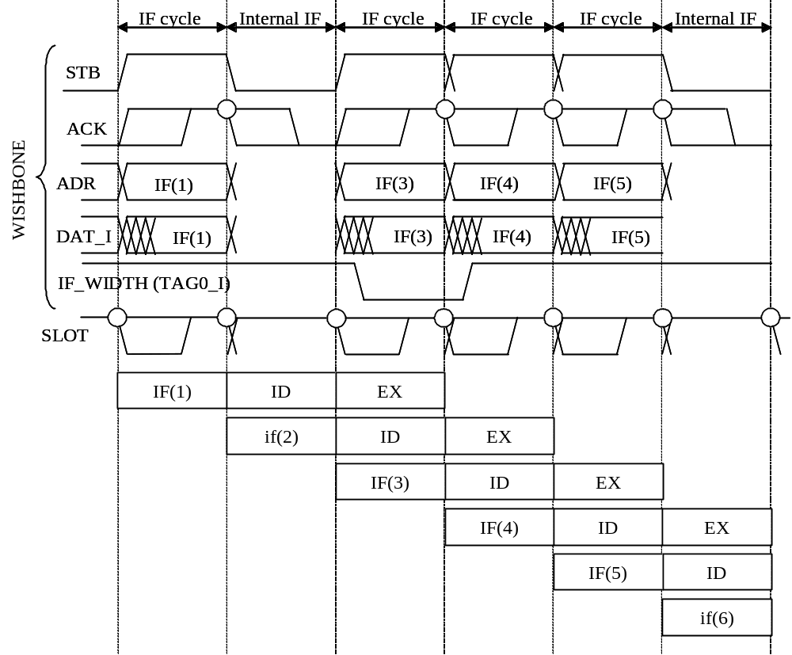
Figure11.5 Bus Width of Instruction Fetch Cycle (IF_WIDTH)

Read Modify Write Cycle (for Instruction TAS.B)
The specification of WISHBONE bus has read-modify-write cycle, in which no bus arbitration is granted between read and write. During read-modify-write cycle, the bus master should keep CYC signal high. The TAS.B (test and set) instruction requires such read-modify-write cycle. To achieve this, the memory access control unit receives KEEP_CYC signal from decoder unit, as shown in Figure11.6.

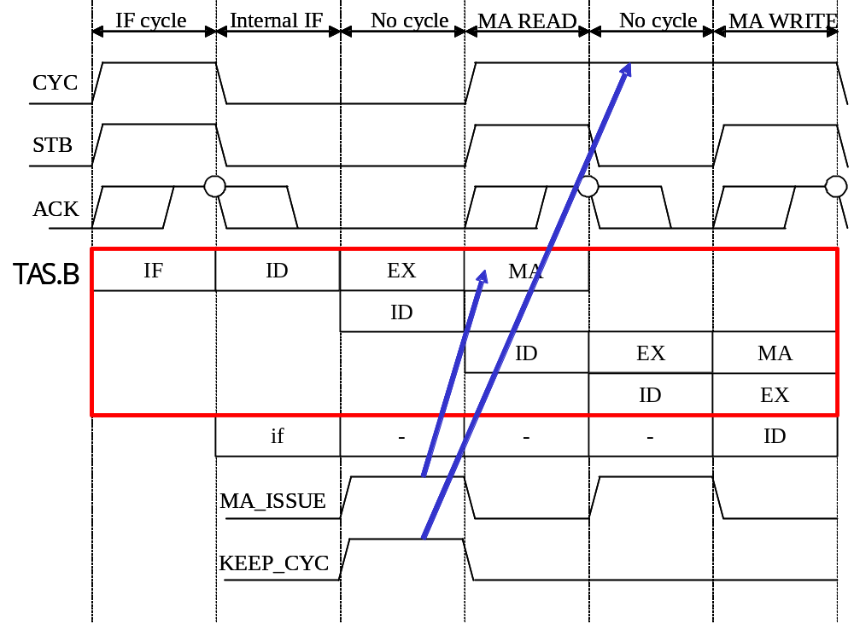
Figure11.6 Read Modify Write Cycle

State Machine of Memory Access Control Unit
Table11.2 shows state definition of memory access control unit. Table11.3 shows key signals regarding instruction fetch. And Table11.4 shows state transitions.
This memory access control unit assumes the CPU bus (WISHBONE) is non-Harvard bus. If you want to modify Aquarius to support Harvard bus, what you should do is (1) modifying the memory access control unit to connect both instruction bus and data bus, and (2) making decoder unit inform to memory access controller if the MA cycle is PC relative or not. Note that, even if you adopt Harvard bus with Aquarius, the PC relative instructions (MOV.L/W @(disp, PC), Rn) must access to instruction space, so this access conflicts to IF cycle. The memory controller for Harvard bus should still return IF_STALL to decoder.
State | Symbol | Meaning
S0 | S_IDLE | Idle state
S1 | S_IFEX | Instruction fetch with external memory read access
S2 | S_MAEX | Data access with external memory read/write access
S3 | S_MAEX_IFPD | Data access with pending instruction fetch (IF-MA conflict)
S4 | S_IDLE_IFKP | Idle state but internal instruction buffer keeps a instruction
S5 | S_IFIN | Instruction fetch from internal instruction buffer
S6 | S_MAEX_IFKP | Data access with keeping a instruction in the buffer
S7 | S_MAEX_IFIN | Data access from memory and Instruction fetch from buffer
Table11.2 State definition of memory access control unit
Signal | Meaning
IF_KEEP | Instruction fetch from long boundary address & IF_WIDTH=1 (32bit width)
IF_FORCE | Next instruction fetch is from long boundary | IF_JP=1
Table11.3 Key signals regarding instruction fetch control
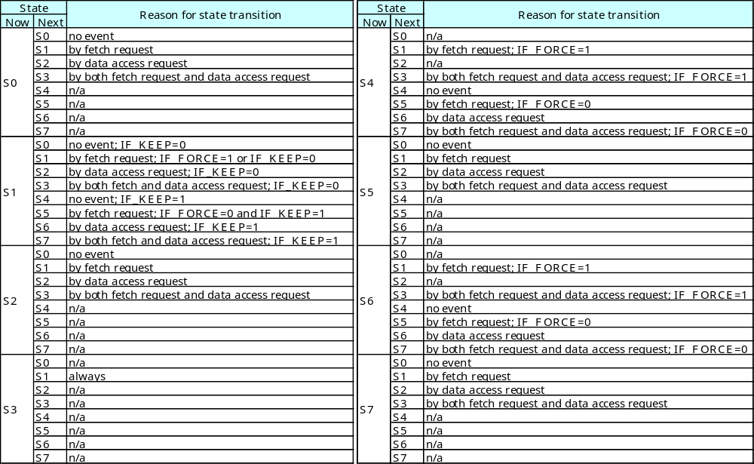
Table11.4 State transition of memory access control unit

Data Path Unit
This chapter describes the details of data path unit (datapath.v).

IN/OUT Signal Table
Table12.1 shows all in/out signals of data path unit.

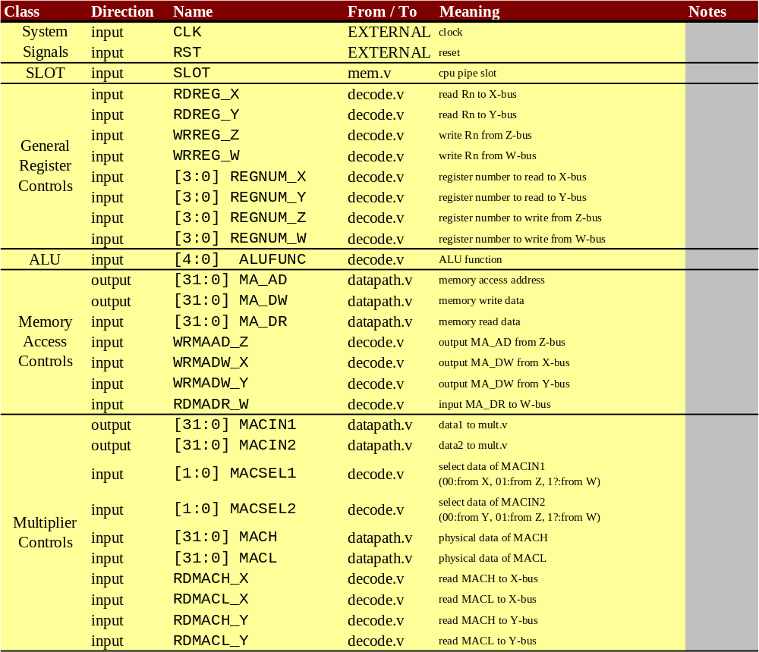
Table12.1 Data Path Unit IN/OUT Signals (1)

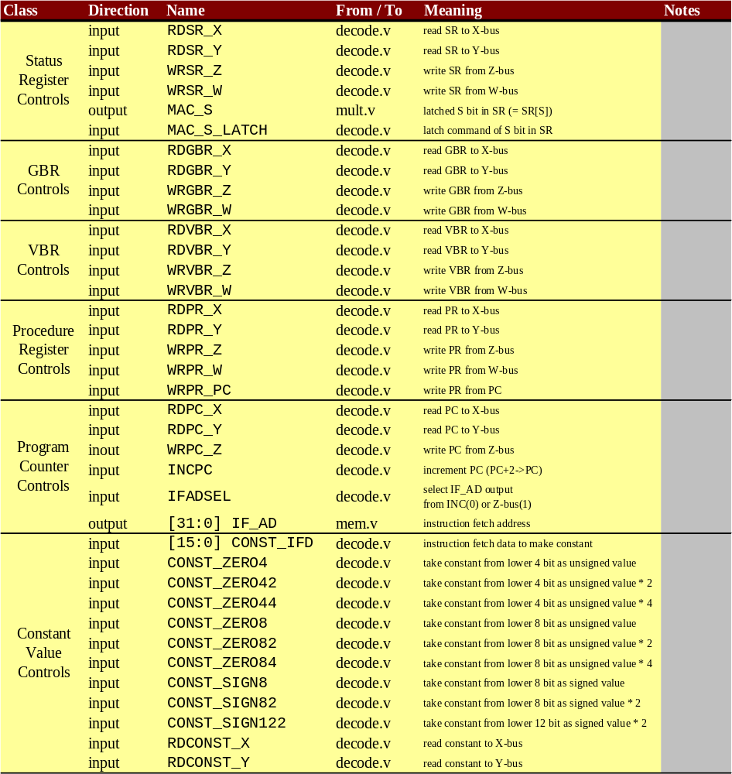
Table12.1 Data Path Unit IN/OUT Signals (2)

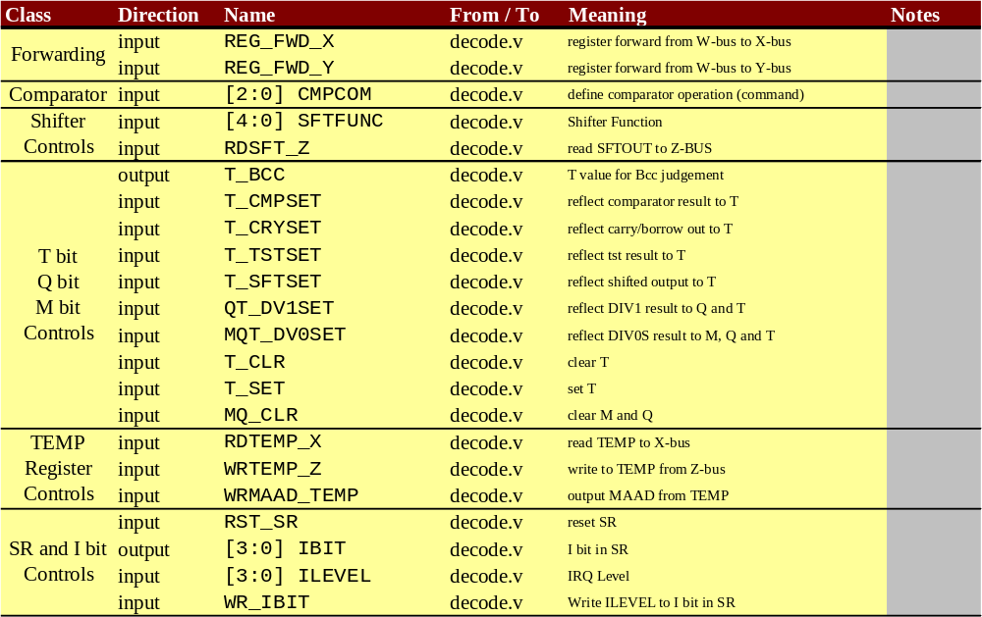
Table12.1 Data Path Unit IN/OUT Signals (3)

Structure of Data Path
Figure12.1 shows the block diagram of data path unit. It also shows basic relationship among data path, decoder, multiplier and memory access controller. In data path RTL description (datapath.v), the general registers R0-R15 (register.v) are located in under data path layer. Data path has 4 internal buses.
X-bus : Data from each register resource
Y-bus : Data from each register resource
Z-bus : Data from results of ALU or Shifter
W-bus : Data from memory load (to be written back to each register resource)
In the data path, all resources are fully controlled by decoder unit. So, there are no state machines in data path unit.
The register forwarding paths are shown in top of Figure12.1 as direct paths from W to X and W to Y.
The T bit, Q bit and M bit in Status Register (SR) are created from several signals as shown in Figure12.2, Figure12.3 and Figure12.4.
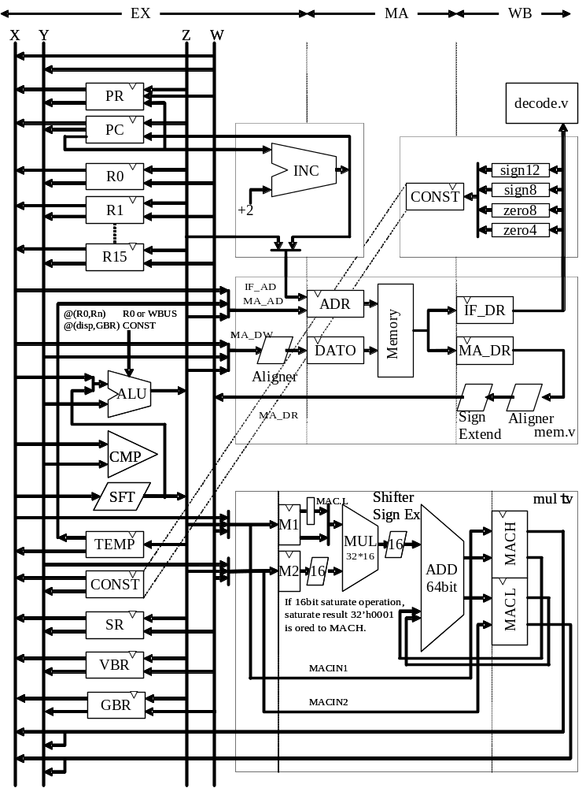
Figure12.1 Block Diagram of Data Path Unit
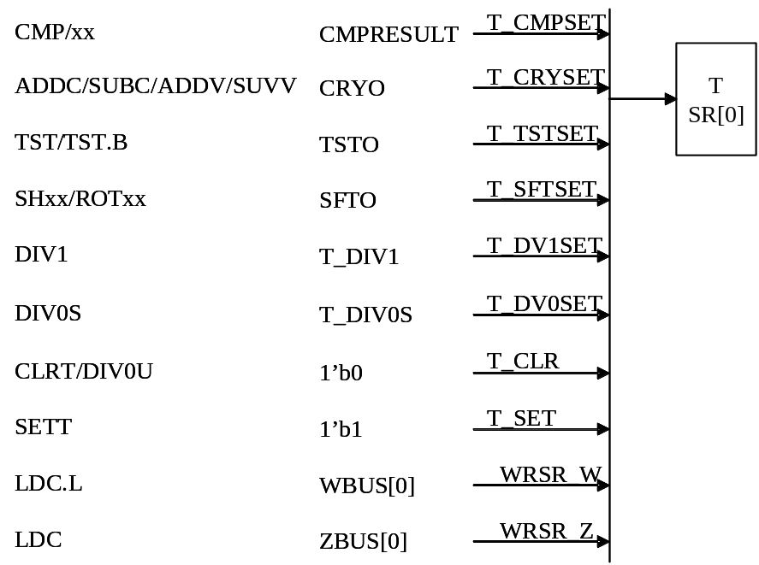
Figure12.2 Generating T bit
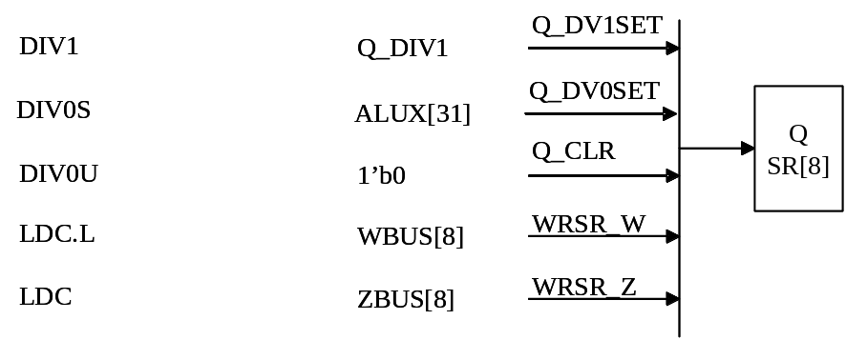
Figure12.3 Generating Q bit
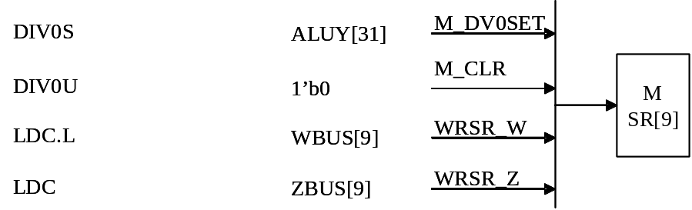
Figure12.4 Generating M bit

Multiplier Unit
This chapter describes the details of multiplier unit (mult.v).

IN/OUT Signal Table
Table13.1 shows all in/out signals of multiplier unit.

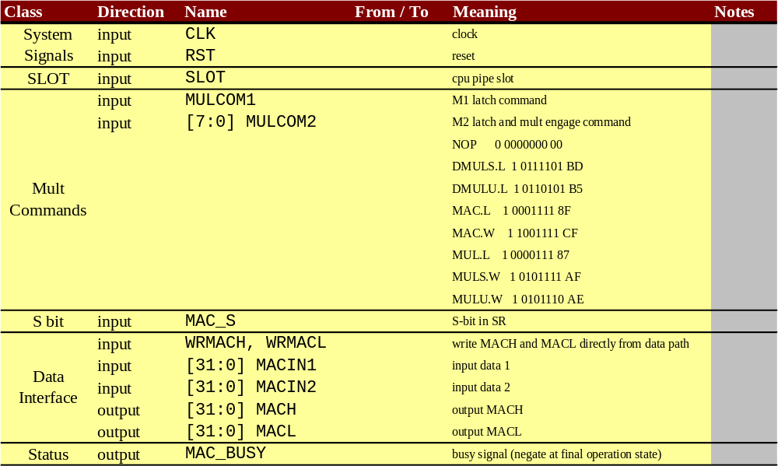
Table13.1 Multiplier Unit IN/OUT Signals

Algorithm of Multiplication
Basically, this multiplier design assumes that it is implemented by using Macro Module of Multiplier for FPGA. So, existence of unsigned 32bit x 16bit (or similar) multiplier is supposed. Now, let me define some symbols to explain.
As[N-1:0] = Assumed as Signed N bit
Au[N-1:0] = Assumed as Unsigned N bit Au[x]=As[x] (each bit is same)
Bs[N-1:0] = Assumed as Signed N bit
Bu[N-1:0] = Assumed as Unsigned N bit Bu[x]=Bs[x] (each bit is same)
- Signed 32bit x 32bit
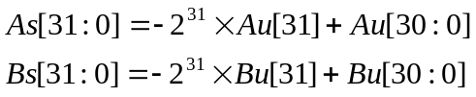
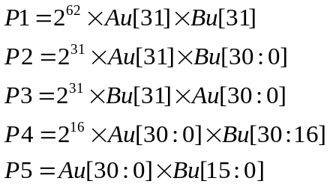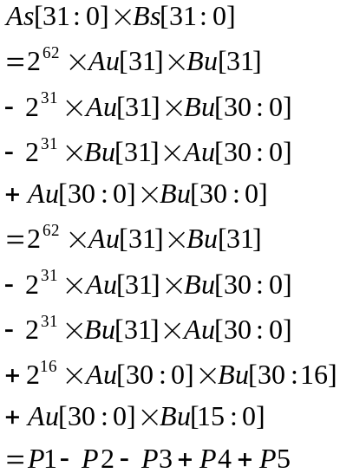

- Unsigned 32bit x 32bit
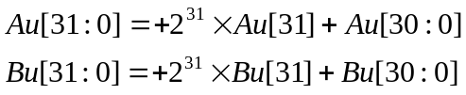
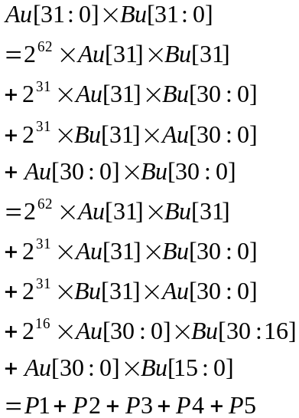
- Signed 16bit x 16bit
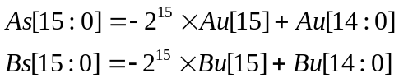
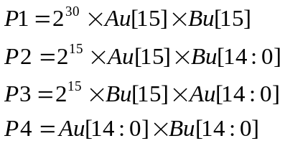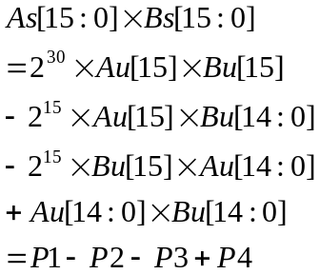

- Unsigned 16bit x 16bit
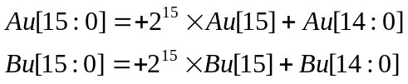
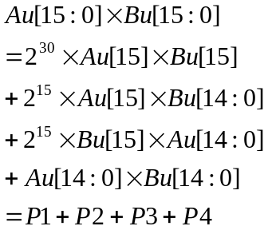

Pn are partial result to be accumulated.
Gathering above way of thoughts, Figure13.1 shows the methods of multiplication. The bit size of multiplication macro module should be at least 31bit x 16bit.

In case of 32bit multiplication, the calculation needs 2 steps. In first step, P4 is accumulated to MAC with preparing P2+P3, and in second step, P1, P2 and P3 are accumulated to MAC with 16bits shifting.

In case of 16bit multiplication, the calculation needs only 1 step. In the step, P1, P2, P3 and P4 are accumulated to MAC at once.
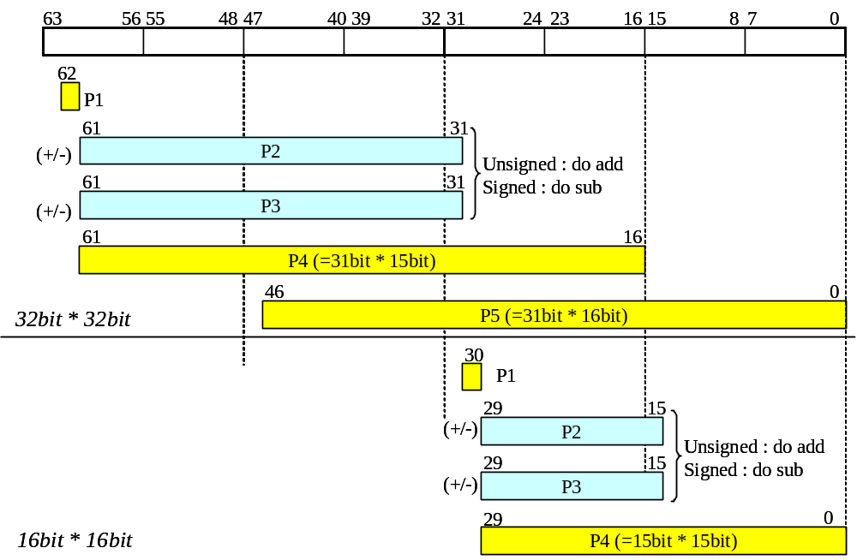
Figure13.1 Algorithm of Multiplication

Structure of Multiplier Unit
According to algorithm shown in Figure13.1, the multiplication unit has designed as shown in Fugure13.2. The some control signals are created by internal state machine as shown in Table13.2. The 64bit accumulation adder should have saturation capability. It is described later.

 |  | SIZE | SIGN | SHIFT | Notes
Signed  32bit | 1st step | 1 | 1 | 0
Signed  32bit | 2nd step | 1 | 1 | 1
Unsigned  32bit | 1st step | 1 | 0 | 0
Unsigned  32bit | 2nd step | 1 | 0 | 1
Signed 16bit |  | 0 | 1 | 0
Unsigned 16bit |  | 0 | 0 | 0
Table13.2 Control Signals in Multiplication Unit
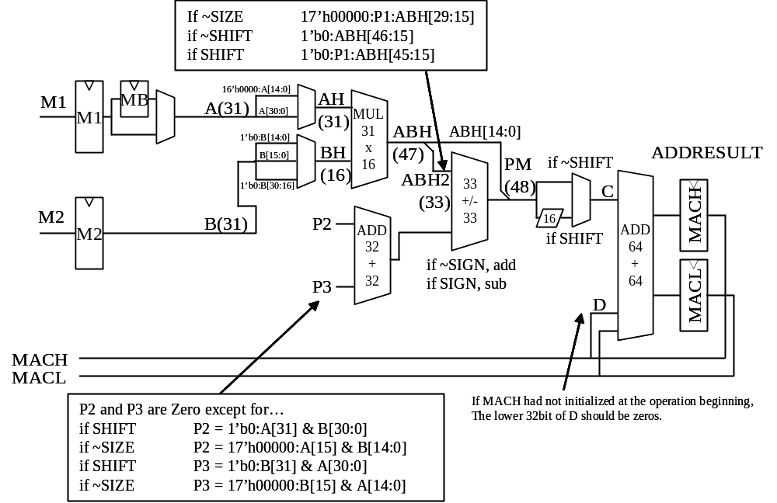
Figure13.2 Block Diagram of Multiplier Unit

Control of Multiplication Unit
The decoder unit sends two kinds of multiplication command to multiplication unit.
One is MULCOM1 which is latch signal of input data MACIN1[31:0]. Another is MULCOM2[7:0] which has 2 meanings; latch signal of input data MACIN2[31:0] and operation class. The MULCOM2[7] means latch signal. And MULCOM2[6:0] is same as {INSTR_STATE[14:12], INSTR_STATE[3:0]}. If MULCOM2[7]=0, it is NOP. Figure13.3 to Figure13.6 shows the timing position of each command. “M1” is MULCOM1, “M2” is MULCOM2. In the figures, the MAC value is determined at timing position with “MAC” and an arrow.

The instructions related to multiplication execute in multi cycles. So, if post instruction uses the result of MAC, it may be stalled.
Each multiplication instruction’s decode stage asserts EX_MAC_BUSY or WB_MAC_BUSY to indicate busy state of MAC register.
On the other hand, each multiplication related instruction asserts MAC_STALL_SENSE at decode stage to declare that it will use MAC resources.
In the decoder unit, MAC_STALL signal is created from each “pipeline shifted” xx_MAC_BUSY signal, MAC_STALL_SENSE and MAC_BUSY (from multiplier unit which indicates second “m” stage from the last). The MAC_STALL is used in decoder unit to control pipeline stall as shown in Figure10.7. Figure13.3 to Figure13.6 also shows how many stall cycle is necessary in the MAC conflict situation.
By the way, for example in Figure13.3, the stall counts of DMULxL / MUL.L / MULx.W can be reduced to 2 from 3, but such reduction has no meaning because the results (MACx) of these instructions should be stored to registers or memories once.

Note that the S bit in SR should be latched at second ID stage of instruction MAC.x, to avoid changing S during MAC operation. (The instruction after MAC may change S bit.)

How to implement Saturating Accumulation
In Figure13.2, the 64 bit adder ADDRESULT = MAC + C should have saturating function for MAC.W and MAC.L (S=1). If S=1, MAC.W should saturate between 32’h80000000 to 32’h7FFFFFFF, and MAC.L should saturate between 64’hFFFF800000000000 to 64’h00007FFFFFFFFFFF. To simplify explanation, consider only latter case.
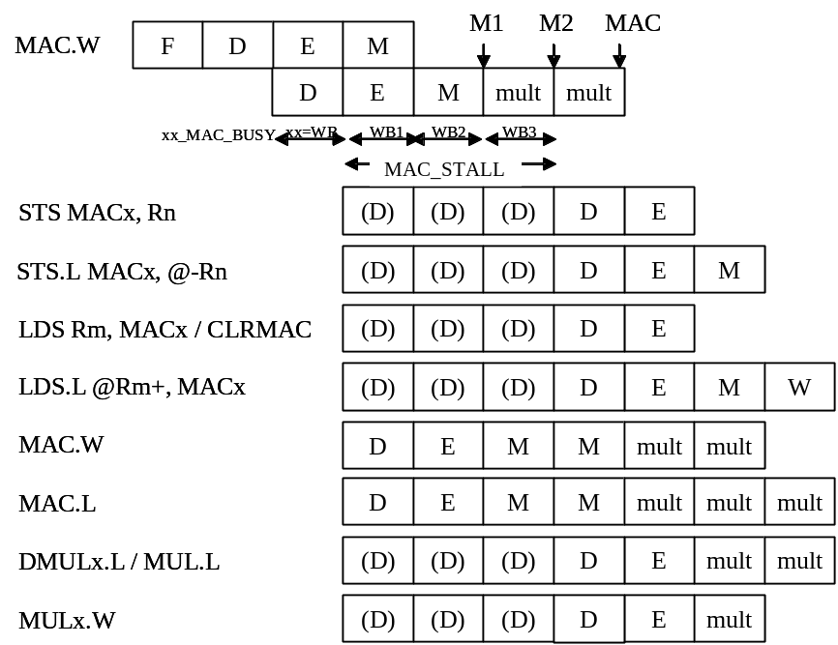
Figure13.3 Conflict MAC.W and its post instruction
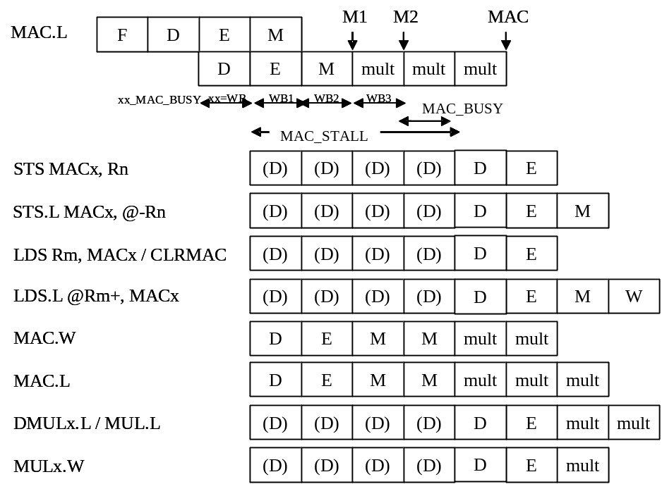
Figure13.4 Conflict MAC.L and its post instruction
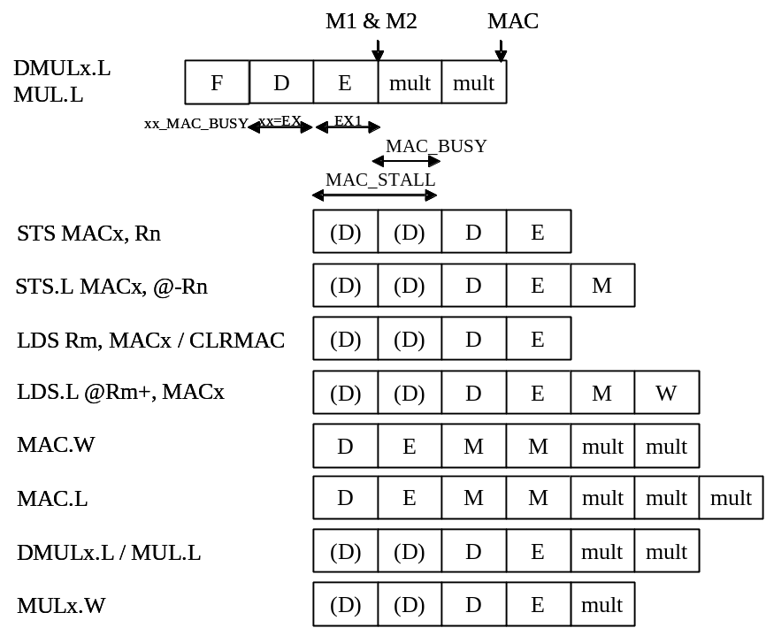
Figure13.5 Conflict DMULx.L / MUL.L and its post instruction
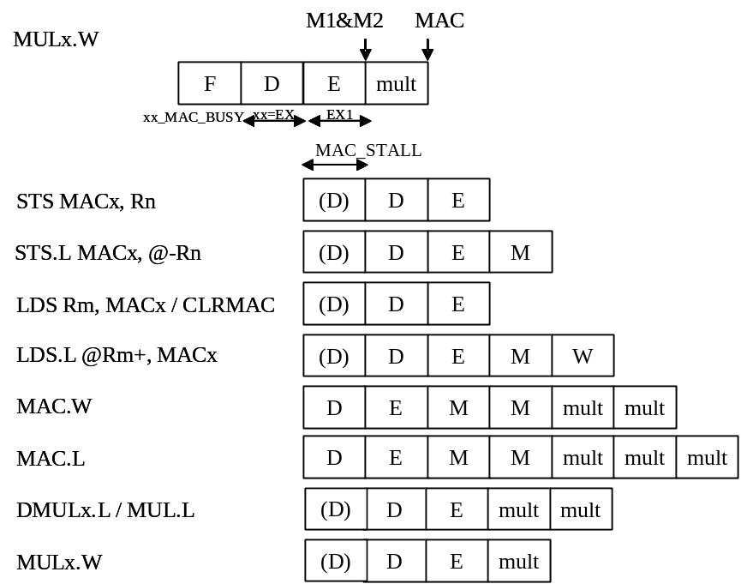
Figure13.6 Conflict MULx.W and its post instruction
One of the simplest implementation of saturation is only to cut carry chain in adder circuit at proper position. But in this case, if the initial value has already been out of saturating value, the final result will not correct one. So, we should consider the initial accumulator value may be any value.

Figure13.7 shows way of thought for correct saturation. The angle is accumulator’s value = MAC. 0 degree means 64’0000000000000000, 180 degrees means 64’7FFFFFFFFFFFFFFF. Now, the desired saturation values is shown as +S and –S. And this plane is divided into 4 regions; P, P’, M and M’. In this plane, we want to do operation add. If we add positive value (+C), the angle of MAC moves counterclockwise; if we add negative value (-C), the angle of MAC moves clockwise.

Table13.3 shows all combinations of MAC angle movement. And from Table13.4 to table13.7 shows the compaction process of combinations. I implemented saturating operation according to Table13.7.

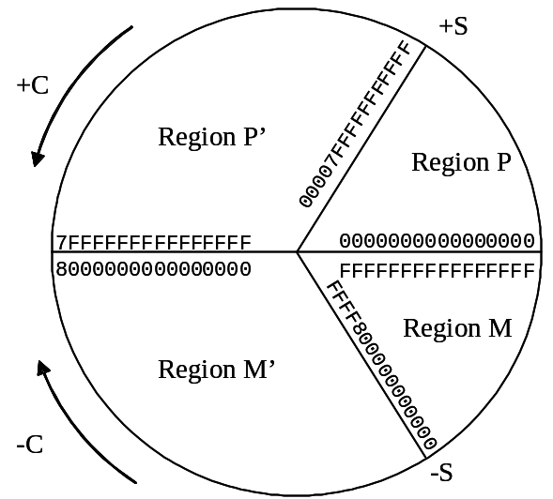
Figure13.7 Way of thought for Saturating Accumulation
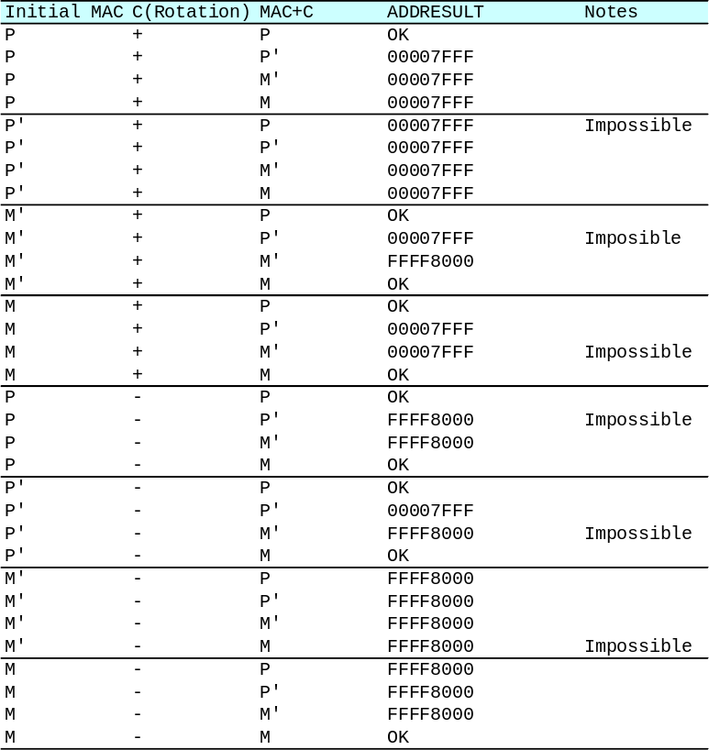
Table13.3 All combinations of angle movement (1)
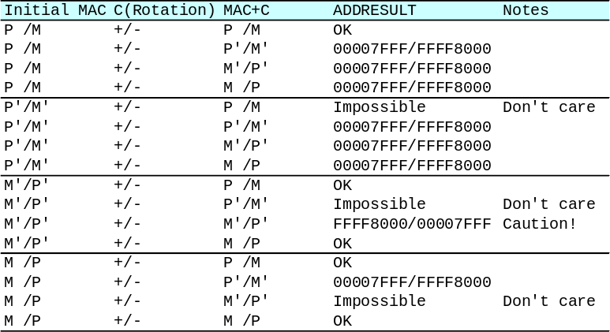
Table13.4 All combinations of angle movement (2)
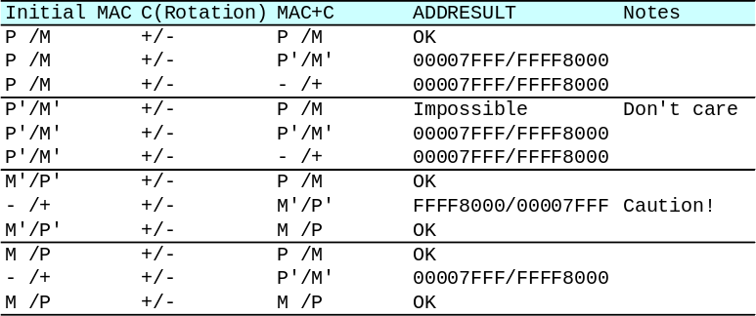
Table13.5 Compressed combinations of angle movement (1)
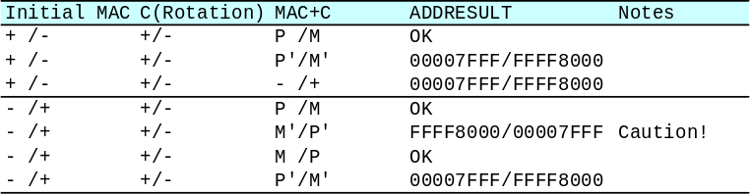
Table13.6 Compressed combinations of angle movement (2)
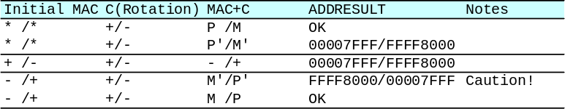
Table13.7 Compressed combinations of angle movement (3)

Appendix: Aquarius Instruction Code
Aquarius instruction codes are compatible to SuperH-2.
Table14.1 shows all instruction codes and their controls.

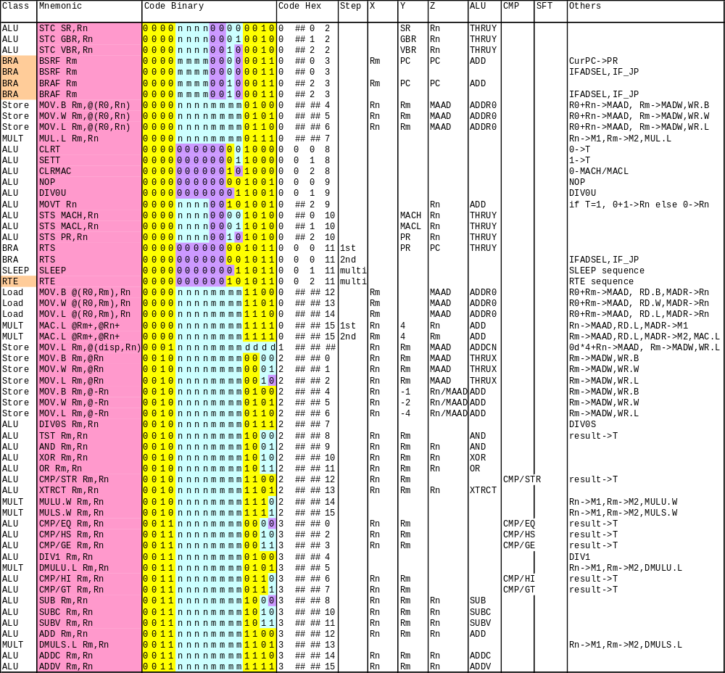
Table14.1 Aquarius Instruction Codes (1)

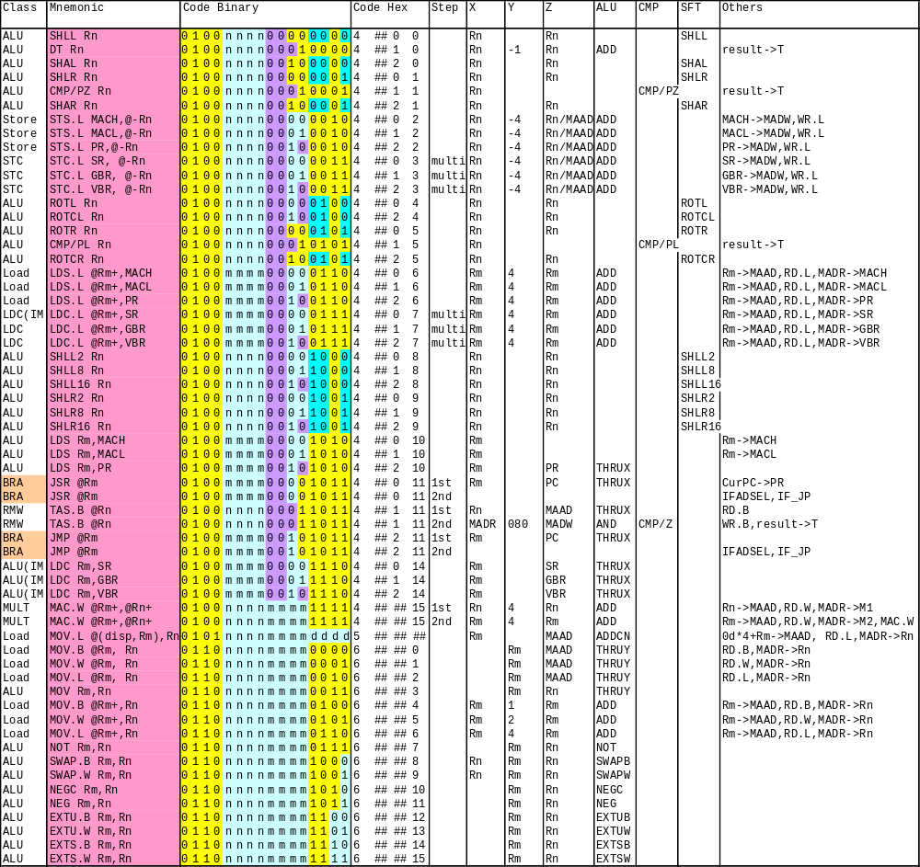
Table14.1 Aquarius Instruction Codes (2)

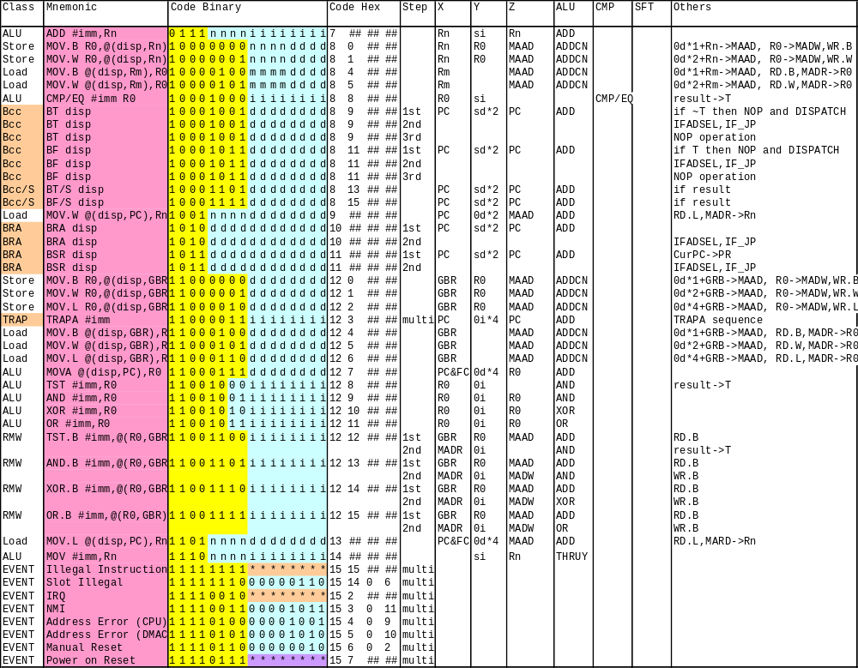
Table14.1 Aquarius Instruction Codes (3)

