**功能测试设计**

1. 修改商品状态

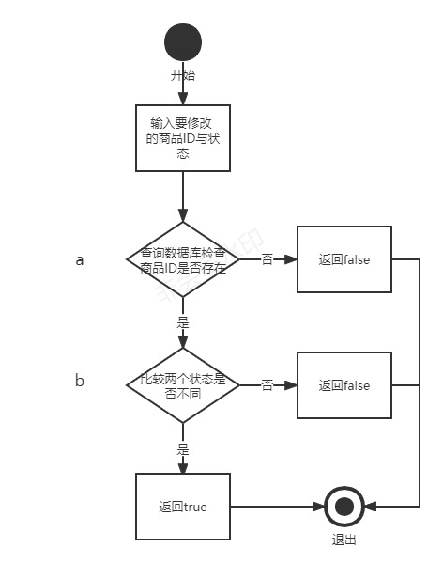

判定表：

|  |  |  |  |  |
| --- | --- | --- | --- | --- |
|  | 序号 | 1 | 2 | 3 |
| 输入 | a | 0 | 1 | 1 |
| b |  | 0 | 1 |
| 输出 |  | false | false | true |

测试用例：

二、修改密码

1.用例设计

|  |  |  |  |  |  |  |
| --- | --- | --- | --- | --- | --- | --- |
| 序号 | | 1 | 2 | 3 | 4 | 5 |
| 条件 | 旧密码 | 1 | 1 | 1 | 1 | 0 |
| 新密码格式正确 | 1 | 1 | 1 | 0 |  |
| 新密码与旧密码不一致 | 1 | 1 | 0 |  |  |
| 确认密码与新密码一致 | 1 | 0 |  |  |  |
| 动作 | 修改成功 | 1 |  |  |  |  |
| 旧密码错误 |  |  |  |  | 1 |
| 新密码与确认密码不一致 |  | 1 |  |  |  |
| 新旧密码一致 |  |  | 1 |  |  |
| 密码要求正确（待填入） |  |  |  | 1 |  |

测试用例：

三、买家填写购买信息

|  |  |  |  |
| --- | --- | --- | --- |
|  | 序号 | 1 | 2 |
| 输入 | 姓名格式错误 | 1 | 0 |
| 输出 |  | 姓名格式不规范 | 通过 |

测试用例：

|  |  |  |  |
| --- | --- | --- | --- |
|  | 序号 | 1 | 2 |
| 输入 | 电话格式错误 | 1 | 0 |
| 输出 |  | 电话格式不规范 | 通过 |

测试用例：

|  |  |  |  |
| --- | --- | --- | --- |
|  | 序号 | 1 | 2 |
| 输入 | 邮寄地址格式错误 | 1 | 0 |
| 输出 |  | 邮寄地址格式不规范 | 通过 |

测试用例：

四、交易状态（交易成功或失败）

|  |  |  |  |  |  |  |  |
| --- | --- | --- | --- | --- | --- | --- | --- |
|  | 序号 | 1 | 2 | 3 | 4 | 5 | 6 |
| 输入 | 查询商品的状态 | 1 | 1 | 1 | 0 | 0 | 0 |
| 更新用户信息表 | 0 | 0 | 0 | 1 | 0 | 0 |
| 更新商品表 | 0 | 0 | 0 | 0 | 1 | 0 |
| 更新商品表中买家信息 | 0 | 0 | 0 | 0 | 0 | 1 |
| 输出 |  | no err |  | err | err | err |  |

测试用例：

五、登录

1.用例设计 1表示正确 0表示错误

|  |  |  |  |  |
| --- | --- | --- | --- | --- |
| 序号 | | 1 | 2 | 3 |
| 条件 | 用户名 | 1 | 1 | 0 |
| 密码 | 1 | 0 | 0 |
| 动作 | 登录成功 | 1 |  |  |
| 用户名错误或不存在 |  |  | 1 |
| 密码错误 |  | 1 |  |

测试用例：

六、创建商品

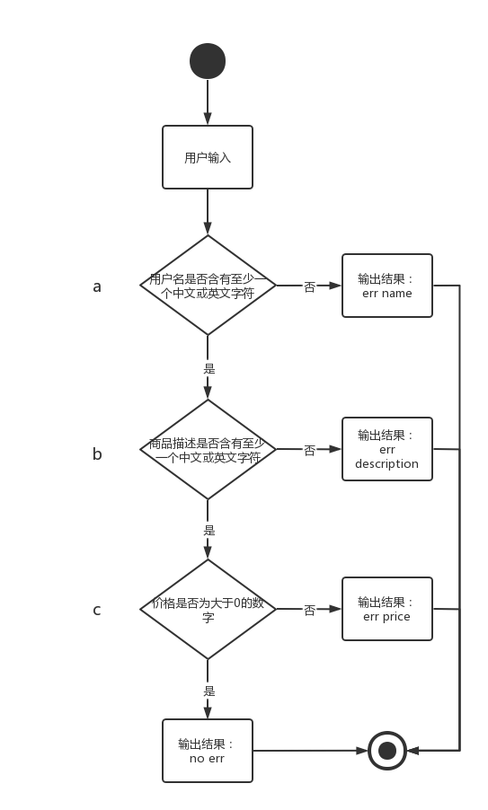

判定表：

|  |  |  |  |  |  |
| --- | --- | --- | --- | --- | --- |
|  | 序号 | 1 | 2 | 3 | 4 |
| 输入 | a | 0 | 1 | 1 | 1 |
| b |  | 0 | 1 | 1 |
| c |  |  | 0 | 1 |
| 结果 |  | err | err | err | no err |

测试用例：

**单元测试设计**