**功能测试用例设计**

1. 创建商品功能测试

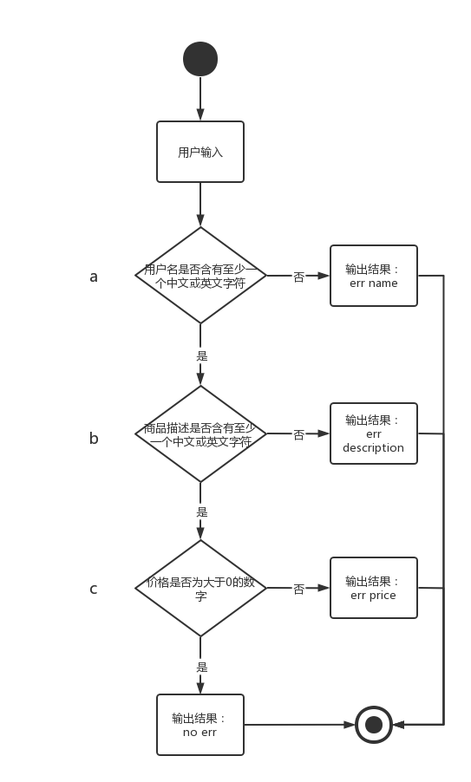

判定表：

|  |  |  |  |  |  |
| --- | --- | --- | --- | --- | --- |
|  | 序号 | 1 | 2 | 3 | 4 |
| 输入 | a | 0 | 1 | 1 | 1 |
| b |  | 0 | 1 | 1 |
| c |  |  | 0 | 1 |
| 结果 |  | err name | err description | err price | no err |

1. 修改商品状态功能测试

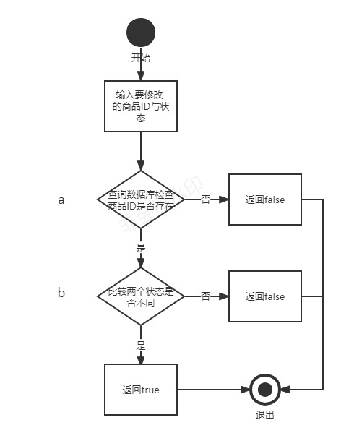

判定表：

|  |  |  |  |  |
| --- | --- | --- | --- | --- |
|  | 序号 | 1 | 2 | 3 |
| 输入 | a | 0 | 1 | 1 |
| b |  | 0 | 1 |
| 输出 |  | False | False | True |

**三、买家填写购买信息功能测试设计**

|  |  |  |  |
| --- | --- | --- | --- |
|  | 序号 | 1 | 2 |
| 输入 | 电话格式错误 | 1 | 0 |
| 输出 |  | 电话格式不规范 | 电话ok |

**四、交易状态（交易成功或失败）功能测试设计**

|  |  |  |  |  |  |  |  |
| --- | --- | --- | --- | --- | --- | --- | --- |
|  | 序号 | 1 | 2 | 3 | 4 | 5 | 6 |
| 输入 | 查询商品的状态 | 1 | 1 | 1 | 0 | 0 | 0 |
| 更新用户信息表 | 0 | 0 | 0 | 1 | 0 | 0 |
| 更新商品表 | 0 | 0 | 0 | 0 | 1 | 0 |
| 更新商品表中买家信息 | 0 | 0 | 0 | 0 | 0 | 1 |
| 输出 |  | no err |  | err price | err price | err price |  |

**五、登录测试**

**1.用例设计 1表示正确 0表示错误**

|  |  |  |  |  |
| --- | --- | --- | --- | --- |
| **序号** | | **1** | **2** | **3** |
| **条件** | **用户名** | **1** | **1** | **0** |
| **密码** | **1** | **0** | **0** |
| **动作** | **登录成功** | **1** |  |  |
| **用户名错误或不存在** |  |  | **1** |
| **密码错误** |  | **1** |  |

**六、修改密码测试**

**1.用例设计 1表示正确 0表示错误**

|  |  |  |  |  |  |  |
| --- | --- | --- | --- | --- | --- | --- |
| **序号** | | **1** | **2** | **3** | **4** | **5** |
| **条件** | **旧密码** | **1** | **1** | **1** | **1** | **0** |
| **新密码格式正确** | **1** | **1** | **1** | **0** |  |
| **新密码与旧密码不一致** | **1** | **1** | **0** |  |  |
| **确认密码与新密码一致** | **1** | **0** |  |  |  |
| **动作** | **修改成功** | **1** |  |  |  |  |
| **旧密码错误** |  |  |  |  | **1** |
| **新密码与确认密码不一致** |  | **1** |  |  |  |
| **新旧密码一致** |  |  | **1** |  |  |
| **密码必须7-11位字符组成且至少有1个数字、1个大写字母、1个小写字母和其它字符** |  |  |  | **1** |  |