Report

For this first website, I wanted something functional with a simple design but easy to understand.

To do this the first thing I do is a navigation bar that can be deployed on the top, to navigate between pages without difficulties:
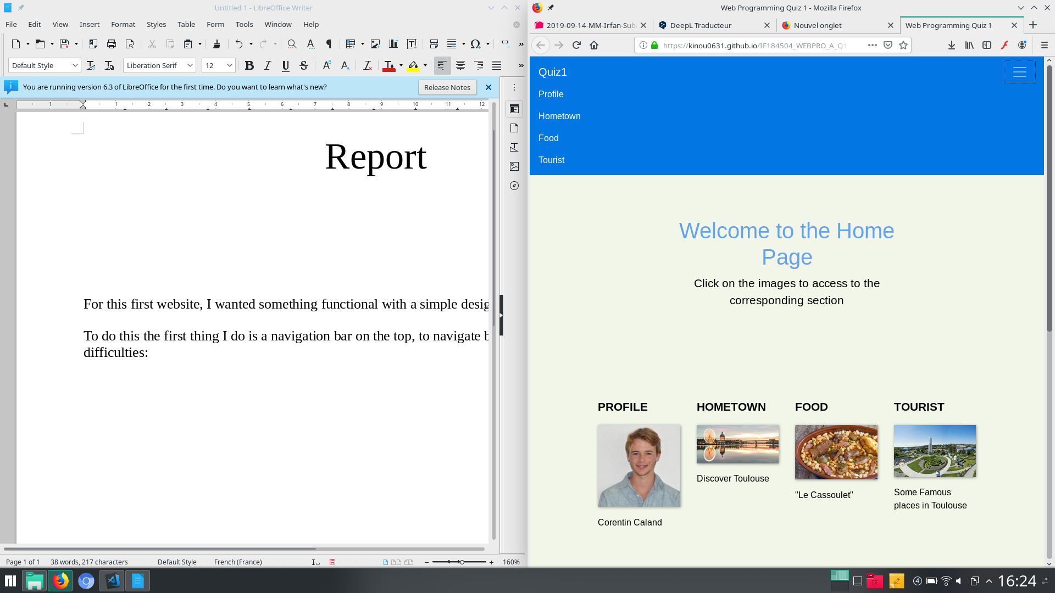
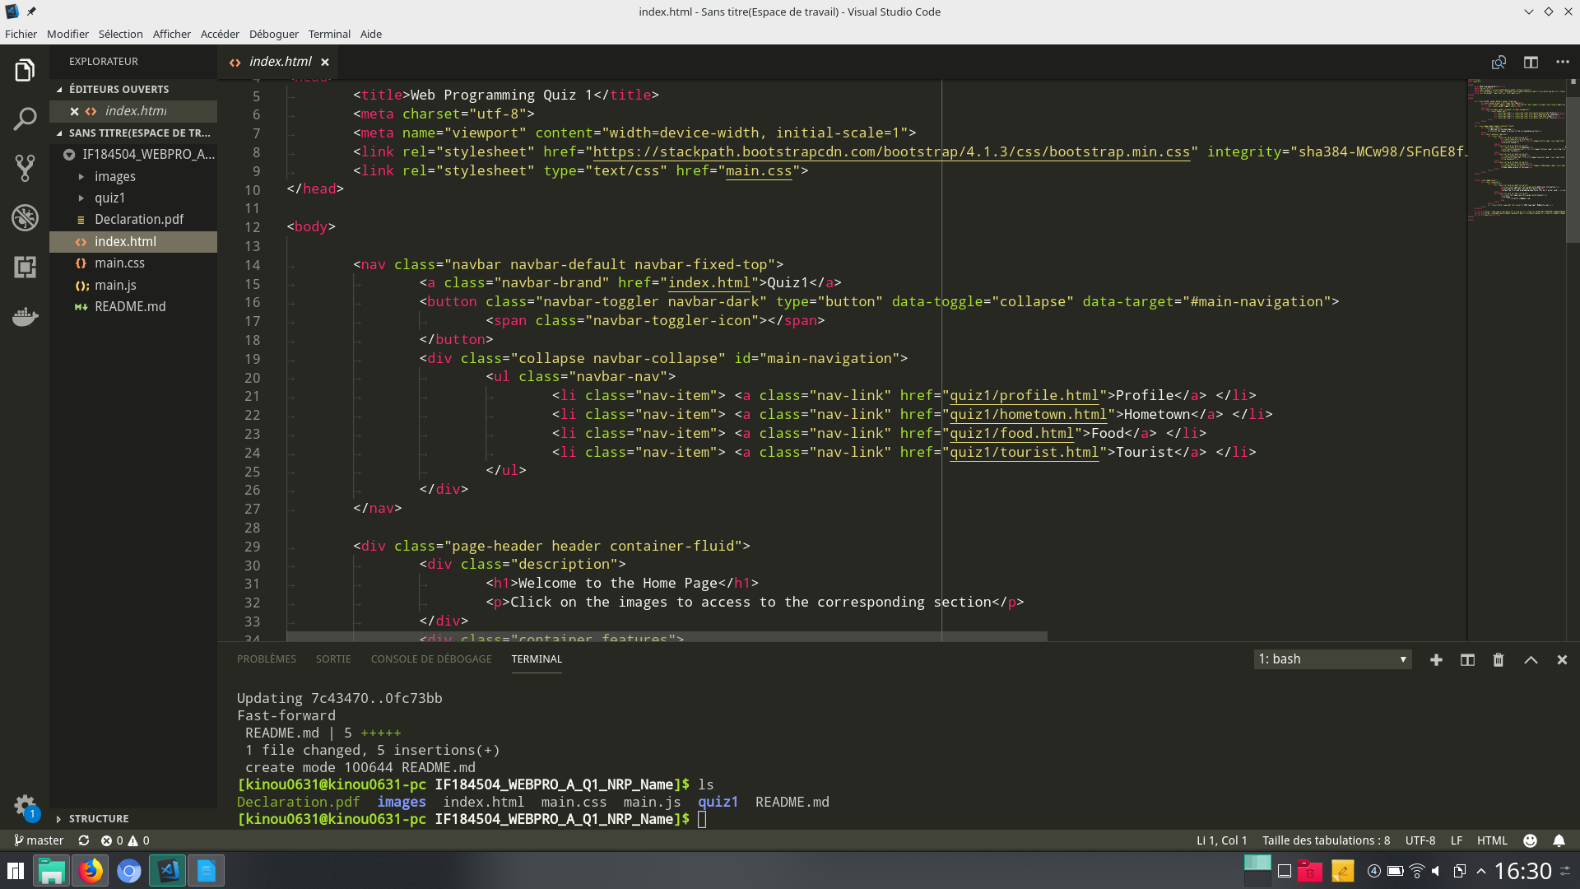

Click on Quiz1 to directly come back to the homepage (By my experience on the web, this is my prefered method)
The navbar is exactly the same for each pages
The navbar is exactly the same for each pages

The second section, is separate in two part:
First a simple title and an indictation to understand the purpose of each pages and after the content (here an exemple from the homepage):
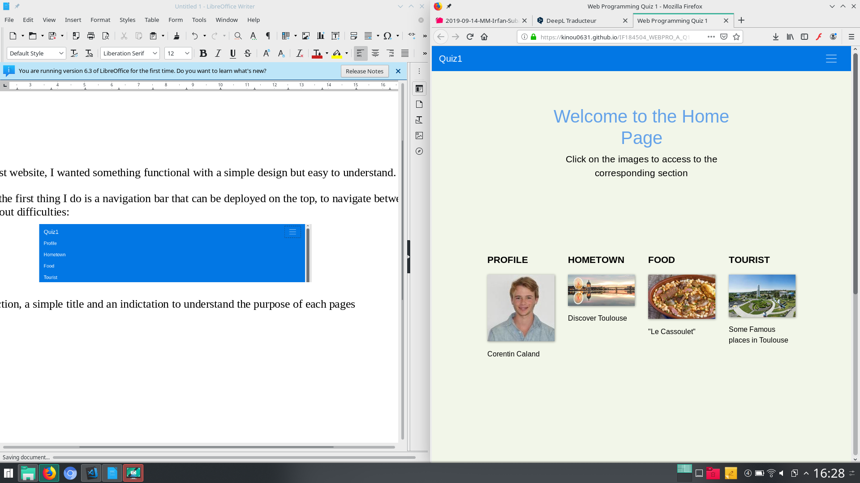
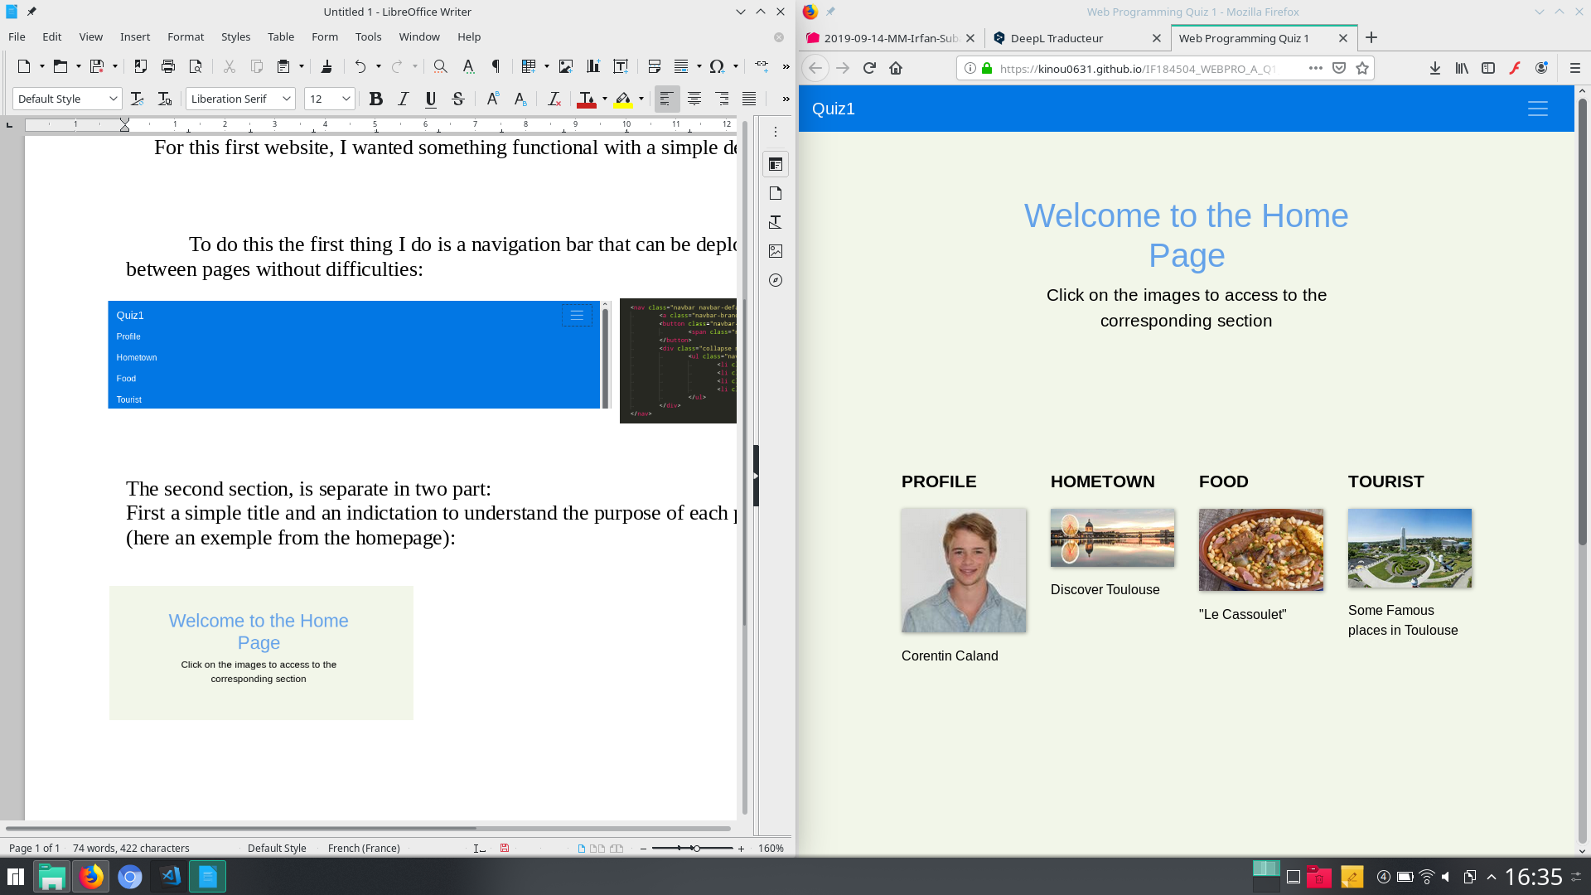

The last section on the bottom of each page is a simple footer. Here more for a design purpose.

To conclude:

This simple strucure in three part allowed me to do a single css script to handle this website which facilitates the development. On other hand this probably not something to do for a larger website.

