TRAN DUC ANH DANG

103995439

Report

Assignment 1

Table of Contents

1. Aim 2

2. Design Outline 2

3. Problems 3

4.1 Clock + Alarm 4

4.2 Finish Working Circuit 5

# 1. Aim

This project's goal is to create a functional clock with an alarm feature that appears on the same display. In order to have a functioning alarm function and sound the alarm if they match, it must also be able to compare the time displayed in the alarm with the time on the clock. In addition, the set time and set alarm must function so that they may become used to altering the beginning time and alarm.

# 2. Design Outline

To build up this digital alarm clock, I have separated it into 3 small part that have an individual function.

1. The first part is a clock part design

- a counter for the “units” column display (value range: 0-9), which increments every clock pulse.

- a counter for the “tens” column display (value range 0-5), which increments every time the units column reaches “9”, and wraps back to “0” after reaching “5”.

- a two digit display that represents minutes as two decimal digits, and wraps back to “00” on the clock pulse immediately after displaying “59” (i.e., as described in the “units” and “tens” counter behaviour described above).

- a led that indicate A.M/P.M

2. The second part is the Set Alarm, when this mode is enabled, the time of the clock should paused and swap to the alarm mode which will allows users to use to adjust the time on the clock. as in extended part, I have added

a light to show whether the alarm is on or off, if m+, hr+ or set am/pm is being used, the alarm on/off will light up to indicate that it alarm has been set. When the time on the clock and alarm is the same to each other, the Text
will light up.

To be able to do that, I have used the XNORGate to connect minute, hour, am/pm from alarm and clock to each other, and if they are all the same, the output from ANDGATE will light up the alarm.

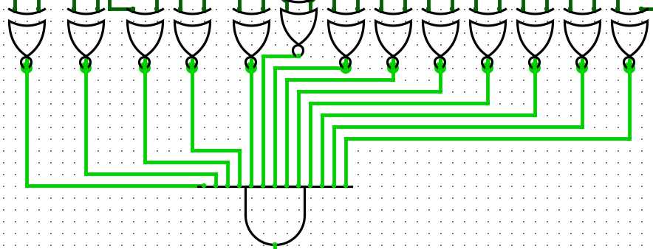

3. The third part is the display part. I'm using a logic that can choose the output from the normal clock and the alarm.

# 3. Problems

There's a small problem that happens in both clock and alarm is once the minute reach 59, no matter how you try to change the time, it won't be able to change. Otherwise, there is no issues that I have found in my project.

# 4. Assumption

I made an effort to construct the circuit during this project without making any assumptions. The preceding courses covered all of the rationale behind this.

# 5.1 Clock + Alarm

Clock and Alarm are basically the same with each other, but Alarm just have some minor changes to sync with each other.

# 5.2 Finish Working Circuit

