All the model is finetune and train on the same dataset with same numbers of epochs

# Model 1 (Provided Model)

test_loss: 0.8686615228652954, test_accuracy: 0.7193999886512756

# Model 2 (Modified base on Model 1)

test_loss: 0.47836971282958984, test_accuracy: 0.8489000201225281

# Model 3 (Transfer Learning from VGG16 Model)

test_loss: 0.9223770499229431, test_accuracy: 0.6909000277519226

# Prediction Results

Model 1:

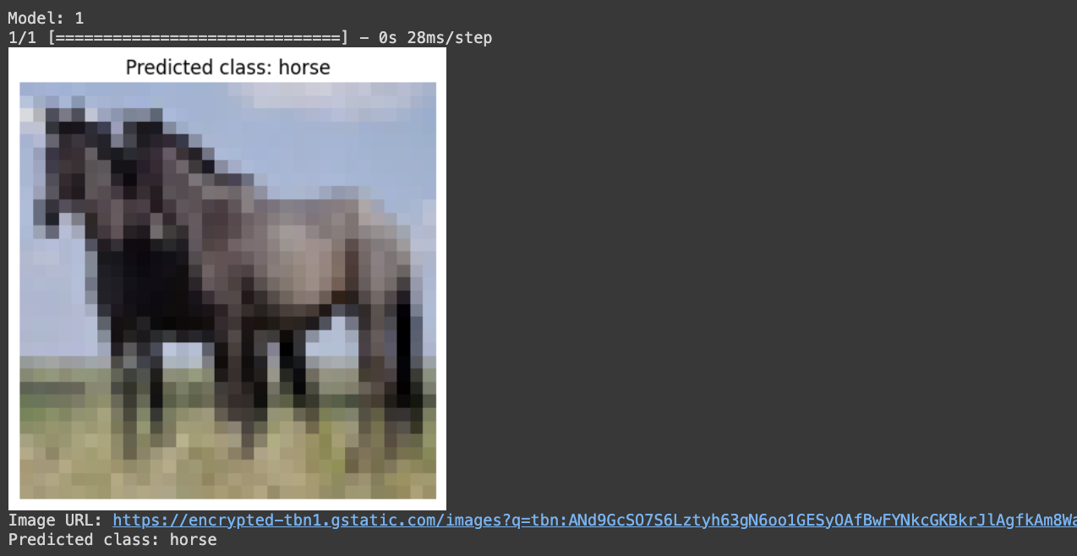

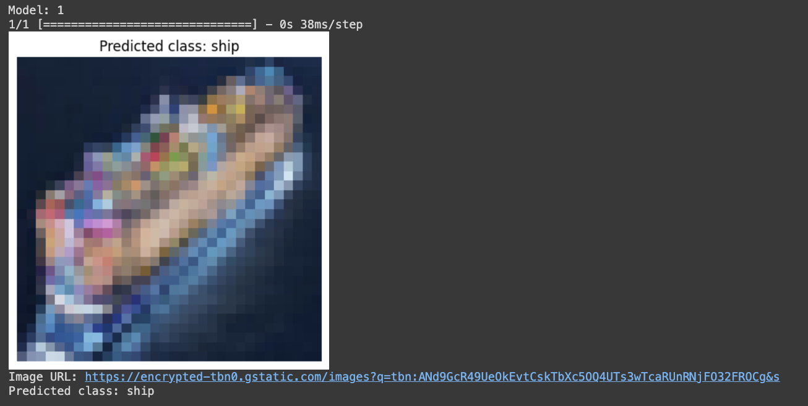

Model 2

All 3 models performs pretty well and reflecting its accuracy during training. This also has shown the the Model 2 has outperforms Model 1 and Model 2 base on both evaluation and predicting stage on untrain image.