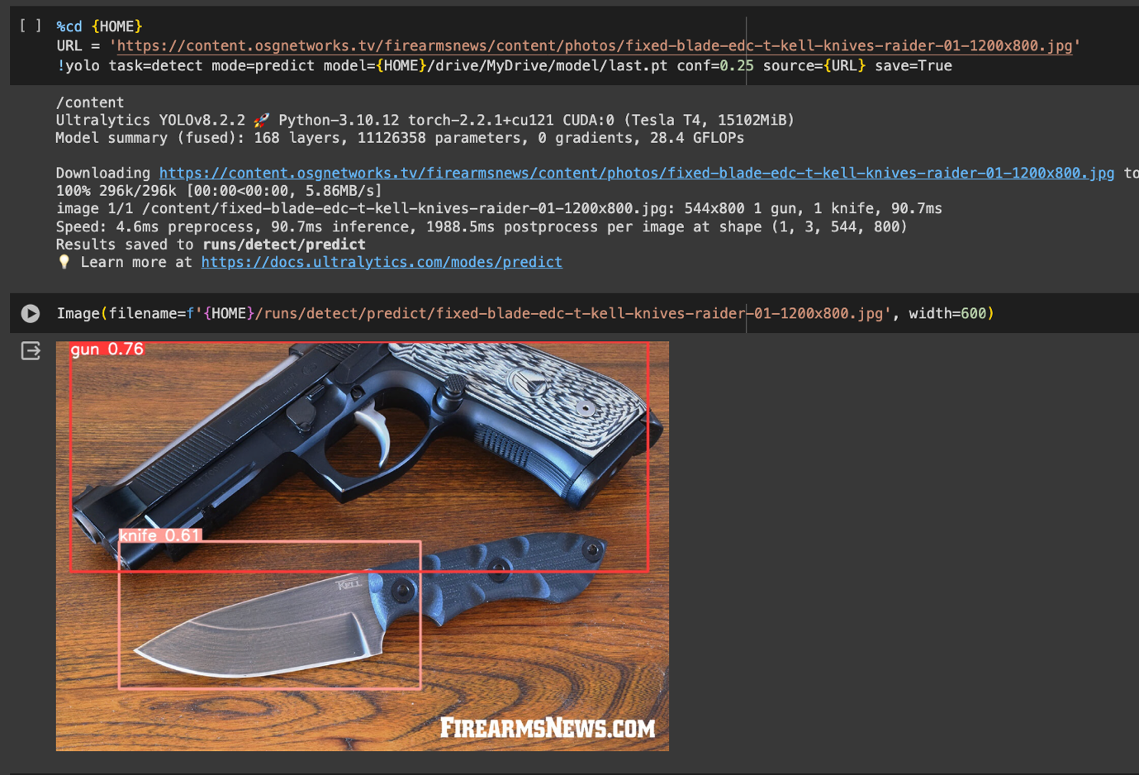

I have finetuned the model to detect some specific object such as gun and knife.

The dataset being used to trained the model is from Roboflow

https://universe.roboflow.com/crime-detection/guns_n_knives-h4bky