COS30082 – Applied Machine Learning

Learning Summary Report

STUDENT NAME (student id)

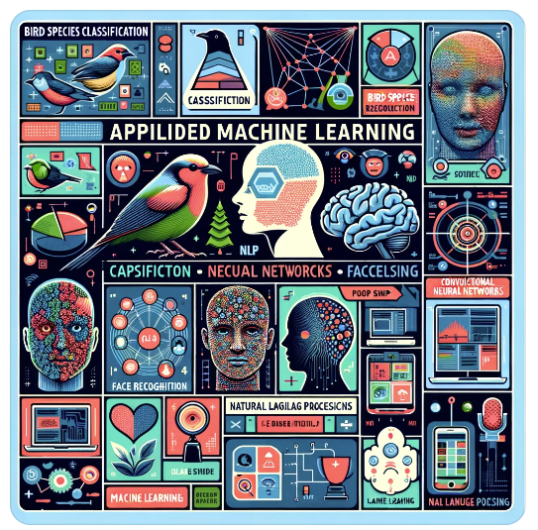

Generated by ChatGPT 4

Self-Assessment Details

The following checklists provide an overview of my self-assessment for this unit.

|  |  |  |  |  |
| --- | --- | --- | --- | --- |
|  | Pass (P) | Credit (C) | Distinction (D) | High Distinction (HD) |
| Self-Assessment (please tick) |  |  |  |  |

*Self-assessment Statement*

|  |  |
| --- | --- |
|  | Included (please tick) |
| Learning summary report |  |
| Weekly tasks signed off |  |

*Pass Checklist*

|  |  |
| --- | --- |
|  | Included (please tick) |
| Assignment (bird species classification) signed off |  |

*Credit Checklist, in addition to Pass Checklist*

|  |  |
| --- | --- |
|  | Included (please tick) |
| Project (face recognition) submitted |  |

*Minimum Distinction / High Distinction Checklist, in addition to Credit Checklist*

# Declaration

I declare that this portfolio is my individual work. I have not copied from any other student’s work or from any other source except where due acknowledgment is made explicitly in the text, nor has any part of this submission been written for me by another person.

Signature:

# Introduction

This report summarises what I learnt in COS30082 Applied Machine Learning. It includes a self-assessment against the criteria described in the unit outline, a justification of the pieces included, details of the coverage of the unit’s intended learning outcomes, and a reflection on my learning.

# Overview of Pieces Included

Add a list of all of the pieces that you are including. Write a sentence to briefly describe each. (then delete this box)

This section outlines the pieces that I have included in my portfolio.

1. **Tutorial 8 Face Recognition** : this tutorial…
2. …

# Coverage of the Intended Learning Outcomes (ILO)

This section outlines how the pieces I have included above demonstrate the depth of my understanding in relation to each of the unit’s intended learning outcomes.

For each ILO, describe the work you have included in your portfolio that demonstrates your ability in relation to the required outcomes. Then delete this box.

## ILO 1. Explain machine learning life cycle

## ILO 2. Use appropriate data engineering techniques for data preparation

## ILO 3. Analyse and apply advanced machine learning algorithms to solve real-world problems

## ILO 4. Evaluate, deploy and optimise machine learning project outcomes to domain specific users

## ILO 5. Interpret and effectively communicate machine learning project outcomes to domain specific users

# Reflection

Reflect on your learning and discuss these areas. Read the suggestions in [ ] for each question. Write your reflections then delete the text in the [ ] and delete this box.

## The most important things I learnt:

[ Think about topics covered, but also other general things you may have learnt. Think about what you have learnt in this subject, and reflect on what you think were key learning points, or incidents. Did you learn what you wanted/expected to learn? ]

## The things that helped me most were:

[ List and explain ]

## I found the following topics particularly challenging:

[ List and explain – if none explain why ]

## I found the following topics particularly interesting:

[ List and explain – remove if none ]

## I feel I learnt these topics, concepts, and/or tools really well:

[ List and explain – if none explain why, refer to your pieces for evidence to support your claims ]

## I still need to work on the following areas:

[ List and explain – if none explain why, refer to your pieces ]

## This unit will help me in the future:

[ How will the things you learnt relate to the rest of your studies, and career. What have you learnt that will be valuable for you in the future? ]

## If I did this unit again I would do the following things differently:

[ List and explain, how will you approach learning in the future? What things worked well, but what could you change to make sure you did better next time?]

## Other…:

[ Add any other reflections you think help you demonstrate your learning ]