https://www.bilibili.com/video/BV1i34y1i75m?p=11&spm_id_from=pageDriver

https://blog.csdn.net/u011535541/article/details/83379151?ops_request_misc=%257B%2522request%255Fid%2522%253A%2522164454892516780265443771%2522%252C%2522scm%2522%253A%252220140713.130102334..%2522%257D&request_id=164454892516780265443771&biz_id=0&utm_medium=distribute.pc_search_result.none-task-blog-2~all~top_positive~default-1-83379151.pc_search_insert_es_download&utm_term=git%E6%95%99%E7%A8%8B&spm=1018.2226.3001.4187

git config --global user.name "kinshandash"

git config --global user.email "znationz@163.com"

git init

git add readme.txt

git commit -m "new create readme.txt"

git status

git diff readme.txt

git log

git log --pretty=oneline

git log reflog

git reset --hard HEAD^

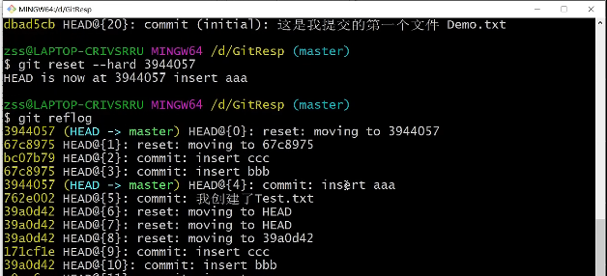

cat

touch

vi >esc >wq!

git checkout -- readme.txt 丢弃工作区的修改

rm b.txt

rm test -rf

git checkout -- b.txt 在版本库中恢复此文件

ssh-keygen -t rsa –C “youremail@example.com”

git remote add origin https://github.com/tugenhua0707/testgit.git

git push -u origin master 加上了 –u参数，Git不但会把本地的master分支内容推送的远程新的master分支，还会把本地的master分支和远程的master分支关联起来，在以后的推送或者拉取时就可以简化命令

git push origin maste

git clone https://github.com/tugenhua0707/testgit.git

git checkout -b dev same as below 2 cmd:

git branch dev

git checkout dev

git checkout master

git merge dev

git branch -d dev :del dev

查看分支：git branch

创建分支：git branch name

切换分支：git checkout name

创建+切换分支：git checkout –b name

合并某分支到当前分支：git merge name

删除分支：git branch –d name