Choose the Right Hardware

Proposal Template

# Scenario 1: Manufacturing

Client Requirements and Potential Hardware Solution

Look through the scenario and find any relevant client requirements. Then, suggest a potential hardware type and explain how this hardware would satisfy each of the requirements.

|  |
| --- |
| **Which hardware might be most appropriate for this scenario?**  **(CPU / IGPU / VPU / FPGA)** |
| *FPGA* |

|  |  |
| --- | --- |
| **Requirement Observed**  **(Include at least two.)** | **How does the chosen hardware meet this requirement?** |
| *Example requirement:*  The client requires a tiny device to be connected to their CPU—and their budget is only about $100 for each device. | *Example explanation:*  VPU or NCS2 is only about 27.40 mm in size and would fit in the price range. |
| *Client has requirement for 30-35 FPS which can be used to monitor the people in factory line.* | *FPGAs have very low latency for processing the video stream. As per the chart below, FPGAs are best fit.* |
| *Client can repurpose the system in the future.* | *FPGAs are reprogrammable.* |
| *Client has sufficient budget and they would like the system to last 5-10 years* | *FPGAs have long life span, which can easily last 5-10 years* |

## Queue Monitoring Requirements

|  |  |
| --- | --- |
| **Maximum number of people in the queue** | *2* |
| **Model precision chosen (FP32, FP16, or Int8)** | *FP16* |

## Test Results

After you've tested your application on all four hardware types (CPU, IGPU, VPU, and FPGA), copy the matplotlib output showing the comparison into the spaces below. You should have three graphs (for model load time, inference time, and FPS).

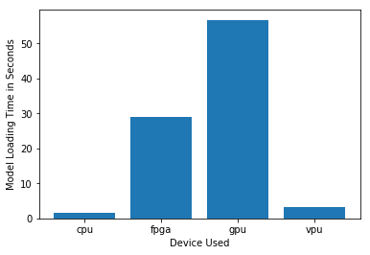

***Model Load Time***

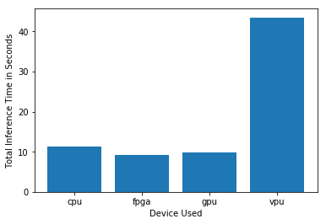

***Inference Time***

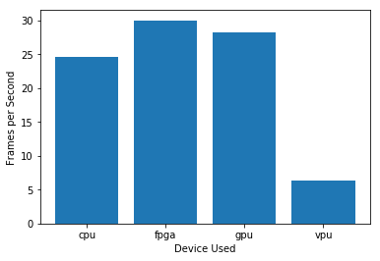

***FPS***

## Final Hardware Recommendation

Now synthesize your points from above and provide a brief write-up describing why the chosen hardware is the best choice for this scenario. Be sure to discuss the client's requirements, the test results, and how these relate to one another (e.g., perhaps one of the devices performed better than the rest, but does not meet one of the client's requirements).

|  |
| --- |
| **Write-up: Final Hardware Recommendation** |
| *FPGA is the perfect fit for the current scenario as it meets all the requirements. It can work at 30 FPS and is reprogrammable for the future usage. It also has long lifespan which means it can easily last 5-10 years.* |

# 

# Scenario 2: Retail

Client Requirements and Potential Hardware Solution

Look through the scenario and find any relevant client requirements. Then, suggest a potential hardware type and explain how this hardware would satisfy each of the requirements.

|  |
| --- |
| **Which hardware might be most appropriate for this scenario?**  **(CPU / IGPU / VPU / FPGA)** |
| *CPU* |

|  |  |
| --- | --- |
| **Requirement Observed**  **(Include at least two.)** | **How does the chosen hardware meet this requirement?** |
| *Example requirement:*  The client requires a tiny device to be connected to their CPU—and their budget is only about $100 for each device. | *Example explanation:*  VPU or NCS2 is only about 27.40 mm in size and would fit in the price range. |
| *Most of the store's checkout counters already have a modern computer, each of which has an Intel i7 core processor. Currently these processors are only used to carry out some minimal tasks that are not computationally expensive.* | *Though IGPU have delivered slightly better than CPU, but we already have CPUs which can deliver similar results. This ensures that the processors are used for some hard-core work, rather than minimal tasks which they are doing.* |
| *The client does not have much money to invest in additional hardware, and also would like to save as much as possible on his electric bill.* | *As the client doesn’t have enough budget at the moment, we can reuse the CPUs as compute unit for the people counter at the checkout.* |

## Queue Monitoring Requirements

|  |  |
| --- | --- |
| **Maximum number of people in the queue** | *5* |
| **Model precision chosen (FP32, FP16, or Int8)** | *FP16* |

## Test Results

After you've tested your application on all four hardware types (CPU, IGPU, VPU, and FPGA), copy the matplotlib output showing the comparison into the spaces below. You should have three graphs (for model load time, inference time, and FPS).

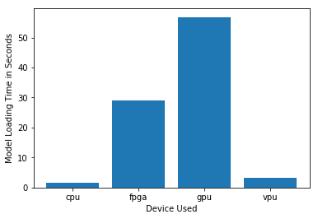

***Model Load Time***

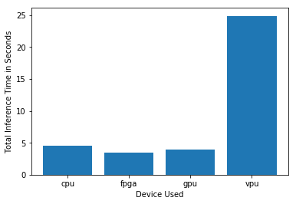

***Inference Time***

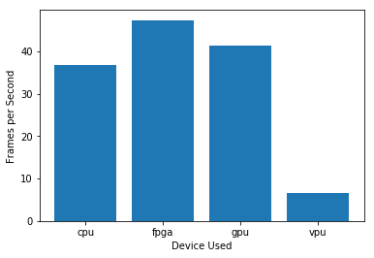

***FPS***

## Final Hardware Recommendation

Now synthesize your points from above and provide a brief write-up describing why the chosen hardware is the best choice for this scenario. Be sure to discuss the client's requirements, the test results, and how these relate to one another (e.g., perhaps one of the devices performed better than the rest, but does not meet one of the client's requirements).

|  |
| --- |
| **Write-up: Final Hardware Recommendation** |
| *CPU is the recommendation for this scenario, as we have a budget constraint and the it performs marginally slower when it comes to other expensive solutions like GPU and FPGA. So, it meets all the technical as well as budget requirements.* |

# 

# Scenario 3: Transportation

Client Requirements and Potential Hardware Solution

Look through the scenario and find any relevant client requirements. Then, suggest a potential hardware type and explain how this hardware would satisfy each of the requirements.

|  |
| --- |
| **Which hardware might be most appropriate for this scenario?**  **(CPU / IGPU / VPU / FPGA)** |
| *VPU* |

|  |  |
| --- | --- |
| **Requirement Observed**  **(Include at least two.)** | **How does the chosen hardware meet this requirement?** |
| *Example requirement:*  The client requires a tiny device to be connected to their CPU—and their budget is only about $100 for each device. | *Example explanation:*  VPU or NCS2 is only about 27.40 mm in size and would fit in the price range. |
| *The client monitors the entire situation with 7 CCTV cameras on the platform. These are connected to closed All-In-One PCs that are located in a nearby security booth. The CPUs in these machines are currently being used to process and view CCTV footage for security purposes and no significant additional processing power is available to run inference.* | *VPU fits in here as it doesn’t require additional power or processing, as it works in plug and play manner using USB port. Though due to I/O CPU will throttle and result in higher inference time of around 50 seconds, which is under the constraint.* |
| *The client’s budget allows for a maximum of $300 per machine, and she would like to save as much as possible both on hardware and future power requirements.* | *VPU costs around $100 which easily fits the budget, and consumes extremely low power.* |

## Queue Monitoring Requirements

|  |  |
| --- | --- |
| **Maximum number of people in the queue** | *7* |
| **Model precision chosen (FP32, FP16, or Int8)** | *FP16* |

## Test Results

After you've tested your application on all four hardware types (CPU, IGPU, VPU, and FPGA), copy the matplotlib output showing the comparison into the spaces below. You should have three graphs (for model load time, inference time, and FPS).

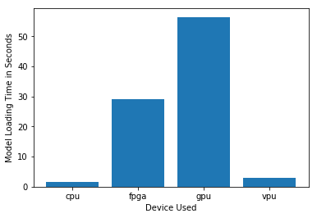

***Model Load Time***

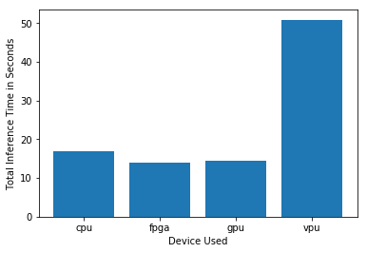

***Inference Time***

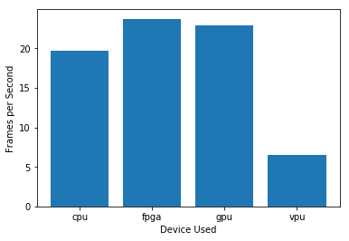

***FPS***

## Final Hardware Recommendation

Now synthesize your points from above and provide a brief write-up describing why the chosen hardware is the best choice for this scenario. Be sure to discuss the client's requirements, the test results, and how these relate to one another (e.g., perhaps one of the devices performed better than the rest, but does not meet one of the client's requirements).

|  |
| --- |
| **Write-up: Final Hardware Recommendation** |
| *VPU is the best fit as we want lower power consumption and a budget of less than $ 300 and does the job with the inference time of around 50 seconds.* |

# 