**Responsive Website**

Creating a responsive website using SASS, JavaScript and HTML, with fully functional links. This project is still a work in progress, and I will be periodically making changes and updating the website as I develop more content for it.

**Prerequisites**

For this project, I have used Atom, a hackable text editor, which synchronizes well with GitHub. I am also using prepros, which is used to compile SASS, LESS, and a variety of other languages and supports live browser reload. Along with these two softwares(which are free to use), I am using the GitHub desktop app to better synchronize my projects.

**Screenshots**

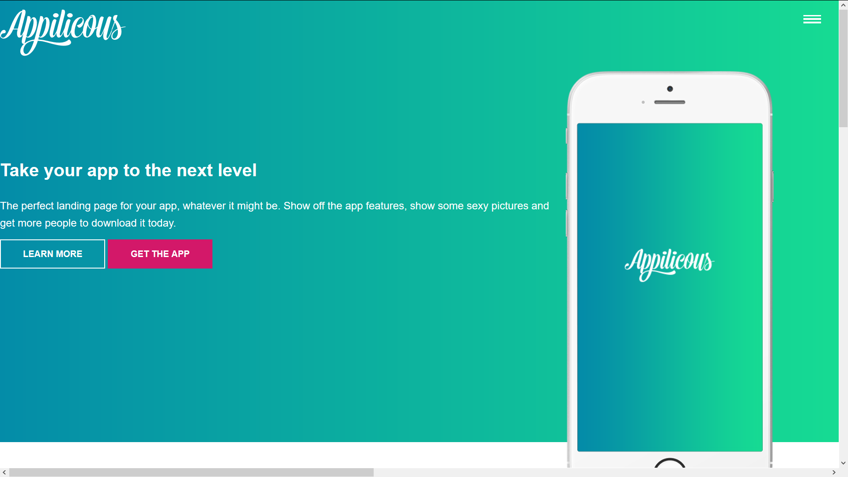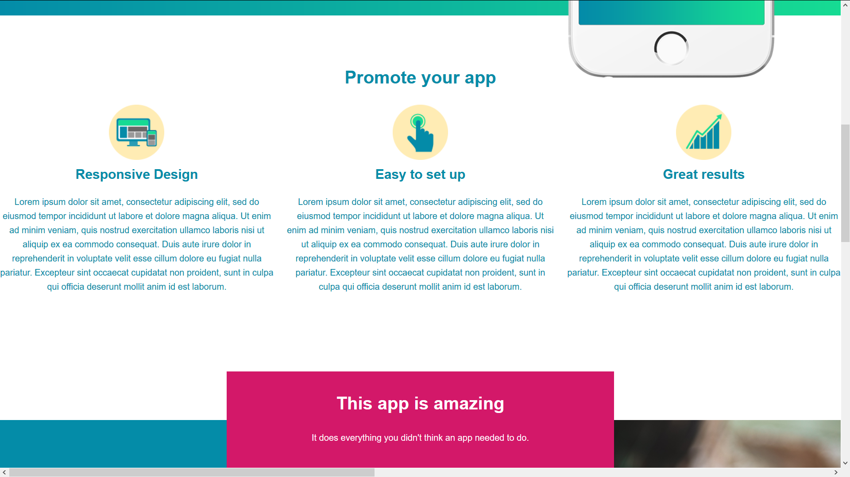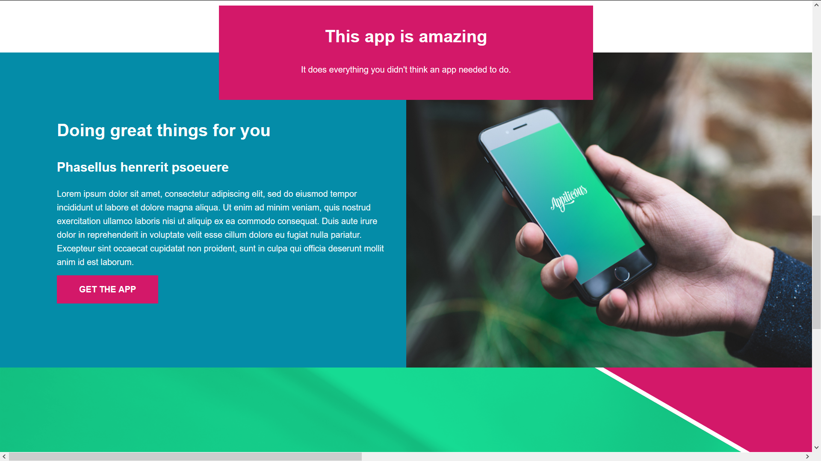

**Acknowledgments**

This website was developed using the tutorial for responsive website by Kevin Powell.