Winter Sem - 2015

To Prof. Lydia Jain

**Software Engineering Project Plan**

VIDEO pLAYER

**Problem Statement**

A **video player** is a kind of media player for playing back digital video data from media such as optical discs (for example, DVD, VCD), as well as from files of appropriate formats such as MPEG, AVI, RealVideo, and QuickTime.

In addition to VCR-like functions such as playing, pausing, stopping, rewinding, and forwarding, some common functions include zooming/full screen, audio channel selection, subtitle selection, and frame capturing.

Many of the video players also support simple playback of digital audio and 3D playback of 2D video.

**Project Objectives**

* Custom video player that plays divx, mkv, flv, (and many more formats) and uses other popular streaming protocols such as MMS, RTSP, RTMP.
* Video playback: The video playback will be able to be forwarded and rewind.
* Recording and taking snapshots of the video being played will be made available.
* Quick Link Tabs: This will categorise different videos separately for fast and easy access.
* User Interface: All of the process of user registration, addition of favourite videos and media list will be done on a user interface.

Member work division:

Kintan Singh: Designing the external framework and functions of the application.

Lakshay Gupta: Adding functionalities to the frame.

**Feasibility Study**

We know that there exist much need for such a feasible system of video player, this gives the application a complete leverage over the market. And millions of people use video player which gives us big market.

The project execution plan is properly designed considering number of factors in account. Also we have taken additional time frame just in case of unexpected delays.

The application will be quite feasible technically, because it will be a user oriented application which means it will be based on the user’s need.. Operation does not involve much other than timely upgrades.

**Process Model**

Incremental Model:

Rather than delivering the system as a one time delivery, the development and delivery is broken down into increments with each increment delivering part of the required functionality.

The reason we chose incremental model:

* So that we can develop the system in Increments.
* By developing system in increments we will be able to evaluate each increment before proceeding to the development of the next increment.
* By this we can assign both the member with work in increments wise.

**Deliverables**

* Various functionalities to be provided like recording, taking snapshots, video playback, etc.
* Multiple formats will be supported.
* Video’s classification and organization.
* Accessibility from multiple computers with required functionalities.

We plan to use Windows platform and framework.

**Project Scheduling**

|  |  |  |  |  |  |
| --- | --- | --- | --- | --- | --- |
| **Milestone** | **Estimated Start Date** | **Estimated Completion Date** | **Estimated Hours** | **Number of Resources** | **Number of Days** |
| **Software Requirements Specification** | **1/19/2015** | **2/1/2015** | **35** | **3** | **9** |
| **Software Design** | **2/2/2015** | **2/15/2015** | **35** | **3** | **9** |
| **Detailed Design** | **2/16/2015** | **3/8/2015** | **60** | **3** | **19** |
| **Coding** | **3/9/2015** | **4/5/2015** | **120** | **3** | **26** |
| **Unit Testing** | **4/6/2015** | **4/12/2015** | **20** | **3** | **5** |
| **Integration Testing** | **4/13/2015** | **4/19/2015** | **20** | **3** | **5** |
| **System Testing** | **4/20/2015** | **4/26/2015** | **20** | **3** | **5** |
| **Project Demo** | **4/27/2015** | **4/27/2015** | **3** | **3** | **1** |
| **Total Hours** | | | **313** | | |

**Gantt chart:**

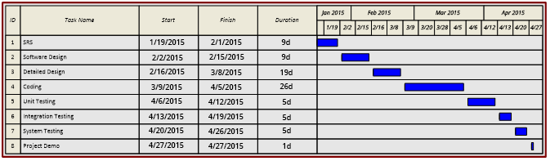

**Pert chart:**

