SRS Document

VIDEO PLAYER APPLICATION

To: Prof. Lydia Jane G.

by-

Lakshay(12bce0462)

Kintan(12bce0362)

**Problem Statement**

A **video player** is a kind of media player for playing back digital video data from media such as optical discs (for example, DVD, VCD), as well as from files of appropriate formats such as MPEG, AVI, RealVideo, and QuickTime.

In addition to VCR-like functions such as playing, pausing, stopping, rewinding, and forwarding, some common functions include zooming/full screen, audio channel selection, subtitle selection, and frame capturing.

Many of the video players also support simple playback of digital audio and 3D playback of 2D video.

**Background Information**

Many video players are available in the app store currently. But only a few are worth downloading and using. Almost all of the video players are either bulky/don’t have a intuitive ui or use to much processing power leaving us feeling angry when lagged in the midst of the action.

Our development team aims to surpass all our competitors to create a video player that is more intuitive, faster, take less processing power and makes your experience so good that you would not want to go to multiplexes anymore.

**Stakeholders**

* Project Development and Design Team
* Customers/Users

**Requirements**

* **Functional Requirement**
  1. Download
  2. Install
  3. Browse
  4. Sort
  5. Play
  6. Manage
  7. Delete File
  8. Update and Manage Application

User Stories:

1. Download:   
   As a new user I would like to download your video player application. So that I can play videos/songs from my multiple computer devices.
2. Install:   
   As an downloader, I would like to start using ur video player.
3. Browse:   
   As a current user of the application I would like to browse my favourite files and play them through your awesome application.
4. Sort:   
   I’d love to have the functionality of sorting my files the way I seem to please.
5. Play:

Now that I have selected the file I’d love to play it via the application.

1. Manage the file:

As a user of the application, I want to manage my files by renaming and reordering them.

1. Delete the file:   
   As a user of the application I would like to delete the files I deem fit.
2. Update and Manage Application:  
   As a project development team member I would like to update the video player application.

**Use Case Diagram:**

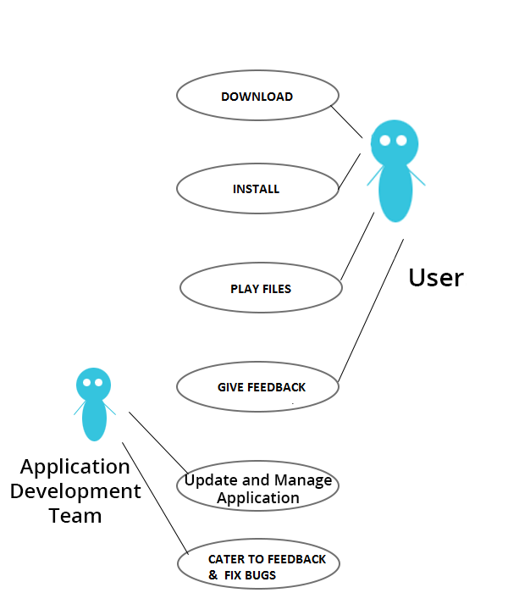

* **Non Functional Requirements**
* [Accessibility](http://en.wikipedia.org/wiki/Accessibility):   
  Anyone can use the application, there is no restriction to any person. The application can be accessed from any of the latest handheld devices.
* Failure Management:   
  In case of any unexpected failure,the development team always welcomes feedback/criticism and promises earliest updates.
* Price:   
  The application is free to use. No charges of any kind to use the application will be collected.
* Response time:   
  The response time of the application will depend on the ram of the device in use,and the file attributes being played .Results may vary.
* Usability:   
  It will be extremely easy to use the application. It would take about 3 minutes to get to know all the features of application and how to use it.
* Scalability:   
  The application will be designed keeping in mind the competition and so there will be real time monitoring of features employed.